Supplemental table 1. Primers used for qPCR amplification.
Gene | Forward sequence (5′-3′) | Reverse sequence (5′-3′)
LGALS1 | CCTGGAGAGTGCCTTCGAGT | CACACGATGGTGTTGGCGTC
CD304 | CCAGGTCGAATCCGATCCT | CGCTGTCGGTGTAAAAAACCA
GAPDH | ACCCACTCCTCCACCTTTGA | CATACCAGGAAATGAGCTTGACAA

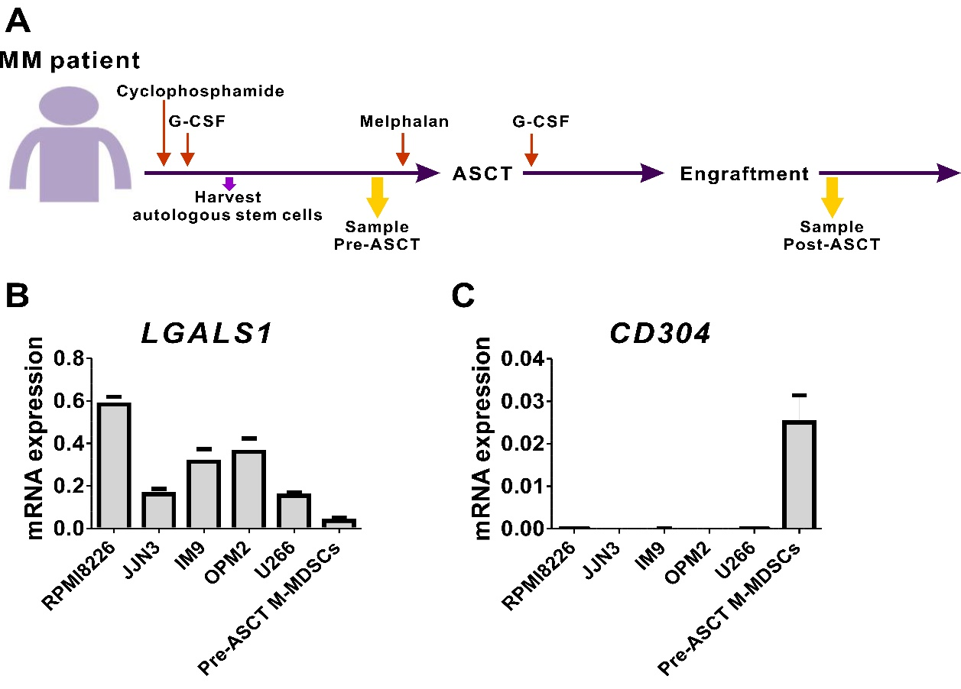
Supplemental figure 1. Expression of LGALS1 and CD304 in HMCLs and M-MDSC from pre-ASCT patients. A. Schematic showing of the ASCT procedure and patient sample collection. The expressions of LGALS1 (B) and CD304 (C) mRNA were evaluated by real-time PCR using 5 HMCLs and 3 M-MDSCs from pre-ASCT patients.

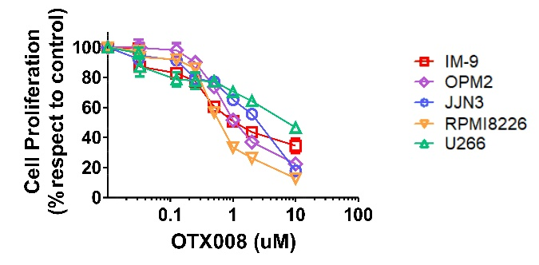

Supplemental figure 2. In vitro effects of galectin-1 inhibition on HMCLs growth. Anti-proliferative effects of OTX008 in five HMCLs after 48h treatment were shown.

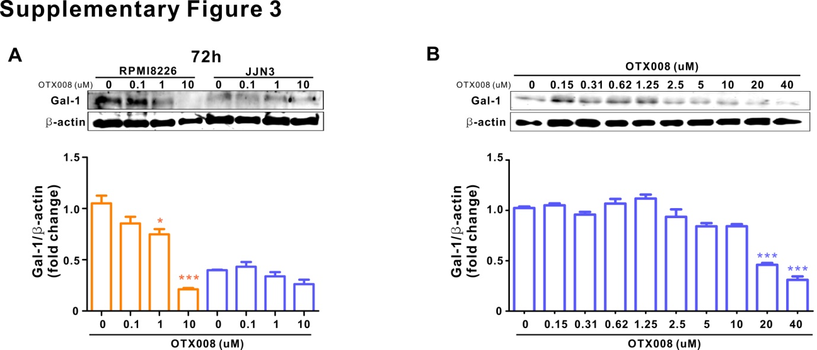

Supplemental figure 3. Effects of OTX008 on galectin-1 protein expression. A, Galectin-1 levels in the two HMCLs treated for 72 h with different concentrations of OTX008. B, Galectin-1 levels in JJN3 cells treated for 48h with different concentrations of OTX008. The data are presented as the mean ± SEM. *P < 0.05; ***P < 0.001 (one-way ANOVA).

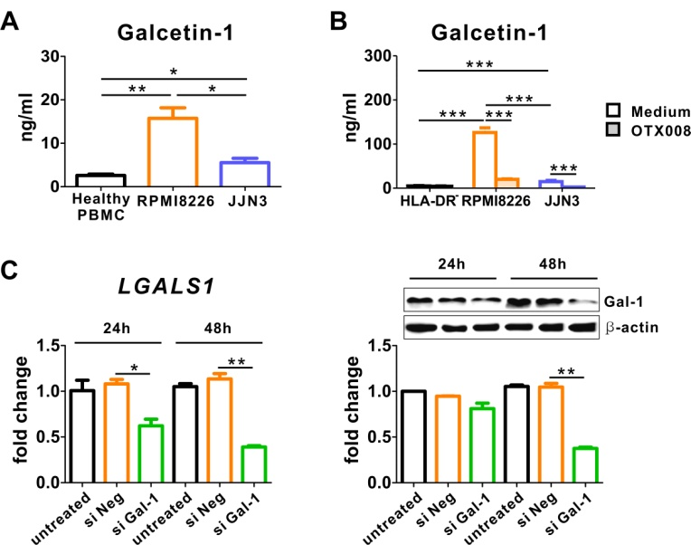

Supplemental figure 4. The 2 HMCLs differently promote the secretion of galectin-1 in vitro. A, Healthy PBMCs were co-culture with RPMI8226 or JJN3 for 5 days and confirmed the presence of galectin-1 in culture media. B, HLA-DR^{low/-} cells from pre-ASCT patients were co-culture with RPMI8225 or JJN3 for 2 days with or without OTX008, and galectin-1 levels were measured in culture media. C, siRNA- mediated knockdown of galectin-1 was confirmed by real-time PCR (left) and western blotting (right). The data are presented as the mean ± SEM. *P < 0.05; **P < 0.01; ***P < 0.001 (one-way ANOVA).

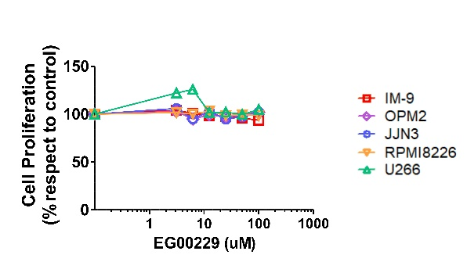

Supplemental figure 5. In vitro effects of CD304 inhibition on HMCLs growth. Anti-proliferative effects of EG00229 in HMCLs after 24h treatment.

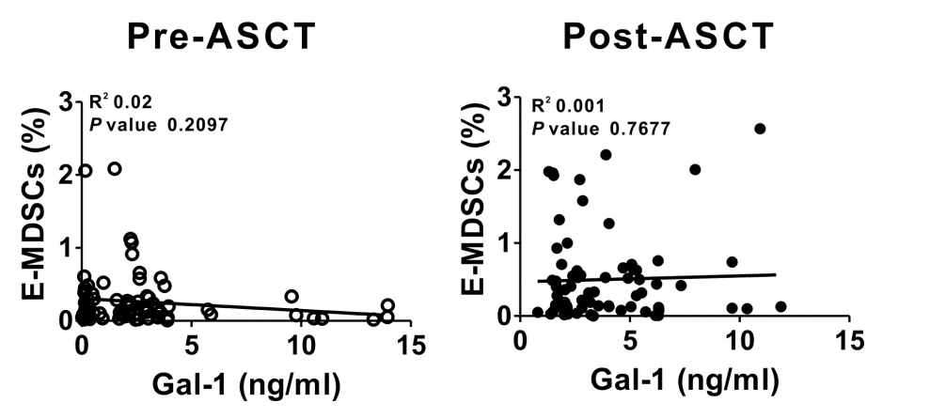

Supplemental figure 6. Correlation between galectin-1 and frequency of pre- and post-ASCT E-MDSCs was analyzed respectively. The Spearman correlation coefficient was used to evaluate the association of continuous variables.

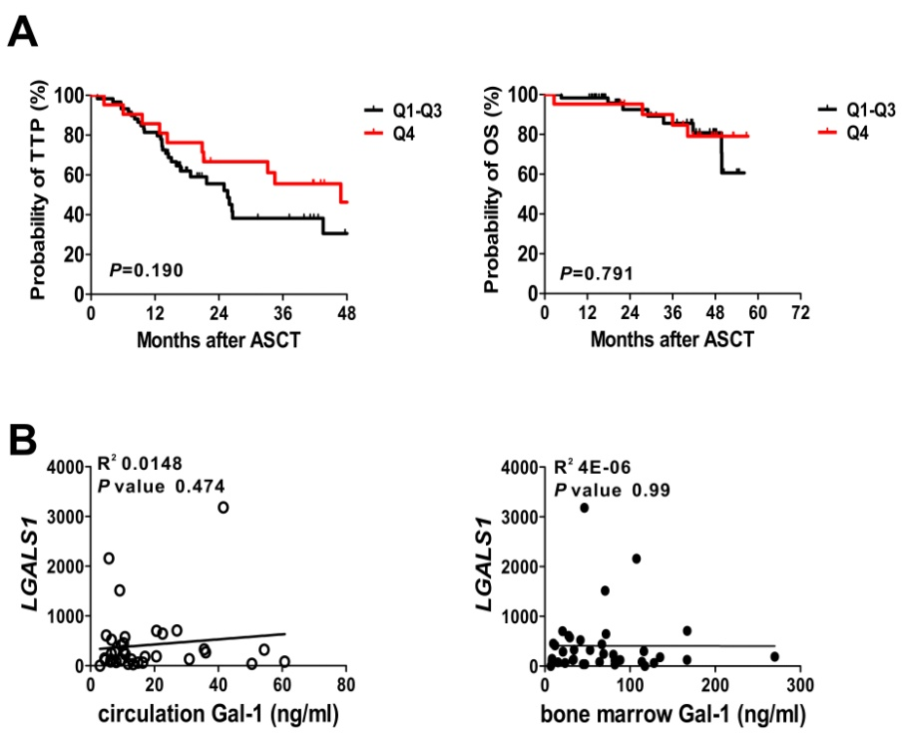

Supplemental figure 7. A. Kaplan-Meier estimated curves represent the probability of time to progression (TTP) and the overall survival (OS) of MM patients according to level of post-ASCT serum galectin-1 as determined by lower quartiles (Q1-Q3, black) and upper quartile (Q4, red). A log-rank test was used to determine differences between the survival curves. B. The Correlation between the malignant PCs LGALS1 and circulation and bone marrow plasma galectin-1 was analyzed respectively. The Spearman correlation coefficient was used to evaluate the association of continuous variables.

