**Supplementary figures, table and legends:**

**Supplementary table 1**

|  |  |  |
| --- | --- | --- |
| **Gene Ontology Pathway** | **P value** | **Number of common genes** |
| IMMUNE SYSTEM PROCESS | 3.30e-17 | 30 |
| LYMPHOCYTE ACTIVATION | 1.25e-14 | 14 |
| CELL ACTIVATION | 1.87e-14 | 15 |
| LEUKOCYTE ACTIVATION | 6.52e-14 | 14 |
| T CELL ACTIVATION | 2.66e-13 | 12 |
| IMMUNE RESPONSE | 1.09e-12 | 22 |
| PLASMA MEMBRANE | 2.35e-12 | 53 |
| POSITIVE REGULATION OF  MULTICELLULAR ORGANISMAL PROCESS | 2.56e-11 | 12 |
| IMMUNOLOGICAL SYNAPSE | 5.48e-11 | 7 |
| REGULATION OF MULTICELLULAR ORGANISMAL PROCESS | 5.84e-11 | 16 |

**Gene ontology pathways in human melanoma samples from the TCGA data bank associated with high *SMPD3* expression.**



**Supplementary Fig 1: *SMPD3* expression on skin samples from metastatic melanoma patients. A-D,** ISH was performed on cutaneous samples from 4 advanced melanoma patients. Blue rectangle: normal skin; Red rectangle: melanoma. **E,** *SMPD3* gene structure: the numbers indicate positions to the Transcription Start Site (TSS) (ENST00000219334.8). The cg03412735 (Infinium HumanMethylation450K BeadChip) is located 73pb downstream from the TSS, in the *SMPD3* promoter core overlapped by the CpG Island 155 (as defined by the UCSC genome browser). **G,** Correlation analysis between *SMPD3* expression and methylation beta values associated to cg03412735 among patients exhibiting high methylation for this CpG (>0.27) (n=116).

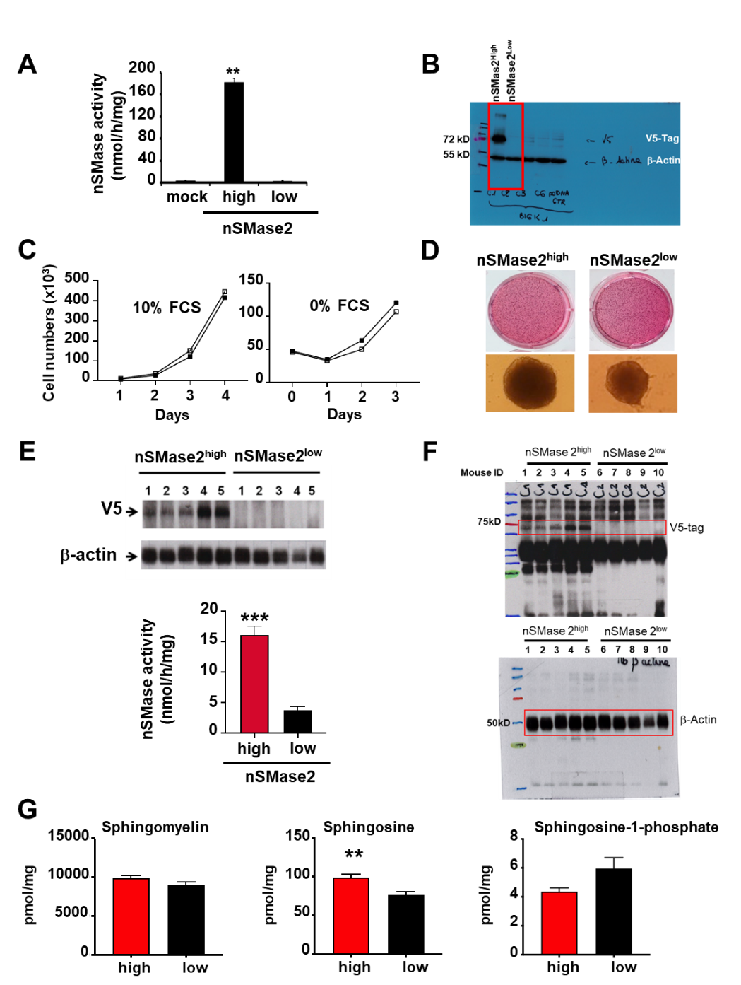

**Supplementary Fig. 2: Impact of nSMase2 expression in B16K1 on *in vitro* growth properties and sphingolipid content in tumors. A,** Neutral SMase activity in B16K1 nSMase2high and nSMase2low as well as in mock-transfected B16K1 cells (one-way Anova). **B,** Complete version of the western blot depicted in Fig.2a showing V5 nSMase expression in nSMasehigh and nSMase2low B16K1 cells. **C.** *In vitro* B16K1 nSMase2high (black symbols) and nSMase2low (open symbols) cell growth was evaluated in 10% FCS or 0% FCS medium. Data are means ± sem of triplicate determinations from one representative experiment out of three. **D,** *In vitro* B16K1 nSMase2high and nSMase2low cell growth on soft agar (top panels) and as spheroids (bottom panels). Data are representative of three independent experiments. **E,** B16K1 nSMase2high and nSMase2low cells were intradermally injected in C57BL/6 mice. At day 23 post-injection, mice were sacrificed, tumors were collected and proteins extracted on samples derived from each tumor. Proteins were analysed by Western blot using anti-V5 or anti--actin antibodies (upper panel), and neutral SMase activity was measured (lower panel). Data are means ±sem of values measured in samples derived from 5 tumors. **F,** Full images of the western blots depicted in E. **G,** Lipid extracts from tumors collected at day 12 were analysed by mass spectrometry to determine total intra-tumor sphingomyelin, ceramide, sphingosine, and sphingosine-1-phosphate levels. Data are means ± sem of values measured in samples derived from 5 mice. Of note, data for total and sub-species of ceramide are depicted in Figure 2F. Mann Whitney test,**p<0.01; ***p<0.001.

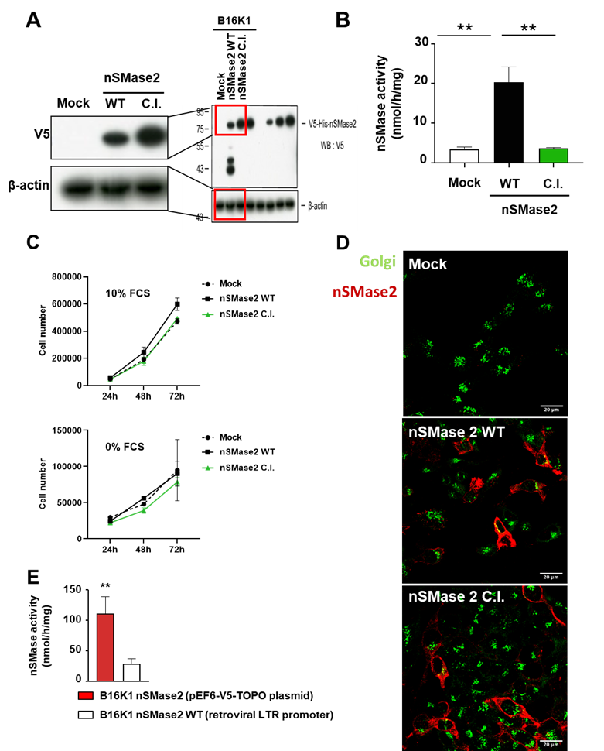

**Supplementary Fig. 3: Generation of B16K1 expressing WT or catalytically-inactive nSMase2.** B16K1 cells were stably transduced with a control retroviral vector (B16K1 mock), a retroviral vector encoding WT (nSMase2 WT) or a catalytically-inactive (nSMase2 C.I.) V5-tagged nSMase2. **A,** Cells were analysed by Western blot using anti-V5 and anti--actin antibodies. **B,** Neutral SMase activity in B16K1 transduced with a control retroviral vector (B16K1 mock), a retroviral vector encoding WT (nSMase2 WT) or a catalytically-inactive (nSMase2 C.I.). Data are means ± sem of 3 independent experiments (**: p<0.01, one-way Anova). **C,** *In vitro* cell growth under 10% (upper panel) and 0% (lower panel) FCS of B16K1 mock, B16K1 nSMase2 C.I. and B16K1 nSMase2 WT. Data are from two independent experiments (error bars = SD). **D,** Confocal microscopy to monitor nSMase2 (red staining) and giantin (green staining) localization in the indicated B16K1 cell populations. Scale: 20m. **E.** Direct Comparison of nSMase activity between B16K1 cells transduced with the retroviral vector coding for WT nSMase2 (LTR promoter) and B16K1 cells transfected with the pEF6-V5_TOPO plasmid coding for nSMase2 (n=4-6, Student T test; **p<0.01, error bars = SEM).

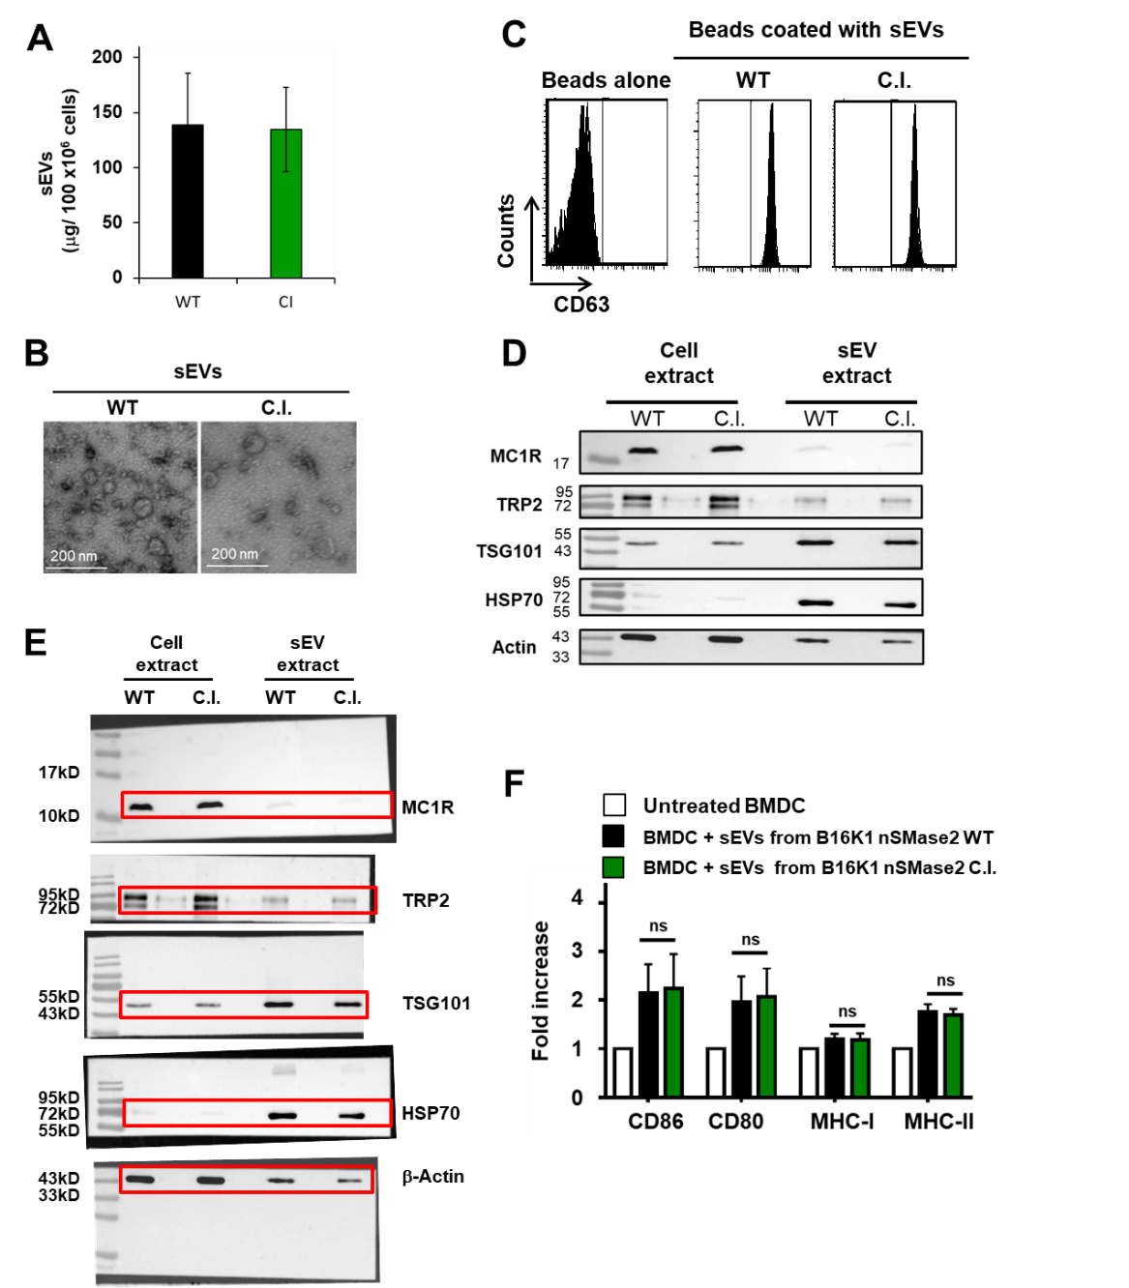

**Supplementary Fig 4**: **Molecular composition of exosomes.** sEVs from B16K1 cells transduced with a retroviral vector encoding wild-type (WT) or catalytically-inactive (C.I.) nSMase2 were purified by ultracentifugation. **A,** Quantity of sEVs as evaluated by protein content of purified sEVs from cell culture medium of B16K1 nSMase2 WT or C.I. Data are means ± sem of 5 independent experiments. **B, P**reparation of sEVs was observed by electronic microscopy. **C,** Beads were coated, or not (beads alone), with sEVs from B16K1 nSMase2 WT or C.I. and stained with an anti-CD63 prior to flow cytometry analysis. **D,** Western blot analysis on cell extracts and sEVs from B16K1 cells expressing wild-type or C.I. nSMase2. **E,** Full western images of the results depicted in D. **F,** Bone marrow-derived dendritic cells from C57BL/6 mice were incubated or not with 10 μg/mL sEVs from B16K1 expressing WT or catalytically-inactive (C.I.) nSMase2. After 24h of co-culture, CD86, CD80, MHC-I and II were analysed by flow cytometry. Data are means ± sem of 3 independent experiments carried out with 2 independent sEV preparations.

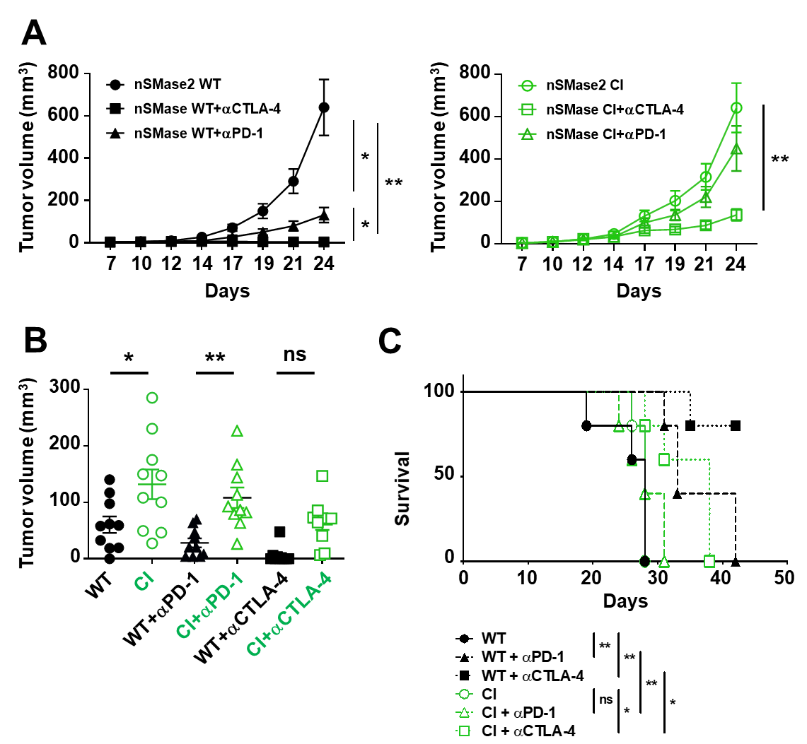

**Supplementary Fig. 5:** **Catalytic activity is required for nSMase2 to enhance response to immunotherapies. A-C**, C57BL/6 WT mice were intradermally and bilaterally injected with B16K1 melanoma cells expressing or the WT or catalytically-inactive (C.I.) nSMase2 cells and received intraperitoneal injection of anti-PD-1 antibodies (αPD-1, 200 µg), anti-CTLA-4 antibodies (CTLA-4, 200 µg first injection then 100 µg) or vehicle (PBS) at days 6, 10 and 13 (n=5 mice per group) and tumor volumes were determined with a calliper. Individual tumor curves are depicted (A) (Two-way Anova). Tumor volumes at day 17 (B) (One-way Anova). Overall survival (C). (*: p<0.05; **p<0.01; ***: p<0.001)

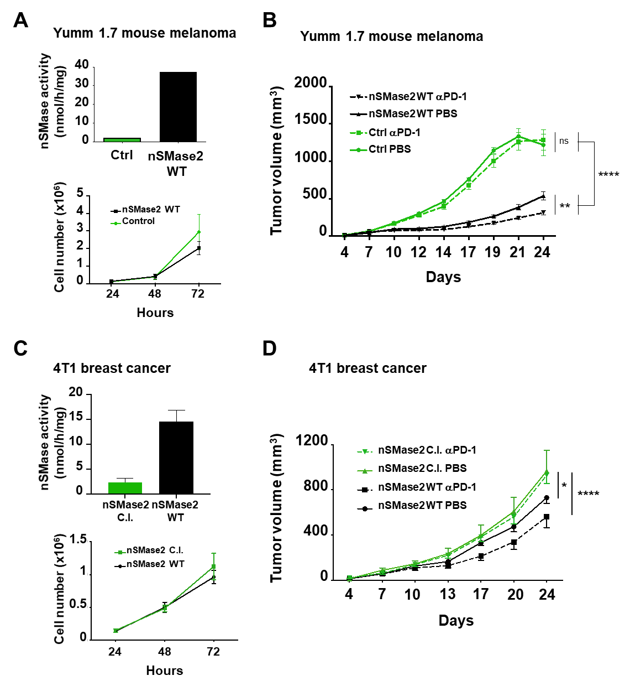

**Supplementary Fig. 6: WT nSMase2 promote melanoma response to anti-PD-1 in additional models of melanoma and breast cancer A and B,** Yumm 1.7 mouse melanoma cells were stably transduced with a control retroviral vector or a vector coding for WT nSMase2. Neutral sphingomyelinase activity (A, upper panel) (n=1) and *in vitro* cell growth are depicted (A, lower panel) (data are mean +/- sem of 3 independent experiments). **B,** Control or WTnSMase2 overexpressing Yumm 1.7 cells were intradermally injected to WT C57BL/6 mice treated with PBS or PD-1 (200 µg) at days 4, 7, 10, 13 and 16. Tumor growth was assessed using a calliper (n=10 mice per group). Significance at day 24 is depicted (two-way Anova). **C and D,** 4T1 cells were stably transduced with a retroviral vector encoding the WT (nSMase2 WT) or catalytically inactive (nSMase2 C.I.) nSMase2. Neutral sphingomyelinase activity of 4T1 cells overexpressing the WT or catalytically inactive form of nSMase2 (C, upper panel) (n=2) as well as *in vitro* cell growth under 10% FCS of 4T1 nSMase2 WT or C.I. Data are mean ±sem of 5 independent experiments (C, lower panel). **D,** 4T1 cells stably expressing the nSMase2 WT (WT) or the nSMase2 C.I. (C.I.) were injected sub-cutaneously to BALB/c mice and treated with PD-1 (200 µg) or PBS at days 6, 10, 13 and 17 (n=7 mice per group). Significance (two-way Anova) at day 24 is depicted. *p<0.05; *p<0.01; ****p<0.0001.

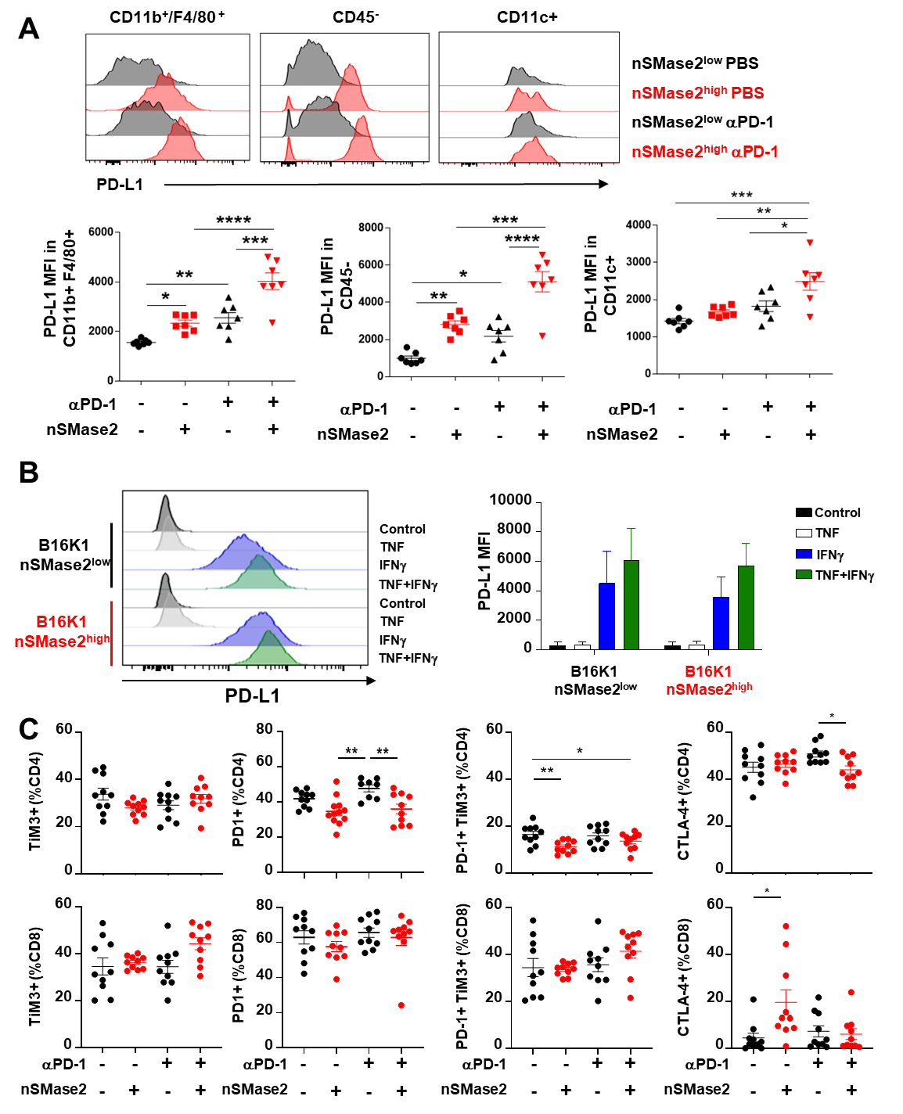

**Supplementary Fig. 7: Impact of melanoma nSMase2 on PD-L1 and immune checkpoint expression.** nSMase2high or nSMase2low B16K1 cells were bilaterally and intradermally grafted to C57BL/6 WT mice. Mice were then treated with 200 µg anti-PD-1 or vehicle at day 7 prior tumor immune infiltrate analysis by flow cytometry at day 10. **A,** Analysis of PD-L1 expression, as evaluated by MFI on macrophages (CD11b+ F4/80+ CD45+ cells) or CD45 negative cells or dentritic cells (CD11b+ F4/80- CD11c+ CD45+ cells) from nSMase2high and nSMase2low tumors treated with PBS or anti-PD-1 (n=7 mice per group). **B,** nSMase2high or nSMase2low B16K1 cells were treated in vitro with 50 ng/mL recombinant murine TNF and/or 100U IFN for 72h. PD-L1 expression on melanoma cells was assessed by flow cytometry (n=3 independent experiments). **C.** The expression of PD-1, TIM-3 and CTLA-4 on CD4 and CD8 TILs was evaluated by flow cytometry (n=10 per group). *p<0.05; **p<0.01; ***p<0.001; ****p<0.0001 (Kruskall Wallis or One-way ANOVA).