Supplemental Figures
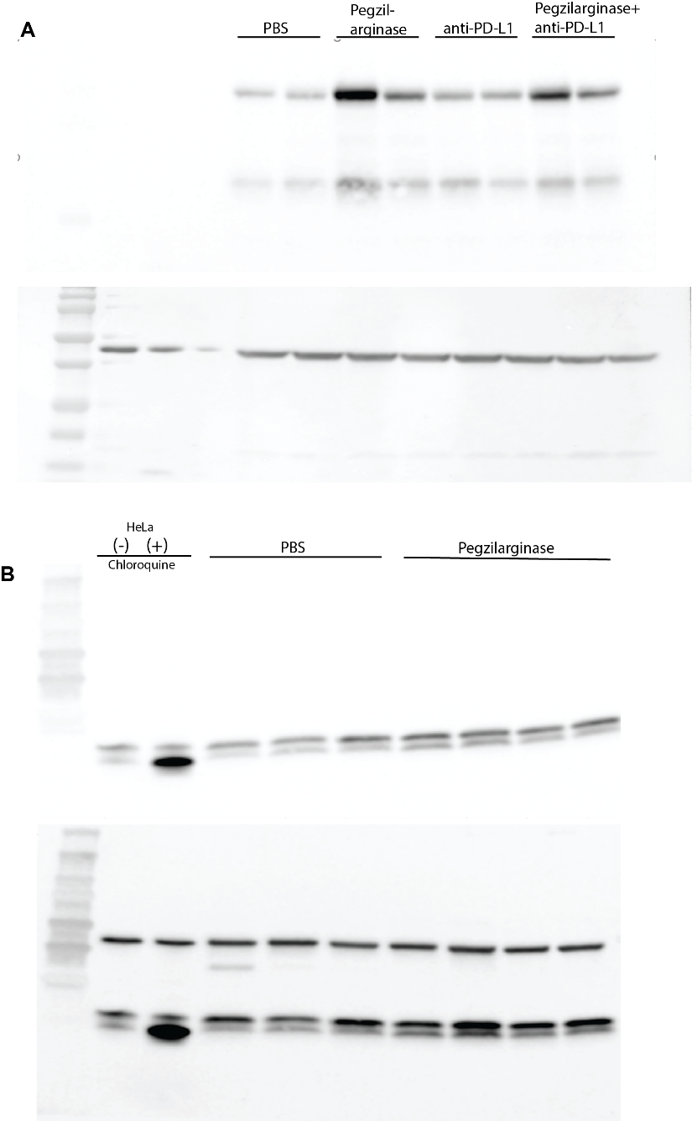
Fig. S1. Full Western blot images for analysis of autophagy and MHC I expression
A) Representative full blot of tumor lysate probed using an anti-H2Kd antibody (top); B-actin staining of same membrane (bottom). Cropped images presented as Figure 2B. B) Representative full blot of tumor lysate probed using an anti-LC3 antibody (top) and re-incubated with an anti-B-actin antibody (bottom). Cropped images presented as Figure 1F.

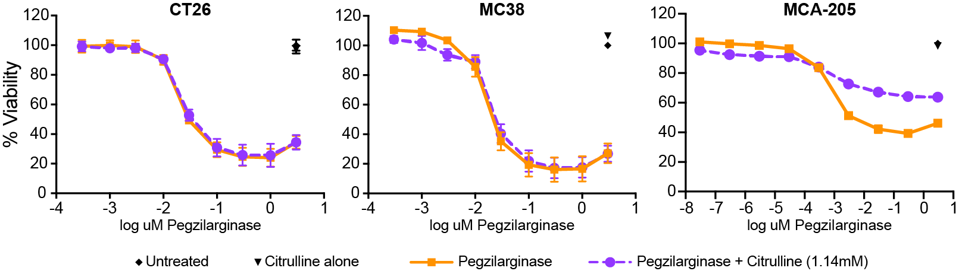
Fig. S2. Activity of pegzilarginase in model tumors.
CT26 (left), MC38 (middle), or MCA-205 cells (right) were cultured with pegzilarginase in the presence or absence of excess citrulline for 72 hours, after which time their viability was assessed. Graphs depict the mean ± SD.

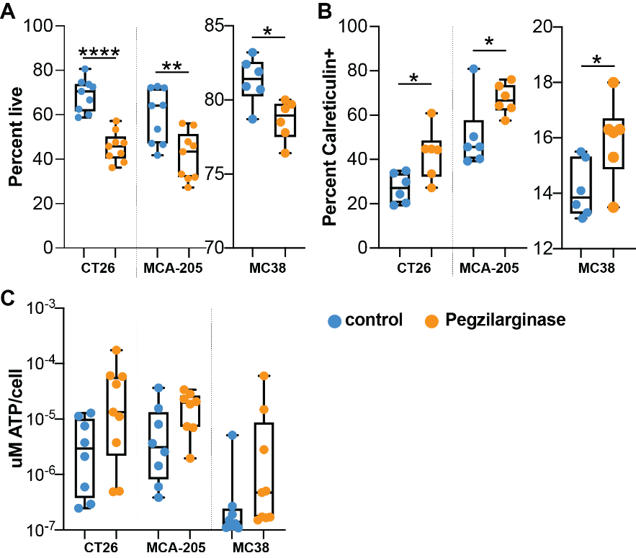
Fig. S3. Pegzilarginase induces immunogenic cell death in vitro.
CT26, MC38, or MCA-205 cells were incubated with 3µM pegzilarginase for 48 hours, when they were collected and stained for viability (A) and calreticulin (B). The supernatants from these cultures were collected and tested for the presence of ATP (C). Graphs depicts median ± IQR (box). Statistics, Students T test, *p<0.05, **p<0.01, ****p<0.0001.

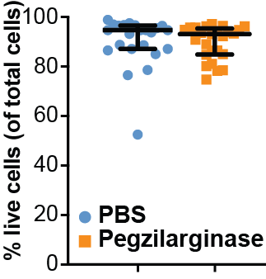
Fig. S4. Pegzilarginase does not alter the percent of total live cells.
Flow cytometric analysis of cells isolated from tumors 3 days post-treatment. Graphs depict median ± IQR; n=25/group.

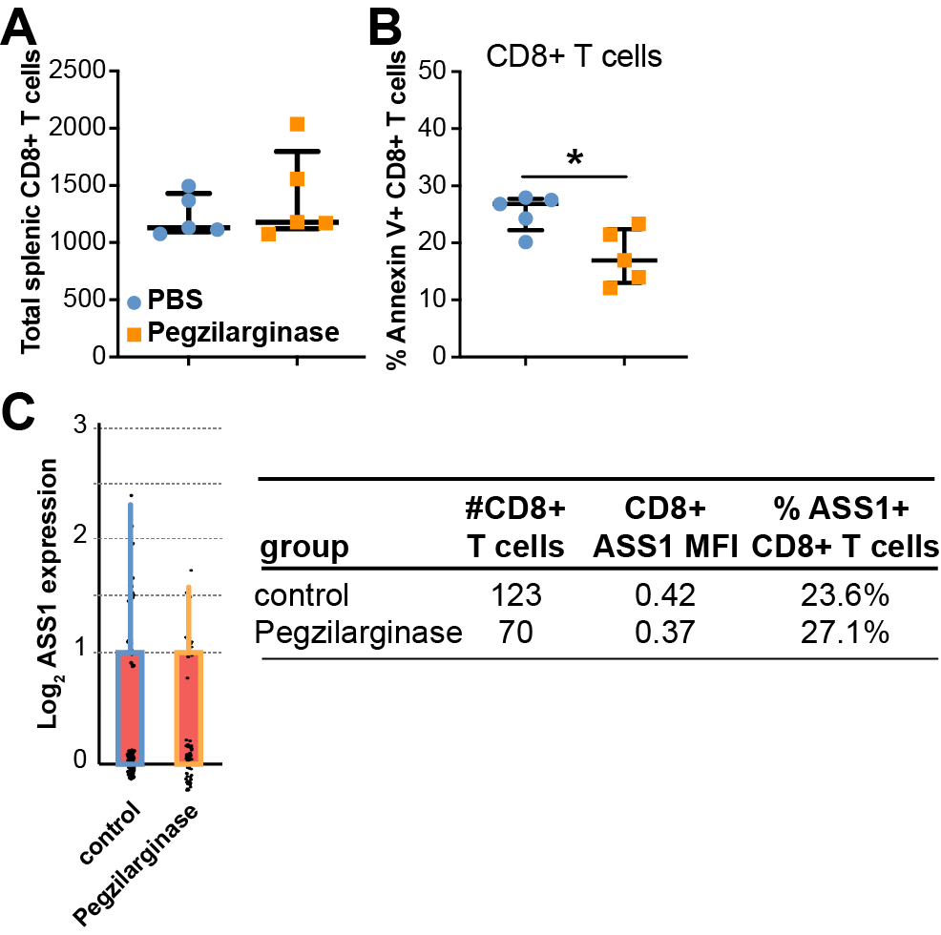
Fig. S5. Pegzilarginase does not induce apoptosis in systemic CD8⁺ T cells or the compensatory gene pathway in CD8⁺ T cells.
A) Flow cytometry of total CD8⁺ T cells isolated from the spleen 3 days post-treatment. n=5/group. B) Annexin V staining of CD8⁺ T cells isolated from the spleen. Graphs depict median ± IQR; n=5/group. C) Log2 ASS1 expression in tumor-associated CD8⁺ T cells 3 days post-pegzilarginase treatment. Corresponding table describes the ASS1 MFI and percent of cells expressing ASS1.
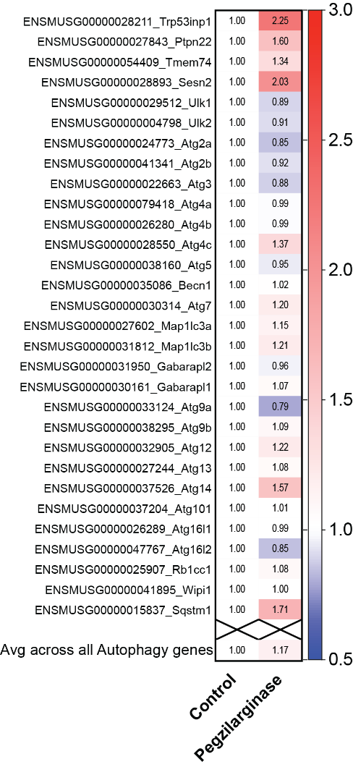
Fig. S6. Pegzilarginase induces autophagy genes in CD45- cells.
CD45- cells were sorted from CT26 tumors 3 days post-treatment and used for bulk RNA seq. Graph depicts transcript levels of 30 autophagy related genes, normalized to the control tumors.
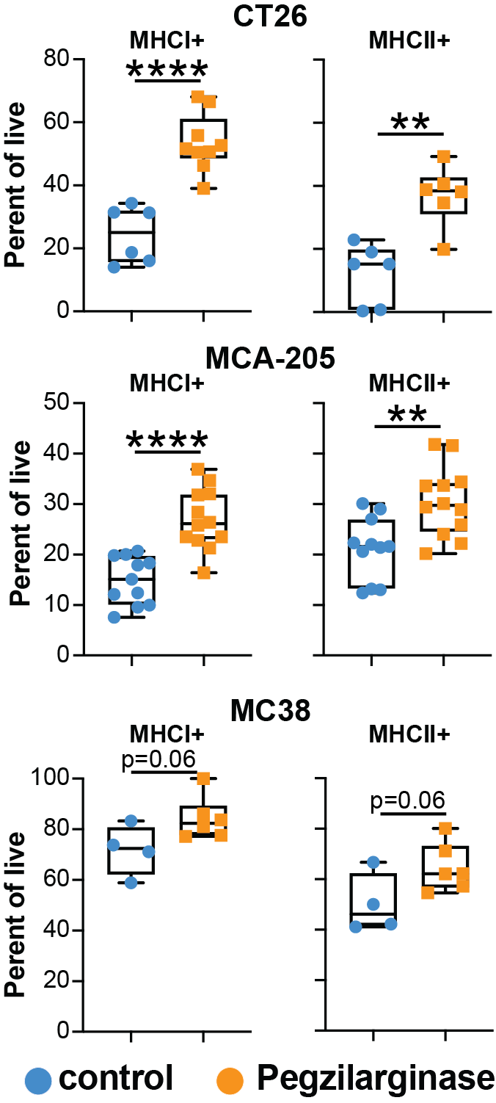
Fig. S7. Pegzilarginase induces MHC I and MHC II expression in vitro.
CT26, MC38, or MCA-205 cells were incubated with 3µM pegzilarginase for 48 hours, when they were collected and stained for MHC I and MHC II. Graphs depicts median ± IQR (box) and minimum and maximum values (whiskers). Statistics, Students T test, **p<0.01, ****p<0.0001.

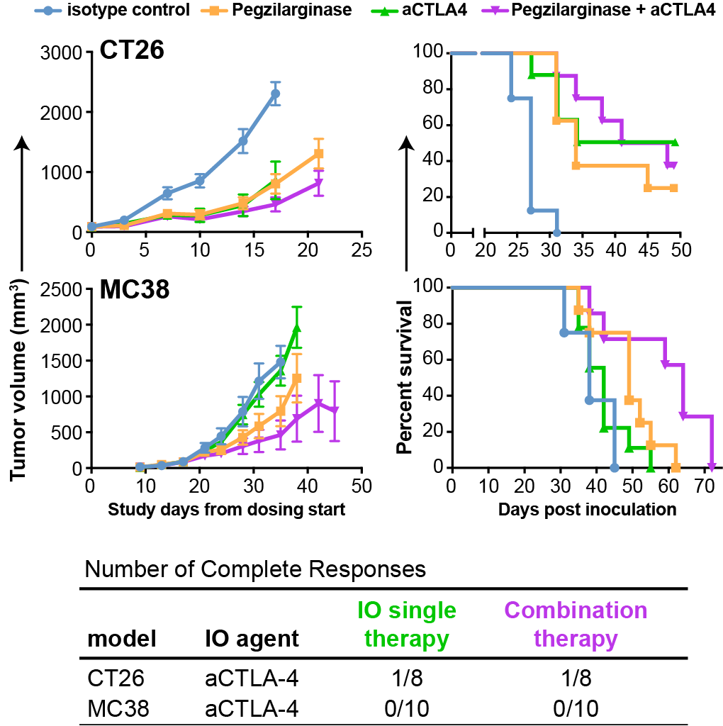
Fig. S8. Combination therapy with pegzilarginase and aCTLA-4 does not significantly improve efficacy over monotherapies.
Tumor growth and survival of mice with CT26 (top) or MC38 (bottom) tumors treated with pegzilarginase and/or aCTLA-4 mAb. n=8-10/group. Complete responses (positive tumor growth followed by complete tumor regression) in each of the studies shown.
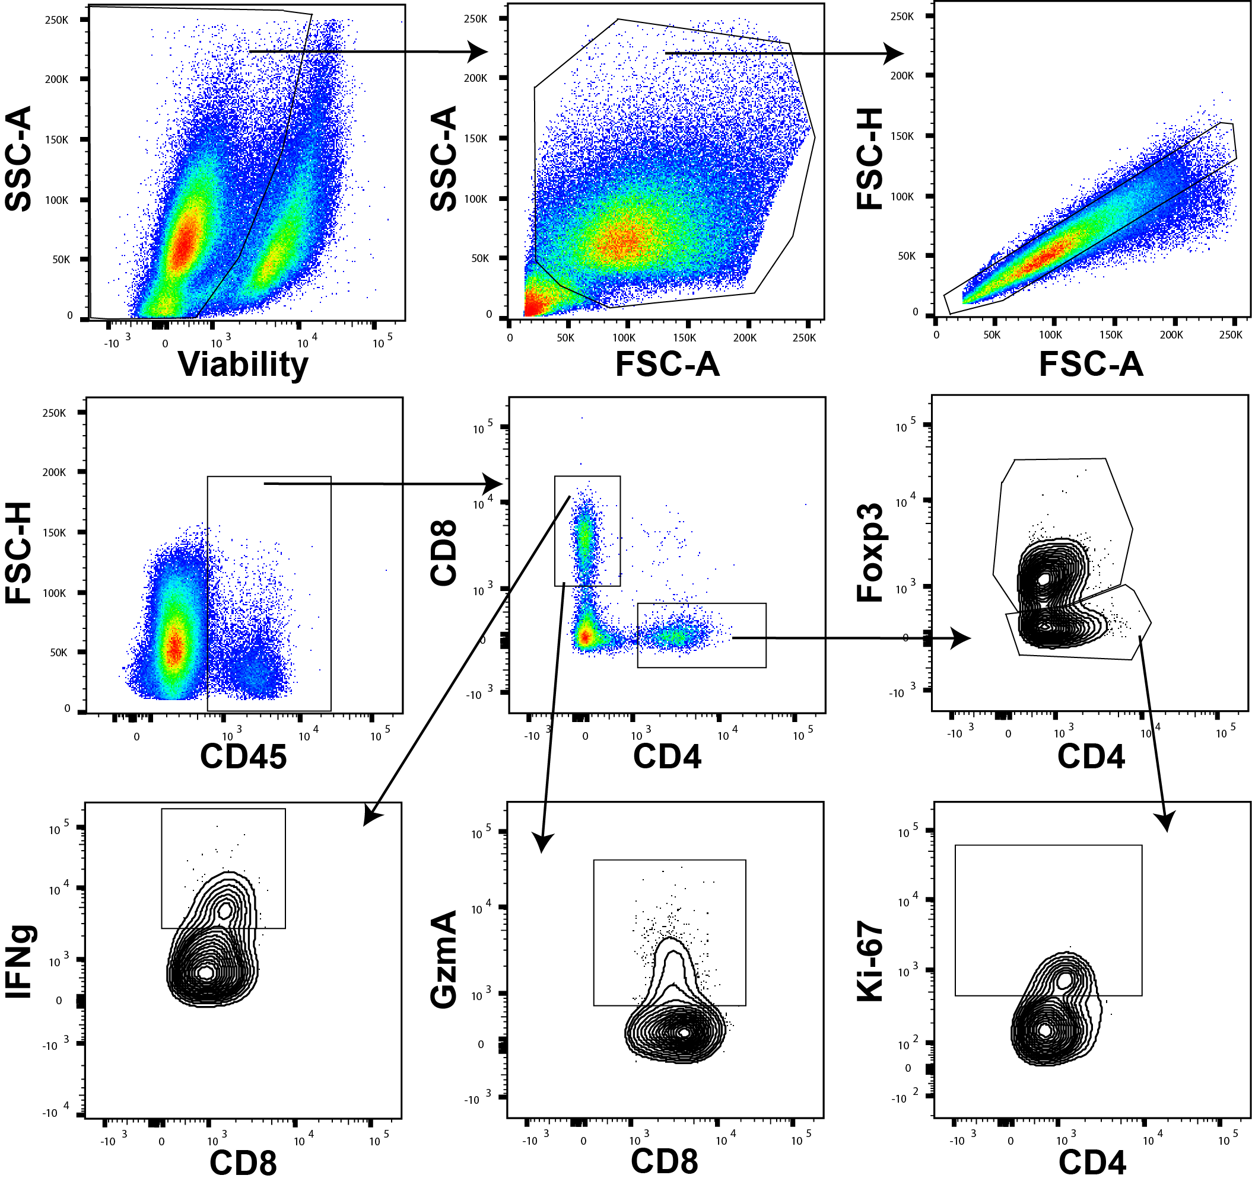
Fig. S9. Gating strategy for intratumoral CD4⁺ and CD8⁺ T lymphocytes.
Single cell tumor homogenates were gated on viability, FSCxSSC, single cells (FSC-A x FSC-H), CD45⁺, and subsequently either CD4⁺ or CD8⁺. Examples of intracellular stains, Foxp3, IFN-γ, GzmA, and Ki-67, are also shown.

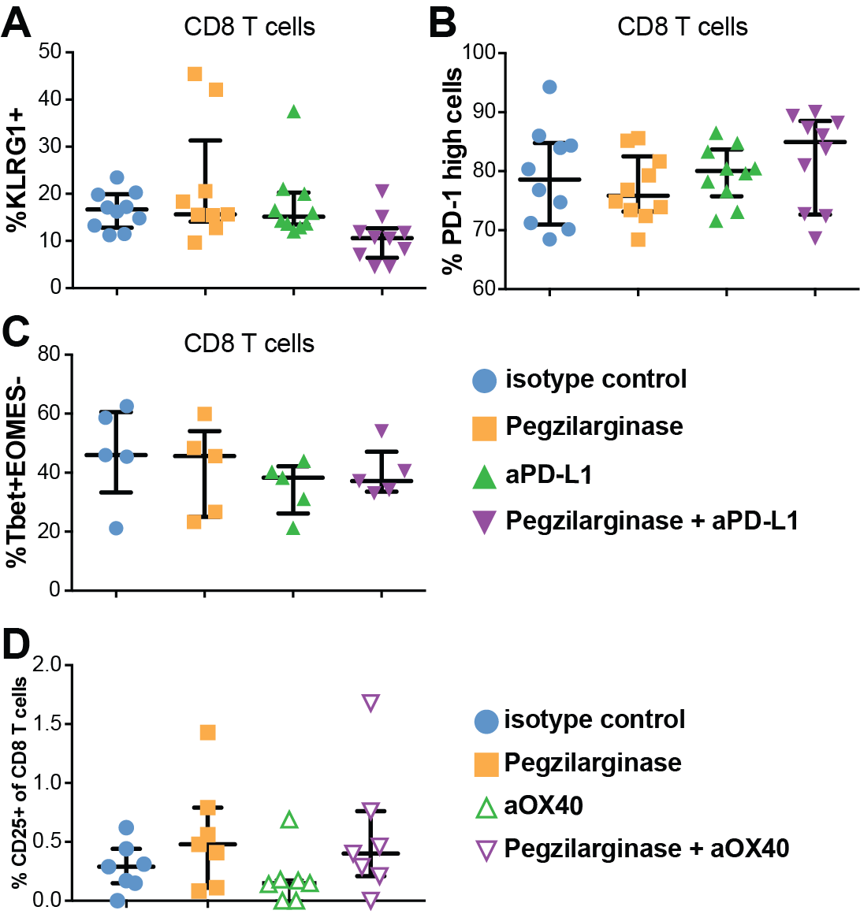
Fig. S10. Immunophenotyping of CT26 tumors treated with pegzilarginase and/or aPD-L1.
Percent of CD8⁺ T cells expressing A) KLRG1, B) PD-1, and C) T-bet/Eomes as assessed using flow cytometry 17 days post-treatment. n=5/ group. D) Flow cytometric analysis of CD25⁺ CD8⁺ T cells from CT26 tumors on day 7 post-treatment with pegzilarginase/aOX40 therapy. n=7/group from two independent experiments; graphs depict median ± IQR.
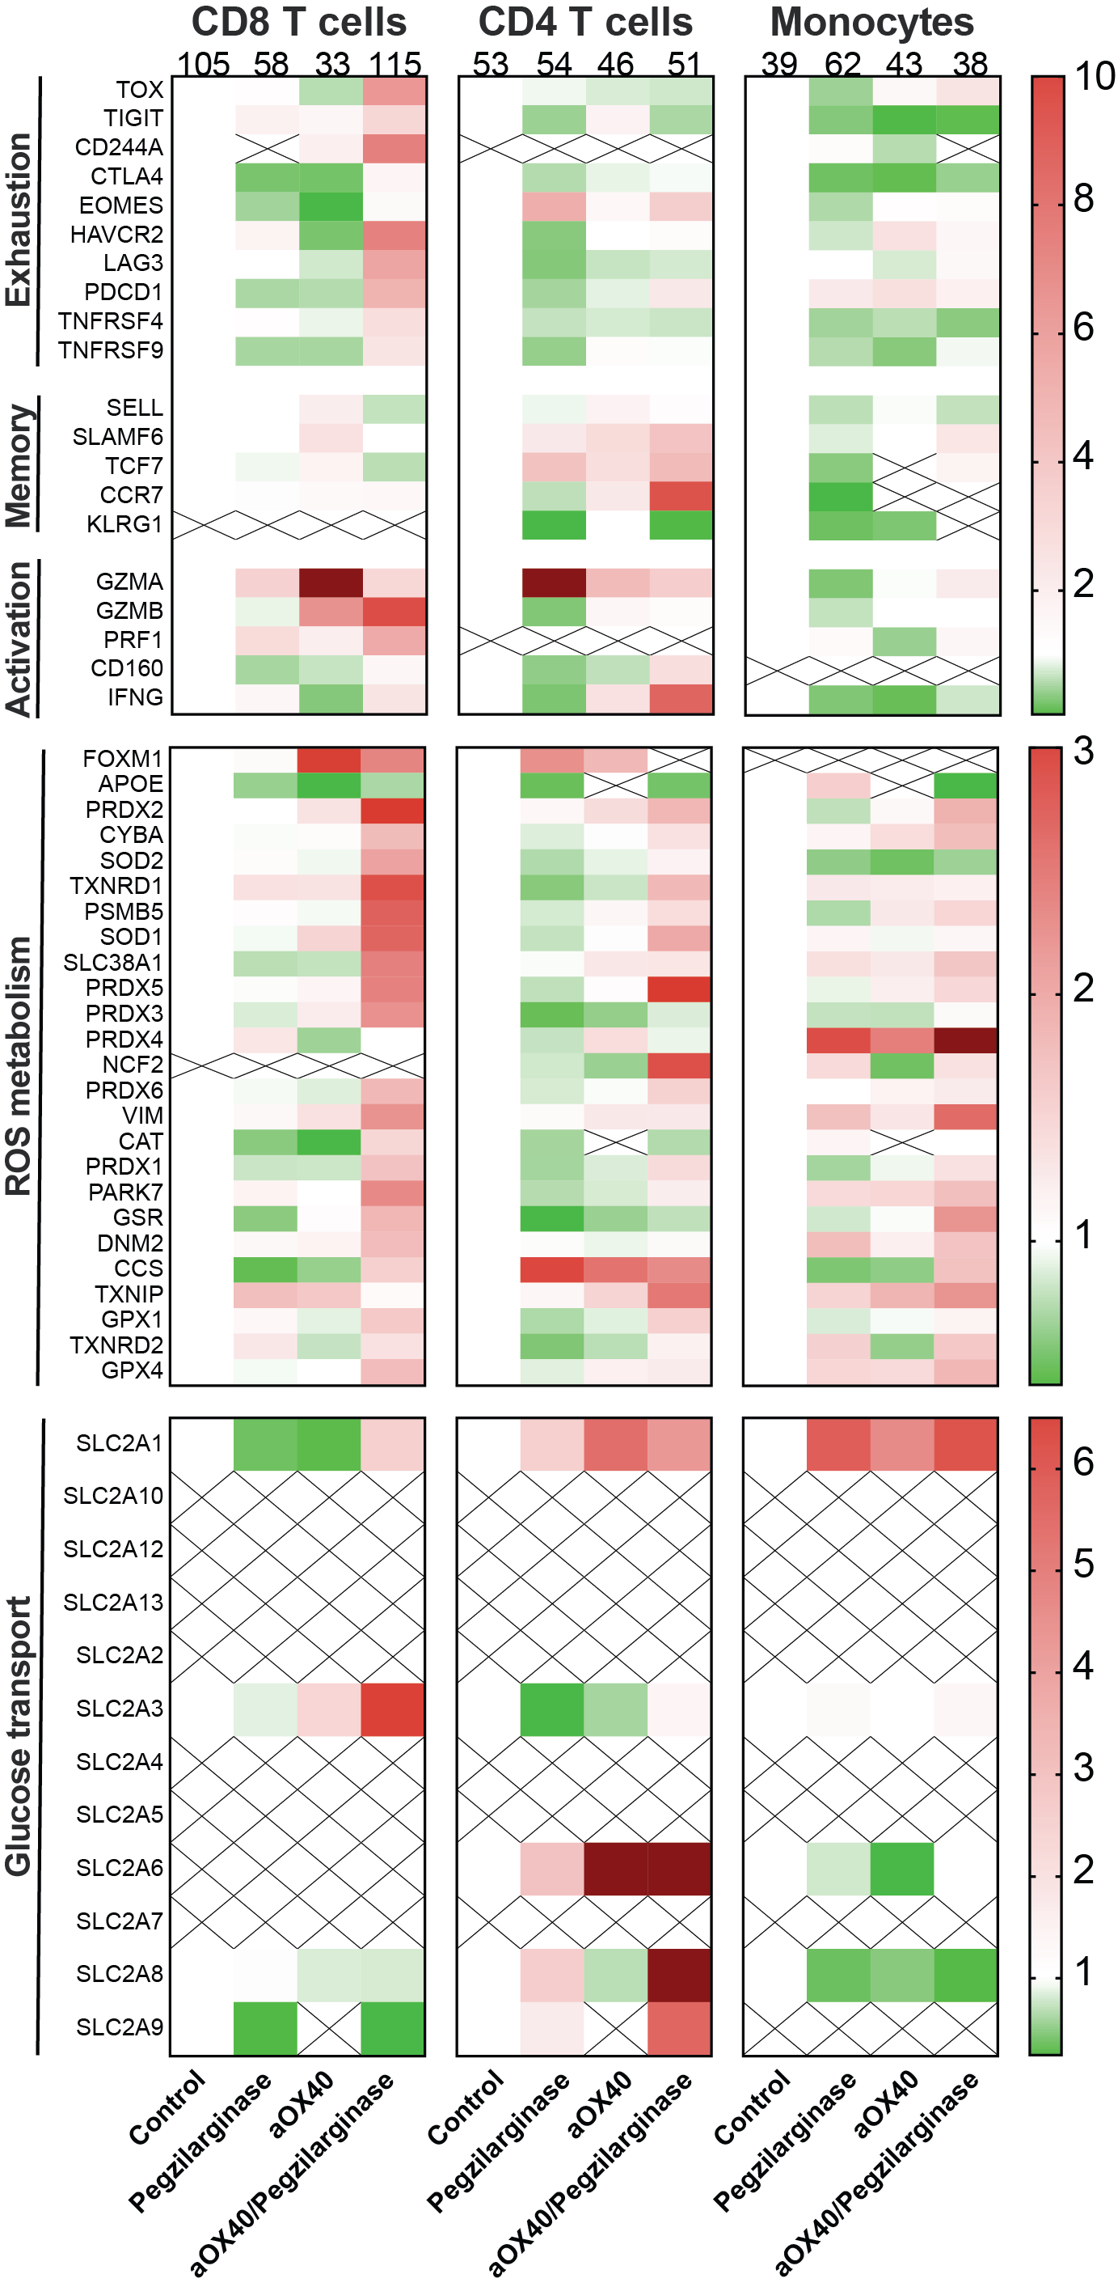
Fig. S11. Pegzilarginase/aOX40 combination therapy induces CD8⁺ T cell exhaustion, activation, and ROS metabolism genes.
CD45⁺ cells were sorted from CT6 tumors 3 days post-treatment and used for single cell RNA sequencing (scRNAseq). For analysis, 2,100 cells were down-sampled from the cells sequenced for scRNAseq for each mouse in each treatment group. Cells expressing CD8, CD4, and monocytes were analyzed separately for expression of genes that indicate exhaustion, memory, activation, ROS metabolism, and glucose transport. Numbers at the top of columns indicate the number of cells in each treatment group. ‘X’ within the heatmap indicates transcripts for that gene were not found.

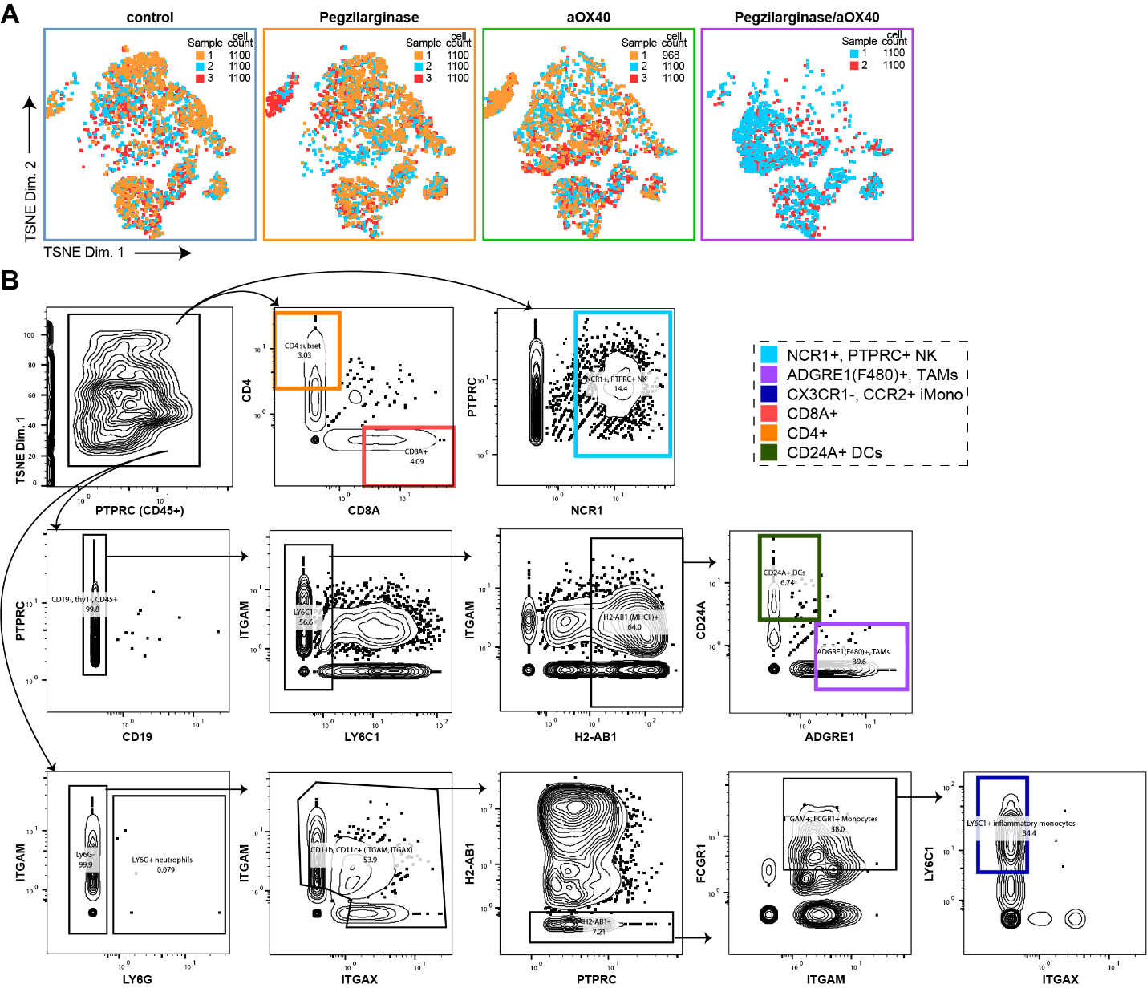
Fig. S12. Pegzilarginase/aOX40 combination therapy dramatically alters the TME.
A) CT26 tumors were harvested 3 days post-treatment and sorted for CD45⁺ cells, which were used for scRNAseq. For analysis, 2,100 cells were down-sampled from the cells sequenced for scRNAseq for each mouse in each treatment group. Here, each individual mouse within each treatment group is displayed in a different color. B) Gating strategy used to identify cell types in scRNAseq.
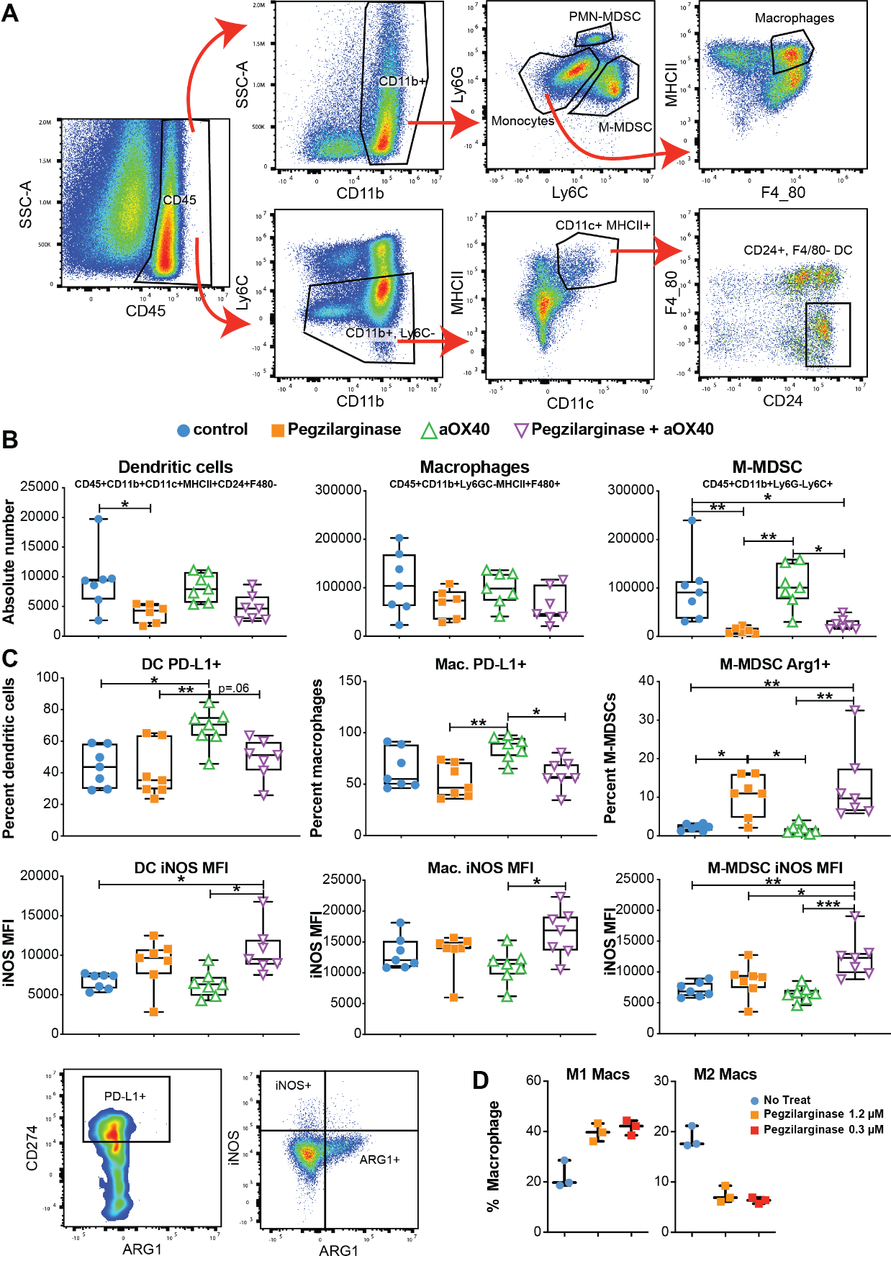
Fig. S13. Pegzilarginase/aOX40 combination therapy alters innate cell phenotypes.
CT26 tumors were harvested 3 days post-treatment to analyze innate immune numbers and phenotypes. (A) Gating strategy used to identify macrophages, MDSCs, and dendritic cells. (B) Absolute numbers of dendritic cells, macrophages, and M-MDSCs per tumor. (C) Percent of dendritic cells or macrophages expressing PD-L1 or M-MDSCs expressing Arginase and the iNOS MFI for those three cell types. (D) In vitro M0 macrophages were co-cultured with CT26 cells and incubated with pegzilarginase for 3 days then monitored for expression of CD206 to indicate conversion to either M1 or M2 type macrophages.

