SUPPLEMENTARY MATERIALS

Supplementary Table S1. Clinicopathologic characteristics of the cohort separated by death at the 5-year time point.
Supplementary Table S2. Primary and secondary antibody information and TSA dye pairings for multiplex IF panel.
Supplementary Table S3. Twenty highest ranking variables associating with overall survival by univariate Cox regression analysis.
Supplementary Table S4. Density and proximity variables selected by least absolute shrinkage and selection operator (LASSO) methods using a 5-fold cross-validation.
Supplementary Figure S1. Image cytometry to quantify immune cell biomarkers in metastatic melanoma.
Supplementary Figure S2. The expression of PD-L1 on tumor cells and ‘Other’ cells is determined by their proximity to CD8+ cells.
Supplementary Figure S3. Characterization of immune neighborhoods associated with overall survival.
Supplementary Computational Methods. Survival and clinical statistical analysis - R markdown document.

Supplementary Table S1. Clinicopathologic characteristics of the cohort separated by death at the 5 year time point

Median Age (years): 56 ± 23
Number of patients alive at last date of follow-up: 29 (31%)
 | Patients alive at 5 years  (n=34) | Patients deceased at 5 years  (n=59) | p-valueª
Stage
III (n=39) | 18 (53%) | 21 (36%) | 0.13
IV (n=54) | 16 (47%) | 38 (64%)
Tumor mutation status
BRAFV600E (n=2) | 1 (3%) | 1 (2%) | 1.0
Negative BRAFV600E (n=61) | 22 (65%) | 39 (66%)
Unknown (n=30) | 11 (32%) | 19 (32%) | -
Serum lactate dehydrogenase (range 140-280 U/L)
<280 (n=35) | 12 (35%) | 23 (39%) | 0.40
>280 (n=7) | 1 (3%) | 6 (10%)
unknown (n=51) | 21 (62%) | 30 (51%) | -
Site of metastasis and biopsy
Lymph node (n=45) | 18/34 (53%) | 27 (46%) | 0.79
Skin / soft tissue (n=22) | 8 (24%) | 14 (24%)
Lung (n=13) | 5 (15%) | 8 (14%)
GI tract (n=7) | 1 (3%) | 6 (10%)
Salivary Gland (n=4) | 2 (6%) | 2 (3%)
Brain (n=2) | 0 (0%) | 2 (3%)
Prior therapies
Surgery (n=60) | 23 (68%) | 37 (63%) | 0.61
Radiation (n=12) | 6 (18%) | 6 (10%) | 0.54
Chemotherapy (includes temozolomide) (n=6) | 3 (9%) | 3 (5%) | 0.83
Biologic therapy (IL-2^{b}, INF^{c}, or imiquimod) (n=12) | 5 (15%) | 7 (12%) | 0.95
Immunotherapy (vaccine, checkpoint inhibitor) (n=2) | 0 (0%) | 2 (3%) | 0.76
Unknown (n=31) | 11 (32%) | 20 (34%) | -
Subsequent therapies
Surgery (n=2) | 1 (3%) | 1 (2%) | 1.00
Radiation (n=26) | 5 (15%) | 21 (36%) | 0.04
Chemotherapy (includes temozolomide) (n=19) | 7 (21%) | 12 (20%) | 1.00
Biologic therapy (IL-2^{b}, INF^{c}, and GM-CSF) (n=17) | 8 (24%) | 9 (15%) | 0.53
Immunotherapy (vaccine, checkpoint inhibitor)(n=17) | 6 (18%) | 11 (19%) | 1.00
Targeted therapy (BRAF or PARP inhibitor) (n=3) | 0 (0%) | 3 (5%) | 0.63
Unknown (n=43) | 16 (47%) | 27 (46%) | -
ª Fisher’s Exact test, 2-sided; ^{b} interleukin-2; ^{c} interferon
Table S2. Primary and secondary antibody information and TSA dye pairings for multiplex IF panel.

Position | Antibody | Clone (host)/Company | Dilution | Incubation (min) | Secondary/ | TSA dye | Dilution
 |  |  |  |  | Company
1 | FoxP3 | 236A/E7(mouse)/ | 1:100 | 30 | Powervision 50%/Leica | 570 | 1:200
 |  | Affymetrix
2 | CD8 | 4B11(mouse)/BioRad | 1:100 | 30 | Opal Polymer/Akoya | 540 | 1:100
3 | Sox10/S100 | BC34(Mouse)/BioCare & 15E2E2+4C4.9 (Mouse)/LS Bio | 1:200/1:3200 | 60 | Opal Polymer/Akoya | 620 | 1:100
4 | PD-1 | EPR4877(2) (rabbit)/AbCam | 1:4000 | 30 | Powervision 50%/Leica | 650 | 1:100
5 | PD-L1 | SP142 (rabbit)/Spring Bio | 1:400 | 60 | Powervision 50%/Leica | 520 | 1:100
6 | CD163 | 10D6(mouse)/Leica | 1:100 | 120 | Opal Polymer/Akoya | 690 | 1:50
7 | DAPI | Akoya Opal 7-color kit | 2 drops/ml | 5 | N/A | N/A | 1:500

Supplementary Table S3. Twenty highest ranking variables associating with overall survival by univariate Cox regression analysis. A total of 557 clinicopathologic variables, cell density and proximity measurements were tested.

 | Variable | P value | HR
1 | CD163+PD-L1- cells/mm² ≤25um from a CD163+ | 1.002 | 0.00004
2 | CD163+PD-L1- cells/mm² ≤25um from a CD163+PD-L1- | 1.002 | 0.00005
3 | CD163+ cells/mm² ≤25um from a CD163+PD-L1- | 1.001 | 0.00008
4 | CD8+PD-L1+ cells/mm² ≤25um from a Tumor PD-L1- | 0.994 | 0.0008
5 | Tumor cells/mm² ≤25um from a PD-1+ | 0.999 | 0.0008
6 | CD8+PD-L1+ cells/mm² ≤25um from an 'Other' PD-L1- | 0.996 | 0.0009
7 | Tumor cells/mm² ≤25um from an ‘Other’ PD-1+ | 0.998 | 0.0010
8 | CD8+ cells/mm² ≤25um from a PD-L1+ | 0.999 | 0.0011
9 | CD163+PD-L1- cells/mm² | 1.001 | 0.0011
10 | PD-1+ cells/mm² ≤25um from a CD8+PD-L1+ | 0.999 | 0.0012
11 | CD163+PD-L1- cells/mm² ≤25um from an ‘Other’ | 1.002 | 0.0012
12 | CD8+ cells/mm² ≤25um from a CD8+PD-L1+ | 0.999 | 0.0012
13 | CD8+PD-L1+ cells/mm² ≤25um from an 'Other' PD-1+ | 0.997 | 0.0012
14 | CD8+ cells/mm2 ≤25um from an 'Other' PD-L1+ | 0.999 | 0.0013
15 | CD8+PD-L1+ cells/mm2 ≤25um from an 'Other' | 0.998 | 0.0017
16 | CD8+PD-L1+ cells/mm2 ≤25um from a CD8+PD-L1- | 0.997 | 0.0017
17 | CD8+PD-L1+ cells/mm2 ≤25um from a PD-1+ | 0.998 | 0.0017
18 | CD8+PD-L1+ cells/mm2 ≤25um from a PD-L1+ | 0.998 | 0.0018
19 | CD8+ cells/mm² | 0.999 | 0.0018
20 | CD8+PD-1- cells/mm² ≤25um from a CD8+PD-L1+ | 0.996 | 0.0018

Table S4. Density and proximity variables selected by least absolute shrinkage and selection operator (LASSO) methods using a 5-fold cross-validation. A total of 555 clinicopathologic variables, cell density and proximity measurements were tested (columns with ‘NA’ values were excluded i.e., ‘size of largest tumor deposit’ and ‘presence of extracapsular extension’).

 | Variable
1 | CD163+PD-L1- cells/mm²
2 | CD163+PD-L1- cells/mm² ≤25um from a CD163+
3 | Tumor cells/mm² ≤25um from an 'Other' PD-1+
4 | CD8+PD-L1+ cells/mm² ≤25um from an 'Other' PD-1+
5 | CD8+PD-1- cells/mm² ≤25um from a CD8+PD-L1+
6 | Other' PD-L1- cells/mm² ≤25um from a CD8+PD-L1+
7 | CD8+PD-L1+ cells/mm² ≤25um from an 'Other' PD-L1-
8 | CD8+PD-L1+ cells/mm² ≤25um from a Tumor PD-L1-

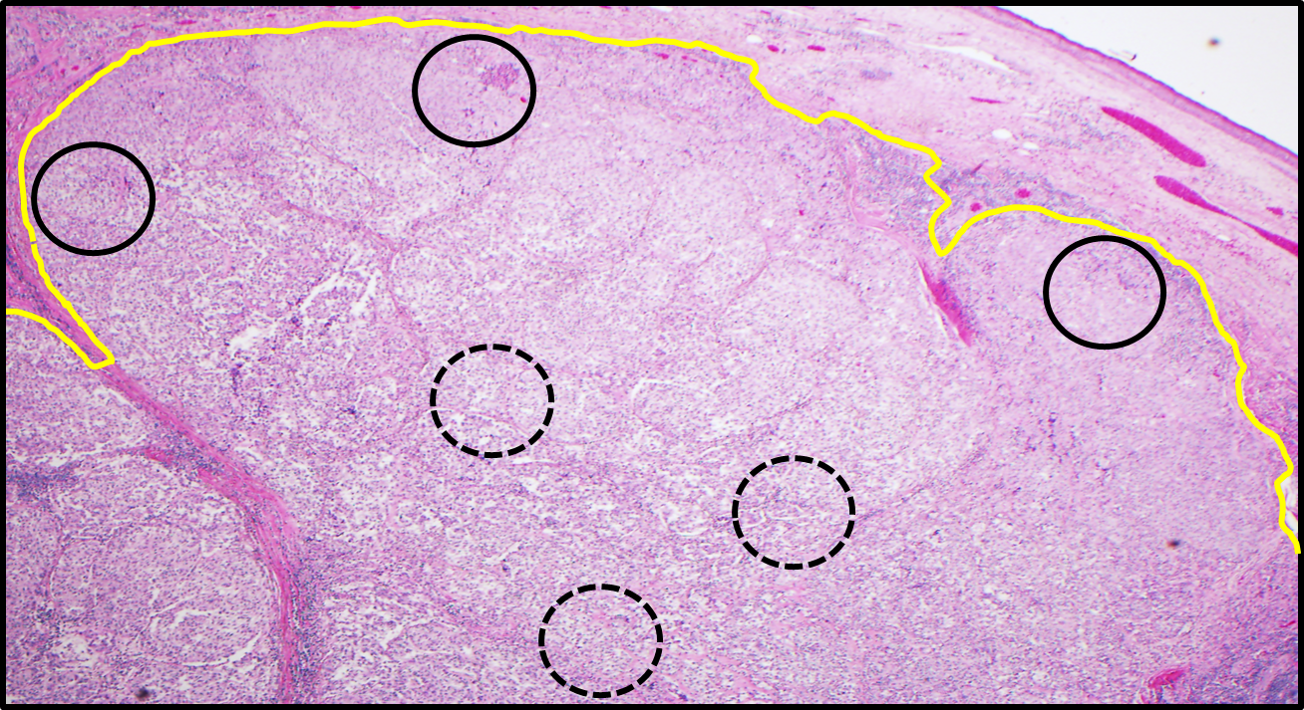
Supplementary Figure S1. Image cytometry to quantify immune cell biomarkers in metastatic melanoma. Photomicrograph demonstrating approach to tissue microarray (TMA) construction. Representative hematoxylin and eosin-stained slide showing a melanoma metastasis in the dermis and subcutaneous tissue (below yellow line). Tissue microarrays were designed to include punches from both the central (dotted black lines) and peripheral (solid black lines) aspects of tumor deposits.

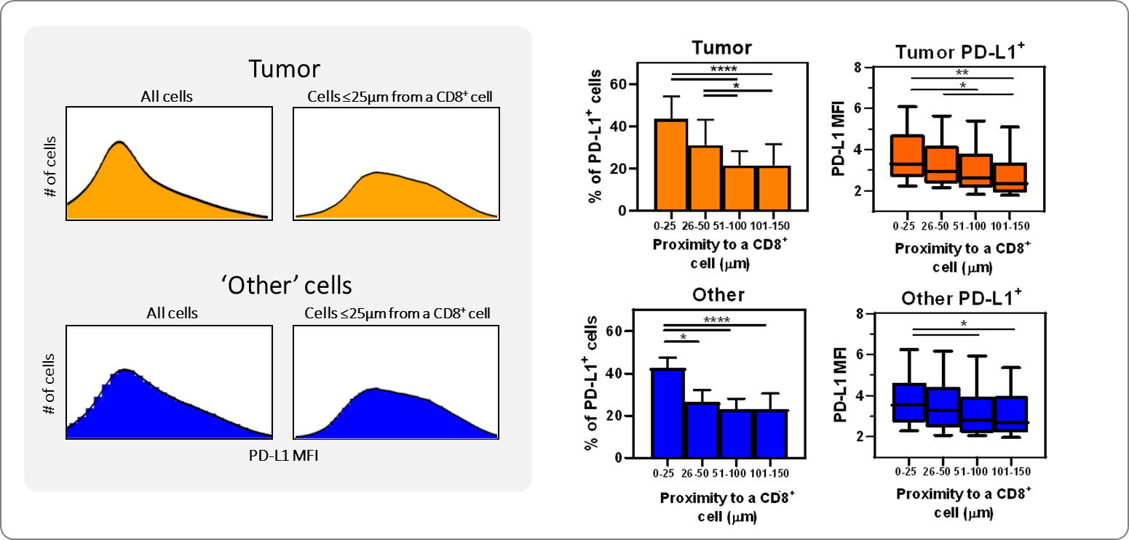
Supplementary Figure S2. The expression of PD-L1 on tumor cells and ‘Other’ cells is determined by their proximity to CD8+ cells. Left upper panel: PD-L1 MFI histograms for all tumor cells (left) and tumor cells located ≤25μm from a CD8+ lymphocyte (right). Left lower panel: PD-L1 MFI histograms for all ‘Other’ cells (left) and ‘Other’ cells located ≤25μm from a CD8+ lymphocyte (right). Right panels: The percentage of tumor cells and ‘Other’ cells displaying PD-L1 as well as the PD-L1 expression intensity increased with proximity to a CD8+ cell.

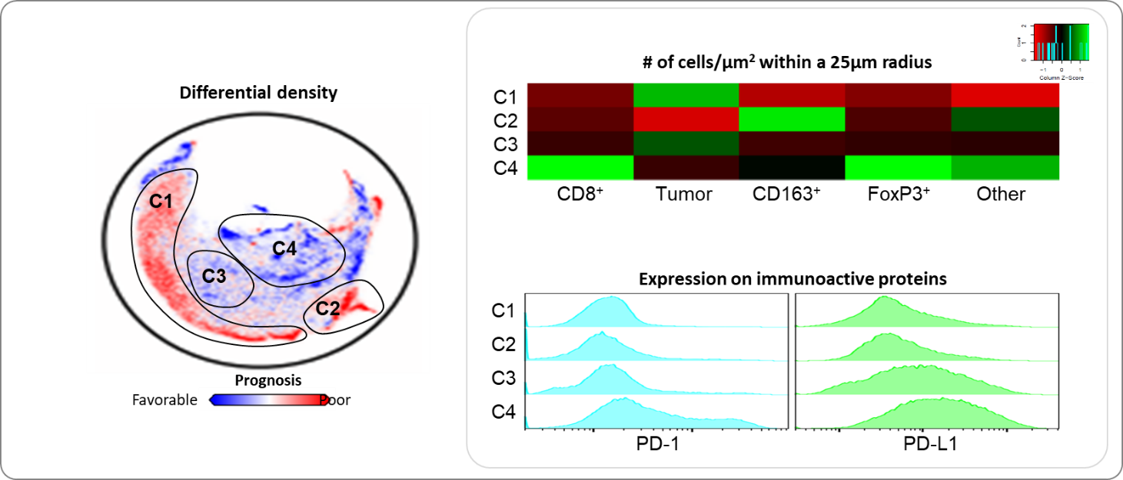
Supplementary Figure S3. Characterization of immune neighborhoods associated with overall survival. Left panel: Differences between the densities were used to identify spatial immune clusters with positive or negative prognostic impact. Numerous spatial clusters associated with clinical outcome were identified by this method, and four of the most prominent ones were selected (C1-C4). Right panel: These four clusters were further characterized for their mIF expression patterns. The heat map shows the average density (number of cells per μm2 within a 25 μm radius) of the five cell ‘lineages’ within each cluster. The histograms show PD-1 and PD-L1 expression for the cells in each cluster, highlighting the heterogeneous expression intensity across distinct spatial neighborhoods.

Supplementary Computational Methods. Survival and clinical statistical analysis R markdown document

Cox regression
# read in mIF variables
masterTab = read.csv('TMA_Melanoma_Master_Table_552variables_5.11.2021_de.identified.csv', row.names = 1, stringsAsFactors = F)
dim(masterTab)
## [1] 93 552
# read in clinical covariates
clinicalInfo = read.csv('Clinical.data_5.12.2021_de.identified.csv', row.names = 1, stringsAsFactors = F)
dim(clinicalInfo)
## [1] 93 20
# check that all patients have clinical info
all(rownames(masterTab) %in% rownames(clinicalInfo))
## [1] TRUE
# create survival object
survObj5y = Surv(as.numeric(clinicalInfo[,"Follow_up_time_5Y"]),
as.logical(as.numeric(clinicalInfo[,"Death_5Y"])))
rownames(survObj5y) = rownames(clinicalInfo)
# convert stage to factor for the further analysis
clinicalInfo$Stage = factor(clinicalInfo$Stage)
clinicalInfo$Location = factor(clinicalInfo$Location)
# clinical covariates to include in the analysis
covToInclude = c("Location", "Age", "Stage", "Size", "Extracapsular")
# markers to include in the analysis
markers = cbind(clinicalInfo[,covToInclude], masterTab)
# run cox regression for every marker
tab = t(sapply(colnames(markers),function(x) {
# print(x)
summary(coxph(survObj5y ~ markers[,x]))$coeff[1,c(2,5)]
}))
tab = tab[order(tab[,2]),]
tab = cbind(tab, FDR = p.adjust(tab[,2]))
write.csv(tab, file = paste0('coxRes_',Sys.Date(),'.csv'), quote = F)
print(head(tab))
## exp(coef) Pr(>|z|) FDR
## CD163.PDL1neg_25um_CD163 1.0019009 4.015989e-05 0.02236906
## CD163.PDL1neg_25um_CD163PDL1neg 1.0018811 4.886338e-05 0.02716804
## CD163_25um_CD163PDL1neg 1.0014520 8.565749e-05 0.04753991
## CD8.PDL1pos_25um_TumorPDL1neg 0.9941012 7.669981e-04 0.42491697
## Tumor_25um_PD1pos 0.9993547 7.950757e-04 0.43967689
## CD8.PDL1pos_25um_OtherPDL1neg 0.9960540 9.026776e-04 0.49827805
#datatable(tab)

LASSO analysis
#================
# cox with lasso
# convert to numeric matrix for further analysis
dat = markers
dat$Location = as.numeric(dat$Location)
dat = t(do.call('rbind',dat))
dat = t(apply(dat,1,as.numeric))
colnames(dat) = colnames(markers)
# remove columns with NAs
s = apply(is.na(dat),2,sum)
which(s>0)
## Size Extracapsular
## 4 5
dat = dat[, -which(s>0)]
# run LASSO
glmRes = glmnet(as.matrix(dat), survObj5y, family = 'cox', alpha = 1)
# run cross-validation
set.seed(123456)
glmRes_cv = cv.glmnet(as.matrix(dat), survObj5y, family = 'cox', alpha = 1, nfolds = 5)
# select threshold from cross-validation results
c1 = coef(glmRes, s = glmRes_cv$lambda.min)
# select top probes using this threshold
topLasso = rownames(c1)[which(c1 != 0)]
print(topLasso)
## [1] "PDL1neg_CD163" "CD163.PDL1neg_25um_CD163"
## [3] "Tumor_25um_OtherPD1pos" "CD8.PDL1pos_25um_OtherPD1pos"
## [5] "CD8.PD1neg_25um_CD8PDL1pos" "Other.PDL1neg_25um_CD8PDL1pos"
## [7] "CD8.PDL1pos_25um_OtherPDL1neg" "CD8.PDL1pos_25um_TumorPDL1neg"

Fisher's test of clinical covariates by death at the 5-year time point
# death at the 5-year time point
table(clinicalInfo$Death_5Y)
##
## 0 1
## 34 59
# summary of age
summary(clinicalInfo$Age)
## Min. 1st Qu. Median Mean 3rd Qu. Max.
## 8.20 46.00 57.00 56.36 69.00 87.00
# threshold for Serum_LDH
clinicalInfo$LDH = as.numeric(clinicalInfo$Serum_LDH) < 280
# calculate Fisher's test for each clinical covariate of interest
# by the death status
# save Fisher's test p-values
pvals = c()
# location (run separately because it's a character variable)
i = "Location"
m = table(data.frame(cov = (clinicalInfo[,i]), Death_5Y = clinicalInfo$Death_5Y), useNA = 'ifany')
print(m)
## Death_5Y
## cov 0 1
## Brain 0 2
## GI_tract 1 6
## LN 18 27
## Lung 5 8
## Salivary gland 2 2
## Skin 2 6
## Soft tissue 6 8
# run Fisher's test
res = fisher.test(m)
# print p-value
print(c("p-value:",res$p.value))
## [1] "p-value:" "0.778519359691425"
pvals = c(pvals,res$p.value)
# covariates of interest
cov = c(3,8,10:21)
# iterate covariates, calculate Fisher's test and save p-values
for(i in cov)
{
print(colnames(clinicalInfo)[i])
# table of covariates by death status
m = table(data.frame(cov = as.numeric(clinicalInfo[,i]), Death_5Y = clinicalInfo$Death_5Y), useNA = 'ifany')
print(m)
# run Fisher's test
res = fisher.test(m)
# print p-value
print(c("p-value:",res$p.value))
pvals = c(pvals,res$p.value)
}
## [1] "Stage"
## Death_5Y
## cov 0 1
## 1 18 21
## 2 16 38
## [1] "p-value:" "0.128399580749993"
## [1] "BRAFV600E"
## Death_5Y
## cov 0 1
## 0 22 39
## 1 1 1
## <NA> 11 19
## [1] "p-value:" "0.999999999999992"
## [1] "Prior_Surgery"
## Death_5Y
## cov 0 1
## 0 0 3
## 1 23 37
## <NA> 11 19
## [1] "p-value:" "0.615567569689784"
## [1] "Prior_Radiation"
## Death_5Y
## cov 0 1
## 0 17 34
## 1 6 6
## <NA> 11 19
## [1] "p-value:" "0.540574279031744"
## [1] "Prior_Chemotherapy"
## Death_5Y
## cov 0 1
## 0 20 37
## 1 3 3
## <NA> 11 19
## [1] "p-value:" "0.826917104558948"
## [1] "Prior_BiologicTherapy"
## Death_5Y
## cov 0 1
## 0 18 33
## 1 5 7
## <NA> 11 19
## [1] "p-value:" "0.953619667297429"
## [1] "Prior_Vaccine.ICPI"
## Death_5Y
## cov 0 1
## 0 23 38
## 1 0 2
## <NA> 11 19
## [1] "p-value:" "0.759992633729355"
## [1] "Post_Surgery"
## Death_5Y
## cov 0 1
## 0 17 31
## 1 1 1
## <NA> 16 27
## [1] "p-value:" "0.999999999999992"
## [1] "Post_Radiation"
## Death_5Y
## cov 0 1
## 0 13 11
## 1 5 21
## <NA> 16 27
## [1] "p-value:" "0.0380821069746092"
## [1] "Post_Chemotherapy"
## Death_5Y
## cov 0 1
## 0 11 20
## 1 7 12
## <NA> 16 27
## [1] "p-value:" "1"
## [1] "Post_Biologic"
## Death_5Y
## cov 0 1
## 0 10 23
## 1 8 9
## <NA> 16 27
## [1] "p-value:" "0.534006416195805"
## [1] "Post_Vaccine.ICPI"
## Death_5Y
## cov 0 1
## 0 12 21
## 1 6 11
## <NA> 16 27
## [1] "p-value:" "1"
## [1] "Post_TT"
## Death_5Y
## cov 0 1
## 0 18 29
## 1 0 3
## <NA> 16 27
## [1] "p-value:" "0.631378379771334"
## [1] "LDH"
## Death_5Y
## cov 0 1
## 0 1 6
## 1 12 23
## <NA> 21 30
## [1] "p-value:" "0.403796709085223"
names(pvals) = c("Location",colnames(clinicalInfo)[cov])
print(pvals)
## Location Stage BRAFV600E
## 0.77851936 0.12839958 1.00000000
## Prior_Surgery Prior_Radiation Prior_Chemotherapy
## 0.61556757 0.54057428 0.82691710
## Prior_BiologicTherapy Prior_Vaccine.ICPI Post_Surgery
## 0.95361967 0.75999263 1.00000000
## Post_Radiation Post_Chemotherapy Post_Biologic
## 0.03808211 1.00000000 0.53400642
## Post_Vaccine.ICPI Post_TT LDH
## 1.00000000 0.63137838 0.40379671
## R version 4.0.3 (2020-10-10)
## Platform: x86_64-w64-mingw32/x64 (64-bit)
## Running under: Windows 10 x64 (build 19041)
##
## Matrix products: default
##
## locale:
## [1] LC_COLLATE=English_United States.1252
## [2] LC_CTYPE=English_United States.1252
## [3] LC_MONETARY=English_United States.1252
## [4] LC_NUMERIC=C
## [5] LC_TIME=English_United States.1252
##
## attached base packages:
## [1] stats graphics grDevices utils datasets methods base
##
## other attached packages:
## [1] xlsx_0.6.5 DT_0.17 dplyr_1.0.4 glmnet_4.1 Matrix_1.3-2
## [6] survival_3.2-7
##
## loaded via a namespace (and not attached):
## [1] knitr_1.31 magrittr_2.0.1 splines_4.0.3 tidyselect_1.1.0
## [5] lattice_0.20-41 R6_2.5.0 rlang_0.4.10 foreach_1.5.1
## [9] stringr_1.4.0 tools_4.0.3 grid_4.0.3 xfun_0.21
## [13] DBI_1.1.1 ellipsis_0.3.1 htmltools_0.5.1.1 iterators_1.0.13
## [17] assertthat_0.2.1 yaml_2.2.1 digest_0.6.27 tibble_3.0.6
## [21] lifecycle_0.2.0 crayon_1.4.1 rJava_0.9-13 purrr_0.3.4
## [25] xlsxjars_0.6.1 htmlwidgets_1.5.3 vctrs_0.3.6 codetools_0.2-18
## [29] shape_1.4.5 glue_1.4.2 evaluate_0.14 rmarkdown_2.6
## [33] stringi_1.5.3 pillar_1.4.7 compiler_4.0.3 generics_0.1.0
## [37] pkgconfig_2.0.3

