Supplementary Figures
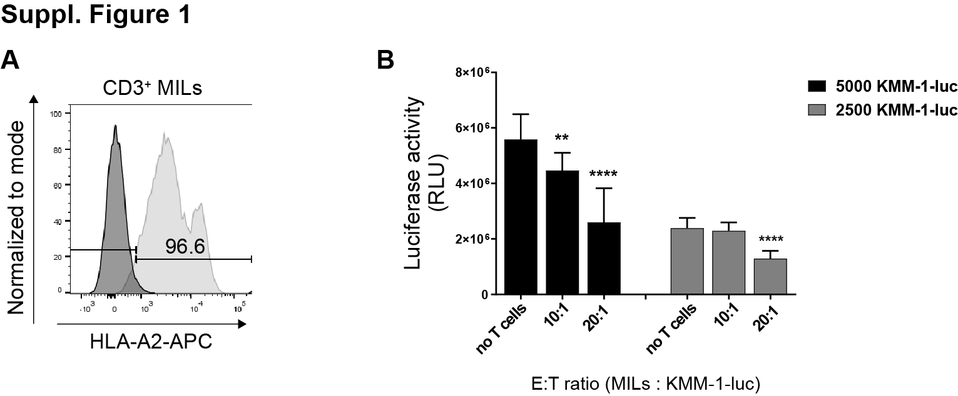
Supplementary Figure 1. Killing ability of HLA-A2 matched marrow infiltrating lymphocytes. (A) FACS-staining on CD3–positive MILs. Cells were stained with anti-HLA-A2 antibody (light grey histogram) and subsequently analyzed by FACS. Isotype control is shown as dark grey histogram. (B) 5000 and 2500 KMM-1-luc cells were co-cultured with MILs in different E:T ratios (20:1, 10:1 and no T cells) and luciferase activity of lysed tumor cells was measured. Columns show mean +/- standard deviation (SD) of two independent experiments. P-values were calculated using two-tailed student´s t-test. * p ≤ 0.05; ** p ≤ 0.01; *** p ≤ 0.001.
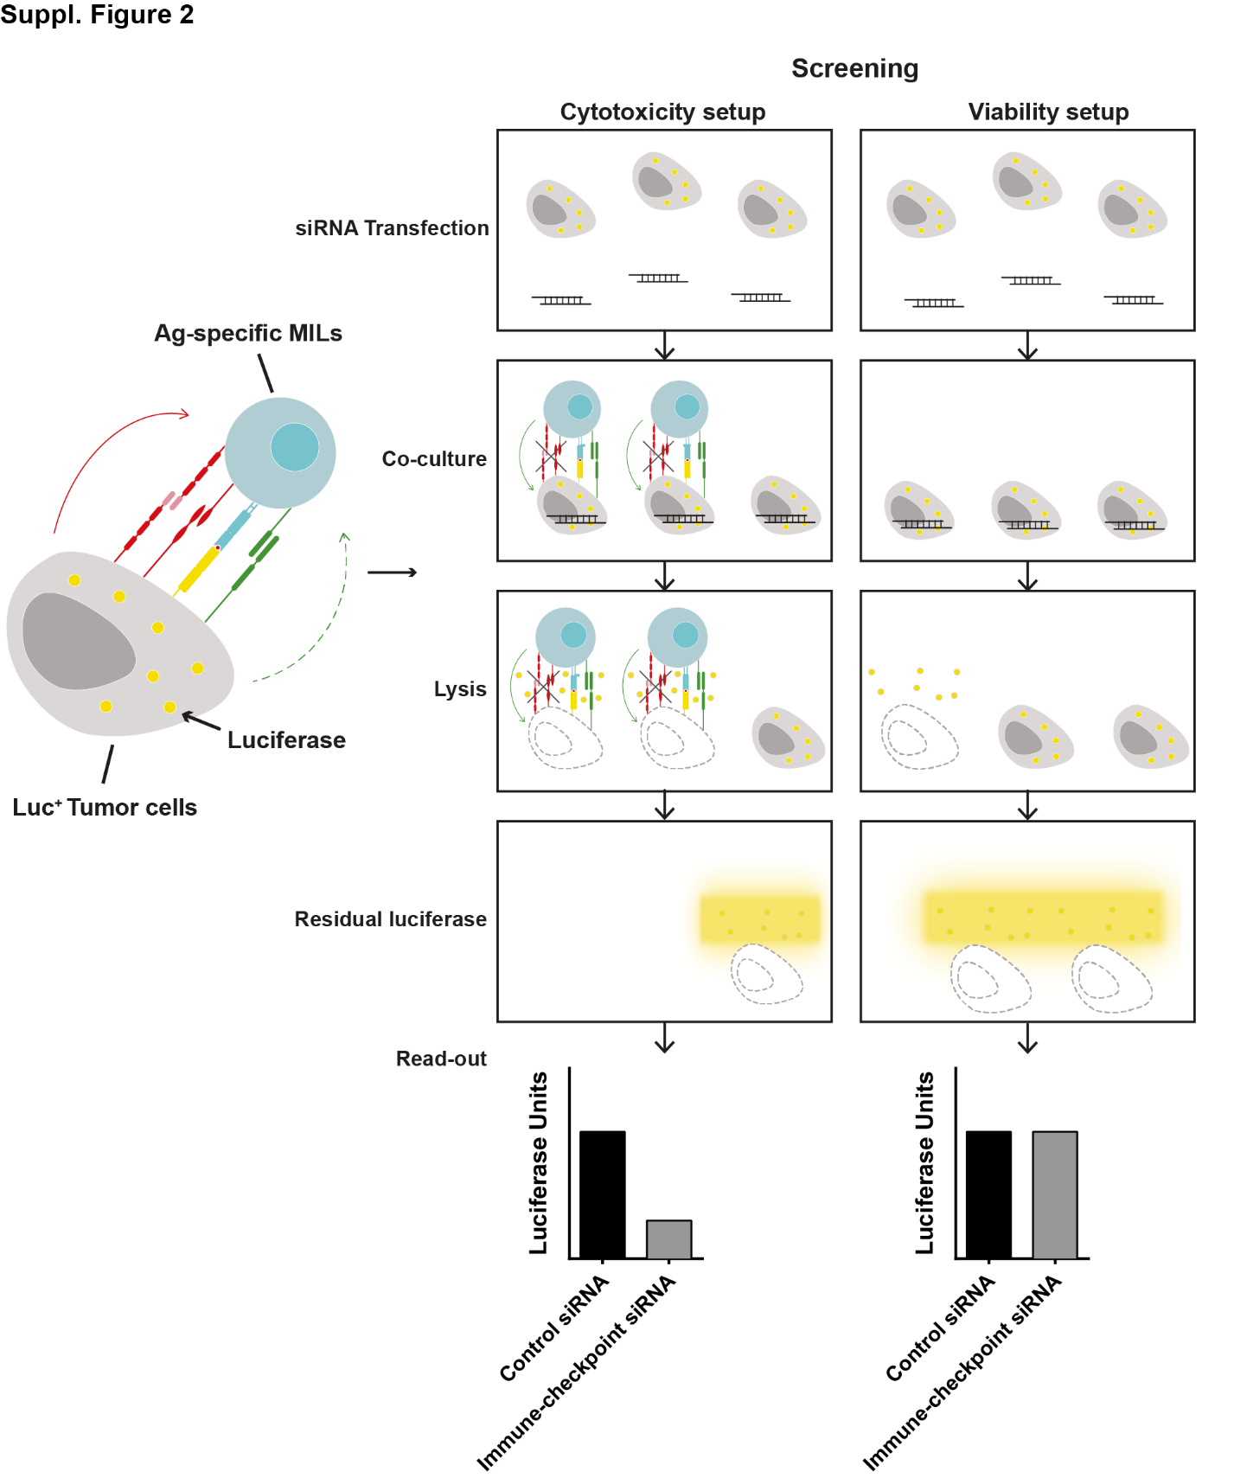
Supplementary Figure 2. HTP-screening scheme for novel immune-checkpoints in MM. A siRNA library of 2887 genes is arrayed in a 384-well format. Each well contains a pool of four non-overlapping siRNA sequences targeting the same gene. Luciferase-expressing KMM-1 (KMM-1-luc) tumor cells are seeded in each well (reverse transfection). In the cytotoxicity setup, 48h after transfection, patient-derived HLA-A2-matched MILs (marrow infiltrating lymphocytes) are added and co-cultured with transfected tumor cells for 20h. Supernatant is removed and luciferase activity of remaining tumor cells is measured after tumor cell lysis. To identify candidate immune-checkpoint molecules, cytotoxicity (tumor cell death) should increase (lowering luciferase activity) upon gene silencing (grey bar) compared to control siRNA (black bar). The HTP-assay also includes viability controls per gene knockdown to which no MILs are added to exclude genes with intrinsic impact on cell survival.
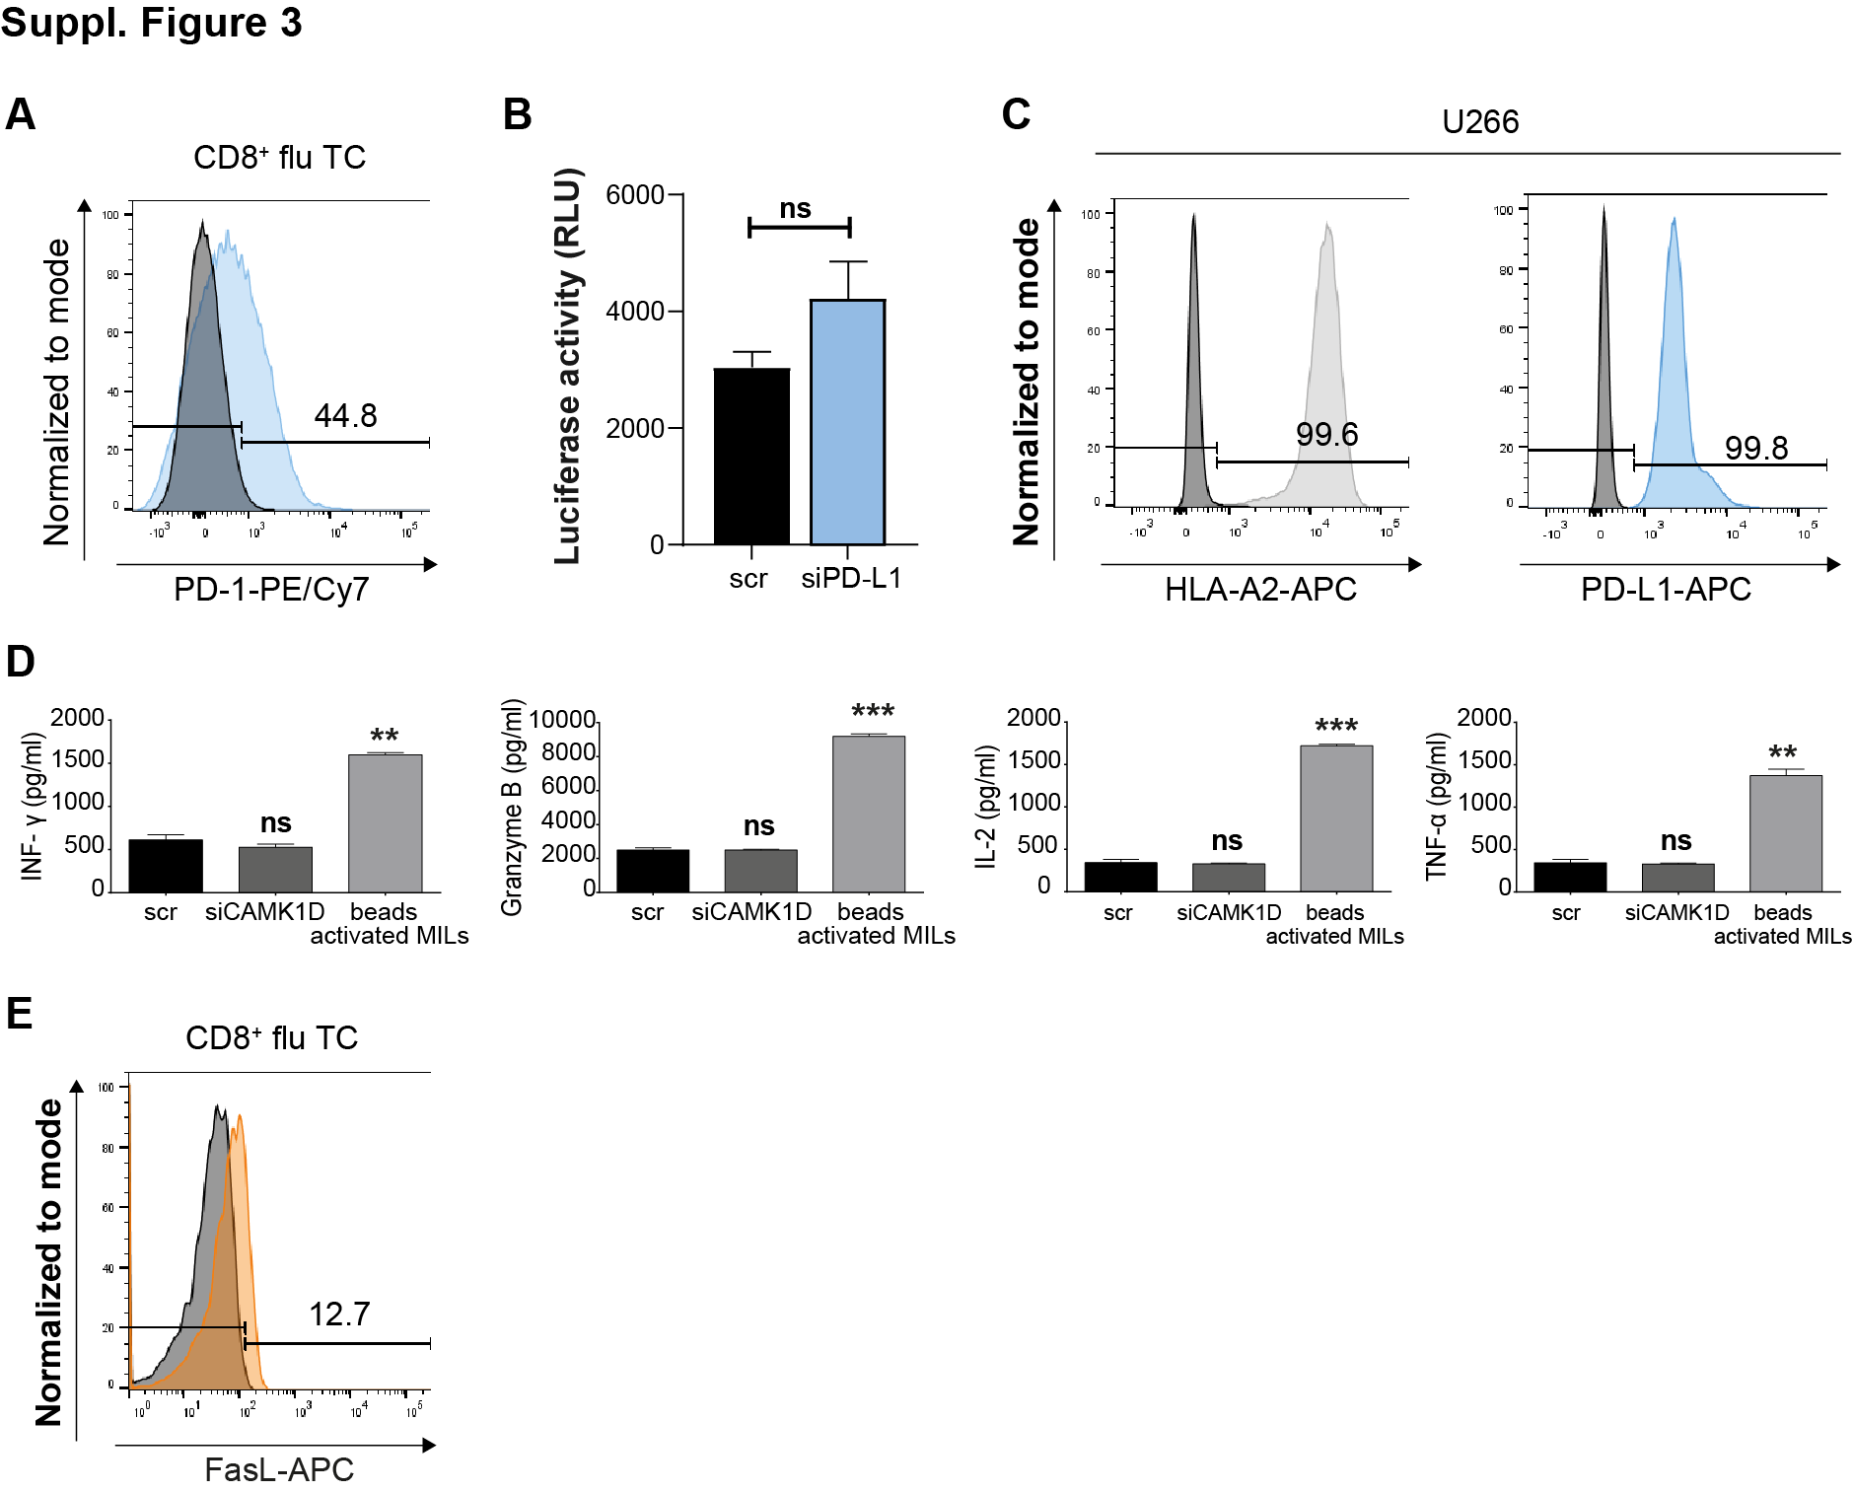
Supplementary Figure 3. Phenotypic characterization of T cells and tumor cells. (A) FACS-analysis of PD-1 (light blue histogram) expression on flu TC. Isotype is shown as dark grey histogram. (B) KMM-1-luc cells were transfected with the indicated siRNA sequences for 48h and pulsed with 0,005μg/ml of HLA-A*02 matched flu peptide for 1h before co-culture with flu-specific T cells (E:T 2,5:1) for 20h. T cell-mediated lysis of target knockdown was determined by measuring the remaining luciferase activity of tumor cells. Representative data of at least two independent experiments. Columns show mean +/- SEM. (C) FACS-analysis of HLA-A2 (light grey histogram) and PD-L1 (blue histogram) on U266 tumor cells. Isotype control is shown as dark grey histogram. (D) KMM-1 cells were transfected with scr or CAMK1D siRNA sequences for 48h. Afterwards MILs were added at an E:T ratio of 10:1 and INF-γ, Granzyme B, IL-2 and TNF-α secretion was measured 20h after co-culture. Anti-CD3/anti-CD28 magnetic beads stimulation served as a positive control. Representative data of two independent experiments. Columns show mean +/- SD. P-values were calculated using unpaired two-tailed student´s t-test. * p ≤ 0.05; ** p ≤ 0.01; *** p ≤ 0.001. (E) FACS-analysis of FasL (orange histogram) expression on flu TC. Isotype is shown as dark grey histogram.

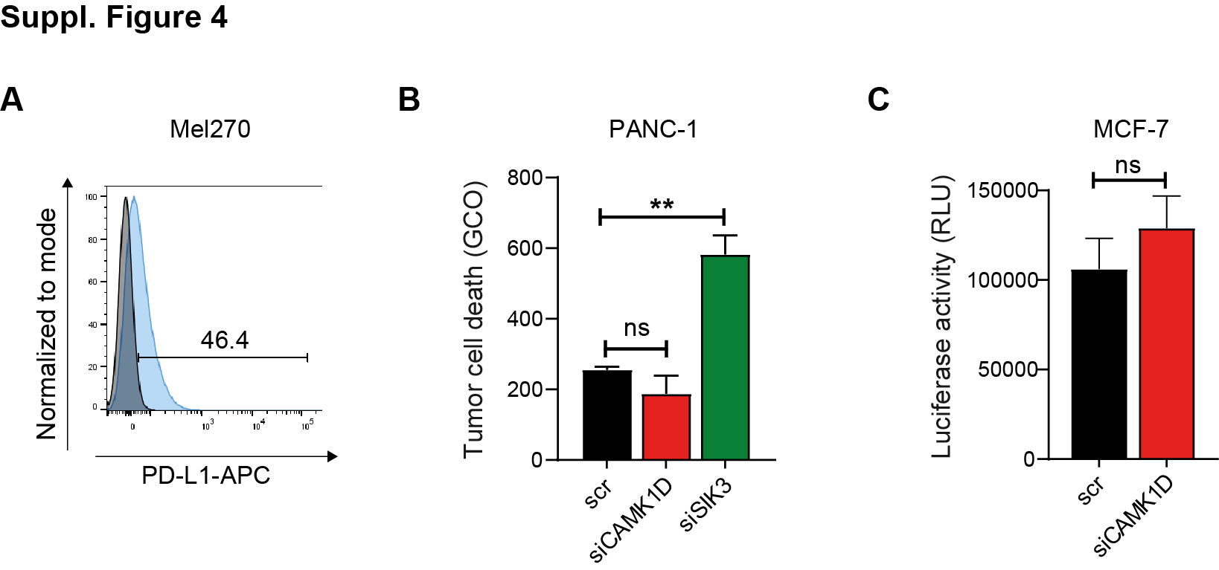
Supplementary Figure 4. PD-L1 positive tumor cells. (A) FACS-staining on Mel270 cells. Cells were stained with anti-PD-L1 (blue histogram) antibody and subsequently analyzed by FACS. Isotype control is shown as dark grey histogram. (B) Live cell-imaging analysis. PANC-1 tumor cells were transfected with the indicated siRNA sequences and co-cultured with PDAC-patient-derived TILs. Tumor cell death was measured by the addition of the YOYO-1 dye. Columns show the green object counted (GCO). siSIK3 was used as a positive control. (C) Luciferase-based kill assay. MCF-7 tumor cells were transfected with scr or siCAMK1D siRNAs for 48h and pulsed with 0,01μg/ml of flu peptide for 1h before co-culture with flu-specific T cells (E:T 2:1) for 20h. T cell-mediated lysis knocked down tumor cells was determined by measuring the remaining luciferase activity. (B, C) Representative data of at least two independent experiments. Graphs show mean +/- SD. P-values were calculated using unpaired two-tailed student´s t-test. * p < 0.05, ** p < 0.01, *** p < 0.001, **** p< 0.0001

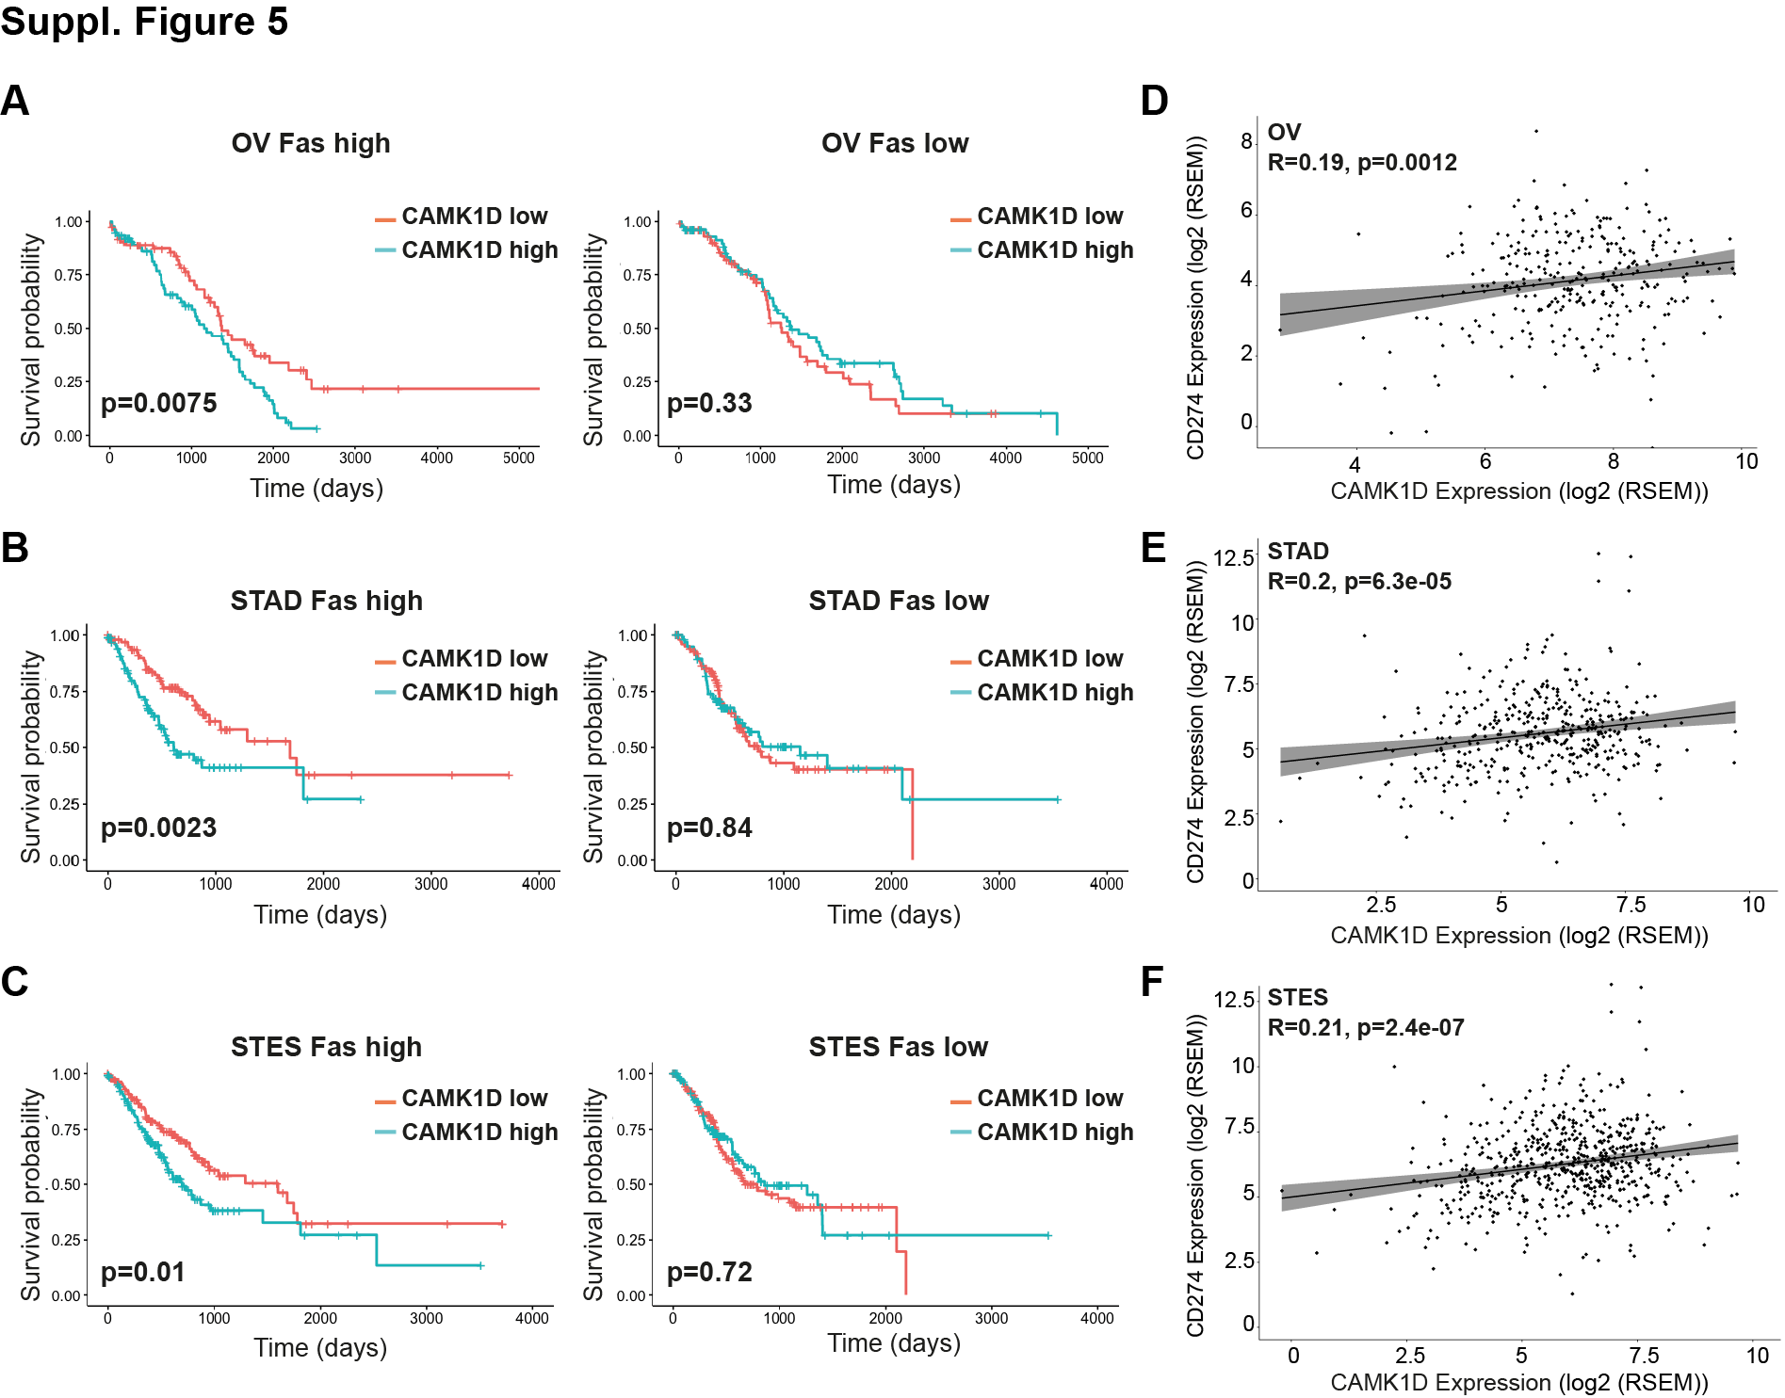
Supplementary Figure 5. TCGA analysis for patient survival probability correlating with Fas, CAMK1D and PD-L1. Correlation between CAMK1D and Fas expression on patient survival in (A) Ovarian serous cystadenocarcinoma (OV), (B) Stomach adenocarcinoma (STAD) and (C) Stomach and Esophageal carcinoma (STES). Fas high and Fas low OV, STAD and STES patients were divided in CAMK1D high and low expression according to the median of CAMK1D expression. Kaplan-Meier curves showing the correlation between CAMK1D expression and patients’ survival probability were generated using TCGA clinical data. Significance was calculated using the log-rank test. (D, E, F) Graphs show CAMK1D and PD-L1 correlation in OV, STAD and STES.

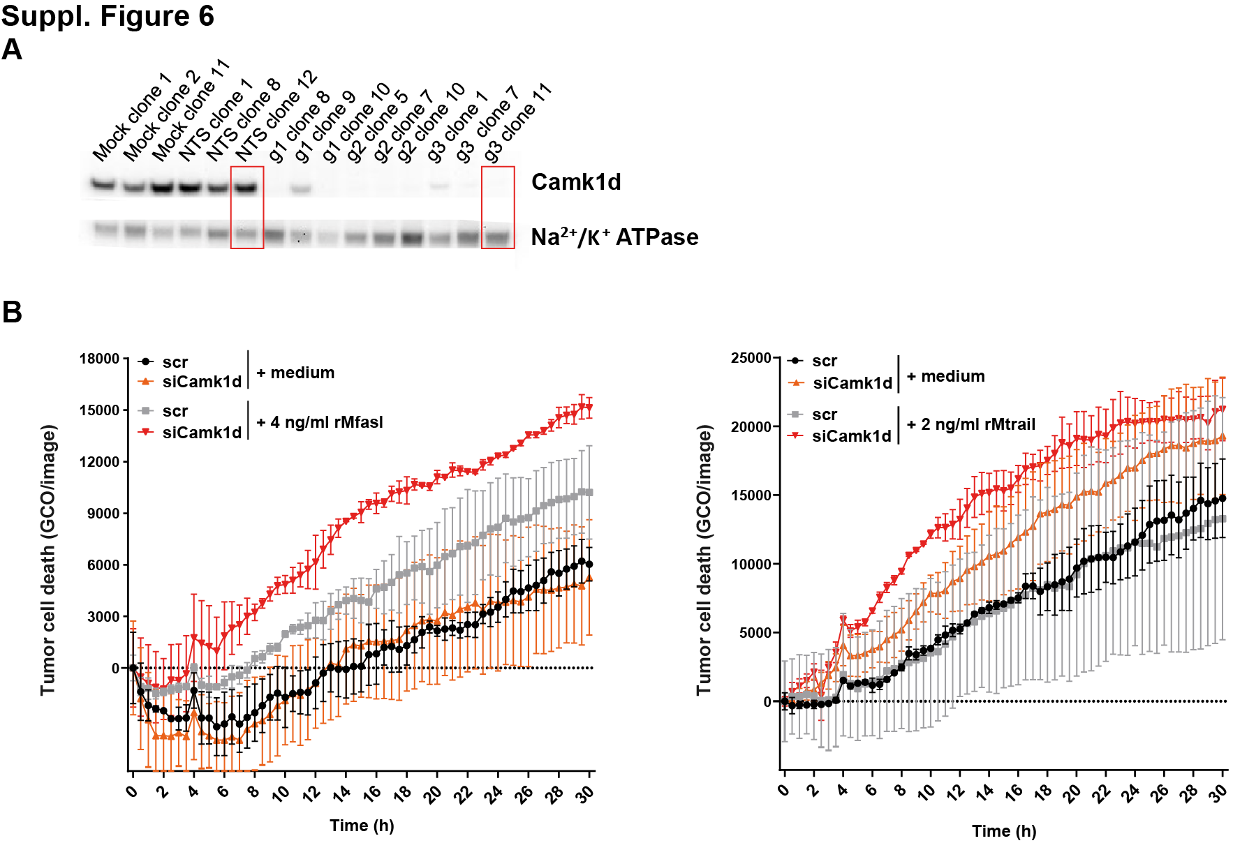

Supplementary Figure 6. The role of CAMK1D in murine tumor cells. (A) Western blot measuring CAMK1D in MC38 single clones generated upon CRISPR/Cas9 transfection. (B) Live cell-imaging analysis showing CAMK1D –proficient and -deficient MC38 cells treated with rMfasl (left) or rMtrail (right). A fluorescent dye (YOYO-1) was added as an indicator of apoptosis measured as green object counted (GCO). The experiment is representative of two independent experiments. Values denote mean ± SEM.

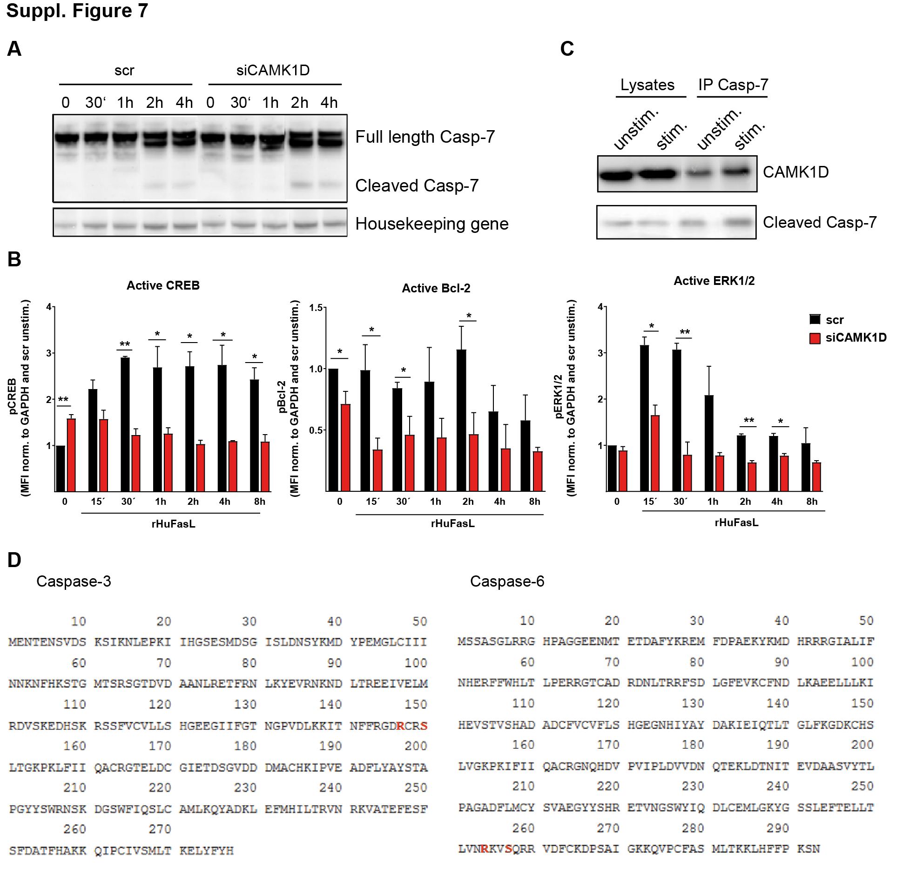
Supplementary Figure 7. CAMK1D interference with the apoptotic cascade. (A) CAMK1D-proficient and -deficient cells were stimulated with rHuFasL for the indicated time frame and full-length and cleaved caspase-7 were measured via western blot. The Sodium Potassium ATPase was used as housekeeping gene. Representative results of at least two independent experiments. (B) CAMK1D-proficient and -deficient cells were stimulated with rHuFasL for different time frames (15min, 30min, 1h, 2h, 4h and 8h). Protein levels were normalized to GAPDH and compared to scr-unstimulated cells. The amount of pCREB, pBcl-2 and pERK1/2 was measured. The experiment is representative of three independent experiments. Values denote mean ± SD. (C) Representative blot showing co-immunoprecipitation of caspase-7 and CAMK1D. KMM-1 cells were stimulated with rHuFasL for 4h. Unstimulated cells were used as negative control. Unstimulated and stimulated cell lysates were used as positive control for CAMK1D detection. (D) Caspase-3 and Caspase-6 amino acid sequences showing the predicted phosphorylation site and potential binding domain of CAMK1D on caspase-3 and -6 using the webtools KinaseNet and UniProt (http://www.kinasenet.ca/showProtein; https://www.uniprot.org/uniprot/P42574). (B) Graphs show mean ± SD and statistical significance was calculated using unpaired, two-tailed Student’s t-test. * p ≤ 0.05; ** p ≤ 0.01; *** p ≤ 0.001; **** p ≤ 0.0001.

