

**Supplementary Figure 1 Gating Strategies used for the detection of immune cells.** (A)Gating strategy of MC-38 tumors for T cells (CD45+CD3+), Ly6G+ cells (CD45+CD11b+Ly6G+), Ly6C+ cells (CD45+CD11b+Ly6C+F4/80-) and macrophages (CD45+CD11b+Ly6C+F4/80+). (B) Gating strategy for detection of T cell proliferation from coculture of T cells (CD3+CD4+ or CD3+CD8) with tumor-associated CD11b+ cells (Figure 1B) or MDSCs (Figures 3A-B).



**Supplementary Figure 2 MC-38 tumor model.** (A)Left, MC-38, MC-38 ARKO and TRAMP C2 cells were cultured *in vitro* and assessed for AR protein expression by Western blot. AR expression in normal mouse prostate is shown as a reference. Right, Western blot quantitation by Image J. Relative AR expression is shown and was calculated using β-actin as a reference; a minimum of 3 independent samples were tested. MC-38 Bulk refers to cells that underwent CRISPR/Cas and were collected prior to selection. *: P≤ 0.01 when compared to relative AR expression by MC-38 ARKO. (B) MC-38 and MC-38 ARKO cells were cultured *in vitro* in the presence of DMSO or 5uM enzalutamide for 24, 48, 72, and 96h and cell numbers were determined at each time point. (C) Tumors from C57BL/6 males injected subcutaneously with MC-38 colon tumor cells and treated *in vivo* with enzalutamide were analyzed for leukocyte infiltration. Graph depicts percentage of tumor infiltrating leukocyte populations within live cells determined by flow cytometry. Graphs show pooled data of 2-3 experiments with 3-4 mice per group. Black filled dots denote untreated and red filled squares indicate enzalutamide-treated mice. **p<0.01, ***p<0.001.

**Supplementary Figure 3 Increased tumor-supporting property of enzalutamide-treated myeloid cells is AR dependent**. (A) C57BL/6 WT male mice were inoculated with different doses of MC-38 tumor cells or inoculated with MC-38 cells admixed with MDSCs in a 2:1 myeloid: tumor cell ratio and implanted subcutaneously on the shoulder of C57BL/6 male mice. Graph indicates tumor growth rates. (B-C) C57BL/6 WT male mice were inoculated with MC-38 cells admixed with GFP+ MDSCs generated in the presence of DMSO or enzalutamide. Graphs indicate (B) percentage of GFP+ admixed myeloid cells within tumor-infiltrating macrophages and Ly6G+ cells, and (C) percentage of leukocyte infiltration within DMSO- and enzalutamide-treated MDSC admixed tumors. (D-E) BMDM and MDSC generated *in vitro* from MARKO bone marrow of C57BL/6 males in the presence of DMSO or enzalutamide were admixed with MC-38 tumor cells and injected into C57BL/6 male mice. Graphs depict tumor growth curves of mice injected with MC-38 cells admixed with DMSO or enzalutamide-treated (D) MARKO BMDM and (E) MARKO MDSC. (F) Gating strategy of cultured MDSCs for PD-L1 and IL-23p90. Black empty squares indicate DMSO-treated MARKO, and red crossed squares indicate enzalutamide-treated MARKO myeloid cells. Graphs depict mean and standard deviation of representative experiment of 1-2 experiments with 3-5 mice/ group. Statistical analysis was done using two-way ANOVA. ns=not significant, *p<0.05. (F) Gating strategy of cultured MDSCs for PD-L1 and IL-23p90.

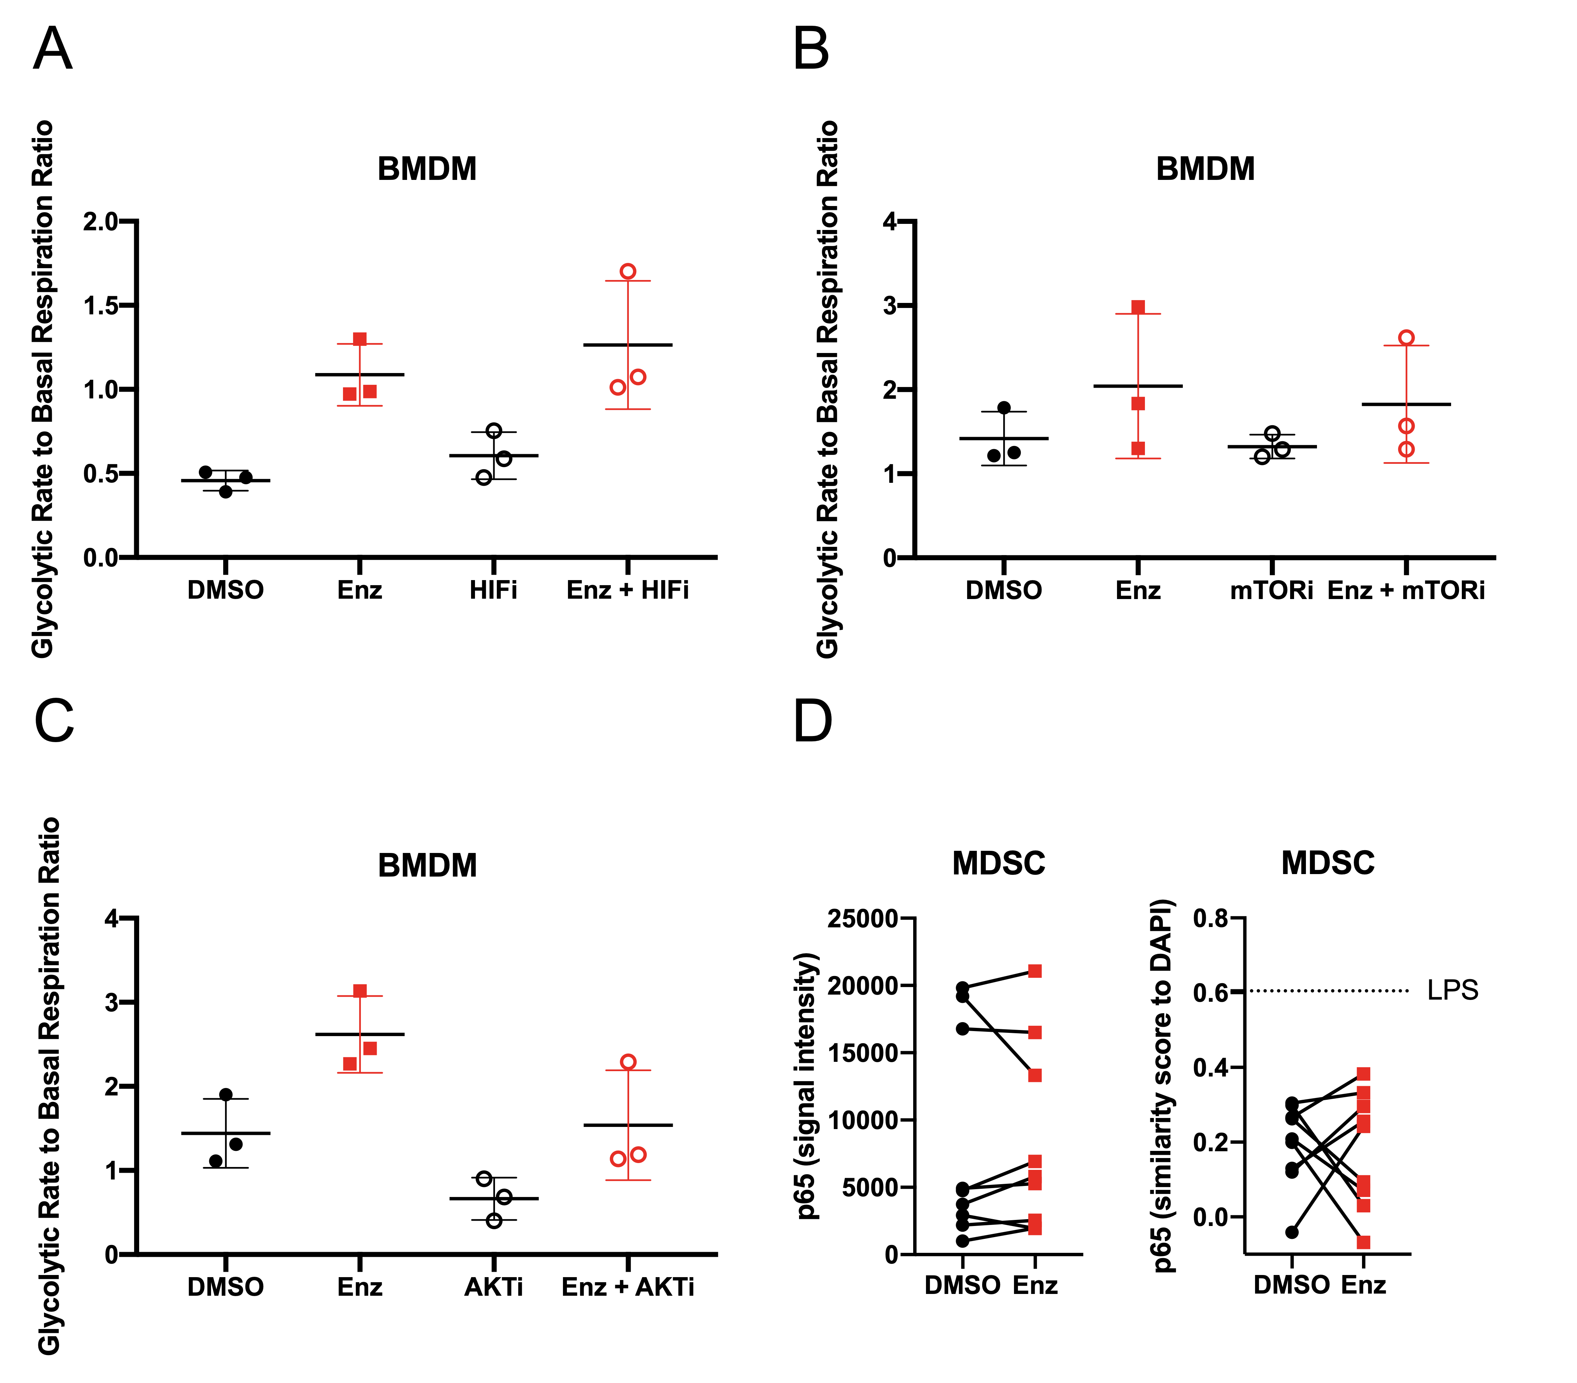

**Supplementary Figure 4 HIF-1α, m-TOR, AKT and NF-kB pathways are not involved in enzalutamide modulation of myeloid cell metabolism**. (A-C) BMDMs were treated with DMSO and 5uM enzalutamide in the presence or absence of inhibitor for HIF-1α (A), mTOR (B) and AKT (C) for 24h and seahorse glycolytic stress and mitochondrial stress test were run. Graphs (A-C) depict ratio of glycolytic rate to basal mitochondrial respiration. (D) MDSC NF-κB p65 expression and nuclear localization were quantified by ImagesStream. Graphs depict p65 expression, and nuclear localization by similarity to DAPI nuclear staining. Dotted line denotes similarity of p65 to DAPI in LPS-treated MDSCs. Plots show mean and standard deviation of data from 1-3 experiments using 3 biological replicates per group. Black dots denote DMSO treated, red squares indicate enzalutamide-treated, empty black dots indicate HIFi (A), mTORi-treated (B), or AKTi (C), and empty red dots indicate enzalutamide and HIFi (A), enzalutamide and mTORi-treated (B), or enzalutamide and AKTi (C) myeloid cells. Statistical analyses were performed with paired tests with corrections when necessary.

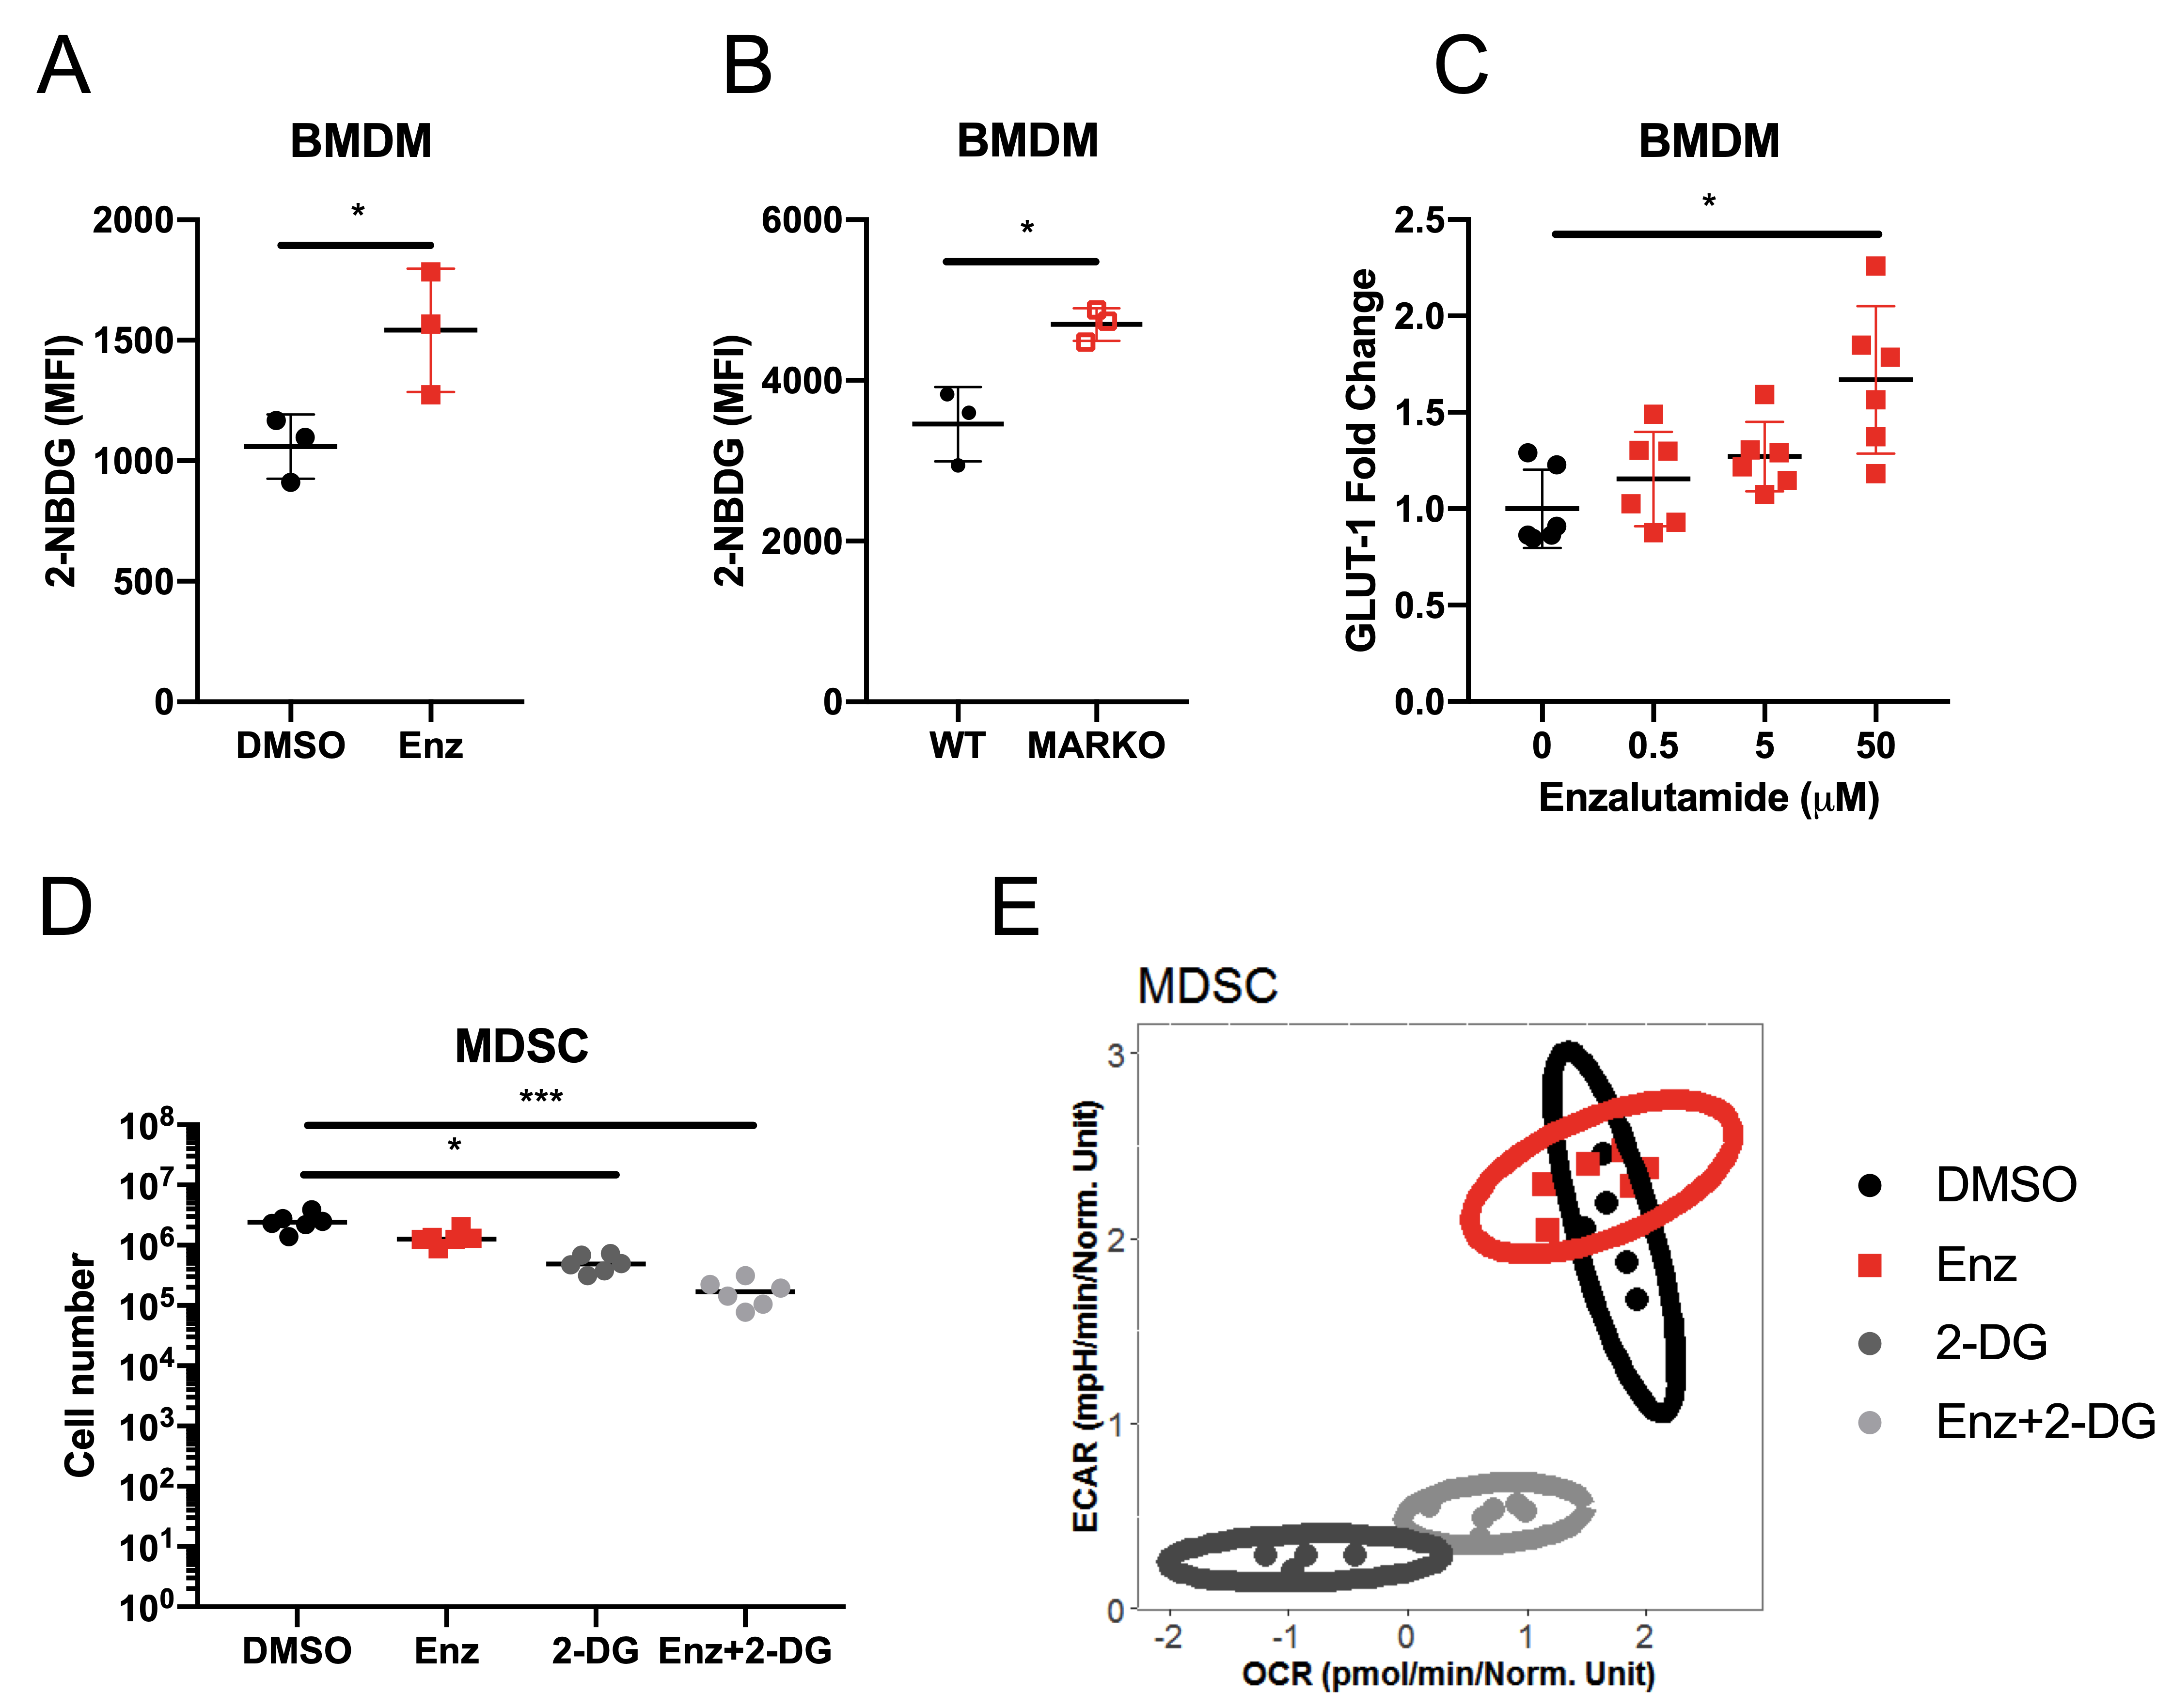

**Supplementary Figure 5 Alterations supporting enzalutamide-induced changes in metabolism of macrophages**. (A) WT BMDMs were treated with DMSO or enzalutamide for 9h or (B) WT BMDM were compared to MARKO BMDM for glucose uptake using 2-NBDG and measured by flow cytometry. (A, B) Graphs indicate 2-NBDG uptake. (C) BMDMs were treated with increasing doses of enzalutamide and RNA expression was assessed by qRT-PCR. Graph depicts GLUT1 fold change in expression relative to 0uM enzalutamide. (D-E) MDSCs were generated in the presence of DMSO, Enzalutamide or 2-DG and assessed for cell number (D) and metabolism by Seahorse (E). Graphs depict MDSC cell number (D), and glycolytic rate vs basal mitochondrial respiration (E) after 4 days of culture. Plots depict mean and standard deviation of pooled data of 1-2 experiments of 3 biological replicates per group. Black filled dots denote DMSO treated, red filled squares indicate enzalutamide-treated, red empty squares indicate MARKO, filled dark grey dots indicate 2-DG-treated, and light grey dots indicate enzalutamide and 2-DG-treated myeloid cells. Statistical analyses were performed with paired tests, t test with Welsh’s correction and one-way ANOVA. *p<0.05, ***p<0.001.

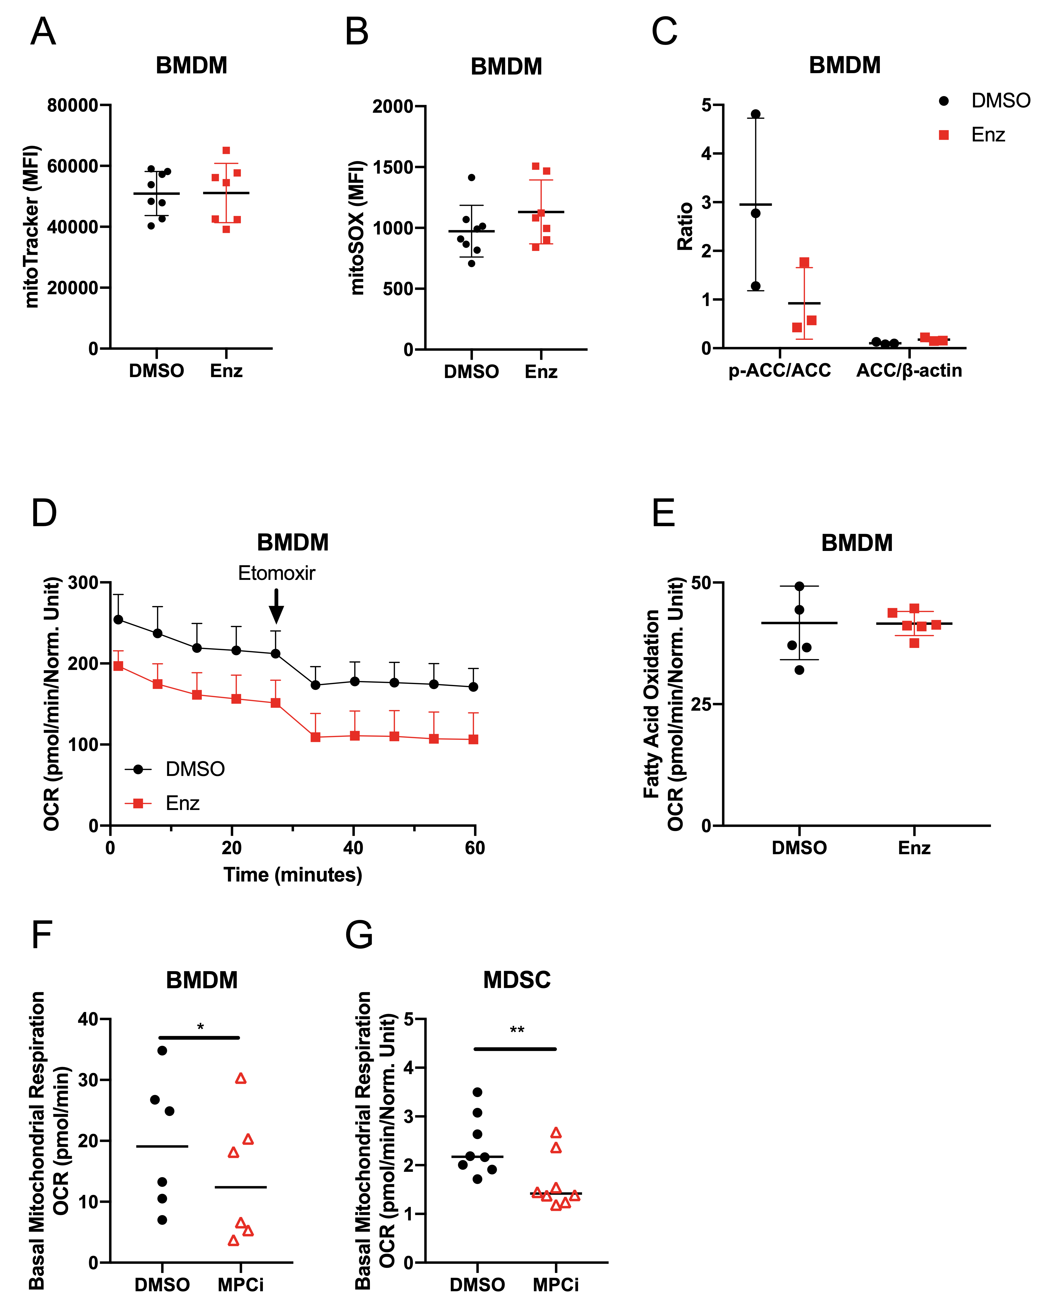

**Supplementary Figure 6 Fatty acid oxidation and mitochondrial superoxide production are not impacted in macrophages treated with enzalutamide**. (A-B) BMDMs were treated with DMSO or enzalutamide for 24h and stained for flow cytometry. Graph (A) indicates mitochondria through mitoTracker labelling. Graph (B) indicates mitochondrial superoxide using mitoSOX. (C) DMSO and enzalutamide-treated BMDMs were assessed for p-ACC and ACC protein expression by western blot. Graph depicts ratio of p-ACC/ACC and ACC/β-actin. (D, E) DMSO and enzalutamide-treated BMDMs were assessed for endogenous fatty acid oxidation (FAO) using seahorse. Graph (D) depicts oxygen consumption rates before and after FAO inhibition with etomoxir. Graph (E) shows calculated FAO for BMDMs. (F-G) Basal mitochondrial respiration was assessed in (F) BMDMs treated with MPCi UK-5509 for 24h, and in (G) MDSCs generated in the presence of DMSO or MPCi. Plots A, B, E, F and G were made from pooled data of 2-3 experiments of 2-3 biological replicates per group. Plot C was made with one experiment with n=3 biological replicates per group. Plots indicate mean and standard deviation. Black filled dots denote DMSO treated, red filled squares indicate enzalutamide-treated, and red empty triangles indicate MPCi-treated myeloid cells. Statistical analyses were performed with paired tests. *p<0.05, **p<0.01.