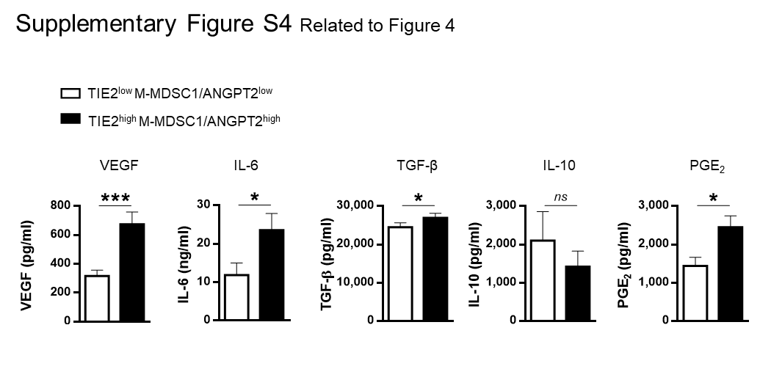
Supplementary Figure S4: Blood cytokines according to the concentration of ANGPT2 and percentages of TIE2⁺ M-MDSCs. Concentrations of proangiogenic (VEGF-A), pro inflammatory (IL-6, PGE₂) and immune suppressive (IL-10, TGF-β), cytokines measured by CBA in the sera of NSCLC patients exhibiting TIE2^{low} M-MDSC1/ANGPT2^{low} versus TIE2^{high} M-MDSC1/ANGPT2^{high} signature in blood (Mann&Whitney).

