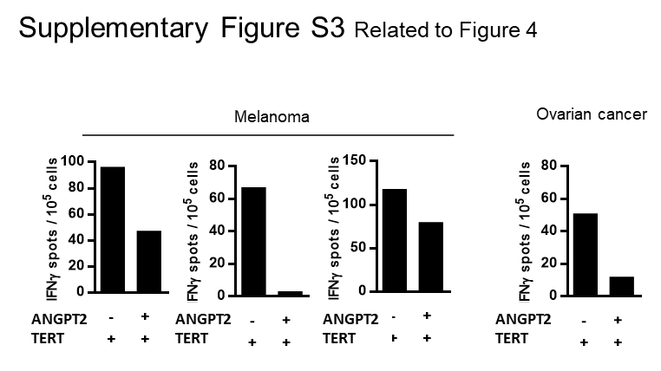
Supplementary Figure S3: ANGPT2 inhibitory effect against TERT-specific T cell responses. Anti-TERT T cell responses in presence or not of ANGPT2 in melanoma and ovarian cancer patients. Histograms represent number of TERT specific IFN-γ+ spots from triplicates.

