Supplemental materials

Pharmacological inhibition of FGFR modulates the metastatic immune microenvironment and promotes response to immune checkpoint blockade

Saeed S Akhand¹, Zian Liu¹, Stephen C. Purdy¹, Ammara Abdullah¹, Hang Lin¹,Gregory M. Cresswell², Timothy L. Ratliff ^{2,3}, Michael Wendt^{1,3}

Supplemental Figure 1:

Fig. S1. 4T07 cell growth is dependent on FGFR signaling. (A) The 4T07 cells (1x10⁴) were serum starved overnight and then stimulated with FGF2 (20 ng/ml) for the indicated amounts of time. Cells were lysed and analyzed by immunoblot for differential phosphorylation of ERK1/2 (pErk1/2) and Akt (pAkt). Total ERK1/2 served as a loading control. Data are representative for 2 independent experiments. (B) 4T07 cells (1x10⁴/well) were plated into a non-adherent 96-well spheroid plate for 2 days. The resulting spheroids were then transferred to a bed of extracellular matrix (Day 0) in the presence or absence of FGFR inhibitors. Shown are representative spheroids grown with no drug or the indicated concentration of FIIN4. (C) The mean (±SD) of bioluminescent values from the spheroid assays described in panel B using 100 nM of the indicated FGFR inhibitors, AZD4547 (AZD), infigratinib (BGJ), or FIIN4. The data were compared via a student’s T-test resulting in the indicated P values, comparing FGFR inhibitor groups to the no drug control (ND) six days after a single drug treatment.

Supplemental Figure 2:
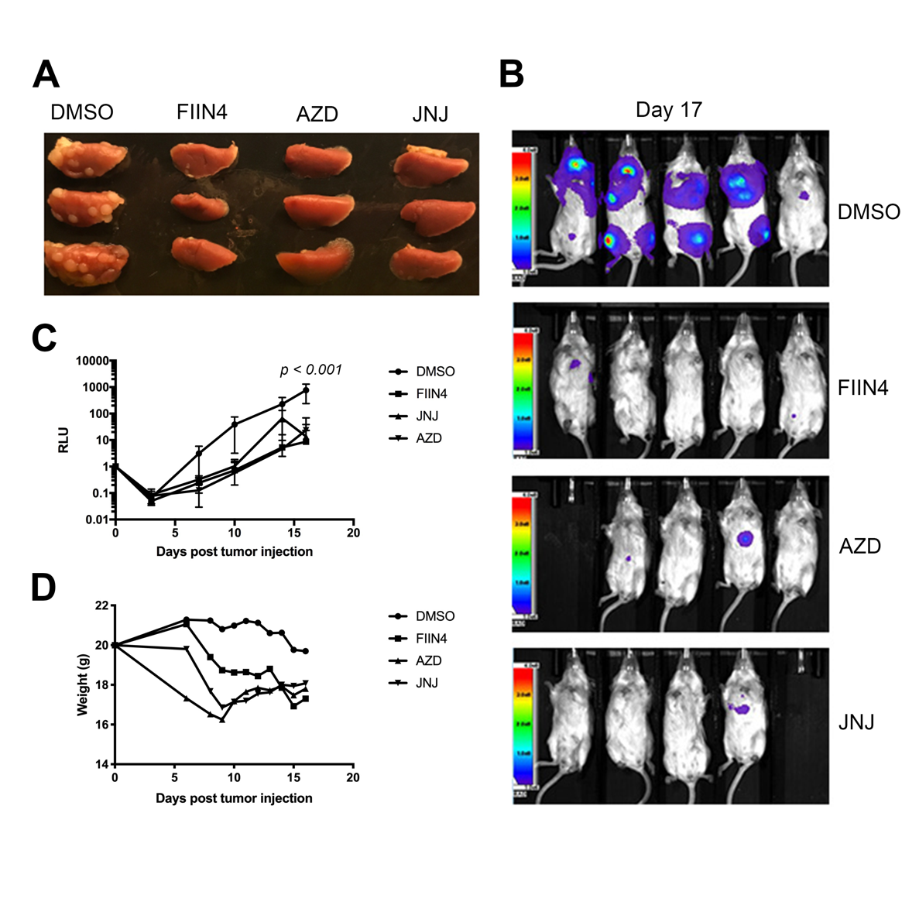
Fig. S2. FGFR inhibitors inhibit pulmonary tumor growth. (A) 4T07 cells (5x10⁵) were delivered to the lungs of BALB/c mice (n=5 mice per group) via tail vein injections. Mice were treated with either vehicle (DMSO) or the indicated FGFR inhibitor, AZD4547 (AZD), erdafitinib (JNJ), or FIIN4, at 100 mg/kg; po, qd starting 2 days after tumor cell engraftment. Shown are fixed right pulmonary lobes of three representative mice from each group, 17 days after tumor cell engraftment. (B) Bioluminescent images of mice at 17 days post engraftment. (C) The mean (±SD) of bioluminescent values from each group taken at the indicated time points; two-way ANOVA test was performed resulting in the indicated P value, comparing FGFR inhibitor groups to control. (D) The average weights (mean) of the individual groups were measured at the indicated time points.

Supplemental Figure 3:

Fig. S3. Adjuvant FIIN4 prevents 4T1 metastasis. (A) A schematic timeline detailing mammary fat pad engraftment of 4T1 cells (5x10⁴) onto BALB/c mice. The primary tumors were grown for two weeks, surgically excised and mice were allowed to recover. Following surgical removal of primary tumors, mice were treated with either vehicle (DMSO) or FIIN4 (50 mg/kg po/qod) via oral gavage. (B and C) The mean (±SD) of thoracic (B) and whole-body (C) bioluminescent values from each group taken at the indicated time points; two way ANOVA tests were performed resulting in the indicated P values. (D) Survival analysis of mice following the primary tumor removal (n=4 mice per group), the indicated P-value was calculated using a log rank test. (E) Bioluminescent images mice at 32 days post engraftment.

Supplemental Figure 4:

Fig. S4. Adjuvant FIIN4 delays pulmonary metastatic growth. BALB/c mice (n=20 mice) were engrafted with 4T1 cells (5X10⁴) via the mammary fat pad. Primary tumors were grown for two weeks, surgically excised, and mice were allowed to recover for nine days, at which point pulmonary metastasis could be detected via bioluminescence. Mice were then separated into two cohorts and treated with either vehicle (DMSO) or FIIN4 (50mg/kg po/qod). (A) Representative bioluminescent images of the mice at the indicated days post primary tumor removal. (B) The mean (±SD) bioluminescent values from each group taken at the indicated time points. (C) Survival analysis of mice following primary tumor removal (n=10 mice per group), the indicated p-value was calculated using a log rank test.

Supplemental Figure 5:

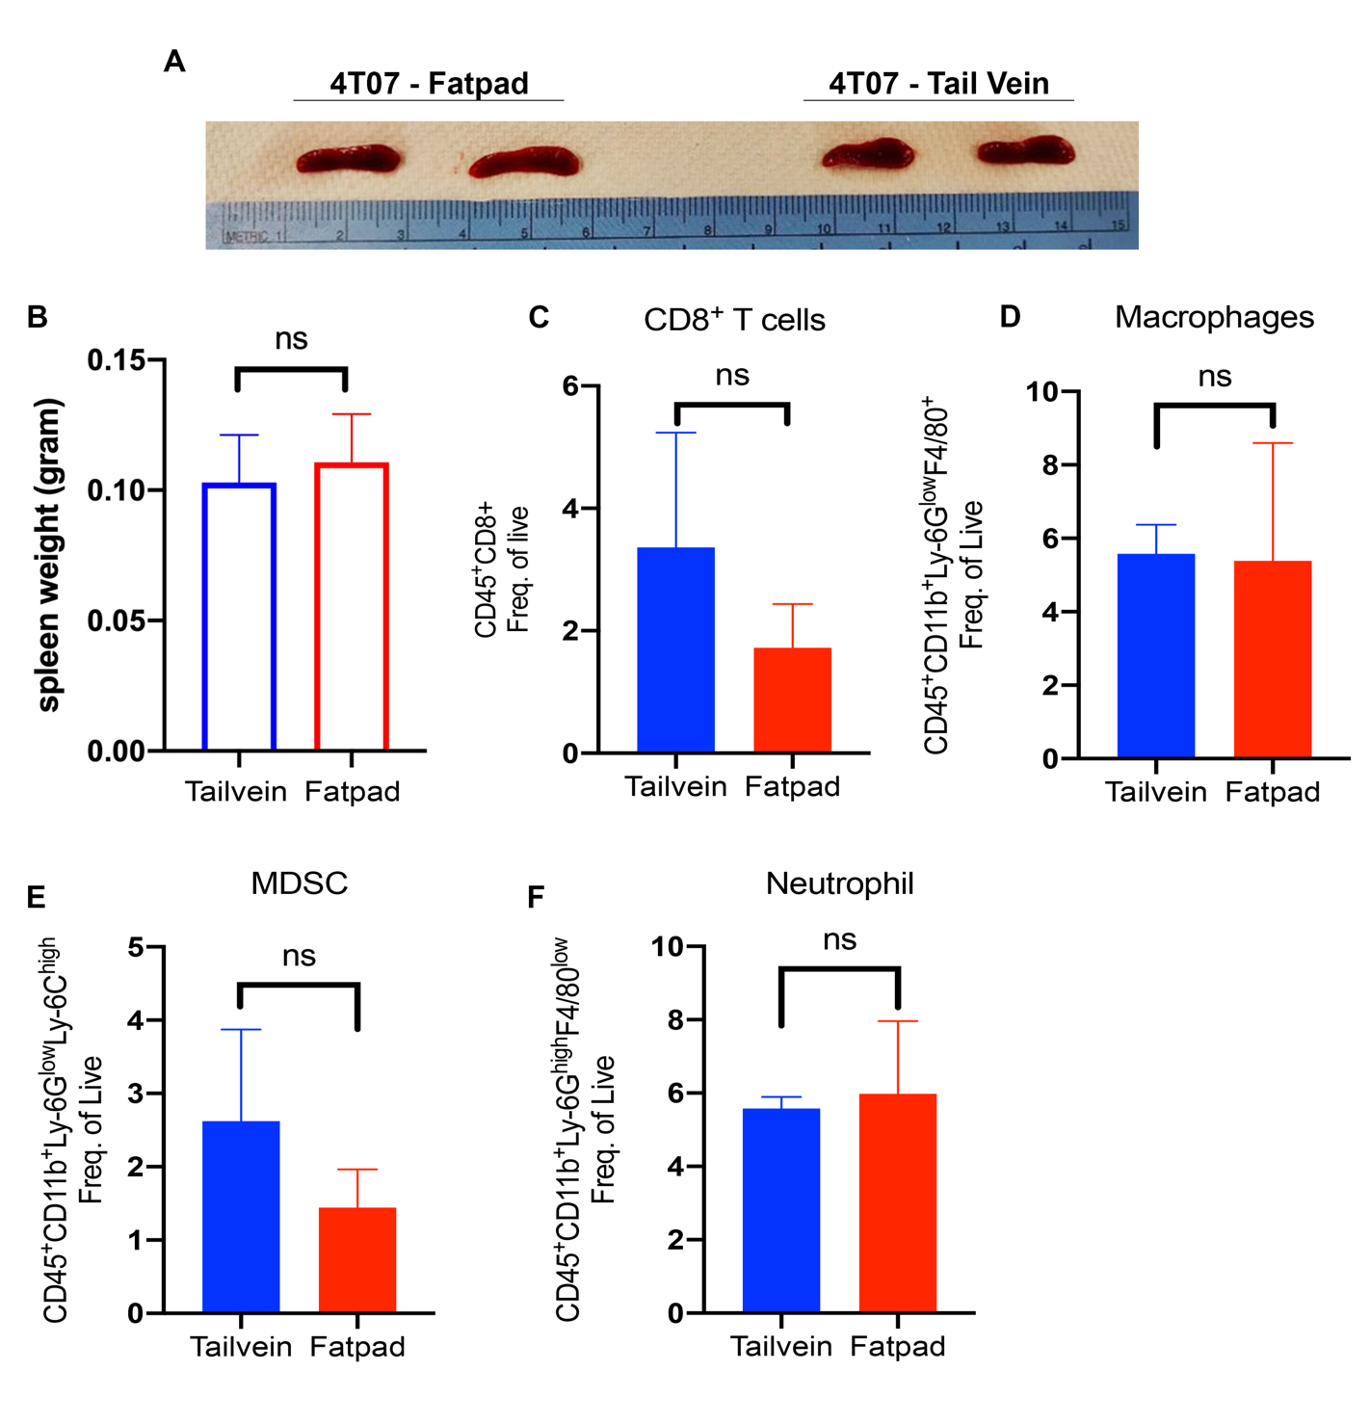

Fig. S5. The 4TO7 tumors elicit similar immune cell infiltrations when delivered via tail vein or fat pad injections. BALB/c mice were engrafted with 4TO7 cells via either the mammary fat pad or tail vein injections. The spleens and tumor tissues were collected on day 7 for immune-profiling. (A and B) Pictures and bar graphs show spleen size and weight, respectively. (C-F) Replicated quantifications of indicated immune cells from the isolated tissue samples, quantified as a frequency of live events per sample. Two-tailed unpaired t-test analyses were performed to determine the significance (ns = not significant).

Supplemental Figure 6:

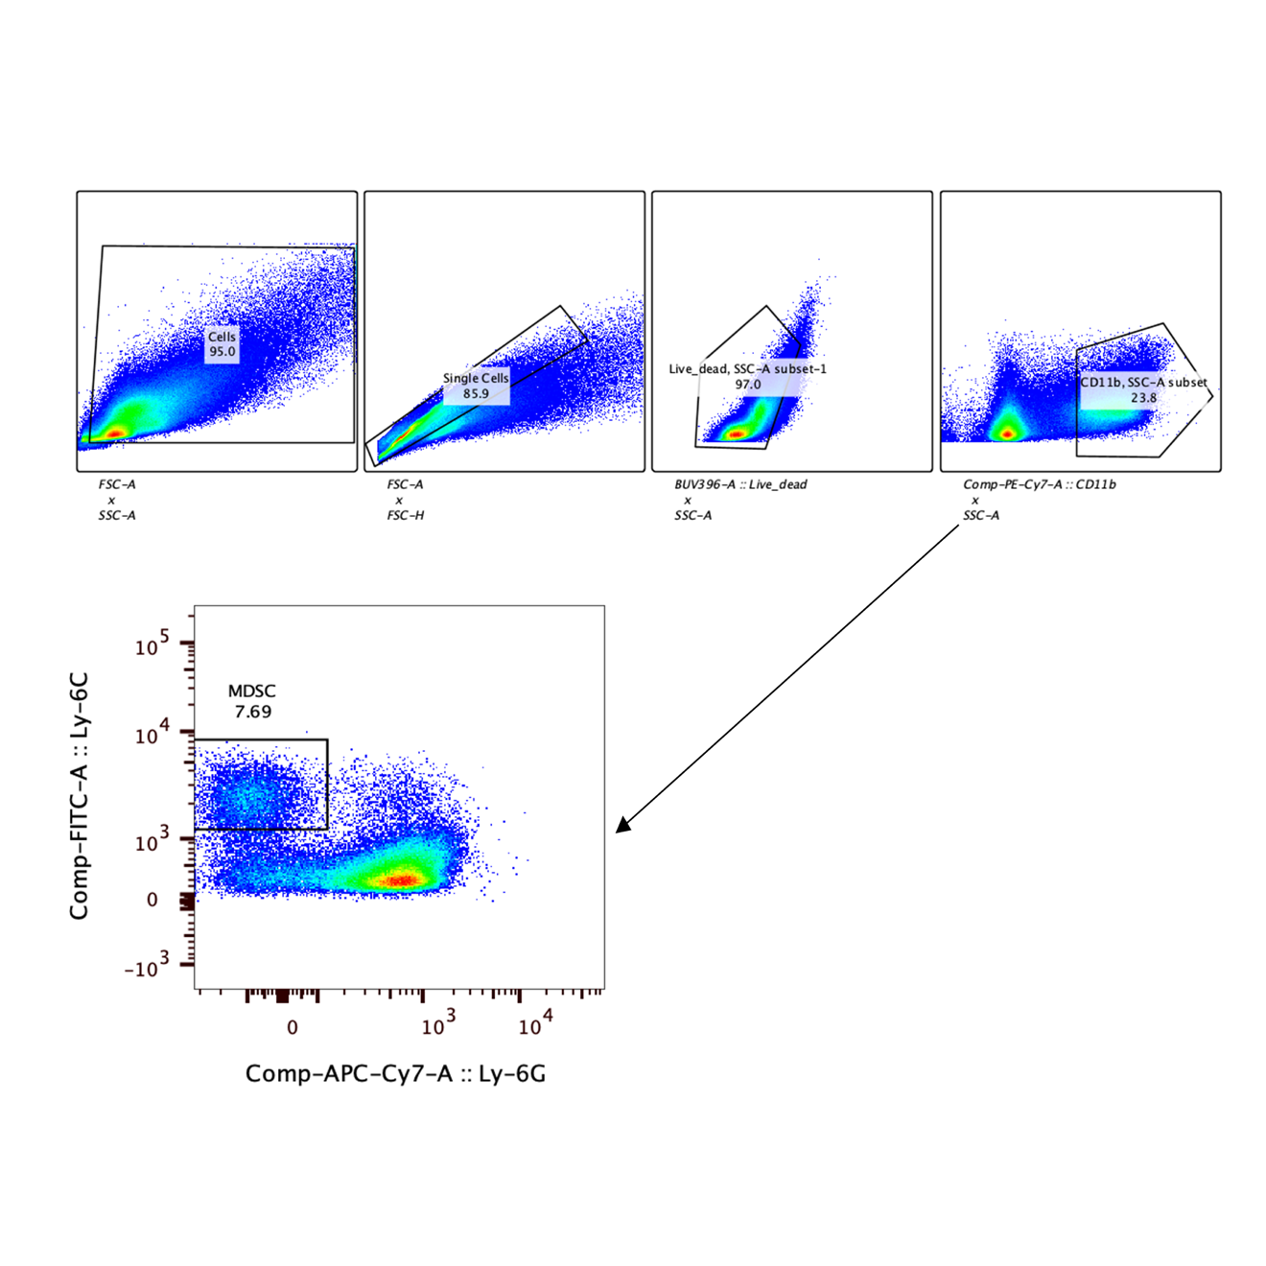
Fig. S6. The gating ancestry for MDSC populations. Tumors were isolated and digested into single cell suspensions as described in the materials and methods. These cells were sequentially gated as shown to identify a population of single cells, live cells, and CD11b⁺ cells prior to analysis of Ly-6G and Ly-6C.

Supplemental Figure 7:

Fig. S7. The addition of immune checkpoint blockade does not improve FIIN4-mediated survival in 4T1 tumor-bearing mice. BALB/c mice were engrafted with 5X10⁴ 4T1 cells via the mammary fatpad (n = 4 mice per group) and primary tumors were removal 14 days later. Following primary tumor removal, mice were allowed to recover for 2 days and subsequently treated with FIIN4 (100 mg/kg/po/qd) in the presence or absence of anti-PD1 antibodies (200 mg) administered every three days for a total of 4 doses. Data are representative of two independent experiments.

Supplemental Figure 8:

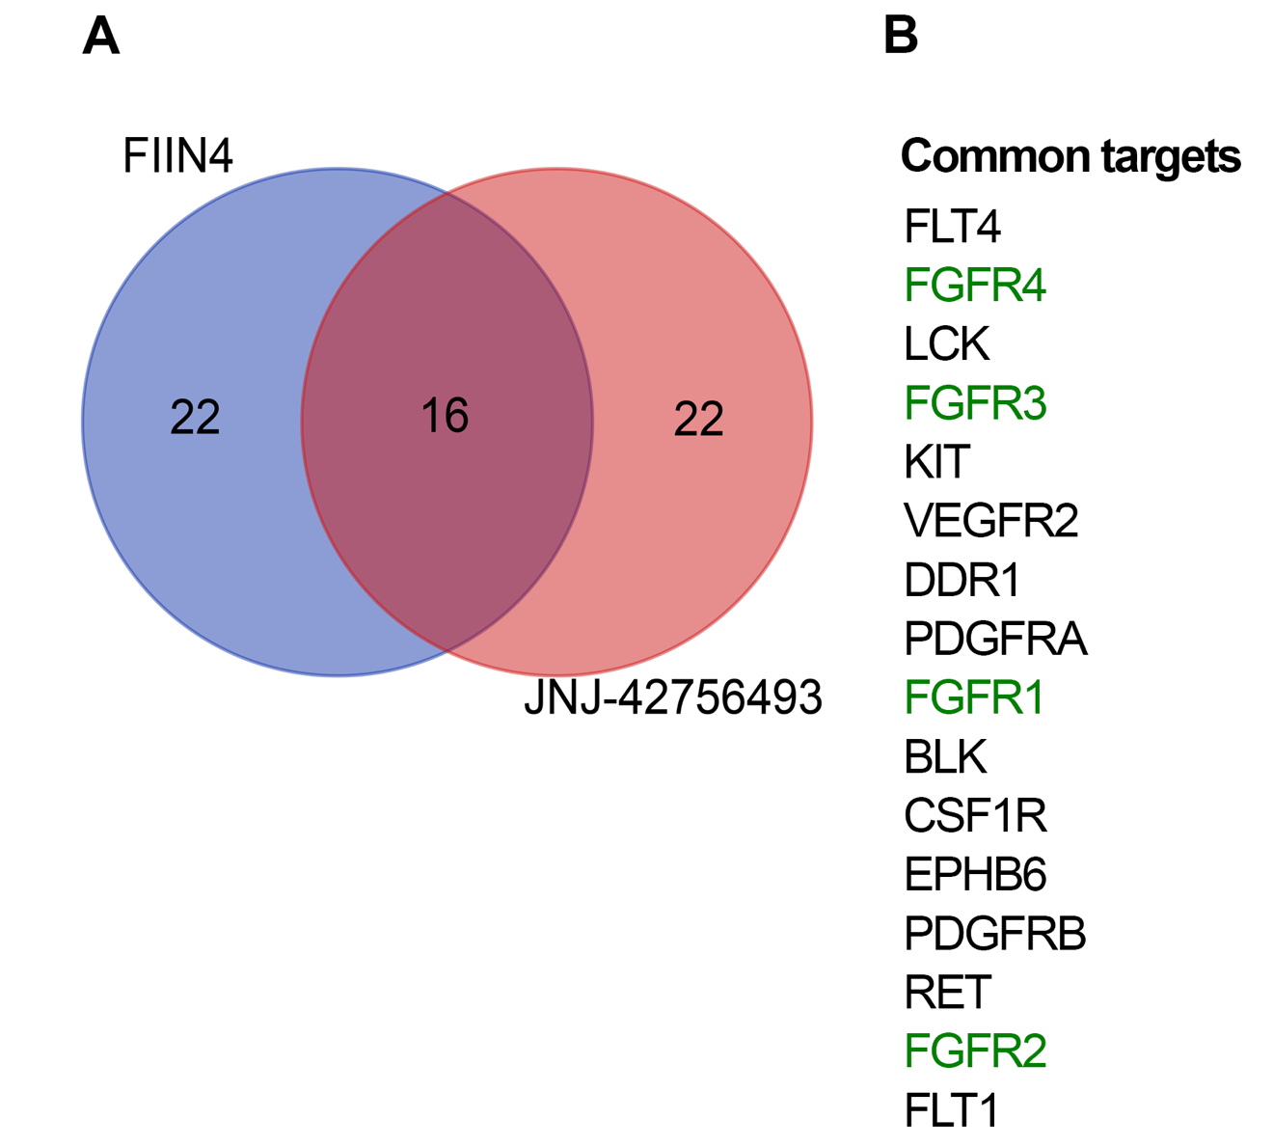

Fig. S8. Comparison of KINOMEscan analyses for FIIN4 vs Erdafitinib. (A) A Venn diagram analyzing overlap between the top 38 kinase binding targets of FIIN4 and erdafitinib (JNJ-42756493). Both KINOMEscan analyses were conducted previously using 1 μM of the indicated compounds against the DiscoverX platform of 450 kinases. (B) A list of the top 16 common target kinases of these two FGFR inhibitors.

