Supplementary Figure 1

Fig. S1. Reactome Pathway Analysis of DEGs Highly Expressed in Responding Tumours (A) and Non-Responders (B). Gene lists resulting from Limma differential expression analysis were analysed by reactome pathway analysis in R and plotted using the reactome package.

Supplementary Figure 2
Fig. S2. Manhattan Distance Analysis of Tumour Expression Against Tnc. A, Top 30 genes with the lowest Manhattan distances from Tnc calculated using median normalised gene expression values between responding and non-responding mice. B, Corresponding bottom 30 genes with the furthest distance from Tnc. C, List of top 30 genes with opposing expressing patterns to Tnc.

Supplementary Figure 3
A
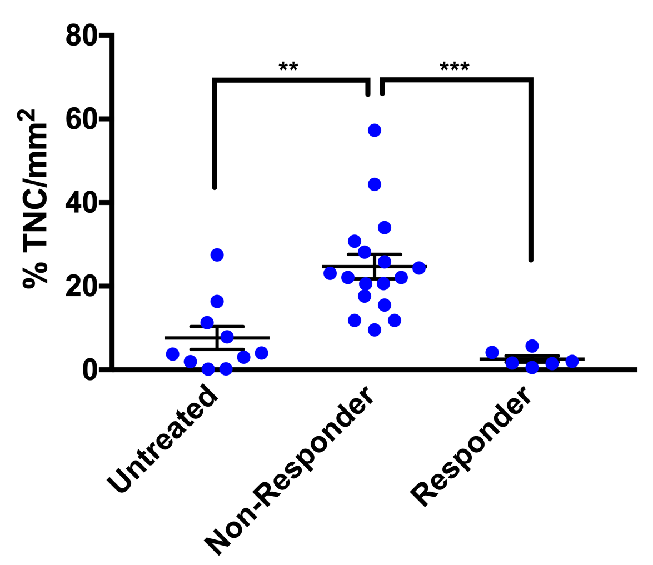
B

Fig. S3. A, Representative images of TNC expression pattern (green) in tumours. A low power image through a whole tumour (left) shows TNC highly concentrated on the edges. Medium power images (centre, 1) show TNC is found more towards the edge (right, 2) than the core (right, 3) of the tumour. B, Quantification of intratumoural TNC immunofluorescent signal in tumours of Untreated (Treg⁺) (N=10), Non-Responder (Treg⁻HEV⁻) (N=17) and Responder (Treg⁻HEV⁺ Foxp3^{DTR}) (N=6) animals. Data are presented as individual data points (individual mice) in % of positive TNC pixels per mm² of tumour tissue, plus mean and standard error of the mean. Statistical significance was determined by Kruskal-Wallis test with Dunn's multiple comparison test.

Supplementary Figure 4
A

B

C

Fig. S4. A, Individual data for each cancer corresponding to Figure 2A. Cancers were not included in subsequent analyses if survival did not correlate with expression of the CTL gene signature (indicated as *Removed in red text on each graph). Only cancers which showed a trend of better survival in the CTL-High tumors were included in the analysis shown in Fig. 2A and Fig. S4B-C. B, Individual data for each cancer corresponding to Fig. 2B. Each group corresponds the orange CTL-High line in Fig. S4A. C, Individual data for each cancer corresponding to Fig. 2C. Each group corresponds the green CTL-Low line in Fig. S4A.
TCGA study abbreviations: BLCA, Bladder Urothelial Carcinoma; BRCA, Breast invasive carcinoma; CESC, Cervical squamous cell carcinoma and endocervical adenocarcinoma; COAD, Colon adenocarcinoma; HNSC, Head and Neck squamous cell carcinoma; KIRC, Kidney renal clear cell carcinoma; KIRP, Kidney renal papillary cell carcinoma; LGG, Brain Lower Grade Glioma; LIHC, Liver hepatocellular carcinoma; LUAD, Lung adenocarcinoma; LUSC, Lung squamous cell carcinoma; OV, Ovarian serous cystadenocarcinoma; PAAD, Pancreatic adenocarcinoma; PCPG, Pheochromocytoma and Paraganglioma; PRAD, Prostate adenocarcinoma; READ, Rectum adenocarcinoma; SARC, Sarcoma; SKCM, Skin Cutaneous Melanoma; STAD, Stomach adenocarcinoma; THCA, Thyroid carcinoma; UCEC, Uterine Corpus Endometrial Carcinoma.

Supplementary Figure 5
Fig. S5. Analysis is the same as that performed in Fig. 2, however with reversed order. A, KM analysis of patients clustered (within each cancer) by relative expression of TNC, followed by clustering of B, TNC-High and C, TNC-Low primary tumour groups by the expression of a CTL gene signature.

Supplementary Figure 6
Fig. S6. Definition of TNC high and low areas. Tumours were individually observed and areas with high or low concentrations of TNC (green) were defined for further analysis, such as T-cell counts.

Supplementary Figure 7

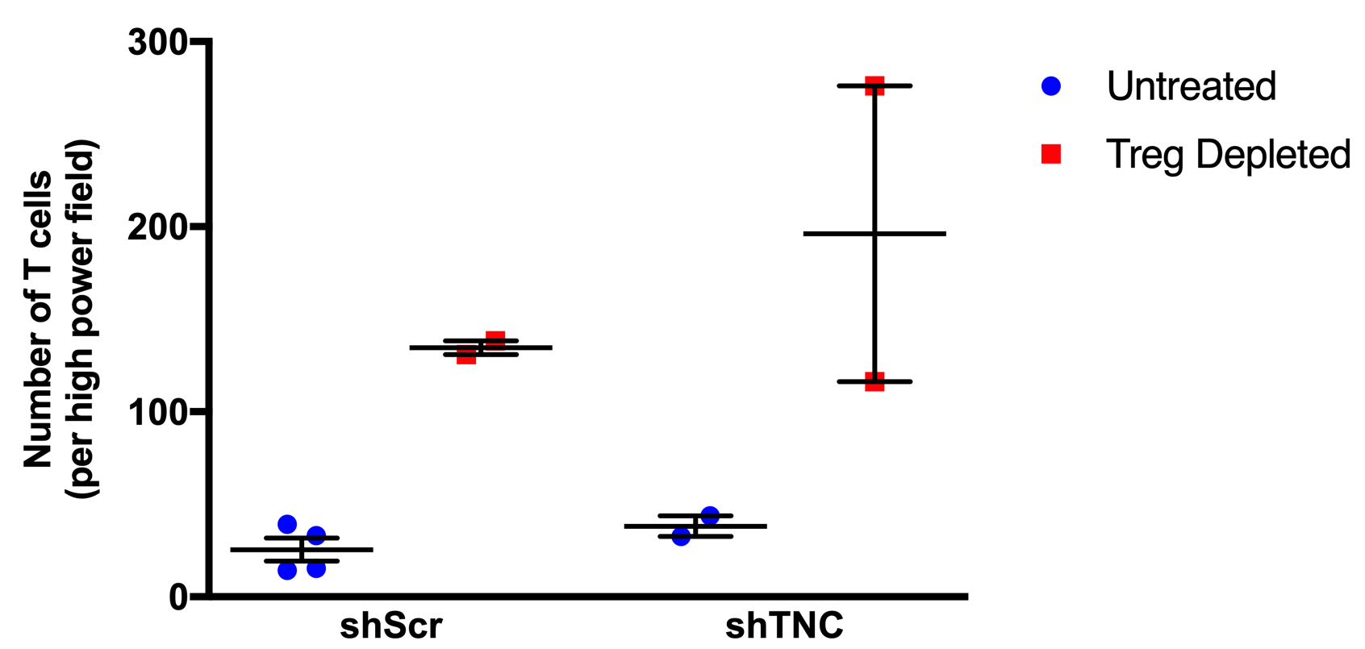

Fig. S7. Number of intratumoural CD3⁺ cells in shScr and shTNC tumours of Foxp3^{DTR} animals, untreated or Treg depleted. Data are presented as individual data points (individual mice) plus mean and standard error of the mean. Statistical significance was determined with Mann-Whitney test, which revealed no statistical difference between groups.

Supplementary Figure 8
Fig. S8. A, CIBERSORT analysis of microarray groups (lymph node n=1, non-responder, responder and untreated, all n=5). Box plots indicate median and interquartile range, with each point representing the estimated cell fraction value for an individual animal. B, Representative high-power images of macrophage markers CD206 and MHC class II (MHC-II) (red) in TNC (green) high and low areas of Untreated, Non-Responder and Responder tumours. Images include the nuclear stain Hoechst. C, Number of intratumoural CD206⁺ (left) and MHC-II⁺ (right) cells in TNC positive and low areas in tumours of Non-Responder and Responder tumours of Foxp3^{DTR} animals (N=3). Data are presented as individual data points (individual mice) plus median and standard error of the mean. Statistical significance was determined with Mann-Whitney test.

