Supplementary material

Hyperglycemia enhances cancer immune evasion by inducing alternative macrophage polarization through increased O-GlcNAcylation
Natália Rodrigues Mantuano, Michal A. Stanczak, Isadora de Araújo Oliveira, Nicole Kirchhammer, Alessandra A. Filardy, Gianni Monaco, Ronan Christian Santos, Agatha Carlos Fonseca, Miguel Fontes, César de Souza Bastos Jr, Wagner B. Dias, Alfred Zipellius, Adriane R.Todeschini* and Heinz Läubli*
* these authors equally supervised the work.

Material and Methods

Antibodies
The following antibodies were used for flow cytometry staining of murine cell: Fc-block antibody anti-CD16/36 (clone 2.4G2), anti-CD45 PercPcy5 (clone 30-F11), anti-Gr1 PEcy7 (clone RB6-8C5), anti-CD11b FITC/BV605 (clone M1/70), anti-F4/80 BV421/APC (clone BM8), anti-MHCII APCcy7 (clone M5/114.15.2), anti-CD3-PE594 (clone 17A2), anti-CD4 BV605 (clone RM4-5), anti-FoxP3 APC (clone 3G3), anti-CD25 PE (clone 3C7), anti-CD19 APCcy7 (clone 6D5), anti-CD11c APC (clone HL3), anti-Ly6C BV605/BV650 (clone AL-21), anti-Ly6G PEcy7 (clone 1A8), anti-CD86 APC (clone GL-1) anti-CD206 PE (clone C068C2). All the antibodies for flow cytometry were purchased from BD Biosciences or Biolegend.

MC38 viability assay
MC38 cells were seeded in 96 well plate and estreptozotocin (Sigma-Aldrich, STZ) was added to the medium in 5 different concentrations (1, 5, 10, 20 and 40 mM) for 24, 48 or 72 hours. 1-(4,5-Dimethylthiazol-2-yl)-3,5-diphenylformazan (Sigma-Aldrich, MTT) 0.5 mg/ml was added and after 3 hours of incubation, the supernatant was discarded and the formazan crystals were resuspended with DMSO (Sigma-Adrich) and the absorbance measured (560nm).

Sialylation deficient MC38 cells
MC38 GNE (UDP-N-acetylglucosamine 2-epimerase/N-acetylmannosamine kinase) deficient cells were generated by CRISPR/CAS9 technique as previously described (1). Briefly, guide RNAs were designed with e-crisp.org and synthesized by Microsynth AG. Guide RNAs were cloned into the pX458 vector (Addgene). A transient transfection of MC38 cells with subsequent single-cell sorting and screening for cell-surface sialylation were performed. Five MC38 GNE-deficient clones were pooled to avoid clonal selection.

GFAT1 deficient MC38 cells
MC38 GFAT1(glutamine fructose-6-phosphate amidotransferase) deficient cells were generated by lentivirus transduction with the pGFP-C-shScrambled or shGFPT1 plasmid (Origene, TL511601) as previously described (2).

Siglec E-Fc production
The Siglec-Fcs were produced as previously described (3). Briefly, transfected 293T HEK cells were cultured in serum free medium and the supernatant collected after 72 hours. Siglec-Fc was isolated from supernatants with protein A.

Siglec E KO mice
The Siglec-E deficient mouse (EKO mouse) was received from Dr.Varki (UCSD) previously described. The mice were bred and backcrossed in-house to our local C57BL/6 strain, in heterozygous breedings for more than 9 generations. Animals were housed under specific pathogen-free conditions.

Survival analysis with TCGA data
Harmonized RNA-Seq data from The Cancer Genome Atlas (TCGA) database were retrieved using the software TCGAbiolinks (4). The normalization method chosen for the expression values was the FPKM-UQ. The survival analysis was performed on the patients of all cancers which were split in two categories, top and low 50% of the list of patients ranked according to expression of the OGT gene. The p-value for Kaplan-Meier curves was calculated with the log rank test. The proportions of the M1 and M2 macrophages infiltrated in the tumors of the TCGA database were retrieved with the CIBERSORT method (5). Survival analysis was performed as described above but using either the M1 or M2 frequency to split the patients.

Nanostring analysis
RNA extraction was performed of tumor embedded in OCT. 5-10 10 µM sections of tumor tissue were lysed in 600 µl RLT buffer using the TissueLyserLT (Qiagen). RNA was extracted using the RNeasy Mini extraction Kit (Qiagen) followed by nCounter Low RNA Input Amplification Protocol (nanoString). The Nanostring data was normalized using the housekeeping genes selected by the geNorm (6) algorithm from the Advanced Analysis of the nSolver software. The limma package was used to perform the differential expression analysis between the normoglycemic and hyperglycemic mice. The data were log2-transformed with the voom function from limma in order to take into account the mean-variance relationship (7). The volcano plot shows in red the genes with a p-value < 0.05. The labelled genes are the ones with a p-value < 0.05 and absolute logFC >0.75.

Pristane treatment in vivo
BALB/c female mice 8-10 weeks old were injected i.p. with Streptozotocin (STZ, Sigma-adrich) 150 mg/kg. After a week, mice received i.p. 0.5 ml of pristane oil (Sigma-Aldrich). The peritoneal cells were collected after 2 weeks of the pristane injection and analysed by FACS using macrophage polarization markers (CD206 and MHC-II) and Ly6C/Ly6G to stain myeloid cells.

References
1. Stanczak MA, Siddiqui SS, Trefny MP, Thommen DS, Boligan KF, von Gunten S, et al. Self-associated molecular patterns mediate cancer immune evasion by engaging Siglecs on T cells. J Clin Invest 2018;128(11):4912-23 doi 10.1172/JCI120612.
2. Vasconcelos-Dos-Santos A, Loponte HF, Mantuano NR, Oliveira IA, de Paula IF, Teixeira LK, et al. Hyperglycemia exacerbates colon cancer malignancy through hexosamine biosynthetic pathway. Oncogenesis 2017;6(3):e306 doi 10.1038/oncsis.2017.2.
3. Laubli H, Pearce OM, Schwarz F, Siddiqui SS, Deng L, Stanczak MA, et al. Engagement of myelomonocytic Siglecs by tumor-associated ligands modulates the innate immune response to cancer. Proc Natl Acad Sci U S A 2014;111(39):14211-6 doi 10.1073/pnas.1409580111.
4. Colaprico A, Silva TC, Olsen C, Garofano L, Cava C, Garolini D, et al. TCGAbiolinks: an R/Bioconductor package for integrative analysis of TCGA data. Nucleic Acids Res 2016;44(8):e71 doi 10.1093/nar/gkv1507.
5. Newman AM, Liu CL, Green MR, Gentles AJ, Feng W, Xu Y, et al. Robust enumeration of cell subsets from tissue expression profiles. Nat Methods 2015;12(5):453-7 doi 10.1038/nmeth.3337.
6. Vandesompele J, De Preter K, Pattyn F, Poppe B, Van Roy N, De Paepe A, et al. Accurate normalization of real-time quantitative RT-PCR data by geometric averaging of multiple internal control genes. Genome Biol 2002;3(7):RESEARCH0034 doi 10.1186/gb-2002-3-7-research0034.
7. Ritchie ME, Phipson B, Wu D, Hu Y, Law CW, Shi W, et al. limma powers differential expression analyses for RNA-sequencing and microarray studies. Nucleic Acids Res 2015;43(7):e47 doi 10.1093/nar/gkv007.
8. Dehal AN, Newton CC, Jacobs EJ, Patel AV, Gapstur SM, Campbell PT. Impact of diabetes mellitus and insulin use on survival after colorectal cancer diagnosis: the Cancer Prevention Study-II Nutrition Cohort. J Clin Oncol 2012;30(1):53-9 doi 10.1200/JCO.2011.38.0303.

Supplementary Figures

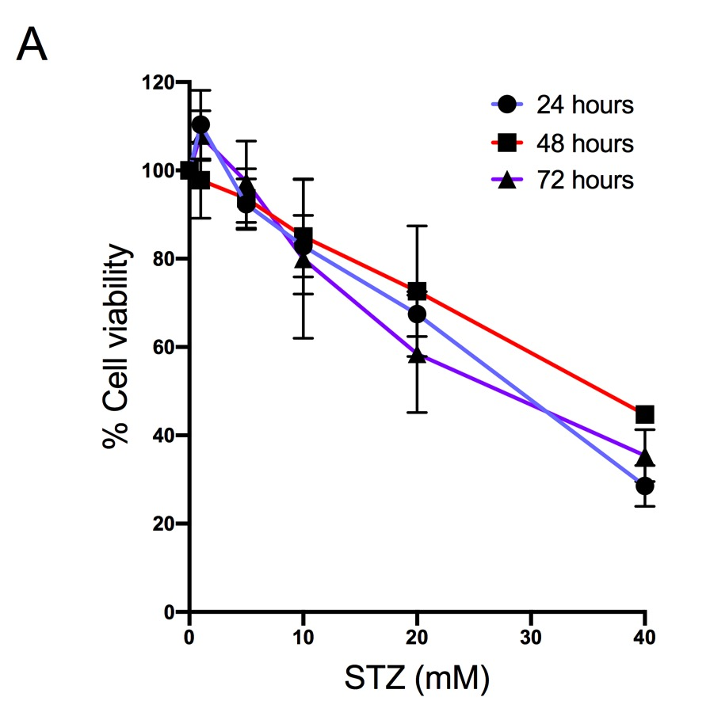
Figure S1- MC38 viability upon STZ treatment. (A) MC38 cells were seeded and estreptozotocin (STZ) was added to the medium in different concentrations (1, 5, 10, 20 and 40 mM) for 24, 48 or 72 hours. MTT was used to measure the cell viability.

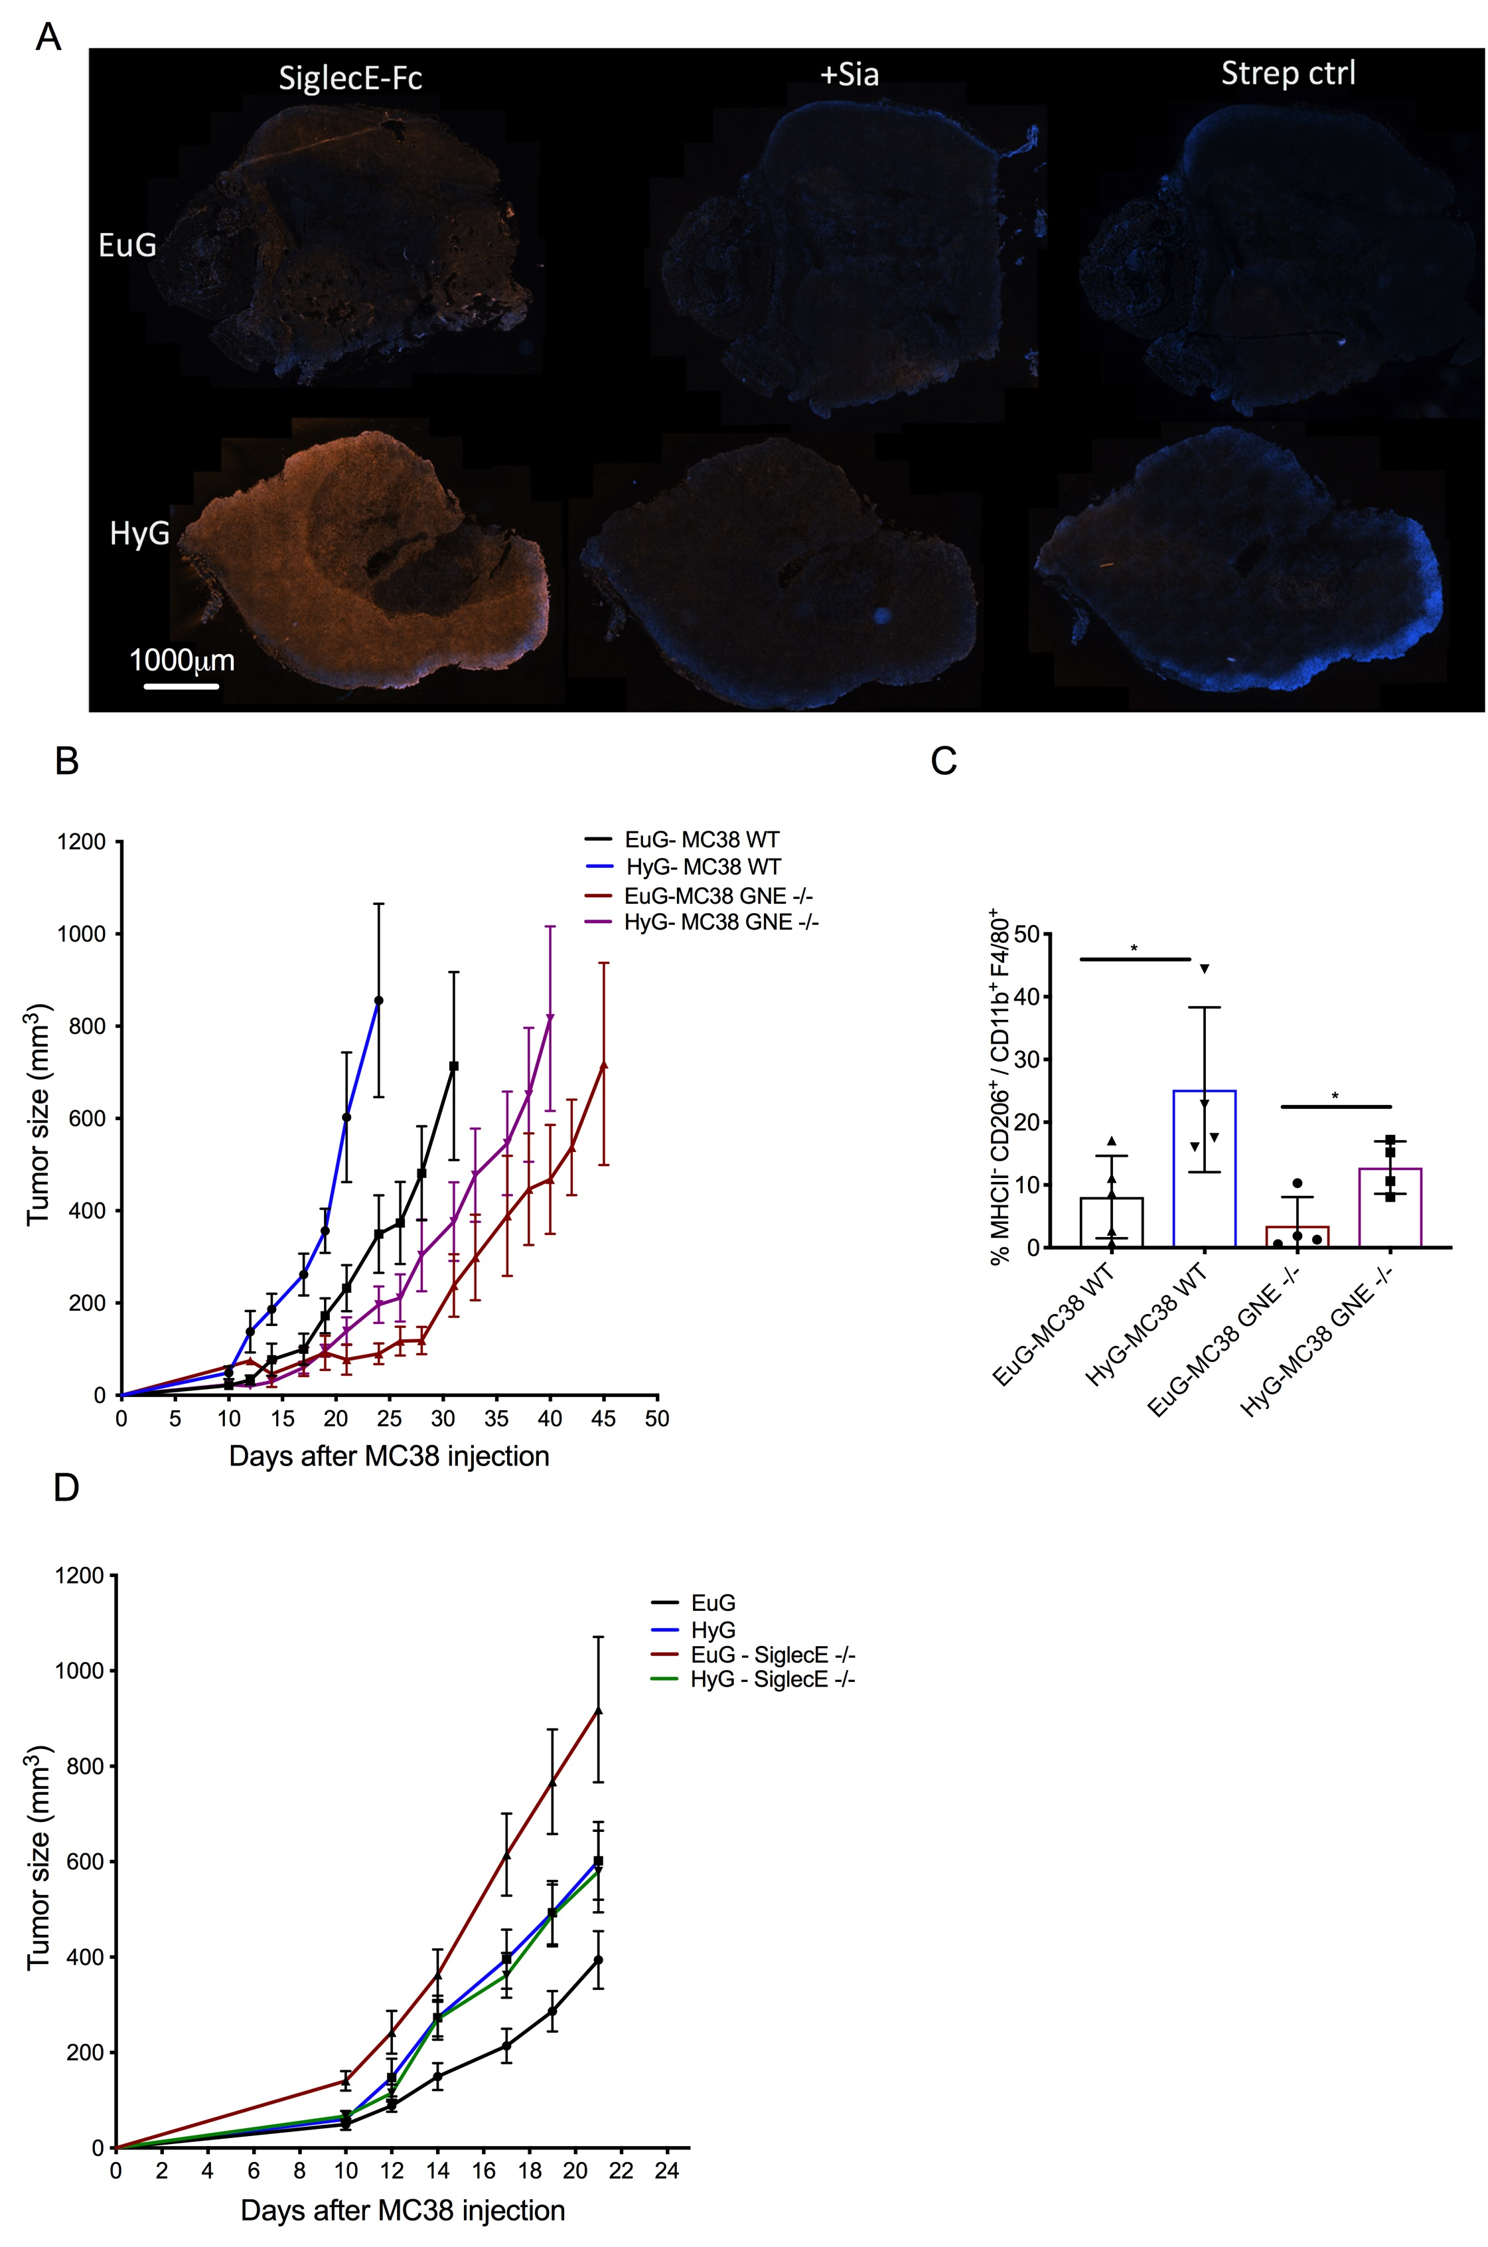
Figure S2- Sialylation is not a key mechanism in hyperglycemia-induced tumor growth. Tumor cells were injected one week after an i.p injection of STZ 150 mg/kg, hyperglycemic mice (HyG) or vehicle Euglyemic group (EuG). (A) The implanted tumors from EuG or HyG mice were sectioned and stained for SiglecE recombinant protein fusionated with a Fc moiety, accessing the Siglec E ligands in the tumor by scanning the whole tumor tissue, the controls were made treating the tumor with sialidase (sia) or using only streptavidin as secondary. (B) Tumor growth curves comparing MC38 wild-type (8) and MC38 GNE -/-, knocked out to GNE (UDP-N-acetylglucosamine 2-epimerase/N-acetylmannosamine kinase), treated with STZ (HyG-MC38 WT and HyG-MC38 GNE -/-) or non-treated (EuG- MC38- WT and EuG-MC38 GNE-/-). (C) The MC38 tumor associated macrophages (n=4-5) were analysed to the population MHCII- CD206+ inside the F4/80 and CD11b cells. (D) Growth curve using C57bl/6 mice knocked out to SiglecE, treated with STZ (HyG-SiglecE -/-, n=8) or non-treated (EuG-SiglecE-/-, n=9) and the control C57bl/6 mice treated with STZ (HyG) and non-treated (EuG). p values were calculated using unpaired Student’s t- test. * P < 0.05.

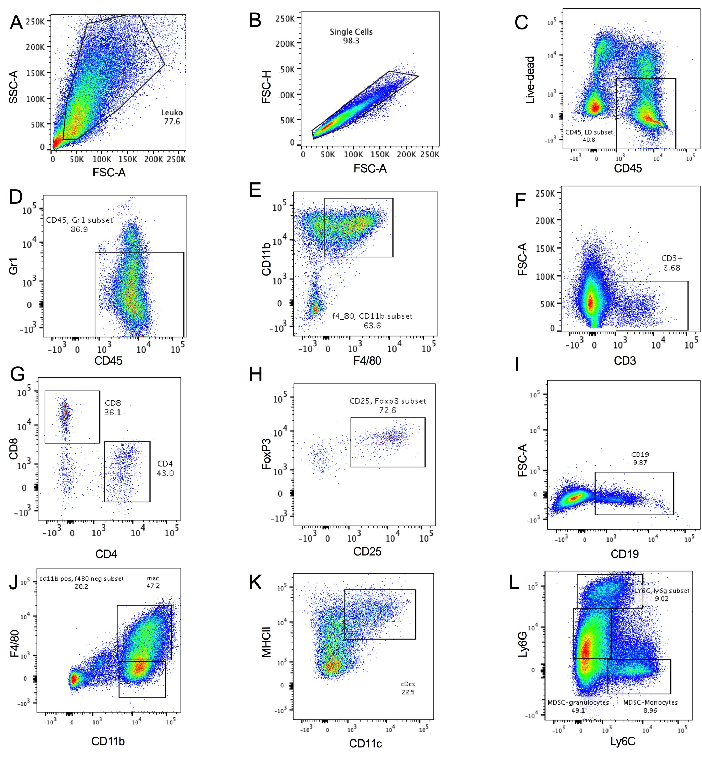
Figure S3- Gating strategy to determine tumor cell infiltrates. All the tumor inflammatory cells were gated on Side Scatter and Forward Scatter (A), singlets (B) and alive CD45+ cells (C). The tumor associated macrophages were also pre-gated on Gr1 negative (D) and CD11b⁺ F4/80⁺ cells (E). The tumor infiltrated lymphocytes are all CD3+ cells (F), gated on CD8⁺ and CD4⁺ (G). The T regulatory cells were analysed using the CD4⁺ cells to quantify CD25⁺ and FoxP3⁺. B cells were gated on CD19⁺ cells (I). Dendritic cells were pre-gated out of F4/80 population and kept the CD11b+ cells (J) and then MHCII⁺ and CD11c⁺(K). The myeloid cells are CD11b+ cells and were selected in three different gates Ly6C^{lo}Ly6G^{hi}, Ly6C^{lo}Ly6G^{int} and Ly6C^{hi}Ly6G^{lo} (L).

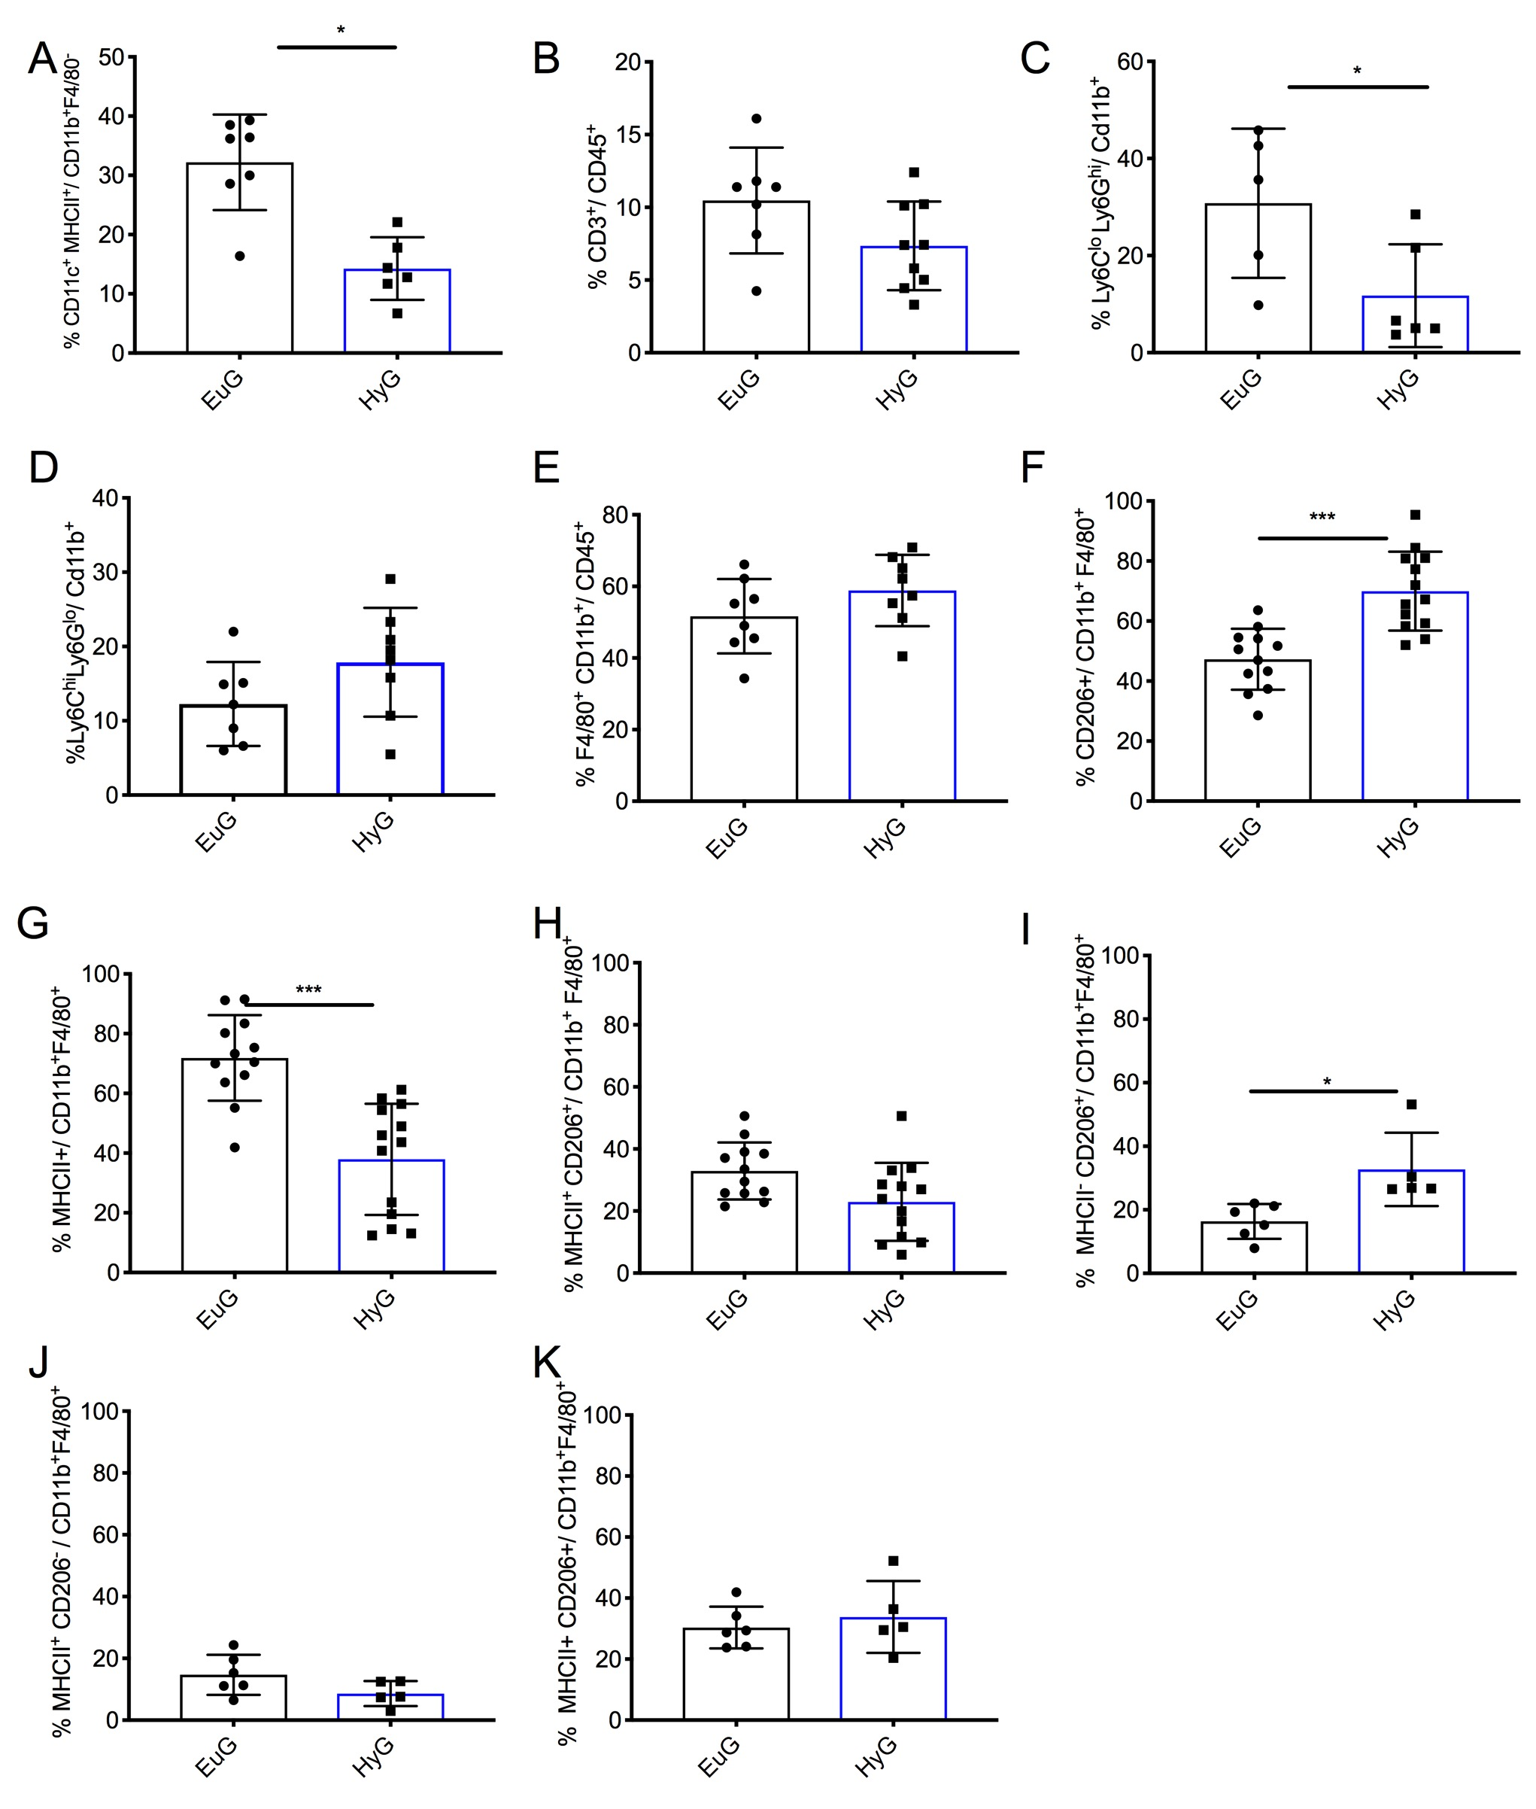Figure S4- Hyperglycemia affects anti-tumoral immunity. Cell infiltrates were determined in MC38 and B16D5 solid tumors. (A) Dendritic cells (CD11c⁺MHCII⁺) were previously gated on CD11b+ F4/80⁻ (n=8-6). Frequency of tumor infiltrated (B) lymphocytes CD3⁺ (n=7-9) in MC38 tumors. The myeloid cells were analyzed using CD11b+ cells, divided in two different populations (C) Ly6C^{lo}Ly6G^{hi} and (D) Ly6C^{lo}Ly6G^{hi} (n=7-9). (E) The MC38 tumor associated macrophages (n=12-13) were analysed to the populations (F) CD206+, (G) MHCII+ and (H) MHCII+ CD206+. The B16D5 tumor associated macrophages (CD45+F4/80+CD11b+Gr1) were analysed according the markers MHCII and CD206 (n=6-5), gates on (I) MHCII⁻CD206+, (J) MHCII+CD206⁻ and (K) MHCII+CD206+. Statistical analysis by unpaired Student’s t- test. * P<0.05 and *** P< 0.001.
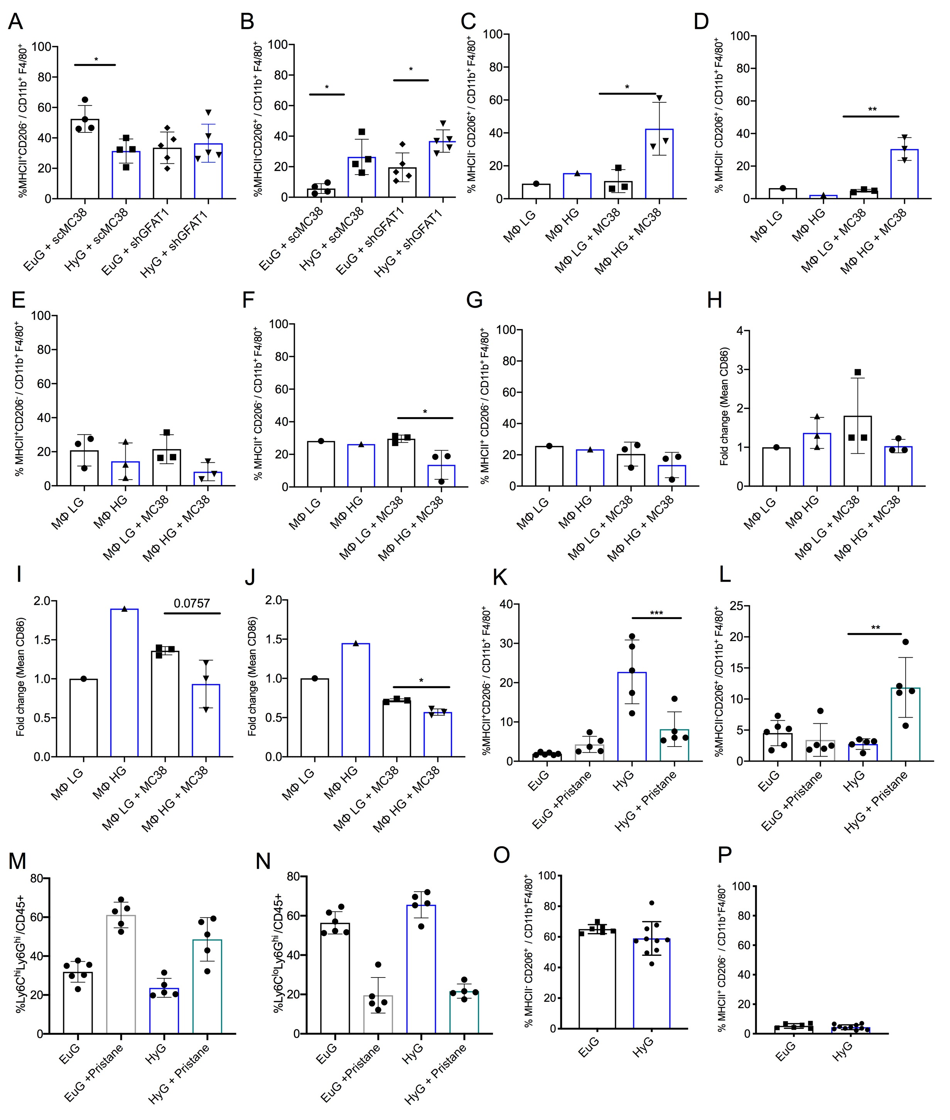
S5-Hyperglycemia impacts macrophage polarization. Cell infiltrates were determined in GFAT1 deficient MC38 solid tumors (shGFAT1) and the control MC38 transduced with a scramble (shGFAT1) in hyperglycaemic mice treated with Streptozotocin (HyG) or the euglycaemic group (EuG). Tumor associated macrophages (CD45+F4/80+CD11b+Gr1) were analysed according the markers MHC-II and CD206 (n=4-5), gates on MHC-II⁺CD206⁻ (A) and MHC-II⁻CD206⁺(B). Bone marrow derived macrophages were differentiated with M-CSF (20 ng/ml) for 6 days in high glucose (HG, 25 mM) or low glucose (LG, 5 mM) DMEM. MC38 cells were co-cultured with macrophages at different time points 2, 4 or 24 hours. Macrophage polarization was accessed by staining against CD206, CD86 and MHC-II. The macrophages were pre-gated to macrophage markers (CD11b and F4/80) and to the population MHC-II⁻CD206⁺ after 4 (C) or 24 (D) hours incubation or MHC-II⁺CD206⁻ after 2 (E), 4 (F) or 24 (G) hours. The M1, marker, CD86, was analysed in the macrophage population after 2 (H), 4 (I) or 24 (J) hours of co-culture. After STZ injection, BALB/c mice received i.p. 0.5 ml of pristane oil (Sigma-Aldrich). The peritoneal cells were collected after 2 weeks of the pristane injection (n=4-5) and analysed by FACS using macrophage polarization markers MHC-II and CD206 (K-L) and Ly6C or Ly6G positive cells (M-N). MC38 cancer cells were implanted subcutaneously in NOD SCID mice (n= 6-10) and the tumor associated macrophages analyzed according the polarizations markers MHC-II⁻CD206⁺(O) and MHC-II⁺CD206⁻ (P). Results are expressed as mean ± S.D. p values were calculated using one-way ANOVA with Tukey post-test. * P < 0.05, ** P < 0.01, *** P < 0.001.

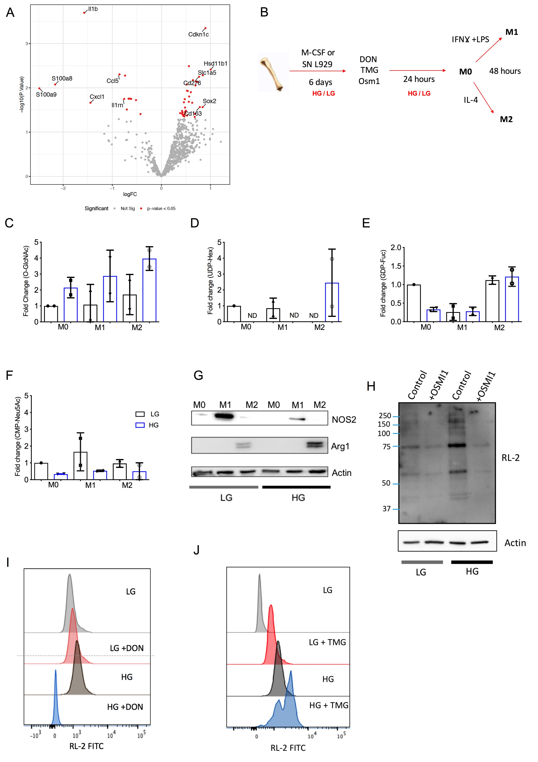
Figure S6- Hyperglycemia affects macrophage polarization through O-GlcNAcylation. Volcano plot of differentially expressed genes between Euglyemic and Hyperglicemic MC38 tumors (n=3-4). (A) RNA was extracted from MC38 tumors and analyzed by Nanostring platform. The volcano plot shows in red the genes with a p-value < 0.05. The labelled genes are the ones with a p-value < 0.05 and absolute logFC >0.75. (B) BMDM differentiated with L929 supernatant or M-CSF were polarized in DMEM HG (high glucose, 25 mM) or LG (low glucose, 5mM). (C) The quantification of O-GlcNAcylation using the antibody RL-2 by western blotting and the metabolites UDP-Hexoses (D), GDP-Fucose (E) and CMP-Neu5Ac (F) were extracted and analysed measured by mass spectrometry. (G) The levels of Arginase1 (Arg1) and Nitric oxide synthase 2 (NOS2) were analysed in the polarized macrophages M1 and M2. O-GlcNAcylation was accessed after 24 hours treatment of (H) OSMI1, (I) DON and TMG (J).

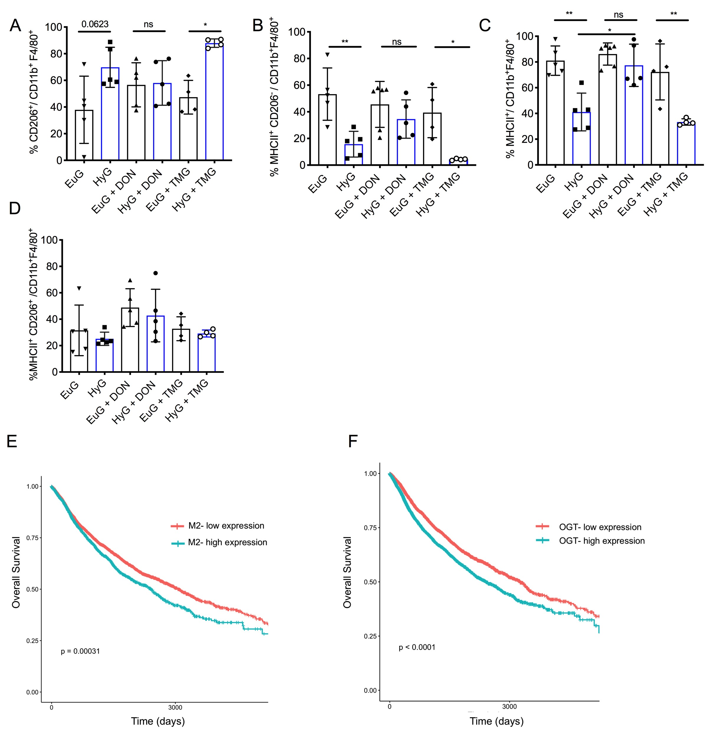

Figure S7 - Flux through HBP induces M2 polarization. Hyperglycemia (HyG) was induced in vivo by i.p. injection of streptozotocin (STZ) 150 mg/kg, while Euglycemic control (EuG) received the vehicle. C57bl/6 mice were injected s.c. with MC38 cells and when tumors reached 300-400 mm³ mice received DON (10 mg/mg) i.p. each 3 days and tumors were measured. Macrophage polarization was analysed after one single injection of DON (10 mg/kg) or TMG (20 mg/kg) when the tumors reached 300-400 mm³. Two days after the treatment, tumors were analyzed by cytometry using macrophage markers CD11b⁺F4/80⁺Gr1⁻ and polarization markers MHCII and CD206 (A-D, n=4-5). Harmonized RNA-Seq data from The Cancer Genome Atlas (TCGA) database were retrieved using the software TCGA biolinks. The survival analysis was performed on the patients of all cancers which were split in two categories, top and low 50% of the list of patients ranked according to expression of the (E) M2 or (F) OGT genes. Results are shown as mean ± S.D. p values were calculated using Anova one-way with Tukey post-test. * P < 0.05, ** P < 0.01, *** P < 0.001.

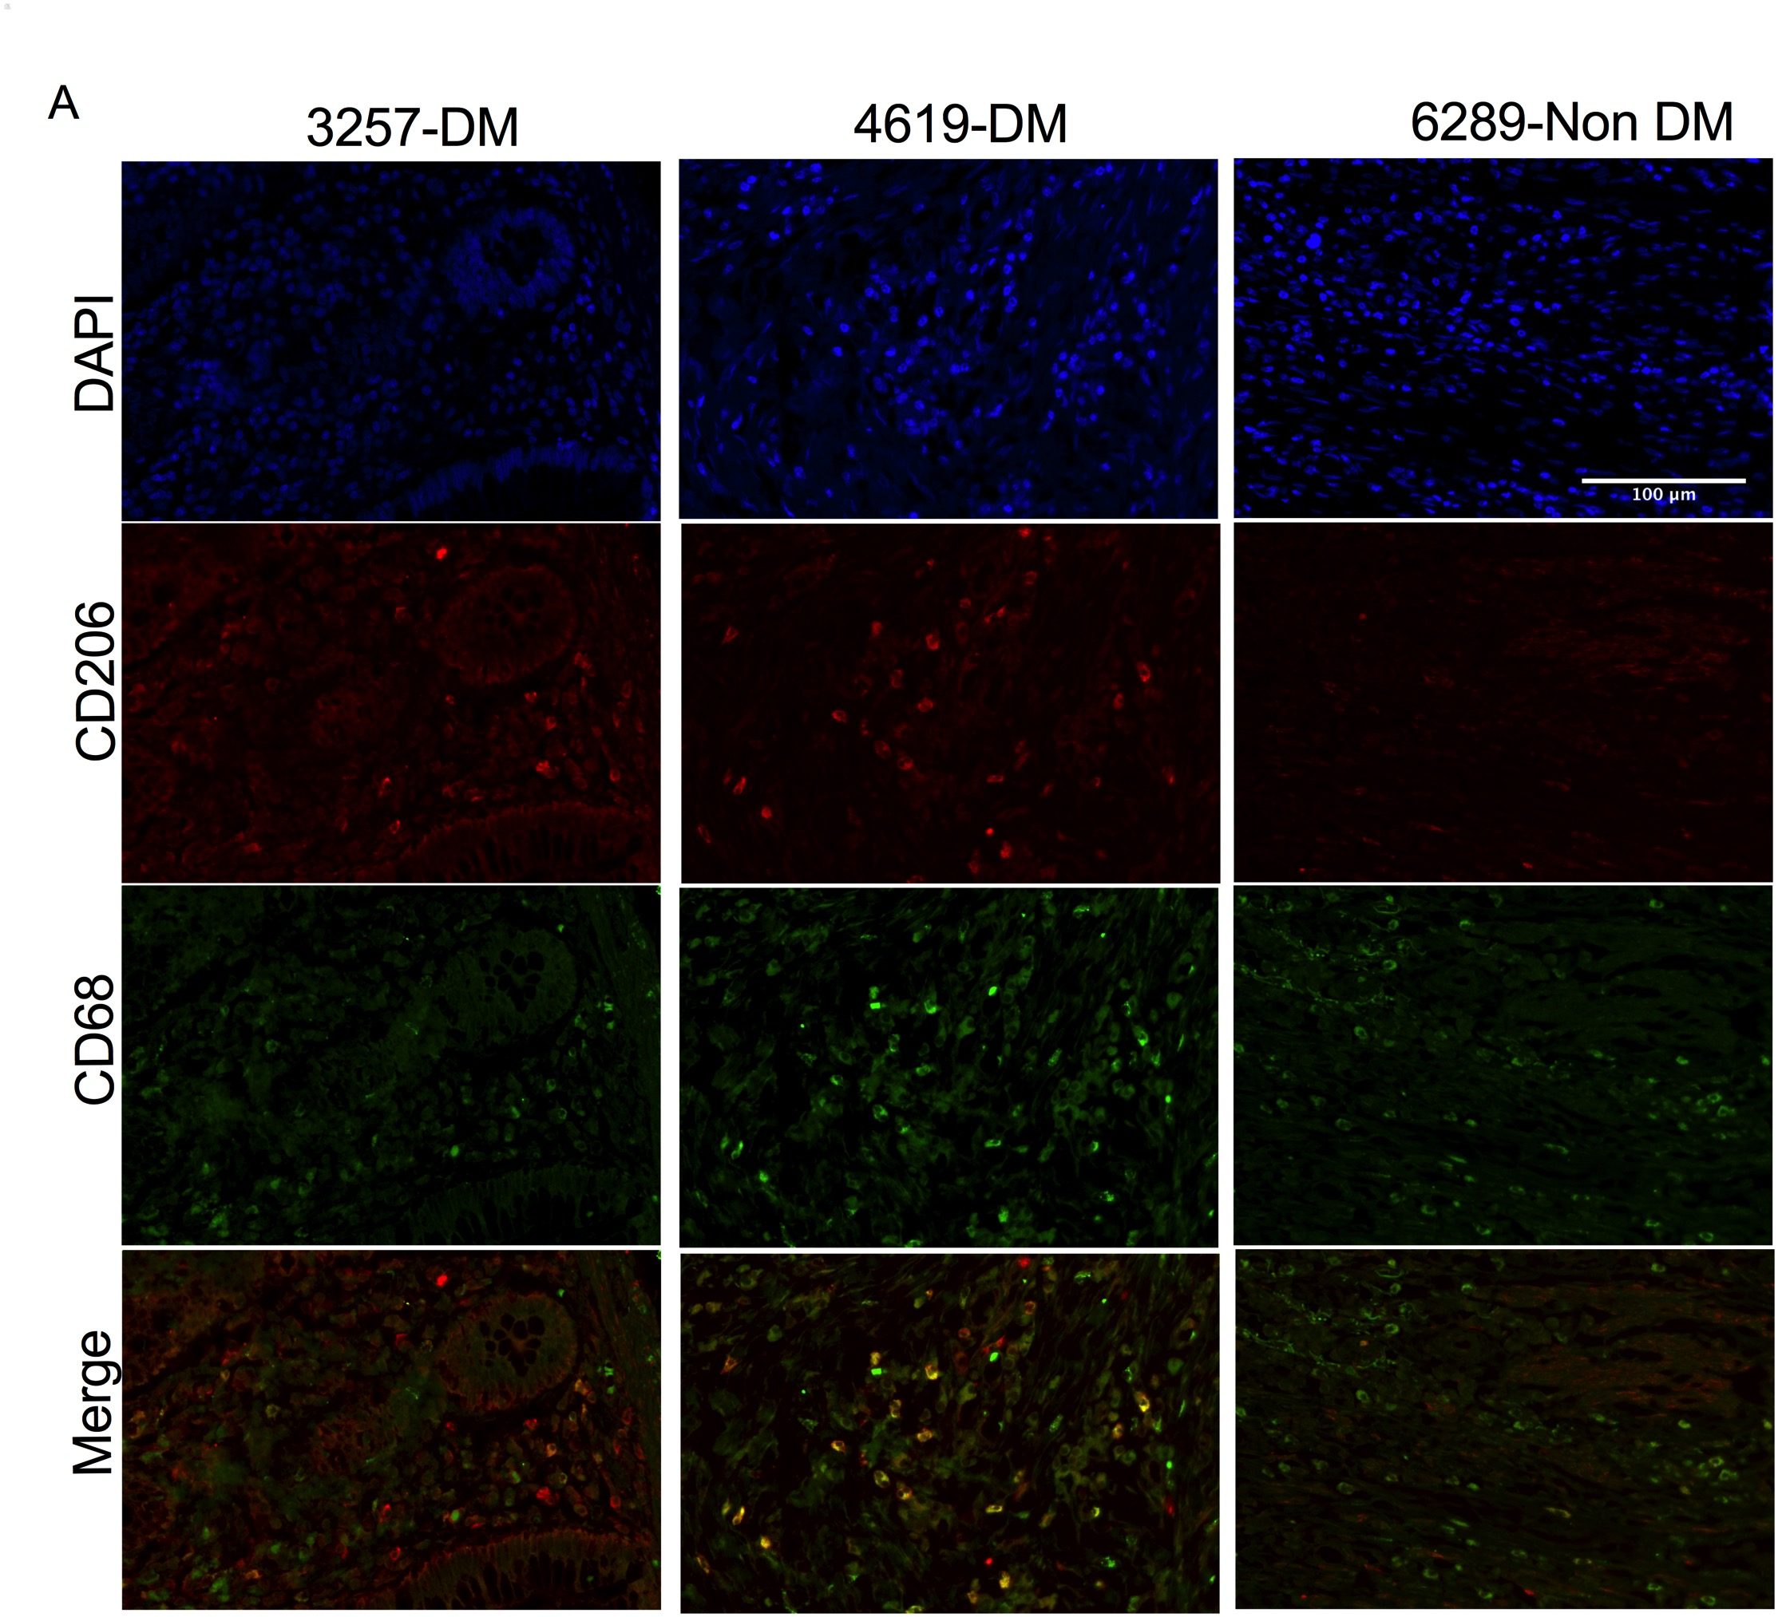

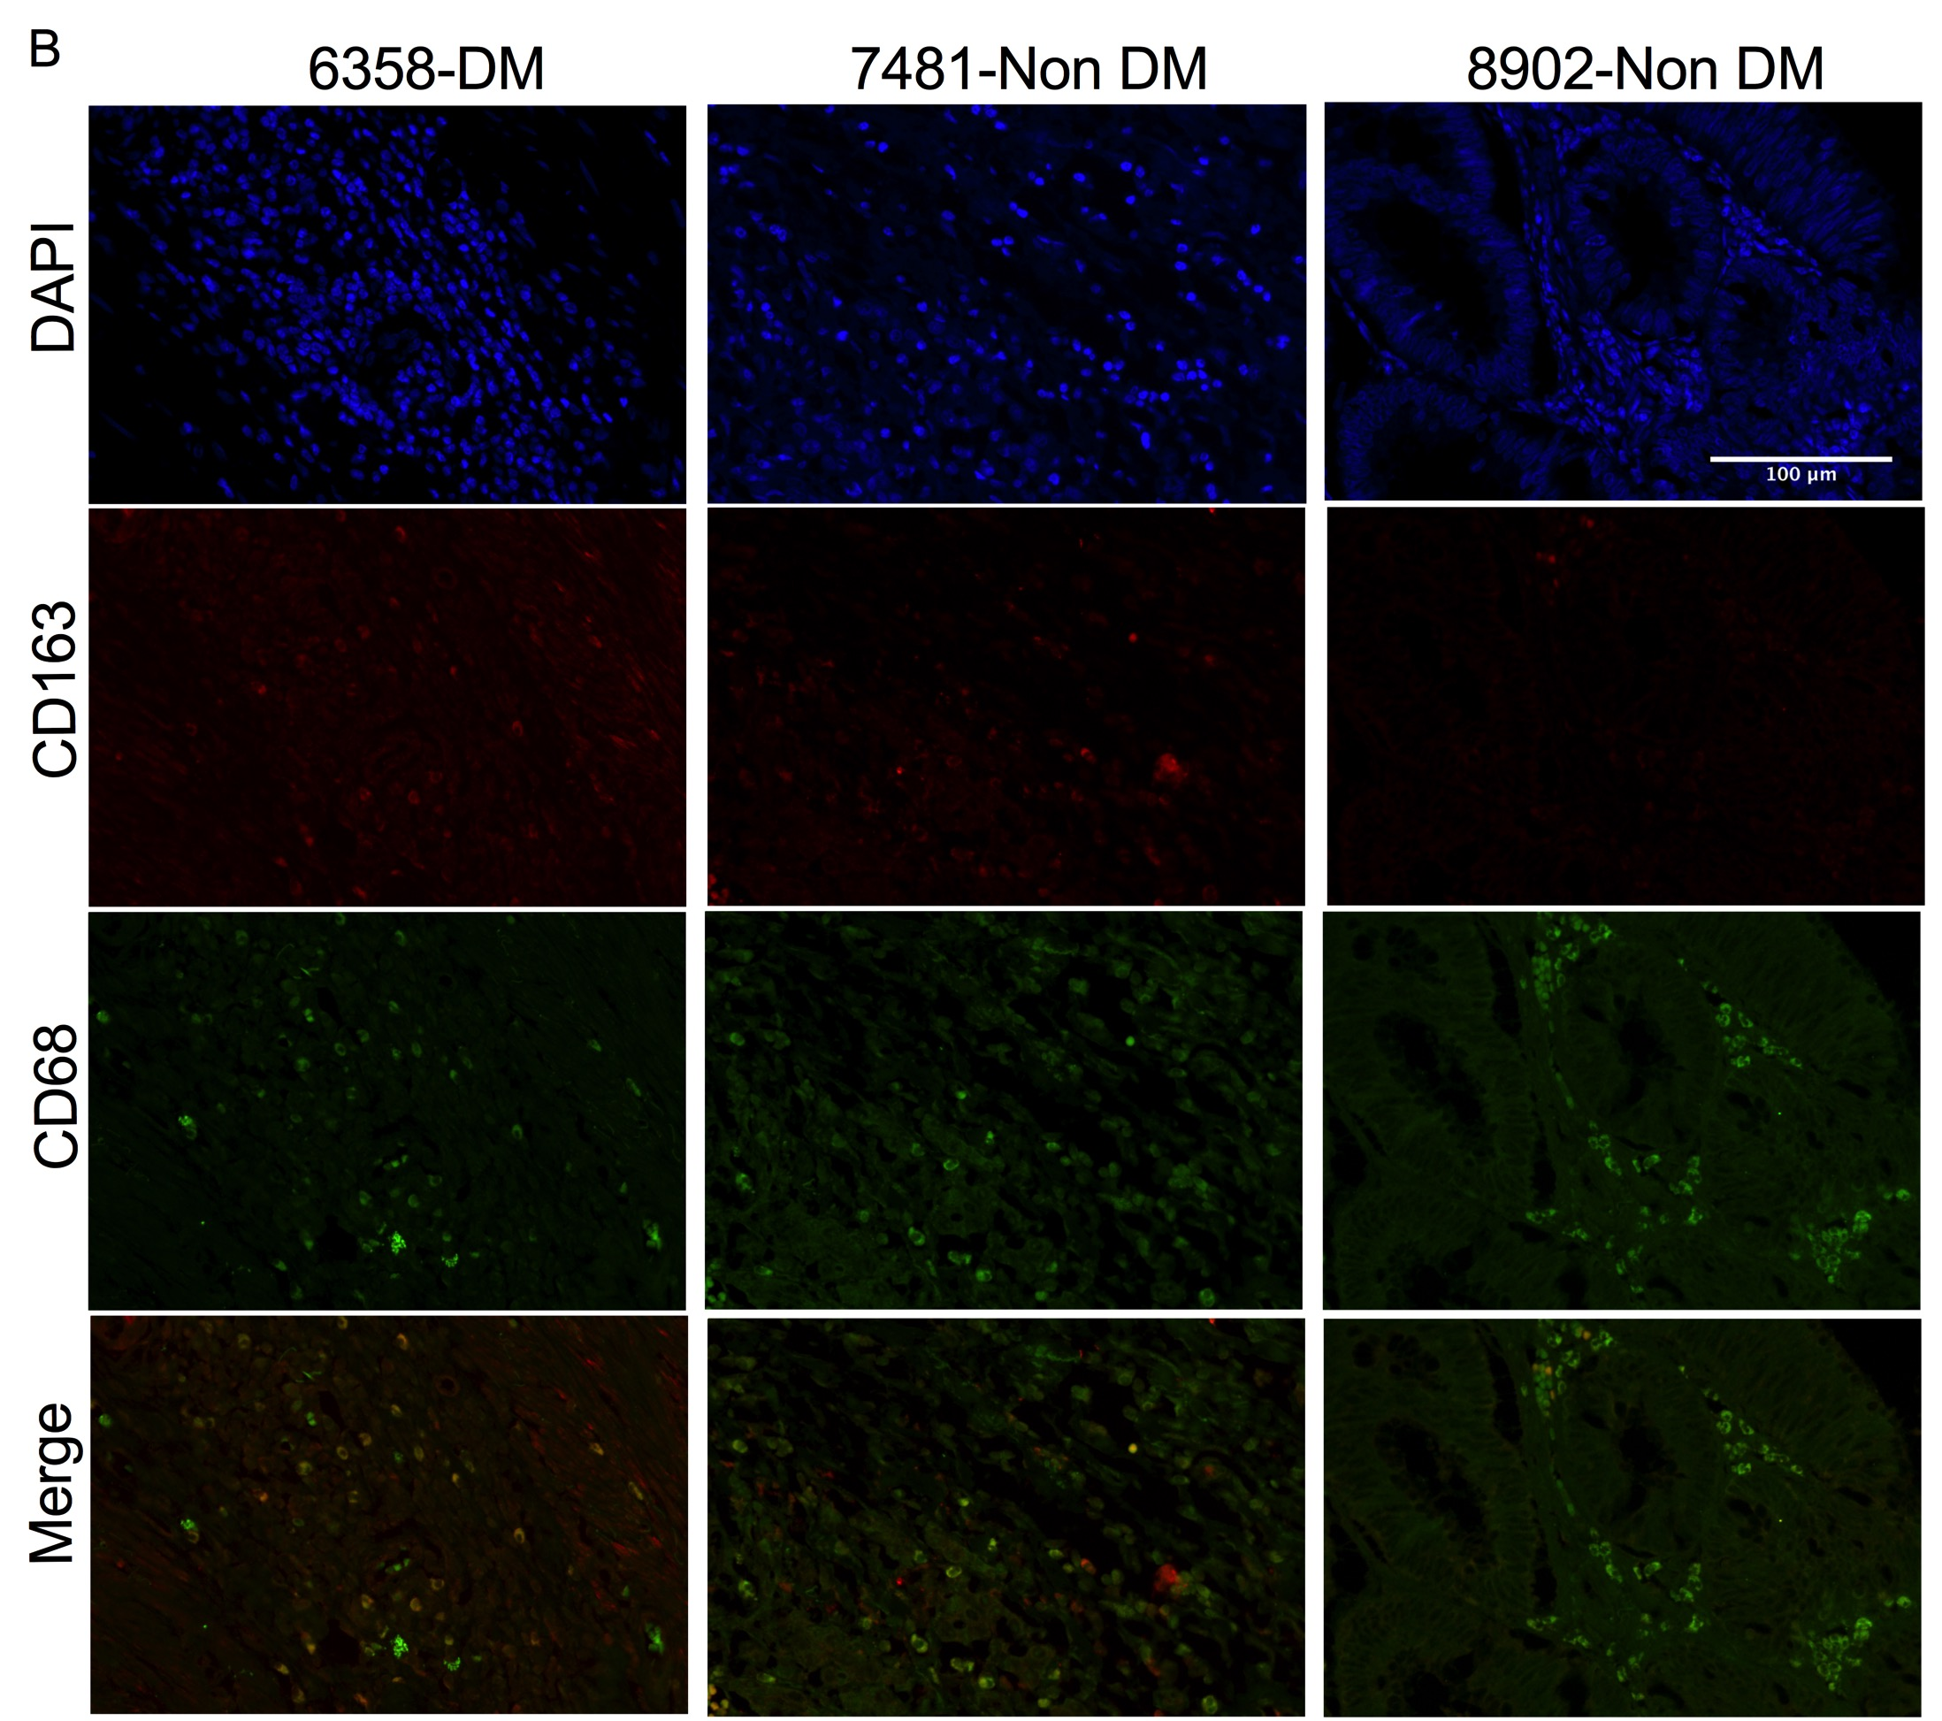

Figure S8 - Diabetes induces M2 polarization in colorectal cancer. CRC samples from patients with diabetes mellitus type 2 (DM) or not (control) were stained for the macrophage marker CD68 (green) and M2 polarization markers (A) CD206 and (B) CD163 (red). The nuclei were stained using mounting medium with DAPI (blue).

