Critical role of tumor lymphatic function in regulating tumor inflammatory and immunosuppressive microenvironment

Raghu P. Kataru¹, Catherine L. Ly¹, Jinyeon Shin¹, Hyeung Ju Park¹, Jung Eun Baik¹, Sonia Rehal¹, Sagrario Ortega², David Lyden³, and Babak J. Mehrara¹

Supplementary Figures & Legends

Supplementary Figure 1. Lymphatic vessels density at apical and basal regions of tumor (A) Representative immunofluorescent image of a normal mouse 2 wk old tumor section showing LYVE-1+ lymphatic vessels (green) in apical and basal regions of tumor. Note the absence of lymphatic vessels at the basal regions of tumor. Scale bar 500 µm.
Supplementary Figure 2. Peritumoral lymphatic vessels are dysfunctional. (A) Representative low-magnification immunofluorescent image of whole-mount ear skin of wild-type mice localizing LYVE-1⁺ lymphatic vessels with lectin 5 minutes after lectin injection (left) and representative high-magnification immunofluorescent images localizing lectin with LYVE-1⁺ initial lymphatic vessels (middle) and α-SMA⁺ collecting lymphatic vessels (right); scale bar, 100 µm. (B) Representative low-magnification (left) and high-magnification (right) immunofluorescent images of whole-B16F10-mCherry tumor section localizing LYVE-1⁺ lymphatic vessels with lectin 1 hour after lectin injection; scale bar, 500, 50 µm. (C) Representative FACS plots of CD11c⁺FITC⁺ DCs in normal flank skin-draining (left) and tumor-draining lymph nodes (right) 18 hours after injection of FITC-conjugated latex beads into normal skin or tumor, respectively. (D) FACS quantification of CD11c⁺FITC⁺ DCs in normal flank skin-draining and tumor-draining lymph nodes. N=5 per group, mean ± SD, unpaired Student’s t-test. ***P<0.001.

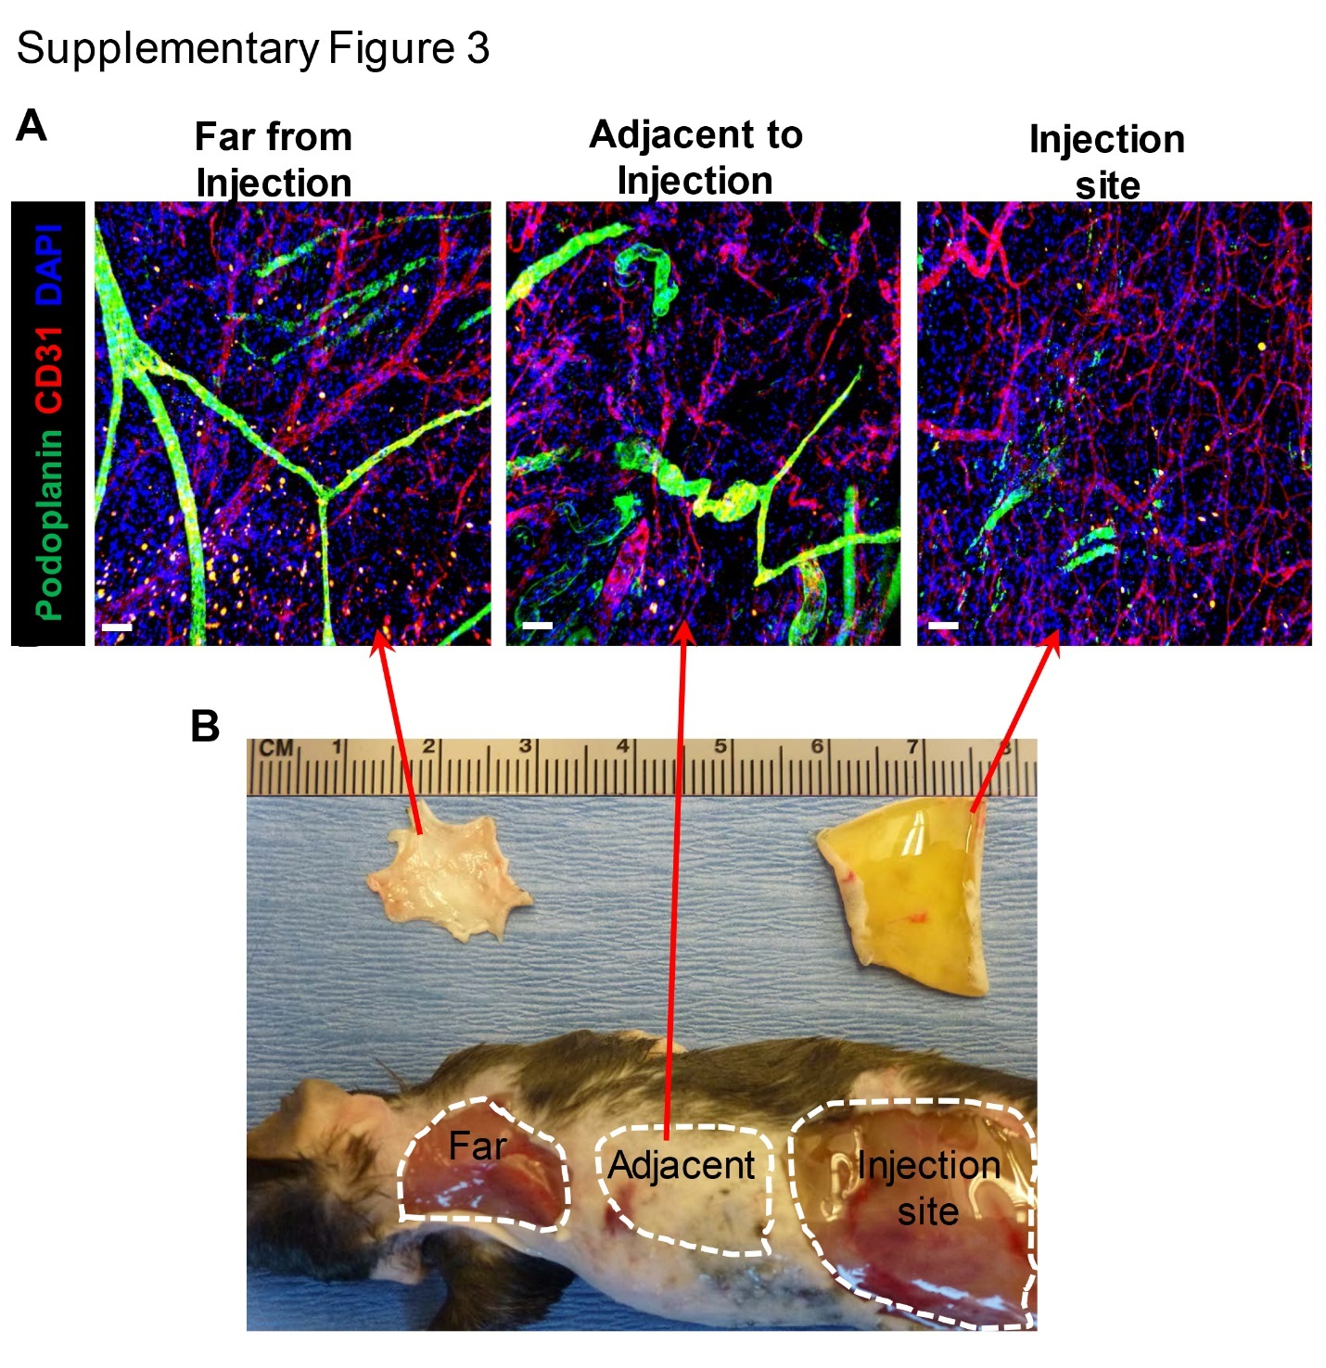
Supplementary Figure 3. Efficient local ablation of lymphatic vessels in LV-/- mice (A) Representative immunofluorescent images of LV-/- mouse back skin showing DT injection site, adjacent and far regions from injection site showing lymphatic vessels (green) and blood vessels (red); scale bar, 50 µm. Note the absence of lymphatic vessels in injection site but not in adjacent or far to injection site. (B) Representative photograph of mouse 1 week after DT injection demarcating the injection site, adjacent and far regions from DT injection. Note the presence of edematous fluid below the skin of DT injected site compared to far from injection

Supplementary Figure 4. Lymphatic ablation does not affect regional lymph node metastasis (A) Representative immunofluorescent images localizing LYVE-1 lymphatic vessels with CD31⁺ blood vessels and m-cherry+ melanoma in axillary lymph nodes 3 wk after tumor implantation melanoma tumor; scale bar, 500 µm. Arrows indicates tumor nodules. (B) Quantification of number of melanoma+ lymph nodes. All analyses conducted 3 weeks after B16F10-mCherry melanoma implantation.

Supplementary Figure 5. Lymphatic ablation does not affect tumor blood vessel permeability or adhesion molecule expression in tumor-bearing mice. (A) Representative immunofluorescent images localizing FITC lectin with CD31⁺ blood vessels in melanoma tumor; scale bar, 200 µm. (B) Pie charts depicting the percentage of MDSCs, Th2 cells, and Tregs based on FACS quantification 2 weeks after melanoma implantation. (C) Representative immunofluorescent images localizing ICAM-1 with CD31⁺ blood vessels in melanoma tumors; scale bar, 20 µm. (D) Representative immunofluorescent images localizing E-selectin with CD31⁺ blood vessels in melanoma tumors; scale bar, 200 µm. All analyses conducted 2 weeks after B16F10-mCherry melanoma implantation.

Supplementary Figure 6. PD-L1 expression on different cell types from tumors of control and LV-/- mice. (A) Schematic showing how single cell suspension of tumors are first predated on live cells and CD45+/- cells. (B). Representative FACS plots quantifying PD-L1+ m-cherry+ melanoma cells, PD-L1+ CD31+ endothelial cells. (C) Representative FACS plots quantifying PD-L1+ CD11b/Gr1+ myeloid cells, PD-L1+ CD11c+ dendritic cells.

Supplementary Figure 7. Lymphatic ablation causes local inflammation in a dose dependent manner. (A) Representative fluorescence-activated cell sorting (FACS) plots quantifying podoplanin⁺CD31⁺ lymphatic endothelial cells and podoplanin⁻CD31⁺ blood endothelial cells in foot pad skin of control and after lymphatic ablation in LV+/-, LV-/- mice. (B) Representative immunofluorescent images of skin sections localizing lymphatic vessels (green), macrophages (red). (C) Representative immunofluorescent images of skin sections localizing lymphatic vessels (green), T cells (red). scale bar, 50 µm.

