Supplementary Methods
Determination of cell lineage profile in TCGA data
Cell Lineage Scores (CLS) were calculated from tumor expression data using BASE
(1). Briefly, gene expression data from the Immunological Genome Project (ImmGen) were processed to create normalized gene expression profiles for 239 murine immune cell lineages. Genes with a 1-to-1 homology mapping to human were identified using Mouse Genome Informatics (http://www.informatics.jax.org/), and the resulting gene-by-lineage normalized expression matrix was provided as input to the BASE algorithm (2) along with gene expression for the tumor samples. The resulting CLS values for each lineage are an inferred approximation of the relative levels of lineage-specific immune infiltrate across the tumor samples. Vista was excluded from the analysis in order to rule out any potential bias when correlating CLS with VISTA expression in tumors.
Survival Analysis
For survival analysis, 313 patients with overall survival data and who did not receive adjuvant chemotherapy were selected. X-Tile (3) was used to stratify patients into high/low expression of vista with respect to a cutoff (RNA normalized log2-value of 5.18, in the range 3.09-6.08) that optimizes survival stratification of VISTA^{high}-versus- VISTA^{low} (17 samples versus 296 samples) (3). In order to conservatively correct for multiple cutoff testing and ensure the robustness of our findings despite unbalanced comparison arms, X-Tile computes an adjusted P-value for the difference between survival curves from 1000 Monte Carlo simulations using the software X-Tile was reported in addition to a standard P-value from the log rank test (3). A log-rank test with subsequent Monte Carlo simulations was used to determine significance.

Figure S1
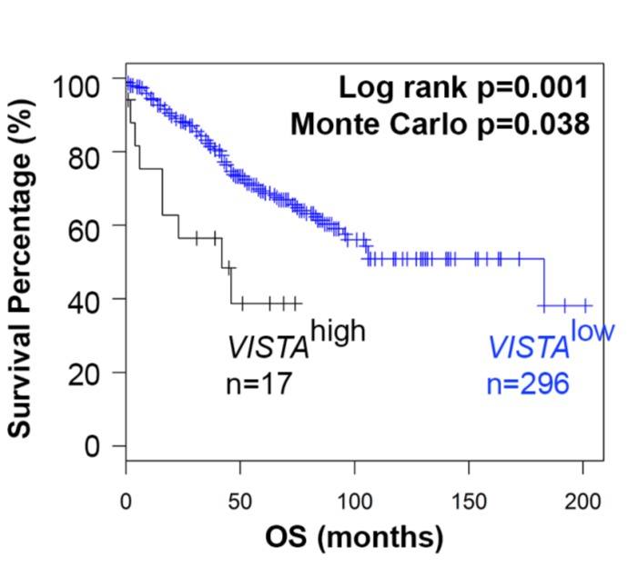

Figure S2
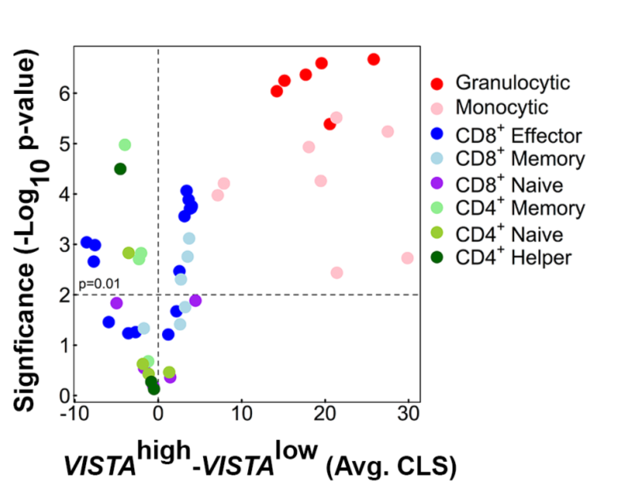

Supplementary Figure Legends
Figure S1. VISTA is an independent predictor of survival in cohort of colon cancer patients. Kaplan-Meier plot of disease specific survival stratified by VISTA expression with optimized cut-off of high/low expression. A log-rank test with subsequent Monte Carlo simulations was used to determine significance
Figure S2. Vista expression is correlated with myeloid infiltration in the TME of colon cancer patients. Volcano plot of CLS differences (granulocytic, monocytic, and αβ T cells) between VISTA^{high} and VISTA^{low} cohorts and the associated significance values obtained using Mann-Whitney tests.

References

1. Varn FS, Andrews EH, Mullins DW, Cheng C. Integrative analysis of breast cancer reveals prognostic haematopoietic activity and patient-specific immune response profiles. Nat Commun. 2016;7:10248.
2. Cheng C, Yan X, Sun F, Li LM. Inferring activity changes of transcription factors by binding association with sorted expression profiles. BMC Bioinformatics. 2007;8:452.
3. Camp RL, Dolled-Filhart M, Rimm DL. X-tile: a new bio-informatics tool for biomarker assessment and outcome-based cut-point optimization. Clin Cancer Res. 2004;10(21):7252-9.

