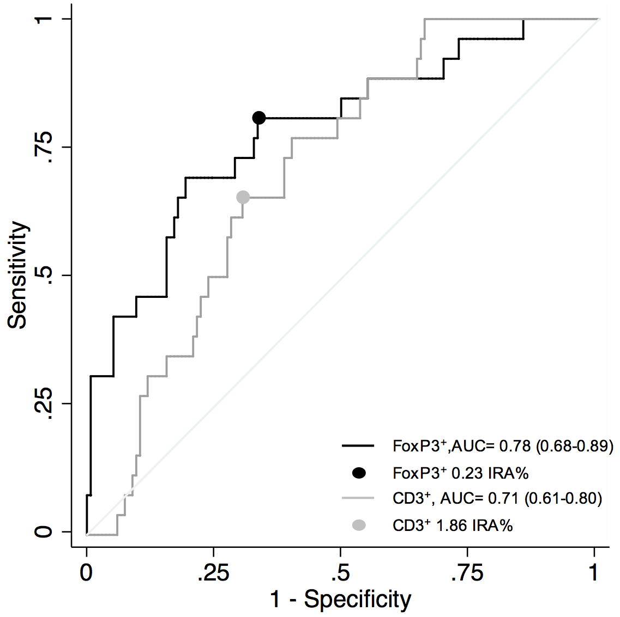
Supplementary Figure 1. ROC curves for densities of FoxP3⁺ and CD3⁺ TILs as predictors of postsurgical recurrence in patients with stage II MSS CRC, validation set. FoxP3⁺ TILs: AUC, 0.78 (bootstrap standard error, 0.05; 95%CI, 0.68-0.89) at cutoff surface of 0.23 IRA%, sensitivity, 0.81; specificity, 0.61. CD3⁺ TILs: AUC, 0.71 (bootstrap standard error, 0.05; 95%CI, 0.61-0.80); at cutoff 1.86 IRA%, sensitivity, 0.66; specificity, 0.62.

