Supplementary Figure 1. Study Design Workflow
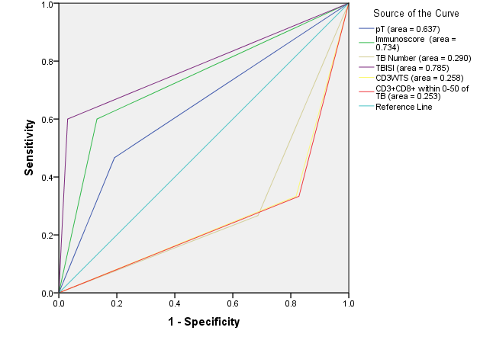

Supplementary Figure 2. ROC curves for pT stage Immunoscore and the components of the Tumor Bud-Immuno Spatial Index for the training cohort.

Supplementary Table 1: Cut-off values for image analysis features. IM = invasive margin, CT = tumour core, WTS = whole tumor section, TB = tumour bud.

Feature | Cut-off value
CD3⁺ density (cells/mm²) in IM | 319.8922
CD3⁺ density (cells/mm²) in CT | 354.4024
CD3⁺ density (cells/mm²) in WTS | 389.6020
CD8⁺ density (cells/mm²) in IM | 308.5554
CD8⁺ density (cells/mm²) in CT | 114.6642
CD8⁺ density (cells/mm²) in WTS | 182.1744
TB.Number | 1104.0000

Features from clinicopathological report | Univariate Cox Regression
 | HR | 95% CI |  | p Value
 |  | Lower | Upper
Age | 1.466 | 0.782 | 2.747 | 0.233
Gender | 0.851 | 0.308 | 2.347 | 0.755
pT | 4.143 | 1.480 | 11.570 | 0.006
Site of Tumor | 0.663 | 0.337 | 1.305 | 0.234
Differentiation | 2.025 | 0.968 | 4.238 | 0.061
Max tum diameter 5cm | 1.224 | 0.411 | 3.646 | 0.716
Apical Node exam binary | 0.366 | 0.082 | 1.641 | 0.189
EMLVI | 0.342 | 0.117 | 1.000 | 0.050
Tumor Type | 4.606e-08 | 0 | Inf | 0.998
Features from image analysis
CD3⁺ density in IM | 0.997 | 0.995 | 0.999 | 0.0023
CD3⁺ density in CT | 0.994 | 0.991 | 0.998 | 0.0003
CD3⁺ density in WTS | 0.995 | 0.993 | 0.998 | 0.0005
CD8⁺ density in IM | 0.997 | 0.995 | 1.000 | 0.0253
CD8⁺ density in CT | 0.997 | 0.994 | 1.000 | 0.0231
CD8⁺ density in WTS | 0.997 | 0.994 | 1.000 | 0.0187
Ratio of CD3⁺ to CD8⁺ densities in IM | 1.132 | 0.819 | 1.565 | 0.4515
Ratio of CD3⁺ to CD8⁺ densities in CT | 0.982 | 0.862 | 1.120 | 0.7842
Ratio of CD3⁺ to CD8⁺ densities in WTS | 0.991 | 0.827 | 1.189 | 0.9245
TB Number | 1.001 | 1.000 | 1.001 | 0.0004
TB Density | 1.030 | 1.000 | 1.060 | 0.0446
CD3⁺ number within 0-50μm of TB | 0.999 | 1.000 | 1.000 | 0.3686
Mean CD3⁺ number within 0-50μm of TB | 0.651 | 0.481 | 0.881 | 0.0054
CD3⁺ number within 0-100μm of TB | 0.999 | 1.000 | 1.000 | 0.1590
Mean CD3⁺ number within 0-100μm of TB | 0.830 | 0.737 | 0.936 | 0.0023
CD8⁺ number within 0-50μm of TB | 0.999 | 1.000 | 1.000 | 0.2266
Mean CD8⁺ number within 0-50μm of TB | 0.601 | 0.405 | 0.892 | 0.0115
CD8⁺ number within 0-100μm of TB | 0.999 | 1.000 | 1.000 | 0.1495
Mean CD8⁺ number within 0-100μm of TB | 0.851 | 0.751 | 0.966 | 0.0122
CD3⁺CD8⁺ number within 0-50μm of TB | 0.999 | 1.000 | 1.000 | 0.2534
Mean CD3⁺CD8⁺ number within 0-50μm of TB | 0.765 | 0.639 | 0.915 | 0.0033
CD3⁺CD8⁺ number within 0-100μm of TB | 1.000 | 1.000 | 1.000 | 0.1144
Mean CD3⁺CD8⁺ number within 0-100μm of TB | 0.904 | 0.847 | 0.964 | 0.0022
Supplementary Table 2: Univariate Cox-regression analysis for patient clinicopathological and all image analysis data of training cohort. Significant features (p < 0.05) are shown in bold. HR = hazard ratio, CI = confidence interval, EM LVI = Extramural lymphovascular invasion, IM = invasive margin, CT = tumour core, WTS = whole tumor section, TB = tumor bud.

Feature | CD3_Cells_IM | CD3_Cells_CT | T_CD3_Cells | CD8_Cells_IM | CD8_Cells_CT | T_CD8_Cells | TB.Number
CD3_Cells_IM | NA | 0.000154 | 1.59 x 10⁻¹⁶ | 3.11 x 10⁻¹¹ | 2.62 x 10⁻⁰⁶ | 5.90 x 10⁻⁰⁹ | 0.015960
CD3_Cells_CT | 0.000154 | NA | 1.95 x 10⁻⁴⁶ | 0.063281 | 0.067623 | 0.053506 | 0.811996
T_CD3_Cells | 1.59 x 10⁻¹⁶ | 1.95 x 10⁻⁴⁶ | NA | 3.59 x 10⁻⁰⁵ | 0.000925 | 0.000116 | 0.492053
CD8_Cells_IM | 3.11 x 10⁻¹¹ | 0.063281 | 3.59 x 10⁻⁰⁵ | NA | 4.44 x 10⁻²⁷ | 1.30 x 10⁻⁵¹ | 0.037192
CD8_Cells_CT | 2.62 x 10⁻⁰⁶ | 0.067623 | 0.000925 | 4.44 x 10⁻²⁷ | NA | 1.11 x 10⁻⁶⁵ | 0.070321
T_CD8_Cells | 5.90 x 10⁻⁰⁹ | 0.053506 | 0.000116 | 1.30 x 10⁻⁵¹ | 1.11 x 10⁻⁶⁵ | NA | 0.041066
TB.Number | 0.01596 | 0.811996 | 0.492053 | 0.037192 | 0.070321 | 0.041066 | NA
Supplementary Table 3: P values of association between tumour buds and lymphocytic infiltration pattern distributions. CD3_Cells_IM = CD3⁺ density at the invasive margin, CD3_Cells_CT = CD3⁺ density at the tumour core, T_CD3_Cells = CD3⁺ density at the whole tumour section, CD8_Cells_IM = CD8⁺ density at the invasive margin, CD8_Cells_CT = CD8⁺ density at the tumour core , T_CD8_Cells = CD8⁺ density at the whole tumour section, TB.Number = Tumour Bud Number.

Variables in the equation | Multivariate Cox Regression Model
 | HR | 95% CI |  | P Value
 |  | Lower | Upper
Tumor Bud-Immuno spatial index | 18.755 | 6.462 | 54.434 | 6.963 x 10⁻⁸
Variables not in equation
pT stage |  |  |  | NS
Immunoscore |  |  |  | NS
TB Number |  |  |  | NS
Supplementary Table 4: Features entered into the multivariate forward stepwise cox regression. Features which add significance (on the top half of table) and features which do not add (on the bottom half of the table) to an integrative model to predict disease specific death. HR = hazard ratio, CI = confidence interval, TB= Tumor Bud, NS = Non-significant.

