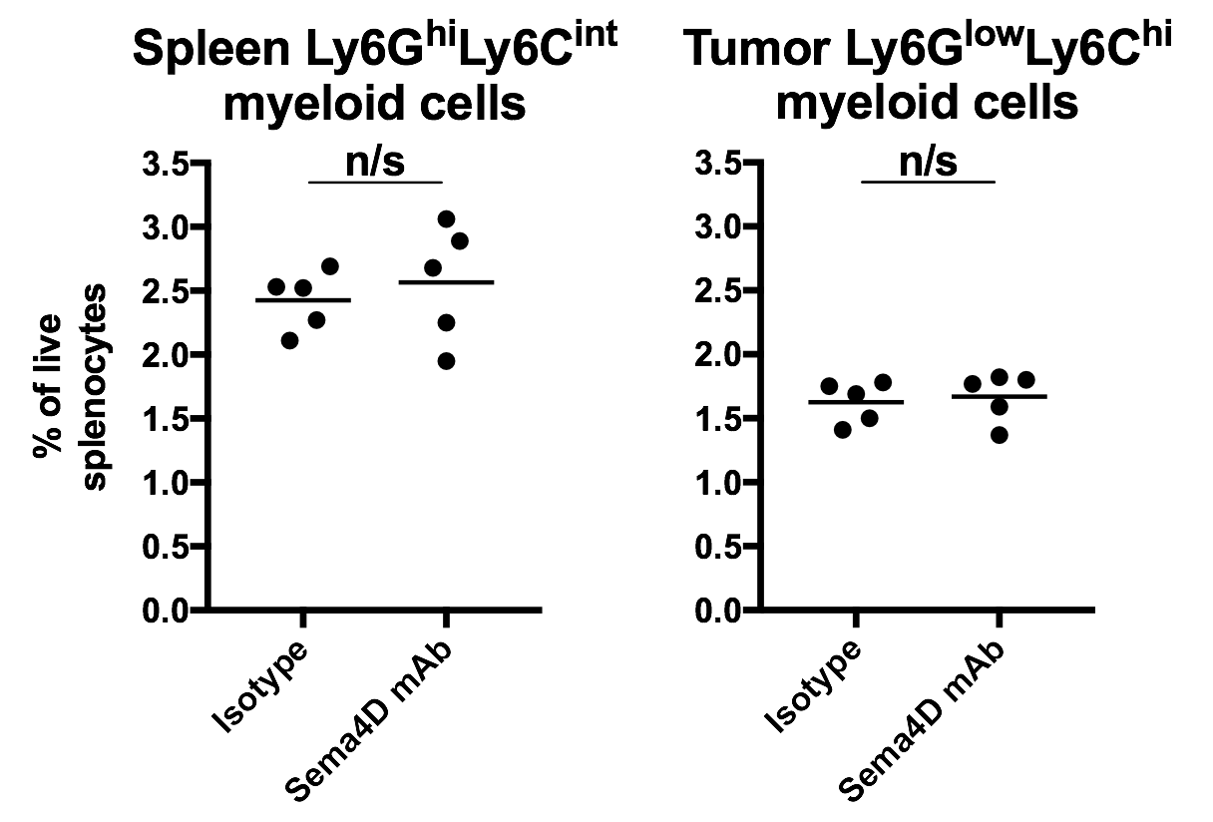

Supplemental figure S1 – Sema4D mAb did not alter peripheral Ly6G^{hi}Ly6C^{int} myeloid cell accumulation
Mice bearing MOC1 tumors were treated with Sema4D mAb (200 μg/injection once every 7 days x 4) or isotype control (n=5/group) and splenocytes harvested 1 day after the last Sema4D mAb treatment were analyzed via flow cytometry for CD45.2⁺CD11b⁺Ly6G^{hi}Ly6C^{int} myeloid cell or CD45.2⁺CD11b⁺Ly6G^{low}Ly6C^{hi} myeloid cell accumulation.
n/s, not significant.

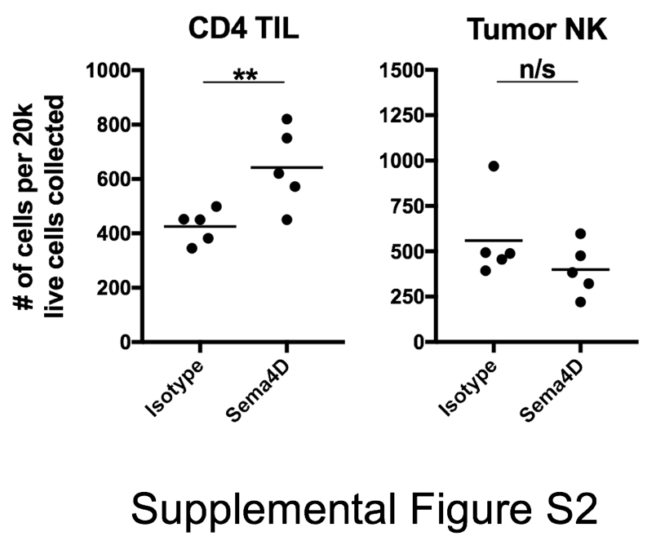
Supplemental figure S2 – Sema4D mAb increased CD4⁺ TIL but not NK cell tumor infiltration
Mice bearing MOC1 tumors were treated with Sema4D mAb (200 μg/injection once every 7 days x 4) or isotype control (n=5/group) and whole tumor digests harvested 1 day after the last Sema4D mAb treatment were analyzed via flow cytometry for CD3⁺CD4+ T-lymphocyte or NK1.1⁺CD3⁻ NK cell infiltration.
**, p<0.01. n/s, not significant.

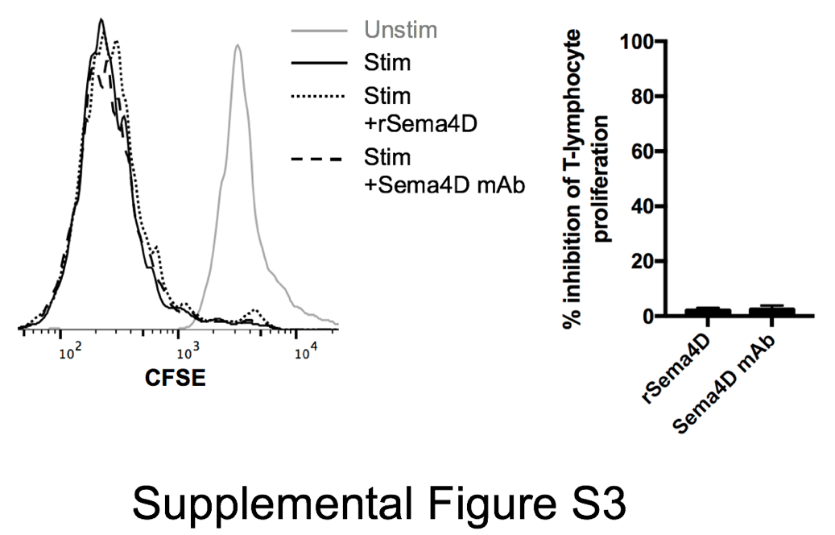
Supplemental figure S3 – Recombinant Sema4D or Sema4D mAb did not directly alter ex vivo T-lymphocyte proliferation
Sorted naïve peripheral T-lymphocytes were CFSE-labelled and stimulated with CD3/28 microbeads (1:1 bead to T-lymphocyte ratio) in the presence or absence of rSema4D (10 μg/mL) or Sema4D mAb (10 μg/mL) and CFSE dilution was measured by flow cytometry. Representative overlaid histograms on left, quantified on right.

