Supplemental Figures (Roghanian et al., CIR-18-0835R)
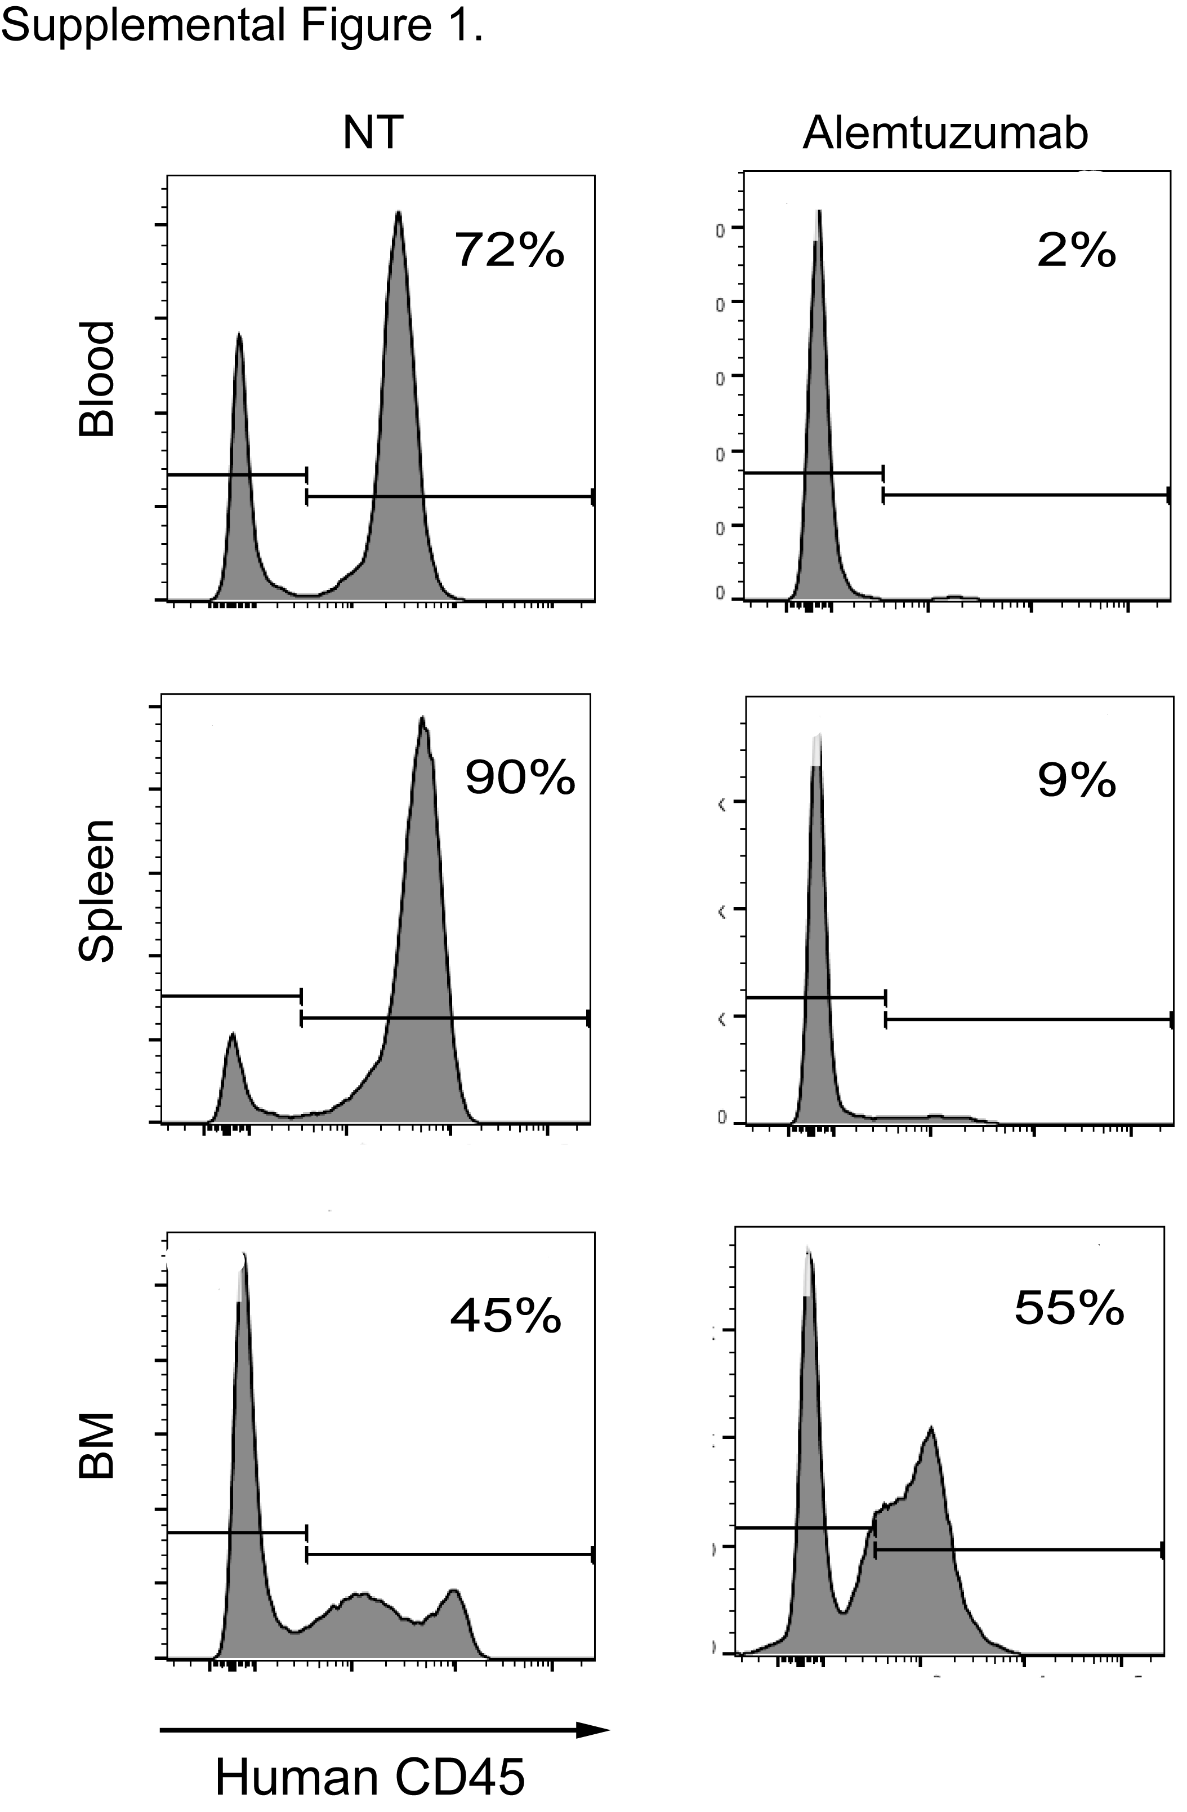

Supplemental Figure 1 (related to Figure 1A). BM-resident B-lymphoma cells are refractory to alemtuzumab treatment. Adult NSG mice were engrafted with 1x10⁷ human B-lymphoma cells and subsequently treated with 10 mg/kg alemtuzumab (anti- human CD52). Mice were sacrificed 5 days post mAb treatment and assayed for the presence of human lymphoma cells in the blood, spleen and BM. Shown are representative histograms for human CD45 staining of total live cells from blood, spleen and BM of non-treated (NT) and alemtuzumab-treated mice (n = 3 mice/group).

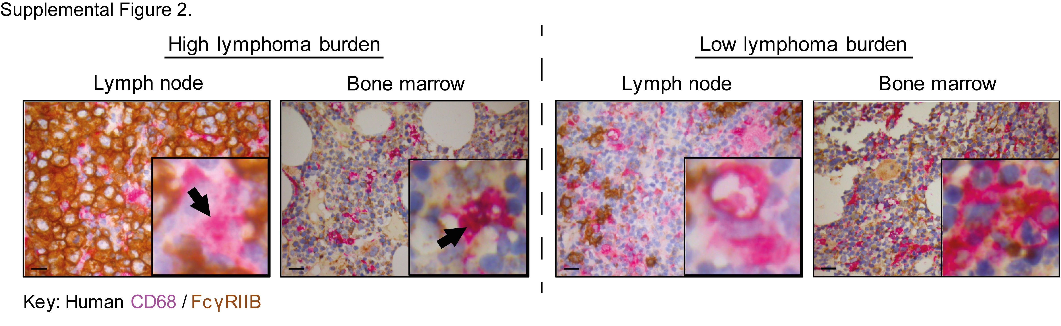

Supplemental Figure 2 (related to Figure 1D). Human BM macrophages express higher levels of FcγRIIB compared to those in LN. FFPE diagnostic LN biopsies and staging BM trephines from a patient with DLBCL were double-stained with antibodies to human CD68 (pink) and FcγRIIB (brown) on the same slide. Representative IHC images are shown (original magnification x400; scale bar is 20µm) from areas with high (left panel) and low lymphoma burden (right panel). The insert in each image represents 10x higher magnification of a representative macrophage taken from the same section. Black arrows point to CD68⁺ macrophages in the LN and BM.

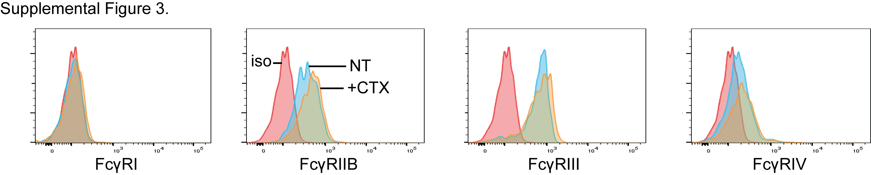

Supplemental Figure 3 (related to Figure 2). CTX treatment results in a modest increase in Ly6C⁺ monocyte FcγRs in non-tumor-bearing mice. Representative flow cytometry histograms of activatory and inhibitory FcγR expression by BM Ly6C⁺ monocytes 2 days post CTX (100 mg/kg) treatment. Red trace: isotype control; blue trace: NT; orange trace: CTX treatment.

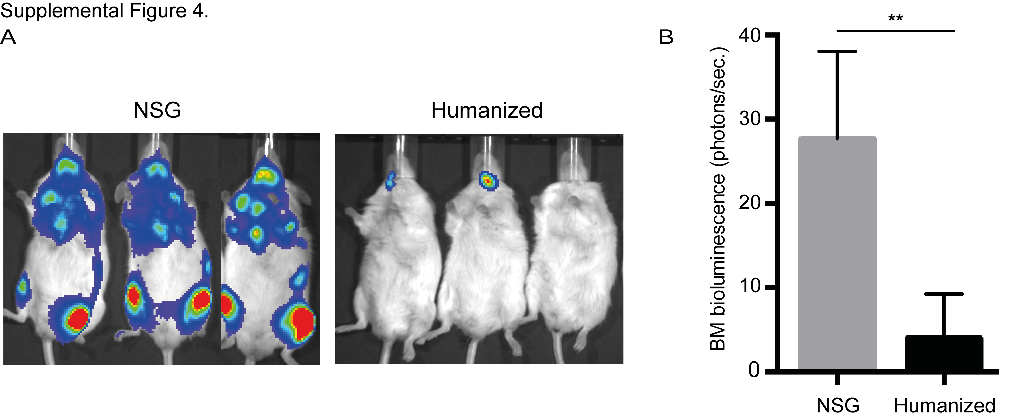
Supplemental Figure 4 (related to Figure 5). Lymphoma cells are rejected from fully reconstituted humanized mice. Adult NSG or humanized mice were engrafted with 1x10⁷ human lymphoma cells intravenously and monitored by (A) IVIS imaging for tumor presence and (B) quantification of bioluminescence intensity of lymphoma cells in the BM; n = 3 mice/group (** p <0.01).

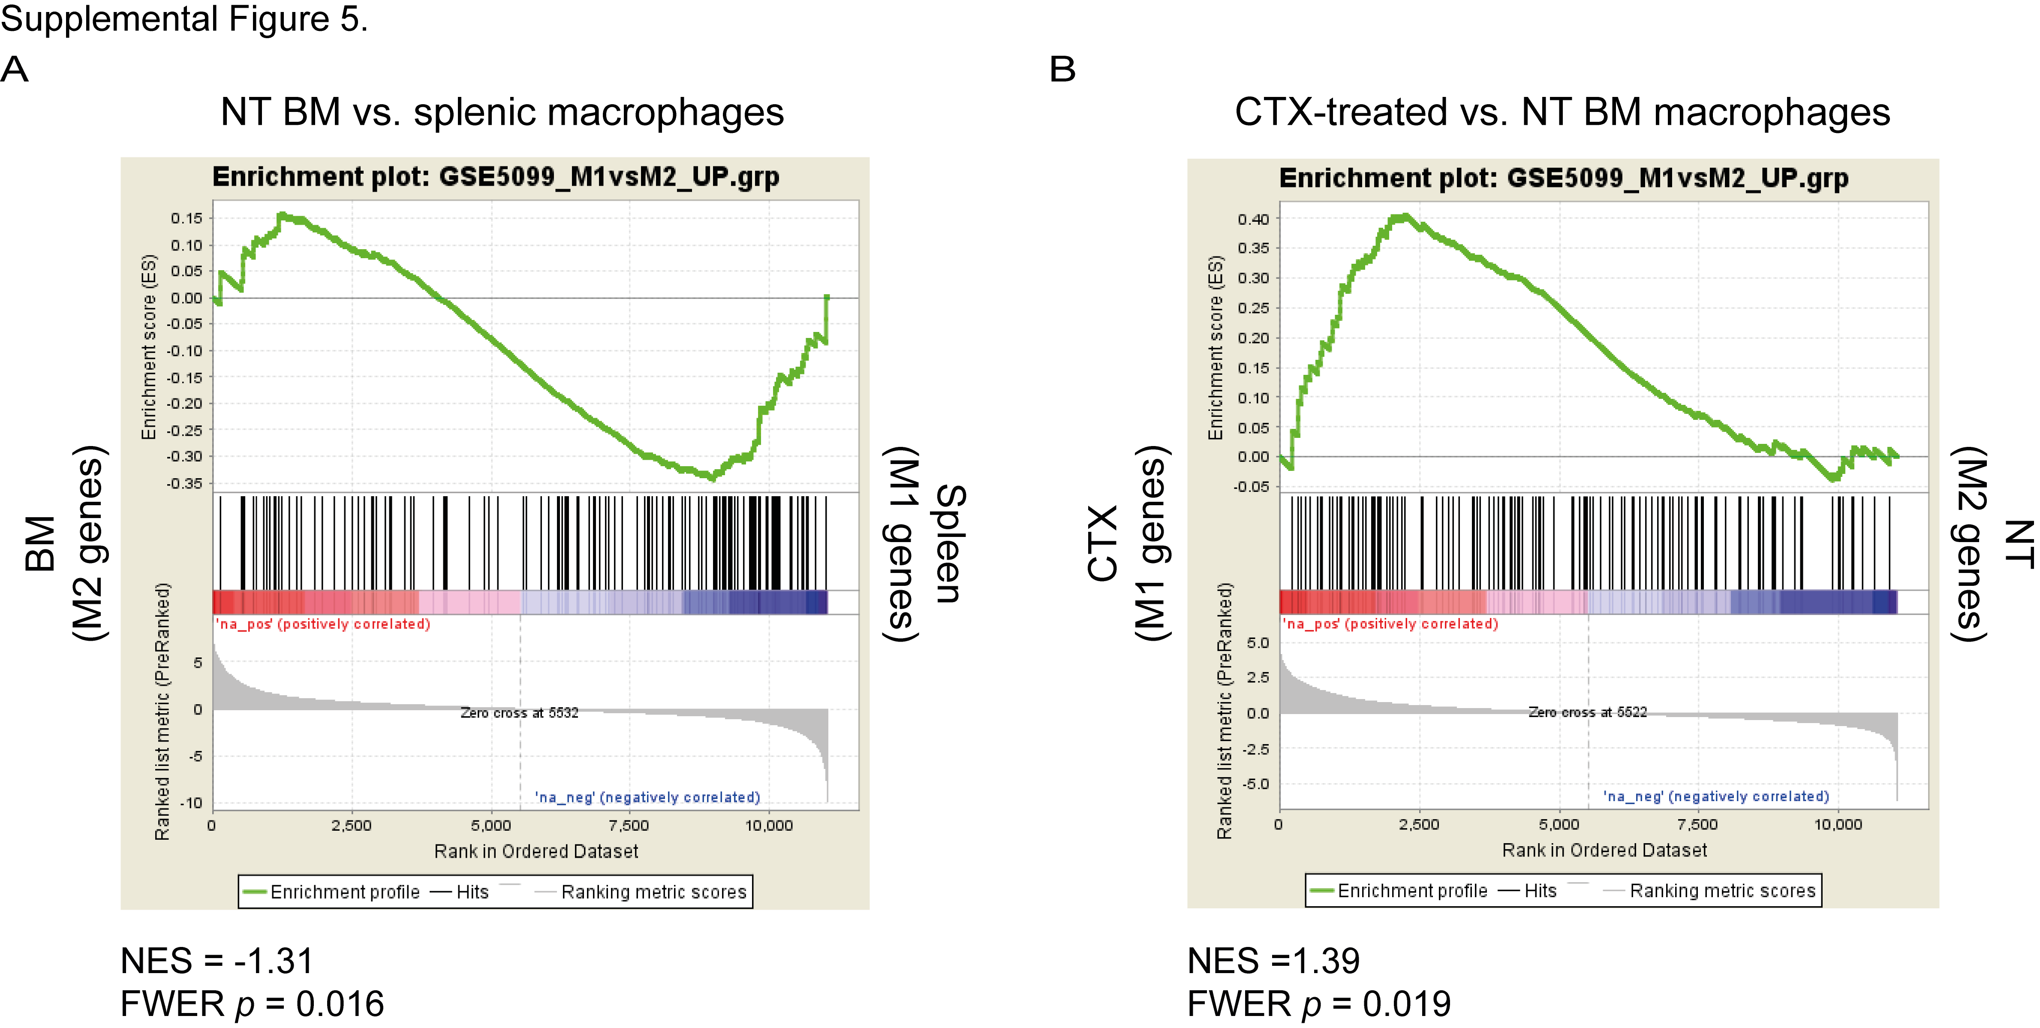

Supplemental Figure 5 (related to Figure 6). BM-resident macrophages resemble M2-like macrophages in the steady state, and shift towards M1-like macrophage upon CTX treatment. ‘Healthy’ humanized mice were injected with 100 mg/kg CTX and splenic and BM macrophages were isolated from non-treated control (NT) and CTX-treated (CTX) mice 2 days later, and subjected to RNAseq analysis. GSEA graphs showing (A) a significant enrichment for M1-polarizing genes in splenic versus BM-resident macrophages in the steady state, and (B) a shift in the balance of BM macrophages towards M1 polarization upon CTX treatment. UP; upregulated, NES; normalized enrichment score; FWER; familywise-error rate.

