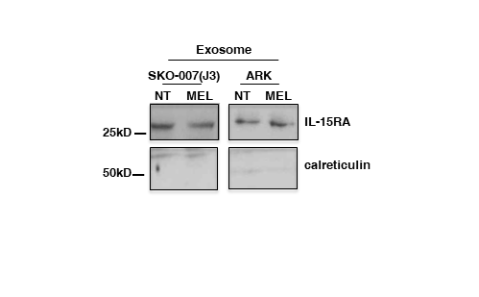
Fig S5. MEL-treated SKO-007(J3) and ARK exosomes display a similar IL-15RA expression. IL-15RΑ and calreticulin expression was evaluated in exosome lysates by Western blot analysis.

