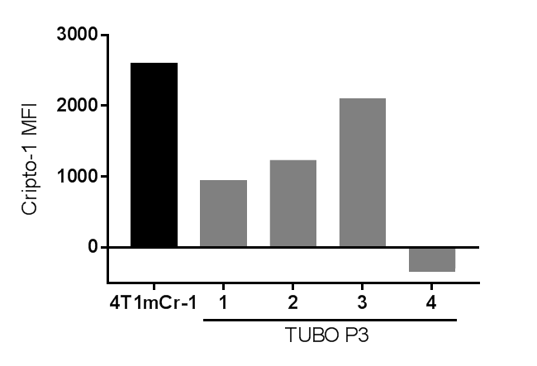

**Supplementary Fig. S7: Cripto-1 expression on TUBO P3 cells.**

TUBO P3 cells from 4 independent cultures were stained following flow cytometry staining protocol. Cripto-1 expression was detected by flow cytometry and mean fluorescent intensity calculated. Cripto-1 MFI was calculated: MFI (pmCr-1) – MFI (pVAX).