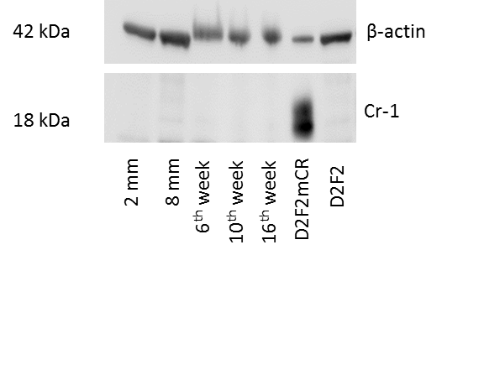

**Supplementary Fig. S4: Western blot analysis of Cripto-1 expression in BALB-neuT primary lesions.**

Primary lesions in the BALB-neuT mice were excised at size 2mm and 8 mm and at 6 weeks, 10 weeks and 16 weeks of age. Cell lysates were prepared of all samples. Lysates from 4T1 and 4T1mCr-1 cell lines are used as negative and positive controls. Cripto-1 levels was qualitatively evaluated by western blot analysis in all samples.