Supplementary Information for Manuscript:
Using antigen-specific B cells to combine antibody and T cell based cancer immunotherapy

Kerstin Wennhold, Martin Thelen, Hans Anton Schlößer, Natalie Haustein, Sabrina Reuter, Maria Garcia-Marquez, Axel Lechner, Sebastian Kobold, Felicitas Rataj, Olaf Utermöhlen, Jan Becker, Geothy Chakupurakal, Sebastian Theurich, Michael Hallek, Hinrich Abken, Alexander Shimabukuro-Vornhagen, Michael von Bergwelt-Baildon
Supplementary figures
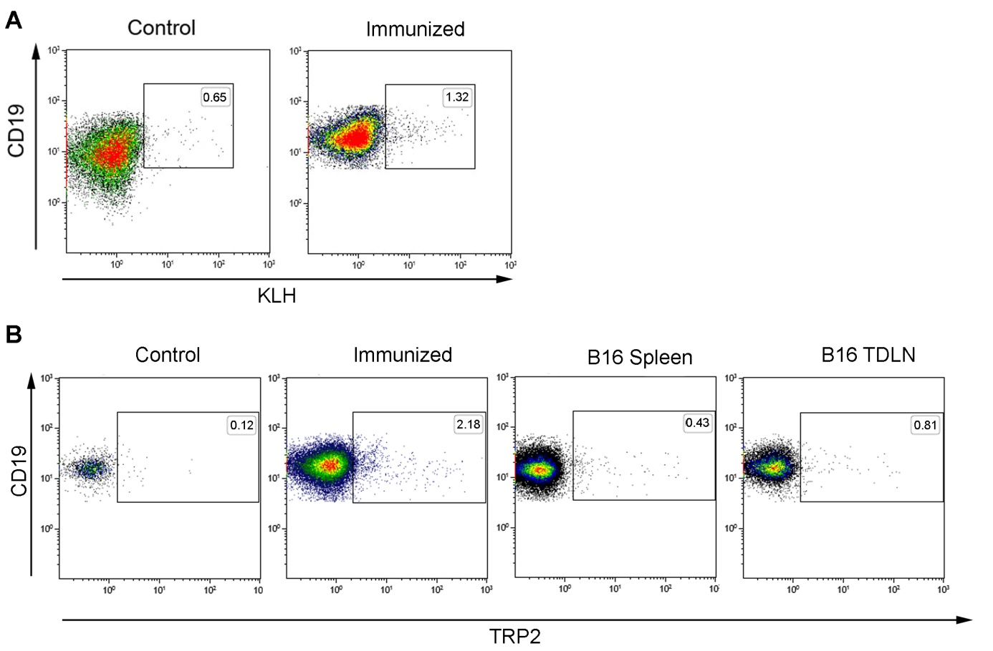
Fig. S1. Flow cytometry staining of KLH and TRP2-specific B cells.
(A) Mice were immunized with 10 µM KLH-protein in IFA twice in an interval of 7 days. 7 days after the last immunization, B cells were isolated from spleens and analyzed by flow cytometry for the presence of KLH-specific B cells. Representative plots of 5 independent experiments are shown. (B) Mice were either immunized with TRP2-Protein in IFA twice in an interval of 7 days (Immunized plot) or they received a single injection of B16.F1 melanoma cells s.c. (B16 spleen and B16 tumor draining lymph node (TDLN)). 7 days later B cells were isolated from spleens or TDLN and analyzed by flow cytometry for the presence of TRP2-specific B cells. Spleens from healthy untreated mice served as controls. Representative plots of 5 independent experiments are shown.

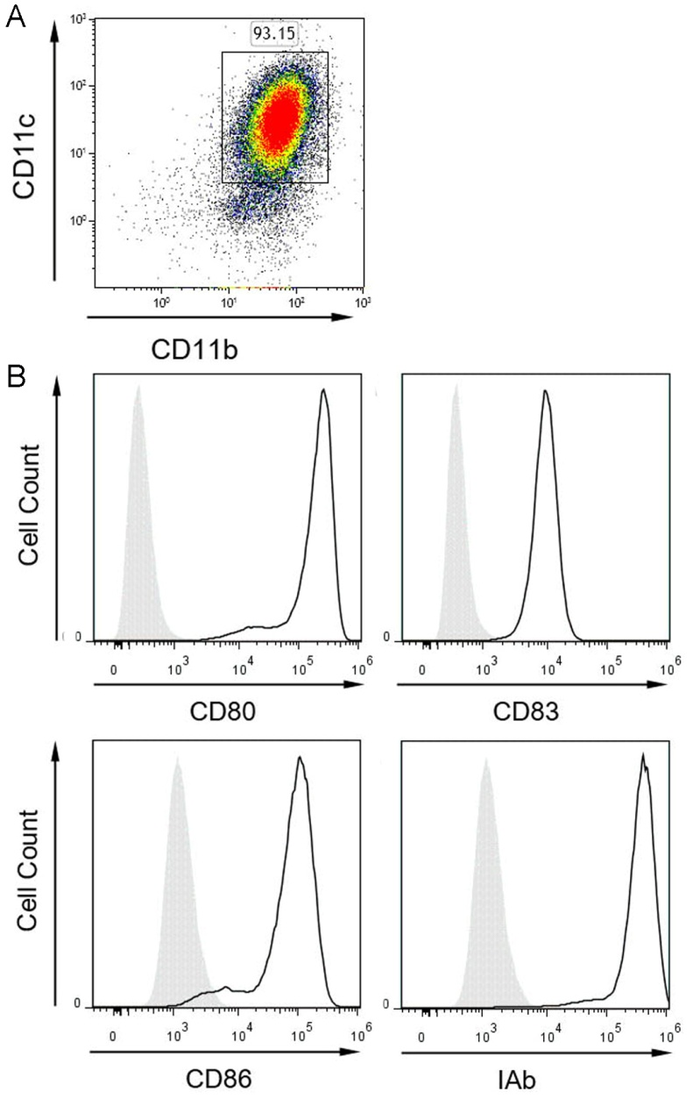

Fig. S2. Quality control of CD40L-matured DCs.
Representative flow cytometry analyses of CD40L-matured DCs out of at least five independent experiments are shown. Mature DCs were stained for (A) CD11b⁺CD11c⁺ cells and (B) among this population for the activation markers CD80, CD83, CD86 and IAb were indicated (black line) compared to an isotype control (filled line).

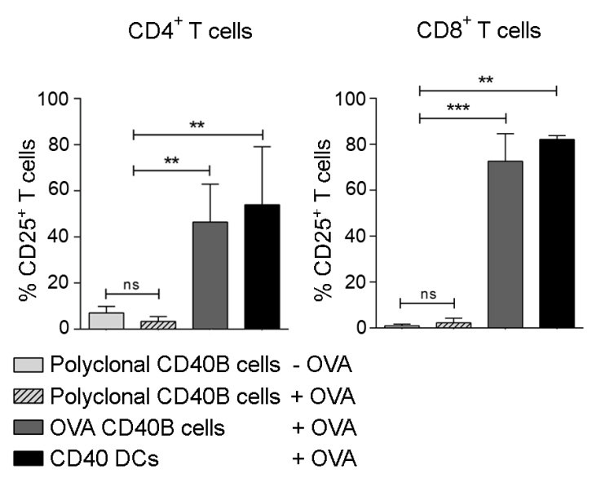
Fig. S3. Antigen-specific CD40B cells activate specific T cells.
In antigen-presentation assays, T cells from OT-II (CD4⁺ T cells) or OT-I (CD8⁺ T cells) mice were cocultured with different unpulsed or protein-pulsed APCs, i.e. polyclonal CD40B cells, OVA-CD40B cells and CD40L-matured DCs (CD40 DCs). The percentage of activated T cells was determined by expression of CD25. Significant differences calculated with one-way ANOVA are marked by an asterisk. ns = not significant, ** p ≤ 0.01, *** p ≤ 0.001.

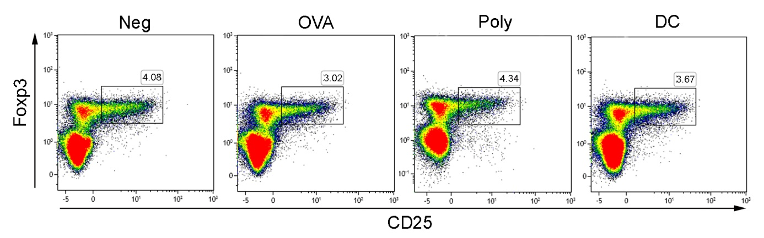
Fig. S4. T cells of immunized mice show normal percentages of Tregs.
B6 mice were immunized with protein-pulsed APCs, i.e. OVA-CD40B cells (OVA), polyclonal CD40B cells (Poly), CD40-matured DCs. PBS served as negative control (Neg). CD3⁺ CD4⁺ T cells from vaccinated mice were stained for the presence of CD25⁺ Foxp3⁺ Tregs. Density plots show representative analyses out of three independent experiments.

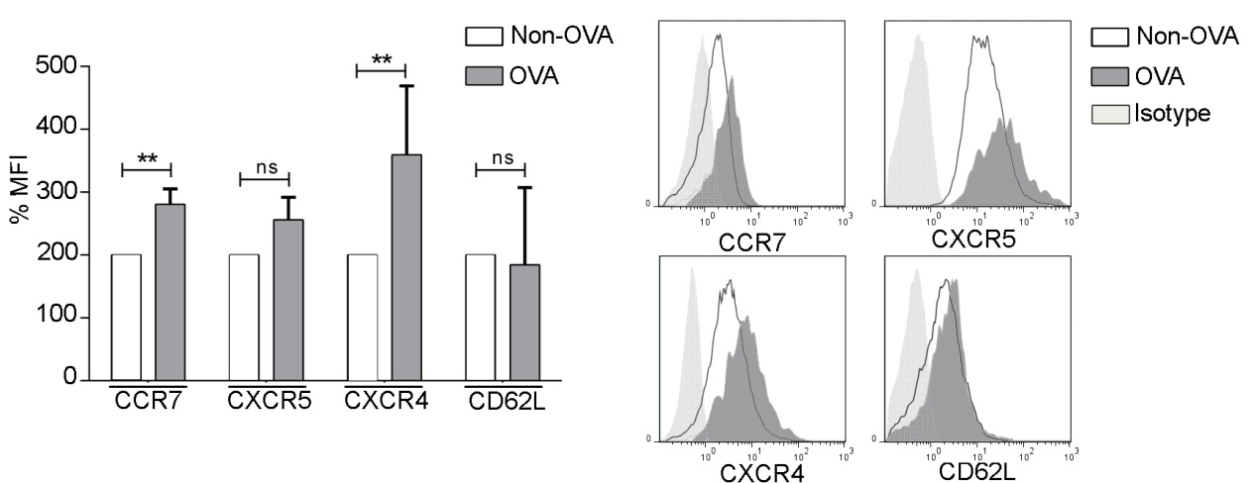
Fig. S5. Unstimulated OVA-B cells express homing molecules.
OVA-B cells from Luc⁺ mice were analyzed by flow cytometry for the expression of the migratory markers CCR7, CXCR5, CXCR4 and CD62L. The MFI was normalized to values of non-specific B cells of the same mice. Significant differences calculated with a two-tailed t-test are marked by an asterisk. ns = not significant, ** p ≤ 0.01. Histograms show representative analyses compared to an isotype control.

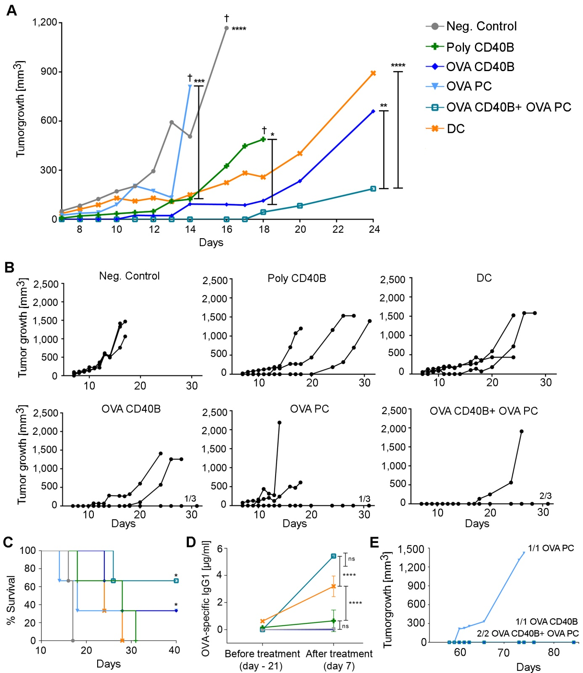
Fig. S6. Preventive combinational immune intervention protects from tumor growth. Mice were treated with 0.1-2 x 10⁶ APCs, i.e. polyclonal CD40B cells (Poly CD40B), OVA-CD40B cells (OVA CD40B), DCs; PBS+IFA as negative controls (Neg. Control); OVA-specific PCs alone (OVA PC) or in combination with OVA-CD40B cells (OVA CD40B+ OVA PCs), thrice i.v. every seven days. On day 28, mice were challenged with 0.4 x 10⁶ E.G7 cells s.c. Growth curves show (A) mean increase or (B) single increase of tumor volume in mm³ of one representative experiment out of three with three mice per group.. Significant differences calculated with a two-way ANOVA are marked by an asterisk. * p ≤ 0.05, ** p ≤ 0.007, *** p ≤ 0.0005, **** p ≤ 0.0001. (C) Survival curves show means of one representative experiment out of three with three mice per group. Significant differences were calculated with the log-rank test: * p ≤ 0.02. (D) Serum samples of mice were taken before treatment and on the day of tumor challenge. ELISA for OVA-specific IgG1 antibodies was performed. Significant differences calculated with two-way ANOVA are marked by an asterisk. ns = not significant, **** p ≤ 0.0001. (E) On day 50 after the first tumor cell injection, tumor-free mice were rechallenged with 0.4 x 10⁶ E.G7 lymphoma cells sc. Tumor growth was measured until day 84.

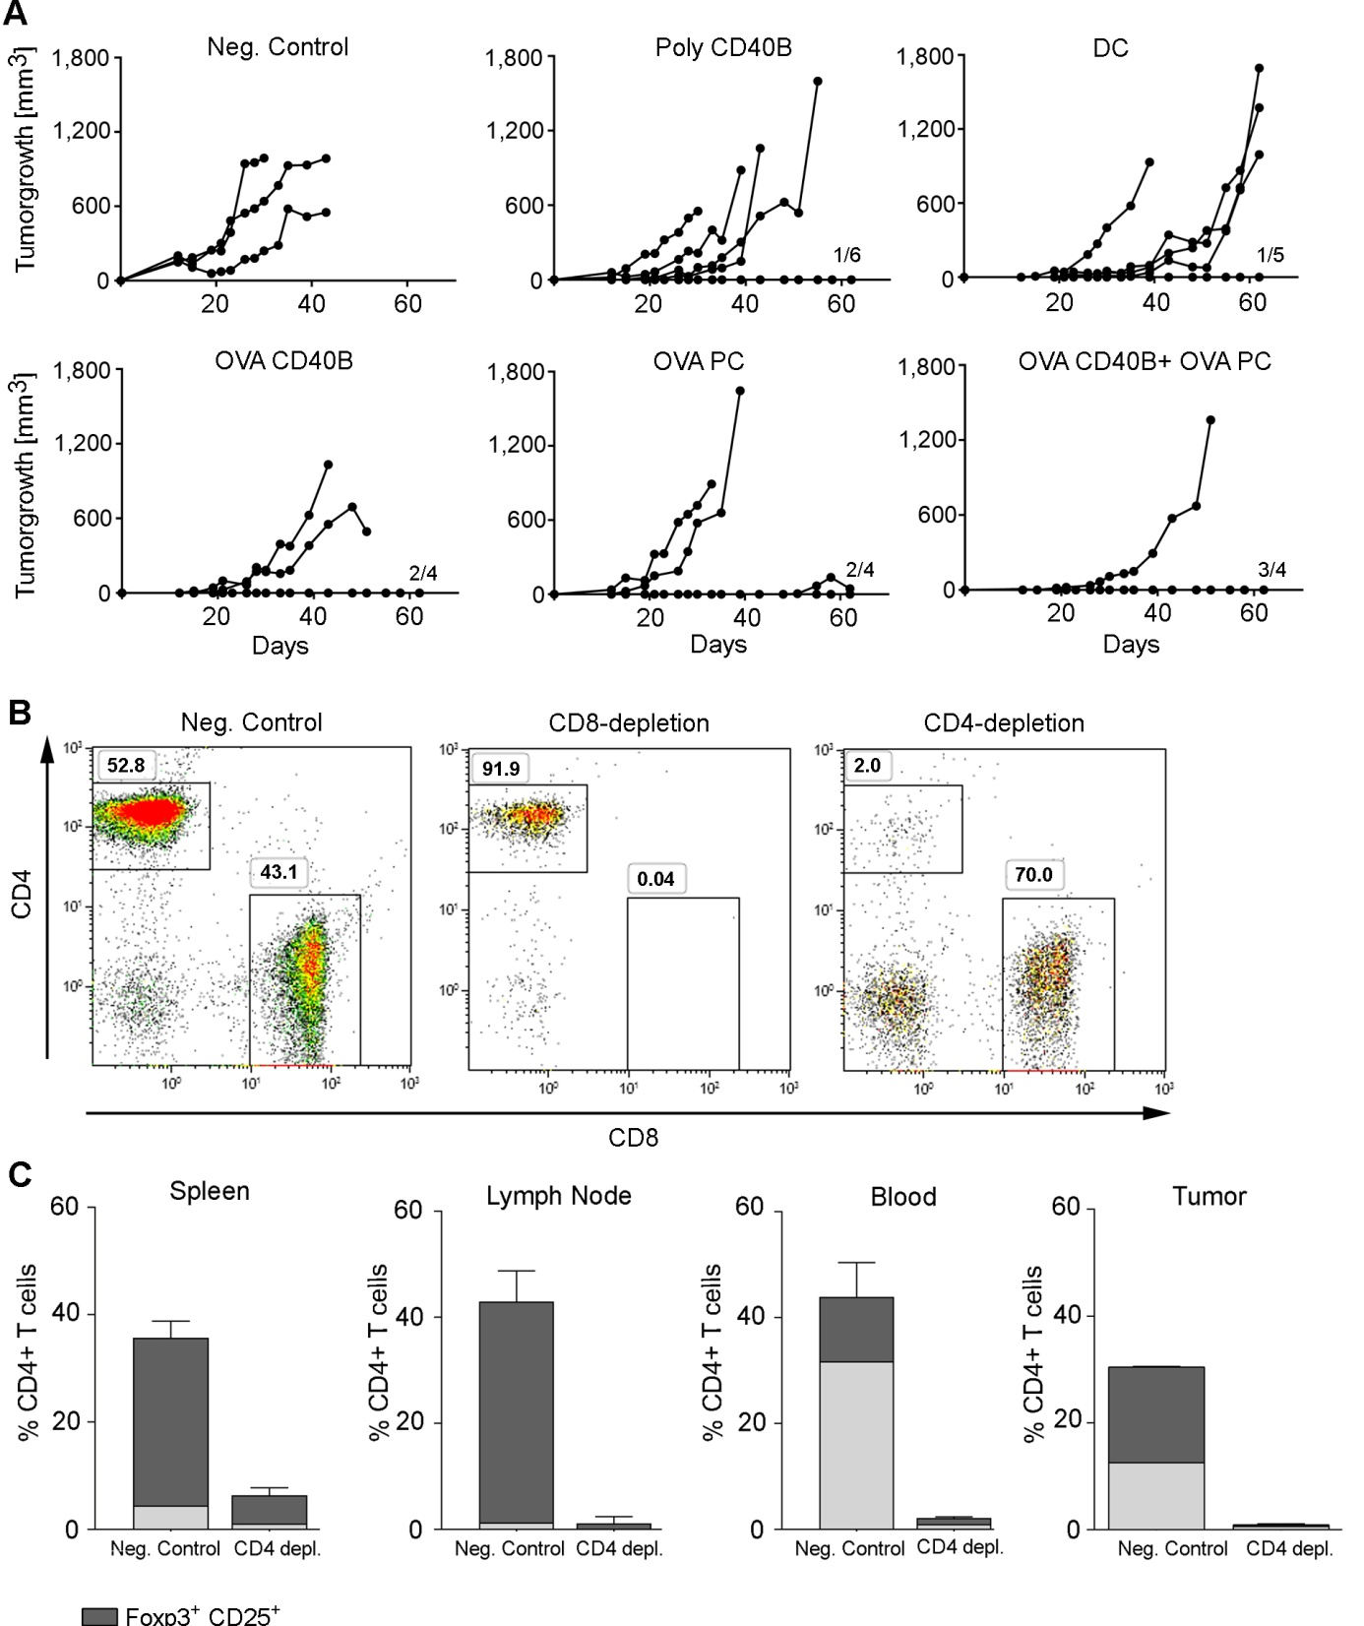
Fig. S7. Combinational immunotherapy induces T cell-dependent anti-tumor immunity
(A) On day 7 and 15, after Panc02OVA tumors became palpable, mice were treated i.v. with 0.1-2 x 10⁶ APCs, i.e. polyclonal CD40B cells (Poly CD40B), OVA-CD40B cells (OVA CD40B), DCs, OVA-specific PCs alone (OVA PC) or in combination with OVA-CD40B cells (OVA CD40B+ OVA PCs), PBS as negative controls (Neg. Control). Growth curves show increase of tumor volume in mm³ in single mice of one representative experiment out of three experiments with 3-6 mice per group. Tumor growth is shown as 0.5 times the product of (length diameter x width diameter²). (B) On day 5 and 25 after Panc02Ova challenge, mice were treated with 500 µg of anti-CD4 (α-CD4) or anti-CD8 (α-CD8) antibody. Efficient T-cell depletion was determined by staining blood samples taken 5 days after first and second T-cell depletion for the presence of CD3⁺CD4⁺ or CD3⁺ CD8⁺ T cells. (C) On day 14 after Panc02OVA challenge, mice were treated with 500 µg of anti-CD4 (α-CD4). Five days later, tumors, spleens, TDLN and blood samples were removed and stained for the presence of CD4⁺ T cells and Foxp3⁺CD25⁺ subpopulations. Shown are means + SD in negative controls, which received PBS (Neg. Control) and CD4-depleted mice, each with 4 mice per group.

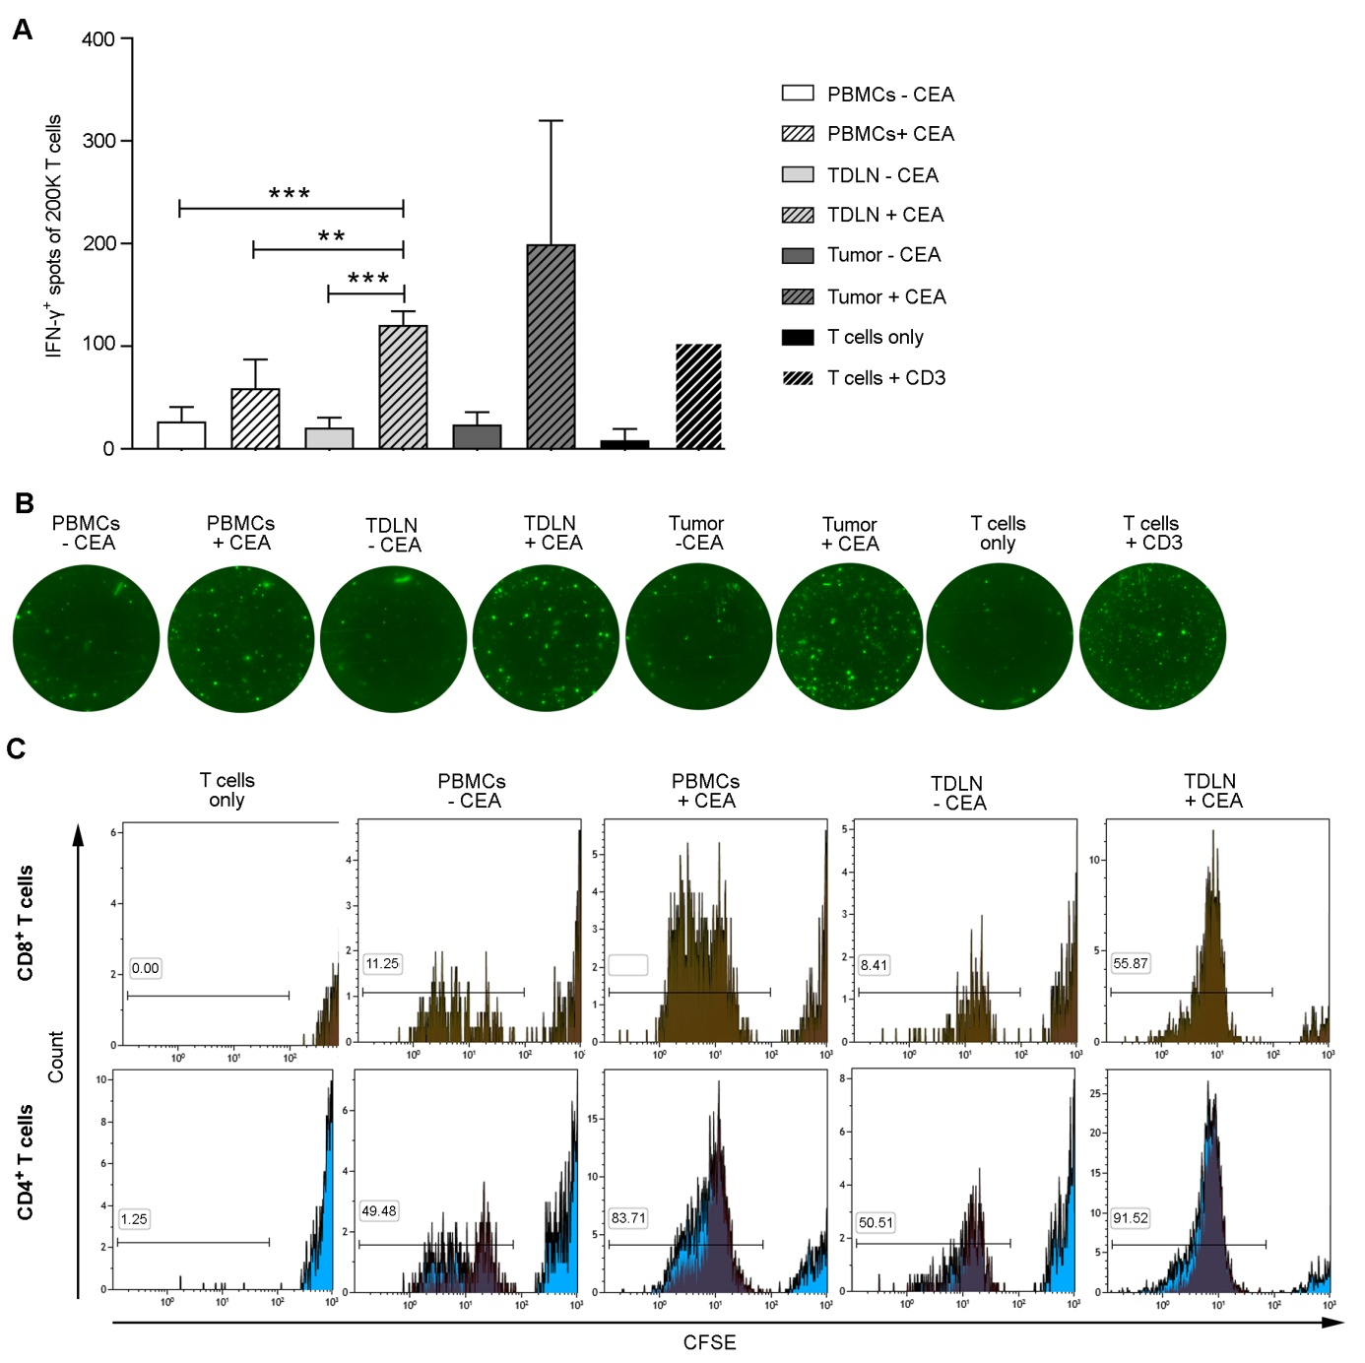
Fig. S8 Human antigen-specific CD40B cells induce specific T-cell responses. (A+B) CD19⁺ purified B cells from PBMCs or single cell suspensions from TDLN or tumors of patients with colorectal cancer were cultivated for 14 days in the presence of the CD40L. Afterwards, 0.2 x 10⁶ negatively isolated T cells from PBMCs were cocultured together with 0.1 x 10⁶ protein-pulsed (+CEA) or unpulsed (-CEA) CD40B cells. Unstimulated T cells served as negative controls (T cells only); T cells + anti-CD3 served as positive controls. Fluorospot analysis was performed 20 hours later. (A) Means of IFN-γ⁺ spots per 0.2 x 10⁶ (200K) T cells + SD are shown. PBMCs and TDLN: n = 2; and Tumor n = 1. Significant differences calculated with a one-way ANOVA are marked by an asterisk. ** p ≤ 0.008, *** p ≤ 0.0006. Tumor samples were excluded from statistical analysis. (B) Representative fluorospot pictures of IFN-γ signal in FITC are shown. Fluorospots with tumor-infiltrating B cells were performed with one high responding donor. (C) CD19⁺ purified B cells from PBMCs or single cell suspensions from TDLN or tumors of patients with colorectal cancer were cultivated for 14 days in the presence of the CD40L. Afterwards, 0.2 x 10⁶ negatively isolated CFSE⁺ T cells from PBMCs were cocultured together with 0.1 x 10⁶ protein-pulsed (+CEA) or unpulsed (-CEA) CD40B cells. Unstimulated T cells served as negative controls (T cells only). After 7 days of culture, proliferation of T cells was analyzed by a decrease in CFSE labeling by flow cytometry. Shown are representative CFSE plots gated on CD4⁺ or CD8⁺ T cells.

