Fig. S1. Representative dot plots and gating strategy for Figure 1.
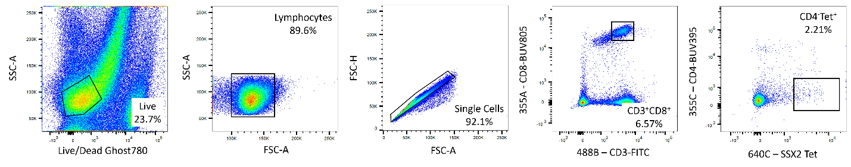

Fig. S2. Representative dot plots and gating strategy for Figure 2.
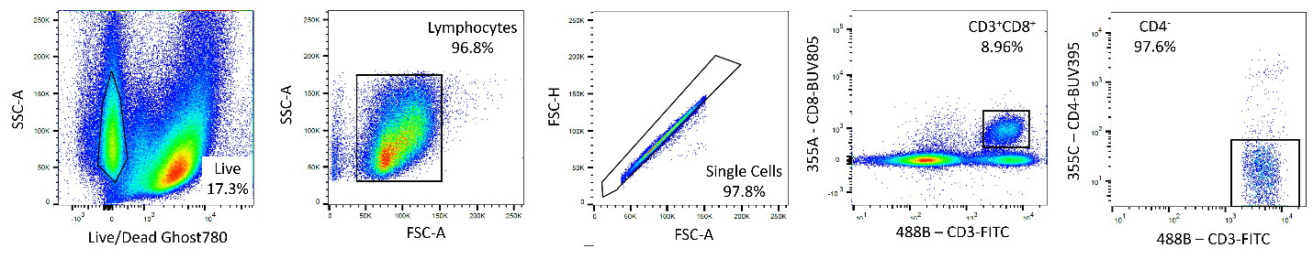

Fig. S3. Representative dot plots and gating strategy for Figure 3.
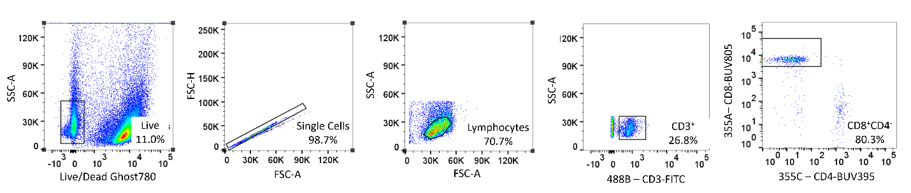

Fig. S4. Representative dot plots and gating strategy for Figure 4.
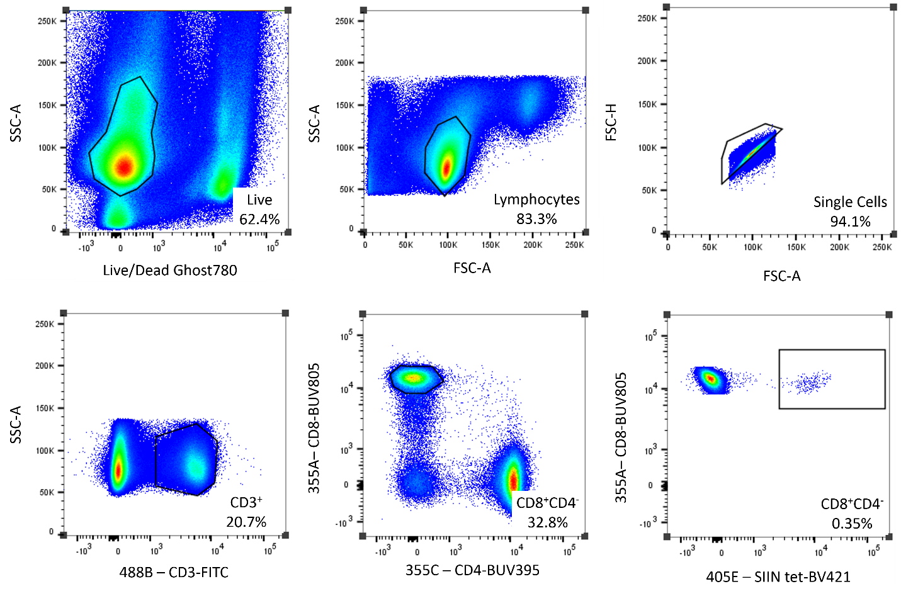

Fig. S5. Representative dot plots and gating strategy for Figure 5.
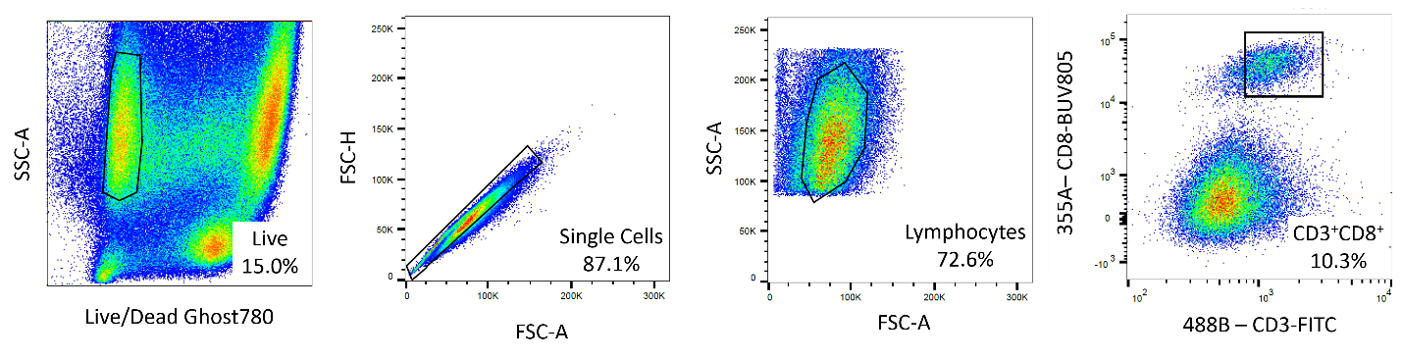

Fig. S6. Representative dot plots and gating strategy for Figure 6.
