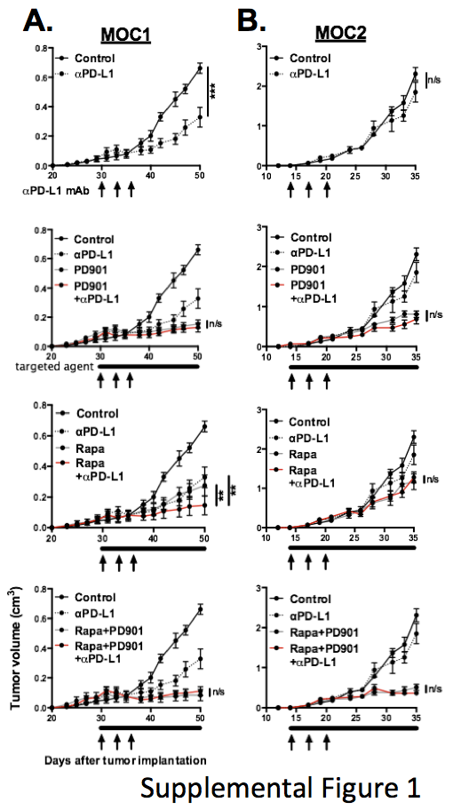

Supplemental Figure 1. Primary tumor growth control is enhanced during treatment with combination rapamycin and αPD-L1 mAb compared to either treatment alone in MOC1 but not MOC2 tumor-bearing mice. Summary primary tumor growth curves for treated MOC1 (A) and MOC2 (B) tumor-bearing mice (n=7-10 mice/group) are shown. Timing of treatments indicated along the x-axis of each. Statistical significance determined by comparing the average tumor volumes on the final day of treatment as indicated. **, p<0.01; ***, p<0.001; ANOVA.

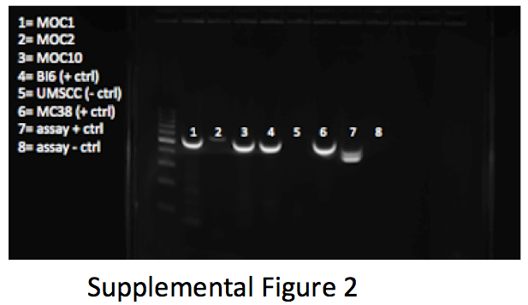

Supplemental Figure 2. MOC1 cells express the murine endogenous retroviral envelope protein p15E. Gel electrophoresis analysis of amplified GP70/p15E gene product is shown. MOC1 and MOC2, along with amplification of gene product from positive control (B16, MC38) and negative control (UMSCC) cell lines and assay positive and negative controls are included.

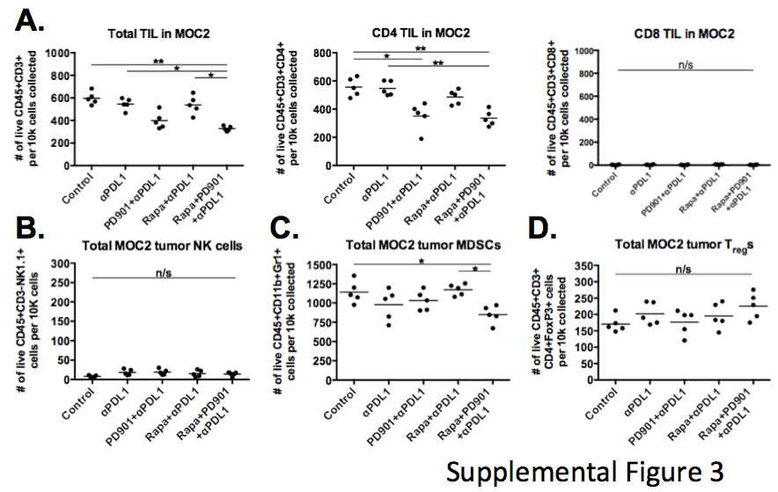

Supplemental Figure 3.
Treatment with rapamycin or PD901 alone or in combination with αPD-L1 mAb fails to induce CD8 TIL or NK tumor infiltration in MOC2 tumor-bearing mice and produces modest, variable effects in tumor infiltrating MDSCs and T_{reg}s. A, Flow cytometric analysis of MOC2 tumor infiltrating 7AAD⁻CD45⁺CD3⁺ total, CD4 and CD8 TIL. Low baseline infiltration of CD8 TIL in MOC2 tumors was not enhanced with any treatment combination. B, Analysis of 7AAD⁻CD45⁺CD3⁻NK1.1⁺ NK cells, C, 7AAD⁻CD45⁺Gr1⁺CD11b⁺ MDSCs and D, 7AAD⁻CD45⁺CD4⁺FoxP3⁺ T_{reg}s in MOC2 tumor-bearing mice. Five individual tumors from each condition were analyzed for each cell type. *, p<0.05; **, p<0.01; ANOVA.

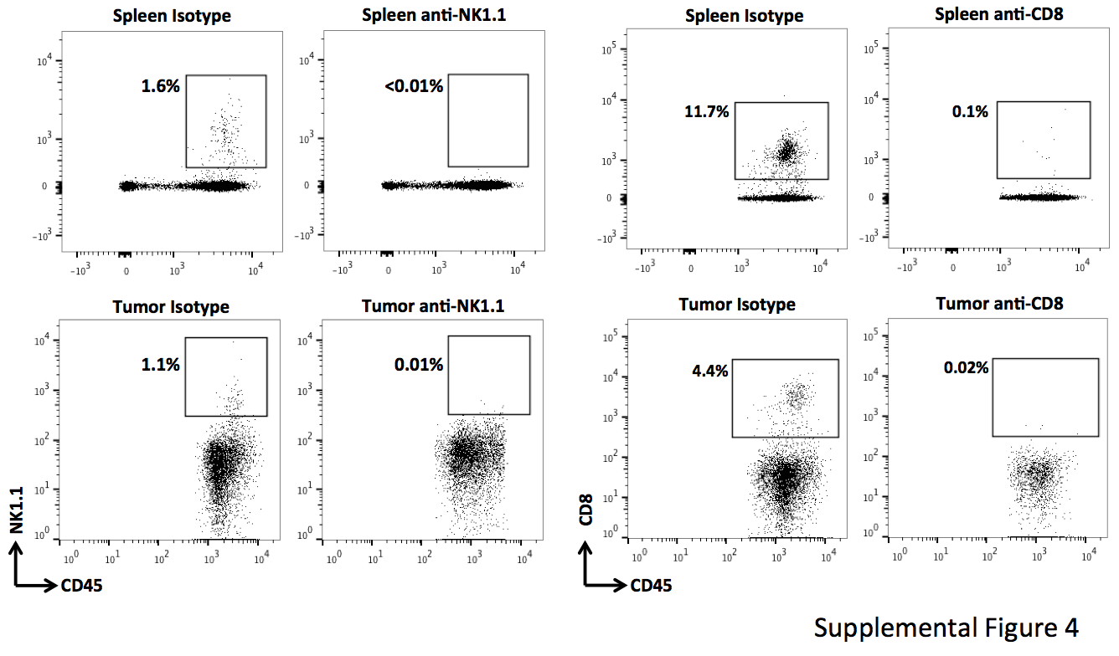

Supplemental Figure 4. Antibody-based CD8 (clone YTS169.4) or NK (clone PK136) cell depletion results in efficient elimination of CD8 and NK cells from both the periphery (spleen) and tumor microenvironment. Representative dotplots demonstrate baseline and post-CD8 and NK cell depletion flow plots from spleen (top panels) and tumor (bottom panels) of mice treated twice weekly for three weeks with depleting antibody (200 μg each antibody twice weekly, n= 3 mice/group for validation experiments). Plots shown are from tissue harvested one day after the final depleting antibody treatment.

