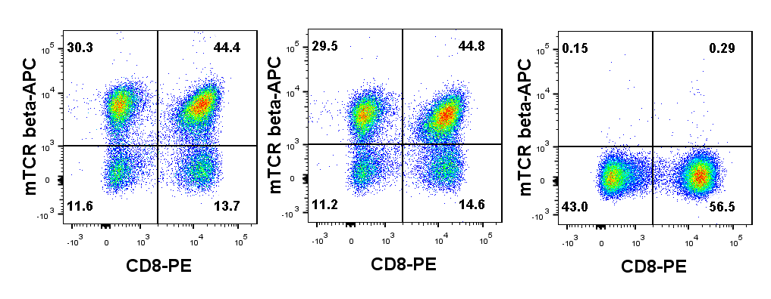
TRAV4-4/DV10*01(1)
TRAV4-4/DV10*01(2)
A
B
TRBV12-2*01
UT

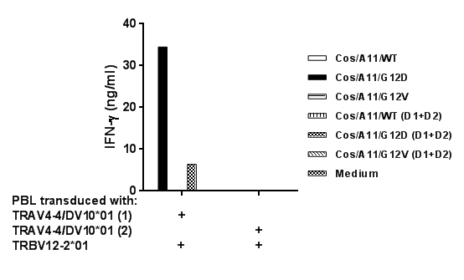

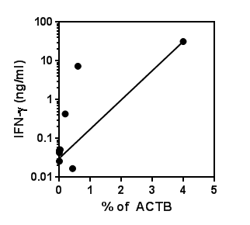
C

Fig. S1. (A) mTCR Expression of human PBL co-transduced with oligoclonal TCR alpha and beta chains. Two oligoclonal alpha chain and one oligoclonal beta chains were identified from murine KRAS G12D-reactive splenocytes (1μM) by 5’RACE (table S4) and individually cloned into the retroviral vector, pMSGV1. Allogeneic PBL were stimulated with anti-CD3 (50ng/ml) for 2 days and co-transduced twice with retroviruses encoding oligoclonal TCR alpha and beta chains at 0.5 x 10⁶ cells per well in a 24-well plate. Three days after transduction, T cells transduced with candidate pairs of TCR alpha and beta chains were labeled with anti-CD3, anti-CD8 and anti-mouse TCR beta antibodies, and analyzed on FACS Canto II. Data was gated on live CD3⁺ population. Untransduced T cells were used as controls. (B) Reactivity of PBL co-transduced with oligoclonal TCR alpha and beta chains. Anti-CD3 stimulated human PBL co-transduced with 2 paired alpha and beta chains were co-cultured with COS7/A11 transduced with minigenes encoding 23 aa of KRAS WT, KRAS G12D, and KRAS G12V, or KRAS genes encoding 165 aa of the protein, including WT (D1+D2), G12D (D1+D2), and G12V (D1+D2). Functional analysis was done by assessing IFN-γ production from the co-culture supernatant after overnight incubation. (C) Correlation between KRAS G12D expression and reactivity of KRAS G12D-reactive TCR. KRAS G12D expression was presented as % of ACTB, and reactivity of KRAS G12D-reactive TCR was presented as IFN-γ production of T cells transduced with TRAV4-4*01/BV12-2*01 against a panel of pancreatic tumor lines with or without G12D mutation (R²=0.978, P<0.001).

