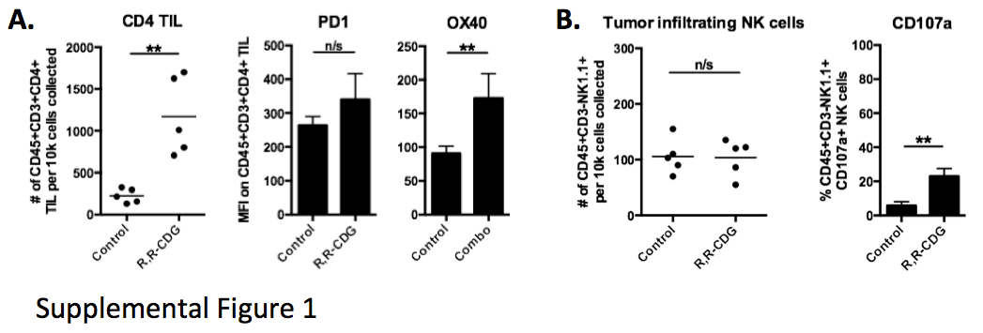
Supplemental Figure 1. CD4 TIL but not NK cells are altered in CDN treated MOC1 tumors. Tumors from control and R,R-CDG treated MOC1 tumor-bearing mice (15 μg/injection q 3 days x 3) were harvested and analyzed by flow cytometry 48 hours after the last R,R-CDG treatment. A, CD4 TIL are quantified (left panel) along with activation markers PD1 and OX40 (right panels). B, tumor-infiltrating NK cells and the degranulation marker CD107a are quantified. **, p<0.01, ANOVA.

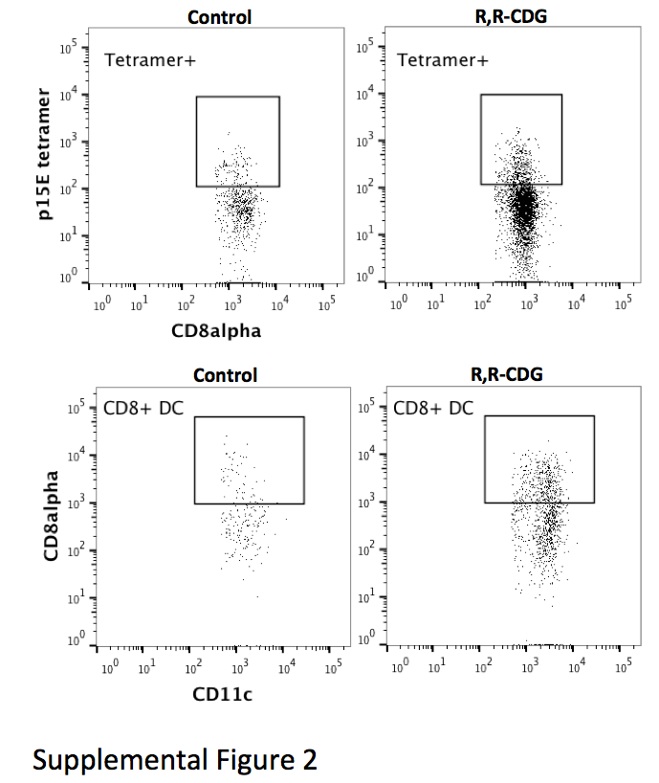
Supplemental Figure 2. Flow cytometry dotplots for selected immune correlates. Tumors (top panels) and tumor-draining lymph nodes (bottom panels) from control and R,R-CDG treated MOC1 tumor-bearing mice were harvested and analyzed by flow cytometry 48 hours after the last R,R-CDG treatment. Cells displayed in the top panels are 7AAD⁻CD45.2⁺CD3⁺. Cells displayed in the bottom panels are 7AAD⁻CD45.2⁺CD11b⁺.

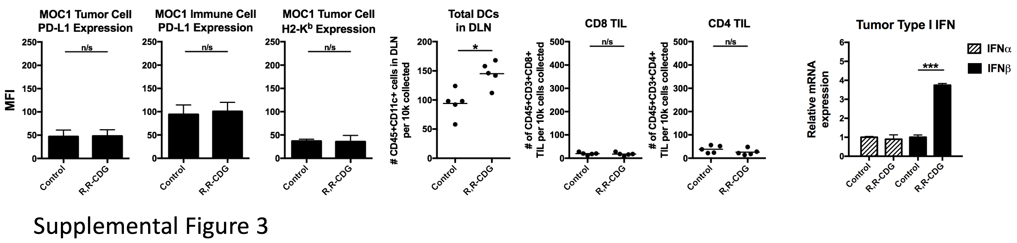
Supplemental Figure 3 – Tumors and tumor-draining lymph nodes (DLN) from control and R,R-CDG treated MOC2 tumor-bearing mice were harvested and analyzed by flow cytometry and immunofluorescence 48 hours after the last R,R-CDG treatment (n=5 mice/group). Left panels, quantification of PD-L1 and H2-K^{b} expression on live CD45.2⁻CD31⁻ tumor cells or PD-L1 expression on live CD45.2⁺CD31⁻ infiltrating immune cells from MOC2 tumors following IT R,R-CDG treatment (n=5 mice/group). Middle panels, quantification of DLN DCs, CD8 and CD4 TIL following treatment. Right panel, whole tumor tissues were analyzed via RT-PCR for type I interferon (IFNβ) expression following R,R-CDG treatment. *, p<0.05; n/s, non-significant.

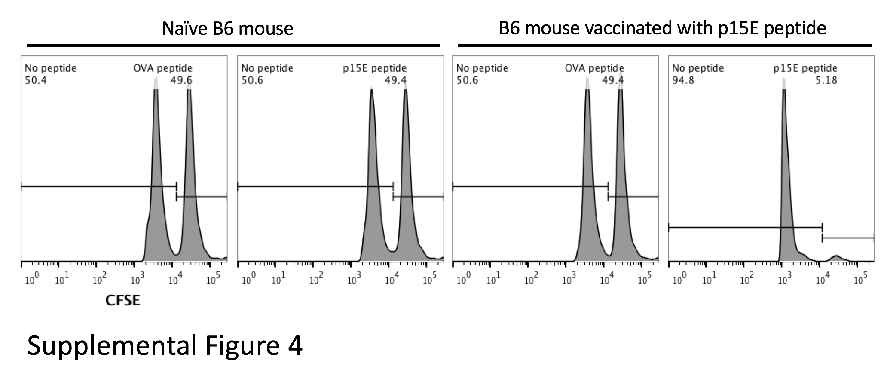
Supplemental Figure 4. Validation of in vivo CTL assay specificity following p15E peptide vaccination. To induce immunity against p15E, WT B6 mice were injected subcutaneously in the flank with 100 μg of p15E (KSPWFTTL) peptide in a 50:50 ration (%vol) of 1xPBS and complete Freund’s adjuvant. Seven days later, mice were boosted with 100 μg of p15E peptide in a 50:50 ration (%vol) of 1xPBS and incomplete Freund’s adjuvant. Three weeks later, WT or vaccinated B6 mice were subjected to an in vivo CTL assay as described in the Materials and Methods, using splenocytes pulsed with either p15E or control OVA (SIINFEKL) peptide.

