Supplementary Table 1: Results for samples obtained ≤12 months prior to therapy (“optimal”) vs. those obtained >12 months from treatment or shortly after starting therapy (“non-optimal”)
Optimal samples (n = 43)
 | Responders  n = 21 | Non-responders  n = 22 | p-value
Mutational load (mutations/MB) | 43.5 | 8.1 | <0.001
Non-optimal samples (n = 22)
 | Responders  n = 11 | Non-responders  n = 11 | p-value
Mutational load (mutations/MB) | 37.5 | 5.5 | 0.027

Supplementary Table 2: Cox proportional hazards model of OS adjusting for baseline variables
Variable |  | Coefficient  ($β$) | Standard  Error ($β$) | P value | HR | 95% CI
Mutational Load Group
 | Intermediate vs. Low | -0.22 | 0.48 | 0.64 | 0.80 | (0.31, 2.0)
 | High vs. Low | -2.39 | 0.65 | 0.0002 | 0.09 | (0.02, 0.32)
Age |  | -0.01 | 0.02 | 0.54 | 0.99 | (0.95, 1.0)
Gender
 | M vs. F | 0.49 | 0.48 | 0.30 | 1.64 | (0.64, 4.2)
Stage
 | IVc vs. IIIC - IVb | 0.29 | 0.64 | 0.65 | 1.33 | (0.38, 4.67)
Prior ipilimumab
 | Yes vs. No | 1.35 | 0.47 | 0.004 | 3.85 | (1.53, 9.69)

Supplementary Table 3: Cox proportional hazards model of PFS adjusting for baseline variables
Variable |  | Coefficient  ($β$) | Standard  Error ($β$) | P value | HR | 95% CI
Mutational Load Group
 | Intermediate vs. Low | -0.10 | 0.40 | 0.80 | 0.90 | (0.41, 1.99)
 | High vs. Low | -2.00 | 0.48 | <0.0001 | 0.14 | (0.05, 0.35)
Age |  | 0.0002 | 0.01 | 0.99 | 1.0 | (0.97, 1.0)
Gender
 | M vs. F | -0.20 | 0.34 | 0.54 | 0.81 | (0.42, 1.58)
Stage
 | IVc vs. IIIC - IVb | -0.10 | 0.44 | 0.82 | 0.90 | (0.38, 2.16)
Prior ipilimumab
 | Yes vs. No | 0.20 | 0.35 | 0.56 | 1.23 | (0.62, 2.44)

Supplemental Figures
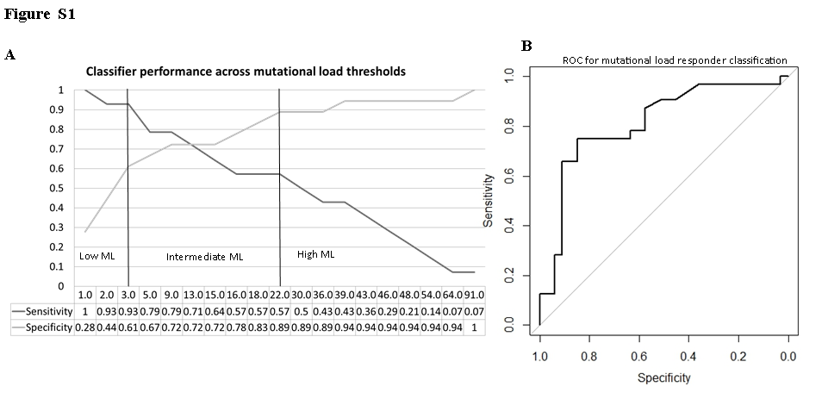

Figure S1: (A) Performance of mutational load across a range of potential thresholds. Vertical bars indicate the thresholds selected based on local performance maxima and clinical relevance. (B) Receiver Operating Curve (ROC) for mutational loads cutoffs of 3·3 mutations/MB (low mutational load group) and 23·1 mutations/MB (high mutational load group).
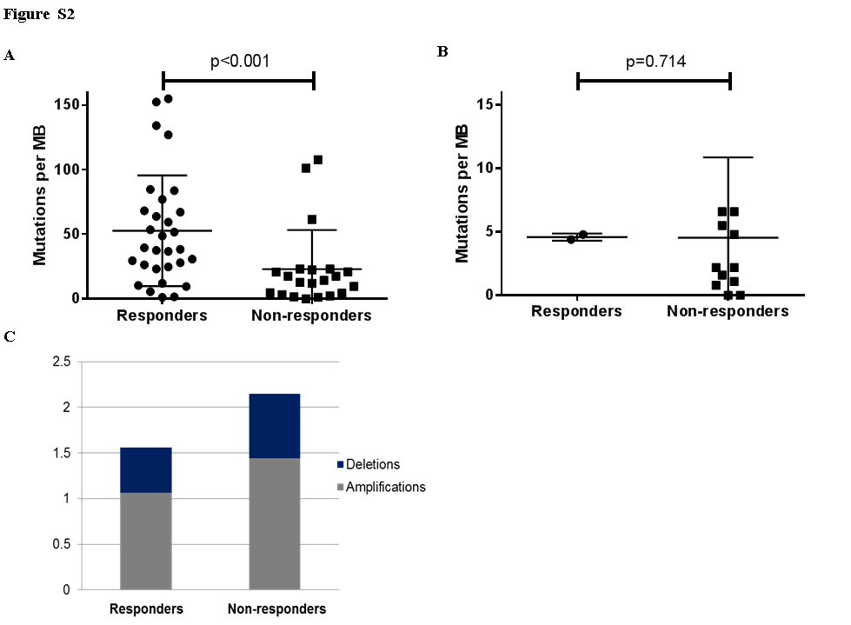
Figure S2: (A) Mutational load in tumors with cutaneous/unknown primaries in responders vs. non-responders. (B) Mutational load in tumors with non-cutaneous primaries (acral, mucosal, uveal) in responders vs. non-responders. (C) Gene amplifications and deletions in responders vs. non-responders.
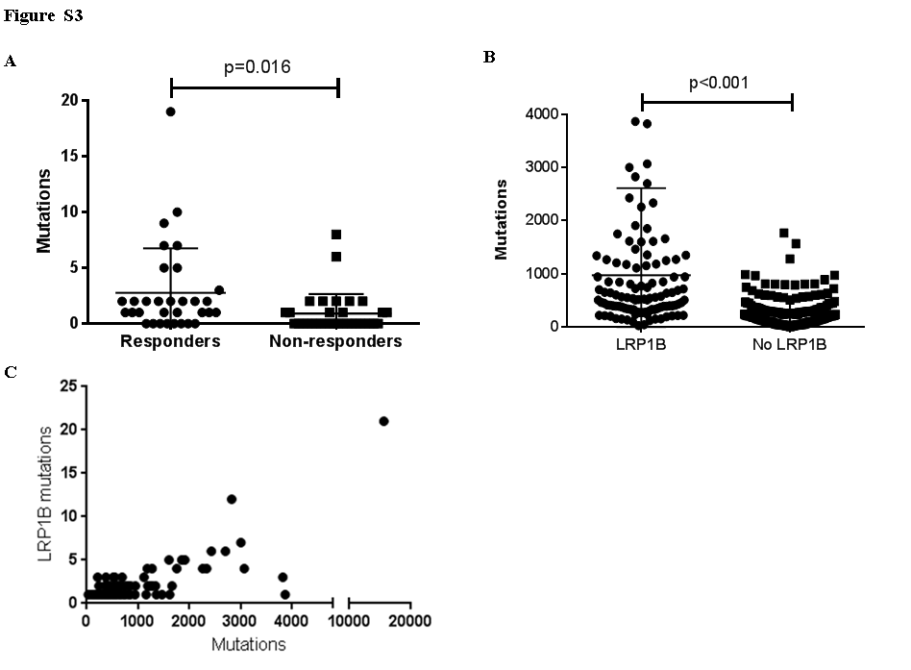

Figure S3: (A) LRP1B mutations/variants of unknown significance in responders vs. non-responders. (B) Total number of mutations among melanomas with and without LRP1B mutations. (C) Association between number of LRP1B mutations and total mutations in the melanoma TCGA (The Cancer Genome Atlas).

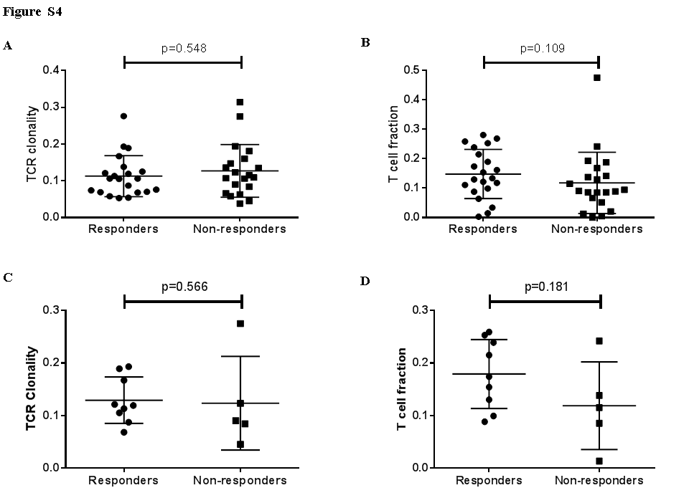
Figure S4: (A) T cell receptor (TCR) clonality in responders vs. non-responders. (B) T cell fraction in responders vs. non-responders. (C) TCR clonality in responders vs. non-responders in “ideal” samples, defined as those obtained within 4 months of anti-PD-1/PD-L1 treatment without other prior therapies. (D) T cell fraction in these “ideal” samples.
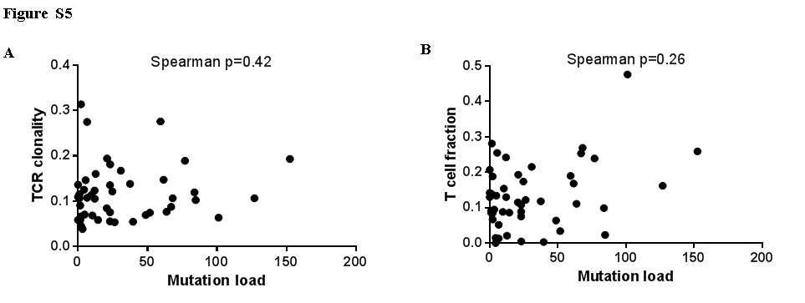
Figure S5: Mutation load correlated with (A) T cell receptor (TCR) clonality and (B) T cell fraction.

