SUPPLEMENTARY FIGURES AND LEGENDS

Supplementary Figure S1. Associations of CGRs and ecDNAs with ploidy, expression, and enhancers.
A, Tumor volumes of individual tumors, either vehicle-treated (n = 6, dashed lines) or MAPKi-treated (n = 12, solid lines) melanoma PDXs until acquired-resistant tumors emerged. Five NRAS^{MUT} (Mel_PDX1, Mel_PDX2, Mel_PDX3, Mel_PDX4, Mel_PDX6) and one BRAF^{V600MUT} (Mel_PDX27) tumors were treated with trametinib at 5 mg/kg/d.
B, Pairwise comparisons of the numbers of ecDNAs and CGRs in MAPKi-sensitive and acquired-resistant tumors (n = 15). Averages used for multiple resistant tumors derived from the same patient. Excluded from analysis, resistant tumors without patient-matched MAPKi-sensitive tumors and tumors without detected ecDNAs or CGRs. P value (paired Student’s t-test): *, p < 0.05.
C, Number of CGR versus ecDNA segments in all tumors (n = 58). P value (Student’s t-test): ***, p < 0.001.
D, Numbers of CGR and ecDNA segments in each of three tumor cohorts. P value (Kruskal-Wallis test): **, p < 0.01.
E, Ploidy versus the numbers of CGR and ecDNA segments. Both MAPKi-sensitive/-naive and acquired MAPKi-resistant tumors were included together. P value (Spearman correlation): r_{s} = 0.44, p = 0.0004.
F, Changes in transcript levels (measured by RNA-seq) and associated CNV values of MAPKi resistance-driver genes (BRAF, NRAS, MYC, EGFR, HRAS and RAC1, as shown in Fig. 1A) in acquired MAPKi-resistant (versus MAPKi-sensitive/-naïve) tumors.
G, Enhancers on ecDNAs and their cis or trans target genes in Pt2-DP1 (EZH2 and XRCC2 in chr7), Pt3-DP1 (BRAF in chr7), RAM12.01-Brain-DD-DP10 (BRAF in chr7), Mel_PDX1 (NRAS in chr1), Mel_PDX2 (NRAS and ATP1A1 in chr1), Mel_PDX4 (RAC1 in chr7). Super-enhancers are indicated with a star.
H, H3K27 acetylation marks in Mel_PDX27-R2 (with BRAF) and Pt9-DD-DP2 (with MYC). Brown arc connecting the endpoints indicates ecDNA and yellow arrow indicates H3K27 acetylation peaks in the enhancers of BRAF and MYC.

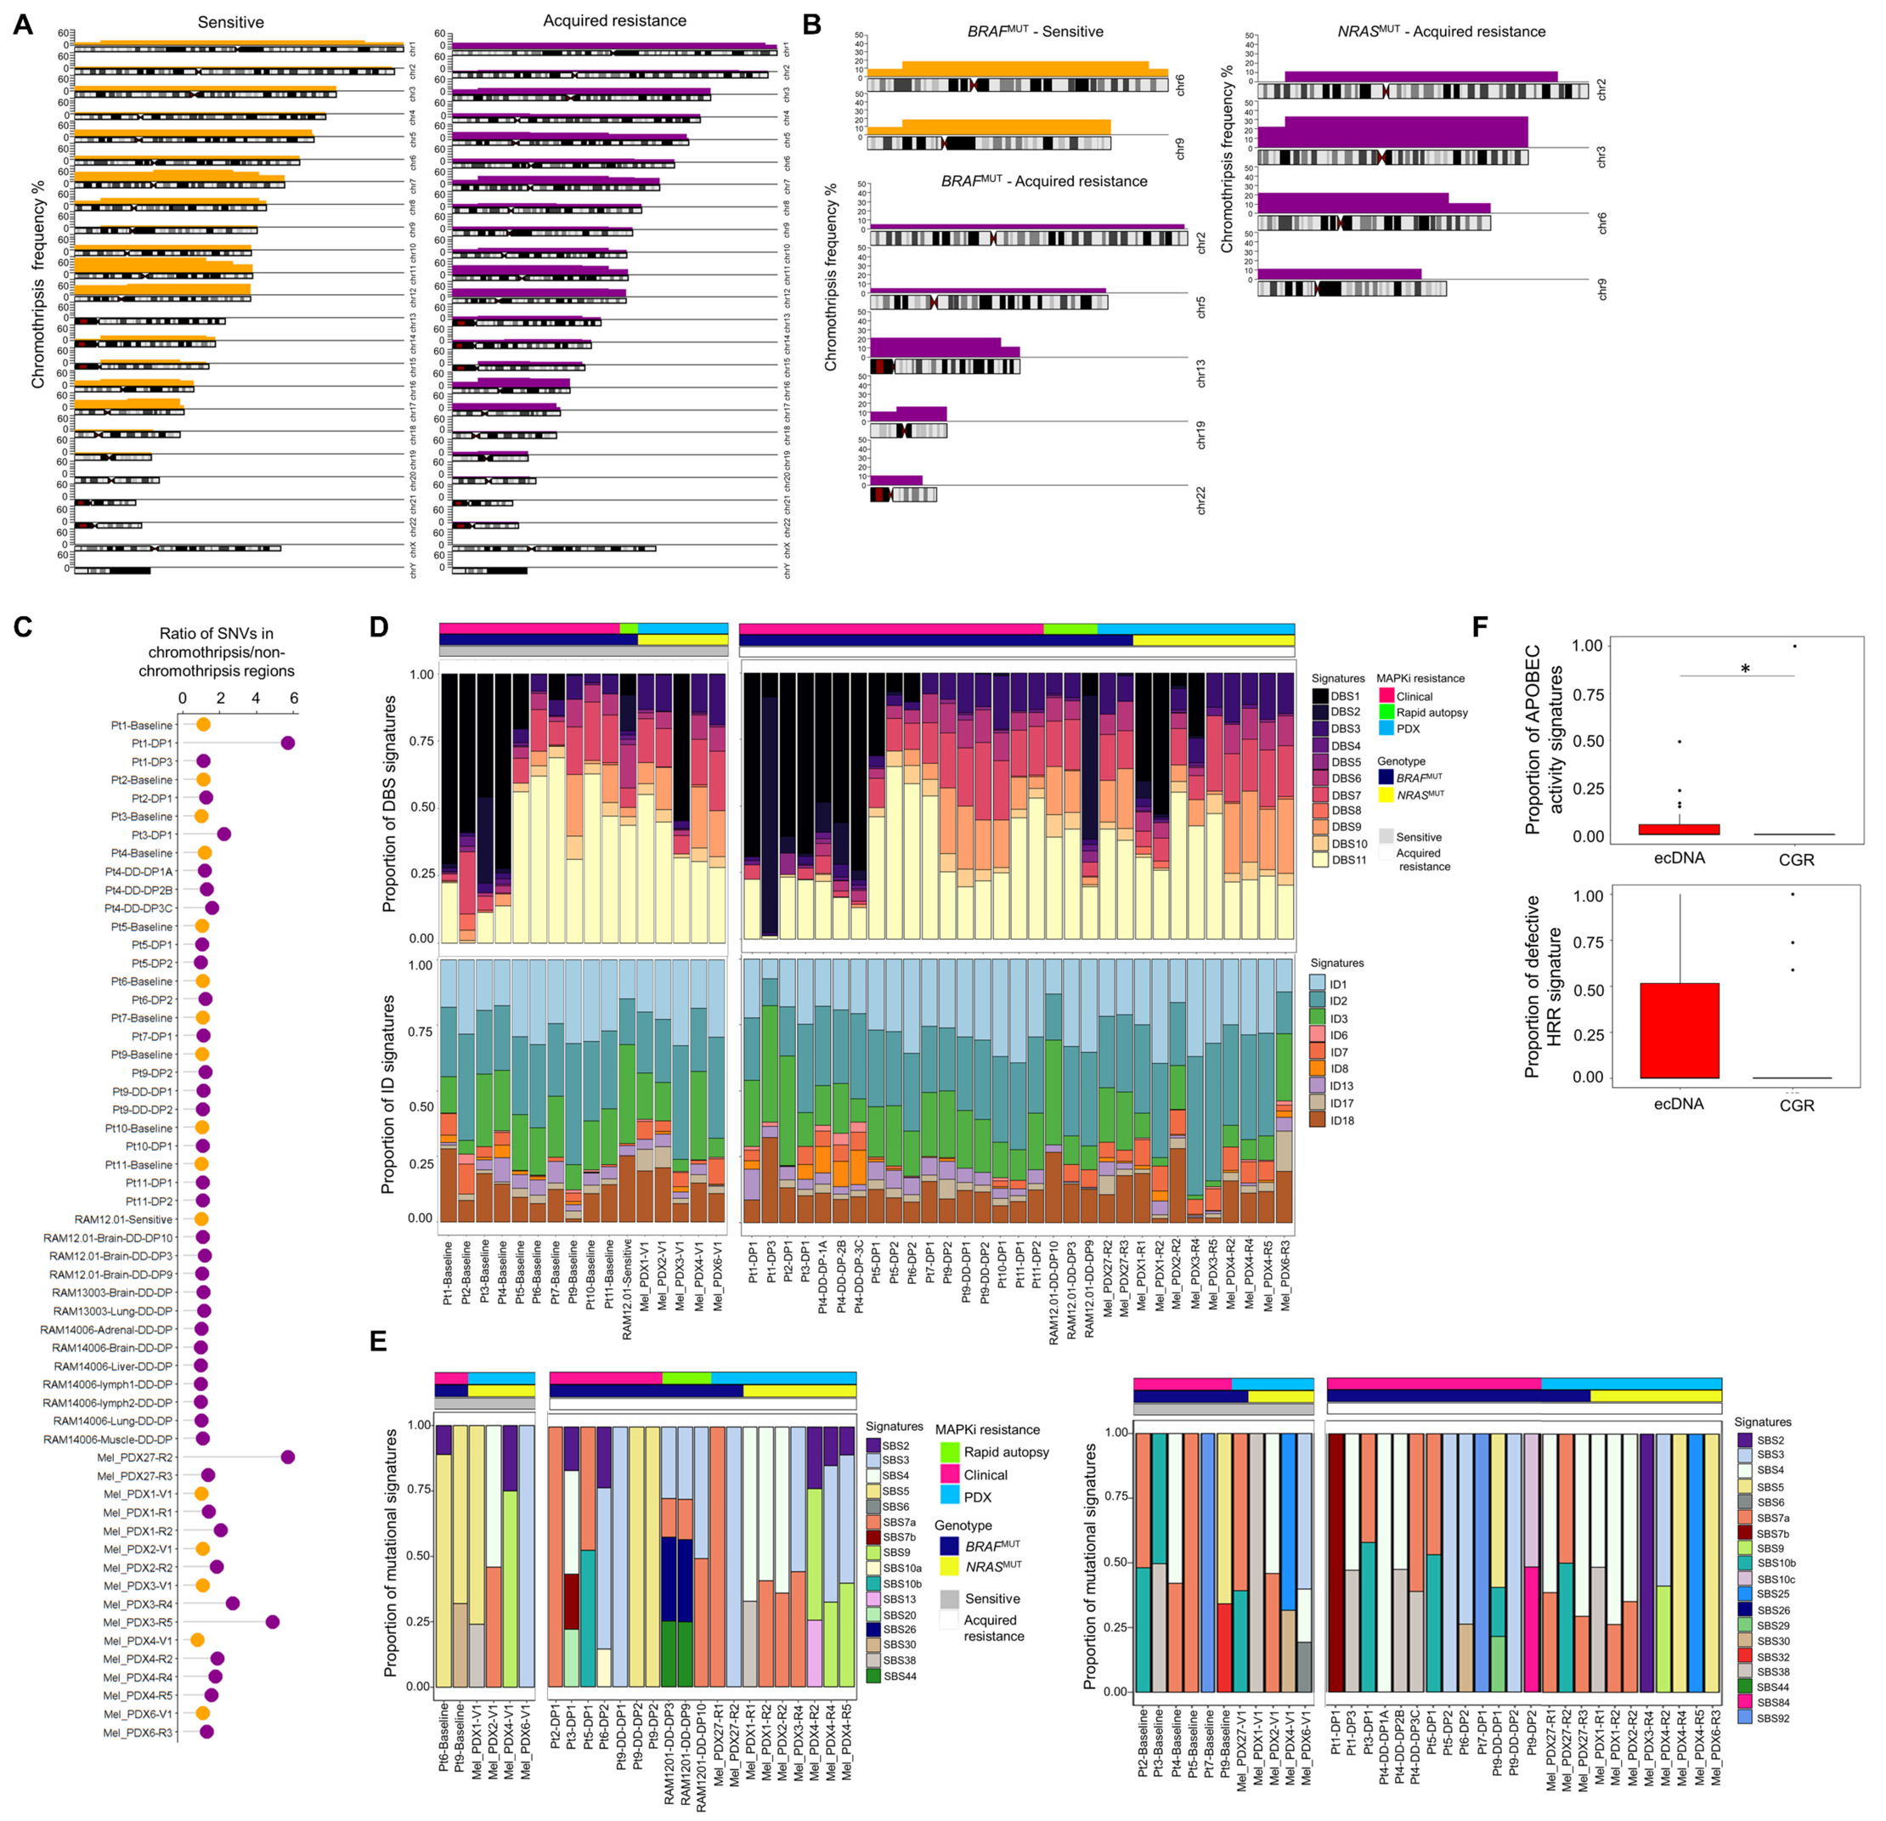

Supplementary Figure S2. Analysis of chromothripsis, ecDNAs, and CGRs in MAPKi-sensitive/-naïve versus -resistant melanoma.
A, Chromothriptic genomic regions in patient-matched MAPKi-sensitive versus acquired resistant genomes (n = 58).
B, Frequencies of chromothriptic events exclusively observed in BRAF^{MUT} MAPKi-sensitive (n = 11), BRAF^{MUT} acquired-resistant (n = 17), and NRAS^{MUT} acquired-resistant (n = 9) tumors.
C, Ratios of tumor mutational burden (somatic SNVs) in regions within and without chromothripsis (n = 58).
D, DBS and ID signatures of chromothriptic genomes in MAPKi-sensitive/naïve (left) versus -resistant (right) melanoma tumors. Excluded from analysis, resistant tumors without patient-matched sensitive tumors.
E, SBS signatures detected in ecDNAs (left; MAPKi-sensitive/-naive, n = 5; acquired resistant, n = 19) and CGRs (right; MAPKi-sensitive/-naive, n = 11; acquired resistant, n = 24). Excluded from analysis, resistant tumors without patient-matched sensitive tumors and tumors without detected ecDNAs and CGRs.
F, Proportions of SBS signatures associated with APOBEC family of cytidine deaminases (top, SBS2 and SBS13) and defective HRR (bottom, SBS3) in ecDNAs (n = 19) and CGRs (n = 24) of acquired resistant tumors. P value (Wilcoxon rank sum test): *, p < 0.05.

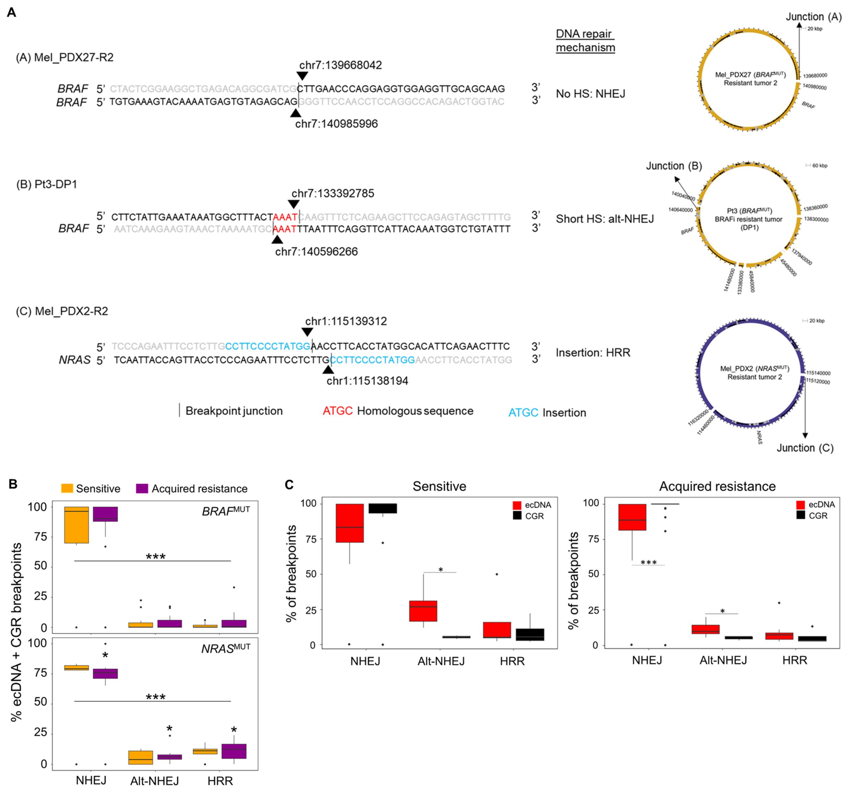

Supplementary Figure S3. Inferring double-stranded DNA break repair pathways underlying ecDNA and CGR breakpoint junctions.
A, (Right) Examples of ecDNAs harboring BRAF, BRAF, and NRAS genes from PDX tumors (A) Mel_PDX27-R2, (B) Pt3-DP1, and (C) Mel_PDX2-R2 and their breakpoint junctions (shown in detail on the left), without and with micro homologous sequences (bases in red) and insertions (bases in blue). Sequences in ecDNAs are shown in black and adjacent DNA sequences in grey. Inferred double-stranded DNA break repair mechanisms shown in the middle. Non-homologous end-joining (NHEJ), alternate-NHEJ (Alt-NHEJ), and homologous recombination repair (HRR).
B, Changes in the percentages of inferred DNA DSB repair processes (NHEJ, alt-NHEJ, HRR) in BRAF^{V600MUT} (top; n = 10 sensitive tumors; n = 29 resistant tumors) and NRAS^{MUT} (bottom; n = 5 sensitive tumors; n = 9 resistant tumors) melanoma. Inferences based on breakpoint-junctional sequence analysis of ecDNAs + CGRs. Excluded from analysis, resistant tumors without patient-matched sensitive tumors and tumors without detectable ecDNAs and CGRs. P value (within group, Kruskal-Wallis test): ***, p < 0.001 and P value (across the groups, BRAF^{V600MUT} versus NRAS^{MUT} tumors; Student’s t-test): *, p < 0.05.
C, Breakpoint-junctional sequence analysis of ecDNAs (red) and CGRs (black) inferring indicated double-stranded DNA break repair processes. Amplicons from MAPKi-sensitive (left, n = 17) and acquired-resistant (right, n = 41) tumors in all three cohorts of tumors combined for analysis. Excluded from analysis, tumors without detectable ecDNAs and CGRs. P value (Wilcoxon rank sum test): *, p < 0.05; **, p < 0.01; ***, p < 0.001.

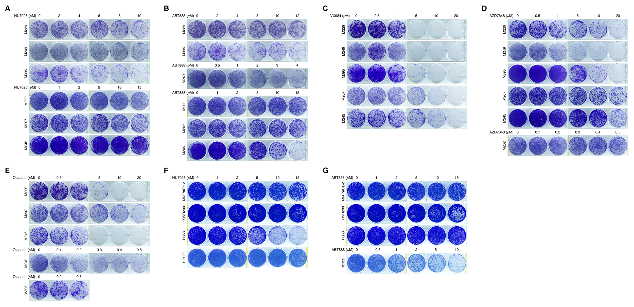

Supplementary Figure S4. Single-agent inhibitory potencies in human melanoma, PDAC, and NSCLC clonogenic growth assays.
A to G, Long-term clonogenic growth of indicated BRAF^{V600MUT} or NRAS^{Q61MUT} human melanoma cell lines (A to E) and KRAS^{G12C} human pancreatic ductal adenocarcinoma and non-small cell lung carcinoma cell lines (F and G) treated with the indicated concentrations of DNA-PKi (NU7026 in A; VX984 in C; AZD7648 in D) or PARPi (ABT888 in B; olaparib in E). Cells were seeded at 5,000 cells/well in 6-well dishes (A to E). Culture durations (days): 9, M207, M245 (C, E); 13, M207, M245, M249 (A, B, D); 15, M202; 17, M229; 18, M395. Seeding densities (cells/well in 6-well dishes) and culture durations (days) for F and G: MIAPaCa-2 (2,000;17), XWR200 (150,000; 14), H358 (20,000; 10), H2122 (10,000, 10).

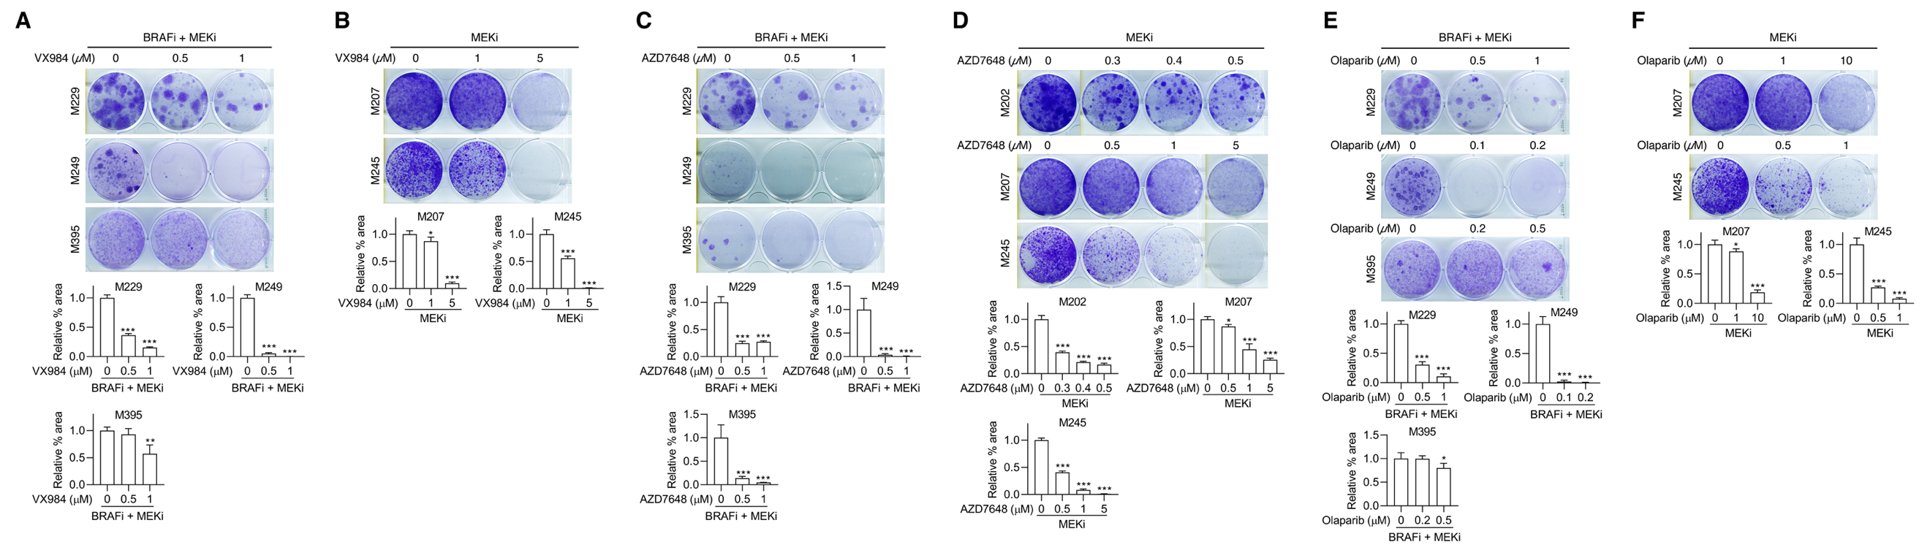
Supplementary Figure S5. DNA-PKi and/or PARPi co-treatment prevents acquired MAPKi-resistance in human melanoma cell lines.
A to F, Long-term clonogenic growth of BRAF^{V600MUT} (A, C and E) or NRAS^{Q61MUT} (B, D and F) cell lines showing acquired-resistant colonies to BRAFi + MEKi (PLX4032 at 0.5 μM, AZD6244 at 0.5 μM for M229 and M395; PLX4032 at 0.25 μM, AZD6244 at 0.25 μM for M249) or MEKi (trametinib at 0.005 μM for M202 and 0.01 μM for M207 and M245) and their suppression by indicated co-treatments with DNA-PKi (VX984 in A and B; AZD7648 in C and D) and/or PARPi (olaparib in E and F) at indicated concentrations. Top, representative cultures; bottom, quantifications over n = 4 fields (mean ± SD). Data representative of 2 independent repeats. Seeding densities (cells/well in 6-well dishes) and culture durations (days): M202 (40,000, 30), M207 (20,000, 16), M229 (5,000, 32), M245 (50,000, 31), M249 (40,000, 40), and M395 (20,000, 30). Data representative of 2 to 4 independent repeats. P values (one-way ANOVA followed by Tukey’s multiple comparison test) comparing indicated cultures versus MAPKi treatment only cultures: *, p < 0.05; **, p < 0.01; ***, p < 0.001.

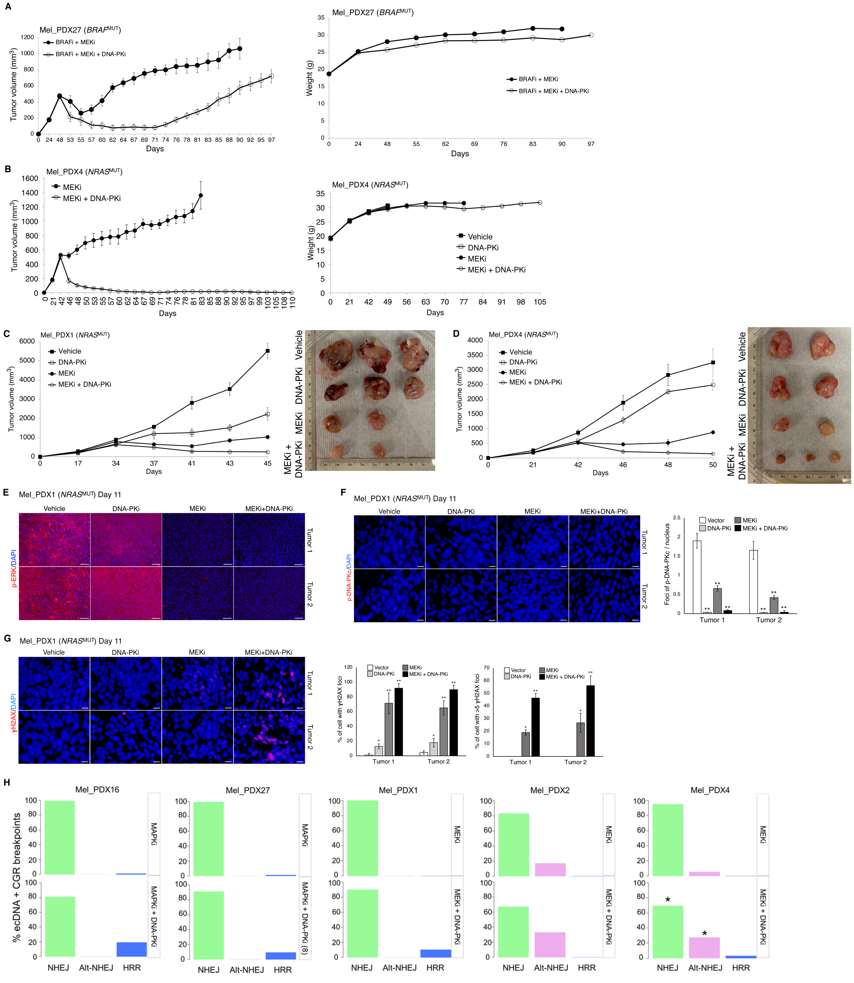
Supplementary Figure S6. In vivo impacts of DNA-PKi when combined with MAPKi.
A and B, Long-term follow-up of tumor volumes (A, BRAFi + MEKi, n = 5 tumors; BRAFi + MEKi + DNA-PKi, n = 6 tumors) (B, MEKi, n = 6 tumors; MEKi + DNAP-PKi, n = 6 tumors) and average mice body weights for A and B. Related to experiments in Figure 7B and 7E, respectively.
C and D, Tumor volumes (mean ± SEM) of two examples of tumor models treated short-term with vehicle or indicated single versus combined agents. Inhibitors and dosages are identical to those in Figures 7C and 7E, respectively. The numbers of tumors and their sizes are shown in the photographs (right) taken at the times of tumor harvest (end points).
E to G, Immunofluorescence of p-ERK (E), p-DNA-PKcs (S2056) (F), or γH2AX (G) levels in Mel_PDX1 tumor model, treated with vehicle or indicated single versus combined agents for 11 days (shown in C). DAPI, nuclear stain. Scale bar, 50 μm (E) and 20 μm (F and G). Representative images shown for two tumors analyzed per group. Quantification of p-DNA-PKcs signals obtained by taking the average of positively stained foci per nucleus (F, representative of 4 fields). Quantification of γH2AX signals analyzed either by percentage of cells with γH2AX foci or percentage of cells with greater than 5 γH2AX foci (G, representative of 4 fields). P values (Student’s t test): *, p < 0.05; **, p < 0.01.
H, Changes in the percentages of inferred DNA double-stranded break repair processes (NHEJ, alt-NHEJ, HRR) due to combined MAPKi + DNA-PKi treatment (versus MAPKi alone). Inferences based on breakpoint-junctional sequence analysis of ecDNAs + CGRs specific to each treatment group. P value (Student’s t-test): *, p < 0.05 (MEKi + DNA-PKi vs. MEKi).

SUPPLEMENTARY TABLE LEGENDS

Supplementary Table S1: Clinical characteristics of patients who donated MAPKi-sensitive/-naive and acquired MAPKi-resistant melanoma.

Supplementary Table S2: Genomic alterations, chromothripsis, and ecDNA-/CGR-amplicons detected in MAPKi-sensitive/-naive and acquired MAPKi-resistant melanoma genomes.

Supplementary Table S3: Genes amplified by ecDNAs, CGRs, and linear amplicons along with copy numbers in MAPKi-sensitive/-naive and acquired MAPKi-resistant melanoma genomes.

Supplementary Table S4: Co-occurrence of resistance-associated genetic alterations (identified in prior studies) with resistance-driver ecDNA and CGR amplicons (identified in the current study).

Supplementary Table S5: Normalized RNA-seq-based transcript expression in MAPKi-sensitive-/naïve- and acquire-resistant tumors.

Supplementary Table S6: MAPK-reactivation amplicons in acquired resistance, copy numbers, and amplicon sub-types.

Supplementary Table S7: MAPKi-resistant genes amplified by ecDNAs and CGRs utilized for pathway enrichment analysis.

Supplementary Table S8: Enhancers associated with ecDNAs and CGRs in MAPKi-sensitive/-naive and acquired MAPKi-resistant melanoma genomes.

Supplementary Table S9: Frequencies of enriched SBS signatures reflecting defective DNA repair mechanisms within chromothripsis and non-chromothriptic regions in MAPKi-sensitive (n = 16) and acquired-resistant (n = 31) tumors.

Supplementary Table S10: ecDNAs, CGRs, copy numbers, and associated genes in human melanoma cell lines (M229, M249) on vehicle treatment or early on treatment.

Supplementary Table S11: ecDNAs, CGRs, copy numbers, and associated genes in vehicle-treated and early on-treatment PDX tumors.

