Supplementary Materials and Methods

Patient samples: Samples were derived from patients enrolled on a clinical protocol (Clinicaltrials.gov: NCT01174121) approved by the institutional-review board (IRB) of the National Cancer Institute (NCI).

Next-generation sequencing: Whole-exome sequencing (WES) was performed by Personal Genome Diagnostics, the Broad Institute, and in the Surgery Branch, NCI on tumor tissue and normal peripheral blood cells as previously described (1). Snap-frozen, un-fixed tumor samples were used for all of the whole exome and RNA-seq libraries, with the exception of the metastatic tumor sample from patient 3971, which was fixed and paraffin-embedded tumor.

Alignment, Processing, Variant calling, and Filters used for screening assays: Alignments were performed using novoalign MPI from novocraft (http://www.novocraft.com/) to human genome build hg19. Duplicates were marked using Picard’s MarkDuplicates tool. Insertion deletion (Indel) realignment and base recalibration was carried out according to the GATK best practices workflow (https://www.broadinstitute.org/gatk/). Post cleanup of data, samtools mpileup (http://samtools.sourceforge.net) was used to create pileup files and Varscan2, (http://varscan.sourceforge.net), SomaticSniper (http://gmt.genome.wustl.edu/packages/somatic-sniper/), Strelka (https://sites.google.com/site/strelkasomaticvariantcaller/), and Mutect (https://www.broadinstitute.org/gatk/). Following callers VCF files were merged using GATK CombineVariants tools and annotated using Annovar (http://annovar.openbioinformatics.org).
Variants were then annotated using Annovar (http://annovar.openbioinformatics.org).

After the variant calling, the following filters were used to generate an initial list of putative mutations for evaluation: a tumor and normal coverage of greater than 10, a variant allele frequency (VAF) of 7% or above, variant read counts of 4 or above, and two of the four callers identifying mutations. For insertions and deletions (Indels) the same cutoffs were used except only a single caller identifying the mutation was required to pass filters, as these were only called by varscan and strelka. Tables of amino acid sequences corresponding the mutant residue joined to the 12 amino acids encoded by regions upstream and downstream of single nucleotide variants (SNVs) (Nmers) were generated from the variants passing filters. For frame-shifted transcripts, sequences were translated until a stop codon was generated in either the normal coding region or in the 3’ un-translated region. The Integrative Genomics Viewer (IGV, Broad Institute), which allows mapped alignments to be visualized, was then used to carry out manual curation of the variant calls. Changes were made to the sequences of Nmers when manual curation revealed that non-synonymous changes resulting from additional somatic variants or germline variants were present within transcripts encoding the Nmers. Variants inferred from reads containing multiple mis-matched nucleotides, indels mapping to different locations in different reads, and variants corresponding to frequent snps were flagged for removal. BLAT analysis of peptide Nmers against the ucsc database resulted in the identification of 27 transcripts, representing less than 0.3% of the total variant calls, that showed identity with germline segments that were potentially mis-mapped using the DNA alignment pipeline (Supplementary Table 10). A list of variants that were detected more than once in a set of greater than 200 tumors sequenced in the Surgery Branch but that do not correspond to known mutational hot-spots was also generated, and variants detected in 2.5% or more of the sequenced tumors were removed from the list of non-synonymous variants, as they likely represent mapping or sequencing errors. Variants that were detected in multiple patients’ tumors but in less than 2.5% of tumors were included in the list of variants that passed filters but were flagged to aid with the manual curation process. The median number of variant transcripts removed from the screening list generated for individual tumor samples by manual curation was 8 and ranged between 0 and 26 variant transcripts. In addition, variant transcripts that were only annotated in the ENSEMBL database, generally represent potential coding regions that have not been verified to encode protein products, were removed. Variants flagged as being present in multiple tumors or known snps were not automatically removed but were further evaluated using IGV, as removing potential false positives, which are unlikely to encode products recognized by T cells, was less critical than removing candidates that could represent false negatives. All transcripts output from the automated variant calling pipeline are reported in Supplementary Table 3, including those that were subsequently removed during the manual curation process described above to generate the final list of transcripts slated for screening.

Only a relatively limited number of in vitro cultured T cells were available for screening assays, which necessitated limiting the number of mutant nMers that could be used for interrogating these responses. Given this fact, more restricted filtering criteria were used for many of the tumors containing more than 200 mutant transcripts. As this screening process evolved over a period of more than seven years, the use of multiple filtering options has been investigated. Although ultimately the results have demonstrated transcript expression is strongly associated with the likelihood that it will give rise to a product recognized by T cells, this was not a given when these studies were initiated. These assays were also carried out as a part of a clinical program to identify T cells that could potentially mediate complete tumor regression, which led to a focus in some patients, many of whose tumors did not all contain the identified mutations, on targeting shared mutant gene products. The fact that consistent filters were not used has allowed conclusions to be drawn that otherwise would not have been possible if, for example, only highly expressed transcripts were evaluated.

RNA-seq Alignment, Processing and Variant calling: Alignments were performed using the STAR (https://github.com/alexdobin/STAR) two pass method to human genome build hg19. Duplicates were marked and Sorted using Picard’s MarkDuplicates tool. Reads were then split and trimmed using GATK SplitNTrim tool. After which In/Del realignment and base recalibration were performed using GATK toolbox. A pileup file was created using the final recalibrated bam file and variants were called using Varscan2 only.

Expression Quartile evaluation: To generate expression quartiles, FPKMs were determined for all genes using Cufflinks under default settings. For each individual patient all genes with an FPKM value greater than 0 were used to determine quartiles of expressed genes and genes were then assigned to appropriate quartile. All unexpressed genes were grouped into quartile 1 for that patient.

Allele-specific copy number analysis and mutation clustering: Whole exome sequencing data was used to carry out copy number analysis. The segmented copy number, cellularity and ploidy were determined using Sequenza v2.1.2 with normal sample as references and hg19 coordinates. The cancer cell fraction (CCF) of each mutation was estimated by integrating the local copy number, tumor purity (obtained from Sequenza), and variant allele frequency (VAF). For the given mutations, only mutations with tumor coverage of at least 20X were used. The observed mutation copy number can be calculated by integrating local copy number, purity and VAF (2). The mutations were classified as either clonal or sub-clonal based on the confidence interval of the CCF. Mutations were defined as clonal if the 95% confidence interval overlapped 1, and subclonal otherwise. All mutations with read depth greater than 4 and VAF greater than 7% were clustered using PyClone v1.3.0 Dirichlet process clustering. (3). PyClone allows clustering to simply group clonal and subclonal mutations based on their cancer cell fraction estimates. We ran PyClone with 50,000 iterations and a burn-in of 1000. The data analysis was performed in the R statistical environment, version 3.4.0.

Generation of tumor-infiltrating lymphocytes (TIL): TIL were generated as previously described (4). Briefly, surgically resected tumors were cut into approximately 1-2 mm fragments and placed individually into wells of a 24-well plate containing 2 ml of complete media (CM) containing high dose IL-2 (6000 IU/ml, Chiron). CM consisted of RPMI supplemented with 10% in-house human serum, 2 mM L-glutamine, 25 mM HEPES and 10 μg/ml gentamicin. In some cases, after the initial outgrowth of TIL (between 2-4 weeks), select cultures were rapidly expanded in gas-permeable G-Rex100 flasks using irradiated PBMC at a ratio of 1 to 100 in 400 ml of 50/50 medium, supplemented with 5% human AB serum, 3000 IU/ml of IL-2, and 30 ng/ml of OKT3 antibody (Miltenyi Biotec). 50/50 media consisted of a 1 to 1 mixture of CM with AIM-V media. All cells were cultured at 37°C with 5% CO2.

Generation of tandem minigene (TMG) constructs and peptide pools (PPs): The description of the tandem minigene (TMG) construct has been published (1,5). Briefly, for each non-synonymous substitution mutation identified by next-generation sequencing, a "minigene" construct encoding the corresponding amino acid change flanked by 12 amino acids of the wild-type protein sequence was made. Multiple minigenes were strung together to generate a TMG construct. For indels, minigenes were made by translating the frame-shifted sequence until the next stop codon. These minigene constructs were codon optimized, synthesized, and cloned in-frame into a modified pcDNA3.1 vector. Linearized DNA plasmid was used for the generation of IVT RNA using the mmessage mmachine T7 Ultra kit (Life Technologies) as directed by the manufacturer.

Synthetic peptides congruent to the mini-genes were synthesized via Fmoc chemistry either commercially or in-house. For indels, 25 amino acid peptides were synthesized overlapping by 10 amino acids based on the translation of the frame-shifted sequence until the next stop codon. Peptides were dissolved in DMSO and mixed in equal volumes to create peptide pools containing 8-24 peptides.

Generation of autologous dendritic cells (DCs): Monocyte-derived, immature dendritic cells were generated using the plastic adherence method as previously described (1). Briefly, apheresis samples were thawed, washed, set to 5-10e6 cells/ml with neat AIM-V media (Life Technologies) and then incubated at approximately 1e6 cells/cm2 in an appropriate sized tissue culture flask at 37°C, 5% CO2. After 90 min, non-adherent cells were removed, and adherent cells were incubated with DC media comprised of RPMI containing 5% human serum, 100 U/ml penicillin and 100 μg/ml streptomycin, 2 mM L-glutamine, 800 IU/ml GM-CSF (Leukine) and 200 U/ml IL-4 (Peprotech). Fresh or freeze/thawed DCs were used in experiments on day 4-6 after culture initiation.

RNA transfections of DCs: DCs were electroporated with IVT RNAs as previously described (1). Briefly, DCs were harvested and resuspended in Opti-MEM (Life Technologies) at 1-3e7 cells/ml. IVT RNA was aliquoted to the bottom of a 2 mm gap electroporation cuvette, and 50 μl or 100 μl of DCs were added directly to the cuvette. Electroporations were carried out using a BTX-830 square wave electroporator. DCs were electroporated with 150 V, 10 ms, and 1 pulse. Transfected cells were incubated overnight (12-14 h) at 37°C, 5% CO2 prior to use in co-culture assays. In co-culture assays, the irrelevant TMG RNA control was a TMG from a different patient.

Peptide pulsing DCs: DCs were pulsed with PPs or individual peptides as previously described (1). Briefly, DCs were harvested and resuspended at 0.5-2e6 cells/ml with DC media containing the appropriate cytokines. PPs were diluted 1:200 – 1:400 into the media containing the DCs. Alternatively, DCs were pulsed with individual peptides at 1-10 μg/ml (or the indicated concentrations for titrations) and incubated 2 hours to overnight at 37°C with 5% CO2. DCs were washed 1x prior co-culture with T cells.

T-cell sorting and expansion: The BD FACSAria and Sony SH800S were used in all experiments requiring cell sorting. In indicated experiments, sorted T cells were expanded using excess irradiated (4000 rad) allogeneic feeder cells (pool of three different donor leukapheresis samples) in 50/50 media containing 50 ng/ml anti-CD3 antibody (OKT3) and 30-3000 IU/ml IL-2. Cells were typically used in assays 2-3 weeks after the initial stimulation.

Co-culture assays: IFN-γ ELISPOT, ELISA, and flow cytometry to assess T-cell activation as previously described (1), and an example of our preliminary gating strategy is provided at the end of this Materials and Methods section.

Identification and construction of mutation-reactive TCRs: Several methods were used to identify mutation-reactive TCR sequences. First, T cells that upregulated an activation marker (4-1BB or OX40) upon co-culture with mutated TMGs or peptides were FACS purified and then directly sequenced or further expanded as previously described (6). Second, in cases where there was a dominant reactivity that correlated with a dominant TCR-Vβ clonotype (as determined using the IO Mark Beta Mark TCR V kit), the dominant TCR-Vβ expressing T cells were FACS purified and then either directly sequenced or further expanded before sequencing as previously described (1,6,7).
Construction of the mutation-reactive TCRs was done by fusing the TCR-alpha V-J regions to the mouse TCR-alpha constant chain, and the TCR-beta-V-D-J regions to the mouse TCR-beta constant chains separated by a furin SGSG P2A linker as previously described 1. Use of mouse TCR constant regions promotes pairing of the introduced TCR and also facilitates identification of positively transduced T cells by flow cytometry using an antibody specific for the mouse TCR-β chain (eBioscience).

TCR transduction of peripheral blood T cells: TCRs were introduced into autologous or allogeneic PBL as previously described (8). Briefly, apheresis samples were thawed and set to 2e6 cells/ml in T-cell media and were stimulated with 50 ng/ml soluble OKT3 (Miltenyi Biotec) and 300 IU/ml rhu IL-2 (Chiron) for 2 days prior to retroviral transduction. To generate transient retroviral supernatants, the retroviral vector MSGV1 encoding the mutation-reactive TCRs (1.5 μg/well) and the envelope encoding plasmid RD114 (0.75 μg/well) were co-transfected into the retroviral packaging cell line 293GP (1e6 cells per well of a 6-well poly-D-lysine–coated plates, plated the day prior to transfection) using Lipofectamine 2000 (Life Technologies). Retroviral supernatants were collected at 42-48 h after transfection, diluted 1:1 with DMEM media, and then centrifuged onto Retronectin-coated (10 μg/ml, Takara), non–tissue culture–treated 6-well plates at 2,000 g for 2 h at 32°C. Activated T cells (2e6 per well, at 0.5e6 cells/ml in 300 - 600 IU/ml IL-2 containing T-cell media) were then spun onto the retrovirus-coated plates for 10 min at 300 g. GFP and mock transduction controls were included in transduction experiments. Cells were typically assayed 10-14 days post-retroviral transduction.

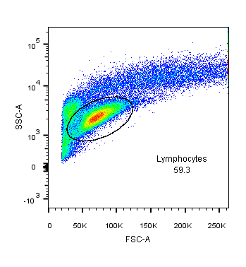
FACS gating strategy to identify live, CD3+ T lymphocytes

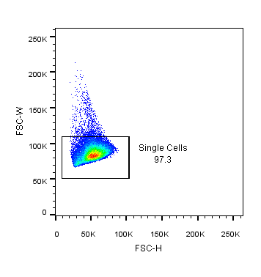
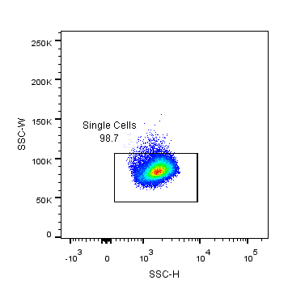
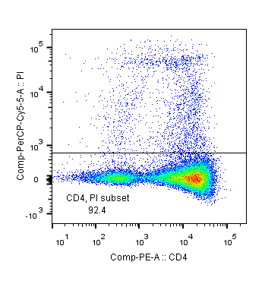
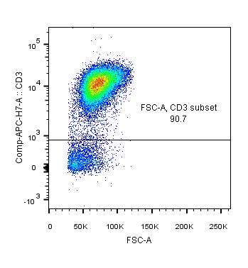

REFERENCES

1. Tran E, Ahmadzadeh M, Lu YC, Gros A, Turcotte S, Robbins PF, et al. Immunogenicity of somatic mutations in human gastrointestinal cancers. Science 2015;350(6266):1387-90.
2. McGranahan N, Furness AJ, Rosenthal R, Ramskov S, Lyngaa R, Saini SK, et al. Clonal neoantigens elicit T cell immunoreactivity and sensitivity to immune checkpoint blockade. Science 2016;351(6280):1463-9.
3. Roth A, Khattra J, Yap D, Wan A, Laks E, Biele J, et al. PyClone: statistical inference of clonal population structure in cancer. Nat Methods 2014;11(4):396-8.
4. Jin J, Sabatino M, Somerville R, Wilson JR, Dudley ME, Stroncek DF, et al. Simplified method of the growth of human tumor infiltrating lymphocytes in gas-permeable flasks to numbers needed for patient treatment. J Immunother;35(3):283-92.
5. Lu YC, Yao X, Li YF, El-Gamil M, Dudley ME, Yang JC, et al. Mutated PPP1R3B is recognized by T cells used to treat a melanoma patient who experienced a durable complete tumor regression. J Immunol 2013;190(12):6034-42.
6. Parkhurst M, Gros A, Pasetto A, Prickett T, Crystal JS, Robbins P, et al. Isolation of T-Cell Receptors Specifically Reactive with Mutated Tumor-Associated Antigens from Tumor-Infiltrating Lymphocytes Based on CD137 Expression. Clin Cancer Res 2017;23(10):2491-505.
7. Pasetto A, Gros A, Robbins PF, Deniger DC, Prickett TD, Matus-Nicodemos R, et al. Tumor- and Neoantigen-Reactive T-cell Receptors Can Be Identified Based on Their Frequency in Fresh Tumor. Cancer immunology research 2016;4(9):734-43.
8. Morgan RA, Dudley ME, Yu YY, Zheng Z, Robbins PF, Theoret MR, et al. High efficiency TCR gene transfer into primary human lymphocytes affords avid recognition of melanoma tumor antigen glycoprotein 100 and does not alter the recognition of autologous melanoma antigens. J Immunol 2003;171(6):3287-95.

