SUPPLEMENTARY TABLES:

Table S1: Donors. Related to figures 1-7. A table describing the donor information for samples used in the study.

Table S2: Differential ChIP-seq peaks. Related to figures 1 and supplementary figure 2. Annotated tables of the H3K4me1, H3K4me3, H3K27me3, and H3K27me3 ChIP-seq peaks that are gained or lost in aged HSCe compared to young (LLR>3 and absolute fold-change>1.5) as well as functional annotation of the peaks that have decreased H3K4me1, H3K4me3, H3K27me3, or H3K27me3 with age.

Table S3: Differentially methylated regions. Related to figure 1. Differentially methylated regions (DMRs) in Aged HSCe compared to Young HSCe (regions with ≥2 DMC, ≥3 CpG, absolute mean methylation difference ≥ 20, and DMR q-value ≤ 0.05).

Table S4: Clusters of age-associated epigenetic changes. Related to figures 2 and 3. Contains the list of peaks within each cluster. Also contains the significant (FDR < 0.1) KEGG pathways enriched in each cluster.

Table S5: Genomic regulatory regions in young HSC. Related to figures 2 and 3. Contains the lists of active and poised enhancers, as well as bivalent promoters, identified in young HSCe.

Table S6: Gene expression. Related to figure 4. Reported are the differentially expressed (padj<0.05, fold-change >1.5) genes in aged HSCe compared to young HSCe. A positive log2 fold-change corresponds to increased gene expression in aged HSCe.

Table S7: Gene set enrichment analysis. Related to figures 4 and 7. Reported are the significant (FDR<0.05) GSEA results for the Wald statistic ranked list of aged HSCe gene expression compared to young HSCe and the GSEA results for the Wald statistic ranked list of gene expression for CD34+ transfected with sgCTRL compared to CD34+ transfected with sgKLF6.

Table S8: Overlap with aging signatures. Related to figure 5. Results of the comparison of HSCe age-associated differentially expressed genes to genes differential expressed in 9 other tissues by Yang et al., 2015.

Table S9: sc-RNAseq. Related to figure 7. Contains the donor information for samples used for sc-RNAseq, as well as the differentially expressed genes in young vs. aged non-cycling HSC.

Table S10: Regions predisposing to AML. Related to figure 6. Contains the results of the k-means clustering performed using young and aged HSCe and AML samples for both DNA methylation and the histone modifications.

Table S11: Oligonucleotides. Related to figures 1 and 7 and S7. Oligonucleotides used throughout the study.

SUPPLEMENTARY FIGURES:

Supplementary Figure S1:
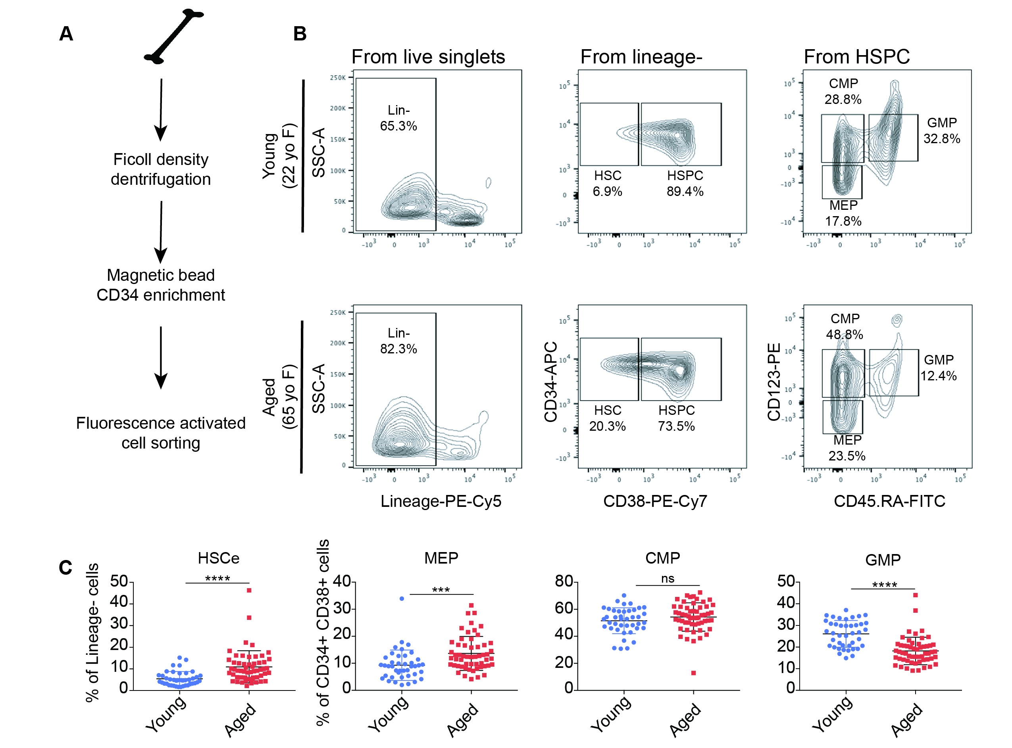

Supplementary Fig. S1: FACS Isolation of HSCe and HSPC. (A) Cell isolation schema used to isolate HSCe (Lin-, CD34+, CD38-) and HSPC (Lin-, CD34+, CD38+) from human healthy bone marrow donors. (B) FACS gating strategy. Shown are representative plots for a young donor (top) and aged donor (bottom). (C) Plots of the frequencies of HSCe, MEP, CMP, and GMP in young and aged samples. Each dot is representative of 1 donor (n=41 young and n=55 aged). p-values calculated using t-test in Prism, p>0.05=ns, p ≤ 0.05=*, p≤0.01=**, p≤0.001=***, p≤0.0001=****. See also Table S1.

Supplementary Figure S2:

Supplementary Fig. S2: Focal reduction of activating histone modifications with age. (A) Metaplots of log₂(Pooled IP/Pooled Input) signal at regions that lose (log₁₀ likelihood ratio > 3, absolute fold-change >1.5) H3K4me1, H3K27ac, H3K4me3, or H3K27me3 signal in aged HSCe compared to young. Represented are 10-kb regions centered around the differential peak areas. (B) Bar plots illustrating the percentage of peaks that are unchanged, gained, or lost in aged HSCe compared to young. See also Figure 1.

Supplementary Figure S3:
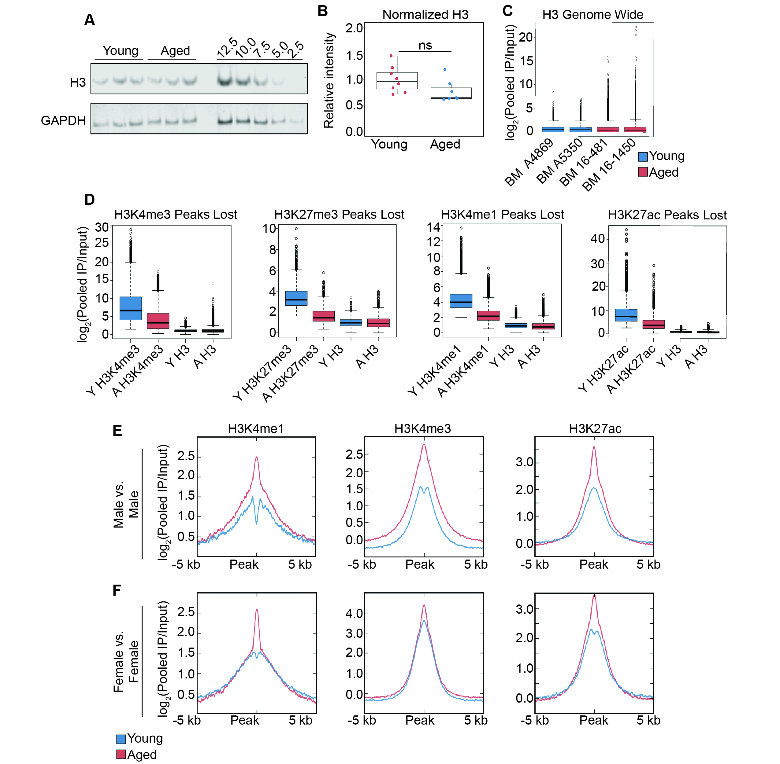
Supplementary Fig. S3: Alterations in histone modifications are not due to donor sex or total change in H3. (A) Representative Western blot analysis performed with 5,000 cells and imaged with the LiCor for each biological replicate of young and aged HSCe for H3 and GAPDH. HSCe from a 53 yo donor were also used to establish the linear range of the assay, with 2,500-12,500 HSCe loaded per lane. (B) Densitometry was performed using Image Studio and Image Lab and normalized intensity of H3 was calculated using GAPDH signal. Each sample was then normalized to the mean young intensity. Each point is representative of a biological replicate or the average intensity of the 2 technical replicates. P-value was calculated using the parametric unpaired t-test was performed using Prism software. (C) Boxplots of genome wide H3 enrichment for 2 young (blue) and 2 aged (red) donors. The genome was binned into 150 bp windows and log2 enrichment of H3 was calculated for each bin. (D) Log₂ enrichment of H3 and H3K4me3 (leftmost), H3K27me3 (second from left), H3K4me1 (second from right) and H3K27ac (rightmost) for the respective histone modifications lost with age. Boxplots are of the log₂ enrichment of the Pooled IP/Pooled Input. (E-F) Metaplots of log₂(Pooled IP/Pooled Input) signal at regions that lose (log₁₀ likelihood ratio > 3, absolute fold-change >1.5) H3K4me1, H3K27ac, or H3K4me3 signal in aged male (E) or female (F) HSCe compared to young HSCe. Represented are 10-kb regions centered around the differential peak areas. See also Figure 1.

Supplementary Figure S4:
Supplementary Fig. S4: Transcriptional changes with HSCe aging are not sex-dependent. (A) Overlap by gene name of genes differentially expressed with aging in HSCe from female donors (pink, n=2,048 genes) or male and female donors (green, n=1,133 genes). (B) Volcano plot of the log₂ fold-change (aged/young) gene expression versus the –log₁₀(p-adj) for HSCe from female donors (n=9 aged and n=3 young donors). Significant downregulated and upregulated genes in aged HSCe compared to young are colored in blue and red, respectively (FDR < 0.05 and fold-change< -1.5 or fold-change > 1.5, respectively). See also Figure 4.

Supplementary Figure S5:
Supplementary Fig. S5: Single-cell RNA-seq of young and aged HSC. (A) Schematic of the cellHarmony analysis used to identify cell types within the HSCe compartment using sc-RNAseq data from young (24-37 yo) and aged (64-71 yo) HSCe. (B) Heatmap of the differentially expressed genes (n=364, fold-change > 1.5, eBayes t-test p<0.05, FDR <0.05) in young nc-HSC compared to aged nc-HSC. Each column corresponds to an individual cell. Age of donor is depicted in the bottom bar. Clustering was performed using HOPACH in AltAnalyze, with 3 main clusters identified (C1-Young in green, C2-Aged in purple, and C3-Aged in red). See also Figure 5.

Supplementary Figure S6:
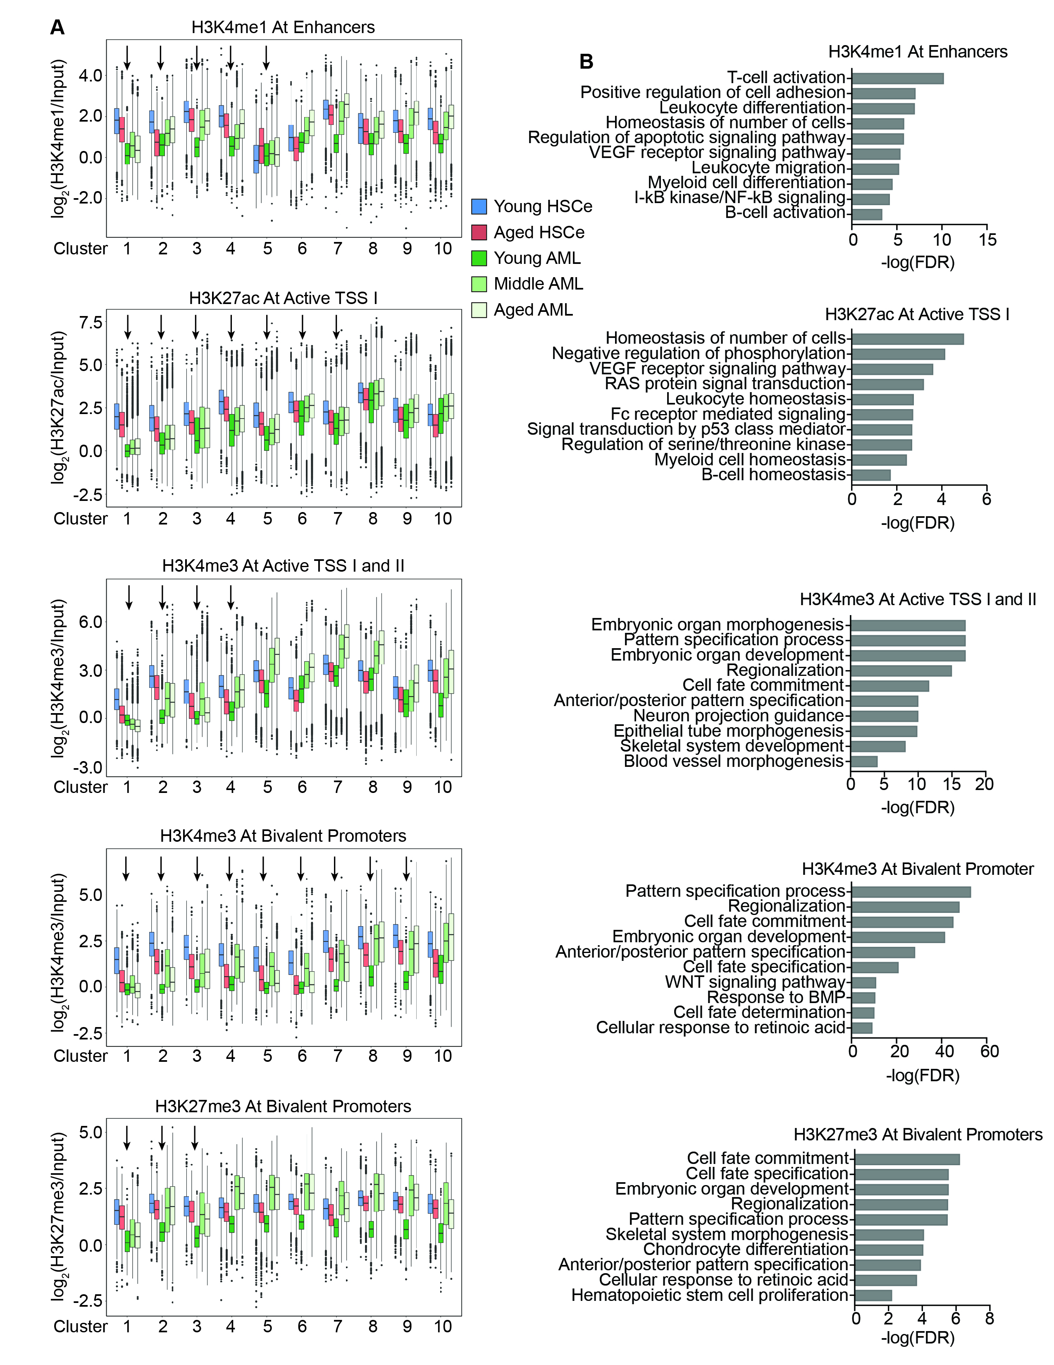
Supplementary Fig. S6: Age-associated histone changes may predispose for AML. (A) Boxplots of the log₂(IP/Input) signal for HSCe (n=4-7 donors) and AML (n=16 for H3K4me1, n=19 for H3K4me3, n=17 for H3K27me3, and n=71 for H3K27ac, respectively) samples for the defining histone marks at the epigenetic categories that are altered with HSCe aging. Arrows denote clusters of regions that may be predisposing to AML (Mann-Whitney rank sum test, p-adjusted < 0.005). (B) Select significant (FDR <0.05) gene ontology biological processes associated with the peaks in the significant clusters in (A). See also Figure 6.

Supplementary Figure S7:

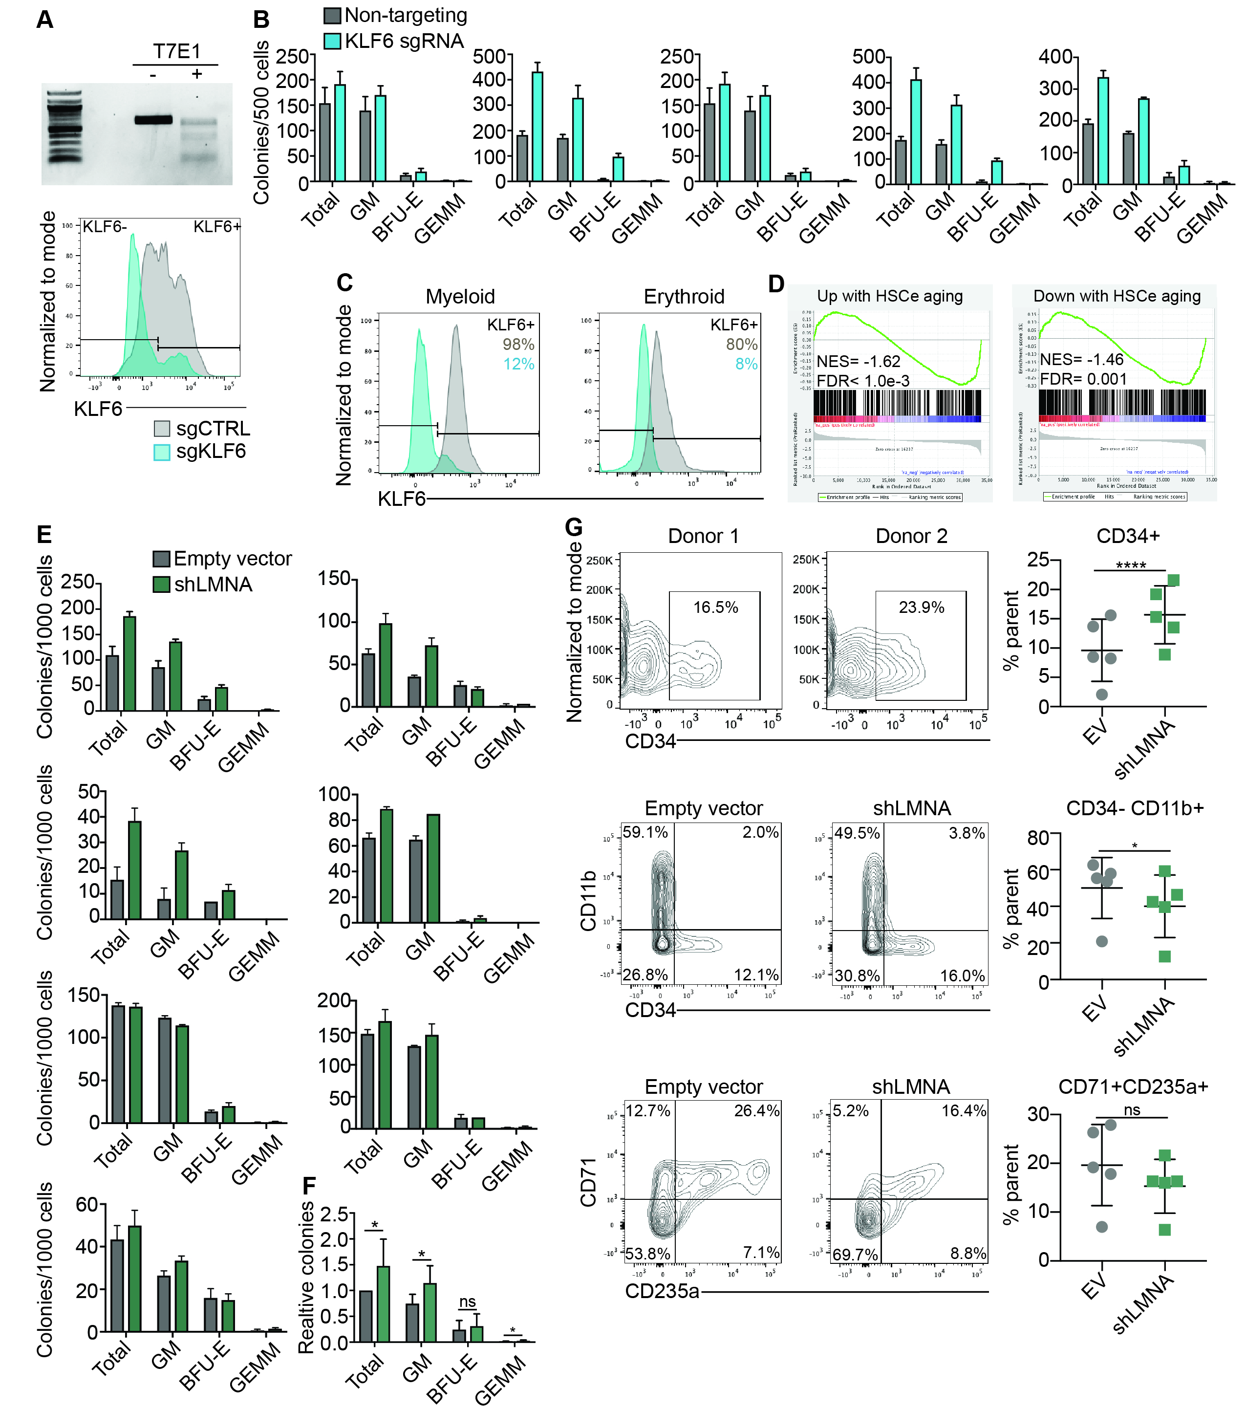
Supplementary Fig. S7: Knockdown of LMNA or KLF6 recapitulates aging phenotypes. (A) Gel image of KLF6 targeting in CD34+ cells with (+) or without (-) the T7E1 nuclease (top) and flow cytometry histograms showing the percentage of KLF6+ cells (84% and 20% in sgCTRL and sgKLF6 transfected cells, respectively) 72 hrs after sorting CD34+ cells (bottom). (B) Colony-forming unit assays of CD34+ cells with CRISPR-Cas9 knockout of KLF6. Colony numbers per 500 CD34+ cells plated are plotted for total colony number, granulocyte-macrophage (GM), granulocyte-erythrocyte-macrophage-megakaryocyte (GEMM) and burst-forming unit erythroid (BFU-E). Each bar plot is representative of 1 donor and the average of 2 technical replicates is plotted for each donor. (C) Flow cytometry histograms showing KLF6 levels after 7 days in myeloid culture (left) or erythroid culture (right) in CD34+ cells transfected with sgCTRL or sgKLF6. Data is from 1 donor. (D) GSEA leading edge plots showing the enrichment of the gene sets for genes up- or down-regulated with HSCe aging in CD34+ cells with LMNA knockdown (n=8 independent biological replicates). GSEA was ran using a list pre-ranked by the Wald-statistic (DESeq2), with the weighted enrichment score. (E) Colony-forming unit assays of CD34+ cells with shRNA mediated knockout of LMNA. Colony numbers per 1000 CD34+ cells are shown as in (B). (F) Bar plot of the relative total colony number, granulocyte-macrophage (GM), granulocyte-erythrocyte-macrophage-megakaryocyte (GEMM) and burst-forming unit erythroid (BFU-E) for n=7 biological replicates. For each replicate, colony numbers were normalized to the total number of colonies for that replicate. (G) Representative contour plots for 2 donors and contour plots from 1 donor for CD34+ cells transfected with empty vector (EV) or shLMNA and cultured in myeloid (top and middle) or erythroid (bottom) promoting conditions for 7 days. Dot plot representation of the percentage of CD34+ cells (top) CD34- CD11b+ (middle) and CD235a+ CD71+ (bottom) cells is also shown (n=5). Prior to setting the above gates, cells were gated on GFP expression. p-values from paired one-tailed t-test, calculated with Prism, p>0.05=ns, p ≤ 0.05=*, p≤0.01=**, p≤0.001=***, p≤0.0001=****. See also Figure 7.

