Supplementary Data

Cycle | HR ALL | NHL | HD | T-L/Ly | AML | NB | Wilms | Ewing’s | Rhabdo | Osteo
pre |  | * | * | * | * | * | * | * | * | *
1 |  | * | * |  |  | * |  | * | * | *
2 |  | * | * |  |  | * |  | * | *
3 | * | * | * |  | * | * | * | * | * | *
4 | * | * | * | * | * | * |  | * | *

Table S1. Statistical significance of expansion relative to standard risk ALL. Pass rate percentage was compared to SR ALL pass rate at the same cycle of chemotherapy for each disease. Statistically significant (p<0.01 with Fisher’s Exact test) differences are noted by a *.

 | SR ALL | HR ALL | NHL | HD | T-LL/Ly |  | AML | NB | Wilms | Ewing’s | Rhabdo | Osteo
Naive |  | 0.019 ↓ | 0.015 ↓ | 0.016 ↓ |  |  |  | 0.04 ↓ |  | 0.006 ↓ | 0.044 ↓
SCM |  |  | 0.001 ↓ |  |  |  |  |  |  | 0.001 ↓ | 0.002 ↓
CM | 0.001 ↑ |  |  |  |  | 0.03 ↑ |  | 0.02 ↑
EM |  |  |  |  |  |  |  |  |  | 0.01 ↓
TE |  |  | 0.045 ↑ | 0.048 ↑ |  | 0.03 ↓ |  |  |  | 0.001 ↑

Table S2. Summary of significant differences in T cell subsets over time/subsequent chemotherapy cycles. Values are the p value for that T cell subset as analyzed by regression, with an arrow indicating if that trend was up or down over subsequent chemotherapy cycles relative to prechemotherapy values. SCM, stem central memory T cells; CM, central memory T cells; EM, effector memory T cells; TE, terminal effector T cells.
Disease | 0 | 1 | 2 | 3 | 4
SR ALL | 2.11 (0.76) | 2.04 (0.82) | 1.69 (0.94) | 1.48 (0.75) | 1.97 (0.72)
HR ALL | 1.80 (0.88) | 1.79 (0.94) | 0.93 (0.65) | 1.14 (0.62) | 1.34 (0.64)
AML | 1.87 (0.64) | 2.96 (1.22) | 2.66 (0.76) | 2.22 (1.38) | 2.34 (1.01)
Hodgkins | 2.21 (1.39) | 2.14 (1.32) | 2.27 (0.67) | 2.16 (0.71) | 2.21 (0.85)
NHL | 1.75 (0.72) | 1.59 (0.88) | 1.71 (0.81) | 1.11 (0.49) | 1.62 (0.65)
Neuroblastoma | 3.66 (1.56) | 2.54 (1.22) | 2.22 (1.43) | 2.89 (0.95) | 2.65 (1.02)
Wilms | 2.54 (0.74) | 1.80 (0.89) | 1.70 (0.88) | 1.85 (0.92) | 1.81 (0.75)
Ewings | 1.38 (0.61) | 2.05 (0.97) | 1.73 (0.69) | 1.74 (0.88) | 2.12 (0.76)
Rhabdo | 2.35 (2.05) | 2.17 (1.11) | 2.10 (0.76) | 0.93 (0.45) | 1.98 (0.64)
Osteosarcoma | 1.89 (0.67) | 1.67 (0.78) | 1.07 (0.66) | 1.38 (0.67) | 1.77 (0.72)
T-ALL/Ly | 2.15 (0.58) | 1.21 (0.82) | 0.96 (0.54) | 1.67 (0.83) | 2.12 (0.59)

Table S3. CD4 to CD8 ratio at diagnosis and after chemotherapy. Values are the CD4 percentage divided by the CD8 percentage to give a ratio. Normal donors are expected to be about 3.0. Standard deviation is presented in parentheses. Due to high variability, no significant differences were detected. “0” indicates prechemotherapy/diagnostic sample.

High Risk Acute Lymphoblastic Leukemia
- Vincristine, Daunorubicin, Asparaginase, Dexamethasone
- Vincristine, Mercaptopurine, Cyclophosphamide, Cytarabine, Asparaginase
- Vincristine, Mercaptopurine, Methotrexate
- Vincristine, Doxorubicin, Dexamethasone, Asparaginase, Cyclophosphamide, Thioguanine, Cytarabine
- Vincristine, Prednisone, Mercaptopurine, Methotrexate *repeats until end of therapy
Standard Risk Acute Lymphoblastic Leukemia
- Vincristine, Asparaginase, Dexamethasone
- Vincristine, Mercaptopurine
- Vincristine, Methotrexate
- Vincristine, Doxorubicin, Dexamethasone, Asparaginase, Cyclophosphamide, Thioguanine, Cytarabine
- Vincristine, Dexamethasone, Mercaptopurine, Methotrexate *repeats until end of therapy
Ewings Sarcoma
- Vincristine, Doxorubicin, Cyclophosphamide
- Ifosphamide, Etoposide *Cycles alternate between these two regimens
Rhabdomyosarcoma
Vincristine, Dactinomycin, Cyclophosphamide
*Repeated every three weeks, dactinomycin held during radiation
Osteosarcoma
1-4. Cisplatinum, Doxorubicin, Methotrexate
5. Doxorubicin, Methotrexate
Wilms Tumor
Vincristine, Doxorubicin, Dactinomycin

T cell Lymphoblastic Leukemia/Lymphoma
- Vincristine, Daunorubicin, Asparaginase, Dexamethasone
- Vincristine, Asparaginase, Mercaptopurine, Cyclophosphamide, Cyatarabine
- Vincristine, Asparaginase, Methotrexate
- Vincristine, Asparaginase, Doxorubicin, Dexamethasone, Cyclophosphamide, Cytarabine, Thioguanine
Non-Hodgkins Lymphoma
- Vincristine, Cyclophosphamide, Prednisone
- Vincristine, Cyclophosphamide, Prednisone, Doxorubicin, Methotrexate
  - Methotrexate, Cytarabine
- Etoposide, Cyatarabine
Hodgkins Disease
Vincristine, Prednisone, Doxorubicin, Bleomyocin, Etoposide, Cyclophosphamide

Neuroblastoma
1-2. Topotecan, Cyclophosphamide
3. Cisplatinum, Etoposide
4. Vincristine, Cyclophosphamide, Doxorubicin
5. Cisplatinum, Etoposide

Acute Myeloid Leukemia
1-2. Cytarabine, Daunorubicin, Etoposide
3. Cytarabine, Etoposide
4. Mitoxantrone, Cytarabine

Supplemental Table S4: Summary of standard of care chemotherapy used to treat patients on the study. Cycles are represented by number, with many being repeated either sequentially or alternating where noted.

Supplementary Figures
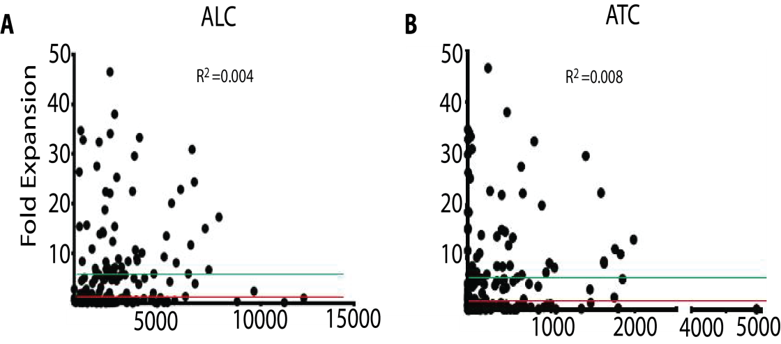
Supplementary Figure S1 : Correlation of absolute lymphocyte count (ALC) or T cell count (ATC) with expansion magnitude. For each individual sample the absolute lymphocyte count was plotted versus the fold expansion in response to CD3/28 bead stimulation. Red line is 1-fold (i.e. no growth) and green line is 5 fold. There is no correlation between ALC or ATC and expansion.

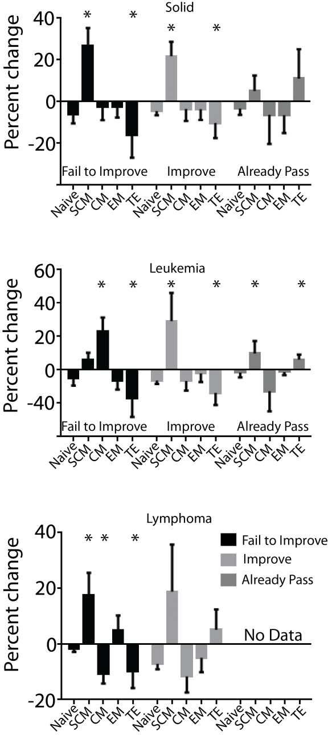
Supplementary Figure S2: IL-7 and IL-15 increase SCM percentage of post-expansion T cells. Plotted here are the average percentage shift in T cell subset phenotypes between samples expanded with beads alone versus beads plus IL-7 and 15. IL-7 and 15 primarily increase the SCM percentage as expected, even in samples which ultimately did not expand (Fail to Improve). This is more pronounced in lymphoma and solid tumor patients, as leukemia patients see an increase in CM T cell percentage also. Notably, in samples that already expanded well, IL-7 and 15 also served to increase the final percentage of terminal effector cells, an undesired subset in cellular therapy products. *=p<0.05

