**Supplementary Table 1: Sequence variants detected by targeted amplicon sequencing in 15 cases of CLL-type progression on venetoclax**

|  |  |  |  |  |  |  |  |
| --- | --- | --- | --- | --- | --- | --- | --- |
|  | **Pre-venetoclax** | | **Post-progression on venetoclax** | | **BCL2 VAF (ddPCR)** | **Est % CLL cells pos**a | **IGVH status** |
| **Patient** | **Gene** | **HGVSc, HGVSp** | **Gene** | **HGVSc, HGVSp** |  |  |  |
| **CLL1** | SF3B1 | c.2098A>G, p.(Lys700Glu) | SF3B1 | c.2098A>G, p.(Lys700Glu) |  |  | Unmutated |
| NOTCH1 | c.7541_7542del, p.(Pro2514Argfs*4) | NOTCH1 | c.7541_7542del, p.(Pro2514Argfs*4) |  |  |
| BIRC3 | c.1670_1673del, p.(Cys557*) | BIRC3 | c.1670_1673del, p.(Cys557*) |  |  |
| TP53 | c.166_167insT, p.(Glu56Valfs*7) |  |  |  |  |
| **CLL2** | NOTCH1 | c.7541_7542del, p.(Pro2514Argfs*4) | NOTCH1 | c.7541_7542del, p.(Pro2514Argfs*4) |  |  | Unmutated |
| TP53 | c.626_627del, p.(Arg209Lysfs*6) | TP53 | c.626_627del, p.(Arg209Lysfs*6) |  |  |
|  |  | **BCL2** | **c.302G>T, p.(Gly101Val)**b | **1.42%** | **25.8%** |
| **CLL3** | SF3B1 | c.2098A>G, p.(Lys700Glu) | SF3B1 | c.2098A>G, p.(Lys700Glu) |  |  | Mutated |
| TP53 | c.818G>A, p.(Arg273His) | TP53 | c.818G>A, p.(Arg273His) |  |  |
| TP53 | c.742C>T, p.(Arg248Trp) |  |  |  |  |
|  |  | **BCL2** | **c.302G>T, p.(Gly101Val)** b | **12.02%** | **68% (70%)**d |
| **CLL4** | NOTCH1 | c.7541_7542del, p.(Pro2514Argfs*4) | NOTCH1 | c.7541_7542del, p.(Pro2514Argfs*4) |  |  | Unmutated |
| BIRC3 | c.1331_1334del, p.(Leu444Tyrfs*2) |  |  |  |  |
|  |  | TP53 | c.842_843delinsTA, p.(Asp281Val) |  |  |
| **CLL5** | Nil |  | **BCL2** | **c.302G>T, p.(Gly101Val)** c | **0.01%** | **45.6%**e | Unmutated |
| **CLL6** | TP53 | c.701A>C, p.(Tyr234Ser) | TP53 | c.701A>C, p.(Tyr234Ser) |  |  | Unmutated |
|  |  | TP53 | c.1125_1140del, p.(Ser376Lysfs*41) |  |  |
|  |  | **BCL2** | **c.302G>T, p.(Gly101Val)** c | **0.4%** | **1.4%** |
| **CLL7** | NOTCH1 | c.7541_7542del, p.(Pro2514Argfs*4) |  |  |  |  | Unmutated |
| TP53 | c.706T>A, p.(Tyr236Asn) | TP53 | c.706T>A, p.(Tyr236Asn) |  |  |
| **CLL8** | TP53 | c.919+1G>A, p.? |  |  |  |  | Mutated |
| TP53 | c.701A>G, p.(Tyr234Cys) |  |  |  |  |
| TP53 | c.530C>T, p.(Pro177Leu) | TP53 | c.530C>T, p.(Pro177Leu) |  |  |
| TP53 | c.524G>A, p.(Arg175His) |  |  |  |  |
|  |  | **BCL2** | **c.302G>T, p.(Gly101Val)** c | **0.53%** | **1.4%** ~~e~~ |
| **CLL9** | Nil |  | Nil |  |  |  | Unmutated |
| **CLL10** | TP53 | c.532dup, p.(His178Profs*3) | TP53 | c.532dup, p.(His178Profs*3) |  |  | Mutated |
| SF3B1 | c.2098A>G, p.(Lys700Glu) | SF3B1 | c.2098A>G, p.(Lys700Glu) |  |  |
| **CLL11** | TP53 | c.808T>C, p.(Phe270Leu) |  |  |  |  | Unmutated |
|  | KRAS | c.38G>A, p.(Gly13Asp) |  |  |  |  |
|  |  | TP53 | c.536A>G, p.(His179Arg) |  |  |
|  |  | KRAS | c.68T>G, p.(Leu23Arg) |  |  |
| **CLL12** | XPO1 | c.1711G>A, p.(Glu571Lys) | XPO1 | c.1711G>A, p.(Glu571Lys) |  |  | Unmutated |
| TP53 | c.742C>G, p.(Arg248Gly) |  |  |  |  |
| TP53 | c.742C>T, p.(Arg248Trp) |  |  |  |  |
|  |  | SF3B1 | c.1998G>T, p.(Lys666Asn) |  |  |
|  |  | **BCL2** | **c.302G>T, p.(Gly101Val)** b | **0.9%** | **60%**e |
| **CLL13** | TP53 | c.476C>A, p.(Ala159Asp) | TP53 | c.476C>A, p.(Ala159Asp) |  |  | Unmutated |
| **CLL14** | Nil |  | **BCL2** | **c.302G>T, p.(Gly101Val)**c | **0.07%** | **4.3%** | Mutated |
| **CLL15** | TP53 | c.469G>T, p.(Val157Phe) | TP53 | c.469G>T, p.(Val157Phe) |  |  | Unmutated |

Individual mutations detected in each patient sample are represented by a line; at progression, persisting mutations share the same line as pre-venetoclax listing, while previously undetected mutations have a new line. aEstimated proportion of CLL cells harboring the BCL2 Gly101Val mutation at progression, assuming heterozygosity; calculated by adjusting the measured VAF by the % of CLL cells in the bone marrow determined by flow cytometry. bDetected by amplicon NGS in progression sample. cDetected only by ddPCR in progression sample. d For CLL3, the estimated proportion was additionally confirmed using CD19+-selected cells, calculated percentage in brackets; eCalculated on samples obtained post-progression

TP53 NM_000546.5, NOTCH1 NM_017617.3, SF3B1 NM_012433.2, BCL2 NM_000633.2, XPO1 NM_003400.3, BIRC3 NM_001165.4, KRAS NM_033360.2

**Supplementary Figures**



**Supplementary Figure 1: The *BCL2* genomic locus is not perturbed, and the Gly101Val mutant transcript is expressed.**

**(A)** Copy number assessment at the *BCL2* locus on chromosome 18q from CD19+ selected cells from patient CLL3 demonstrating no evidence of copy number loss or gain.

**(B)** Integrative genomics viewer (IGV) output (ver 2.3.55(72)) of RNA-sequencing data from CD19+ selected cells from patient CLL3 demonstrating expression of the *BCL2* NM_000633.2:c.302G>T; p.(Gly101Val) mutation



**Supplementary Figure 2. Persistence of Gly101Val in CLL cells during salvage therapy following progression on venetoclax.** Graph of the estimated percentage of CLL cells bearing the Gly101Val mutation in five patients who had bone marrow samples suitable for analysis both during venetoclax therapy and during subsequent treatment(s) after venetoclax was ceased. The percentage of CLL cells bearing the mutation was calculated from the ddPCR VAF adjusted for the percentage of leukocytes that were CD5+19+ by MFC. Zero values represent negative ddPCR results in cases where CLL MRD was detectable by flow cytometry. All received a BTK inhibitor as next therapy (ibrutinib in all except CLL6 who received zanubrutinib) and all achieved a partial response. CLL8 subsequently proceeded to an allogeneic stem cell transplant, but later relapsed with an unchanged percentage of Gly101Val-bearing CLL cells.



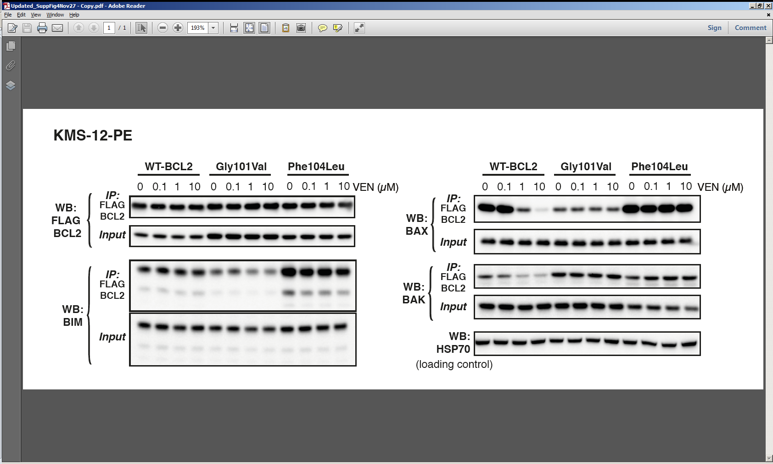

**Supplementary Figure 4: Venetoclax is less able to compete endogenous BAX and BAK off mutant BCL2 in KMS-12-PE cells.**

Independent experiment recapitulating result displayed in Figure 4A.



**Supplementary Figure 5: Effect of the microenvironment and subclonality of Gly101Val on *in vitro* sensitivity to venetoclax.**

(**A**) CLL cells at progression from patients (CLL2, 5) become more resistant to venetoclax when co-cultured with stromal cells. Assays performed as described for **Figure 4C**, and data for the same three venetoclax-naïve patient CLL samples shown in Figure 4C are retained in each panel. Data for CLL2 and CLL5 represent mean ± 1SD of triplicate measures in single experiments per patient sample.

(**B**) KMS-12-PE cells expressing either WT (GFP labelled) or Gly101Val (BFP labelled) BCL2 were mixed in different proportions (indicated by purple lines) in the presence of venetoclax (0-10µM) for 24 hours, and the percentage of alive cells normalized to cells treated with DMSO was shown. Data represent means ± 1SD of three independent experiments.

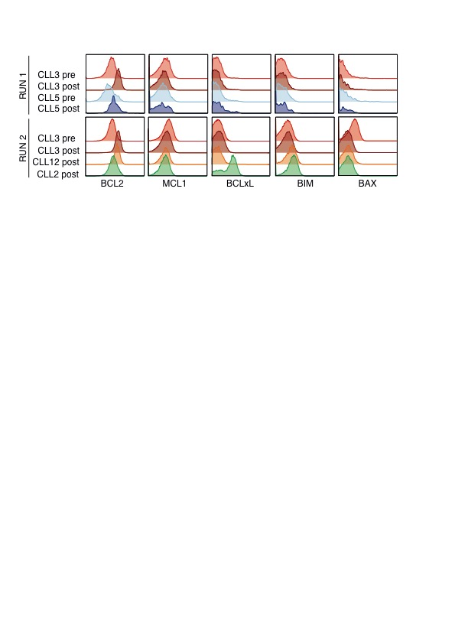

**Supplementary Figure 6: Venetoclax-resistant CLL cells from CLL2 are heterogeneous, with subclones manifesting different mechanisms for resistance.**

Histograms of mass cytometric analysis of BCL2, MCL1 and BCLxL expression in viable (Cisplatinlow) CD5+CD19+ PBMC from the 4 patients with highest representation of BCL2 Gly101Val, at presentation (CLL3,5) and upon relapse (all). CLL3 samples were included in two independent runs. Major shifts in expression of the pro-survival proteins MCL1 and BCLxL are not observed for CLL3, CLL5 and CLL12 at relapse. However, for CLL2 at relapse, a subpopulation expressing higher levels of BCLxL is evident.

**Supplementary Methods - Additional Details**

*Patient Samples*

After providing written informed consent, patient samples were collected at baseline and after venetoclax relapsed (Human Research Ethics Committee approvals: Melbourne Health 2011.044, 2012.092, 2013.016, 2005.008; Peter MacCallum Cancer Centre 03/90, 11/18, 12/45, 13/163, 17/133; Walter and Eliza Hall Institute 05/04).

*Targeted amplicon next generation sequencing*

The target genes analysed were: (ARAF, BCL2, BIRC3, BRAF, BTK, CARD11, CD79B, CXCR4, DNMT3A, EZH2, FOXO1, FYN, ID3, IDH1, IDH2, JAK3, KRAS, MAP2K1, MYD88, NOTCH1, NRAS, PHF6, PLCG1, PLCG2, RHOA, RUNX1, SF3B1, STAT3, STAT5B, STAT6, TCF3, TP53, XPO1).

*Hybridisation-based next generation sequencing analysis*

Indexed libraries were sequenced on an Illumina NetxSeq (paired-end 75bp reads). Alignment to the human reference genome (GRCh37 assembly) and single nucleotide variant (SNV)/indel detection (BWA-MEM/GATK Haplotype Caller). Visualisation of sequence reads was performed using Integrated Genome Viewer (IGV). Copy number variation (CNV) was estimated by comparing read counts to a reference pool comprising 10 normal samples with similar technical artefacts. Boundaries between areas with different copy number were determined using circular binary segmentation. Off-target reads (typically 50-60% of all reads align to regions without baits) were used to estimate low coverage whole genome CNV. Significance was estimated from null distributions empirically derived from the reference pool at matching loci.

*Sanger sequencing*

Sanger sequencing was performed on DNA extracted from patient CLL3 before and after exposure to venetoclax. PCR reaction mix included AmpliTaq Gold 360 Master mix, 0.4µM of forward and reverse primer, and 10ng DNA to a final volume of 10uL. Thermal cycling condition is: 95oC for 5 minutes; 40 cycles of 94oC for 30 seconds, 60oC for 45 seconds, 72oC for 45 seconds; then 72oC for 10 minutes and hold at 4oC. PCR product was purified by Agencourt AMPure using the Biomek NXp Liquid Handler Workstation before being subjected to sequencing reactions using CS primer with ABI BigDye Terminator v.3.1 Cycle Sequencing Kit and run on the ABI3730 sequencer.

*CLL cytotoxicity assays*

For cell culture, blood was collected in EDTA tubes and processed within 2 hours. Blood mononuclear cells were isolated using Ficoll-Paque Plus, GE Healthcare) density gradient centrifugation. Freshly isolated mononuclear cells were seeded in 96-well plates at 100,000 cells/well. 6-point 1:8 serial dilutions of compounds starting from 4μM were used for the screen. After 24 hours at 37°C in a 5% CO2 containing humidified atmosphere, cells were stained with CD5-APC (1:250, Beckman Coulter) and CD19-BV510 (1:200, clone:5J25CI, Becton Dickinson (BD) Biosciences) and cell viability was assessed by propidium iodide (PI, Merck) exclusion using a FACSFortessa (BD). FACS data were analyzed using Flowjo software and GraphPad Prism software was used to calculate drug concentrations causing 50% killing (LC50).

*CLL cell co-culture*

Peripheral blood mononuclear cells (PBMCs) from CLL patients were cultured on mouse embryonic fibroblast cells stably expressing the human CD40 ligand, segmented with rhIL-21 (25ng/ml, R&D systems) and Goat F(ab')2 Anti-Human IgM (200ng/ml, SouthernBiotech). After 1-week, cells were taken off the CD40L-expressing feeder layer and treated with 5-point 1:8 serial dilutions of venetoclax starting from 10μM. After 24 hours, cell viability was assessed by PI exclusion in CD5+CD19+ cells using FACSFortessa.

*FACS-sorting for BCL-XL expression*

PBMCs from CLL2 were thawed and rested for 2 hours. Cells were stained with CD5-APC and CD19-BV510 for 30 min on ice. Cells were fixed with 1.6% paraformaldehyde (Electron Microscope Science) and permeabilized with 1xPerm buffer (Affymetrix eBiosciences). Cells were stained with BCLxL (1:100, clone:E18, Abcam) followed by goat-anti-rabbit-FITC (1:100, SouthernBiotech). Viable CD5+CD19+ BCLxLlow cells and viable CD5+CD19+ BCLxLhigh cells were sorted using the FACSAria (BD).

*SPR binding experiments*

All experiments were performed in HBS-EP buffer consisting 10 mM hepes pH 7.4, 150 mM sodium chloride, 3.4 mM EDTA, 0.005% tween 20 and optionally 1 mM TCEP for BaxBH3 experiments. A streptavidin SPR chip (GE healthcare) was immobilised with either a BimBH3 (DMRPEIWIAQELRRIGDEFNAYYARR), BaxBH3 (ADASTKKLSECLKRIGDELDSNMELQRMIAA) or BimBH3-4A (DMRPEIWAAQEARRAGDEANAYYARR) peptide using hydrodynamic addressing. The sensor surface was immobilised with BimBH3 on spot 1, BimBH3-4A on spot 2 and 4, and BaxBH3 on spot 5, blocking free sites with biotin. All peptides were synthesised (Mimotopes) with an N-terminal biotin modification to allow binding to the streptavidin surface. BCL2 wild type, Gly101Val and Phe104Leu were expressed in *E. coli* and purified as described previously1. All experiments were double referenced using a buffer solution and BimBH3-4A (h1-4 position in the BH3 motif mutated to alanine) as a peptide that does not bind BCL-2. Direct binding experiments were performed with approximately 200 RU peptide coupled to the chip with 180 sec injections and 1000 sec dissociations at 30 uL min-1 flowrate, and BCL2 concentrations in the range 0 – 63 nM. Direct binding data were fitted to a 1:1 kinetic binding model in BIAcore4000 BIAevaluation software (GE healthcare) deriving on and off rates and binding constants. Experiments were repeated with 3 independent purifications of BCL2 and mutants on independent flow cells on different days. Steady-state competition experiments were performed with ~2000 RU of immobilised BH3 peptides as ligand, using various BCL2 concentrations in the range 0-250 nM combined with Venetoclax at 0, 20, 40 or 60 nM as the analyte solutions. Experiments were performed with a 10 uL min-1 flowrate with 600 sec injections and 30 sec dissociation. Responses at the end of the injection phase were derived by affinity analysis in Biacore 4000 BIAevaluation software and values plotted as a function of BCL2 and Venetoclax concentration in Prism 7.0d for mac (GraphPad Software, La Jolla California USA). Data were fitted to a steady-state competitive equation2 (below) where *Rmax* and *KD* for BimBH3 binding were derived froma 1 site specific binding model in Prism 7.0d fixed for each experiment and simultaneously fitting a shared *KI* for each Venetoclax concentration 0, 20, 40 and 60 nM. Experiments were performed with independent batches of BCL2 on independent days. Steady-state competition equation:

*R* = response, *Rmax* = fixed maximal response, *[BCL2]* = fixed BCL2 concentration, *[VEN]* = fixed Venetoclax concentration, *KD* = fixed BimBH3 peptide apparent steady-state binding constant, *KI*= fitted equilibrium binding constant for Venetoclax.

*Co-immunoprecipitation*

2x107 KMS-12-PE cells expressing FLAG-BCL2 or the BCL2 mutants were treated with increasing concentrations of venetoclax or the DMSO control in the presence of 25μM pan-caspase inhibitor Q-VD-OPH (MP Biomedicals) for 6 hours. Cells were then harvested, washed twice with PBS and lysed in 500μl ONYX lysis Buffer (20mM Tris-HCl pH 7.4, 135mM NaCl, 1.5 mM MgCl2, 1mM EDTA, 10% glycerol) containing 1% Triton X-100 and complete protease inhibitors (Roche). Protein content was quantified using the Bradford assay (Bio-Rad). Equivalent amount of total protein lysates was then incubated with anti-FLAG antibody (clone 9H1, WEHI) at 4°C for 3h followed by the incubation of protein G-sepharose beads (GE Healthcare) at 4°C overnight. Beads were then collected by spin at 3,000rpm at 4°C for 1min and washed with PBS for 5 times. Bound proteins were eluted with 100μl 2x SDS reducing buffer boiled at 95°C for 10 mins. An aliquot of total protein lysates was spared, diluted with 4XSDS reducing buffer at a 3:1 ratio, denatured at 95°C for 10min and served for loading control. The amount of immunoprecipitated and/or total level of BIM (clone 3C5, WEHI, 1:1000), BAX (clone 21C10, WEHI, 1:1000), BAK (clone 7D10, WEHI, 1:1000), FLAG (clone 9H1, WEHI, 1:1000), HSP70 (clone N6, WEHI, 1:5000) was then determined by immunoblotting.

*Mass cytometry*

After incubation with cisplatin to allow detection of non-viable cells by mass cytometry, cells were fixed with paraformaldehyde (PFA: Electron Microscopy Sciences, Hatfield, PA, USA) at a concentration of 1.6%(v/v) for 10 minutes at room temperature. Cells were pelleted and washed once with cell staining medium (CSM; PBS with 0.5% BSA and 0.02% sodium azide) to remove residual PFA and stored at -80°C.

Cell samples for batch analysis were barcoded using the 20-plex palladium barcoding kit according to manufacturer’s instructions (Fluidigm, South San Francisco, CA, USA). Following barcoding, cells were pelleted and washed once with CSM to remove residual PFA. Cells were then permeabilized at 4°C with methanol for 10 min. Cells were washed three times with CSM and stained with anti-BCL2157Gd (clone 100, WEHI), anti-MCL1160Gd (Clone Y37, Abcam), anti-BCLxL153Eu (Clone E18, Abcam), anti-BIM165Ho (Clone 3C5, WEHI) and anti-BAX154Sm (Clone 1B4, WEHI) for 30 min at room temperature. Cells were washed with CSM, then stained with 125nM 191Ir/193Ir DNA intercalator (Fluidigm, South San Francisco, CA, USA) in PBS with 1.6% PFA at 4°C overnight. Cells were washed once with CSM, washed three times with double-distilled water and filtered to remove aggregates and resuspended with EQ normalisation beads immediately before analysis using a Helios mass cytometer (Fluidigm, South San Francisco, CA, USA). Throughout the analysis, cells were maintained at 4°C and introduced at a constant rate of ~300 cells/sec.

**Supplementary References**

1. Petros AM, Medek A, Nettesheim DG, et al. Solution structure of the antiapoptotic protein bcl-2. *Proc Natl Acad Sci U S A* 2001; **98**(6): 3012-7.

2. de Mol NJ. Affinity constants for small molecules from SPR competition experiments. *Methods Mol Biol* 2010; **627**: 101-11.