A MUTATION IN HISTONE H2B REPRESENTS A NEW CLASS OF ONCOGENIC DRIVER
Richard L. Bennett, Aditya Bele, Eliza C. Small, Christine M. Will, Behnam Nabet, Jon A. Oyer, Xiaoxiao Huang, Rajarshi P. Ghosh, Adrian T. Grzybowski, Tao Yu, Qiao Zhang, Alberto Riva, Tanmay P. Lele, George C. Schatz, Neil L. Kelleher, Alexander J. Ruthenburg, Jan Liphardt and Jonathan D. Licht

SUPPLEMENTAL METHODS
Histone Preparation and Mass Spectrometry Analysis
Histone proteins were acid extracted from isolated nuclei, digested with trypsin and chemically derivatized using propionic anhydride (1). The resulting peptides were resuspended in 0.1% TFA and analyzed on a triple quardrupole (QqQ) mass spectrometer (Thermo Fisher Scientific TSQ Quantum) directly coupled with Dionex UltiMate 3000 nano-LC system using the selected reaction monitoring method (2). Raw MS files were imported and analyzed using Skyline software with Savitzky-Golay smoothing (3). Peptide peak areas from Skyline were used to determine the relative abundance of each histone modification. The relative levels of specific modified peptides were calculated by dividing peak area against the total of all modified peptides sharing the same sequence.
1. Garcia BA, Mollah S, Ueberheide BM, et al. Chemical derivatization of histones for facilitated analysis by mass spectrometry. Nature Protocols 2007;2:933-8.
2. Zheng Y, Sweet SM, Popovic R, et al. Total kinetic analysis reveals how combinatorial methylation patterns are established on lysines 27 and 36 of histone H3. Proceedings of the National Academy of Sciences of the United States of America 2012;109:13549-54.
3. MacLean B, Tomazela DM, Shulman N, et al. Skyline: an open source document editor for creating and analyzing targeted proteomics experiments. Bioinformatics 2010;26:966-8.

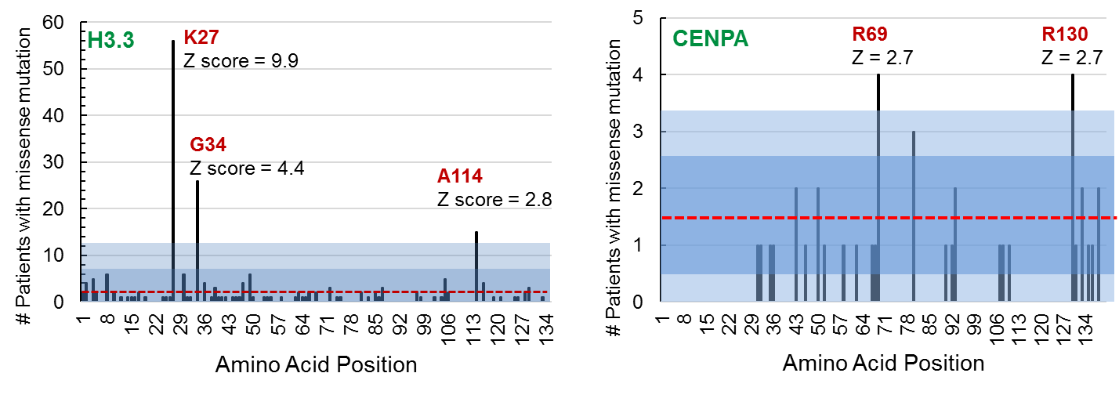

Supplemental Figure 1. Analysis of the most common histone H3 variant missense mutations in cancer. A cross cancer mutation summary was performed using the cBioPortal to search 159 non-redundant cancer studies with a total of 41,738 patients. The number of patients reported to have a missense mutation at each amino acid residue position in the histone H3 variants H3.3 (H3F3A/B) and CENPA was graphed. The average number of mutations is indicated for each histone by a red line, and first two standard deviations indicated by the blue shaded boxes. Locations of the most significant mutations (Z score > 2) are indicated.

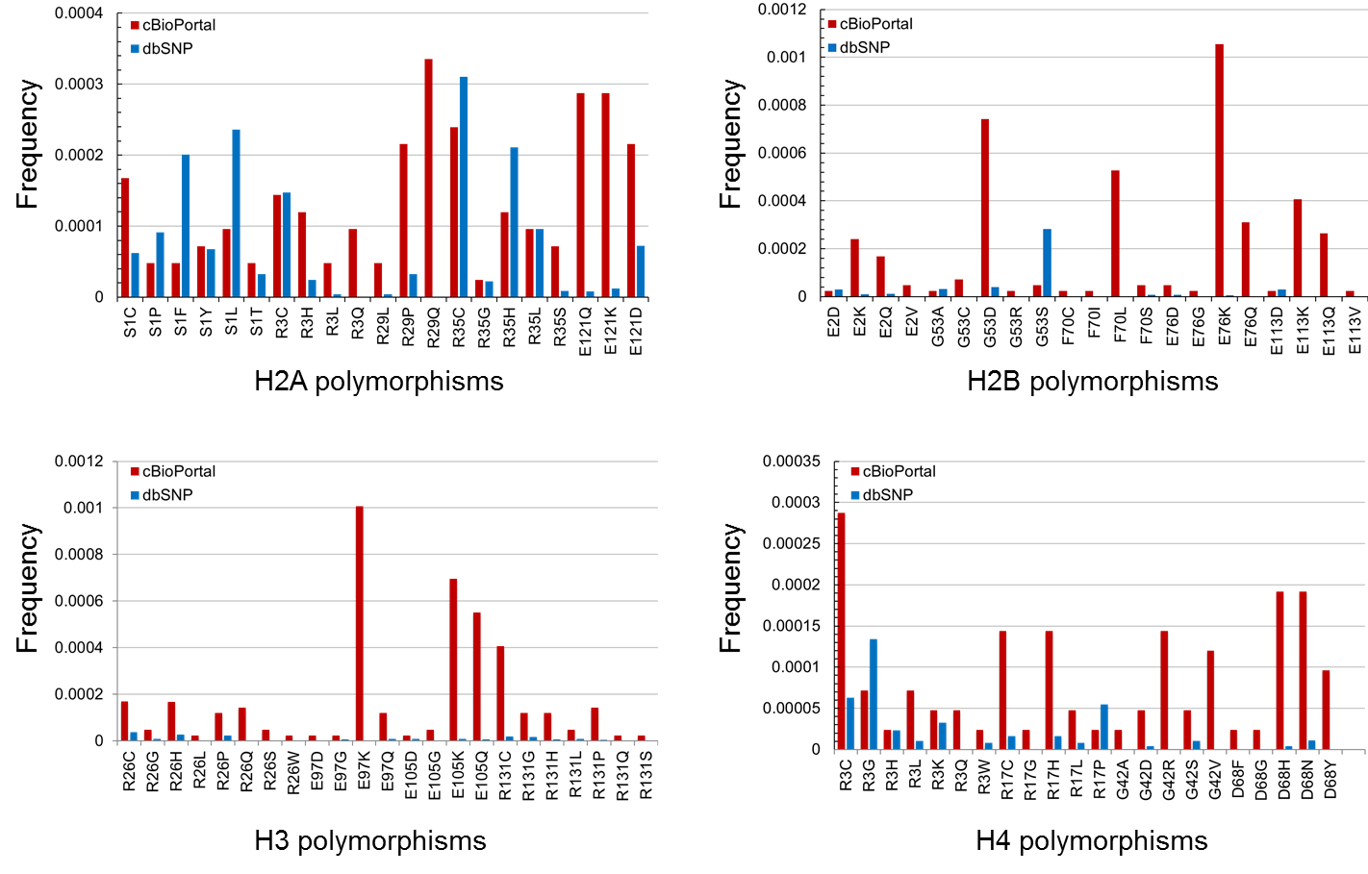

Supplemental Figure 2. Single nucleotide polymorphism frequency at amino acid positions found recurrently mutated in cancer. The single nucleotide polymorphism database (dbSNP) was queried to compare the frequency of single base nucleotide substitutions in histone genes to the frequency found in in the cBioPortal for cancer genomics. Frequencies were compared for each amino acid substitution mutation found most recurrently in cancer.

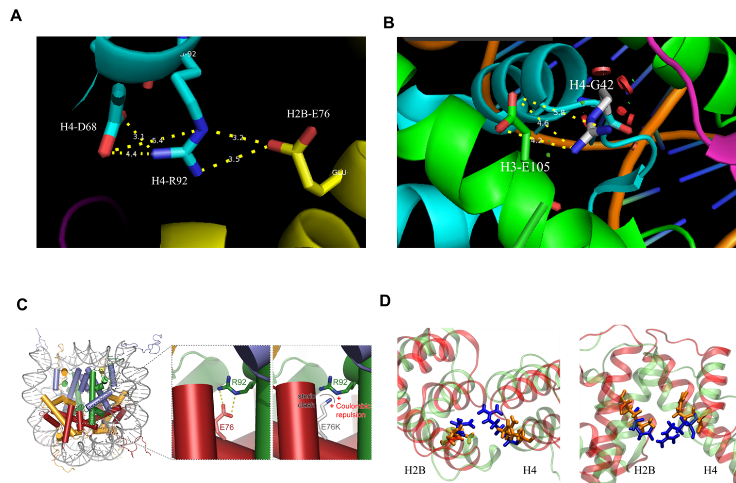
Supplemental Figure 3. Recurrent histone mutations observed in cancer cluster at important structural hotspots of the nucleosome. (A) The H2B residue E76 forms a salt bridge with H4 amino acids R92 and D68 in the nucleosome structure. (B) The Histone H3-H4 interaction depends on a salt bridge formed between amino acid E105 in H3 and G42 in H4. (C) The H2B-E76K mutant (left) disrupts a salt bridge between H2B E76 and H4 R92 in the WT nucleosome crystal structure (right). (D) The molecular dynamics snapshot of H2B/H4 dimer structure with WT in lime green and E76K-mutant in red. Note that the left blue residue was E76 in the WT-H2B and the right blue residue was R92 in the WT-H4. The left orange residue was K76 in the mutant-H2B and the right orange residue was R92 in the mutant-H4.

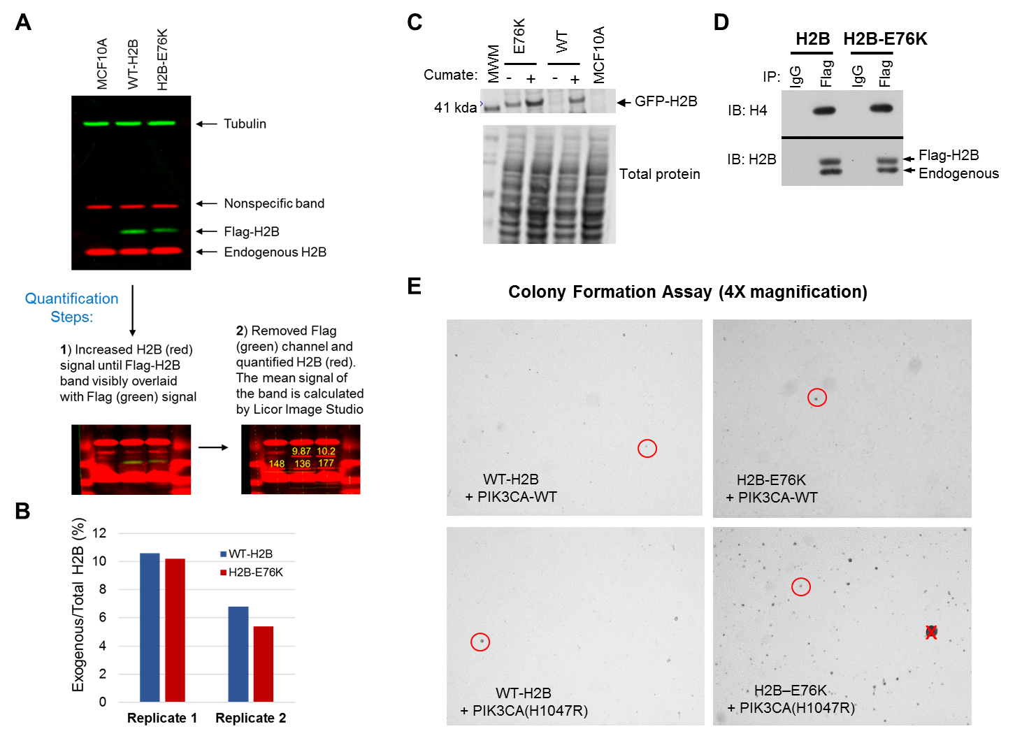

Supplemental Figure 4. Expression and analysis of H2B-E76K in MCF10A cells. (A) After transduction of Flag-tagged WT or E76K H2B into MCF10A cells, stable expression was measured in nuclear extracts and compared to control, non-transduced, MCF10A lysates by western blotting. Bands corresponding to endogenous and exogenous H2B were visualized using an Odyssey infrared imager (Li-Cor) and quantified with Image Studio (Ver. 5.2, Li-Cor). (B) Relative abundance of exogenous Flag-tagged H2B compared to total H2B in MCF10A cells from two biological replicates. (C) Western blot of nuclear lysates from MCF10A cells expressing cumate-inducible GFP-tagged WT or H2B-E76K measured before and after induction of expression with cumate for 5 days. (D) Flag-tagged WT or H2B-E76K was immuno-precipitated from transduced MCF10A cells and western blotting performed to confirm that mutant H2B remained able to associate with histone H4. IgG, IgG control immunoprecipitation. (E) Colony formation was assessed after 14 days growth of MCF10A cells expressing PIK3CA and either WT-H2B or H2B-E76K. A red circle indicates a representative colony that was counted. A red X indicates an excluded spot that may be due to a gel artifact.

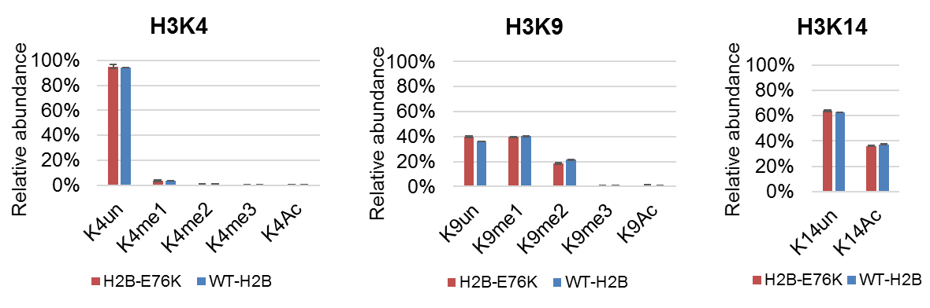
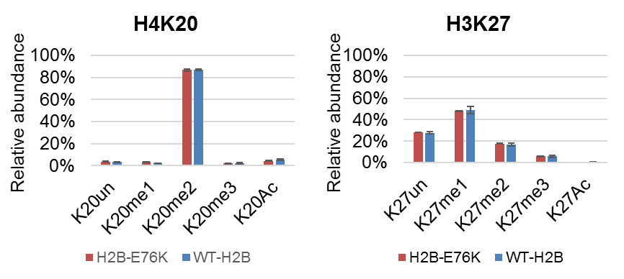
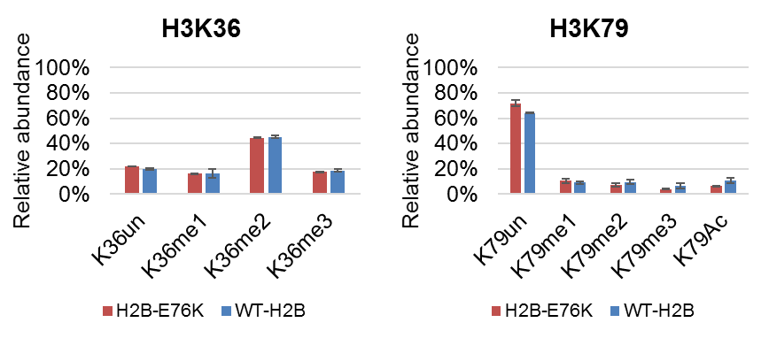

Supplemental Figure 5. Expression of H2B-E76K does not affect common chromatin marks in MCF10A cells. Acid extracted histones were digested with trypsin and mass spectrometry was performed to compare the relative abundance of common histone post-translational modifications between cells expressing WT-H2B vs. H2B-E76K.

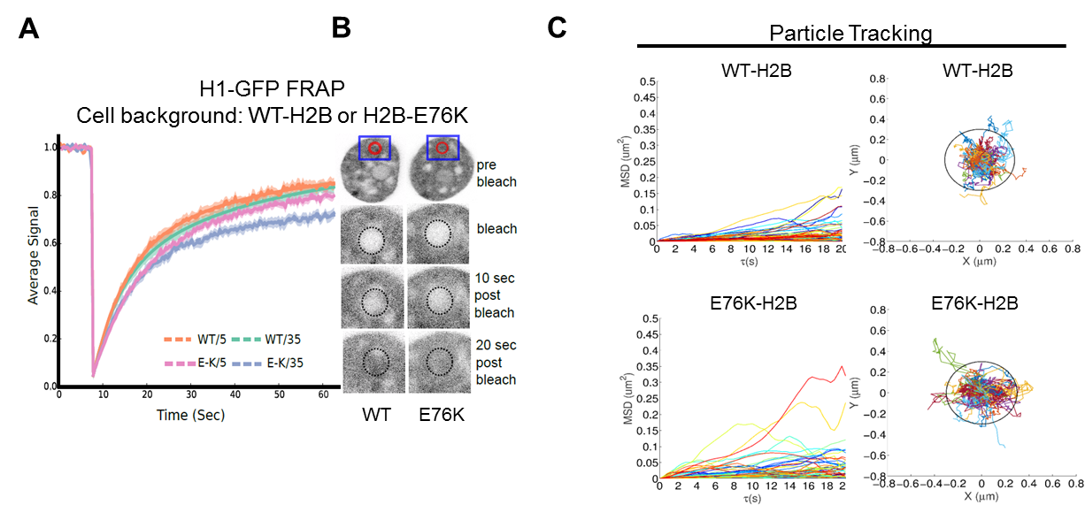
Supplemental Figure 6. H2B-E76K has altered chromatin dynamics. (A) FRAP analysis of histone H1-GFP dynamics in MCF10A cells inducibly expressing WT-H2B or H2B-E76K mCherry fusions. FRAP curves and corresponding fits of experiments carried out on 5th and 35th day post-cumate induction of WT or E76K H2B mCherry cells. Cells were transiently transfected with H1-GFP on the day prior to the experiment. (B) Representative pre-bleach, bleach and post-bleach images of nuclei expressing H1-GFP in cells with WT and E76K H2B mCherry background. (C) Mean Square Displacement (MSD) of particles over time and particle trajectory plots for a representative nuclear nanoparticle tracking experiment in MCF10A cells expressing either WT- or E76K-H2B.

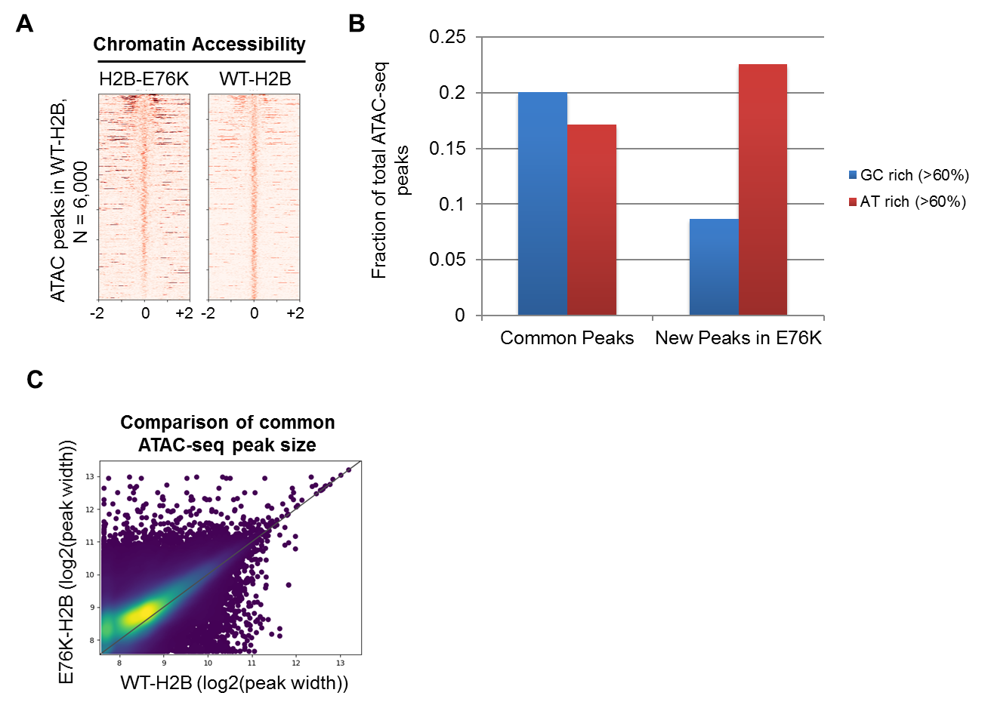
Supplemental Figure 7. Effect of H2B-E76K on chromatin accessibility. (A) Heat map of ATAC-Seq peaks that found within a ± 2Kb window of MCF10A cells that are modestly higher in MCF10A cells expressing WT H2B compared to cells expressing H2B-E76K. Peaks are ordered by highest ATAC-seq signal to lowest. (B) Comparison of the fraction of ATAC seq peaks that are AT rich (> 60% AT content, red) or GC rich (>60% GC content, blue) in both WT and H2B-E76K MCF10A cells (common peaks) and new peaks found enriched in H2B-E76K cells. (C) Density heat map for the common ATAC-seq peak sizes (Log2 (peak width)) in MCF10A cells expressing E76K-H2B or WT-H2B.

