Supplementary Figure S3. Genomic breakpoints of fusions.
Genomic breakpoints of NCOA4-RET, ATP1B1-PRKACA, and ATP1B1-NRG1 fusions in KRASwt patients. A: RET fusion in patient 17. The RET rearrangement in patient 17 displayed the canonical fusion architecture involving exons 1-9 of NCOA4 and exons 12-20 of RET, which encode the protein kinase domain facilitating its unregulated activity. B: PRKACA fusion in the PDCM. C: NRG1 fusion in TCGA-3A-A9I5. The fusion structure resembles that of patient 14 and only differs in the lack of a second breakpoint in NRG1.

A | 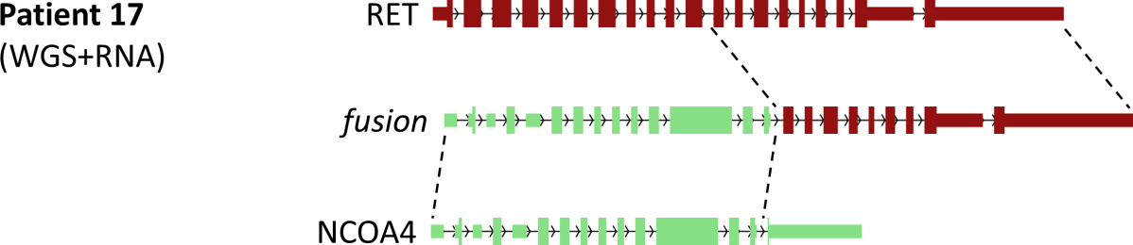
B | 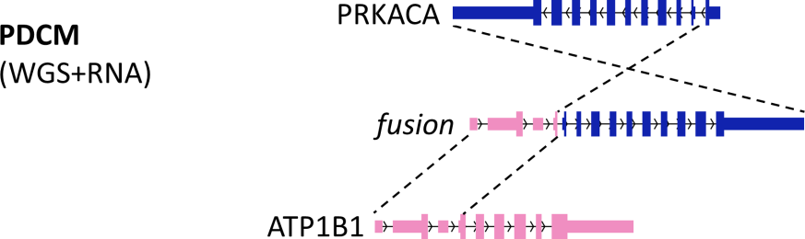
C | 