Supplementary Information

CD38-mediated immunosuppression as a mechanism of tumor cell escape from PD-1/PD-L1 blockade

Limo Chen, Lixia Diao, Yongbin Yang, Xiaohui Yi, B. Leticia Rodriguez, Yanli Li, Pamela A. Villalobos, Tina Cascone, Xi Liu, Lin Tan, Philip L. Lorenzi, Anfei Huang, Qiang Zhao, Di Peng, Jared J. Fradette, David H. Peng, Christin Ungewiss, Jonathon Roybal, Pan Tong, Junna Oba, Ferdinandos Skoulidis, Weiyi Peng, Brett W. Carter, Carl M. Gay, Youhong Fan, Caleb A. Class, Jingfen Zhu, Jaime Rodriguez-Canales, Masanori Kawakami, Lauren Averett Byers, Scott E. Woodman, Vassiliki A. Papadimitrakopoulou, Ethan Dmitrovsky, Jing Wang, Stephen E. Ullrich, Ignacio I. Wistuba, John V. Heymach, F. Xiao-Feng Qin, and Don L. Gibbons

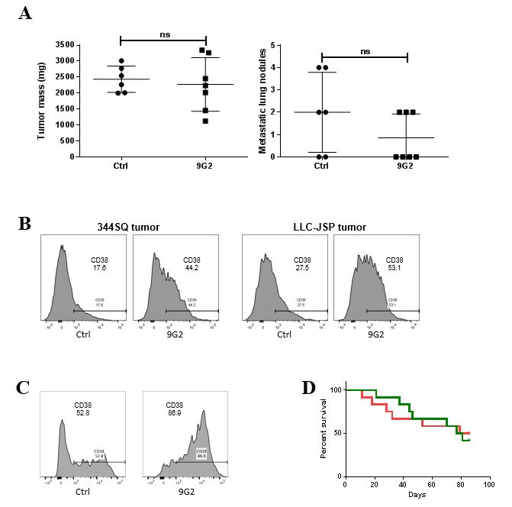
Supplementary Figure S1. CD38 on anti-PD-L1 resistant tumor cells is up-regulated, which is associated with tumor progression.
(A) At the endpoint, 344SQ bearing mice in Figure 1A were sacrificed and tumor weights and lung metastatic nodules were measured.
(B) (Left panel) 344SQ tumors in Figure 1A were harvested and CD38 expression on tumor cells was analyzed by FACS at week 5, and the representative histogram is shown. Cumulative data for all the tumors is shown in Figure 1C left panel. (Right panel) LLC-JSP tumors in Figure 1A were harvested and CD38 expression on tumor cells was analyzed by FACS at week 4, and the representative histogram is shown. Cumulative data for all the tumors is shown in Figure 1C right panel.
(C) Representative histograms of CD38 expression on tumor cells (CD31⁻CD45⁻EpCAM⁺) in Figure 1G at the endpoint are shown.
(D) Percent survival was measured for the animals treated in Figure 1G (n = 9 or 13). Green line represents Ig G control group. Red line represents anti-PD-L1 group.

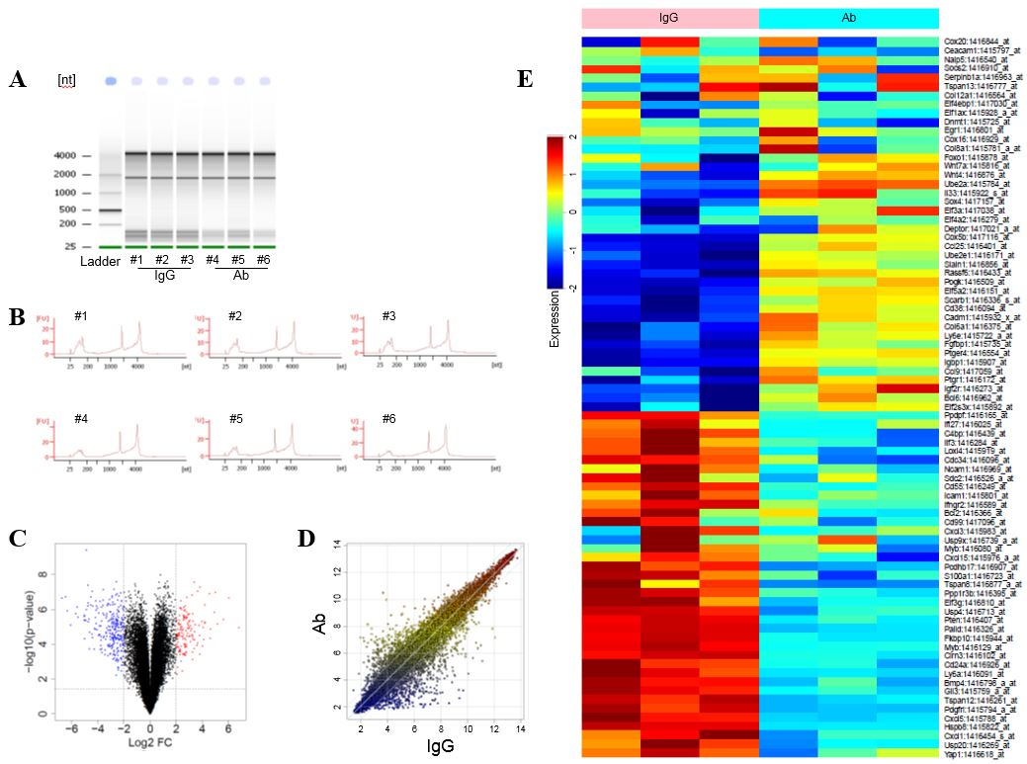
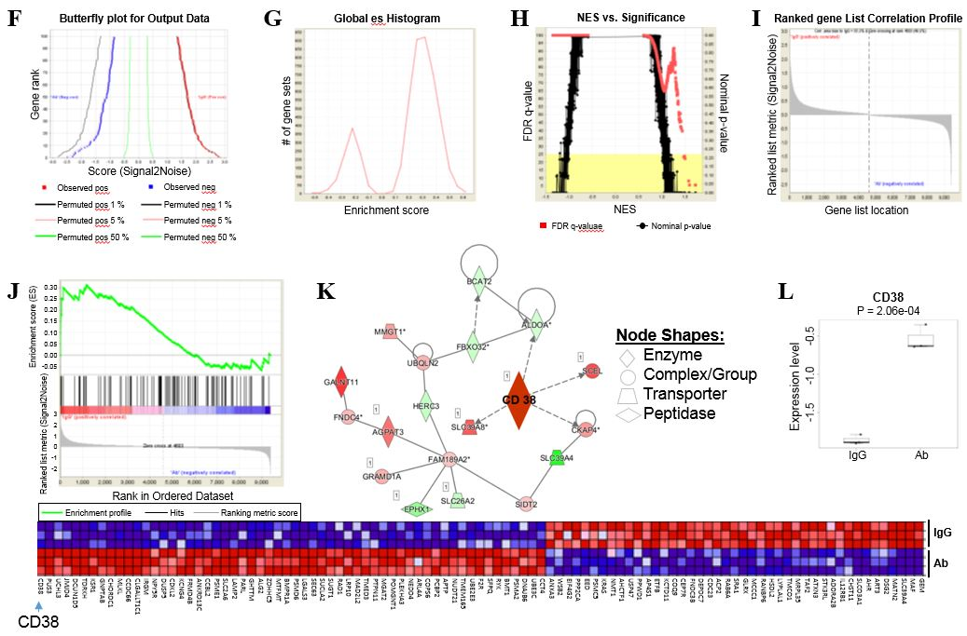
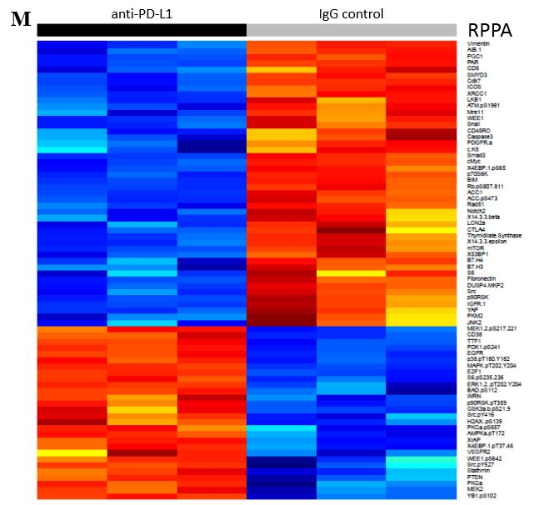
Supplementary Figure S2. anti-PD-L1 resistant tumors demonstrate the distinct mRNA and protein profiling for immune signature, reflecting the upregulation of CD38.
(A) The electrophoresis for RNA quality control. The samples #1-3 are from 344SQ tumors treated by IgG control isotype (IgG) for 5 weeks. The samples #4-6 are from 344SQ tumors treated by anti-PD-L1 antibody (Ab) for 5 weeks.
(B) RNA quality control was confirmed by total RNA NanoAssay before Affymetrix GeneChip was performed.
(C) Volcano plot showing differences in the mRNAs detected by RNA profiling for the control and the anti-PD-L1-treated 344SQ tumor samples (n = 3) in Figure 1A harvested at week 5. There are 412 probes (red dots for the up-regulated genes; blue dots for the down-regulated genes) with FDR ≤ 0.05 (corresponding p value: 0.035118632219514) and fold change (≥ 2 or ≤ -2). The vertical line is –log10 (0.035118632219514), corresponding to FDR level of 0.05 and the horizontal line is 2 and -2.
(D) Scatterplot of the average signal of gene expression microarray data for anti-PD-L1 (Ab) versus IgG isotype control (IgG) treated 344SQ tumors at week 5 in Figure 1A. The analysis was conducted by using R software (version 3.2).
(E) The heat map showing differentially expressed mRNAs for immune markers from the two groups profiled in Figure 1A.
(F) The butterfly plot shows the observed correlation, as well as permuted (1%, 5%, 50%) positive and negative correlation, for the top genes. The butterfly plot offers one way to visualize the extent to which dataset permutations change the correlation between gene rank and the ranking metric score.
(G) Histogram of enrichment scores across gene sets, which provides a quick, visual way to grasp the number of enriched gene sets.
(H) Plot of p values versus normalized enrichment scores (NES), with the number of enriched gene sets that are significant.
(I) Plot shows the correlation between the ranked genes and the phenotypes.
(J) The enrichment score plot for the gene set of T cell activity is shown in the upper panel. The heat map with significant changes is shown in the bottom panel.
(K) The data set from microarray and corresponding fold change values were uploaded to the Ingenuity Pathway Analysis (IPA) tool using a 2-fold cutoff. A total of 1123 genes were found to be differentially expressed between anti-PDL1 antibody and its IgG isotype treated 344SQ tumors at week 5 in Figure 1A. The top network identified with IPA software is shown. The intensity of node color denotes degree of up (red/pink) or down (green) regulation.
(L-M) RPPA reveals an upregulation of CD38 in anti-PD-L1-treated tumors in Figure 1A. The statistical graph is shown in (L). 74 protein markers involved in immune signaling pathways, cell cycle signaling, tumor metabolism markers were included for RPPA and the heatmap is shown in (M).

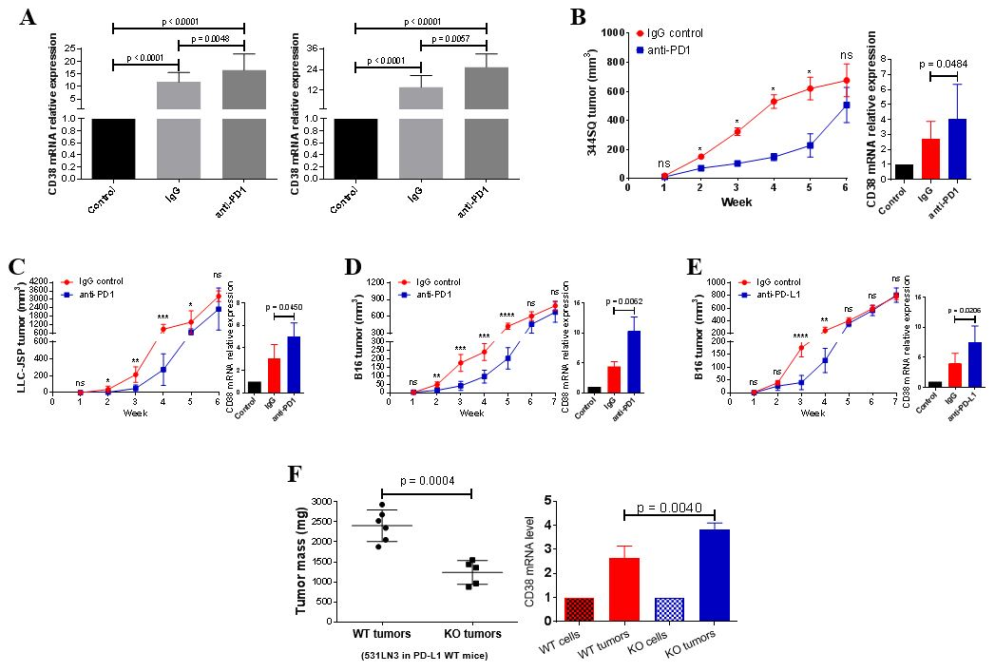Supplementary Figure S3. PD-1/PD-L1 blockade results in CD38 up-regulation and acquired resistance in KP-derived lung and melanoma transplantation tumors.
(A) (Left panel) lung cancer 344P cells (1 x 10⁶ cells per mouse) were subcutaneously injected into immune competent 129/Sv mice (n = 3). Mice were treated by anti-PD-1 (200 μg per mouse; IP injection, twice a week) or its isotype for 2 weeks. At day 14, mice were euthanized and tumors were removed for preparing RNA. CD38 expression on tumor cells was measured by qPCR. The experiments were repeated three times and the data was graphed and shown as mean ± SEM. The expression of CD38 on 344P cell line was included as the control. The unpaired t-test was used to analyze. (Right panel) lung cancer 393P cells (1 x 10⁶ cells per mouse) were subcutaneously injected into immune competent 129/Sv mice (n = 3). Mice were treated by anti-PD-1 (200 μg per mouse; IP injection, twice a week) or its isotype for 4 weeks. At day 28, mice were euthanized and tumors were removed for preparing RNA. CD38 expression on tumor cells was measured by qPCR. The experiments were repeated three times and the data was graphed and shown as mean ± SEM. The expression of CD38 on 393P cell line was included as the control. ANOVA test was used to analyze.
(B) (Left panel) anti-PD-1 antibody or an IgG control was injected into 129/Sv mice (200 μg; intraperitoneally) twice a week for 6 weeks beginning on day 7 after 344SQ lung tumor cells were subcutaneously implanted (1.5 x 10⁶ cells per mouse). Tumors were measured once a week for 6 weeks. The tumor growth curve is shown, with tumor sizes (n = 12) presented as mean ± SEM. ns, no significant difference, *p < 0.05. (Right panel) At the endpoint, mice were euthanized and tumors were removed for preparing RNA. CD38 expression on tumor cells was measured by qPCR. The experiments were repeated three times and the data was graphed and shown as mean ± SEM. The expression of CD38 on 344SQ cell line was included as the control. ANOVA test was used to analyze.
(C) (Left panel) anti-PD-1 antibody or an IgG control was injected into C57BL/6 mice (300 μg; intraperitoneally) once a week for 5 weeks beginning on day 7 after the subcutaneous implantation of LLC-JSP lung tumor cells (0.5 x 10⁶ cells per mouse). Tumors were measured once a week for 6 weeks. The tumor growth curve is shown, with tumor sizes (n = 7/group) presented as mean ± SEM. ns, no significant difference, *p < 0.05, **p < 0.01, ***p < 0.001. (Right panel) Relative CD38 mRNA levels in sorted LLC-JSP tumor cells (CD31⁻CD45⁻EpCAM⁺ for sorting) were quantified by qPCR using the tumor samples at week 6 (n = 4 or 5) from the IgG control and anti-PD-1 groups. mRNA levels are normalized to L32. The experiments were repeated three times and the data was graphed and shown as mean ± SEM. The expression of CD38 in LLC-JSP cell line was included as the control. ANOVA test was used to analyze.
(D) (Left panel) anti-PD-1 antibody or an IgG control was injected into C57BL/6 mice (300 μg; intraperitoneally) once a week for 6 weeks beginning on day 7 after the subcutaneous implantation of melanoma B16 tumor cells (0.1 x 10⁶ cells per mouse). Tumors were measured once a week for 7 weeks. The tumor growth curve is shown, with tumor sizes (n = 6/group) presented as mean ± SEM. ns, no significant difference, **p < 0.01, ***p < 0.001, ****p < 0.0001. (Right panel) Relative CD38 mRNA levels in sorted B16 tumor cells (CD31⁻CD45⁻EpCAM⁺ for sorting) were quantified by qPCR using the tumor samples at week 7 (n = 6) from the IgG control and anti-PD-1 groups. mRNA levels are normalized to L32. The experiments were repeated three times and the data was graphed and shown as mean ± SEM. The expression of CD38 in B16 cell line was included as the control. ANOVA test was used to analyze.
(E) (Left panel) anti-PD-L1 antibody or an IgG control was injected into C57BL/6 mice (200 μg; intraperitoneally) once a week for 6 weeks beginning on day 7 after the subcutaneous implantation of melanoma B16 tumor cells (0.1 x 10⁶ cells per mouse). Tumors were measured once a week for 7 weeks. The tumor growth curve is shown, with tumor sizes (n = 5 or 6/group) presented as mean ± SEM. ns, no significant difference, **p < 0.01, ****p < 0.0001. (Right panel) Relative CD38 mRNA levels in sorted B16 tumor cells (CD31⁻CD45⁻EpCAM⁺ for sorting) were quantified by qPCR using the tumor samples at week 7 (n = 5 or 6) from the IgG control and anti-PD-1 groups. mRNA levels are normalized to L32. The experiments were repeated three times and the data was graphed and shown as mean ± SEM. The expression of CD38 in B16 cell line was included as the control. ANOVA test was used to analyze.
(F) Wildtype 531LN3 lung cancer cells or 531LN3 with PD-L1 KO (3 x 10⁶ cells per mouse) were subcutaneously injected into immune competent 129/Sv mice (n = 5 or 6). Mice were sacrificed 4 weeks post-injection. The primary tumor mass is shown in the left panel presented as mean ± SEM. CD38 mRNA levels quantified with qPCR assay in sorted tumor cells are shown in the right panel. mRNA levels are normalized to L32. ANOVA test was used to analyze.
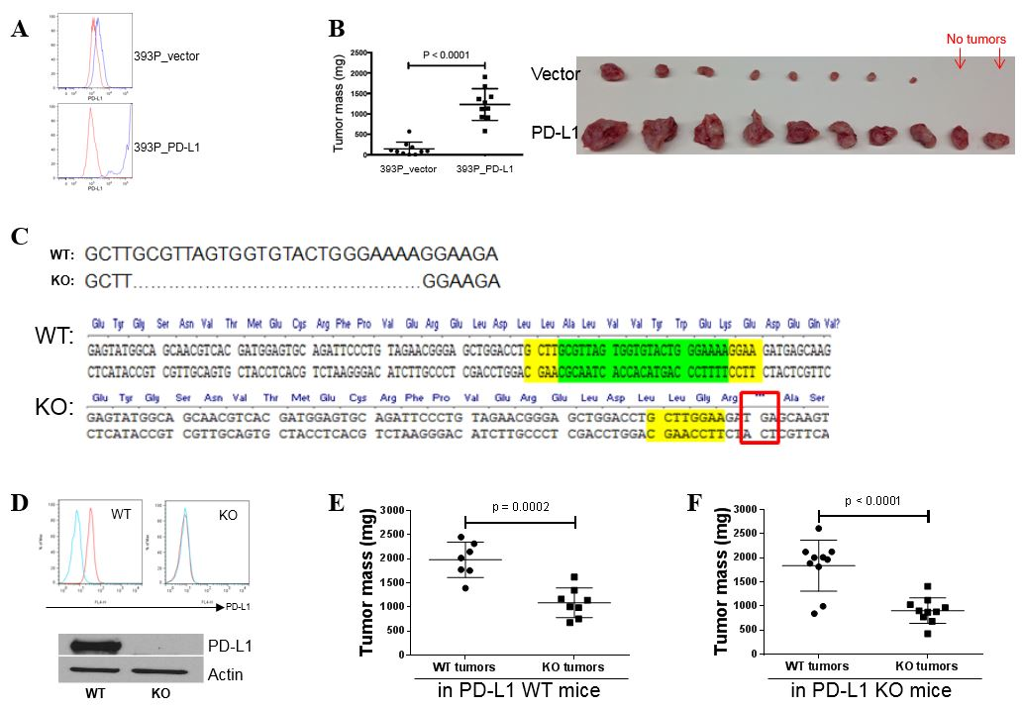

Supplementary Figure S4. Tumor-associated PD-L1 promotes tumor growth but PD-L1 knockout cancer cells still form tumors.
(A) The surface expression of PD-L1 on 393P_vector (vector control) or 393P_PD-L1 (PD-L1 overexpression) cells were measured by FACS analysis.
(B) 393P_vector or 393P_PD-L1 cells (1 x 10⁶ cells per mouse) were subcutaneously injected into immune competent 129/Sv mice (n = 10). Tumor sizes 6 weeks post-injection, with tumor sizes presented as mean ± SEM, are shown in the left panel. The tumor photos are shown in the right panel.
(C) The sequencing result shows the large fragment deletion on PD-L1 ORF. Deletion large fragment on CD274 ORF mediated by CRISPR/Cas9 system causes the shift of reading frame, and leading to appearance of stop codon in mouse CD274 ORF.
(D) The PD-L1 knockout in LLC-JSP cells was confirmed by FACS analysis (upper panel) and Western blotting (bottom panel).
(E) 0.5 x 10⁶ PD-L1^{WT} or PD-L1^{KO} LLC-JSP cancer cells were subcutaneously injected into PD-L1 WT mice (n = 7 or 8). The mice were euthanized at week 6 and the primary tumor mass is shown, with tumor sizes presented as mean ± SEM. t-test was used to analyze.
(F) 0.5 x 10⁶ PD-L1^{WT} or PD-L1^{KO} LLC-JSP cancer cells were subcutaneously injected into PD-L1 KO mice (n = 10). The mice were euthanized at week 6 and the primary tumor mass is shown, with tumor sizes presented as mean ± SEM. t-test was used to analyze.
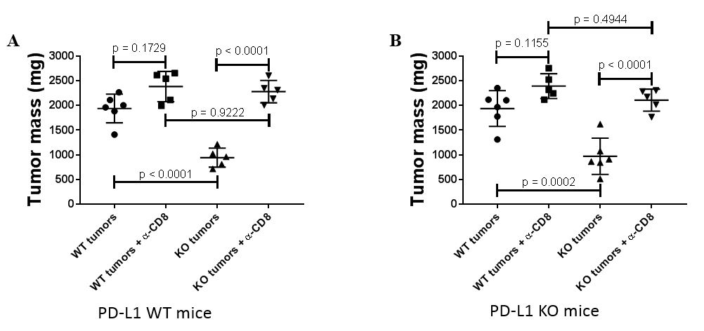
Supplementary Figure S5. PD-L1 knockout effect on tumor growth is CD8 T cell-dependent.
(A) 0.5 x 10⁶ PD-L1^{WT} or PD-L1^{KO} LLC-JSP cancer cells were subcutaneously injected into PD-L1 WT mice (n = 5 or 6) after CD8 T cells were depleted (α-CD8). The mice were euthanized at week 6 and the primary tumor mass is shown, with tumor sizes presented as mean ± SEM. ANOVA test was used to analyze.
(B) 0.5 x 10⁶ PD-L1^{WT} or PD-L1^{KO} LLC-JSP cancer cells were subcutaneously injected into PD-L1 KO mice (n = 5 or 6) after CD8 T cells were depleted (α-CD8). The mice were euthanized at week 6 and the primary tumor mass is shown, with tumor sizes presented as mean ± SEM. ANOVA test was used to analyze.

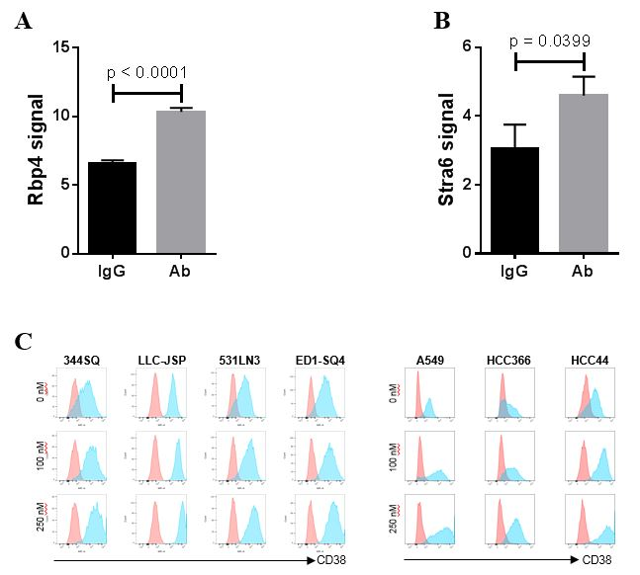
Supplementary Figure S6. CD38 up-regulation after anti-PD-L1 treatment is associated with all-trans retinoic acid signaling.
The differences of key all-trans retinoic acid synthesis genes Rbp4 (A) and Stra6 (B) in the mRNAs detected by RNA profiling for the IgG control (IgG) and the anti-PD-L1 (Ab)-treated 344SQ tumor samples (n = 3) in Figure 1A harvested at week 5. t-test was used to analyze the significance.
(C) Mouse lung cancer cells (left panel) or human lung cancer cells (right panel) were incubated with ATRA at different concentrations (0 nM, 100 nM, and 250 nM) for 3 days and stained with anti-CD38 antibody. The experiments were repeated three times. The representative FACS histograms of cell surface expression of CD38 on different mouse lung cancer cell lines are shown. Pink line, isotype control staining; light blue line, anti-CD38 staining.

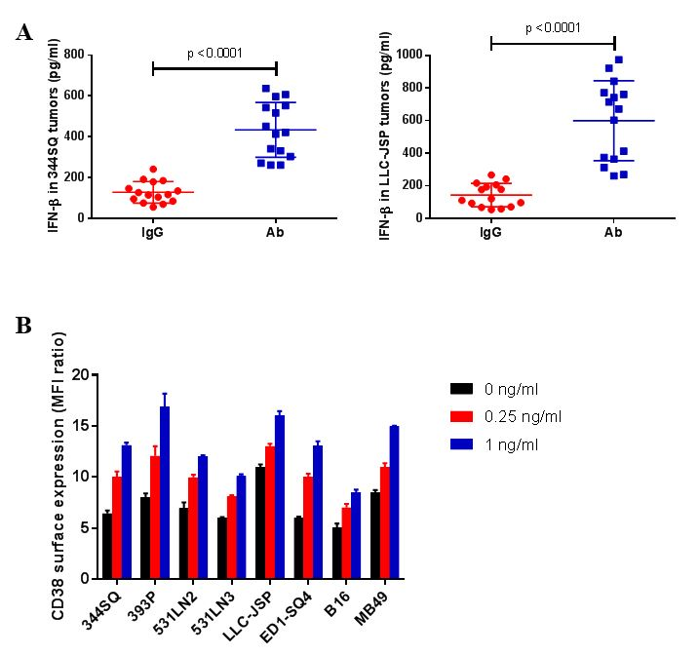
Supplementary Figure S7. IFN-β, which is enriched in anti-PD-L1 treated tumors, up-regulates CD38 expression on multiple cancer cell lines.
(A) The indicated tumor-bearing mice (n = 5) were treated with anti-PD-L1 antibody (Ab) or an IgG control (IgG) (200 μg; intraperitoneally) once a week for 4 weeks beginning on day 7 after tumor cells were subcutaneously implanted (1 x 10⁶ cells per mouse). Tumor lysates were subjected to measure the concentration of IFN-β using ELISA assay. ELISA assays were conducted three times and the data were pooled. The concentrations of IFN-β in tumors are presented as mean ± SD with p values.
(B) Cells were incubated with IFN-β at different concentrations (0 ng/ml, 0.25 ng/ml, and 1 ng/ml) for 3 days and stained with anti-CD38 antibody. CD38 surface expression on mouse lung cancer cell lines 344SQ, 393P, 531LN2, 531LN3, LLC-JSP, and ED1-SQ4, melanoma B16, and bladder cancer cell line MB49 was quantified by FACS analysis with the ratio of mean fluorescence intensity (MFI). The experiments were repeated three times.

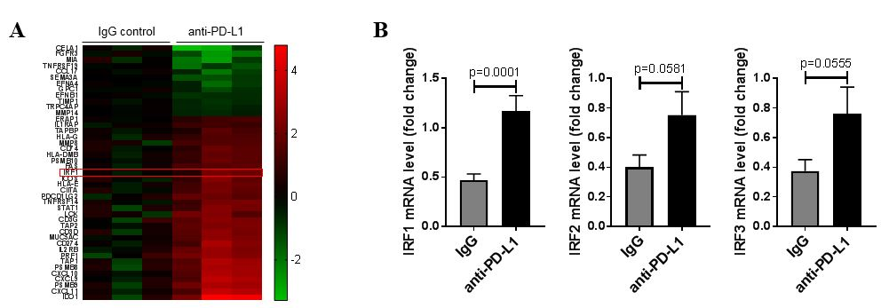
Supplementary Figure S8. IRF1, which links ATRA and IFN-b, is upregulated after anti-PD-L1 treatment.
(A) 344SQ tumor bearing mice (n = 3) were treated with anti-PD-L1 antibody (200 μg per mouse) and the Ig G control once a week for 2 weeks. Tumor RNAs were subject to Nanostring Assay. Statistical analysis on NanoString nCounter data was conducted in R version 3.4.2. Differential expression analysis was conducted on the log2-transformed data using the Empirical Bayes method.
(B) The RNAs from (A) were used to perform qPCR assay to measure IRF1 mRNA level. mRNA levels were normalized to L32. The summarized data from three independent experiments are shown. The family members IRF2 and IRF3 were included as the control.

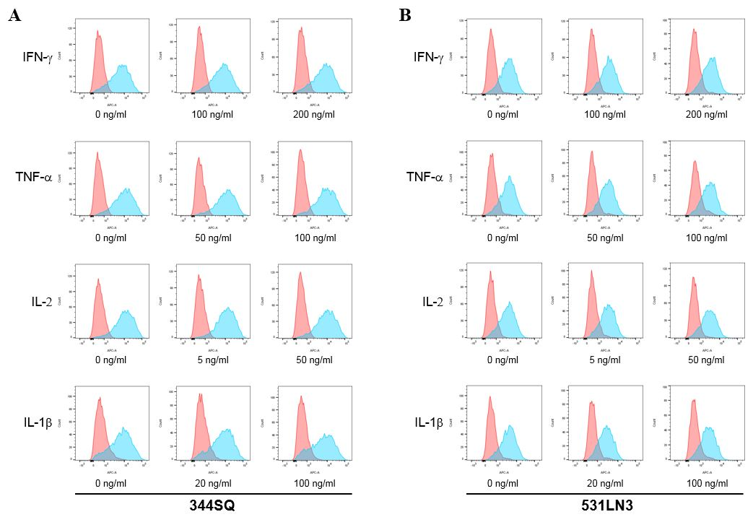
Supplementary Figure S9. IFN-γ, TNF-α, IL-2, and IL-1β don’t regulate CD38 expression on lung cancer cells.
The surface expression of CD38 on 344SQ (A) or 531LN3 (B) cells were measured by FACS analysis after incubating with IFN-γ, TNF-α, IL-2, and IL-1β, respectively, in indicated concentrations for 3 days. Pink line, isotype control staining; light blue line, anti-CD38 staining.

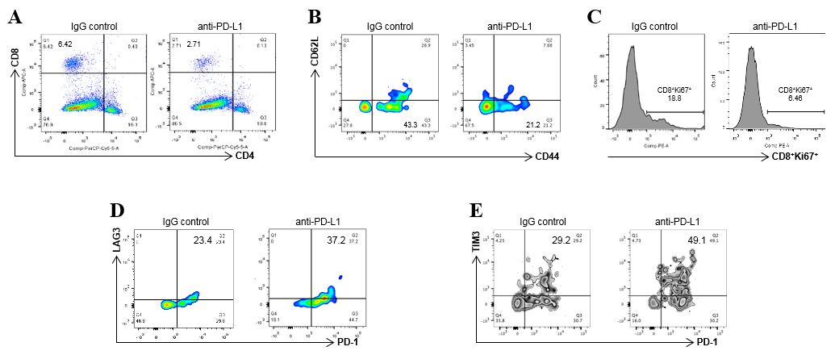
Supplementary Figure S10. The anti-PD-L1 resistant tumors demonstrate an immune suppressive microenvironment.
(A-E) Representative histograms of FACS analysis are shown for cumulative data in Figure 2B.

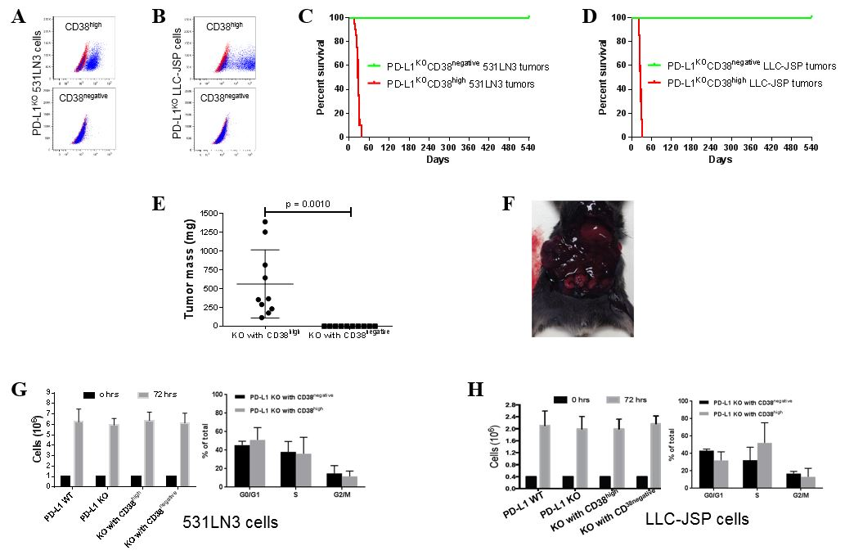
Supplementary Figure S11. CD38 substantially changes in vivo tumor formation of PD-L1KO cancer cells, but does not change in vitro cell growth rate and cell cycle.
(A) The sorted PD-L1^{KO}CD38^{high} and PD-L1^{KO}CD38^{negative} 531LN3 cells were stained by anti-CD38 antibody to confirm before performing in vitro and in vivo experiments. Red dots, isotype control. Blue dots, anti-CD38.
(B) The sorted PD-L1^{KO}CD38^{high} and PD-L1^{KO}CD38^{negative} LLC-JSP cells were stained by anti-CD38 antibody to confirm before performing in vitro and in vivo experiments. Red dots, isotype control. Blue dots, anti-CD38.
(C) For the survival assay, 5 x 10⁶ sorted cells were subcutaneously injected into each 129/Sv mouse (n = 20 or 22). Due to their tumor-free condition, all of the mice injected with PD-L1^{KO}CD38^{negative} 531LN3 cells were euthanized at day 540 post-injection. The percentage of surviving mice injected with each tumor cell type is shown.
(D) For the survival assay, 2 x 10⁶ sorted cells were subcutaneously injected into each C57BL/6 mouse (n = 20). Due to their tumor-free condition, all of the mice injected with PD-L1^{KO}CD38^{negative} LLC-JSP cells were euthanized at day 540 post-injection. The percentage of surviving mice injected with each tumor cell type is shown.
(E) The indicated sorted LLC-JSP lung cancer cells (0.5 x 10⁶ cells per mouse) were subcutaneously injected into immune competent C57BL/6 mice (n = 10). The primary tumor mass at week 4 is shown, with tumor sizes presented as mean ± SEM. t-test was used to analyze.
(F) A representative photo of a PD-L1^{KO}CD38^{high} LLC-JSP tumor bearing mouse representing aggressive local growth/invasion with associated peritoneal bleeding caused by tumors in Figure S9D.
(G) 531LN3 cells with indicated numbers were seeded in the 150 mm dish and cultured. At 72 h, cells were harvested and counted with 0.4% Trypan Blue staining. The cell growth graph is shown in the left panel. 2 x 10⁶ cells were stained with propidium iodide and cell cycle analysis was performed on the Gallios flow cytometer. The summarized data from three times experiments is shown in the right panel.
(H) LLC-JSP cells with indicated numbers were seeded in the 150 mm dish and cultured. At 72 h, cells were harvested and counted with 0.4% Trypan Blue staining. The cell growth graph is shown in the left panel. 2 x 10⁶ cells were stained with propidium iodide and cell cycle analysis was performed on the Gallios flow cytometer. The summarized data from three times experiments is shown in the right panel.

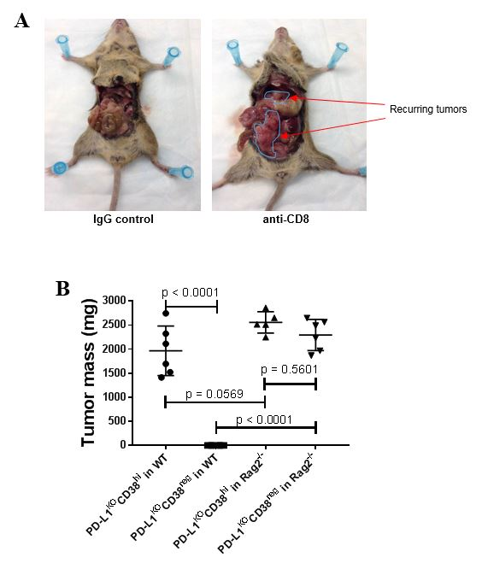
Supplementary Figure S12. The elimination of PD-L1^{KO}CD38^{negative} cancer cells is CD8⁺ T cell dependent.
(A) 5 x 10⁶ of PD-L1^{KO}CD38^{negative} 531LN3 cells were subcutaneously injected into 129/Sv mice (n = 10) after CD8 T cells were depleted (anti-CD8). The T cell un-depleted group was included as the control (IgG control). Mice underwent necropsy 5 weeks post tumor cell transplantation. There were no recurring tumors in IgG control group (left). The recurring tumors after CD8⁺ T cell depletion are highlighted (right). The representative photos are shown.
(B) PD-L1^{KO}CD38^{high}531LN3 cells or PD-L1^{KO}CD38^{negative}531LN3 cells (5 x 10⁶ cells per mouse) were subcutaneously injected into immune competent 129/Sv mice or Rag2^{-/-} mice (n = 5 or 6). The primary tumor sizes at week 4 are shown with mean ± SEM. ANOVA test was used to analyze.

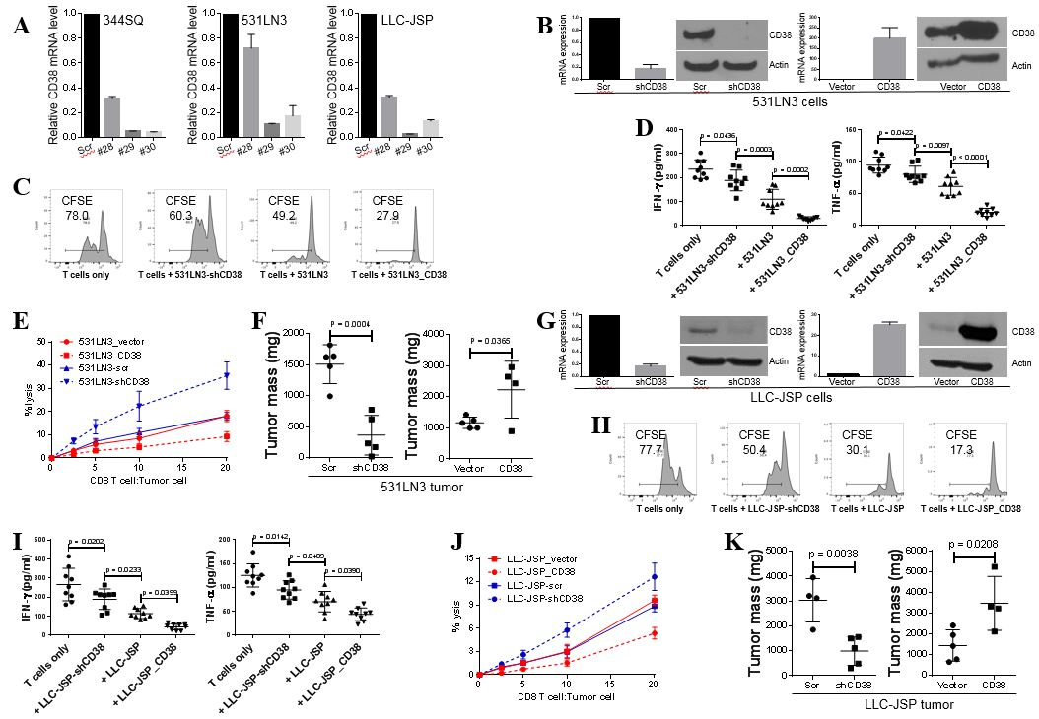

Supplementary Figure S13. CD38 on tumor cells inhibits CD8⁺ T cell function and protects tumor cells from CD8⁺ T cell killing.
(A) KP (344SQ and 531LN3) and LLC-JSP cells were stably transfected with shRNAs against CD38 or a scrambled control hairpin. Relative mRNA expression of CD38 for each stable transfect is shown vs the isogenic scramble control. Based upon these results and subsequent Western/FACS analysis, shRNA #29 was chosen as the best representative knockdown for each cell line.
(B) 531LN3 cell lines with stable expression of a scramble control (Scr), shRNA against CD38 (shCD38), an empty vector control (Vector), or CD38 overexpression (CD38) were subjected to qRT-PCR and Western blotting. The CD38 mRNA knockdown or overexpression efficiency is shown on the left. Relative mRNA levels are normalized to L32. The Western blot for protein is shown on the right, versus β-actin as a loading control.
(C - E) To prepare tumor specific CD8⁺ T cells, 129/Sv mice were challenged with 1 x 10⁶ 531LN3 for 2 weeks. CD8⁺ T cells were isolated from these tumors, blood, and spleens. CFSE-labeled CD8⁺ T cells were co-cultured with indicated cancer cells in the presence of anti-CD3 (5 μg/ml) and anti-CD28 (5 μg/ml) for 4 days. CD8⁺ T cells only was included as the control. T cell proliferation was quantified using FACS analysis (C). The supernatants from each co-culture were subjected to ELISA assay to measure IFN-γ and TNF-α (D). Tumor cells and CD8⁺ T cells were co-cultured at the indicated ratios in the presence of anti-CD3 (5 μg/ml) and anti-CD28 (5 μg/ml) for 4 days. Tumor cells only were used as the control for calculation. At day 4, CD8⁺ T cells and some dead tumor cells were washed away and viable tumor cells were counted with 0.4% Trypan Blue staining. The CD8⁺ T cell killing efficiency is shown in (E). The experiments were repeated at least three times. p values were calculated with ANOVA test.
(F) 2 x 10⁶ cells per mouse for 531LN3-scr, 531LN3-shCD38, 531LN3_vector, or 531LN3_CD38 were subcutaneously injected into syngeneic 129/Sv mice. At the endpoint in Figure 3M, tumor weights were measured and shown as mean ± SEM. t-test is used to analyze the difference.
(G) LLC-JSP cell lines with stable expression of a scramble control (Scr), shRNA against CD38 (shCD38), an empty vector control (Vector), or CD38 overexpression (CD38) were subjected to qRT-PCR and Western blotting. The CD38 mRNA knockdown or overexpression efficiency is shown on the left. Relative mRNA levels are normalized to L32. The Western blot for protein is shown on the right, versus β-actin as a loading control.
(H - J) To prepare tumor specific CD8⁺ T cells, C57/BL6 mice were challenged with 0.1 x 10⁶ LLC-JSP for 2 weeks. CD8⁺ T cells were isolated from these tumors, blood, and spleens. CFSE-labeled CD8⁺ T cells were co-cultured with indicated cancer cells in the presence of anti-CD3 (5 μg/ml) and anti-CD28 (5 μg/ml) for 4 days. CD8⁺ T cells only was included as the control. T cell proliferation was quantified using FACS analysis (H). The supernatants from each co-culture were subjected to ELISA assay to measure IFN-γ and TNF-α (I). Tumor cells and CD8⁺ T cells were co-cultured at the indicated ratios in the presence of anti-CD3 (5 μg/ml) and anti-CD28 (5 μg/ml) for 4 days. Tumor cells only were used as the control for calculation. At day 4, CD8⁺ T cells and some dead tumor cells were washed away and viable tumor cells were counted with 0.4% Trypan Blue staining. The CD8⁺ T cell killing efficiency is shown in (J). The experiments were repeated at least three times. p values were calculated with ANOVA test.
(K) 1 x 10⁶ cells per mouse for LLC-JSP-scr or LLC-JSP-shCD38 injection, 0.5 x 10⁶ cells per mouse for LLC-JSP_vector or LLC-JSP_CD38 were subcutaneously injected into syngeneic C57/BL6 mice. At the endpoint in Figure 3M, tumor weights were measured and shown as mean ± SEM. t-test is used to analyze the difference.

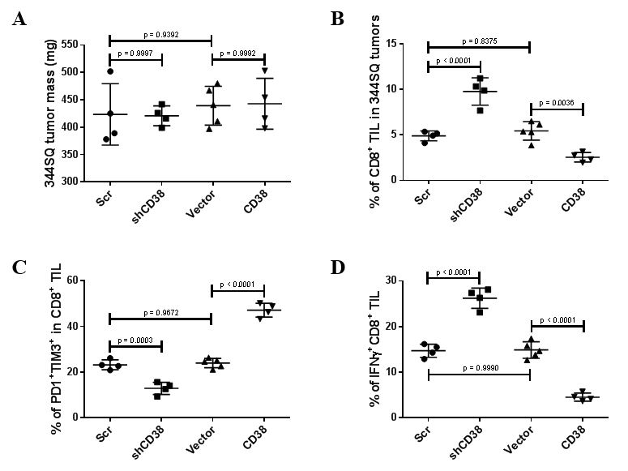
Supplementary Figure S14. CD38-mediated CD8⁺TIL dysfunction is not affected by tumor growth rate/tumor size.
344SQ-scr cells (1 × 10⁶), 344SQ-shCD38 cells (3 × 10⁶), 344SQ_vector cells (1 × 10⁶), or 344SQ_CD38 cells (0.5 × 10⁶) were injected subcutaneously into 129/Sv mice (n = 6-8). 4-5 mice in each group with comparable primary tumor masses (A) were chosen for examining CD8⁺TIL function by FACS analysis at necropsy 4 weeks post-injection. CD8⁺TILs in primary tumors are shown in (B). The percent of exhausted CD8⁺ T cells measured by PD-1⁺TIM3⁺ is shown in (C). The percent of antitumor IFN-γ⁺CD8⁺ T population is shown in (D). ANOVA test was used to analyze data.

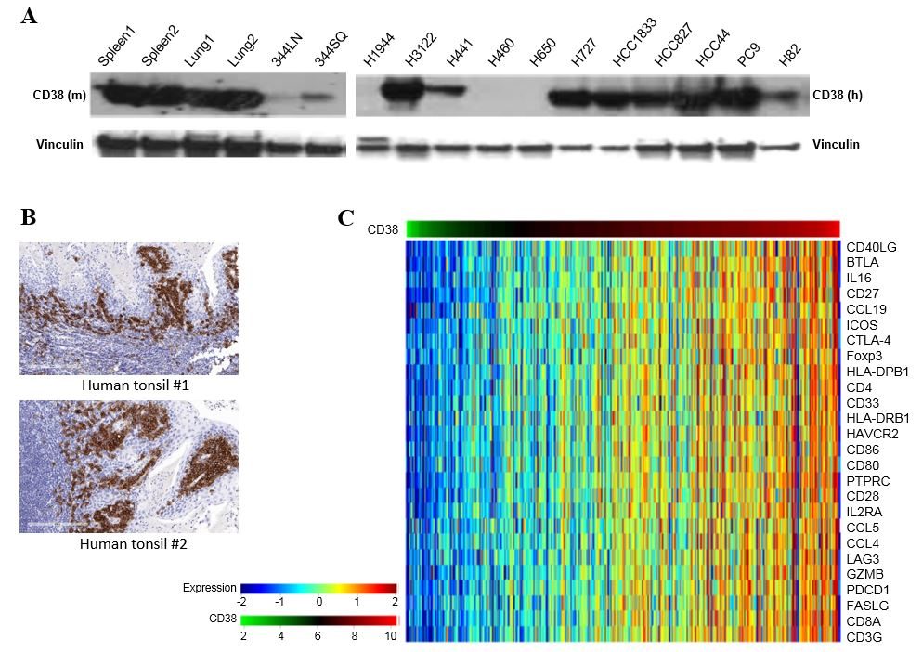
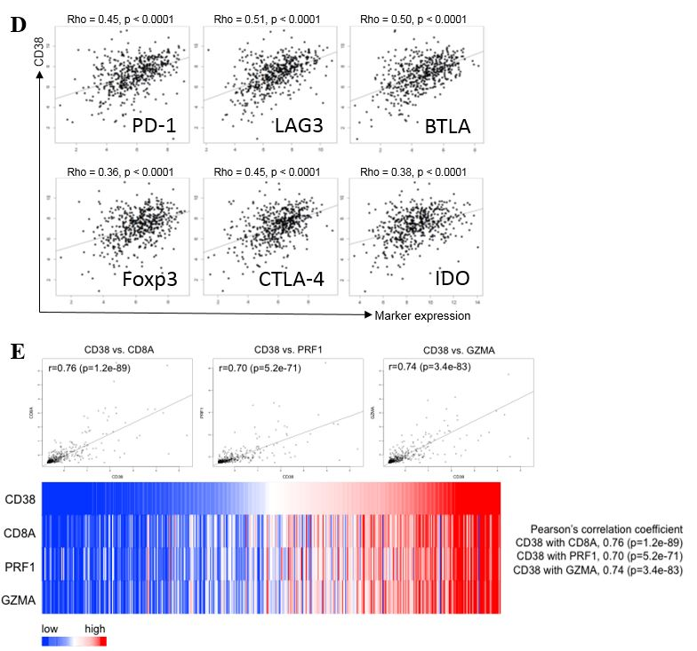
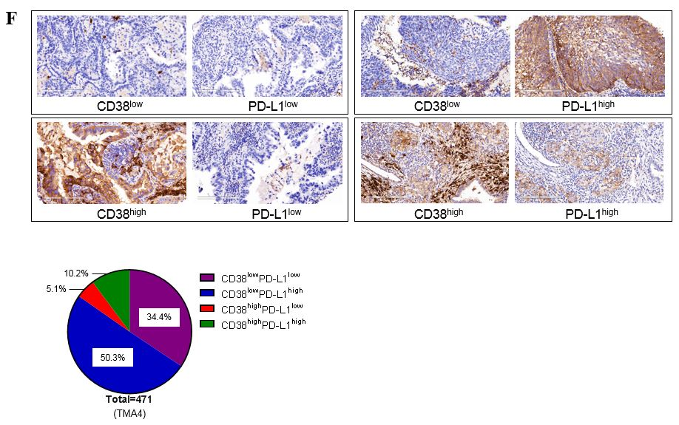
Supplementary Figure S15. CD38 expression in cancer cell lines and patient tissues, which is associated with the differentiated immune features.
(A) (Left panel) CD38 expression in mouse spleen, lung, and lung cancer cell lines detected by Western blotting. (Right panel) CD38 expression in a panel of human lung cancer cell lines detected by Western blotting. Vinculin as the protein loading control.
(B) Normal human tonsils were used to validate the specificity of anti-CD38 antibody for lung cancer patient tumor IHC staining.
(C) Heat map of the Spearman correlation test applied on each gene to check the association with mRNA levels of CD38 in TCGA lung squamous cancer dataset. Adjusted p value < 0.05 and spearman rho ≥ 0.5 are used as the criteria to select the most significant immune markers for generating the heat map.
(D) Dot plots of CD38 mRNA expression level (Y-axis) and the concordant expression of multiple immune suppressive molecules including PD-1, LAG3, BTLA, Foxp3, CTLA-4, and IDO from the samples in the TCGA LUAD dataset. Spearman correlation and p values are shown.
(E) Co-expression of CD38 with cytolytic T-cell markers in cutaneous melanoma. Pearson’s rank correlation were used to assess the association between CD38 expression and CD8 or Perforin 1 (PRF1) or Granzyme A (GZMA) in melanoma samples from SKCM TCGA (n = 469) dataset. Heat map showing mRNA expression level of CD38 relative to cytolytic T-cell markers (CD8A, PRF1, and GZMA).
(F) (Upper panel) The co-locational CD38 and PD-L1 IHC staining were performed in tumors from the lung cancer patient tissue microarray bank TMA4 (n = 534; 471 of 534 are IHC staining qualified). Representative images of cell membrane staining intensity are shown. The cell membrane staining intensity and percentage of positive cells were analyzed and used to generate an H-score for each sample that passed quality control. Samples were stratified as CD38^{low} (H-score < 2.5), CD38^{high} (H-score > 2.5), PD-L1^{low} (H-score < 15), or PD-L1^{high} (H-score > 15). The percent distribution of each co-locational expression pattern of CD38 and PD-L1 IHC staining was summarized and shown in the pie chart.

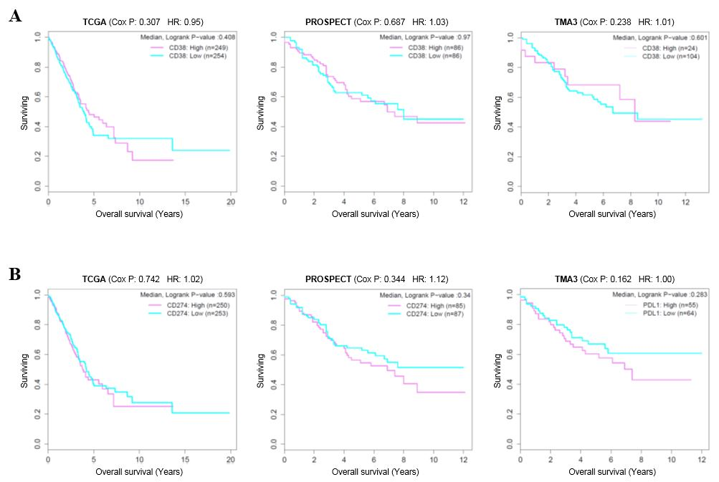
Supplementary Figure S16. CD38 or PD-L1 expression is not correlated with overall survival in early-stage lung cancer.
(A and B) The correlation of CD38 or CD274 (PD-L1) with overall survival of lung cancer in TCGA, PROSPECT, and TMA4 datasets was analyzed using Cox model (considered as continuous variable) with Median as cutoff.

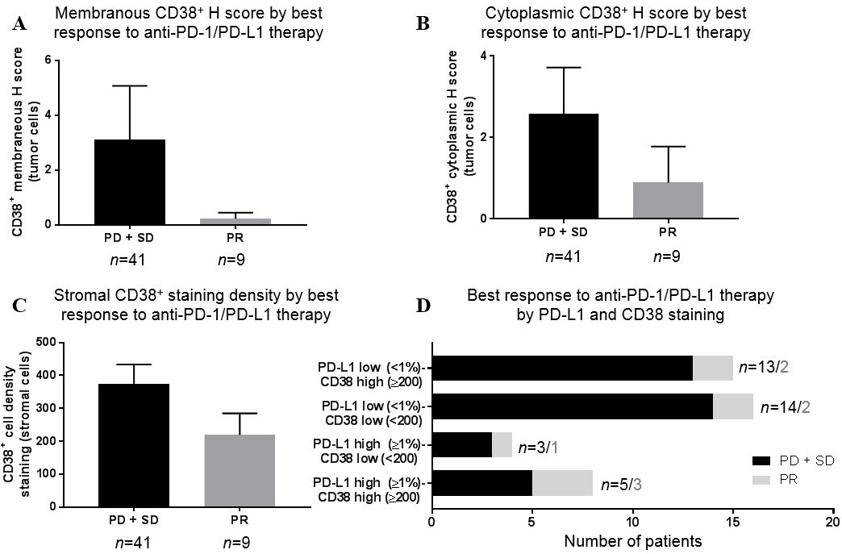

Supplementary Figure S17. Pre-treatment levels of CD38 and PD-L1 expression in NSCLC patients who received anti-PD-1/PD-L1 therapy, as divided by clinical outcome.
(A-C) Pre-treatment expression levels of PD-L1 and CD38, as evaluated by IHC staining, in tumor samples from NSCLC patients who received anti-PD-1/PD-L1 therapy and separated by clinical outcomes. Patients were divided into responders and non-responders based on best response to therapy (partial response [PR] and progressive disease [PD] plus stable disease [SD], respectively). CD38 membranous, p=0.15 (A) and cytoplasmic, p=0.09 (B) H scores, and CD38 tumor-associated stromal cell staining density, p=0.24 (C) were available in a total of 50 NSCLC patients from the GEMINI dataset with disease response (n=41, PD=SD, n=9, PR). Best response to therapy was used for analysis. Data is shown as mean ± SEM.
(D) Best response to therapy based on tumor PD-L1 and CD38 expression. Combined CD38 stromal cell staining density and percentage of membranous PD-L1 staining on cancer cells were both available in a total of 43 NSCLC patients with disease response to therapy (GEMINI dataset). PD-L1 expression status was defined as low or high (<1% or ≥1% membranous PD-L1 staining on cancer cells, respectively). CD38 stromal cell density was defined as low (<200 [median of all CD38 stromal cell staining densities]) or high (≥ 200). Best response to therapy is shown. Data is shown as mean ± SEM. n indicates the number of patients per each subgroup based on PD-L1 and CD38 expression. Unpaired t-test was used for calculation of p-values.

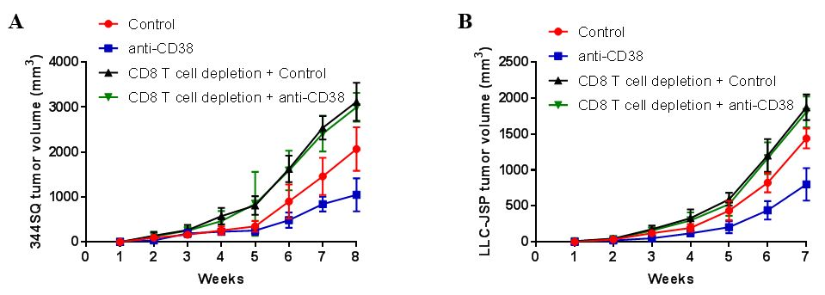
Supplementary Figure S18. The effect of cancer immunotherapy by anti-CD38 is CD8 T cell dependent.
(A and B) anti-CD38 (250 μg per mouse) or the isotype-matched IgG control was intraperitoneally injected into syngeneic mice (n = 5 or 6) once a week for indicated weeks beginning on day 7 after subcutaneous tumor cell injection (0.5 x 10⁶ 344SQ cells per mouse; 0.1 x 10⁶ LLC-JSP cells per mouse). For CD8 T cell depletion, 400 μg of anti-CD8 per mouse was injected 1 week prior to subcutaneous tumor cell injection then 200 μg of anti-CD8 per mouse was injected weekly to maintain the depletion. Tumors were measured once a week and the tumor growth curves are shown.

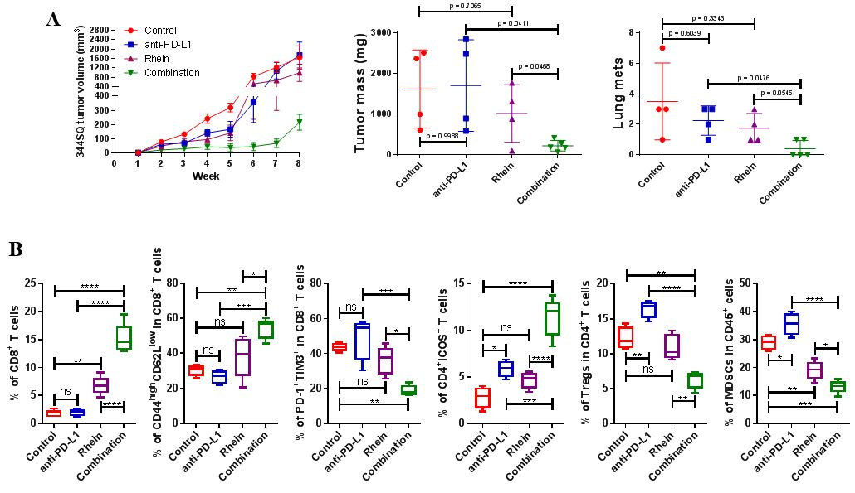
Supplementary Figure S19. Combined inhibitors of CD38 and PD-L1 inhibits tumor growth and metastases.
(A) 129/Sv mice (n = 4 or 5) were treated with anti-PD-L1 and Rhein (CD38 inhibitor) once a week for 7 weeks beginning on day 7 after the subcutaneous 344SQ tumor cell injection (1 x 10⁶ cells per mouse). Dosing per intraperitoneal injection was 200 μg of anti-PD-L1, 50 mg/kg of Rhein. Tumors were measured once a week for 8 weeks. The tumor growth curves are shown in left panel. Tumor weights and lung metastases at the endpoint are shown in right panel. ANOVA test was used to analyze.
(B) FACS analysis of CD4⁺ICOS⁺TIL and CD8⁺TIL frequency, percent of memory CD8 T cells and exhausted CD8 T cells, and tumor-infiltrating Tregs and MDSCs from the endpoint primary tumors. The statistical summary is shown with ANOVA test. ns, no significance; *, p < 0.05; **, p < 0.01; ***, p < 0.001; ****, p < 0.0001.

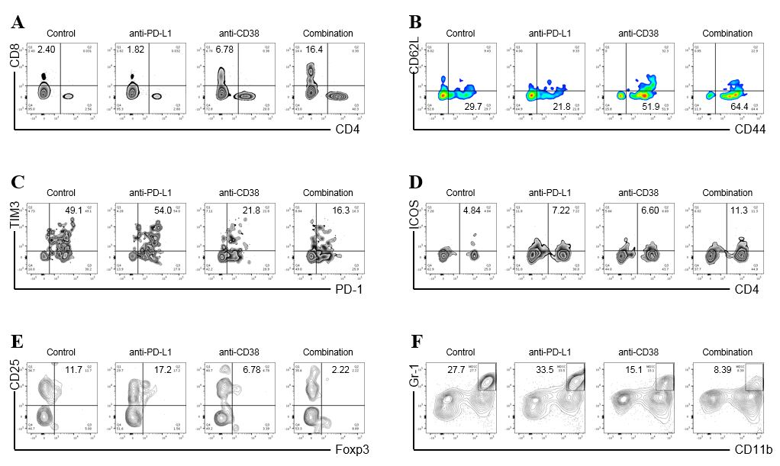
Supplementary Figure S20. The co-inhibition of PD-L1 and CD38 leads to a favorable antitumor immune microenvironment.
(A-F) 344SQ tumors in Figure 5A were harvested and the immune profiling was analyzed by FACS at the endpoint, and the representative plot is shown. Cumulative data for all the tumors is shown in Figure 5F. Effector memory CD8 T cells: CD45⁺CD3⁺CD8⁺CD44^{high}CD62L^{low}, Exhausted CD8 T cells: CD45⁺CD3⁺CD8⁺PD-1⁺TIM3⁺, ICOS⁺ CD4 T cells: CD45⁺CD3⁺CD4⁺ICOS⁺, Treg cells: CD45⁺CD3⁺CD4⁺CD25⁺Foxp3⁺, MDSCs: CD45⁺CD3⁻CD11b^{high}Gr-1^{high}.

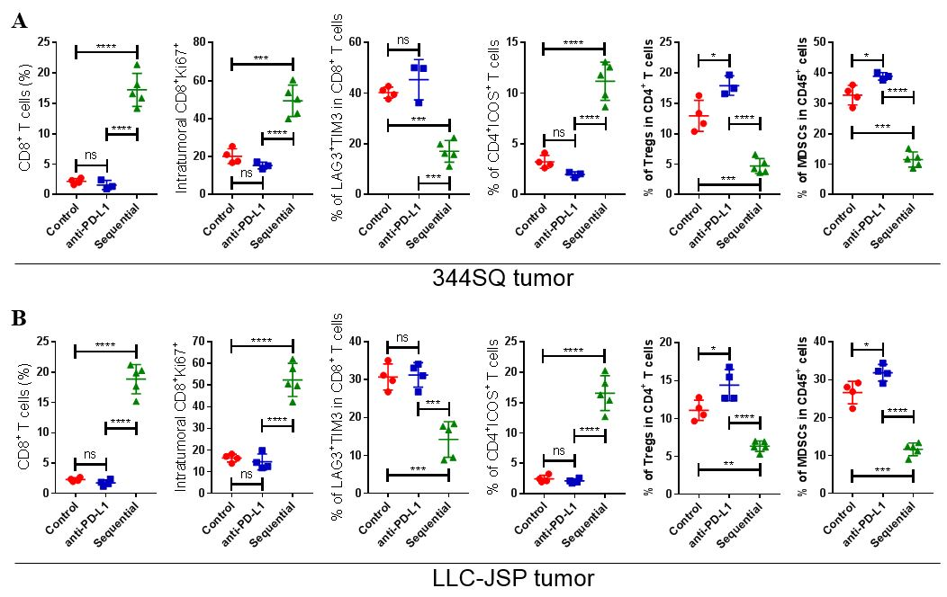
Supplementary Figure S21. Sequential treatment of anti-PD-L1 and anti-CD38 results in enhanced immune response in tumor microenvironment.
(A) 344SQ tumors in Figure 5I were harvested and the immune profiling with indicated markers was analyzed by FACS at the endpoint. Cumulative data for all the tumors is shown with ANOVA test. ns, no significance; *, p < 0.05; ***, p < 0.001; ****, p < 0.0001.
(B) LLC-JSP tumors in Figure 5I were harvested and the immune profiling with indicated markers was analyzed by FACS at the endpoint. Cumulative data for all the tumors is shown with ANOVA test. ns, no significance; *, p < 0.05; **, p < 0.01; ***, p < 0.001; ****, p < 0.0001.

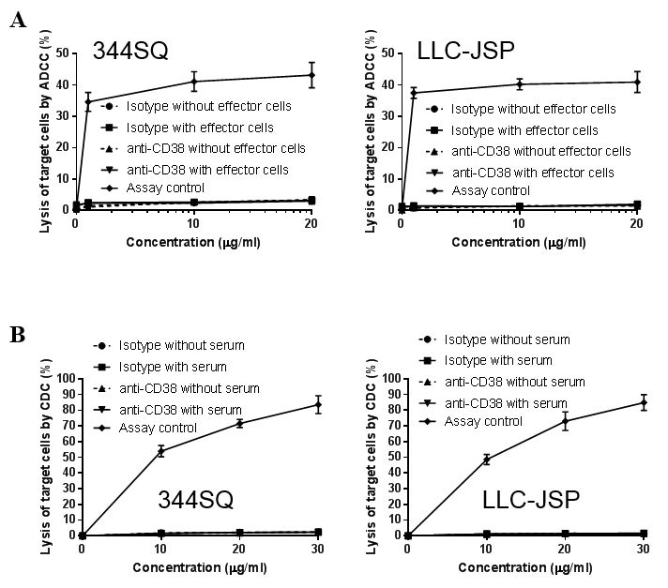
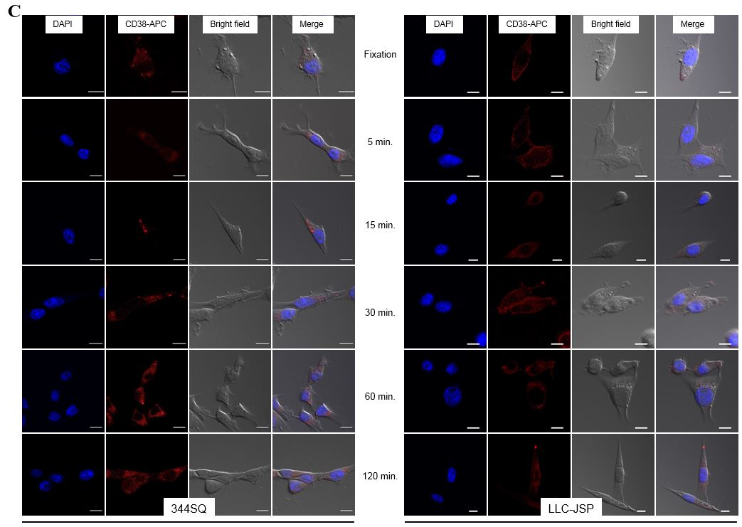
Supplementary Figure S22. anti-mouse CD38 antibody (NIMR-5) does not directly kill tumor cells through ADCC and CDC, but causes CD38 internalization.
(A) 344SQ or LLC-JSP cells (10,000 cells/well), natural killer cells from 129/Sv or C57BL/6 mice (200,000 cells/well), and anti-mouse CD38 antibody (clone NIMR-5) or the isotype control with indicated concentrations were incubated for 6 hours. The cytotoxicity was determined using a lactate dehydrogenase release assay. The control assay was performed using Raji cells, anti-CD20 antibody, human natural killer cells from healthy donors. Dots indicate mean percentage (± SEM) of maximal cytotoxicity from three independent experiments.
(B) 344SQ or LLC-JSP cells (100,000 cells/well), mouse serum (20%) from 129/Sv or C57BL/6 mice, anti-mouse CD38 antibody (clone NIMR-5) or the isotype control with indicated concentrations were incubated for 4 hours. The cytotoxicity was determined using a lactate dehydrogenase release assay. The control assay was performed using Raji cells, anti-CD20 antibody, human serum from healthy donors. Dots indicate mean percentage (± SEM) of maximal cytotoxicity from three independent experiments.
(C) 5,000/well of 344SQ or LLC-JSP were seeded onto a 4 well chamber plate and grown until they were ~50% confluent. Anti-mouse APC CD38 antibody (NIMR-5) 5µg/ml was added to each well and incubated for indicated time at 37 °C 5% CO₂. Cells were washed 3 times with warm PBS and fixed in 4% PFA for 10 min. After fixation cells were washed 3 times with warm PBS and mounted using pro-gold mounting media with DAPI. Time zero represents cells that have been fixed before antibody addition. Bright field and fluorescence images were acquired using a 60× objective on a Nikon A1+ confocal microscope. The NIS elements software (Nikon) was used for analysis.

Supplementary Tables (The Tables S1, S3-5, S7, S8 are provided separately in Excel format.)

Supplementary Table S2. Tumor immune markers with the greatest differential transcriptional levels after anti-PD-L1 treatment.
Gene symbol | Fold change | p value | Gene description
Pak3 | 48.71859845 | 3.78E-06 | p21 protein (Cdc42/Rac)-activated kinase 3
Mlf1 | 24.74878598 | 1.38E-05 | myeloid leukemia factor 1
Klhl22 | 23.27100493 | 1.24E-07 | kelch-like 22
Gli3 | 9.625897228 | 1.73E-06 | GLI-Kruppel family member GLI3
CD38 | 6.732047914 | 1.67E-05 | Cd38 antigen
Smco4 | 6.076914048 | 1.20E-06 | single-pass membrane protein with coiled-coil domains 4
Ly6e | -81.2549431 | 1.22E-06 | lymphocyte antigen 6 complex, locus E
Cxcl3 | -26.7707086 | 5.20E-06 | chemokine (C-X-C motif) ligand 3
Cxcl5 | -25.7444893 | 3.56E-06 | chemokine (C-X-C motif) ligand 5
Ly6a | -10.1592602 | 2.32E-06 | lymphocyte antigen 6 complex, locus A

Supplementary Table S6. The most changed immune-related genes after anti-PD-L1 treatment.

Upregulated genes | Downregulated genes
DNMT1 Eif1ax  Fgfbp1 Eif2s3x  Gli3 Eif3a  Ube2a Eif3g  Ube2e1 Eif4a2  Pdgfrl Eif5a2  Icam1 Eif4ebp1  Wnt4 Tspan8  Wnt7a Ccl9  Hspb8 Ccl25  Igbp1 Igf2r  Loxl4 Ilf3  Cadm1 Scarb1  Cd38 Pten  Cd99 Sdc2  Cdc34 Yap1  Usp9x Bmp4  Usp20 Slain1 | Ly6a Cox5b  Ly6e Cox16  Col6a1 Cox20  Col8a1 Ptgr1  Col12a1 Cd24a  Deptor Cd55  Cxcl1 Tspan12  Cxcl3 Tspan13  Cxcl5 Palld  Cxcl15 Bcl2  Il33 Bcl6  Ifi27 Rassf6  Ifngr2 C4bp  Socs2 Pogk  Ceacam1 Naip5  Ncam1 Ptger4  Foxo1 Usp4  Fkbp10 S100a1  Myb Egr1  Clrn3 Pcdhb17  Ppdpf Serpinb1a  Ppp1r3b Sox4

Supplementary Table S9. The correlation between CD38 and suppressive immune markers in LUAD dataset.

Name | Pearson correlation | Pearson p value | Spearman Rho | Spearman p value | Pad just p value
PD-1 | 0.431471879 | 1.25E-24 | 0.453906152 | 0 | 0
LAG3 | 0.494250548 | 6.81E-33 | 0.505807284 | 1.31E-34 | 1.18E-32
TIM3 | 0.301739371 | 3.08E-12 | 0.293428706 | 1.58E-11 | 5.53E-10
PD-L2 | 0.386509514 | 1.09E-19 | 0.38521559 | 0 | 0
HVEM | 0.150206916 | 0.000649981 | 0.142720439 | 0.001215405 | 0.007978
BTLA | 0.513277717 | 9.36E-36 | 0.502284446 | 0 | 0
Foxp3 | 0.378890788 | 6.35E-19 | 0.363995033 | 7.43E-18 | 4.64E-16
CTLA4 | 0.458829972 | 5.06E-28 | 0.44909434 | 0 | 0
IDO | 0.367828096 | 7.55E-18 | 0.378582014 | 0 | 0
CCL2 | 0.182874954 | 3.14E-05 | 0.181847581 | 3.59E-05 | 0.000401

Supplementary Table S10. The correlation between CD38 and suppressive immune markers in LUSC dataset.

Name | Pearson correlation | Pearson p value | Spearman Rho | Spearman p value | Pad just p value
PD-1 | 0.575357 | 4.65E-45 | 0.595218 | 7.22E-49 | 2.27E-47
LAG3 | 0.56608 | 2.29E-43 | 0.563865 | 5.69E-43 | 1.73E-41
TIM3 | 0.557644 | 7.11E-42 | 0.576918 | 0 | 0
PD-L2 | 0.498043 | 1.88E-32 | 0.484521 | 0 | 0
HVEM | 0.323491 | 1.52E-13 | 0.339319 | 1.05E-14 | 2.01E-13
BTLA | 0.652094 | 2.16E-61 | 0.644905 | 1.16E-59 | 3.78E-58
Foxp3 | 0.513669 | 9.59E-35 | 0.534068 | 0 | 0
CTLA4 | 0.569559 | 5.39E-44 | 0.58577 | 5.05E-47 | 1.57E-45
IDO | 0.405101 | 5.18E-21 | 0.434971 | 0 | 0
CCL2 | 0.371544 | 1.11E-17 | 0.354154 | 4.71E-16 | 9.73E-15

Supplementary Table S11. The available NSCLC patients with CD38 and PD-L1 tumor cell IHC staining and responses to anti-PD-1 therapy.

PD-L1 (<1%-low; ≥1%-high)  CD38 (≥200 medium-high; <200 medium-low) | PD + SD | PR | Total
PD-L1 high (≥1%)  CD38 high (≥200) | 5 | 3 | 8
PD-L1 high (≥1%)  CD38 low (<200) | 3 | 1 | 4
PD-L1 low (<1%)  CD38 low (<200) | 14 | 2 | 16
PD-L1 low (<1%)  CD38 high (≥200) | 13 | 2 | 15
Total | 35 | 8 | 43

Supplementary Table S12. The co-inhibition effect of PD-L1 and CD38 on tumor growth and metastasis.

Tumor type |  | Combination therapy of anti-PD-L1 and anti-D38  Control anti-PD-L1 anti-CD38 Combination | Combination therapy of anti-PD-L1 and Rhein  Control anti-PD-L1 Rhein Combination
344SQ | tumor mass (mg) | Presented in Figure 5A | 1617 ± 478.3 1699 ± 561.2 1013 ± 353.7 222.6 ± 58.10
 | lung mets (nodules) | Presented in Figure 5A | 3.500 ± 1.26 2.250 ± 0.48 1.750 ± 0.47 0.4000 ± 0.25
LLC-JSP | tumor mass (mg) | 5876 ± 999.2 5350 ± 553.6 2071 ± 420.3 658.8 ± 198.7 | 6835 ± 543.4 6709 ± 574.7 3006 ± 1189 152.3 ± 95.73
 | lung mets (nodules) | 9.333 ± 1.45 5.750 ± 0.85 6.000 ± 1.35 1.600 ± 0.51 | 10.00 ± 1.16 6.000 ± 1.00 4.750 ± 1.88 0.6000 ± 0.40

SUPPLEMENTARY MATERIALS AND METHODS

Reagents
anti-PD-L1 (clone 9G2), anti-PD-1 (clone RMP1-14), and the isotype-matched IgG controls were purchased from BioXCell. anti-CD38 (clone NIMR-5) antibody and the isotype-matched IgG control were purchased from Novus Biologicals. Rhein (CD38 inhibitor; catalog # R7269-50MG) was purchased from Sigma-Aldrich. Recombinant IFN-γ (Pepro Tech) was used for in vitro studies. Recombinant IFN-β (R&D systems; catalog # 8234-MB-010) was used for in vitro studies. IL-2 (Miltenyi Biotec), and Cyclophosphamide (Sigma-Aldrich) were used for in vivo studies. All-trans retinoic acid (ATRA; catalog # S1653) was purchased from Selleckchem. Retinoic acid receptor (RAR) α-selective antagonist BMS 195614 (catalog # 3660) as well as adenosine receptors’ antagonists PSB 36 (catalog # 2019), SCH 58261 (catalog # 2270), and PSB 1115 (catalog # 2009) were purchased from TOCRIS. β-Nicotinamide adenine dinucleotide (NAD⁺; catalog # N0632-1G), adenosine deaminase inhibitor EHNA (catalog # E114-25MG), and acetonitrile (ACN; catalog # 271004) were purchased from Sigma-Aldrich.

Cells and Mice
Cell lines were verified by short tandem repeat fingerprinting at MD Anderson Cancer Center. We routinely conduct Mycoplasma testing by using the LookOut(R) Mycoplasma PCR Detection Kit (Catalog# MP0035), per the manufacturer’s instructions. In general, cell lines are grown to 80% confluency within a 48 hour timeframe, 1 ml of media is collected, and boiled at 95 degrees for 2 min, followed by PCR amplification. PCR products are detected after separation on a 2% agarose gel. All the cell lines used in this study were tested and were Mycoplasma free. The cell lines in low passages (p9-16) were used for this study.
Murine lung cancer cell lines 393P, 393LN, 344LN, 344P, 344SQ, 531LN2, 531LN3, 412P, and 307P were derived from K-ras^{LA1/+}p53^{R172H∆g/+} mice, as previously described in prior studies(1-7). B16 melanoma, 4T1 breast, MCA205 sarcoma, and LLC-JSP (8,9) Lewis lung tumor cell lines were maintained in our laboratories. Stable cell lines 393P_ZEB1, 531LN3-shCD38, 531LN3_CD38, 344SQ-shCD38, 344SQ_CD38, LLC-JSP-shCD38, LLC-JSP_CD38 were generated in our laboratory. The shCD38 sequences are shown below.
#28: CCGGCCACAGATATTCACATGGTAACTCGAGTTACCATGTGAATATCTGTGGTTTTTG
#29: CCGGGCTGAAGATGATTGTGCAGAACTCGAGTTCTGCACAATCATCTTCAGCTTTTTG
#30: CCGGCCAGGAGATACTGAGTACATTCTCGAGAATGTACTCAGTATCTCCTGGTTTTTG
Murine lung cancer cell line ED1-SQ4 was developed from ED1 cells which were originally derived from lung tumor of cyclin E transgenic mice (10,11). ED1 cells were subcutaneously injected into FVB syngeneic mice and let grow. When tumors reached more than 1 cm (typically 4-8 weeks after injection), mice were euthanized and tumors were resected. Resected tumors were cut into small pieces (approximately 1mm diameter) and subcutaneously transplanted into other FVB mice. After growth, the tumors were resected, cut into small pieces, and transplanted into other FVB mice again. This process was repeated four times. After four transplantations, resected tumors were minced and incubated in 300 units/ml collagenase (Sigma), 0.25% trypsin (Invitrogen), and 10U/ml DNase (Invitrogen) for 2 hours at 37ºC. Cell suspensions were put through 40 μm Cell Strainer (BD Bioscience) and plated onto BD BioCoat Collagen I-coated tissue culture plates (BD Bioscience) with RPMI 1640 supplemented with 20% fetal bovine serum (FBS). Cells were cultured at 37ºC with 5% CO₂ in a humidified incubator. ED1-SQ4 cell line was established after several passages.
Tumor cell lines 531LN3 with PD-L1 KO, LLC-JSP with PD-L1 KO, and B16 with PD-L1 KO were generated by CRISP/Cas9 editing system (12). PD-L1^{KO}CD38^{negative} 531LN3, PD-L1^{KO}CD38^{high} 531LN3, PD-L1^{KO}CD38^{negative} LLC-JSP, PD-L1^{KO}CD38^{high} LLC-JSP were sorted by FACS from 531LN3 with PD-L1 KO, LLC-JSP with PD-L1 KO cells. Human lung cancer cell lines A549, H82, H441, H460, H650, H727, H1944, H3122, HOP62, H2023, H2073, HCC44, HCC366, HCC827, HCC1833, HCC2814, and PC9 were purchased from the American Type Culture Collection or maintained in our department lung cancer cell line bank.
Six- to 8-week-old 129/Sv or C57BL/6 mice were obtained from Charles River Laboratories and maintained in our laboratory. PD-L1-deficient C57/BL6 mice were obtained from Dr. Lieping Chen laboratory and maintained as a homozygous line and 6- or 8-week-old mice were used for the experiments. Spontaneous Kras^{LA1/+} and Kras^{LA1/+}/p53 ^{R172H∆g/+} mice were previously generated and maintained in our laboratory (2,13). 8- to 12- month-old Kras^{LA1/+} and Kras^{LA1/+}/p53 ^{R172H∆g/+} mice were used for the experiments. All animal procedures were reviewed and approved by The University of Texas MD Anderson Cancer Center Animal Care and Use Committee.

CRISPR/Cas9 Editing
The sgRNA was designed using online tools from Zhang’s lab (http://crispr.mit.edu/). According to the database (http://arep.med.harvard.edu/human_crispr/) from Church’s lab, all the sgRNAs are located on the exon of PD-L1 gene. The sgRNA targeting on PD-L1 ORF with high specificity was cloned into sgRNA expression vector through BbsI restriction site (Fermentas Thermo). After co-transfection with CRISPR-Cas9 vector in the cancer cell line, cells were selected with 5 μg/ml of puromycin (Sigma). Successful targeting of PD-L1 was determined by flow cytometry screening of clones treated with and without 100 ng/ml of IFN-γ (PeproTech).

Antibody-mediated Cell Depletion
Mice were pretreated with anti-CD8 antibody (2.43; BioXCell; 400 μg per mouse, intraperitoneally) one week before tumor cell injection. 200 μg of anti-CD8 antibody per mouse was injected into the mice once weekly for indicated weeks beginning on day 1 after a subcutaneous cancer cell injection as previously described (3).

CD8⁺ T Cell Adoptive Transfer
The protocol was modified according to the previous reports (14). To prepare CD8⁺ T cells, 129/Sv mice were challenged with 0.5 x 10⁶ 344SQ for 2 weeks by subcutaneous injection. CD8⁺ T cells were isolated from these tumors, blood, and spleens by MACS technology according to the manufacturer’s instructions (Miltenyi Biotec). CD8⁺ T cells (6 x 10⁶) were injected via the tail vein into 129/Sv mice 6 h after pre-conditioning with cyclophosphamide.

mRNA Profiling of Murine Tumors
1 × 10⁶ of 344SQ cancer cells in 100 µl of phosphate-buffered saline (PBS) were injected into 129/Sv mouse flank. Mice were treated with anti-PD-L1 antibody or an IgG control (200 μg, intraperitoneally; n = 3) once a week beginning on day 7 after tumor cells were subcutaneously implanted. Tumors were removed to extract the total RNAs at week 5 post-treatment. The RNA electrophoresis and NanoAssay were used to determine RNA quality before Affymetrix GeneChip was performed for mRNA profiling. The data was processed by Affymetrix Mouse 430_2. The Robust Multiarray Analysis (RMA) algorithm was applied to quantify the Affymetrix arrays. There were 14955 native features (genes) in the dataset. After collapsing features into gene symbols, there were 9391 genes. The top 100 up-regulated genes and top 100 down-regulated genes were included to form the Volcano plot Venn diagram. 98 genes involved in T cell activity from Gene Set Enrichment Analysis (GSEA) were selected to form the GSEA Venn diagram. The top 19 networks identified with Ingenuity Pathway Analysis (IPA) software were used to form the IPA Venn diagram.

Flow Cytometry
Single-cell suspensions were prepared and stained according to standard protocols for flow cytometry with the following antibodies: mouse CD3-PerCP (mouse; BD Biosciences, 560527 1:100 dilution), CD3-PE/Dazzle (mouse; BioLegend, 100246, 1:150 dilution), CD3-Alexa Fluor 700 (mouse; eBioscience, 56-0033-82, 1:200 dilution), CD4-APC (mouse; BD Biosciences, 553051, 1:100 dilution), CD4-FITC (mouse; BD Biosciences, 553729, 1:50 dilution), CD8b-PerCP (mouse; BioLegend, 126610, 1:150 dilution), CD8b-FITC (mouse, eBioscience, 11-0083-82, 1:200 dilution), CD8b-APC (mouse; eBioscience, 17-0083, 1:100 dilution), CD8b-PE (mouse; eBioscience, 12-0083-83, 1:200 dilution), CD31-BV421 (mouse; BioLegend, 102423, 1:200 dilution), CD44-APC (mouse; BD Biosciences, 559250, 1:200 dilution), CD45-PerCP (mouse; BioLegend, 103130, 1:100 dilution), CD45-PE (mouse; eBioscience, 12-0451-82, 1:250 dilution), CD45-APC/Cy7 (mouse; BD Biosciences, 557659, 1:150 dilution), CD45-FITC (mouse; eBioscience, 11-0451-82, 1:200 dilution), CD62L-FITC (mouse; BioLegend, 104406, 1:300 dilution), CD11b-APC (mouse; eBioscience, 17-0112-83, 1:100 dilution), Gr-1-PE (mouse; BD Biosciences, 553128, 1:100 dilution), CD25-APC (mouse; eBioscience, 17-0251-82, 1:100 dilution), Foxp3-PE (mouse; BioLegend, 126404, 1:50 dilution), Ki67-PE (eBioscience, 12-5698-82, 1:100 dilution), PD1-PE (mouse; eBioscience, 12-9985-83, 1:150 dilution), PD1-FITC (mouse; eBioscience, 11-9985-82, 1:150 dilution), PD-L1-PE (mouse; BD Biosciences, 558091, 1:200 dilution), ICOS/CD278-PE (mouse; BioLegend, 117406, 1:300 dilution), TIM3-PE (mouse; eBioscience, 12-5870-83, 1:150 dilution), and LAG3-PE (mouse; eBioscience, 12-2231-83, 1:100 dilution), Ep-CAM-APC (mouse; BioLegend, 118214, 1:150 dilution), CD38-PE (mouse; BioLegend, 102708, 1:100 dilution), CD38-APC (mouse; BioLegend, 102712, 1:200 dilution), CD38-PE (human; BD Biosciences, 555460, 1:150 dilution), CD38-APC (human; BioLegend, 303510, 1:200 dilution), IFN-γ-PE (mouse; eBioscience, 12-7311-82, 1:100 dilution). For IFN-γ staining, cells were stimulated ex vivo with phorbol 12-myristate 13-acetate (50 ng/ml) and ionomycin (500 ng/ml) for 6 hr at 37 °C and with BD GolgiStopTM (4 μl of BD GolgiStopTM for every 6 ml of cell culture) for the last 4 hr. For intracellular staining, cells were fixed and permeabilized with BD Cytofix/Cytoperm (BD Biosciences). The data were acquired on a Fortessa, Canto, or Calibur platform (BD Biosciences) and analyzed with FlowJo software (version 7.6; Tree Star).

Nanostring Analysis
1 x 10⁶ 344SQ cells were implanted into 129/Sv mice and treated with IgG control or anti-PD-L1 antibody (200 μg per mouse) twice a week for two weeks starting week one after implantation. Tumor RNAs were isolated using the mirVana RNA isolation kit from Invitrogen Thermofisher Scientific following manufacturer instructions. 100 ng of RNA of each sample was used for nanostring. The Mm_TMEN_1.5b custom code set was used following manufacturing recommendations. Statistical analysis on NanoString nCounter data was conducted in R version 3.4.2. Positive control normalization was applied as described in the nCounter data analysis manual, using the geometric means of positive control counts in calculating the lane-specific scale factors (NanoString Technologies, Inc., 2011). Background assessment was conducted using a one-sided t-test comparing the detected expression of a gene across all lanes with the expression of negative control genes. Endogenous genes were retained for analysis if their average expression was greater than the negative control gene expression with p < 0.001. Housekeeping gene normalization was applied using the same geometric mean scaling, using a housekeeping gene set identified as most stable in a larger data set by the established method (15). This set consisted of Alas1, Abcf1, Tbp, Ppia, and Tubb5. Differential expression analysis was conducted on the log2-transformed data, comparing anti-PD-L1 treatment vs. IgG control using the Empirical Bayes method (16,17).

qRT-PCR and Western Blotting
Total RNA was isolated from cultured cells or tumor tissues with TRIzol (Invitrogen). cDNA was synthesized by using the SuperScript III kit (Invitrogen), and qPCR was performed with the SYBR Green PCR Master Mix (Applied Biosystems). Primers were designed with National Center for Biotechnology Information (NCBI) primer design software. Relative expression levels were normalized by L32 and calculated by the 2^{-ΔΔCt} method (18). The primers used for amplification are shown below:
L32: forward 5’-GTAACCCGTTGAACCCCATT-3’
reverse 5’-CCATCCAATCGGTAGTAGCG-3’
CD38: forward 5’-GGTCCAAGTGATGCTCAATGGG-3’
reverse 5’-AGCTCCTTCGATGTCGTGCATC-3’
RARα: forward 5’-GCTTCCAGTCAGTGGTTACAGC-3’
reverse 5’-CAAAGCAAGGCTTGTAGATGCGG-3’
ADORA1: forward 5’-GATCGGTACCTCCGAGTCAAGA-3’
reverse 5’-CACTCAGGTTGTTCCAGCCAAAC-3’
ADORA2a: forward 5’-CACGCAGAGTTCCATCTTCAGC-3’
reverse 5’-CCCAGCAAATCGCAATGATGCC-3’
ADORA2b: forward 5’-TTCGTGCTGGTGCTCACACAGA-3’
reverse 5’-AAGGACCCAGAGGACAGCAATG-3’
IRF1: forward 5’-TCCAAGTCCAGCCGAGACACTA-3’
reverse 5’-ACTGCTGTGGTCATCAGGTAGG-3’
IRF2: forward 5’-TGTGTCAGCCACTGTATCCTCC-3’
reverse 5’-CTGCTTCTCCTTTAGCTCACGC-3’
IRF3: forward 5’-CGGAAAGAAGTGTTGCGGTTAGC-3’
reverse 5’-CAGGCTGCTTTTGCCATTGGTG-3’
Total protein was extracted using NP40 lysis buffer (0.5% NP40, 250 mM NaCl, 50 mM Hepes, 5 mM ethylenediaminetetraacetic acid, 0.5 mM egtazic acid) supplemented with protease inhibitors cocktails (Sigma-Aldrich). Lysates was centrifuged at 12,000 rpm for 10 min, and the supernatant was collected for experiments. Protein lysates (40 μg) were resolved on denaturing gels with 4% to 20% sodium dodecyl sulfate (SDS)-polyacrylamide and transferred to nitrocellulose membranes (Biorad Laboratories). Membranes were probed with the following antibodies: primary antibodies anti-mouse CD38 (R&D, AF4947, 1:1000 dilution), anti-human CD38 (Santa Cruz, sc-15362, 1:500 dilution), anti-mouse PD-L1 (Abcam, ab213480, 1:200 dilution), anti-Actin (Abcam, ab8227, 1:5000 dilution), and anti-Vinculin (Abcam, ab129002, 1:2000 dilution), and secondary antibody labeled by horseradish peroxidase (Amersham GE Healthcare). The secondary antibody was visualized using a chemiluminescent reagent Pierce ECL kit (Thermo Scientific).

Liquid Chromatography–Mass Spectrometry (LC-MS) Analysis
To determine ATRA concentration in tissue lysates, extracts were prepared and analyzed by LC-MS/MS. First, samples were thawed on ice and centrifuged at 17,000 g for 5 min at 4°C. Then 100 µL of samples were extracted using methanol to remove protein and matrix residues. Supernatants were transferred to clean tubes, followed by evaporation to dryness using nitrogen and reconstituted in mobile phase A. 10 µL was injected into a Thermo Scientific Vanquish liquid chromatography (LC) system containing a Fortis Speed Core PFP 50×2.1 mm 2.6 µM HPLC column heated to 35 °C with mobile phase A (MPA) consisting of 0.1% formic acid in water and mobile phase B (MPB) consisting of 100% methanol. Using a flowrate of 0.300 mL/min, the gradient elution program was: 0 min (50% MPB) - 2.0 min (50% MPB) - 5.0 min (95% MPB) -10.0 min (95% MPB) - 10.1 min (50% MPB) - 15.0 min (Stop). Pure ATRA was used to generate a standard curve. Data were acquired using the Thermo Orbitrap Fusion Tribrid Mass Spectrometer via Selected Ion Mode (SIM) electrospray positive mode. Peak integration and ratio calculation were performed using Skyline software.
To determine the adenosine concentration in samples, acetonitrile (ACN) was immediately added (1:2 ratio at 4°C) to stabilize adenosine and the samples were stored at -80°C until use. The extracts were then prepared and analyzed by LC-MS/MS. Samples were thawed on ice and centrifuged at 17,000 g for 5 min at 4°C. Then 100 µL of samples were extracted using 1% formic acid in 90/10 (v/v) acetonitrile/water to remove protein and matrix residues. Supernatants were transferred to clean tubes, followed by evaporation to dryness using nitrogen and reconstituted in mobile phase A. 10 µL was injected into a Thermo Scientific Vanquish liquid chromatography (LC) system containing a HyperCarb 150×2.1 mm 3 µM HPLC column heated to 35°C with mobile phase A (MPA) consisting of 0.05% Ammonium Hydroxide in 10mM Ammonium Acetate and mobile phase B (MPB) consisting of 0.05% Ammonium Hydroxide in acetonitrile. Using a flowrate of 0.200 mL/min, the gradient elution program was: 0 min (20% MPB) - 1.0 min (20% MPB) - 6.0 min (90% MPB) – 10.0 min (90% MPB) - 10.1 min (20% MPB) – 15.0 min (Stop). Data were acquired using the Agilent Triple Quad (QQQ) 6460 Mass Spectrometer via Multiple Reaction Monitoring Mode (MRM) electrospray positive mode. Peak integration and ratio calculation were performed using Agilent Mass Hunter Work Station software.

Histologic Analysis
Tissues were fixed in 10% paraformaldehyde and embedded in paraffin. Hematoxylin and eosin-stained sections were examined to identify lesions in patient lungs. For immunohistochemistry staining, human CD38 (antibody clone SPC32, catalog # NCL-L-CD38-290, Novocastra; 1:100 dilution) and human PD-L1 (antibody clone E1L3N, catalog # 13684, Cell Signaling Technology; 1:100 dilution) were detected with the Leica Bond Polymer Refine detection kit (Leica Microsystems), including diaminobenzidine reaction to detect the antibody labeling and hematoxylin counterstaining. The stained slides were digitally scanned using the Aperio® ScanScope Turbo slide scanner (Leica Microsystems).

ELISA and RPPA
The supernatants from the co-cultures were collected to perform ELISA assays with the antibodies IFN-γ (eBioscience, 88-7314-88) and TNF-α (eBioscience, 88-7324-86). To measure the concentration of IFN-β in tumors, the tumor lysates from anti-PD-L1 treatment and its control group were used to perform ELISA assay with mouse IFN-β ELISA Kit (R&D Systems, 42400-1). The experiments were conducted three times.
For RPPA analysis, five serial dilutions of each protein lysate were printed on nitrocellulose-coated slides using an Aushon Biosystems 2470 arrayer (Burlington, MA) and stained sequentially with primary and secondary antibodies in an autostainer (BioGenex), prior to signal detection using a signal amplification system and DAB-based colorimetric reaction. MicroVigene Software (VigeneTech) as well as an in-house R package was used to assess spot intensities and the SuperCurve method was applied to estimate protein levels in each sample. For comparisons, data were log transformed (to the base of 2) and median-centered across antibodies to correct for protein loading. All statistical analyses were performed using R packages (version 2.10.0).

ADCC/CDC and Internalization Assays
Antibody-dependent cellular cytotoxicity (ADCC) and complement-dependent cytotoxicity (CDC) were conducted as described previously using a lactate dehydrogenase release assay (Pierce™ LDH Cytotoxicity Assay Kit, Catalog # 88953) (19). For ADCC, 344SQ or LLC-JSP cells were transferred to a 96-well plate at a concentration of 10,000 cells/well. The sorted natural killer cells from 129/Sv or C57BL/6 mice were added to the culture at a concentration of 200,000 cells/well. The anti-mouse CD38 antibody (clone NIMR-5) or the isotype control was added to the wells at different concentrations. Cells were incubated for 6 hours and the resulting absorption was analyzed at 490 nm using a microplate reader. For CDC, 100,000 344SQ or LLC-JSP cells were plated into a 96-well plate and mouse serum from 129/Sv or C57BL/6 mice was added at a final concentration of 20%. The anti-mouse CD38 antibody (clone NIMR-5) or the isotype control was added to the wells at different concentrations. Cells were incubated for 4 hours and the resulting absorption was analyzed at 490 nm using a microplate reader. Raji cells, anti-CD20 antibody, human natural killer cells and serum from healthy donors were used for the control assay.
To perform internalization assay, 5,000/well of 344SQ or LLC-JSP were seeded onto a 4 well chamber plate and grown until they were ~50% confluent. Anti-mouse APC CD38 antibody (NIMR-5) 5µg/ml was added to each well and incubated for indicated time at 37 °C 5% CO₂. Cells were washed 3 times with warm PBS and fixed in 4% PFA for 10 min. After fixation cells were washed 3 times with warm PBS and mounted using pro-gold mounting media with DAPI. Time zero represents cells that have been fixed before antibody addition. Bright field and fluorescence images were acquired using a 60× objective on a Nikon A1+ confocal microscope. The NIS elements software (Nikon) was used for analysis.

Human Samples
The samples analyzed consisted of adenocarcinoma and squamous cell carcinoma from lung cancer cases in The Cancer Genome Atlas (TCGA) project (http://cancergenome.nih.gov/)(20), which represent early-stage surgical resection specimens and were collected in accordance with The Cancer Genome Atlas (TCGA) Human Subjects Protection and Data Access Policies. The second set of samples was from the Department of Thoracic/Head and Neck Medical Oncology at MD Anderson. The Profiling of Resistance patterns and Oncogenic Signaling Pathways in Evaluation of Cancers of the Thorax (PROSPECT) trial was developed in 2006 with the purpose of investigating molecular mechanisms of therapeutic resistance, and was recently completed. After MDACC Institutional Review Board approval of the protocol, retrospectively-identified samples were collected from two hundred and fifteen patients enrolled in the PROSPECT trial (21,22). Stage distribution varied, but almost all patients had locoregionally confined disease, as expected from a set of specimens from surgical resection. The third set BATTLE-2 of samples was from the Department of Thoracic/Head and Neck Medical Oncology at MD Anderson. BATTLE-2 Program (A Biomarker-Integrated Targeted Therapy Study in Previously Treated Patients With Advanced Non-Small Cell Lung Cancer) was an umbrella study to evaluate the effects of targeted therapies focusing on Kras-mutated cancers, which was very recently completed (23). The cutaneous melanoma samples were from The Cancer Genome Atlas (TCGA) project (24), and primarily consisted of tumors in the state of advanced disease (stage III or IV).
Clinical outcomes, CD38 and PD-L1 expression levels in tumor tissues available from patients with a pathologic diagnosis of recurrent/metastatic NSCLC collected as part of the GEMINI (Genomic Marker-guided Therapy) database at MD Anderson Cancer Center (25), and who received anti-PD-1/PD-L1 therapy were included in the analyses. Best response to therapy was evaluated by an experienced thoracic radiologist (B.W.C.) using the Response Evaluation Criteria in Solid Tumors (RECIST) version 1.1 (26). Immunohistochemical (IHC) staining was performed as previously described (21). Briefly, formalin-fixed and paraffin-embedded (FFPE) tumor samples were used. From each FFPE sample, 4 microns sections were cut in a microtome and mounted on charged glass slides. Consecutive sections were stained for immunohistochemistry (IHC) with the following monoclonal antibodies: PD-L1 (clone E1L3N, dilution 1:100; Cell Signaling Technology, Beverly, MA, USA; or DAKO PDL1 IHC 22c3 pharmDx) (27) and CD38 (clone SPC32, dilution 1:100; Novocastra, Leica Biosystems, CA, USA). All IHC reactions were performed in a Leica Bond Max autostainer system (Leica Biosystems), according to standard automated protocols. The immunostained sections were digitally scanned using the Aperio® ScanScope Turbo slide scanner (Leica Biosystems) under 20 × objective magnification. In malignant cells, PD-L1 and CD38 expression were evaluated by 2 pathologists using a standard microscope approach. PD-L1 expression was quantified as percentage of malignant cells with positive membranous staining. CD38 expression was scored by staining intensity 0 (no staining), 1+ (weak staining), 2+ (moderate staining), or 3+ (strong staining) and extension of IHC expression (percentage of positive cells) in malignant cells, and an H Score was obtained as previously described (21). From the total tumor compartment, 5 random 1 mm2 areas were selected for CD38 expression analysis in the immune cells. CD38 was evaluated as cell density (CD38+cells/mm2) by digital image analysis supervised by a pathologist, using the nuclear algorithm of the Aperio Brightfield Toolbox image analysis software (Leica Biosystems).

Statistics
All statistical analyses were performed using GraphPad Prism version 6.00 (GraphPad Software, La Jolla) or alternatively, the R system (version 2.10.0) for statistical computing. The un-paired t-test was used for comparisons between two-group means, where the data could be assumed to have been sampled from populations with normal (or approximately normal) distributions. Mann-Whitney U test was used to compare the mean ranks between two groups. All p values are two-tailed and for all analyses, p < 0.05 is considered statistically significant, unless otherwise specified.

REFERENCES
1. Ahn YH, Gibbons DL, Chakravarti D, Creighton CJ, Rizvi ZH, Adams HP, et al. ZEB1 drives prometastatic actin cytoskeletal remodeling by downregulating miR-34a expression. J Clin Invest 2012;122(9):3170-83 doi 10.1172/JCI63608.
2. Chen L, Gibbons DL, Goswami S, Cortez MA, Ahn YH, Byers LA, et al. Metastasis is regulated via microRNA-200/ZEB1 axis control of tumour cell PD-L1 expression and intratumoral immunosuppression. Nat Commun 2014;5:5241 doi 10.1038/ncomms6241.
3. Chen L, Yi X, Goswami S, Ahn YH, Roybal JD, Yang Y, et al. Growth and metastasis of lung adenocarcinoma is potentiated by BMP4-mediated immunosuppression. Oncoimmunology 2016;5(11):e1234570 doi 10.1080/2162402X.2016.1234570.
4. Gibbons DL, Lin W, Creighton CJ, Rizvi ZH, Gregory PA, Goodall GJ, et al. Contextual extracellular cues promote tumor cell EMT and metastasis by regulating miR-200 family expression. Genes Dev 2009;23(18):2140-51 doi 10.1101/gad.1820209.
5. Peng DH, Ungewiss C, Tong P, Byers LA, Wang J, Canales JR, et al. ZEB1 induces LOXL2-mediated collagen stabilization and deposition in the extracellular matrix to drive lung cancer invasion and metastasis. Oncogene 2016 doi 10.1038/onc.2016.358.
6. Ungewiss C, Rizvi ZH, Roybal JD, Peng DH, Gold KA, Shin DH, et al. The microRNA-200/Zeb1 axis regulates ECM-dependent beta1-integrin/FAK signaling, cancer cell invasion and metastasis through CRKL. Sci Rep 2016;6:18652 doi 10.1038/srep18652.
7. Yang Y, Ahn YH, Chen Y, Tan X, Guo L, Gibbons DL, et al. ZEB1 sensitizes lung adenocarcinoma to metastasis suppression by PI3K antagonism. J Clin Invest 2014;124(6):2696-708 doi 10.1172/JCI72171.
8. Palumbo JS, Kombrinck KW, Drew AF, Grimes TS, Kiser JH, Degen JL, et al. Fibrinogen is an important determinant of the metastatic potential of circulating tumor cells. Blood 2000;96(10):3302-9.
9. Palumbo JS, Potter JM, Kaplan LS, Talmage K, Jackson DG, Degen JL. Spontaneous hematogenous and lymphatic metastasis, but not primary tumor growth or angiogenesis, is diminished in fibrinogen-deficient mice. Cancer Res 2002;62(23):6966-72.
10. Ma Y, Fiering S, Black C, Liu X, Yuan Z, Memoli VA, et al. Transgenic cyclin E triggers dysplasia and multiple pulmonary adenocarcinomas. Proc Natl Acad Sci U S A 2007;104(10):4089-94 doi 10.1073/pnas.0606537104.
11. Liu X, Sempere LF, Galimberti F, Freemantle SJ, Black C, Dragnev KH, et al. Uncovering growth-suppressive MicroRNAs in lung cancer. Clin Cancer Res 2009;15(4):1177-83 doi 10.1158/1078-0432.CCR-08-1355.
12. Cong L, Ran FA, Cox D, Lin S, Barretto R, Habib N, et al. Multiplex genome engineering using CRISPR/Cas systems. Science 2013;339(6121):819-23 doi 10.1126/science.1231143.
13. Zheng S, El-Naggar AK, Kim ES, Kurie JM, Lozano G. A genetic mouse model for metastatic lung cancer with gender differences in survival. Oncogene 2007;26(48):6896-904 doi 10.1038/sj.onc.1210493.
14. Rosenberg SA, Spiess P, Lafreniere R. A new approach to the adoptive immunotherapy of cancer with tumor-infiltrating lymphocytes. Science 1986;233(4770):1318-21.
15. Vandesompele J, De Preter K, Pattyn F, Poppe B, Van Roy N, De Paepe A, et al. Accurate normalization of real-time quantitative RT-PCR data by geometric averaging of multiple internal control genes. Genome Biol 2002;3(7):RESEARCH0034.
16. Ritchie ME, Phipson B, Wu D, Hu Y, Law CW, Shi W, et al. limma powers differential expression analyses for RNA-sequencing and microarray studies. Nucleic Acids Res 2015;43(7):e47 doi 10.1093/nar/gkv007.
17. Smyth GK. Linear models and empirical bayes methods for assessing differential expression in microarray experiments. Stat Appl Genet Mol Biol 2004;3:Article3 doi 10.2202/1544-6115.1027.
18. Pfaffl MW. A new mathematical model for relative quantification in real-time RT-PCR. Nucleic Acids Res 2001;29(9):e45.
19. Atanackovic D, Panse J, Hildebrandt Y, Jadczak A, Kobold S, Cao Y, et al. Surface molecule CD229 as a novel target for the diagnosis and treatment of multiple myeloma. Haematologica 2011;96(10):1512-20 doi 10.3324/haematol.2010.036814.
20. Cancer Genome Atlas Research N. Comprehensive molecular profiling of lung adenocarcinoma. Nature 2014;511(7511):543-50 doi 10.1038/nature13385.
21. Parra ER, Behrens C, Rodriguez-Canales J, Lin H, Mino B, Blando J, et al. Image Analysis-based Assessment of PD-L1 and Tumor-Associated Immune Cells Density Supports Distinct Intratumoral Microenvironment Groups in Non-small Cell Lung Carcinoma Patients. Clin Cancer Res 2016;22(24):6278-89 doi 10.1158/1078-0432.CCR-15-2443.
22. Lou Y, Diao L, Cuentas ER, Denning WL, Chen L, Fan YH, et al. Epithelial-Mesenchymal Transition Is Associated with a Distinct Tumor Microenvironment Including Elevation of Inflammatory Signals and Multiple Immune Checkpoints in Lung Adenocarcinoma. Clin Cancer Res 2016;22(14):3630-42 doi 10.1158/1078-0432.CCR-15-1434.
23. Papadimitrakopoulou V, Lee JJ, Wistuba, II, Tsao AS, Fossella FV, Kalhor N, et al. The BATTLE-2 Study: A Biomarker-Integrated Targeted Therapy Study in Previously Treated Patients With Advanced Non-Small-Cell Lung Cancer. J Clin Oncol 2016 doi 10.1200/JCO.2015.66.0084.
24. Cancer Genome Atlas N. Genomic Classification of Cutaneous Melanoma. Cell 2015;161(7):1681-96 doi 10.1016/j.cell.2015.05.044.
25. Schvartsman G, Peng SA, Bis G, Lee JJ, Benveniste MFK, Zhang J, et al. Response rates to single-agent chemotherapy after exposure to immune checkpoint inhibitors in advanced non-small cell lung cancer. Lung Cancer 2017;112:90-5 doi 10.1016/j.lungcan.2017.07.034.
26. Eisenhauer EA, Therasse P, Bogaerts J, Schwartz LH, Sargent D, Ford R, et al. New response evaluation criteria in solid tumours: revised RECIST guideline (version 1.1). Eur J Cancer 2009;45(2):228-47 doi 10.1016/j.ejca.2008.10.026.
27. Rimm DL, Han G, Taube JM, Yi ES, Bridge JA, Flieder DB, et al. A Prospective, Multi-institutional, Pathologist-Based Assessment of 4 Immunohistochemistry Assays for PD-L1 Expression in Non-Small Cell Lung Cancer. JAMA Oncol 2017;3(8):1051-8 doi 10.1001/jamaoncol.2017.0013.

