SUPPLEMENTARY FIGURES
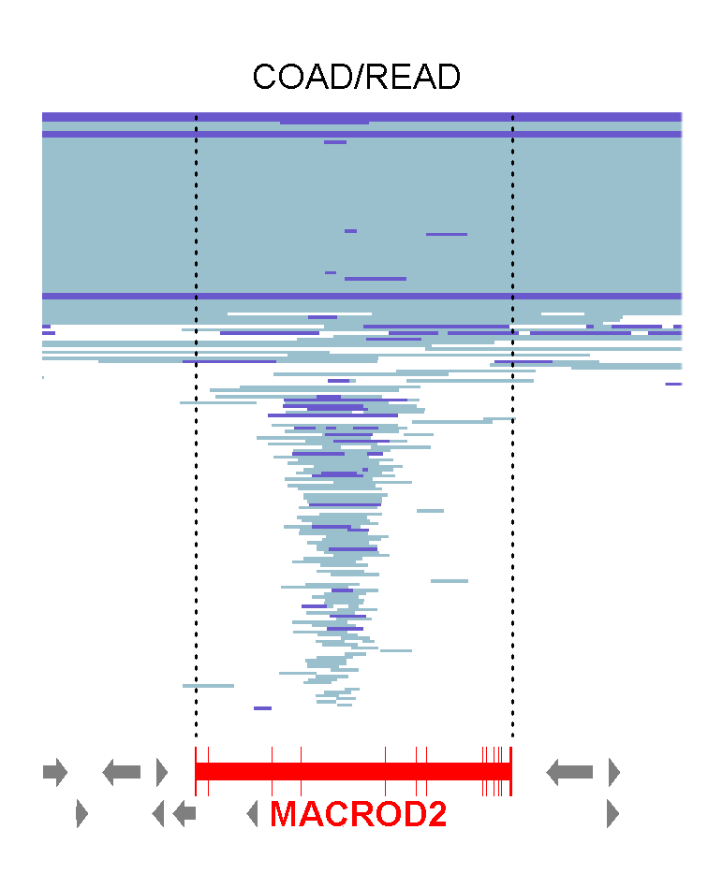

Figure S1. Fine map of deletions at the MACROD2 locus in 616 TCGA-analyzed CRC cancers (COAD/READ). SNP array segmentation map showing the area surrounding MACROD2 on chromosome 20. Cases are sorted by region of loss at the MACROD2 locus; heterozygous (light blue bars) and homozygous (dark blue bars) deletions are labelled. Position and exons of the MACROD2 gene are indicated (red bars). Surrounding genes are indicated with grey arrows.
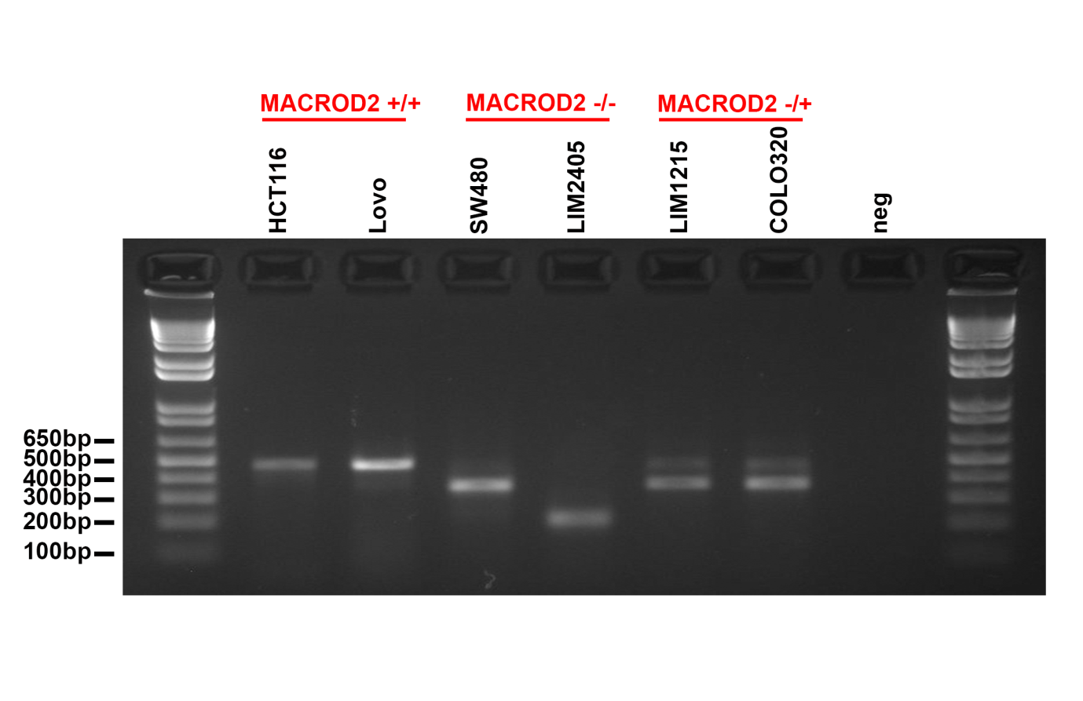
Figure S2. Representative gel image of MACROD2 mRNA transcripts detected in MACROD2 wild-type (LOVO, HCT116), heterozygous deleted (LIM1215, COLO320) and homozygous deleted (SW480, LIM2405) CRC cells. Wild-type fragment (exon 3-9) = 491bp.

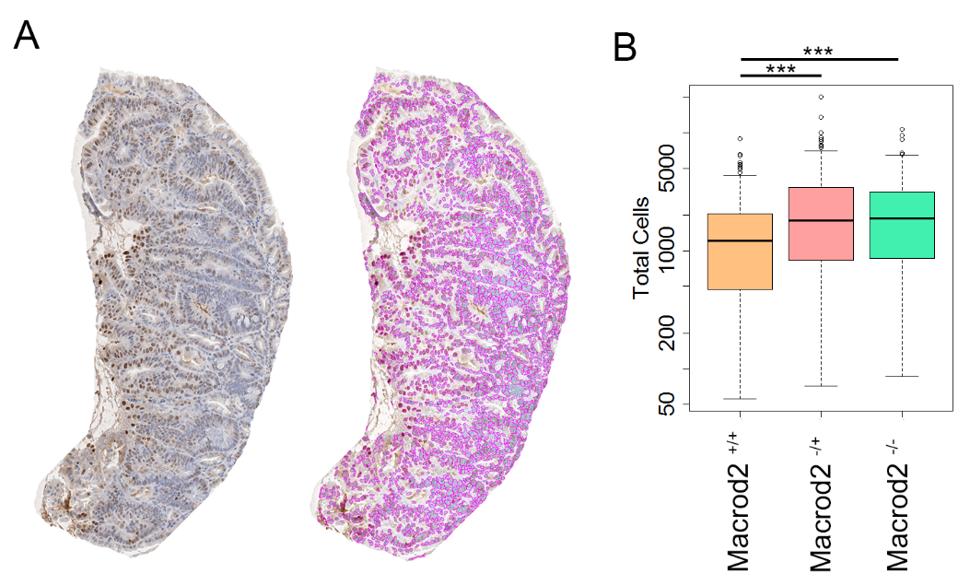

Figure S3. MACROD2 deficiency enhances intestinal tumorigenesis in Apc^{Min/+} mice (A) Representative adenoma section from the small intestine of an Apc^{Min/+}/Macrod2^{-/-} mouse stained with hematoxylin and eosin, and detection of neoplastic cells using image analysis. (B) Quantification of the number of neoplastic cells per adenoma, shown as boxplots. *** p<0.001 (Student’s t test).

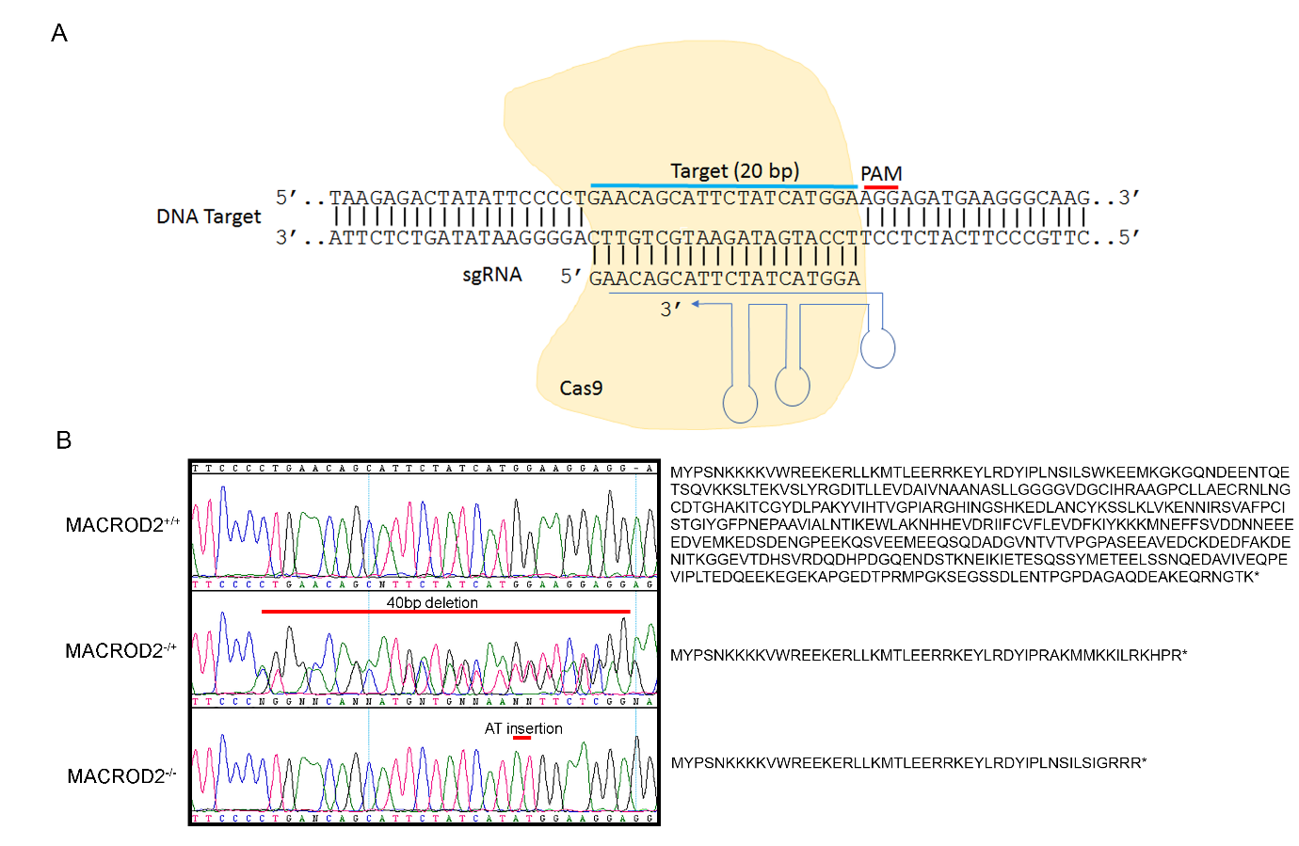

Figure S4. Generation of isogenic HCT116-MACROD2^{-/-}, HCT116-MACROD2^{-/+} and HCT116-MACROD2^{+/+} cells using CRISPR/Cas9 technology. (A) Schematic diagram showing the strategy to disrupt the human MACROD2 gene via CRISPR/Cas9 targeting of exon 2. (B) Sequencing chromatograms for wild-type, heterozygous and homozygous MACROD2 knock-out clones and predicted protein sequences.

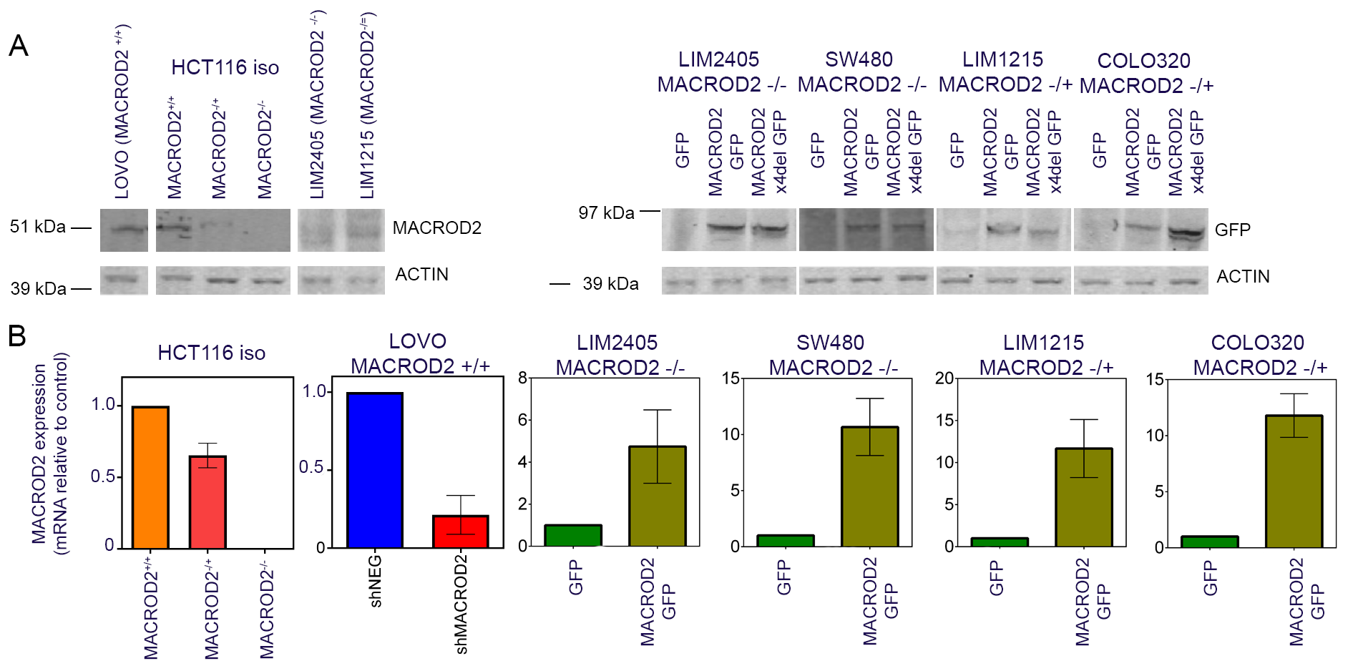

Figure S5. Expression levels of MACROD2 at endogenous levels and for GFP-tagged rescue constructs in isogenic MACROD2 knock-out (HCT116) and MACROD2 homozygous (LIM2405, SW480) and heterozygous (LIM1215, COLO320) deleted cell lines. (A) MACROD2 protein levels detected by western blot with anti-MACROD2 antibody (endogenous proteins) or anti-GFP antibody (overexpressed proteins). Actin was used as loading control. Endogenous MACROD2 = 52kDa, MACROD2 GFP = 79 kDa, MACROD2 x4del GFP = 78 kDa. (B) MACROD2 transcript levels detected using qRT-PCR relative to HMBS transcript levels and normalized to control for the indicated cell lines.

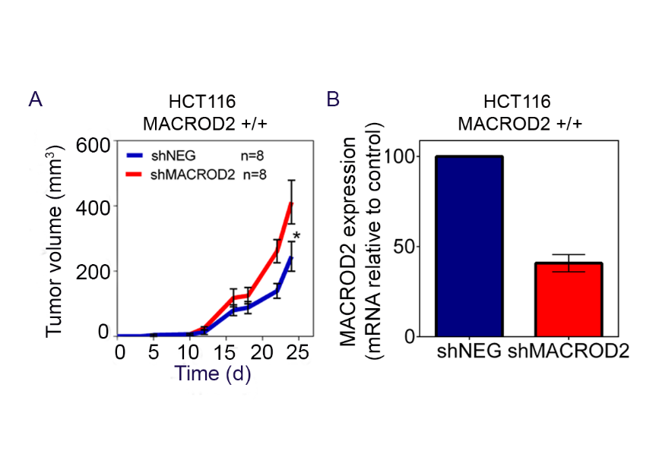
Figure S6. MACROD2 deficiency enhances tumor xenograft growth of human CRC cell lines. (A) Human tumor xenograft establishment rate and growth in CBA athymic nude mice injected subcutaneously with HCT116-MACROD2^{+/+} cells stably transfected with shRNA-MACROD2 or shRNA-control. Data are means ± SEM of 12 tumors per condition representative of duplicate experiments. *p<0.05 (Compare Groups of Growth Curves test). (B) Quantification of MACROD2 mRNA expression levels relative to HMBS and normalized to control in HCT116 knock-down and control cells detected using qRT-PCR prior to injection.

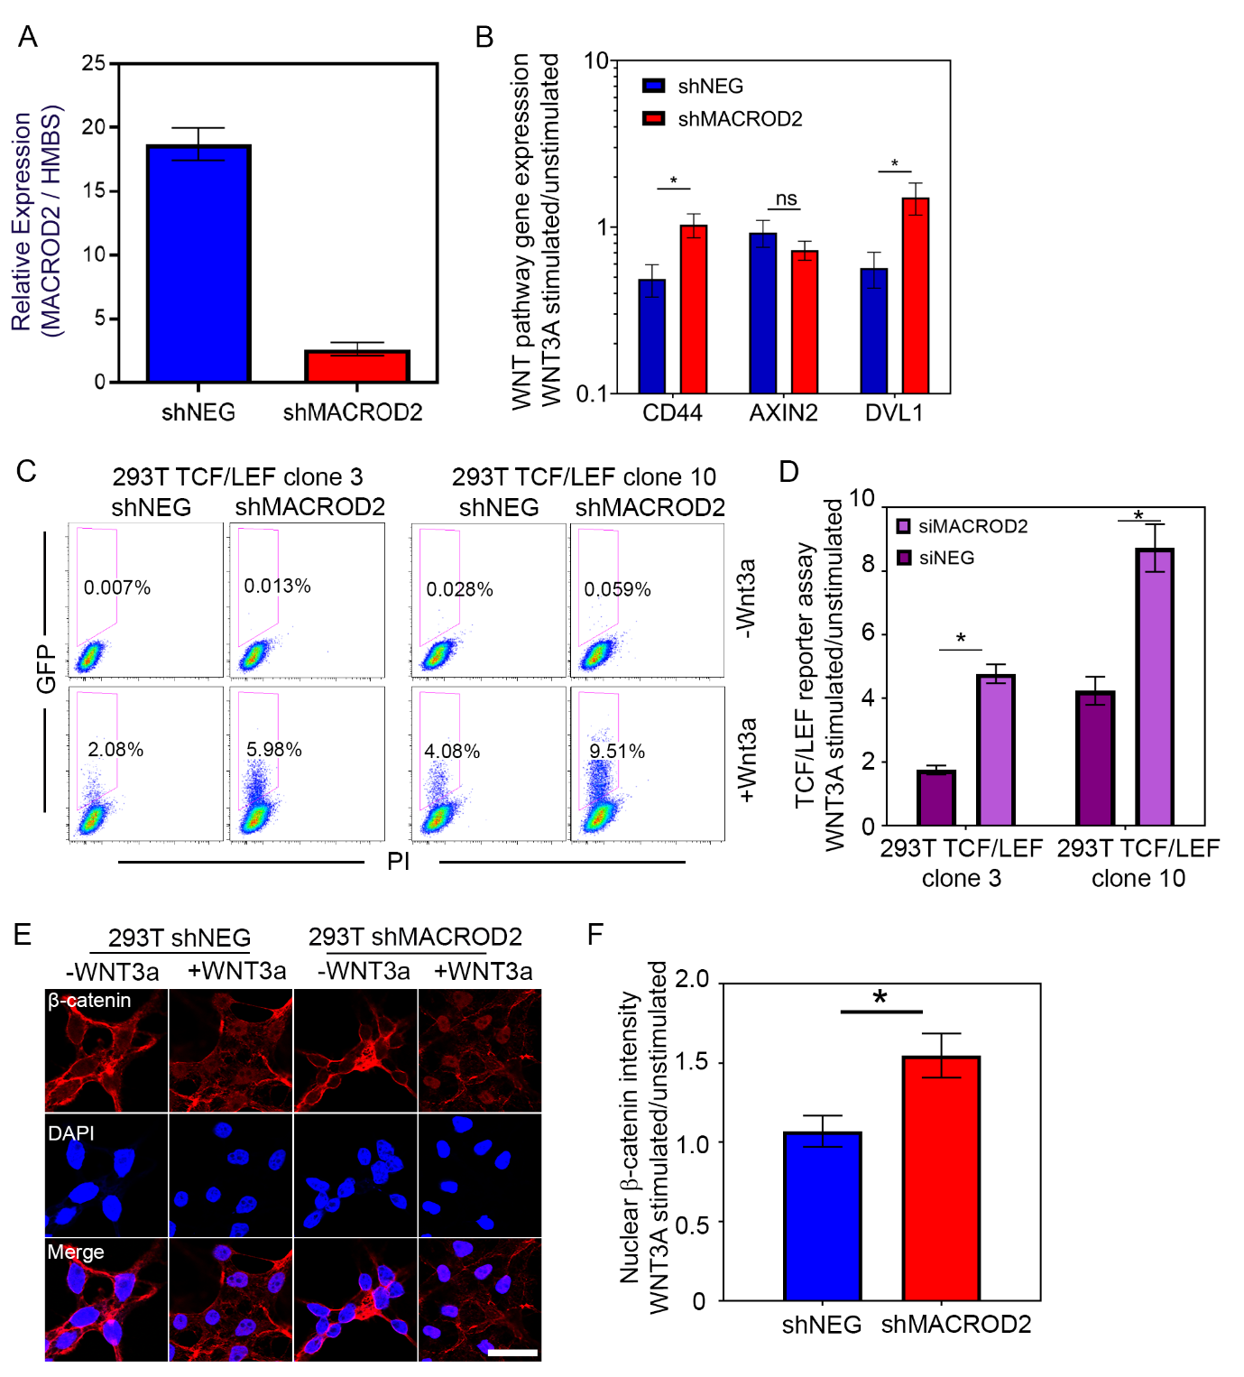

Figure S7. MACROD2 deficiency affects WNT signaling in APC and β-catenin wild-type HEK293T cells. (A) Quantification of MACROD2 mRNA expression levels relative to HMBS in HEK293T knock-down and control cells using qRT-PCR. (B) Induction of WNT target gene expression in response to stimulation with WNT3A for 24 hours. Data are means ± SEM for 6 replicates representative of duplicate experiments. ns, not significant, *p<0.05 (Student’s t test) (C) Representative flow cytometry plots of TCF/LEF reporter activity for two stable HEK293T clones transfected with siRNA-MACROD2 or siRNA-Control in response to WNT3A stimulation for 48 hours. 20,000 events were acquired. (D) Quantification of TCF/LEF reporter activity in response to WNT3A stimulation for 48 hours. Data are means ± SEM for 6 replicates representative of duplicate experiments * p<0.05 (Student’s t-test). (E) Representative immunofluorescence images of β-catenin re-localization in HEK293T knock-down and control cells in response to WNT3A stimulation for 16 hours. β-catenin (red), DAPI (blue) (scale bar, 20 µm). (F) Quantification of nuclear β-catenin re-localization after WNT3A stimulation for 16 hours. Data are means ± SEM of >100 cells representative of duplicate experiments. * p<0.05 (Student’s t-test).

Figure S8. MACROD2 deletion transcripts cloned from CRC cell lines and expressed in HeLa cells. Western blot for GFP-tagged full-length MACROD2, MACROD2Δex1-8, MACROD2Δex4, MACROD2Δex5 and MACROD2Δex4-5 proteins. Presence and absence of the MACROD2 macrodomain and expected protein sizes are indicated.

Figure S9. MACROD2 macrodomain deletion causes repression of PARP1 transferase activity. Incorporation of biotinylated PAR onto histone proteins for isogenic HCT116-MACROD2^{-/-}, HCT116-MACROD2^{-/+} and HCT116-MACROD2^{+/+} cells or LIM2405-MACROD2^{-/-} and LIM1215-MACROD2^{-/+} cells reconstituted with wild-type MACROD2 or GFP control challenged with γ-irradiation (IR, 10 Gy). Data is presented as the mean ± SEM of 6 repeats representative of duplicate experiments. *p<0.05, **p<0.01, ***p<0.001 (Student’s t-test).

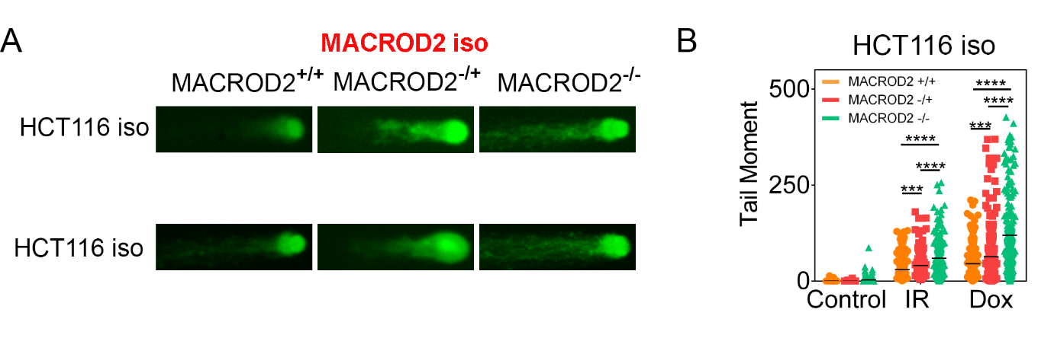
Figure S10. MACROD2 deficiency increases cell sensitivity to genotoxic stress-induced DNA damage. (A) Representative images of γ-irradiation (IR, 10Gy) and doxorubicin (Dox, 0.5µM) induced DNA damage in MACROD2^{+/+}, MACROD2^{-/+} and MACROD2^{-/-} isogenic HCT116 cells, as measured by the neutral comet assay (detects DNA-DSBs). (B) Levels of DNA damaged quantified by the tail moment in the comet assay. All data are means ± SEM for >100 comets of a representative duplicate experiment. ***p<0.001, ****p<0.0001 (Student’s t test).

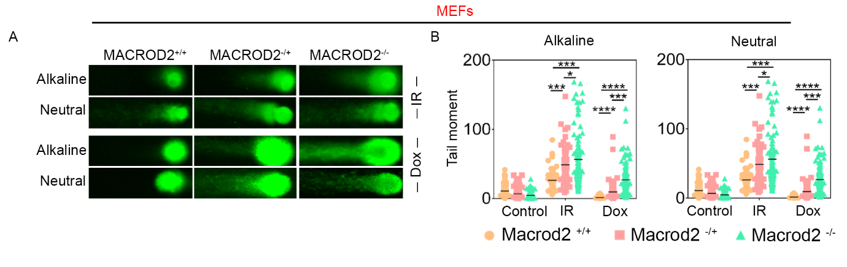
Figure S11. MACROD2 deficiency increases cell sensitivity to genotoxic stress-induced DNA damage. (A) Representative images of γ-irradiation (IR, 10Gy) and doxorubicin (Dox, 0.5µM) induced DNA damage in Macrod2^{+/+}, Macrod2^{-/+} and Macrod2^{-/-} MEF cells, as measured by the alkaline comet assay (detects DNA-SSBs) and neutral comet assay (detects DNA-DSBs). (B) Levels of DNA damaged quantified by the tail moment in the comet assay. Data are presented as the mean ± SEM for >100 comets representative of duplicate experiments. *p<0.05, **p<0.01, ***p<0.001, ****p<0.0001 (Student’s t-test).

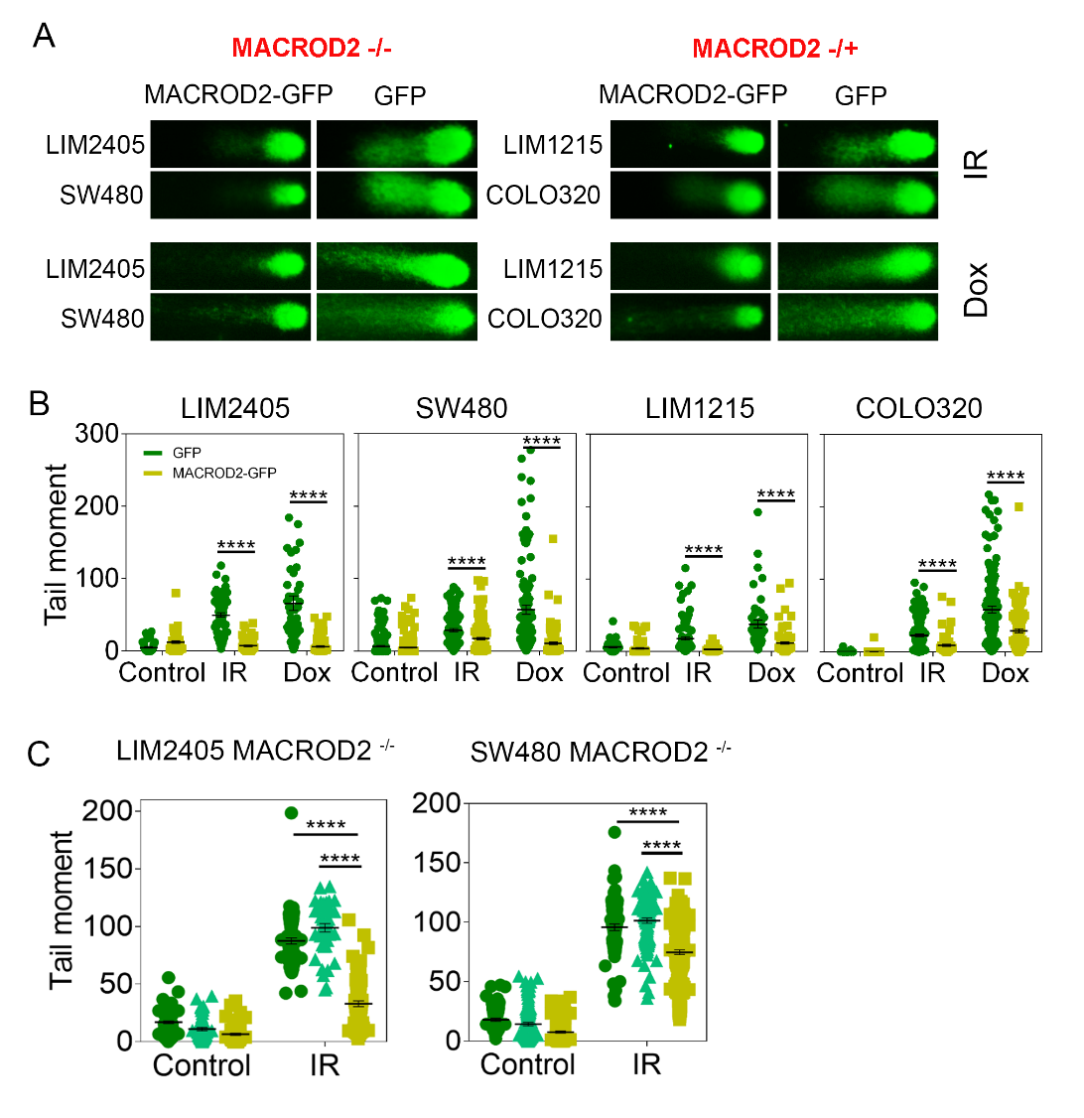
Figure S12. MACROD2 deficiency increases cell sensitivity to genotoxic stress-induced DNA damage. (A) Representative images of IR and Dox induced DNA damage in LIM2405-MACROD2-/-, SW480-MACROD2-/- and LIM1215-MACROD2-/+ or COLO320-MACROD2-/+ cells reconstituted with wild-type MACROD2 or GFP control, as measured by the neutral comet assay. (B) Levels of DNA damaged quantified by the tail moment in the comet assay. (C) Reconstitution of MACROD2 deleted cell lines with MACROD2Δex4 protein lacking the macrodomain did not rescue MACROD2 loss associated DNA repair defects. Levels of γ-irradiation (IR, 10Gy) induced DNA damaged quantified by the tail moment in LIM2405-MACROD2^{-/-} and SW480-MACROD2^{-/-} cells reconstituted with MACROD2Δex4 protein, wild-type MACROD2 or GFP control, as measured by the alkaline comet assay. Data are means ± SEM for >100 comets of a representative duplicate experiment. ****p<0.0001 (Student’s t test)
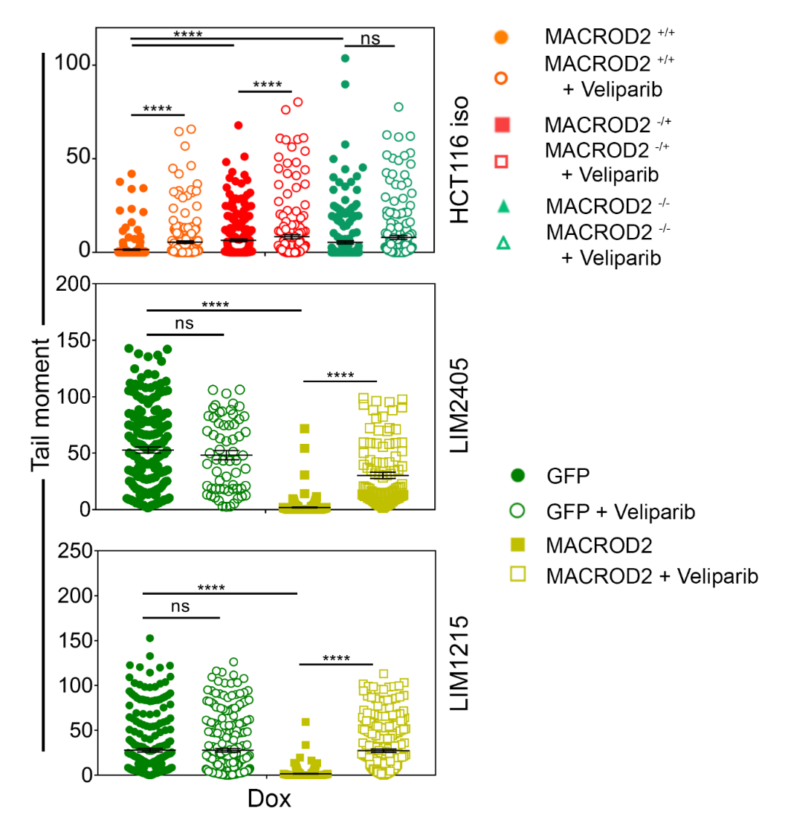
Figure S13. Pharmacological inhibition of PARP1 in MACROD2^{+/+}, MACROD2^{-/+} and MACROD2^{-/-} isogenic HCT116 cells and LIM2405-MACROD2^{-/-} and LIM1215-MACROD2^{-/+} reconstituted with wild-type MACROD2 or GFP control. Cells were treated with γ-irradiation (IR, 10Gy), doxorubicin (Dox, 0.5µM) and/or veliparib (1µM) as indicated. DNA damage was measure using the alkaline comet assay and quantified by the tail moment. Data are presented as the mean ± SEM for >100 comets representative of duplicate experiments. ns, not significant; ****p<0.0001, Student’s t-test.

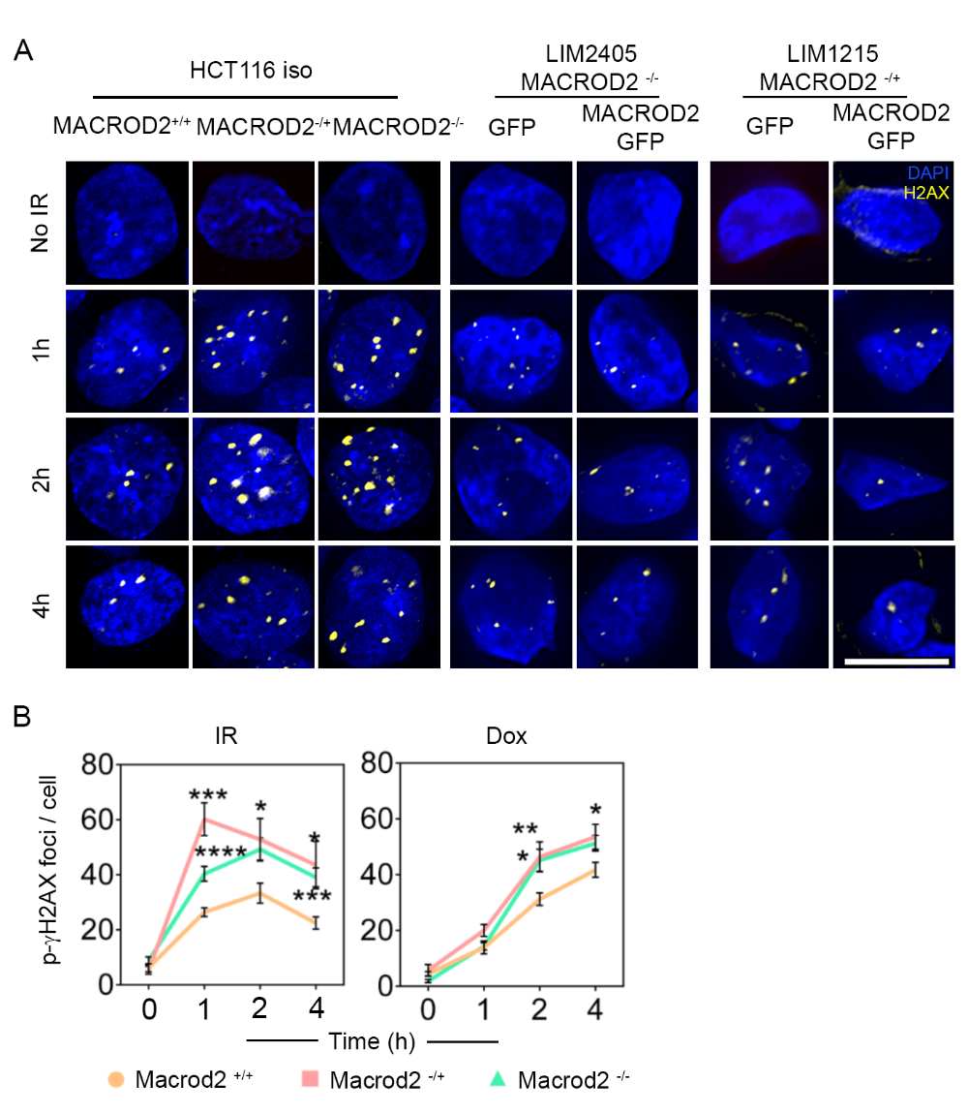
Figure S14. MACROD2 deficiency increases cell sensitivity to genotoxic stress-induced DNA damage as measured by γ-H2AX foci. (A)Representative images of γ-H2AX foci in isogenic HCT116-MACROD2^{-/-}, HCT116-MACROD2^{-/+} and HCT116-MACROD2^{+/+} cells or LIM2405-MACROD2^{-/-} and LIM1215-MACROD2^{-/+} cells reconstituted with wild-type MACROD2 or GFP control. Cells were subject to IR (2Gy), collected at the times indicated and immunostained with anti-γH2AX antibody (yellow) and DAPI (blue) (scale bar, 20µm). (B) Quantification of the number of γ-H2AX foci for IR or treatment with doxorubicin in in Macrod2^{+/+}, Macrod2^{-/+} and Macrod2^{-/-} MEF cells (> 80 cells). Data are means ± SEM for a representative duplicate experiment. *p<0.05, **p<0.01, ***p<0.001, ****p<0.0001 (Student’s t-test).

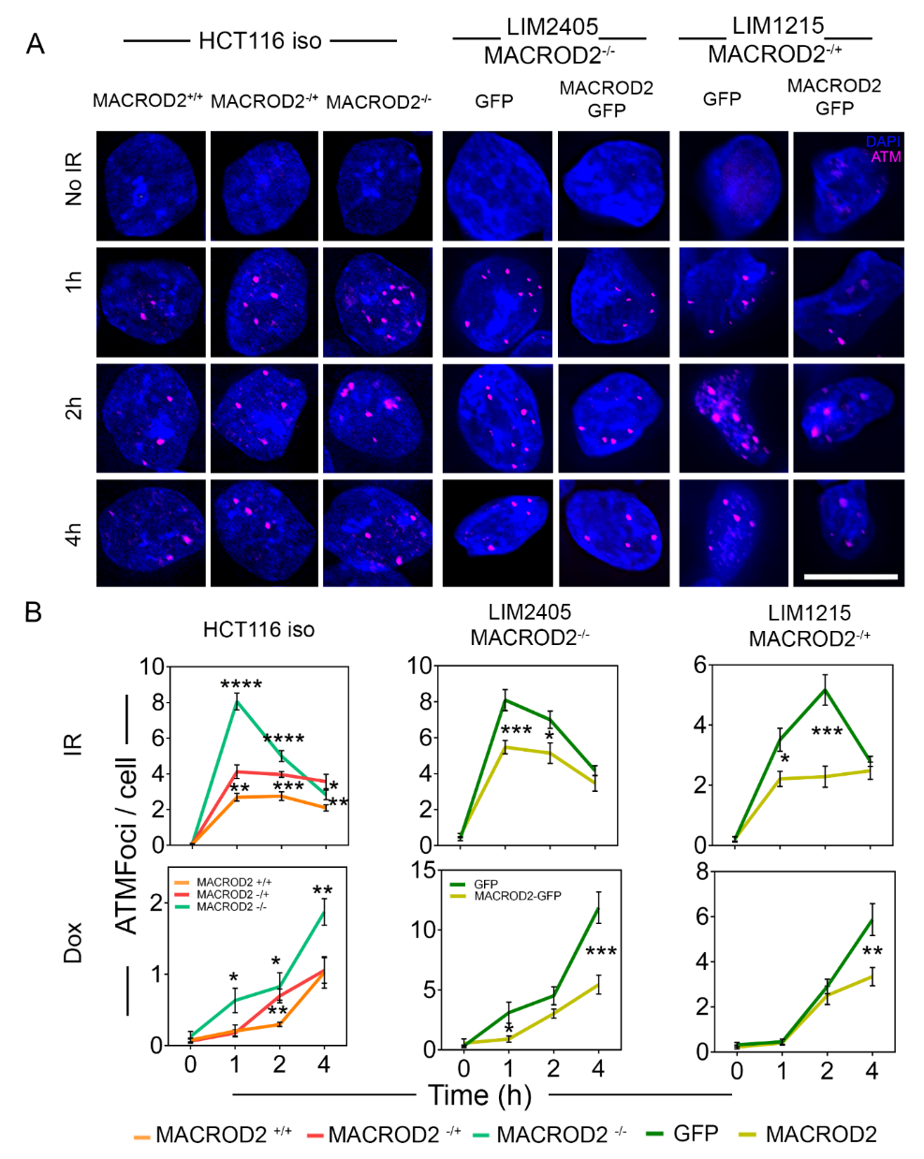
Figure S15. MACROD2 deficiency increases cell sensitivity to genotoxic stress-induced DNA damage as measured by p-ATM foci. (A) Representative images of p-ATM foci in isogenic HCT116-MACROD2^{-/-}, HCT116-MACROD2^{-/+} and HCT116-MACROD2^{+/+} cells or LIM2405-MACROD2^{-/-} and LIM1215-MACROD2^{-/+} cells reconstituted with wild-type MACROD2 or GFP control. Cells were subject to IR (2Gy), collected at the times indicated and immunostained with anti-pATM (red) and DAPI (blue) (scale bar, 20µm). (B) Quantification of the number of pATM foci for IR or treatment with doxorubicin (Dox, 0.5µM) in > 80 cells for the indicated CRC cell lines. Data are means ± SEM for a representative duplicate experiment. *p<0.05, **p<0.01, ***p<0.001, ****p<0.0001 (Student’s t test).
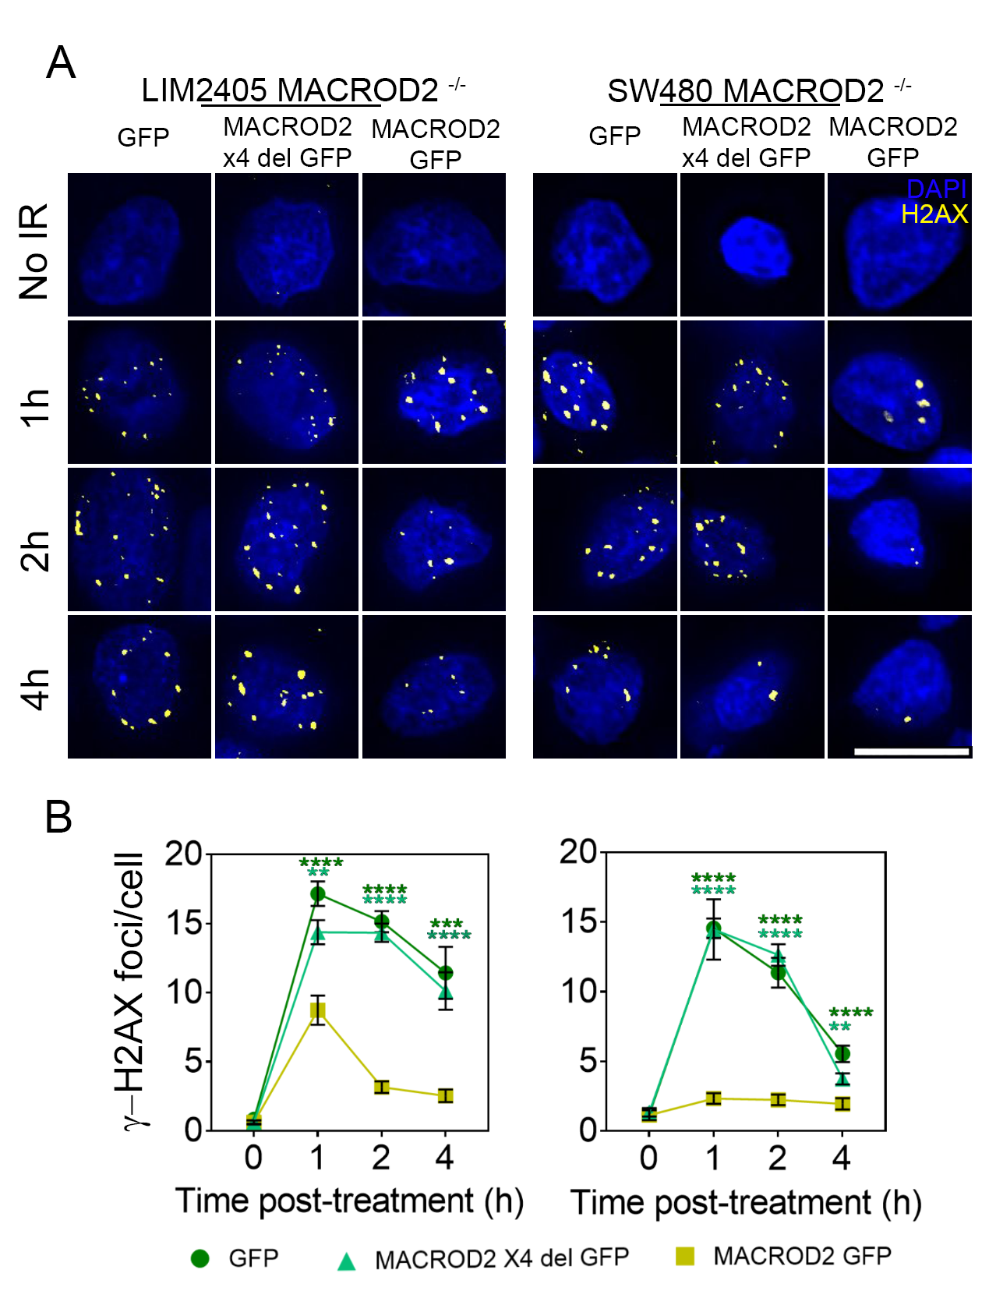
Figure S16. Reconstitution of MACROD2 deleted cell lines with MACROD2Δex4 protein lacking the macrodomain did not rescue MACROD2 loss associated DNA repair defects as measured by γ-H2AX foci. (A) Representative images of γ-H2AX foci. Cells were subject to IR (2Gy), collected at the times indicated and immunostained with anti-γ-H2AX (yellow) and DAPI (blue) (scale bar, 20µm). (B) Quantification of the number of γ-H2AX foci for IR in > 80 cells. Data are means ± SEM for a representative duplicate experiment. **p<0.01, ***p<0.001, ****p<0.0001 (Student’s t test).

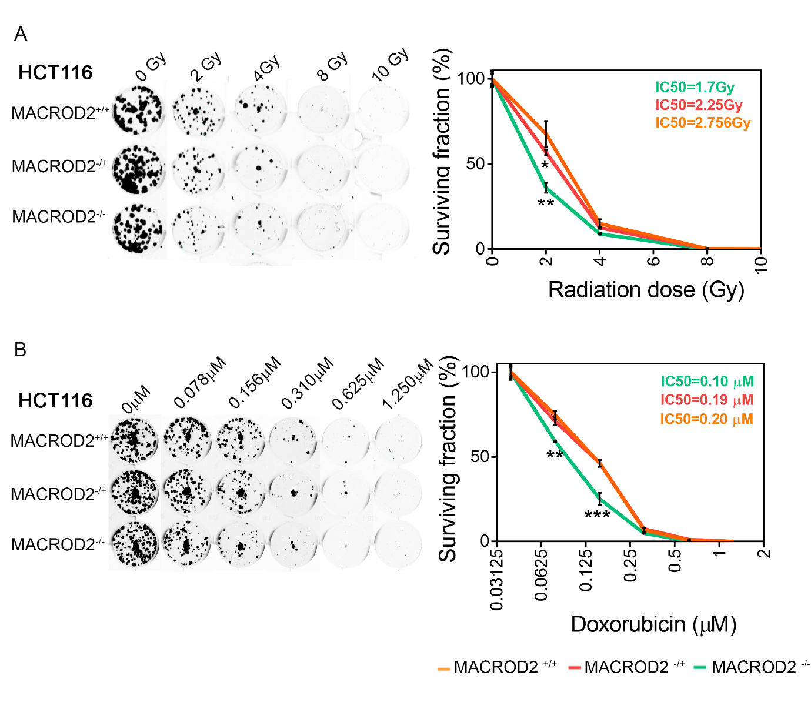
Figure S17. Clonogenic assays for isogenic HCT116-MACROD2^{-/-}, HCT116-MACROD2^{-/+} and HCT116-MACROD2^{+/+} cells treated with γ-irradiation or doxorubicin at the indicated concentrations. Representative images of colony formation and plots of surviving fraction over concentration ranges are shown. *p<0.05, **p<0.01, ***p<0.001 (Student’s t test).

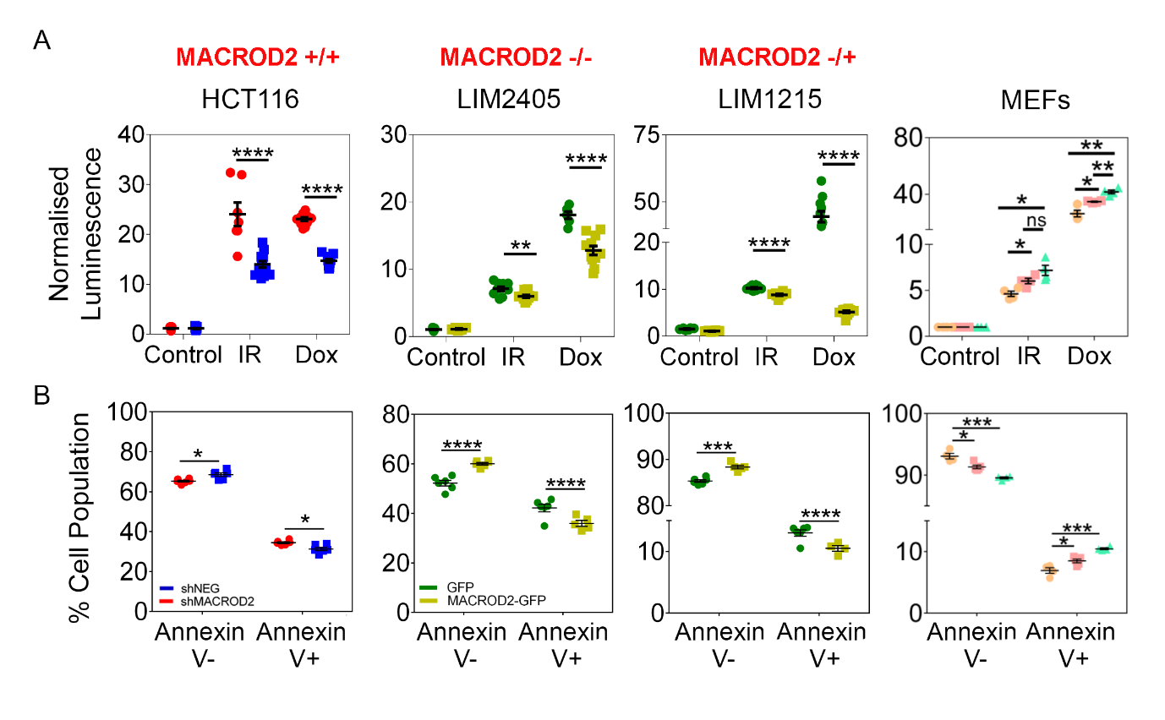
Figure S18. MACROD2 deficiency increases cell sensitivity to DNA damage induced apoptosis in HCT116-MACROD2^{+/+} cells expressing MACROD2-shRNA or Control-shRNA, and in LIM2405-MACROD2^{-/-} and LIM1215-MACROD2^{-/+} cells reconstituted with wild-type MACROD2 or GFP control and Macrod2 MEFs (A) Caspase 3/7 activity at 72 hrs post γ-irradiation (IR, 10Gy) or doxorubicin (Dox, 0.5 µM) treatment as measured by the Caspase-Glo® 3/7 Assay and (B) proportion of Annexin V positive cells at 24 hrs post IR as measured by flow cytometry. Data are means ± SEM of 12 replicates of a representative duplicate experiment for Caspase assay and means ± SEM of 4 replicates of a triplicate experiment for Annexin V flow cytometry. *p<0.05, **p<0.01, ***p<0.001, ****p<0.0001 (Student’s t test).

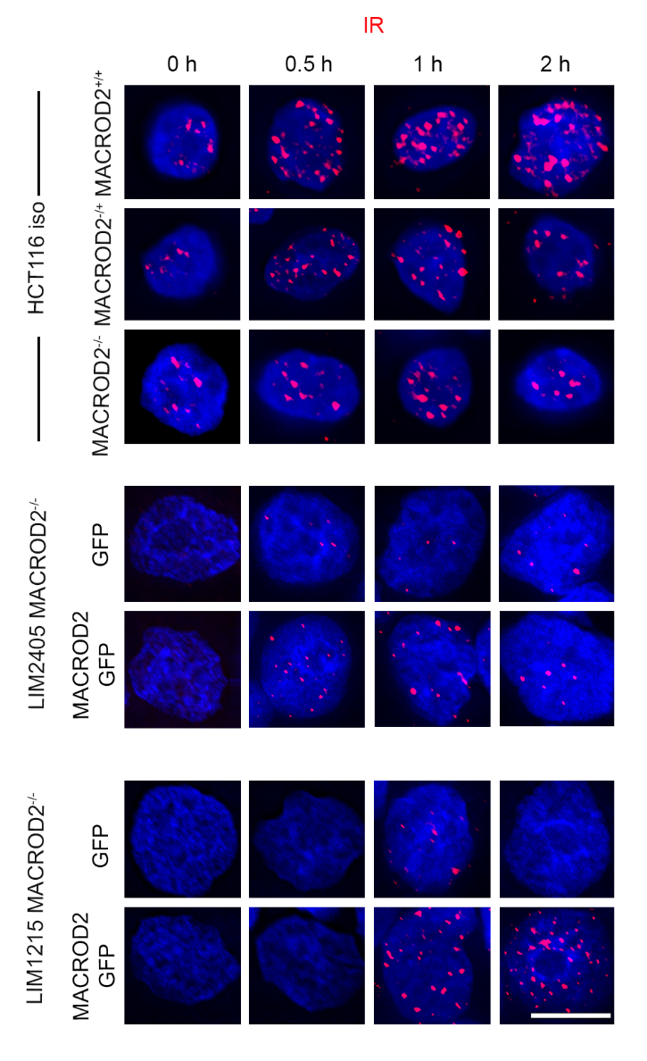
Figure S19. Representative images of BRCA1 foci in isogenic HCT116-MACROD2^{-/-}, HCT116-MACROD2^{-/+} and HCT116-MACROD2^{+/+} cells or LIM2405-MACROD2^{-/-} and LIM1215-MACROD2^{-/+} cells reconstituted with wild-type MACROD2 or GFP control. Cells were subject to IR (2Gy), collected at the times indicated and immunostained with anti-BRCA1 antibody (pink) and DAPI (blue) (scale bar, 20µm).

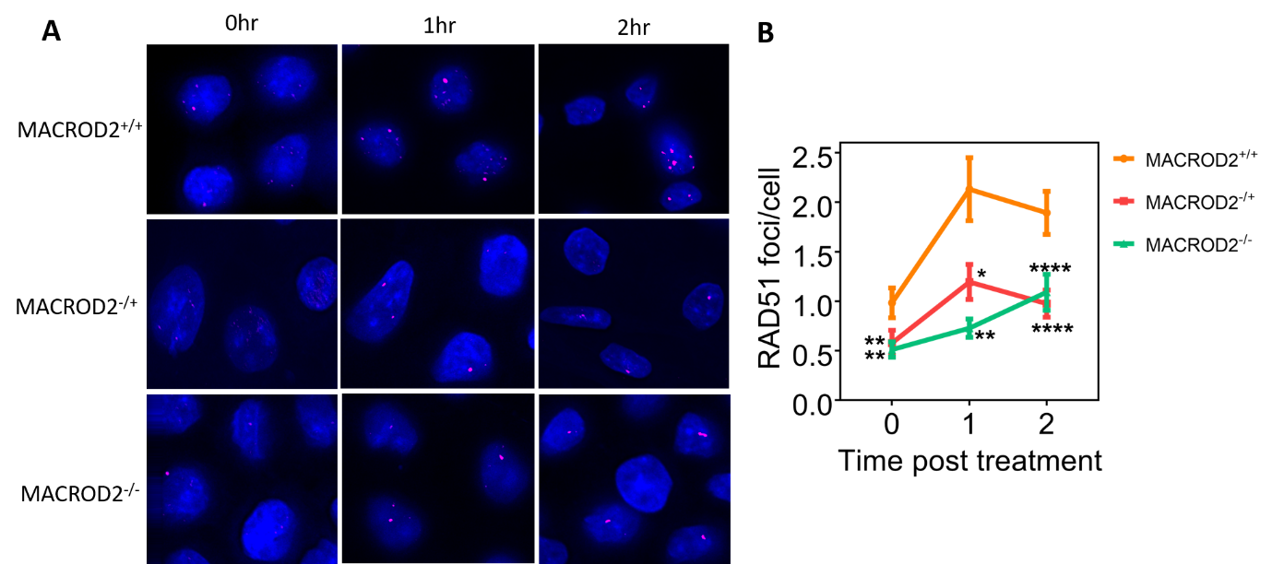

Figure S20. Representative images (A) and quantification (B) of RAD51 foci in isogenic HCT116-MACROD2^{-/-}, HCT116-MACROD2^{-/+} and HCT116-MACROD2^{+/+} cells. Cells were subject to IR (2Gy), collected at the times indicated and immunostained with anti-RAD51 antibody (pink) and DAPI (blue) (scale bar, 20µm). Quantification of the number of RAD51 foci is for >80 cells; data are means ± SEM. *p<0.05, **p<0.01, ***p<0.001, ****p<0.0001 (Student’s t test).

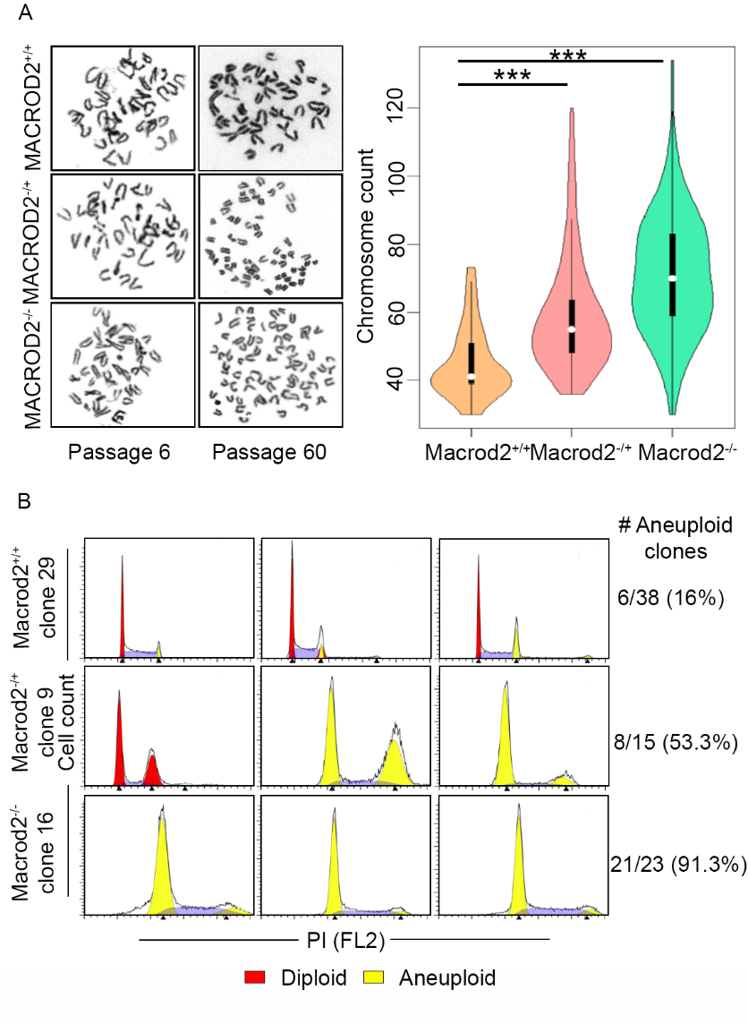
Figure S21. MACROD2 deficiency promotes chromosome instability. (A) Metaphase analyses for Macrod2^{-/-}, Macrod2^{-/+} and Macrod2^{+/+} MEF cells showing representative spreads at passage 6 and 60 and violin plots summarizing chromosome counts (>50 metaphases per genotype). ***p<0.001 (Levene's test). (B) Flow cytometry analysis for DNA content (Red = diploid, Yellow = aneuploid) of single cell clones from Macrod2^{-/-}, Macrod2^{-/+} and Macrod2^{+/+} MEF cells at passage 60. Representative plots shown.

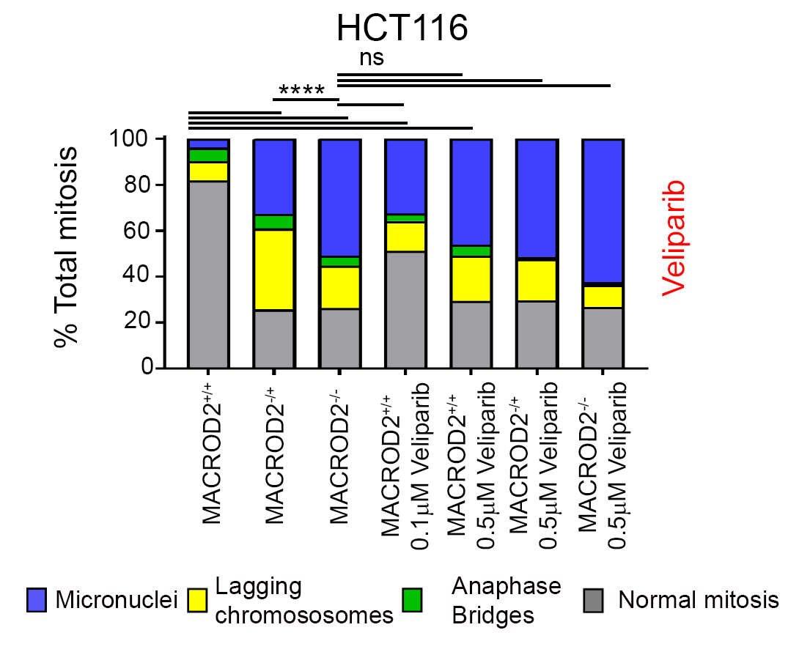
Figure S22. MACROD2 deficiency promotes chromosome instability. Quantification of segregation errors for isogenic HCT116-MACROD2^{-/-}, HCT116-MACROD2^{-/+} and HCT116-MACROD2^{+/+} cells with/without veliparib treatment at the indicated concentrations. HCT116 cells were stained with DAPI, CENP-A and β-tubulin. Data is representative of triplicate experiments with 150 mitotic events scored. ns, not significant; ****p<0.0001 (Student’s t test).

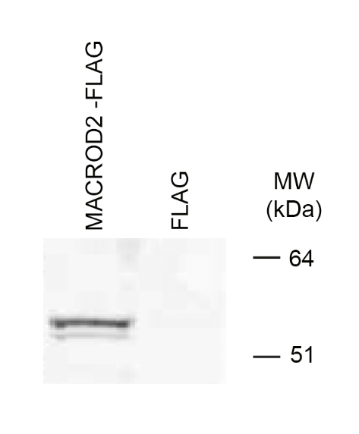
Figure S23. Validation of specificity of immunopurified anti-MACROD2 antibody by western blot using HeLa cells transfected with FLAG-MACROD2 fusion protein.

