Efficacy of BGJ398, a fibroblast growth factor receptor (FGFR)1–3 inhibitor, in patients with previously treated advanced urothelial carcinoma with FGFR3 alterations
Sumanta K. Pal et al.

Supplementary Material

Mutation Patterns in cfDNA and Tumor Samples
Mutation patterns in cfDNA were compared with those in matched tumor samples. Tumor mutations that were not detected in cfDNA were shown to have a low allele fraction in the tumor. cfDNA was also analyzed to investigate whether it was possible to predict tumor heterogeneity. Internal assay validation showed that mutations in cfDNA with at least a 5% allele fraction were likely to be a true positive for this mutation in the tumor.

Supplementary Tables

Supplementary Table S1. Response to prior immunotherapy in patients receiving BGJ398.

Patient ID | Best Overall Response to BGJ398 | Best Percent Change from Baseline in Size of Target Lesion (%) | Time on BGJ398 Treatment (months) | Best Overall Response to Immunotherapy | Time on Immunotherapy (months)
1 | SD (uPR) | -36.40 | 2.201 | PD | 2.858
2 | SD | -2.90 | 5.257 | Not available | 1.281
3 | SD | -23.20 | 4.600 | SD | 5.290
4* | SD | 16.80 | 3.187 | PD | 0.690
5* | PD | UNK | 0.657 | PD | 5.092
6 | SD (uPR) | -77.80 | 3.220 | SD | 8.969
7 | PD | 32.70 | 1.840 | PD | 3.548
8 | PD | 0.00 | 1.840 | PD | 4.501
9 | SD (uPR) | -38.90 | 3.680 | PD | 14.587
10 | SD (uPR) | -31.00 | 6.735 | PD | 3.548
11 | UNK | 13.70 | 0.657 | SD | 1.380
- *For patients who had 2 prior immunotherapies, the longer time on immunotherapy is presented.
-uPR=unconfirmed Partial Response; SD=Stable Disease; PD=Progressive Disease; UNK=Unknown

Supplementary Figures
Figure S1. Genetic alterations at baseline, as identified using Foundation Medicine next-generation sequencing, and response to BGJ398
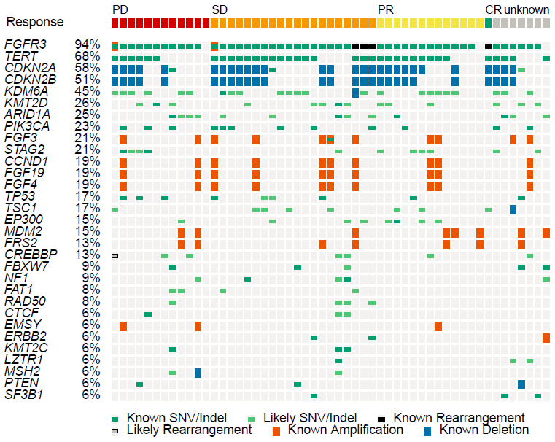
CR, complete response; PD, disease progression; PR, partial response; SD, stable disease; SNV, single nucleotide variant

Figure S2. Detectable TMB in cfDNA for all samples with detectable FGFR3 mutations. Patients are sorted by the lowest TMB across all timepoints. All patients with a PR had a TMB of less than 15/Mb, as indicated by the horizontal line.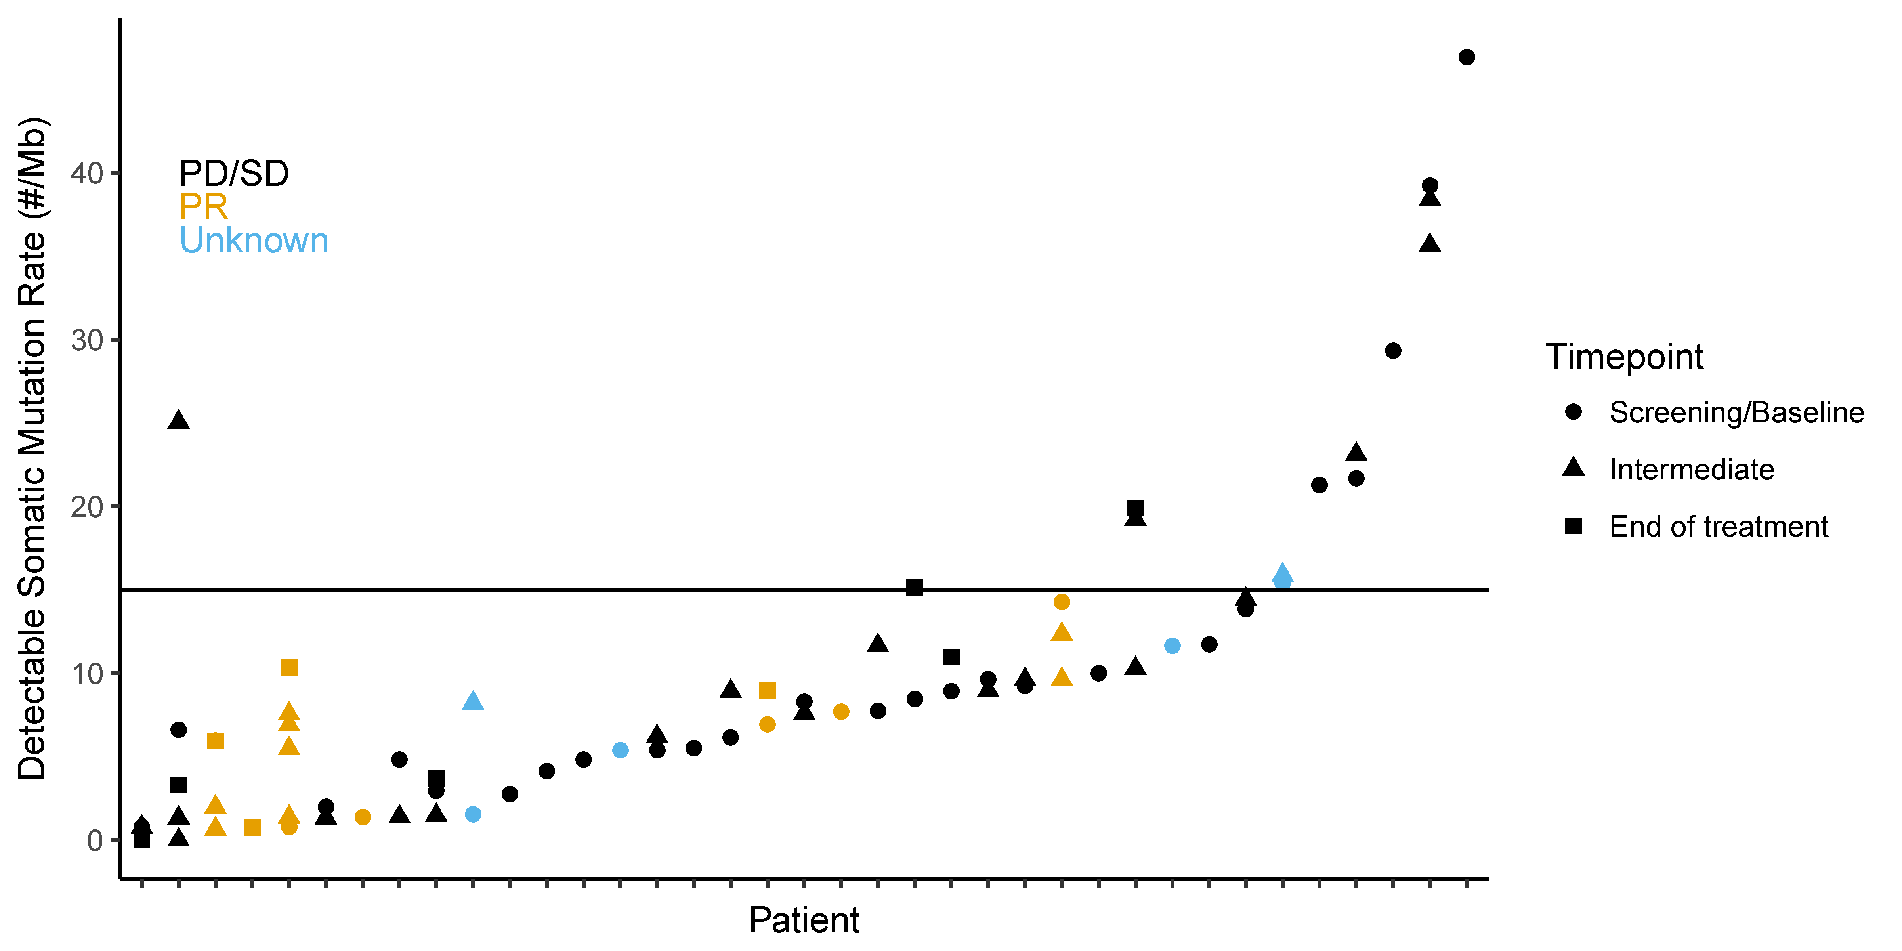
cfDNA, cell-free DNA; PD, progressive disease; PR, partial response; SD, stable disease; TMB, tumor mutational burden

