**Supplementary Table S1.** Anti-PD-1/L1 treatment experience by SD-101 dose group.

|  |  |  |  |  |  |
| --- | --- | --- | --- | --- | --- |
| **Prior anti-PD-1/L1 treatment experience** | **SD-101 Dose** | | | |  |
| **1 mg**  **(N = 6)** | **2 mg**  **(N = 5)** | **4 mg**  **(N = 5)** | **8 mg**  **(N = 6)** | **Total(N = 22)** |
| Naive to prior anti-PD-1/L1 therapy | 3 | 4 | 1 | 1 | 9 |
| Received prior anti-PD-1/L1 therapy | 3 | 1 | 4 | 5 | 13 |

**Supplementary Table S2.** Overview of safety.

|  |  |  |  |  |  |
| --- | --- | --- | --- | --- | --- |
| **Event, n(%)** | **SD-101 Dose** | | | | **Total**  **(N = 22)** |
| **1 mg**  **(N = 6)** | **2 mg**  **(N = 5)** | **4 mg**  **(N = 5)** | **8 mg**  **(N = 6)** |
|  | **n (%)** | **n (%)** | **n (%)** | **n (%)** | **n (%)** |
| All TEAEs | 6 (100) | 5 (100) | 5 (100) | 6 (100) | 22 (100) |
| Grade 3-4 | 3 (50) | 4 (80) | 1 (20) | 4 (67) | 12 (55) |
| irAEs | 2 (33) | 1 (20) | 0 | 0 | 3 (14) |
| TEAEs related to SD-101 | 6 (100) | 5 (100) | 5 (100) | 5 (83) | 21 (96) |
| Grade 3-4 | 3 (50) | 2 (40) | 1 (20) | 0 | 6 (27) |
| TEAEs related to pembrolizumab | 6 (100) | 5 (100) | 5 (100) | 5 (83) | 21 (96) |
| Grade 3-4 | 2 (33) | 2 (40) | 1 (20) | 0 | 5 (23) |
| AEs leading to d/c of SD-101 | 1 (17) | 0 | 1 (20) | 1 (17) | 3 (14) |
| AEs leading to d/c of pembrolizumab | 1 (17) | 2 (40) | 0 | 1 (17) | 4 (18) |
| AEs leading to d/c of either or both drugs | 1 (17) | 2 (40) | 1 (20) | 1 (17) | 5 (23) |
| Dose limiting toxicities | 0 | 0 | 0 | 0 | 0 |
| SAEs | 1 (17) | 4 (80) | 1 (20) | 3 (50) | 9 (41) |
| AEs leading to death | 0 | 0 | 0 | 0 | 0 |

d/c = discontinuation; irAE = immune-related adverse event; SAE = serious adverse event; TEAE = treatment-emergent adverse event.

**Supplementary Table S3.** Treatment-related events in 20% or more of patients in the total treatment cohort are presented. The causal relation (related or not related) between study drugs and adverse events was determined by the investigators.

|  |  |  |  |  |  |  |  |  |  |  |  |
| --- | --- | --- | --- | --- | --- | --- | --- | --- | --- | --- | --- |
| **Adverse Event** | **SD-101 Dose** | | | | | | | | **Total**  **(N=22)** | | |
| **1 mg**  **(N=6)** | | **2 mg**  **(N=5)** | | **4 mg**  **(N=5)** | | **8 mg**  **(N=6)** | |
| **Grade 1-2** | **Grade 3-4** | **Grade 1-2** | **Grade 3-4** | **Grade 1-2** | **Grade 3-4** | **Grade 1-2** | **Grade 3-4** | **Grade 1-2** | **Grade 3-4** | **Grade 1-4** |
| **n** | **n** | **n** | **n** | **n** | **n** | **n** | **n** | **n (%)** | **n (%)** | **N (%)** |
| Patients w/ at least 1 event | 3 | 3 | 3 | 2 | 4 | 1 | 5 |  | 15 (68) | 6 (27) | 21 (95) |
| Malaise | 5 | 1 | 4 |  | 4 |  | 3 |  | 16 (73) | 1 (5) | 17 (77) |
| Fatigue | 4 | 1 | 3 | 1 | 3 |  | 5 |  | 15 (68) | 2 (9) | 17 (77) |
| Headache | 3 | 1 | 4 | 1 | 4 |  | 4 |  | 15 (68) | 2 (9) | 17 (77) |
| Chills | 2 | 2 | 2 | 1 | 5 |  | 5 |  | 14 (64) | 3 (14) | 17 (77) |
| Myalgia | 2 | 2 | 4 | 1 | 4 |  | 3 |  | 13 (59) | 3 (14) | 16 (73) |
| Injection site erythema | 1 |  | 3 |  | 4 | 1 | 4 |  | 11 (50) | 1 (5) | 12 (55) |
| Pyrexia | 1 |  | 3 |  | 1 |  | 3 |  | 8 (36) |  | 8 (36) |
| Influenza-like illness |  |  |  |  | 4 |  | 1 |  | 5 (23) |  | 5 (23) |
| Nausea | 3 |  | 1 |  | 1 |  |  |  | 5 (23) |  | 5 (23) |
| Injection site pain | 1 | 2 |  | 1 | 2 |  | 1 |  | 4 (18) | 3 (14) | 7 (32) |
| Injection site swelling | 1 | 1 | 2 |  |  |  | 1 |  | 4 (18) | 1 (5) | 5 (23) |

**Supplementary Figure S1.**Percent change from baseline over time in tumors in patientswho werenaïve to anti-PD-1/L1 therapy. Decreases in tumor size were seen in nearly all presented patients. **A.** Injected tumors. **B.** Non-injected tumors. **C.** Subcutaneous tissues. **D.** Lung.

**A.**

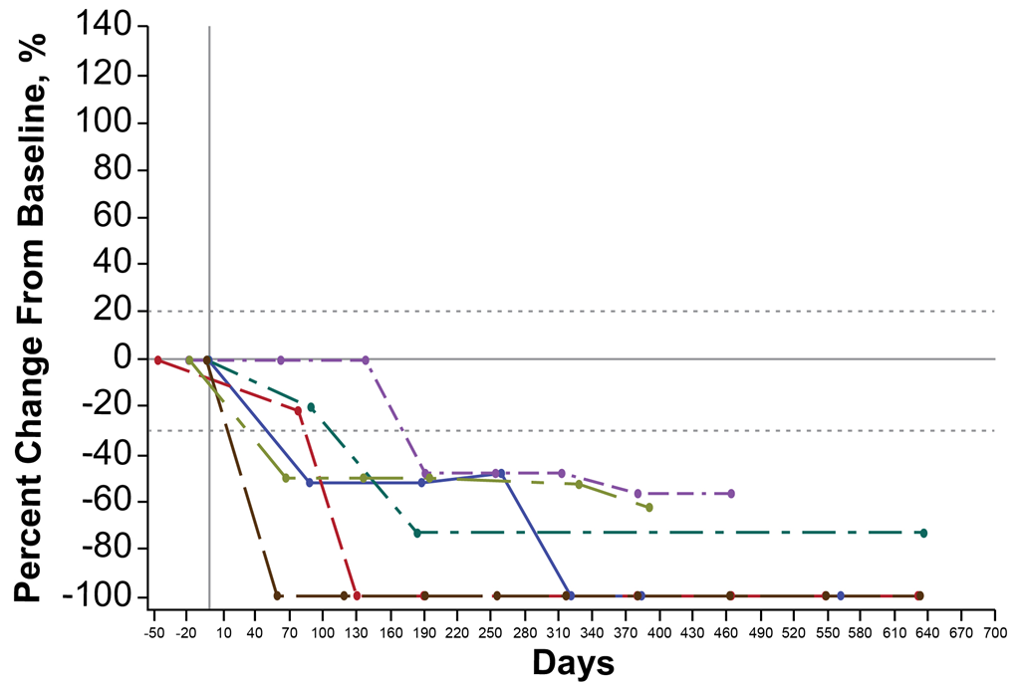

**B.**

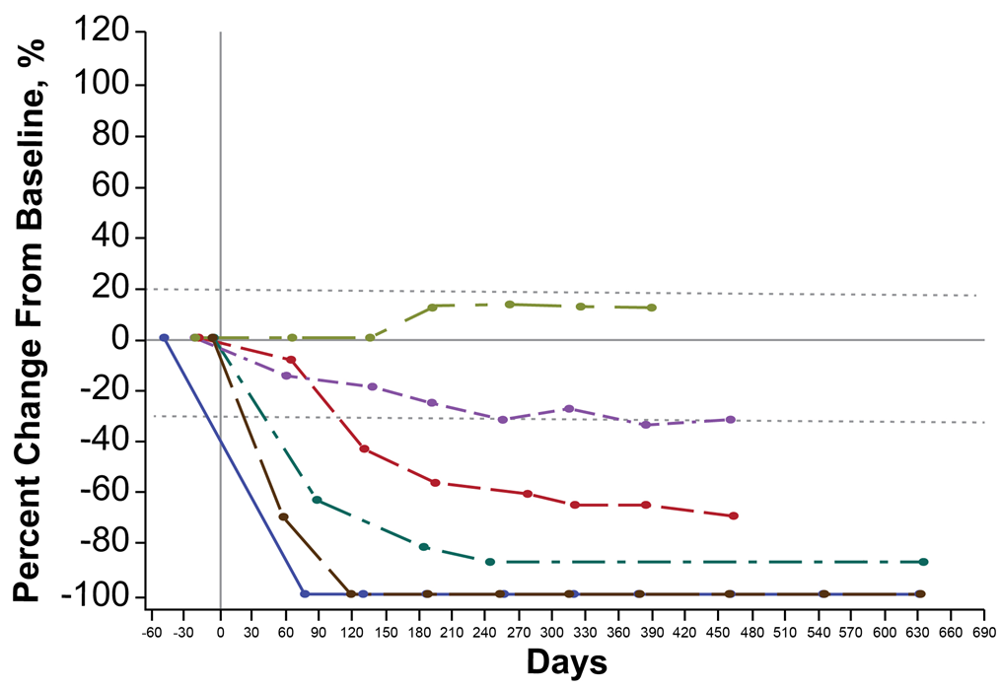

**C.**

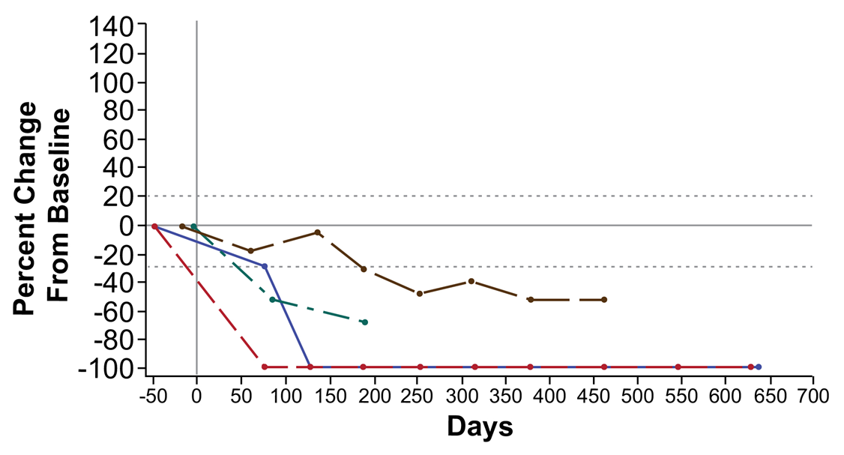

**D.**

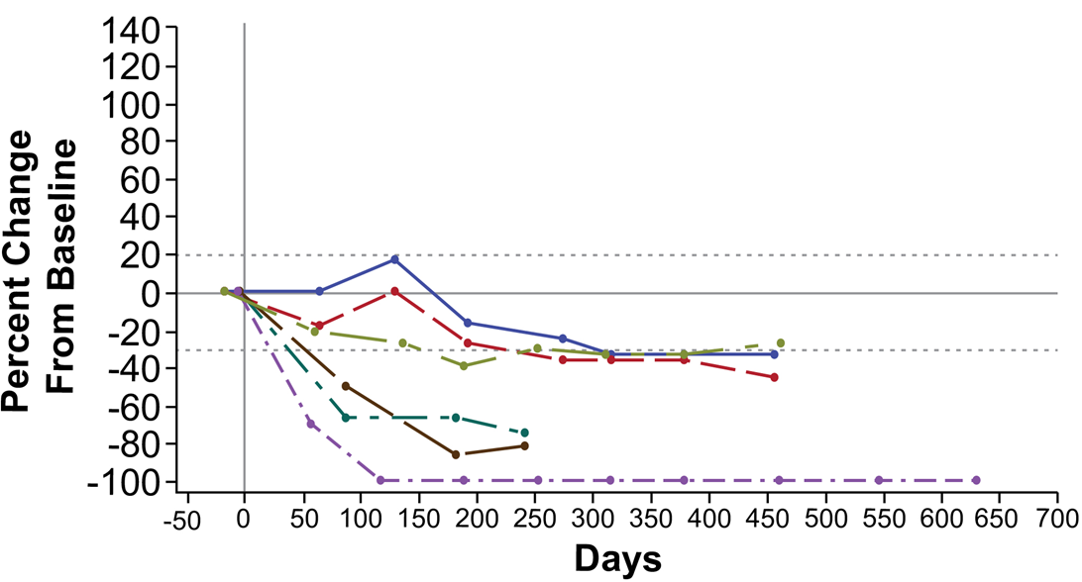

**Supplementary Figure S2.** IFN gene signature in Blood Cells. The expression of the 4 interferon (IFN)-alpha responsive genes (GBP1, IFIT2, CCL2, and MX2) was assessed at baseline (Day 1) and Day 9, 24 hours after injection with SD-101. Activity is represented as the geometric mean of the relative Ct of the 4 genes. Target engagement was seen at all dose levels and is dose-related.



**Supplementary Figure S3.** RNA gene expression profiling.

Administration of SD-101 and pembrolizumab results in an influx of immune cells into the tumor microenvironment. The immunophenotype of biopsies collected during screening (baseline) and Day 29 was determined by RNA expression profiling using NanoString PanCancer Immune Profiling Panel. All patients naïve to prior anti-PD-1 treatment (left column) and approximately half of the patients that received prior anti-PD-1 treatment (right column) had a robust increase in a variety of immune cells types. The decrease in Th2 cells is consistent with the induction of a type I IFN response.

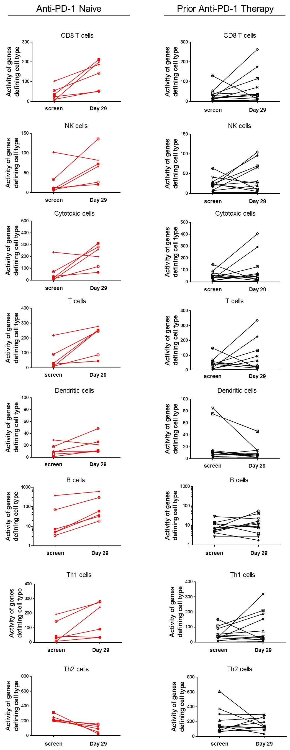

**Supplementary Figure S4.** A subset of patient biopsies that were assessed by RNA expression profiling, were assessed by fluorescent immunohistochemistry for infiltration of CD4 (A) and CD8 (B) T cells. Generally, a greater percentage of patients naive to prior anti-PD-1/L1 therapy (red symbols) demonstrate an increase in infiltrating T cells. Two different but similar methods were used to assess the presence of CD4 and CD8 cells in the tumor environment. Closed circles use left y-axis; open circles use right y-axis. .

**A**

**B**



**Supplementary Figure S5.** Correlation between fluorescent immunohistochemistry (IHC) and RNA expression profiling by Nanostring. X-axes represent changes in immunofluorescence (log2). Y-axes represent changes in Nanostring activity (log2) defining specific cells types. A. CD4 T cells. B. CD8 T cells. C. CD8 immunofluorescence vs cytotoxic T cells by Nanostring. C. NK cells (CD56 staining for immunofluorescence).

**A**

**B**



**D**

**C**

 