Supplementary Materials

A transposon screen identifies loss of primary cilia as a mechanism of resistance to Smo inhibitors

Xuesong Zhao,^{1,2,5,*} Ekaterina Pak,^{1,2,5} Kimberly J. Ornell,^{1,2} Maria F. Pazyra-Murphy,^{1,2} Ethan L MacKenzie,^{1,2} Emily J. Chadwick,^{1,2} Tatyana Ponomaryov,^{1,2,3} Joseph F. Kelleher,⁴ and Rosalind A. Segal^{1,2,*}

Supplementary Figures

Supplementary Figure S1, related to Figure 1

Supplementary Table S1, related to Figure 1

Supplementary Figure S2, related to Figure 1

Supplementary Figure S3, related to Figure 2 and Figure 3

Supplementary Figure S4, related to Figure 4

Supplementary Figure S5, related to Figure 5

Supplementary Figure S6, related to Figure 5

Supplementary Table S2, related to Figure 6

Supplementary Figure S7, related to Figure 6

Supplementary Methods

Supplementary Figures
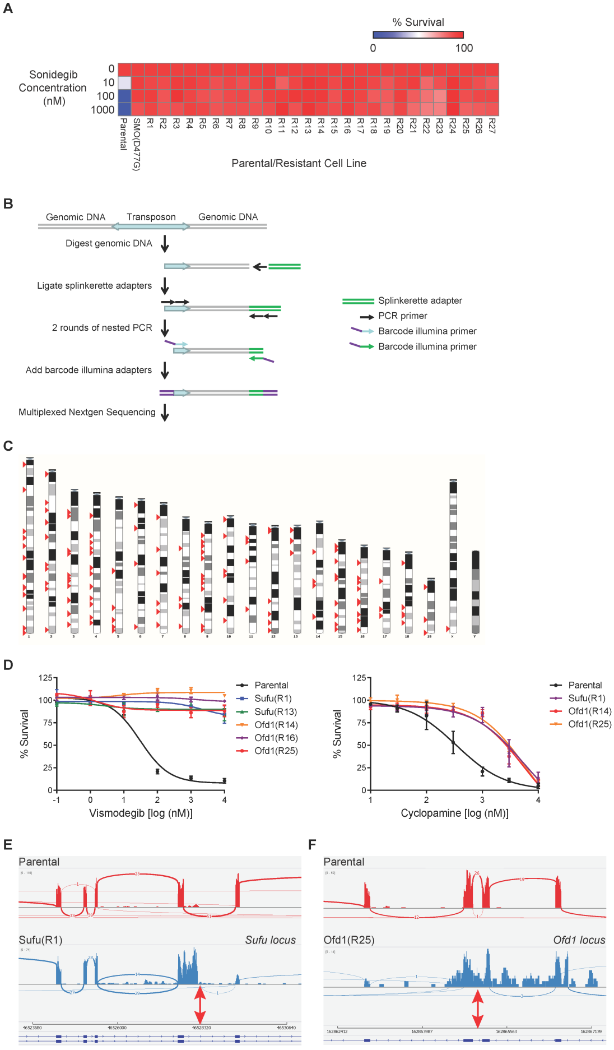
Supplementary Figure S1. Transposon-mediated drug resistance screen identifies recurrent mutations in Sufu and Ofd1, related to Figure 1. (A) Summary of a secondary test, 27 resistant clones confer resistance to Sonidegib in a multi-dose survival assay. (72 hrs, relative to DMSO-treated controls, data represents mean of 3 experiments). (B) A barcoded splinkerette-PCR approach coupled with parallel sequencing is utilized to identify transposon insertion loci in each clone. (C) Distribution of transposon insertion sites in the genome. (D) Survival analysis of parental, Sufu mutant (R1, R13) and Ofd1 mutant (R14, R16, R25) cells treated with indicated Vismodegib or Cyclopamine concentrations for 72 hrs (relative to DMSO-treated controls; mean ± s.e.m., n = 3-4 independent experiments). (E and F) Sashimi plots of RNA-seq alignment data around transposon insertion sites in Sufu (R1) and Ofd1 (R25). The coverage for each alignment track is plotted as a bar graph. Arcs representing splice junctions connect exons. Arcs display the number of reads split across the junction (junction depth). Genomic coordinates and the gene annotation track are shown below the junction tracks. Parental is plotted in red; mutants in blue. Red arrows indicate insertion sites.

Supplementary Table S1, related to Figure 1. A total of 182 transposon insertions were identified in 27 resistant clones. Provided as a separate Excel file.

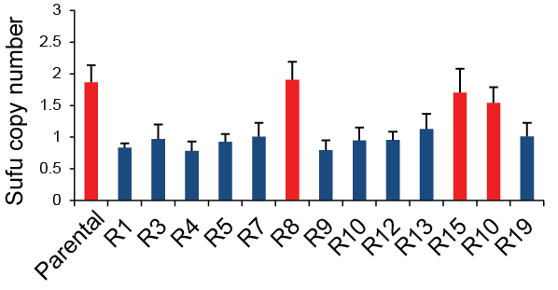
Supplementary Figure S2. Sufu genomic copy number of parental and Sufu mutant cells determined by quantitative PCR, related to Figure 1. Blue: clones with one genomic copy of Sufu. mean ± s.d., n = 3 experiments.

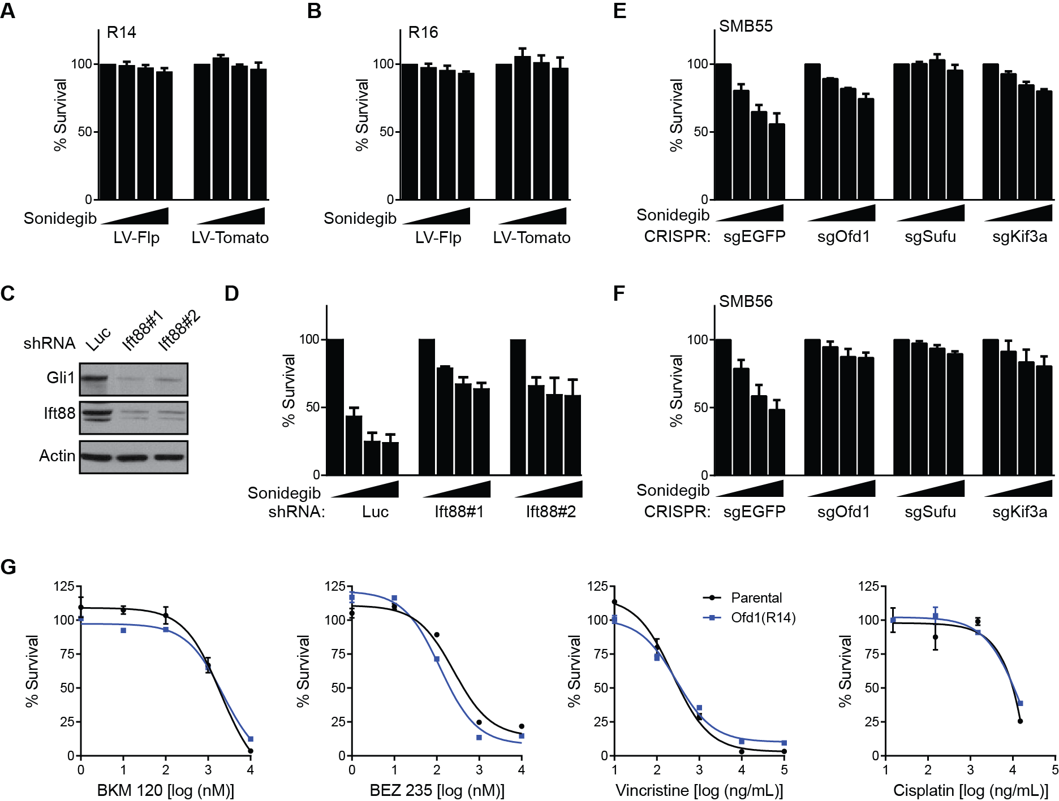
Supplementary Figure S3. Validation of causal relationship between loss of primary cilia and resistance phenotype, related to Figure 2 and Figure 3. (A and B) Removal of transposon cargo by Flp/FRT recombination failed to restore Sonidegib sensitivity in R14 and R16, which have transposon insertions in the coding exon of Ofd1. R14 and R16 cells were infected with lentivirus expressing Flp or tdTomato (control), then assayed by relative survival at Sonidegib concentrations (0, 10, 100, 1000 nM) (72hrs, relative to DMSO-treated controls; mean ± s.e.m., n = 7 independent experiments for R14, n = 3 independent experiments for R16). (C and D) Short hairpin RNA (shRNA)-mediated depletion of Ift88 confers resistance to Smo inhibition in parental SMB21 cells. Assayed by relative survival at Sonidegib concentrations (0, 10, 100, 1000 nM) (72hrs, relative to DMSO-treated controls; mean ± s.e.m., n = 3 independent experiments). (E and F) CRISPR/Cas9-mediated depletion of Ofd1, Kif3a, or Sufu confers resistance to Smo inhibition in SMB55 and SMB56 cells. Assayed by relative survival at Sonidegib concentrations (0, 10, 100, 1000 nM) (72hrs, relative to DMSO-treated controls; mean ± s.e.m, n = 3 independent experiments). (G) Survival analysis for parental and Ofd1 mutant cells treated with BKM120, BEZ235, Vincristine or Cisplatin. mean ± s.e.m., n = 3 technical replicates, representative of 3-4 independent experiments.

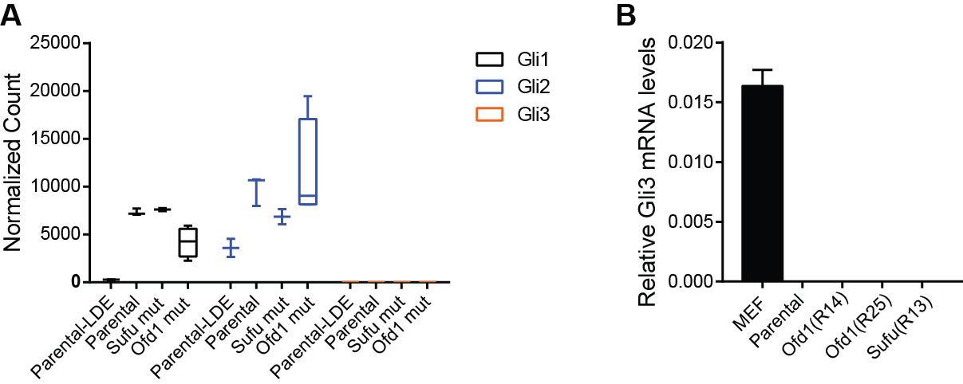
Supplementary Figure S4. Expression of Gli2 and Gli3 in MB cells, related to Figure 4. Gli2 mRNA is highly expressed in parental, Sufu and Ofd1 mutant cells, whereas no Gli3 mRNA can be detected by RNAseq (A) or quantitative RT-PCR (B) (mean ± s.e.m., n = 3 experiments). “Parental-LDE” indicates samples collected from parental cells treated with Sonidegib.

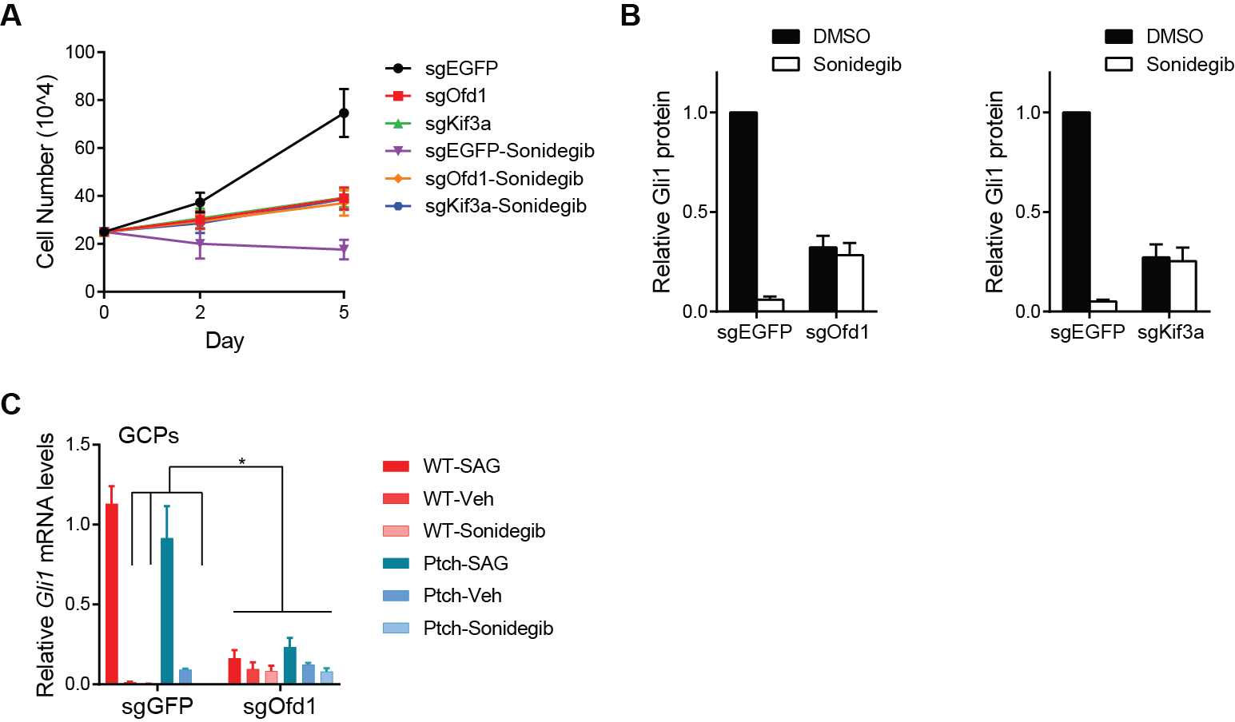
Supplementary Figure S5. Parental SMB cells and granule cell precursors depleted of Ofd1 or Kif3a exhibited low activation of Hh signaling, related to Figure 5. CRISPR/Cas9-mediated depletion of Ofd1 or Kif3a in parental SMB cells (A-B) or granule cell precursors (GCPs) from P5 wild-type and Ptch^{+/-} mice (C). (A) Growth curve of cells treated with DMSO or Sonidegib. mean ± s.d., n = 3 technical replicates, representative of 3 independent experiments (B) Quantification of Gli1 expression from immunoblots. mean ± s.d., n = 6 independent experiment for sgOfd1, n=3 independent experiments for sgKif3a. (C) qRT-PCR analysis of Gli1 mRNA levels after 24 hour treatment with Smo agonist (SAG), Vehicle, or Sonidegib in GCPs. mean ± s.d., n = 3 technical replicates, representative of 3 independent experiments. *p < 0.05, one-way ANOVA with Dunnett’s correction.

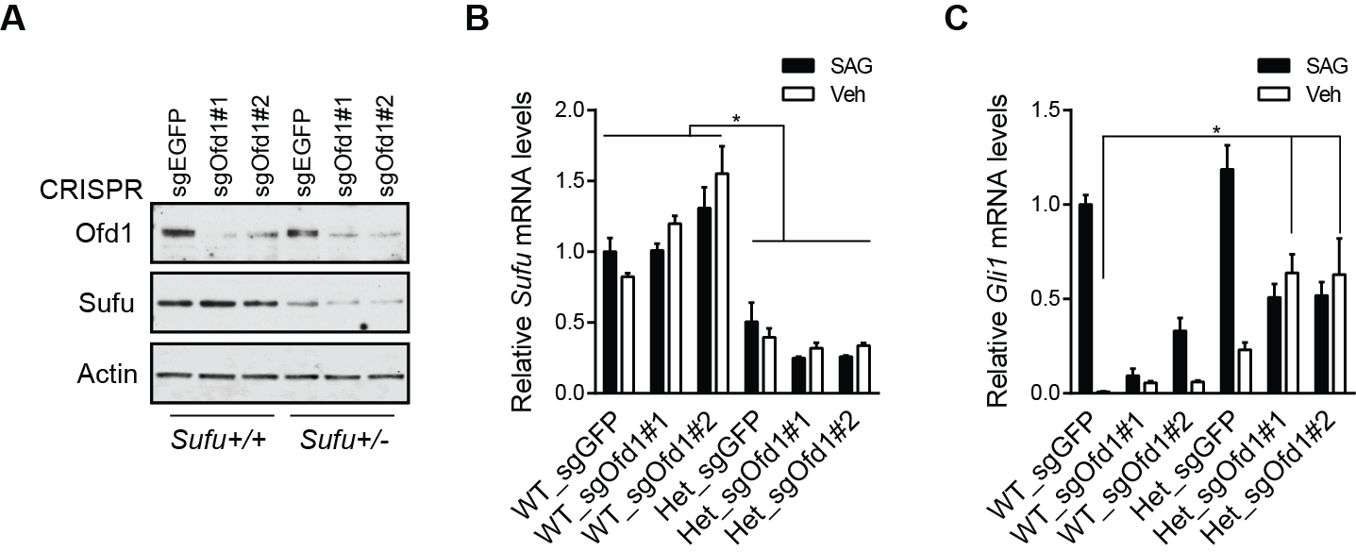
Supplementary Figure S6. Sufu heterozygosity synergizes with cilia loss to enhance Hh signaling output, related to Figure 5.
(A-C) Sufu heterozygosity synergizes with cilia loss to elevate Hh signaling. (A) Immunoblot for indicated antibodies in Sufu+/+ and Sufu+/- MEFs after CRISPR/Cas9-mediated depletion of Ofd1. (B and C) qRT-PCR analysis of Sufu and Gli1 mRNA levels after 24 hour treatment with Smo agonist (SAG) or Vehicle in MEFs from (A). mean ± s.d., n = 4 independent experiments. *p < 0.05, one-way ANOVA with Bonferroni’s correction.

Supplementary Table S2, related to Figure 6. Mutations in ciliary genes were identified from whole-exome sequencing data of untreated and resistant BCC samples previously published (1). Ciliary genes were determined using the SYSCILIA gold standard list of 303 genes for known ciliary components (2). Provided as a separate Excel file.

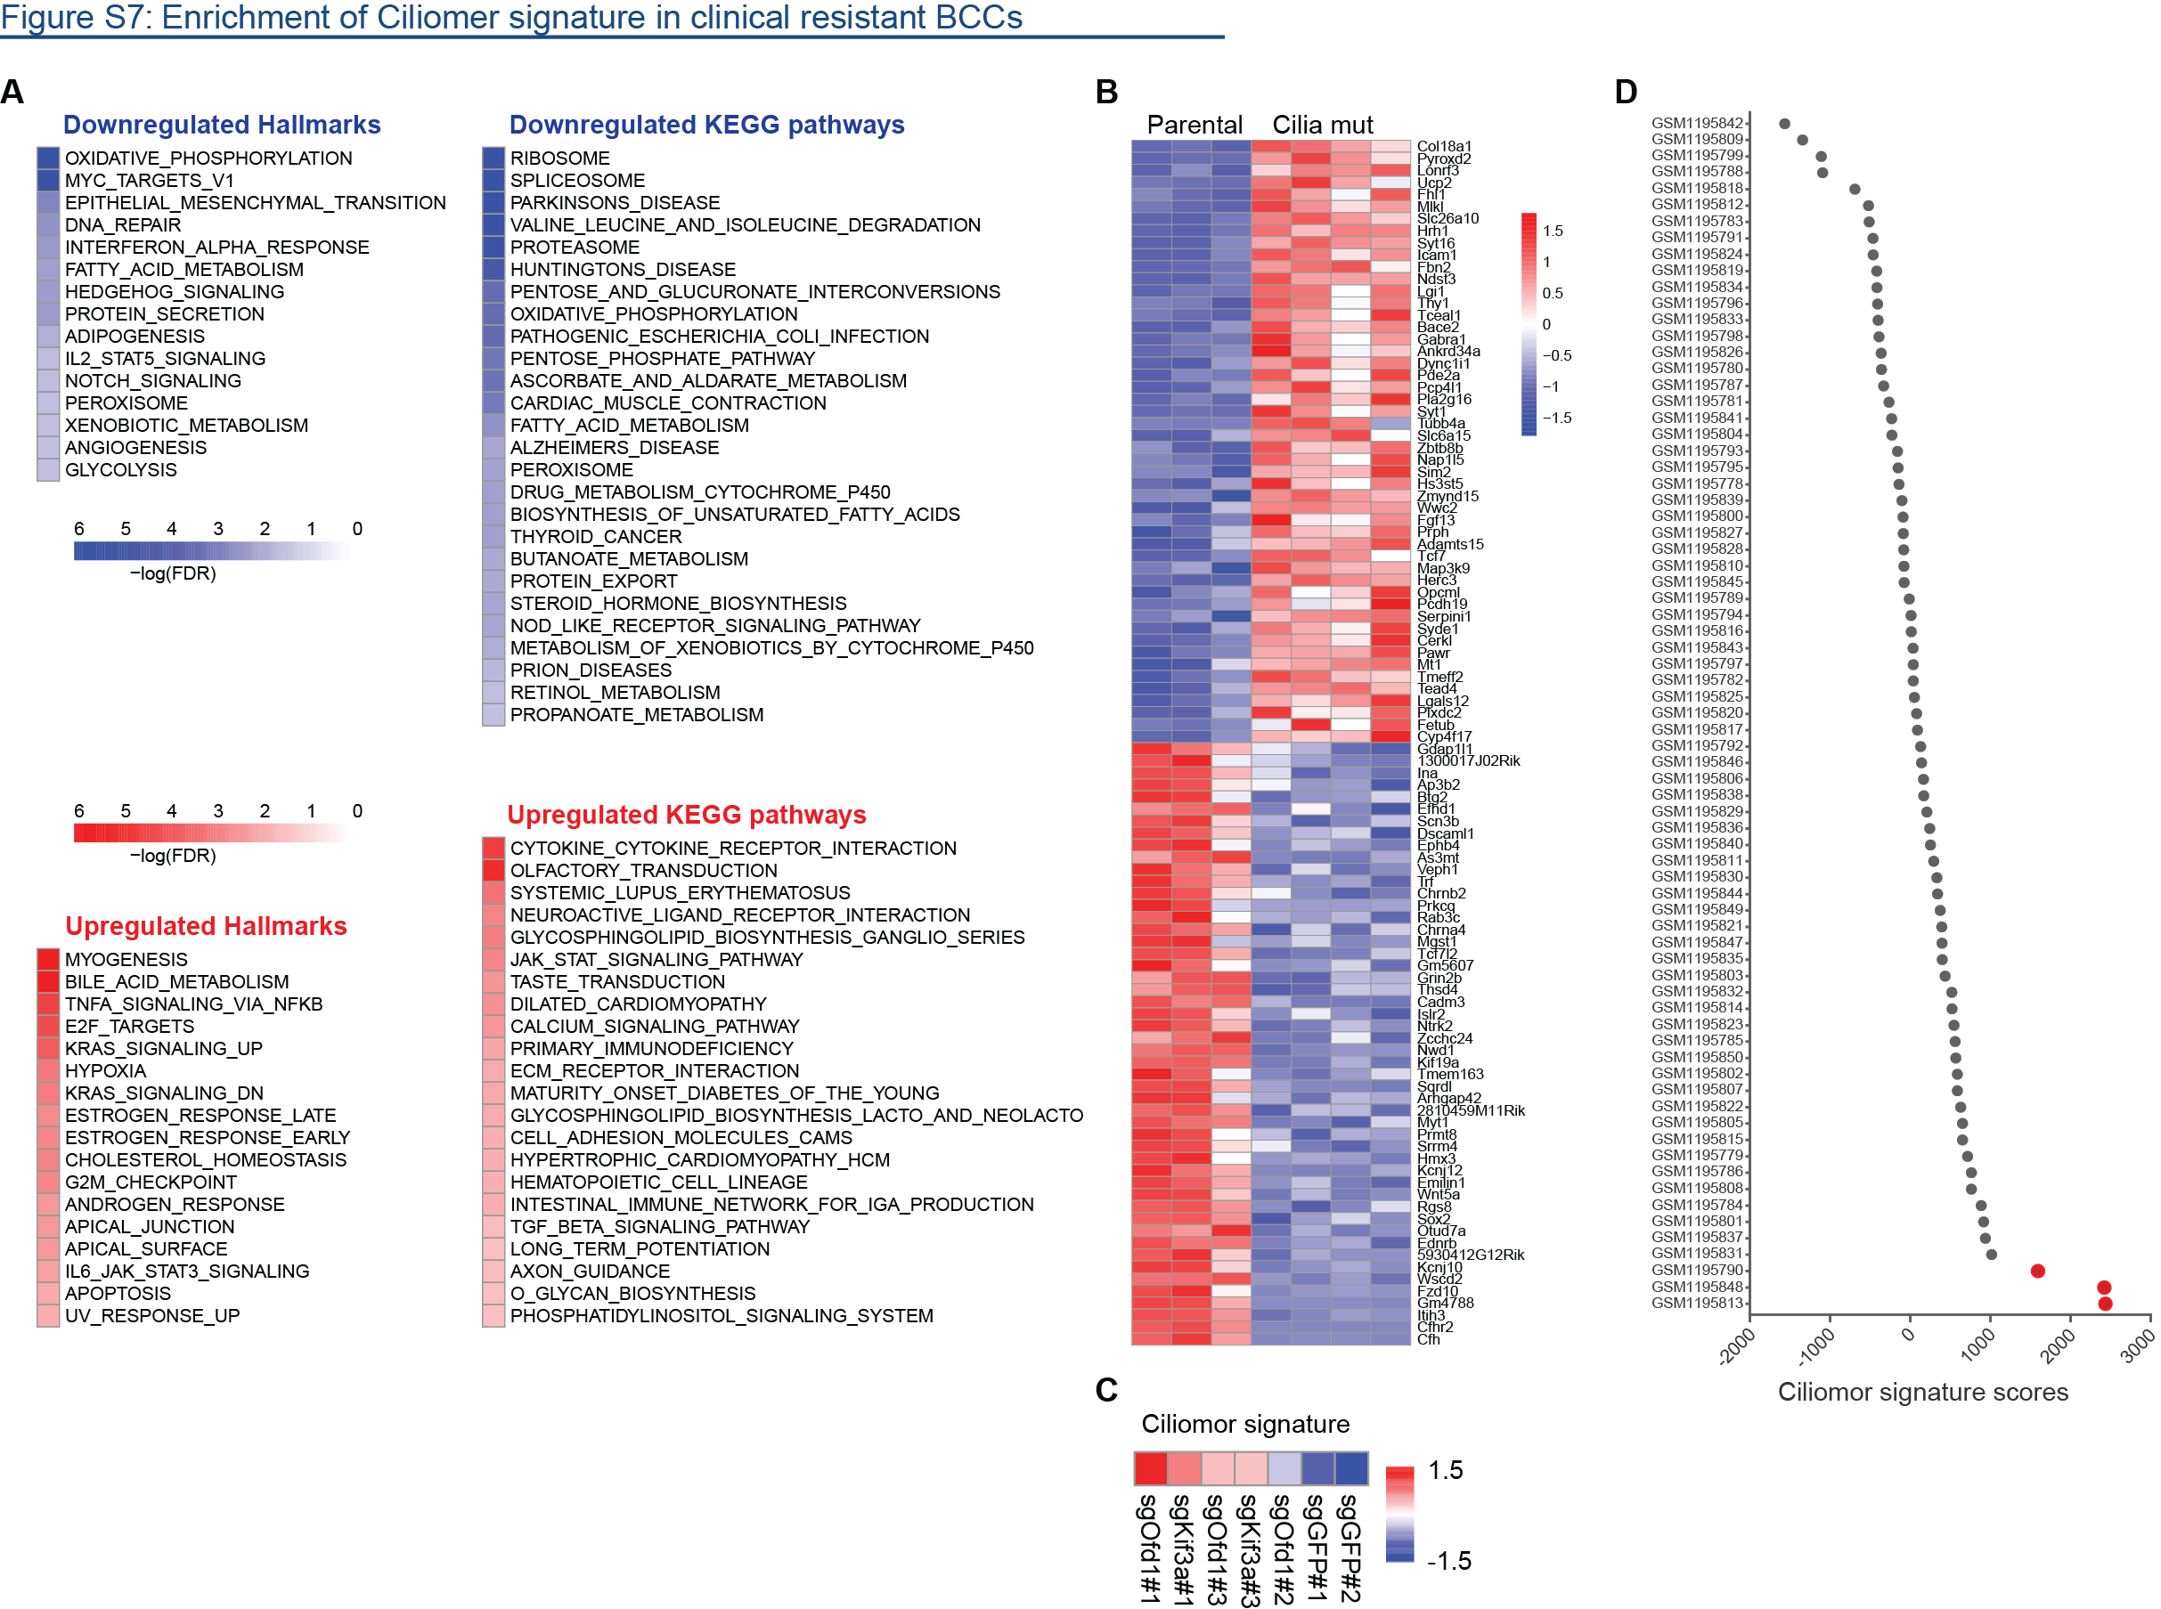
Supplementary Figure S7. Enrichment of Ciliomor signature in clinical resistant BCC samples after treatment of Smo inhibitor, related to Figure 6.
(A) RNAseq-based gene expression profiles of cilia mutant cells were compared to those of parental SMB cells. The top Hallmark gene sets and the KEGG pathways differentially regulated between parental SMB and cilia mutant cells by GSEA analysis. (B) The top 50 differentially upregulated genes and the top 50 downregulated genes were defined as Ciliomor signature. (C) Validation of Ciliomor signature on cilia mutant cells derived from CRISPR/Cas9-mediated Ofd1 or Kif3a knockout. Single-sample gene set enrichment analysis (ssGSEA) was applied to calculate an enrichment score for Ciliomor Signature in each sample. Heatmap shows a normalized Ciliomor signature comparison. (D) Single-sample gene set enrichment analysis (ssGSEA) was applied to generate an enrichment score of Ciliomor signature in each patient sample in a treatment-naïve cohort of MB. Samples with z-score > 2 marked as red.

Supplementary Methods
Plasmids
mPBase plasmid was obtained from Wellcome Trust Sanger Institute (3). piggyBac transposon screen vector was constructed as follows. The PB backbone was gene synthesized, including the piggyBac 5’ and 3’ terminal repeats linked by two FRT sites and multiple cloning sites. The CMV promoter expression cassette was cloned into the PB backbone vector from pcDNA3.1 vector (Invitrogen). The ubiquitin C (UbC) promoter expression cassette was cloned from pPB-UbC plasmid (4). The GFP-2A-PTK fragment was synthesized and cloned into the UbC expression cassette. For Lentiviral expression constructs, coding sequences of EGFP (Clontech), tdTomato (Clontech), Flpo (Addgene plasmid 13793)(5), mouse Sufu, mouse Ofd1, and Luc2 (Promega) were subcloned into the Gateway-compatible lentiviral vector pLX304 (Addgene plasmid 25890)(6). LentiCRISPR was a gift from Feng Zhang (Addgene plasmid 49535). pLKO.1 lentiviral shRNAs were from the Broad Institute RNAi Consortium (TRC). All plasmids were verified by sequencing, and sequences can be provided upon request.

MEF Cell Culture
Sufu^{+/-} and Sufu^{+/+} MEFs were a generous gift from Stephan Teglund (Karolinska Institute) (7). Cells were cultured at 37°C in a humidified incubator with 5% CO₂ in DMEM media (10% heat-inactivated FBS, 1% L-glutamine, 1% penicillin/streptomycin). To passage cultures, cells were dissociated with 0.25% Trypsin-EDTA and plated 1:2 in fresh media.

Isolation and Culture of Primary Granule Cell Precursors
Primary cultures of granule cell precursors (GCPs) were prepared from P5 wild-type or Ptch^{+/-} mice. Briefly, cerebella were dissected, meninges were removed, and tissue was dissociated with papain dissociation kit (Worthington Biochemical Co., Lakewood, New Jersey) according to the manufacturer’s instructions. Dissociated cells were passed through a 70 μm nylon mesh strainer and plated in DMEM/F12 media (2% B27, 1% Pen/Strep). 1 hour after plating, virus-containing media were added. 48 hours later, SAG, Vehicle or Sonidegib was added to each well. Cells were harvested for RNA at 24 hours after stimulation.

Lentiviral production
Lentivirus was generated using the protocol from The RNAi Consortium (TRC) at the RNAi Platform of the Broad Institute of MIT and Harvard at http://www.broadinstitute.org/rnai/public/. Briefly, 293T cells (ATCC) were seeded in 6-well plates and transfected with 1 μg of lentiviral plasmid, 900 ng Δ8.9 (gag, pol) and 100 ng VSV-G using 6 μL Fugene6 transfection reagent (Roche). Viral supernatants were harvested at 48 hrs and 72 hrs post transfection in DMEM/F12 media.

ShRNA knockdown and CRISPR knockout
Targeted knockout of Ofd1, Sufu, or Kif3a was achieved using lentiCRISPR vector system (8). Knockdown of Ift88, Gli2, or Smo was achieved using pLKO lentiviral shRNA system. Infected cells were selected with 1 μg/mL puromycin for 2-4 weeks before downstream experiments. For Gli2 knock-down, cells were plated with virus, selected in puromycin 24 hours after plating, and either assayed for viability by MTS assay or collected for RNA extraction after 4 days in virus. sgRNA and shRNA sequences are listed as follows:
EGFP_sgRNA GAAGTTCGAGGGCGACACCC
mOfd1_sgRNA01 CACCCCGATCCTTAAACGTC
mOfd1_sgRNA02 GAAGCCGCCATCCATTTCAG
mSufu_sgRNA TGACCAGCCGAACCCGCTCC
mKif3a_sgRNA01 CTATAGACAGGCCGTCAGCG
mKif3a_sgRNA02 CGTTGGAGGAATCGGTCTTA
mKif3a_sgRNA03 AAATGTCTTTGGAGGTTCGT
shLuc CTTCGAAATGTCCGTTCGGTT
shIft88#1 GCCCTCAGATAGAAAGACCAA
shIft88#2 GCCAAATAAGTCATTTACCAA
shGli2#2 TATCTCCTTGATACGACTTTC
shGli2#3 CACCAACCCTTCAGACTATTA

Growth Curve Measurement
2.5 x 10⁵ SMB cells were seeded in 6-well plates at day 0. Trypan-blue excluding, viable cells were counted at day 2 and 5.

Electron microscopy
0.5-1×10⁶ cells were collected, fixed (2.5% paraformaldehyde, 5% glutaraldehyde, 0.06% picric acid in 0.2 M cacodylate buffer), resin embedded, and sectioned (~60nm). Sections were picked up onto copper grids stained with lead citrate and examined in a TecnaiG² Spirit BioTWIN microscope. Images were recorded with an AMT 2k CCD camera.

Subcellular Fractionation
2-3 x 10⁶ cells were plated and treated with DMSO or 1 μM Sonidegib for 24 hours. Cells were collected for whole-cell fractions into RIPA buffer or were separately processed into subcellular fractions according to protocol (Thermo Scientific Subcellular Protein Fractionation Kit for Cultured Cells 78840 78833). Lysates were loaded into 4-12% Bis-Tris Tris/Glycine gels (Invitrogen) based on cell numbers per sample and processed as described above for Immunoblotting.

Quantitative RT-PCR
RNA was extracted from cells using Trizol (Invitrogen) and RNeasy kit (Qiagen) according to the manufacturer’s protocol. Reverse transcription was performed using High Capacity cDNA Reverse Transcription Kit (Applied Biosystems) according to the manufacturer’s specifications. Quantitative real-time PCR was performed using TaqMan gene expression assays (Applied Biosystems) to assess expression of Gli1 (Mm00494645), Gli2 (Mm01293117), Gli3 (Mm00492333_m1), Sufu (Mm00489385), Ofd1 (Mm00616877_m1). Each analysis was performed in triplicate. Expression was normalized to Gapdh (4352339E).

Transposon Insertion Identification
Genomic DNA from each clone was extracted using DNeasy Blood & Tissue Kit (Qiagen 69504). 0.5 μg of DNA was digested with Sau3AI restriction enzyme, then ligated with Splinkerette adaptor. To amplify the junction fragments between the flanking genomic sequence and the transposon insertion, two round of PCR reaction were used with nested-PCR primers. The third round PCR was used to add barcoded illumina sequencing adaptor. PCR products from individual clones were pooled together and purified with QIAquick PCR purification Kit (Qiagen). The resulting purified PCR product library was then sequenced utilizing Nextgen sequencing (Illumina MiSeq) with single-end 150bp reads by the Molecular Biology Core Facilities at Dana-Farber Cancer Institute. Raw sequences were first de-multiplexed according to barcodes, and low QC reads were discarded. The splinkerette adapter sequence and piggybac transposon terminal repeat sequences were trimmed off. Processed reads were then mapped to mouse genome (mm10) using the bowtie algorithm. The site and orientation of transposon insertion was determined from mapped sequences with custom scripts.

Gene Expression Analysis
RNA was isolated from cells, primary tumors and normal mouse brain using RNeasy Kit (Qiagen). Libraries were prepared using Illumina TruSeq Stranded mRNA sample preparation kits from 500ng of purified total RNA according to the manufacturer’s protocol. The finished dsDNA libraries were quantified by Qubit fluorometer, Agilent TapeStation 2200, and RT-qPCR using the Kapa Biosystems library quantification kit according to manufacturer’s protocol. Uniquely indexed libraries were pooled in equimolar ratios and sequenced on a single Illumina NextSeq500 run with single-end 75bp reads by the Dana-Farber Cancer Institute Molecular Biology Core Facilities. STAR aligner was used to map sequenced reads to the mm9 genome assembly and to quantify gene level expression. Comparative analysis was performed by DESeq2. For evaluating activity of Hh signaling, enrichment score of the gene set (LEE_TARGETS_OF_PTCH1_AND_SUFU_UP) from Molecular Signatures Database v5.1 was calculated by gene set enrichment analysis (GSEA). For global comparison, a total of 236 gene signatures were evaluated by GSEA, including 186 gene sets derived from the KEGG pathway database and 50 hallmark gene sets from the Molecular Signatures database (9).

Ciliomor Signature and Single-sample Gene Set Enrichment Analysis of BCC Patients
The Ciliomor Signature was defined by the top 50 differentially upregulated genes together with the top 50 differentially downregulated genes in cilia mutant cells compared to parental sensitive cells. Expression heatmap of Ciliomor signature genes is shown in Figure S7.
Single-sample GSEA (ssGSEA), an extension of Gene Set Enrichment Analysis (GSEA), calculates an enrichment score for each sample against one gene set (10). The ssGSEA enrichment score represents the degree to which the genes in this gene set are coordinately up- or down-regulated within a sample. Single-sample gene set enrichment analysis (ssGSEA) was applied to generate an enrichment score of Ciliomor signature in each patient sample. Gene expression data of normal skin (n=8), sensitive (n=4) and resistant BCC (n=9) samples were obtained from GEO (GSE58375) (11). Gene expression data of treatment-naïve MB samples were from GEO (GSE49243) (12).

Gene Copy Number Analysis
Genomic DNA was extracted with the DNeasy Blood and Tissue Kit (Qiagen). Genomic copy number for Sufu was determined by quantitative real-time PCR reagents (Applied Biosystems) with custom-designed primers using 5 ng of genomic DNA/reaction. Sufu forward primer: GACTCTAGAGCAGCAGCAAC; Sufu reverse primer: CTTAGCTGTAGGAACCACTA; SINE1 forward primer: AGATGGCTGAGTGGGTAAAGG; SINE1 reverse primer: GTGGAGGTCAGAGGACAAACTT. Real-time PCR was carried out with the cycling method (50°C for 2 min, 95°C for 10 min, followed by 40 cycles at 95°C for 15 seconds and 60°C for 1 minute) using 5 ng of genomic DNA/reaction. Copy number was calculated as 2(T_{DNA}/C_{DNA}), where T_{DNA} and C_{DNA} are the calculated amounts of test gene DNA at the recorded C_{t} for tumor and calibrator, respectively. Copy number data for Sufu were normalized to SINE1 elements with the formula 2(T_{dna}/L_{dnaT})/(C_{dna}/L_{dnaC}), where T_{dna} and C_{dna} represent the amounts of Sufu-calculated DNA in the tumor and calibrator, respectively, and L_{dnaT} and L_{dnaC} are the corresponding amounts of their SINE1 DNA at the recorded C_{t} values.

BCC human data analysis and the SYSCILIA gold standard list of ciliary genes
Publicly available whole-exome sequencing of resistant and untreated BCC samples were analyzed based on reported single nucleotide variants and insertions/deletions. Original data doi: 10.1016/j.ccell.2015.02.001.(1)
Mutations in ciliary genes were determined using the SYSCILIA gold standard list of 303 genes for known ciliary components (2).

Statistical Analysis
Statistical analyses were performed with the Student’s t test, one-way ANOVA with Dunnett or Bonferroni post-hoc test as indicated. A p value of 0.05 or less was considered statistically significant. All data analyses were performed using Microsoft Excel or GraphPad Prism 5.

Supplementary References
1. Sharpe HJ, Pau G, Dijkgraaf GJ, Basset-Seguin N, Modrusan Z, Januario T, et al. Genomic analysis of smoothened inhibitor resistance in basal cell carcinoma. Cancer Cell. 2015;27:327-41.
2. van Dam TJ, Wheway G, Slaats GG, Group SS, Huynen MA, Giles RH. The SYSCILIA gold standard (SCGSv1) of known ciliary components and its applications within a systems biology consortium. Cilia. 2013;2:7.
3. Cadinanos J, Bradley A. Generation of an inducible and optimized piggyBac transposon system. Nucleic Acids Res. 2007;35:e87.
4. Yusa K, Rad R, Takeda J, Bradley A. Generation of transgene-free induced pluripotent mouse stem cells by the piggyBac transposon. Nat Methods. 2009;6:363-9.
5. Raymond CS, Soriano P. High-efficiency FLP and PhiC31 site-specific recombination in mammalian cells. PLoS One. 2007;2:e162.
6. Yang X, Boehm JS, Salehi-Ashtiani K, Hao T, Shen Y, Lubonja R, et al. A public genome-scale lentiviral expression library of human ORFs. Nat Methods. 2011;8:659-61.
7. Svard J, Heby-Henricson K, Persson-Lek M, Rozell B, Lauth M, Bergstrom A, et al. Genetic elimination of Suppressor of fused reveals an essential repressor function in the mammalian Hedgehog signaling pathway. Dev Cell. 2006;10:187-97.
8. Shalem O, Sanjana NE, Hartenian E, Shi X, Scott DA, Mikkelsen TS, et al. Genome-scale CRISPR-Cas9 knockout screening in human cells. Science. 2014;343:84-7.
9. Subramanian A, Tamayo P, Mootha VK, Mukherjee S, Ebert BL, Gillette MA, et al. Gene set enrichment analysis: a knowledge-based approach for interpreting genome-wide expression profiles. Proc Natl Acad Sci U S A. 2005;102:15545-50.
10. Barbie DA, Tamayo P, Boehm JS, Kim SY, Moody SE, Dunn IF, et al. Systematic RNA interference reveals that oncogenic KRAS-driven cancers require TBK1. Nature. 2009;462:108-12.
11. Atwood SX, Sarin KY, Whitson RJ, Li JR, Kim G, Rezaee M, et al. Smoothened variants explain the majority of drug resistance in basal cell carcinoma. Cancer Cell. 2015;27:342-53.
12. Kool M, Jones DT, Jager N, Northcott PA, Pugh TJ, Hovestadt V, et al. Genome Sequencing of SHH Medulloblastoma Predicts Genotype-Related Response to Smoothened Inhibition. Cancer Cell. 2014;25:393-405.

