**Supplementary Material for**

**Tumor heterogeneity and lesion-specific response to targeted therapy in colorectal cancer**

Mariangela Russo*, Giulia Siravegna*, Lawrence S. Blaszkowsky*, Giorgio Corti, Giovanni Crisafulli, Leanne G. Ahronian, Benedetta Mussolin, Eunice L. Kwak, Michela Buscarino, Luca Lazzari, Emanuele Valtorta, Mauro Truini, Nicholas A. Jessop, Hayley E. Robinson, Theodore S. Hong, Mari Mino-Kenudson, Federica Di Nicolantonio, Ashraf Thabet, Andrea Sartore Bianchi, Salvatore Siena, A. John Iafrate, Alberto Bardelli#, Ryan B. Corcoran#

**Supplementary Methods**

**Supplementary Figures**

* Supplementary Figure S1: MEK1 K57 mutation confers resistance to anti-EGFR antibodies in CRC preclinical models.
* Supplementary Figure S2: Dual blockade of EGFR and MEK restores sensitivity to CRC cells expressing MEK1 K57N or K57T.
* Supplementary Figure S3: Longitudinal analysis of founder mutations in patient plasma during panitumumab and trametinib treatment.

**Supplementary Tables**

* Supplementary Table S1: 1000 gene sequencing panel.
* Supplementary Table S2: 40 gene targeted sequencing panel.
* Supplementary Table S3: Summary of targeted sequencing and ddPCR data on tissue specimens.
* Supplementary Table S4: Next generation sequencing data from plasma ctDNA.
* Supplementary Table S5: Summary of serial ctDNA analyses.
* Supplementary Table S6: Ratio of resistance-associated genetic alterations and founder mutations in serial plasma ctDNA timepoints.

**Supplementary Methods**

**Next Generation Sequencing analysis**

Libraries were prepared with Nextera Rapid Capture Custom Enrichment Kit (Illumina Inc., San Diego, CA, USA), according to the manufacturer’s protocol. Preparation of libraries was performed starting from 105 ng of plasma ctDNA and 100 ng of gDNA from PBMC (as corresponding normal reference). gDNA was fragmented using transposones, adding simultaneously adapter sequences. For ctDNA libraries preparation was used NEBNext® Ultra™ DNA Library Prep Kit for Illumina® (New England BioLabs Inc., Ipswich MA). Purified gDNA and ctDNA after tagmentation step were used as template for subsequent PCR to introduce unique sample barcodes. Fragments’ size distribution of the DNA was assessed using the 2100 Bioanalyzer with a High Sensitivity DNA assay kit (Agilent Technologies, Santa Clara, CA). Equal amount of DNA libraries were pooled and subjected to targeted panel hybridization capture. Libraries were then sequenced using Illumina MiSeq or NextSeq500 sequencer (Illumina Inc., San Diego, CA, USA).

**Droplet digital PCR**

8 to 10 µl of DNA template was added to 10 µl of ddPCR™ Supermix for Probes (Bio-Rad) and 2 µl of the primer/probe mixture. This reaction mix was added to a DG8 cartridge together with 60µl of Droplet Generation Oil for Probes (Bio-Rad) and used for droplet generation. Droplets were then transferred to a 96 well plate (Eppendorf) and then thermal cycled with the following conditions: 5 minutes at 95°C, 40 cycles of 94°C for 30s, 55°C for 1 minute followed by 98°C for 10 minutes (Ramp Rate 2°C/sec). Droplets were analyzed with the QX200™ Droplet Reader (Bio-Rad) for fluorescent measurement of FAM and HEX probes. Gating was performed based on positive and negative controls, and mutant populations were identified. The ddPCR data were analyzed with QuantaSoft analysis software (Bio-Rad) to obtain Fractional Abundance of the mutant DNA alleles in the wild-type/normal background. The quantification of the target molecule was presented as number of total copies (mutant plus WT) per sample in each reaction. Fractional Abundance is calculated as follows: F.A. % = (Nmut/(Nmut+Nwt))*100), where Nmut is number of mutant events and Nwt is number of WT events per reaction. ddPCR analysis of normal control plasma DNA (from cell lines) and no DNA template controls were always included. Samples with too low positive events were repeated at least twice in independent experiments to validate the obtained results.

**Bioinformatic analysis**

Sequence files were mapped to the hg19 reference genome using BWA-mem algorithm(1); PCR duplicates were then removed and the resulting BAM file(2) was used as input for several pipelines. All analyzes are comparison between a normal and tumor sample. We used a custom script in order to call somatic variations and gene copy-number alterations; Pindel(3) software was instead run in searching for INDEL events. Each result was further annotated by main biological information and COSMIC database occurrence.

**Bliss interaction index analysis**

Bliss interaction index - defined as the difference between the Observed combined fractional inhibition effect YObs and the Expected combined inhibition YExp (whereby Yexp= InhMEKi + InhEGFRi – InhMEKi *InhEGFRi) – was calculated for each drug combination over a concentration range of trametinib tested with a fixed clinically-relevant dose of EGFR monoclonal antibodies. Yobs> Yexp, Yobs≈Yexp, or Yobs<Yexp, indicate synergistic, independent or antagonistic interaction respectively. As a consequence, the difference Δ between Yobs and Yexp can indicate synergism, additivity or antagonism when ΔYobs -Yexp (Interaction index) >0, ≈0 or <0, respectively.

**Supplementary Figures**

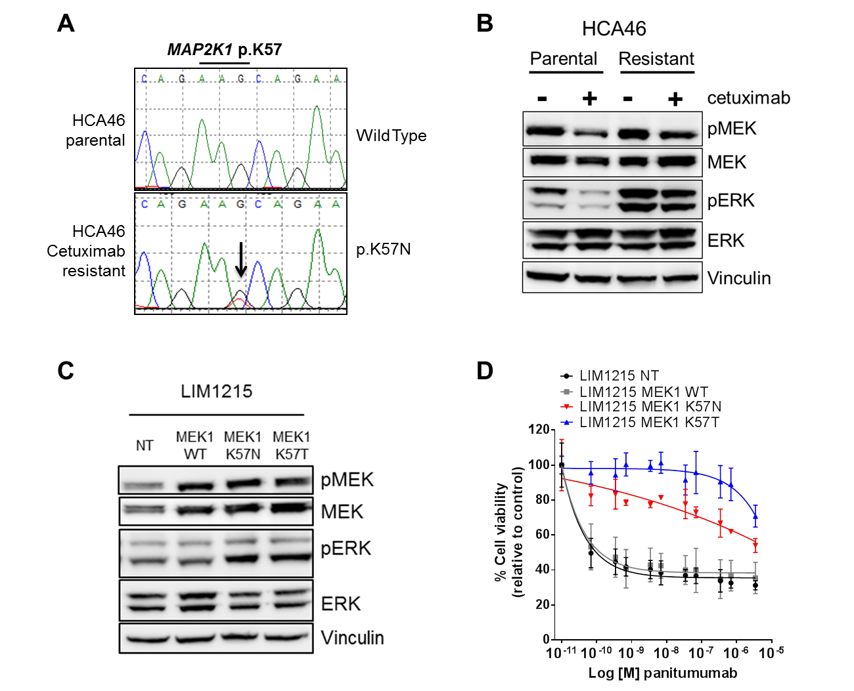

**Supplementary** **Figure S1. MEK1 K57 mutations confer resistance to anti-EGFR antibodies in CRC preclinical models**

Cetuximab-resistant cells, generated from the CRC cell line HCA46, harbor a MEK1 K57N mutation as shown in the electropherogram in panel A. HCA46 *RAS*-wildtype parental cell lines harbor wildtype MEK1. In panel B, parental HCA46 cells and cetuximab-resistant HCA46 clones (harboring MEK1 K57N mutation) were treated with or without cetuximab 50µg/ml for 24h and western blotting was performed with the indicated antibodies. Panel C shows a western blot of LIM1215 CRC cells exogenously expressing wildtype (WT), K57N, or K57T MEK1. NT indicates not transduced cells. In panel D exogenous expression of MEK1 K57T or MEK1 K57N in an independent cetuximab-sensitive *RAS*-wildtype colorectal cancer cell line (LIM1215) confers resistance to panitumumab, relative to expression of wildtype MEK1. NT indicates not transduced cells.

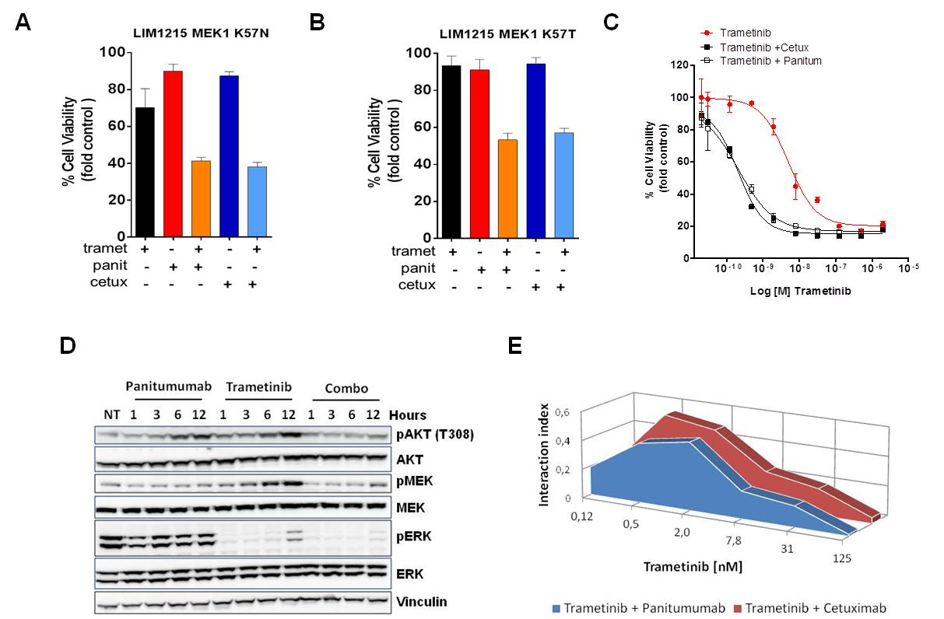

**Supplementary Figure S2. Dual blockade of EGFR and MEK restores sensitivity to CRC cells expressing MEK1 K57N or K57T.**

The combination of cetuximab (cetux) and trametinib (tramet) or panitumumab (panit) and trametinib (tramet) can restore sensitivity to LIM1215 CRC cells exogenously expressing MEK1 K57N (panel A) or K57T (panel B). In panel C anti-EGFR antibodies enhance the efficacy of trametinib on HCA46 cetuximab-resistant cells harboring a MEK1 K57N mutation. Cells were treated with increasing concentrations of trametinib and panitumumab (panitum) or cetuximab (cetux). Cell viability was assessed by measuring ATP content after 5 days of treatment. In Panel D, combinatorial treatment of panitumumab and trametinib is necessary to achieve a prolonged downregulation of both PI3K and MAPK pathways in HCA46 cetuximab resistant cells. Cell lines were treated with trametinib 50nM, panitumumab 50µg/ml, or the combination of both at the indicated time points, after which whole-cell extracts were subjected to western blot analysis and membranes were probed with indicated antibodies. Vinculin was included as a loading control. (E) Bliss interaction index between trametinib (MEKi) and anti-EGFR antibodies (cetuximab and panitumumab) in HCA46 cetuximab-resistant cells. Synergism, additivity, or antagonism is indicated by an Interaction Index >0, ≈0 or <0, respectively. The interaction index is greater than 0 across all trametinib concentrations tested, indicating that its combination with either cetuximab or panitumumab has synergistic effects.

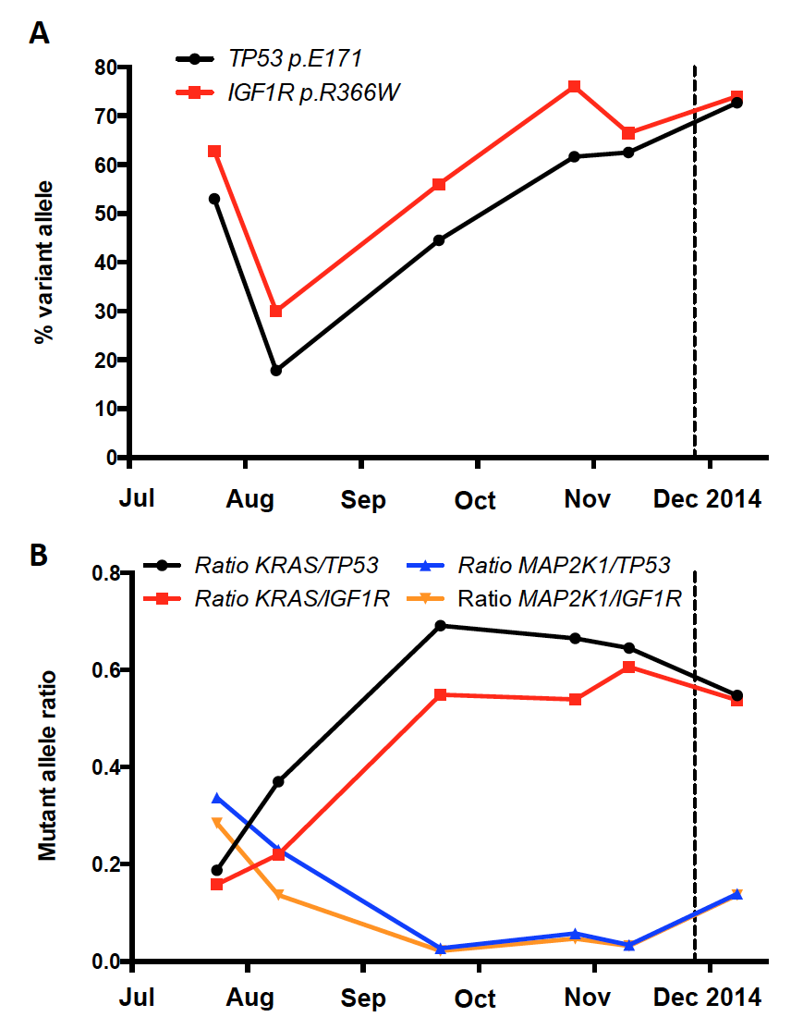

**Supplementary Figure S3. Longitudinal analysis of founder mutations in patient plasma during panitumumab and trametinib treatment.** Serial assessments of plasma circulating tumor DNA for the percent abundance of variant alleles for *TP53* p.E171* and *IGF1R* p.R366W are shown throughout treatment (panel A). In Panel B, the ratio of either *MAP2K1* p.K57T or *KRAS* p.Q61H to each founder mutation (*TP53* p.E171* or *IGF1R* p.R366W) is shown throughout treatment.

**Supplementary Tables**



**Supplementary Table S1. 1000 gene sequencing panel.** The primary tumor and segment 8 liver metastasis were analyzed using a sequencing panel providing full exome coverage of the genes listed in the table.

|  |  |
| --- | --- |
| **40 GENE PANEL** | |
| AKT1 | IDH1 |
| ALK | IDH2 |
| APC | KIT |
| BRAF | KRAS |
| CDH1 | MAP2K1 |
| CDKN2A | MET |
| CTNNB1 | NOTCH |
| DDR2 | NRAS |
| EGFR | PDGFRA |
| ERBB2 | PIK3CA |
| ESR1 | PIK3R1 |
| FBXW7 | PTEN |
| FGFR1 | RET |
| FGFR2 | ROS1 |
| FGFR3 | SMAD4 |
| FOXL2 | SMO |
| GNA11 | STK11 |
| GNAQ | TERTprmt |
| GNAS | TP53 |
| HRAS | VHL |

**Supplementary Table S2. 40 gene targeted sequencing panel.** Patient’s tumor tissue specimen were analyzed using a clinical next generation sequencing assay covering these 40 cancer-related genes.

|  |  |  |  |  |  |
| --- | --- | --- | --- | --- | --- |
| **LESION** | **TARGET** | **MUT READS** | **WT READS** | **FRACTIONAL ABUNDANCE (%)** | **DETECTED BY ddPCR** |
| **1.) Left colectomy** | ***TP53* p.E171\*** | 124 | 363 | 34.2 | **+** |
| ***MAP2K1* (MEK1) p.K57T** | 0 | 93 | 0 | **-** |
| ***KRAS* p.Q61H** | 0 | 251 | 0 | **-** |
| **2.) Low anterior resection** | ***TP53* p.E171\*** | 5 | 93 | 5.4 | **+** |
| ***MAP2K1* (MEK1) p.K57T** | 0 | 89 | 0 | **-** |
| ***KRAS* p.Q61H** | 0 | 96 | 0 | **-** |
| **3.) Partial hepatectomy** | ***TP53* p.E171\*** | 167 | 322 | 51.9 | **+** |
| ***MAP2K1* (MEK1) p.K57T** | 0 | 416 | 0 | **-** |
| ***KRAS* p.Q61H** | 0 | 817 | 0 | **-** |
| **4.) post-progression biposy (segment 8 liver lesion)** | ***TP53* p.E171\*** | 299 | 474 | 63.1 | **+** |
| ***MAP2K1* (MEK1) p.K57T** | 35 | 309 | 11 | **+** |
| ***KRAS* p.Q61H** | 0 | 256 | 0 | **-** |
| **5.) progressing segment 5 liver lesion** | ***TP53* p.E171\*** | 151 | 387 | 39.0 | **+** |
| ***MAP2K1* (MEK1) p.K57T** | 0 | 186 | 0 | **-** |
| ***KRAS* p.Q61H** | 92 | 302 | 30 | **+** |

**Supplementary Table S3. Summary of targeted sequencing and ddPCR data on tissue specimens.** Each tissue specimen obtained was analyzed by NGS (40 gene panel) and droplet digital PCR (ddPCR). The number of mutant (MUT) or wildtype (WT) sequencing reads and the relative fractional abundance for each variant shown are indicated.

|  |  |  |  |  |  |  |
| --- | --- | --- | --- | --- | --- | --- |
| **COSMIC occurrence** | **gene** | **variant effect** | **variant** | **WT reads** | **MUT reads** | **Fractional abundance (%)** |
| 29 | *TP53* | stopgain | p.E171* | 219 | 249 | 53.0 |
| 207 | *KRAS* | nonsynonymous | p.Q61H | 199 | 15 | 7.0 |
| 8 | *MAP2K1* | nonsynonymous | p.K57T | 166 | 27 | 14.0 |
| 1 | *NBN* | nonsynonymous | p.T268M | 122 | 235 | 65.8 |
| 0 | *IGF1R* | nonsynonymous | p.R366W | 15 | 33 | 68.8 |
| 0 | *FGFR4* | stopgain | p.R416* | 71 | 46 | 39.3 |
| 0 | *KDR* | nonsynonymous | p.T761M | 183 | 33 | 15.2 |
| 0 | *CHEK2* | nonsynonymous | p.P552S | 222 | 10 | 4.3 |

**Supplementary Table S4. Next generation sequencing data from plasma ctDNA.** The table shows the mutations found in the patient’s plasma ctDNA (before initiation of panitumumab and trametinib) compared to genomic DNA isolated from peripheral blood mononuclear cells (PBMC) using the IRCC-TARGET next generation sequencing panel. To uncover somatic mutations, we compared germline (PBMC) and ctDNA samples, and identified basepair mismatches (Fisher's Test) with fractional abundance above 1%. Mutations were then called only when supported by a 5% statistical significance and their occurrence was checked in the COSMIC database. Mutations were annotated by a custom script printing (from left to right) gene name, the variant effect (synonymous, non-synonymous, stop-loss/gain), protein change (variant), number of wildtype (WT) or mutated (MUT) reads and the allelic frequencies (fractional abundance). Every somatic mutation was validated by visual examination using BAM files. Sequencing coverage depth was 229x for PBMC and 213x for plasma.

|  |  |  |  |  |  |  |  |  |
| --- | --- | --- | --- | --- | --- | --- | --- | --- |
| **GE/ml plasma** | **Blood draw** | **TARGET** | **MUT EVENTS**  **ddPCR** | **WT EVENTS ddPCR** | **FRACTIONAL ABUNDANCE (%)**  **ddPCR** | **MUT READS**  **(NGS)** | **WT READS**  **(NGS)** | **FRACTIONAL ABUNDANCE**  **(%)**  **(NGS)** |
| 121747 | **Jul 2014** | ***TP53* p.E171\*** | 217 | 193 | 53 | 219 | 249 | 53.0 |
| ***IGF1R* p.R366W** | 601 | 356 | 62.8 | 15 | 33 | 68.8 |
| ***MAP2K1*p.K57T** | 92 | 423 | 17.9 | 166 | 27 | 14.0 |
| ***KRAS* p.Q61H** | 32 | 290 | 9.9 | 199 | 15 | 7.0 |
| 55950 | **Aug 2014** | ***TP53*p.E171\*** | 38 | 175 | 18 | NA | | |
| ***IGF1R* p.R366W** | 89 | 204 | 30 |
| ***MAP2K1*p.K57T** | 10 | 234 | 4.1 |
| ***KRAS* p.Q61H** | 14 | 198 | 6.6 |
| 66532 | **Sep 2014** | ***TP53* p.E171\*** | 101 | 126 | 44 | NA | | |
| ***IGF1R* p.R366W** | 73 | 58 | 56 |
| ***MAP2K1*p.K57T** | 4 | 330 | 1.2 |
| ***KRAS* p.Q61H** | 103 | 232 | 30.8 |
| 187088 | **Oct 2014** | ***TP53* p.E171\*** | 201 | 125 | 62 | NA | | |
| ***IGF1R* p.R366W** | 1027 | 325 | 76 |
| ***MAP2K1*p.K57T** | 32 | 870 | 3.6 |
| ***KRAS* p.Q61H** | 243 | 350 | 41 |
| 1462004 | **Nov 2014** | ***TP53* p.E171\*** | 445 | 267 | 63 | NA | | |
| ***IGF1R* p.R366W** | 537 | 271 | 66.5 |
| ***MAP2K1*p.K57T** | 21 | 980 | 2,1 |
| ***KRAS* p.Q61H** | 862 | 1277 | 40.3 |
| 2725500 | **Dec 2014** | ***TP53* p.E171\*** | 1991 | 748 | 73 | 63 | 34 | 64.9 |
| ***IGF1R* p.R366W** | 181 | 63 | 74 | 68 | 13 | 83.9 |
| ***MAP2K1*p.K57T** | 218 | 1940 | 10.1 | 19 | 146 | 11.5 |
| ***KRAS* p.Q61H** | 1539 | 2328 | 39.8 | 74 | 126 | 37.0 |

**Supplementary Table S5. Summary of serial ctDNA analyses.** Circulating tumor DNA (ctDNA) was isolated from serial blood draws collected before initiation of panitumumab and trametinib (Jul 2014), throughout treatment, and after discontinuation of therapy (Dec 2014). Each time point was analyzed by droplet digital PCR (ddPCR). The number of Genome Equivalents (GE), mutated (MUT) and wild type (WT) events and fractional abundance are listed. Plasma from week 0 and 19 were analyzed also with the IRCC-TARGET panel(4). Mutated (MUT) and wild type (WT) reads and fractional abundance are listed. Sequencing coverage depth was 213x for week 0 and 140x for week 19.



**Supplementary Table S6.** **Ratio of resistance-associated genetic alterations and founder mutations in serial plasma ctDNA timepoints.** Table lists mutational frequency and ratio (%) between founder (*TP53* p.E171* and *IGF1R* p.R366W) and resistance-associated genetic alterations (*KRAS* p.Q61H and *MAP2K1* p.K57T) assessed by ddPCR in serial plasma ctDNA timepoints.

**REFERENCES**

1. Li H, Durbin R. Fast and accurate long-read alignment with Burrows-Wheeler transform. Bioinformatics 2010;26(5):589-95.

2. Li H, Handsaker B, Wysoker A, Fennell T, Ruan J, Homer N, et al. The Sequence Alignment/Map format and SAMtools. Bioinformatics 2009;25(16):2078-9.

3. Ye K, Schulz MH, Long Q, Apweiler R, Ning Z. Pindel: a pattern growth approach to detect break points of large deletions and medium sized insertions from paired-end short reads. Bioinformatics 2009;25(21):2865-71.

4. Siravegna G, Mussolin B, Buscarino M, Corti G, Cassingena A, Crisafulli G, et al. Clonal evolution and resistance to EGFR blockade in the blood of colorectal cancer patients. Nature medicine 2015.