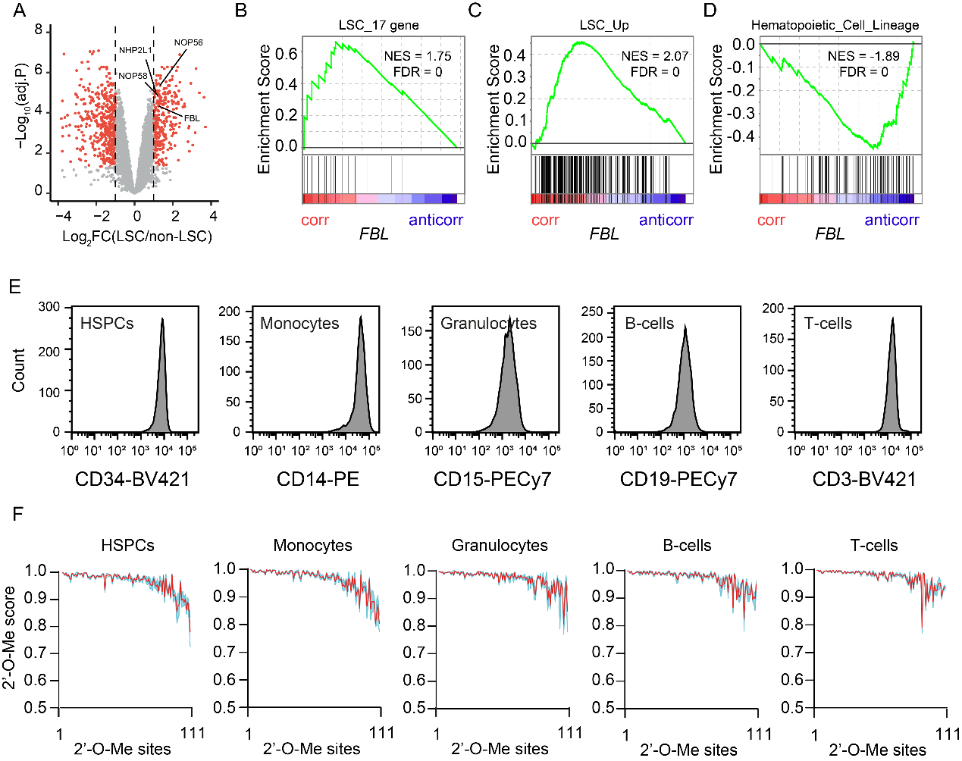

Supplementary Figure S1, The rRNA 2’-O-methylation in leukemia and normal hematopoietic cells.
A, Volcano plot of proteomics data (30) showing that FBL and other C/D box snoRNP protein are overrepresented in functionally validated leukemia stem cells. Data represents 6 populations (3 LSC and 3 non-LSC fractions) from 3 AML patients.
B to D, GSEA analysis of transcript correlated and anticorrelated with FBL mRNA expression. Transcripts correlated with FBL mRNA were enriched for LSC signatures (b and C), the anti-correlated transcripts were enriched for hematopoietic differentiation genes (D). Transcriptome analysis was performed in n = 90 primary AML samples at the time of diagnosis.
E, Purity of each cell type analysed by the indicated lineage surface marker by flow cytometry. CD34⁺ HSPC were isolated from cord blood, Monocytes, Granulocytes, B-cells and T-cells were isolated from peripheral blood.
F, 2’-O-Me on each rRNA modification site in healthy hematopoietic cells. The 111 modification sites were ranked in the same order as for AMLs shown in Fig. 1C.

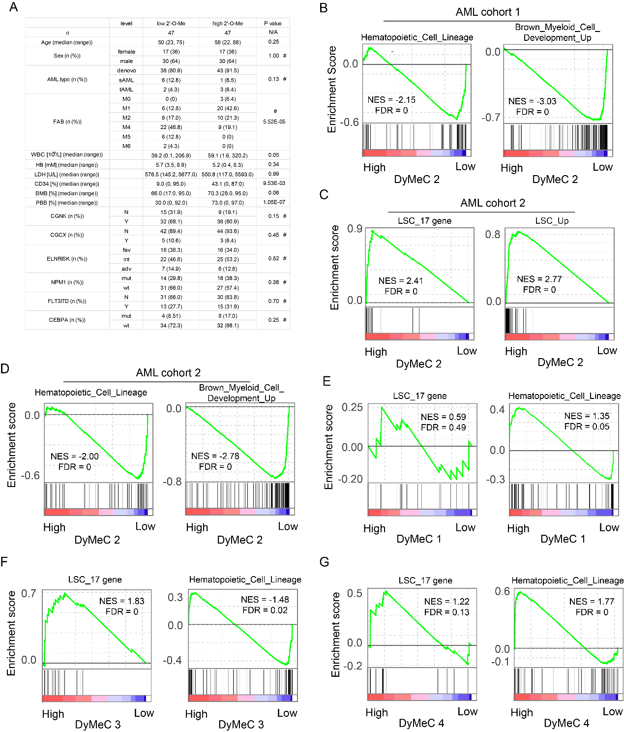
Supplementary Figure S2, Association of rRNA 2’-O-methylation with leukemia stem cells.
A, Clinical characteristics of the 94 patients for rRNA 2’-O-methylation analysis. Patients were grouped according to the total 2’-O-methylation on DyMeC cluster 2. sAML, secondary AML; tAML, therapy-associated AML; CGNK, cytogenetically normal karyotype; CGCX, complex cytogenetic karyotype. P values indicated by Student’s unpaired t-test, #P value by Pearson’s Chi-Square test.
B, GSEA plot showing negative enrichment of hematopoietic differentiation genes in AML patients with higher total rRNA 2’-O-Me on cluster DyMeC 2.
C and D, Confirmation of GSEA analysis with an independent patient cohort containing 18 human AML samples. The samples have been described in our previous study (22), gene expression data is from GSE49642.
E to G, gene expression and GSEA analysis based on methylation of cluster DyMeC 1 (E), DyMeC 3 (F) and DyMeC 4 (G) in AML cohort 1.

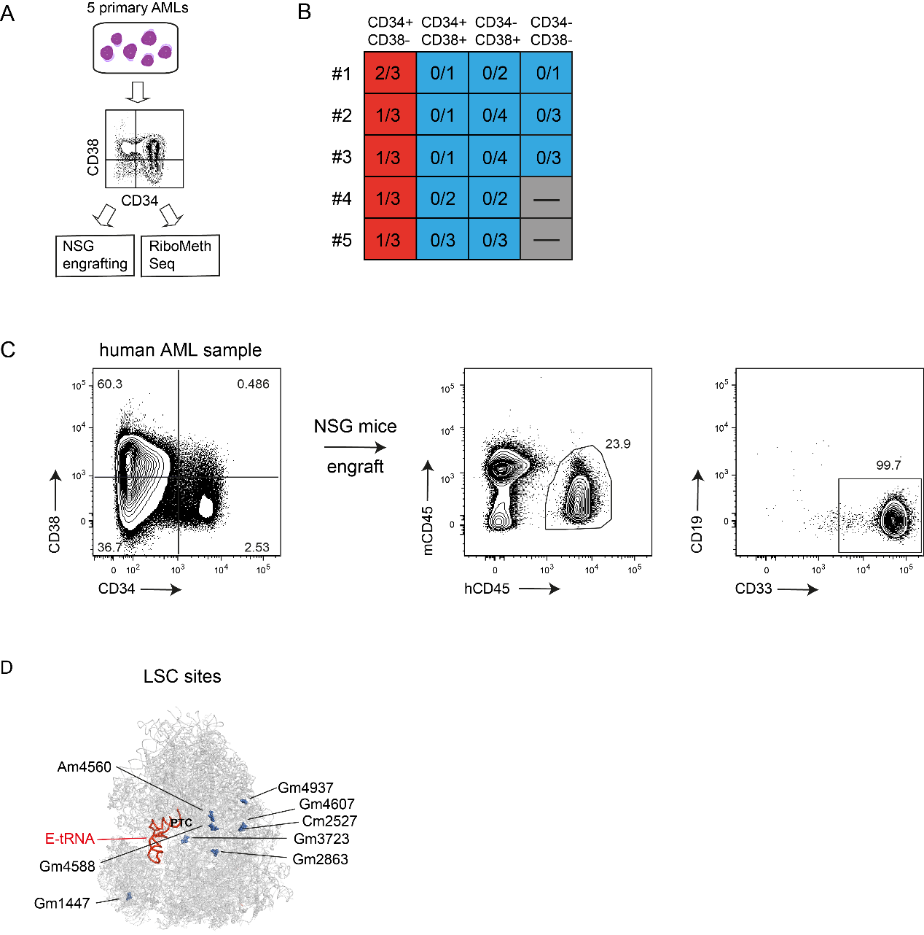
Supplementary Figure S3, Determination of rRNA 2’-O-Me in leukemia stem cells.
A, Experimental scheme for rRNA 2’-O-Me profiling in leukemia stem cells from 5 AML patients.
B, Summary of LSC and non-LSC fractions in CD34/CD38 cell populations of 5 primary AMLs defined by leukemia engraftment in NSG mice. Number is shown as engrafted/total transplanted mice. Sorted fractions were defined as LSC if transplanted cells generated an AML graft in 1 or more mice. The remaining fractions were defined as non-LSC.
C, Example of in vivo engrafting assay. Primary AML samples were sorted into four populations based on CD34 and CD38 expression (pre-gated on live, lineage negative cells). Each population was injected into NSG mice. The engraftment was measured 10–14 weeks after xenotransplantation. LSC population was defined as engraftment of human CD45⁺ cells in mouse bone marrow > 0.5%, with more than 95% of human cells being CD33 positive.
D, Distribution of LSC sites on human ribosome structure (PDB 4UGO).

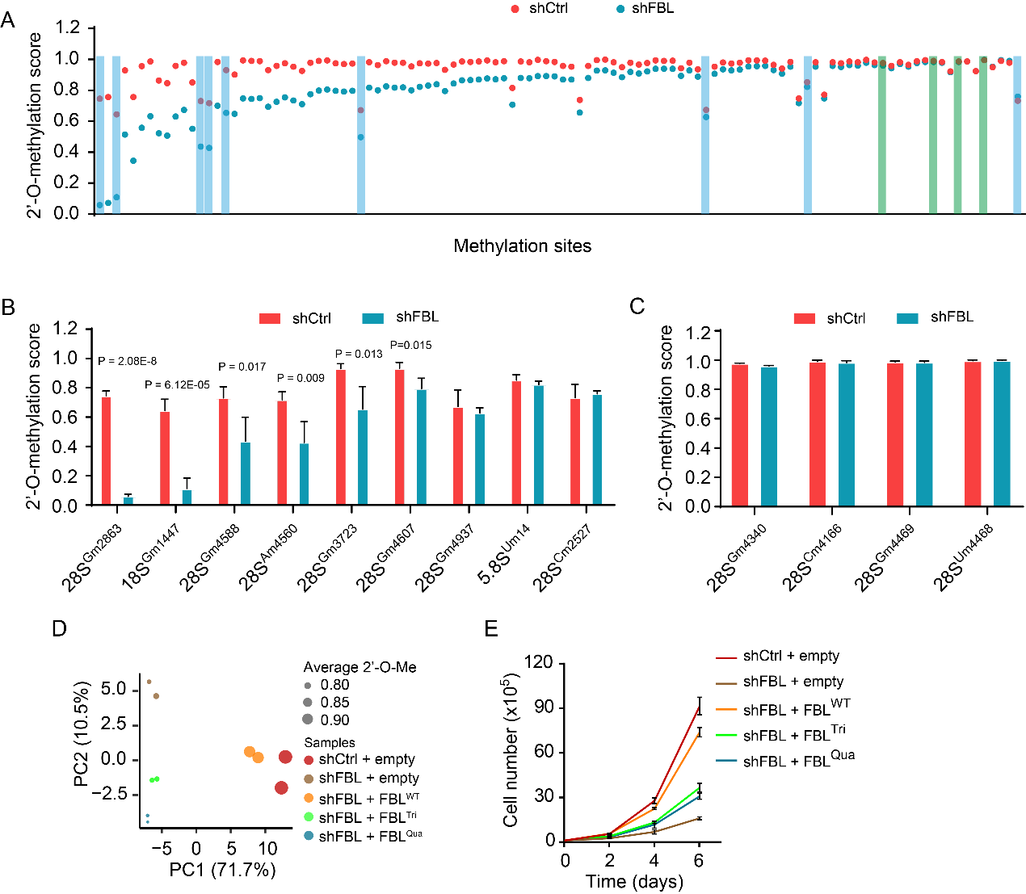
Supplementary Figure S4, FBL knockdown predominantly reduced 2’-O-methylation on LSC sites.
A, 2’-O-methylation score on 111 modification sites in control (shCtrl) and FBL knockdown (shFBL) cells. Sites were ranked based on the change in 2’-O-Me after FBL knockdown. Dots represent the mean value of 2’-O-methylation from 4 samples of two different shRNAs. Blue bars indicate LSC sites and green bars highlight the 4 sites in ribosome core function regions. Experiment was performed in leukemia cell line Kasumi-1.
B and C, Bar charts showing 2’-O-Me level on LSC sites (B) and the 4 sites in ribosome core function regions (C). Data shown as mean with SD of 4 independent experiments; indicated P values by Student’s unpaired t-test.
D, Principle component analysis based on 2’-O-Me. Colour of dots represent different conditions, the size of dots represents the average of overall 2’-O-Me level. n = 2 independent experiments analysed per group.
E, Proliferation of FBL knockdown and rescued cells. Mean ± SD of three independent experiments are given. P value indicated by Student’s t-test. One of four experiment is shown.
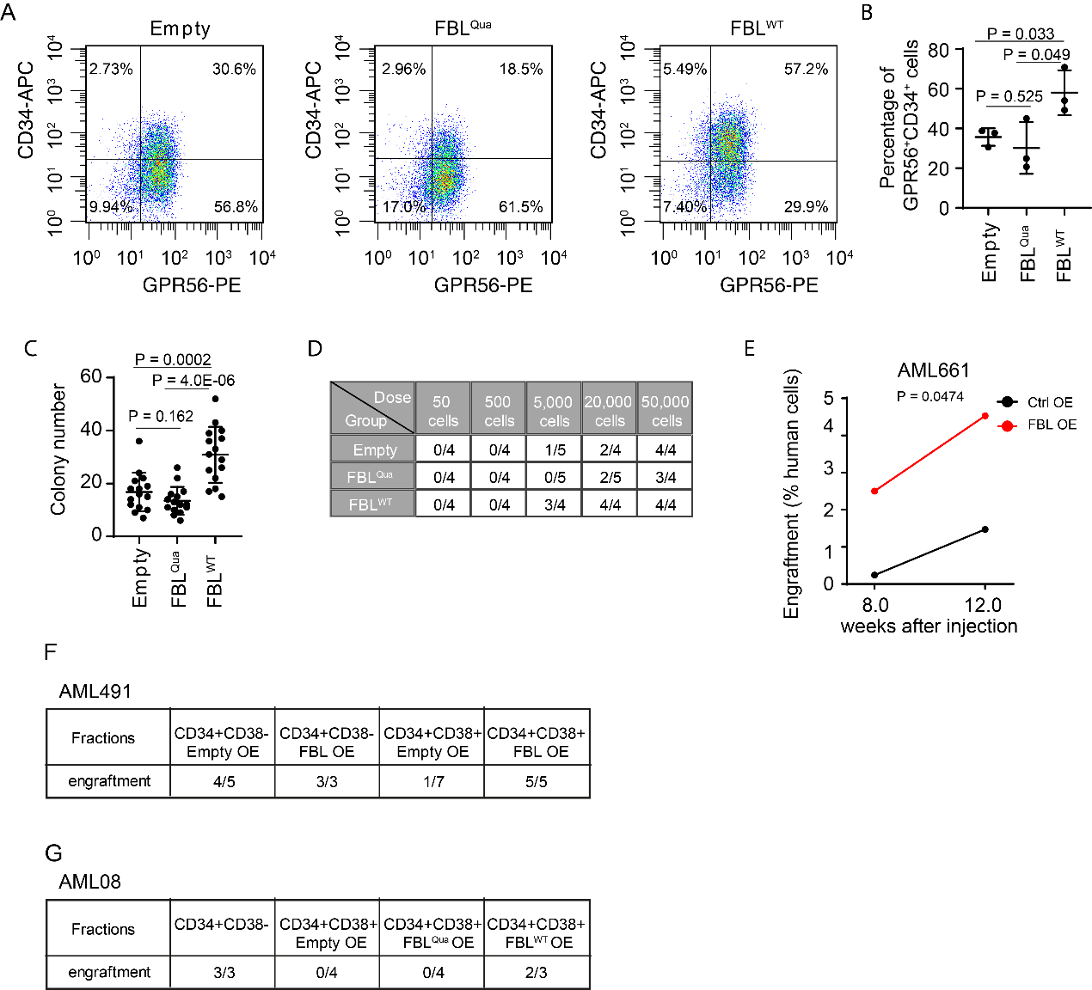
Supplementary Figure S5, 2’-O-methyltransferase regulates AML stemness.
A, Representative flow cytometric analysis of GPR56⁺CD34⁺ PDX cells.
B, Quantification showing percentages of GPR56⁺CD34⁺ PDX cells in the bone marrow of NSG mice receiving PDX cells transduced with empty vector, wildtype and mutant FBL. Each dot represents one mouse. Data shown as mean ± SD; indicated P values by Student’s unpaired t-test.
C, Quantification of colony numbers from PDX cells. Each dot represents one culture of 20,000 cells. PDX cells from 3 animals per group were analysed. Data shown as mean ± SD; indicated P values by Student’s unpaired t-test.
D, Limiting dilution analysis of PDX samples. Indicated dose of each PDX cells were injected into recipient NSG mice, the engrafted/tested number of mice were shown.
E, Engraftment of human primary cells transduced with empty vector or wildtype FBL at 8- and 12-weeks post-transplantation. Mean of n = 4 mice per group is shown. P value indicated by Student’s paired t-test.
F and G, Summary of engraftment of each fraction of AML cells with overexpression of FBL. The LSC enriched CD34⁺CD38⁻ and LSC depleted CD34⁺CD38⁺ PDX cells (F, AML491) and primary AML cells (G, AML08) transduced with indicated vectors were transplanted into NSG mice. The engrafted/total mice are indicated.

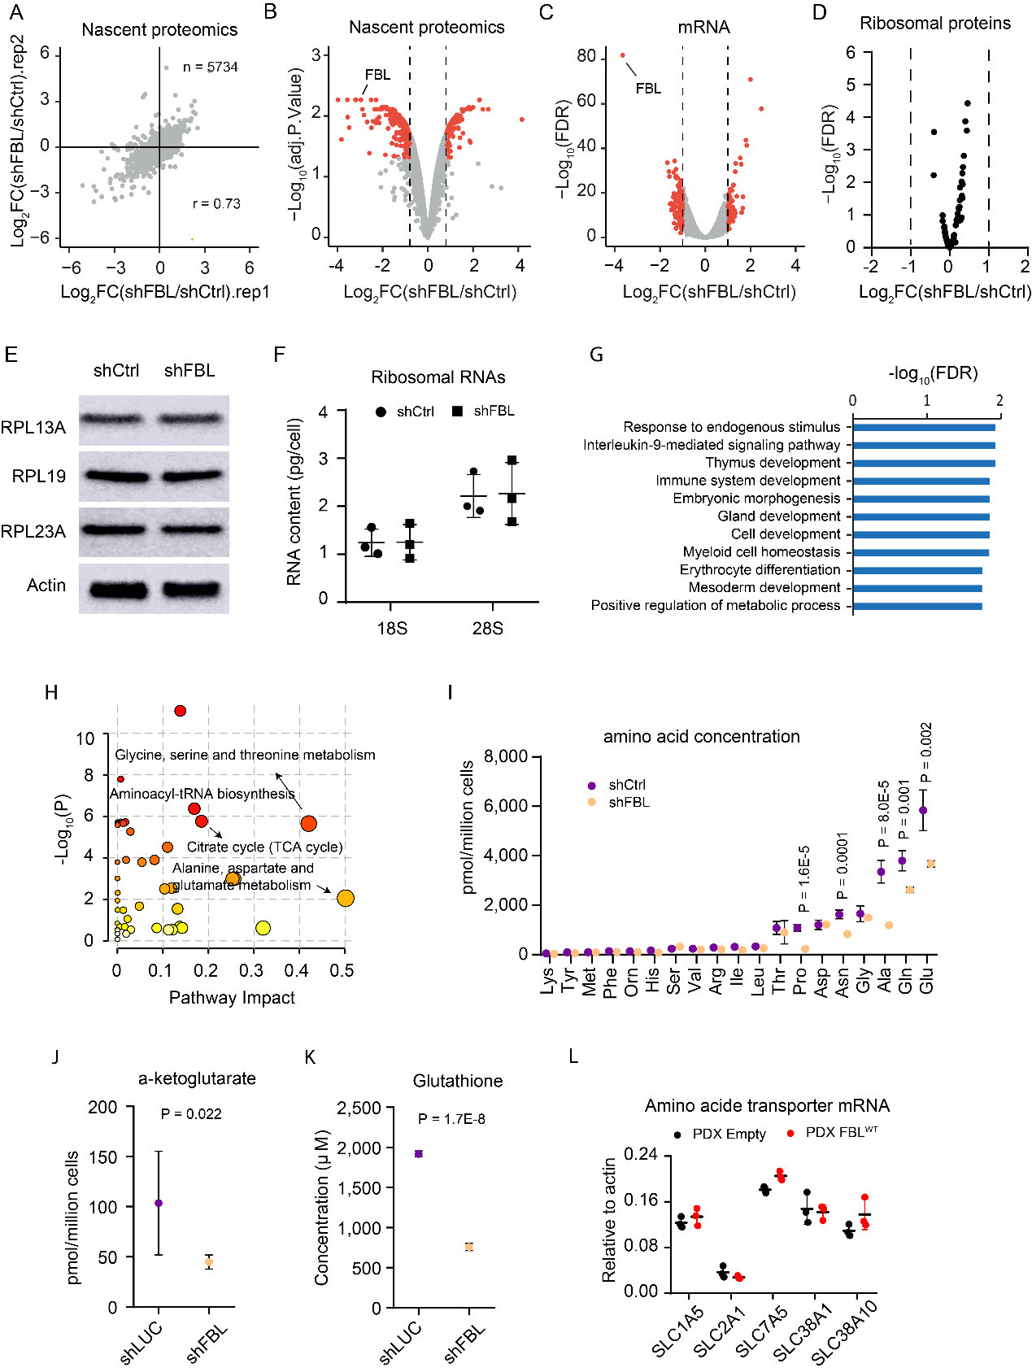
Supplementary Figure S6, Nascent proteomics to identify differentially translated proteins after FBL knockdown.
A, Correlation of two nascent proteomics experiments. Experiments were performed in Kasumi-1 cells. n = 5734 proteins were captured in both experiments, Pearson r = 0.73.
B, Changes in nascent proteins after FBL knockdown. Highlighted in red are nascent proteins with log₂FC ≥ 0.8, adjust P < 0.05. Dashed line indicates log₂FC = 0.8.
C, Changes in transcriptome determined by mRNA-Seq after FBL knockdown. Highlighted in red are differentially expressed genes with log₂FC ≥ 1, FDR < 0.05. Dashed line indicates log₂FC = 1.
D, Volcano plot showing changes of mRNAs coding for ribosomal proteins upon FBL knockdown in Kasumi-1 cells, determined by mRNA-Seq.
E, Western Blot showing total level of indicated ribosomal proteins in control (shCtrl) and FBL knockdown (shFBL) Kasumi-1 cells.
F, Content of 18S and 28S rRNA in control and FBL knockdown Kasumi-1 cells.
G, Gene ontology analysis of proteins with increased translation after FBL knockdown.
H, Metabolic pathways altered by FBL knockdown by metabolite enrichment analysis. n = 5 independent experiments for both of control and FBL knockdown condition.
I, Target analysis for cellular amino acids. n = 4 independent experiments for each condition. Data shown as mean ± SD; indicated P values by Student’s unpaired t-test.
J, Cellular α-ketoglutarate levels. n = 4 independent experiments for control, n = 6 independent experiments for FBL knockdown cells, Data shown as mean ± SD; indicated P values by Student’s unpaired t-test.
K, Cellular glutathione levels. n = 4 independent experiments for each condition, Data shown as mean ± SD; P values indicated by Student’s unpaired t-test.
L, Relative mRNA levels of amino acid transporters in PDX cells expressing empty vector or wildtype FBL. PDX cells were isolated from bone marrow of recipient mice, n = 3 mice for each group. Error bar represents mean ± SD.

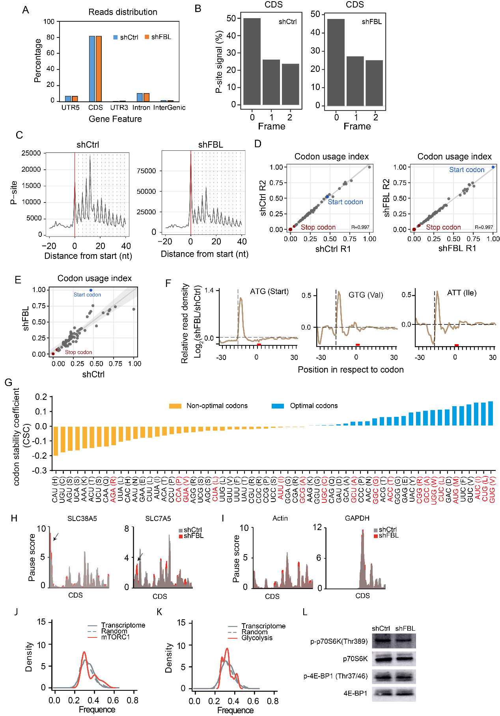

Supplementary Figure S7, FBL knockdown alters codon usage.
A, Distribution of sequencing reads from ribosome profiling. Experiments were performed in Kasumi-1 leukemia cells with (shFBL) and without (shCtrl) FBL knockdown.
B, Percentage of P-sites in the three frames along CDS region.
C, Meta-profiles showing the periodicity of ribosomes along the transcripts on genome-wide scale.
D, Pearson correlation coefficient for the codon usage based on in-frame P-sites between replicates.
E, Comparison of transcriptome-wide P-site codon occupancy between control and FBL knockdown cells.
F, Changes in P-site occupancy on indicated codons after FBL knockdown. The red box indicates position 0, vertical dashed line shows position 15, corresponding to ribosome A-site.
G, Codons with increased ribosome P-site occupancy (labelled in red) are enriched for optimal codons. Optimal and non-optimal codons are defined by previously published codon stability coefficient (CSC) scores derived from human cell HEK293T (40).
H and I, Ribosome pause score on amino acid transporters (H) and housekeeping genes (I).
J and K, Distribution of codons with increased P-site ribosome occupancy in in mTOCR1 pathway genes supressed by FBL knockdown (J) and in glycolysis pathway genes supressed by FBL knockdown (K). The whole transcriptome and 1,000 random selected transcripts were used as background.
L, Western Blot showing phosphorylation on ribosomal protein S6 kinase (p70S6K) and on eukaryotic translation initiation factor 4E-binding protein 1 (4E-BP1) before and after FBL knockdown. Phosphorylation on Thr389 of p70S6K and Thr37/46 of 4E-BP1, the direct targets of mTORC1, was measured. Total p70S6K and 4E-BP1 was used as control.

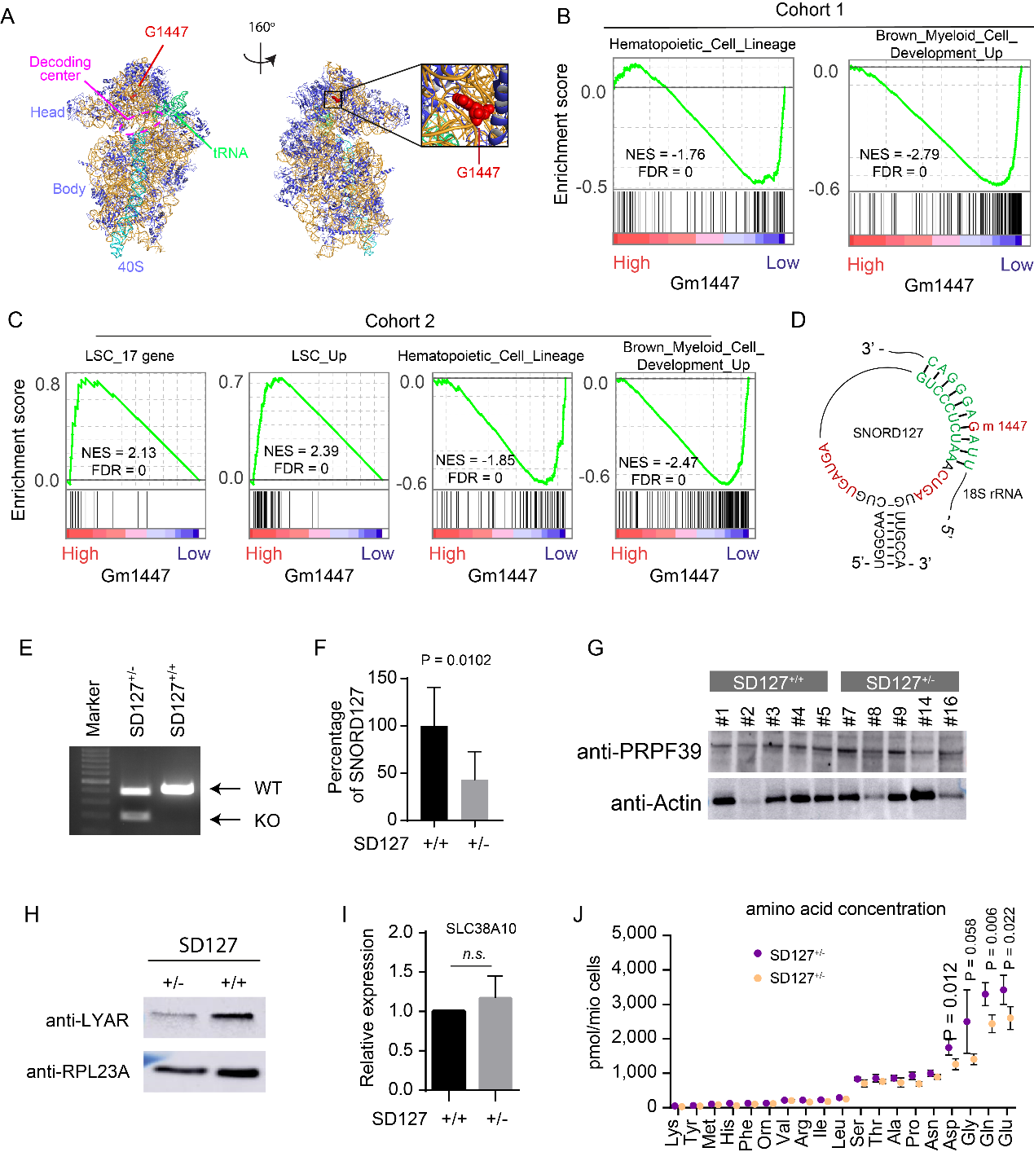
Supplementary Figure S8, Gm1447 is associated with LSC signature.
A, Location of G1447 on human ribosome structure (PDB 4UGO).
B, GSEA plot showing negative enrichment of hematopoietic differentiation genes in patients with higher Gm1447 in AML cohort 1.
C, GSEA analysis in the second AML cohort containing 18 samples.
D, Alignment of SNORD127 guiding sequence with 18S rRNA sequence surrounding G1447. Sequences in red are C/D box motifs.
E, Genotyping PCR showing heterozygous deletion of SNORD127 by CRISPR/Cas9 in Kasumi-1 cells.
F, Real-time PCR showing relative expression of SNROD127 in SNORD127^{+/+} and SNORD127^{+/-} OCI-AML2 cells. n = 6 single clones for SNORD127^{+/+} and n = 8 for SNORD127^{+/-}, Data shown as mean with SD, indicated P values by Student’s unpaired t-test.
G, Western Blot showing protein level of PRPF39 in SNORD127^{+/+} and SNORD127^{+/-} OCI-AML2 single clones, with Actin as internal control.
H, Western Blot showing LYAR from purified 80S ribosome from SNORD127^{+/+} and SNORD127^{+/-} Kasumi-1 cells by sucrose gradient, with RPL23A as internal control.
I, SLC38A10 mRNA level relative to ACTB (Actin) in SNORD127^{+/+} and SNORD127^{+/-} Kasumi-1 single clones, determined by real-time PCR. n = 3 replicates of two single clones.
J, Cellular amino acid concentrations in SNORD127^{+/+} and SNORD127^{+/-} Kasumi-1 cells. n = 4 samples per group. Data shown as mean ± SD, indicated P values by Student’s unpaired t-test.

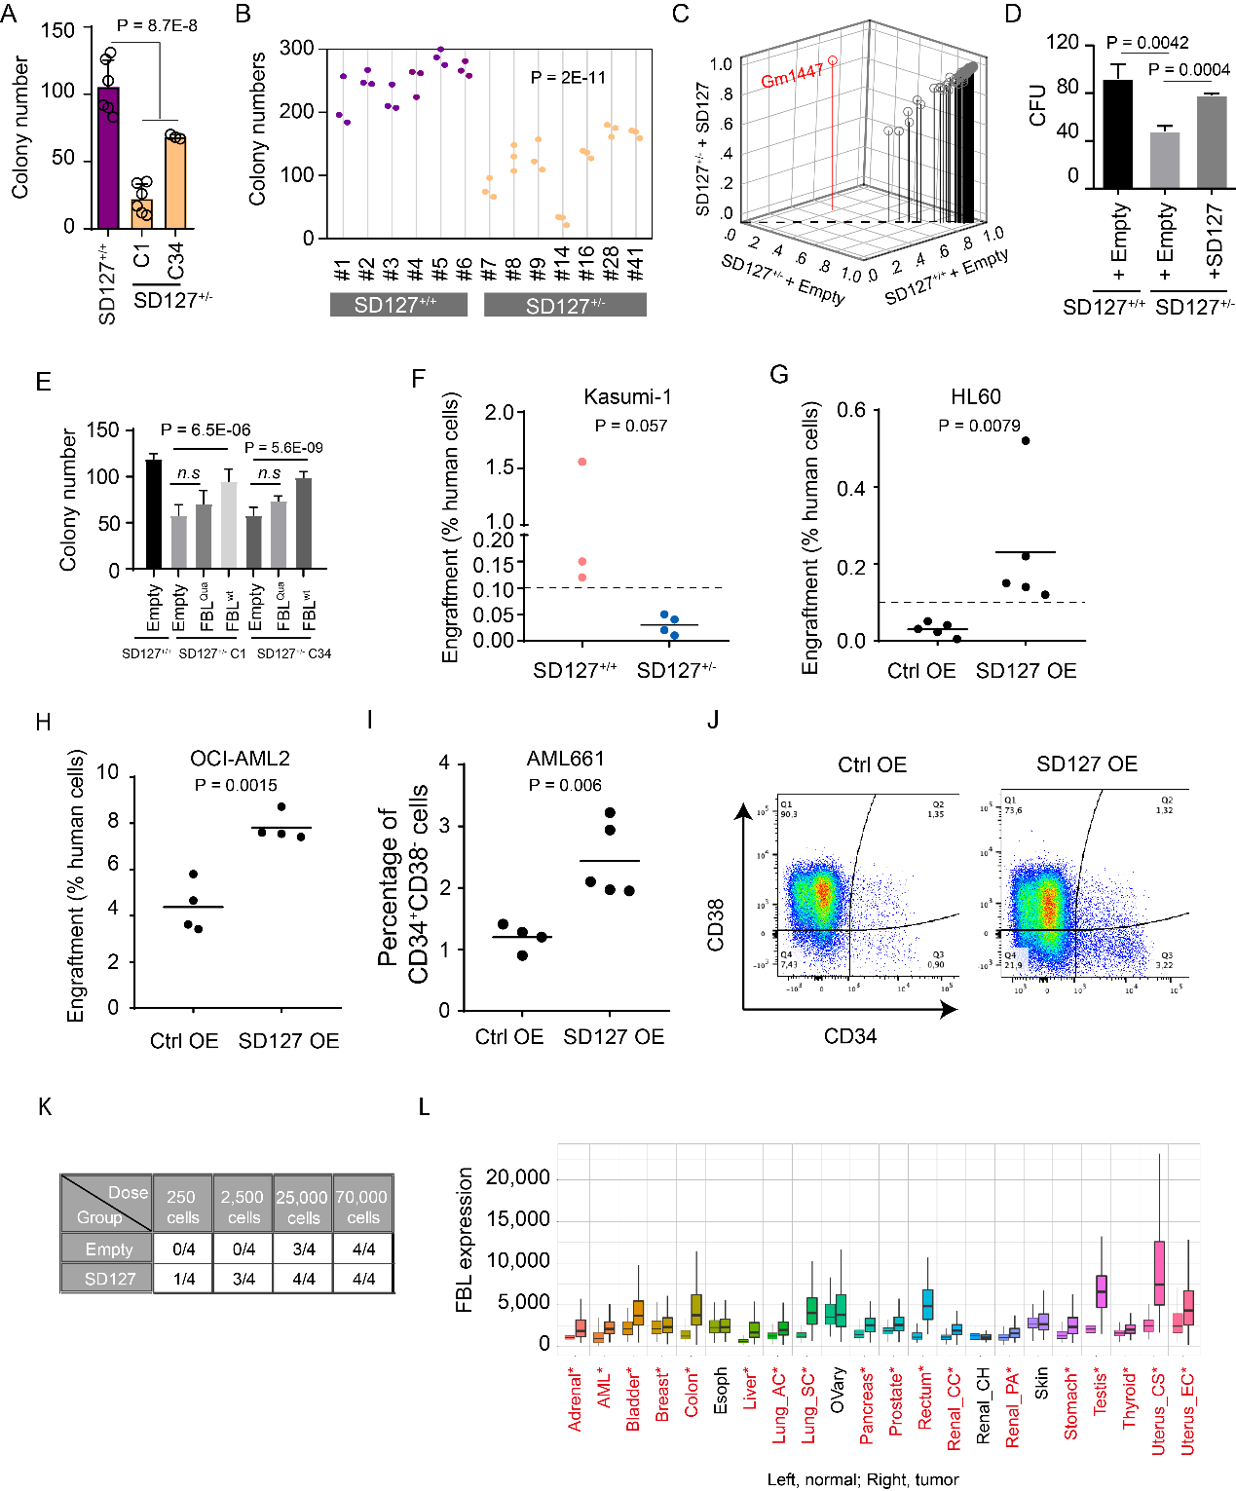
Supplementary Figure S9, SNORD217 mediated Gm1447 promoted leukemia engraftment.
A, Colony formation of SNORD127^{+/+} and its sister SNORD127^{+/-} single clones derived from Kasumi-1 cells. n = 6 cultures for SNORD127^{+/+} and C1 SNORD127^{+/-} clone, n = 3 cultures for C34 SNORD127^{+/-} clone, data shown as mean with SD, indicated P values by Student’s unpaired t-test.
B, Colony formation of SNORD127^{+/+} and SNORD127^{+/-} single clones derived from OCI-AML2 cells. Indicated P values by Student’s unpaired t-test.
C, 2’-O-Me in SNORD127^{+/+} and SNORD127^{+/-} Kasumi-1 cells transduced with empty vector or SNORD127. Deletion and re-expression of SNORD127 only affect 2’-O-Me on G1447.
D, Colony formation of SNORD127^{+/+} and SNORD127^{+/-} Kasumi-1 cells transduced with empty vector or SNORD127. n = 9 cultures from 3 independent experiments. Indicated P values Student’s unpaired t-test.
E, Colony formation of SNORD127^{+/+}, SNORD127^{+/-} Kasumi-1 cells transduced with empty vector, wildtype or mutant FBL. n = 9 cultures from 3 independent experiments. Indicated P values Student’s unpaired t-test.
F, Engraftment of SNORD127^{+/+} and SNORD127^{+/-} Kasumi-1 cells in NSG mice (percentage of leukemia cells among bone marrow cells; each dot represents one mouse; n = 3 mice each group). Dashed line indicates an engraftment of 0.1%.
G and H, Engraftment of HL60 (G) and OCI-AML2 (H) with overexpression of SNORD127 or empty control in NSG mice. Each dot represents one mouse. Short horizonal line indicates mean, indicated P values by Student’s unpaired t-test.
I, Fraction of CD34⁺CD38⁻ leukemia stem cells within all human cells in the bone marrow of NSG mice receiving AML661 transduced with empty vector and SNORD127. Each dot represents one mouse. Short horizonal line indicates mean, indicated P values by Student’s unpaired t-test.
J, Representative flow cytometric analysis of CD34⁺CD38⁻ leukemia stem cells.
K, Limiting dilution analysis of leukemia stem cell frequency in AML494 transduced with empty vector or SNORD127. Indicated dose of AML cells were injected into recipient NSG mice, the engrafted/tested number of mice were shown.
L, Pan-cancer analysis showing FBL expression in tumour and normal tissues. Significant differences by Mann-Whitney U test are marked with red*, data source from https://tnmplot.com/analysis/.

Supplementary table titles.
Supplementary table S1: rRNA 2’-O-methylation sites identified in human AMLs.
Supplementary table S2: rRNA 2’-O-methylation sites in each DyMeC cluster.
Supplementary table S3: Location of rRNA 2’-O-methylation static sites in ribosome regions.
Supplementary table S4: List of proteins with altered translation after FBL knockdown.

