Supplementary Methods:
- MAPPYACTS inclusion/exclusion criteria (protocol V.4.0)
Inclusion criteria:
- Written informed consent signed by the patient, or parents or legal representative and assent of the minor child to perform biopsy/surgery and molecular analysis of the tumor and blood sample
- Patient with confirmed solid tumor or leukemia which is recurrent or refractory to standard treatment and who is eligible for an early phase clinical trial
- In case of solid tumor, lesion must be accessible for biopsy or surgical resection or cytological puncture
- Age: Patients aged ≥ 6 months at time of inclusion and aged ≤ 18 years at the time of initial diagnosis
- Performance status and life expectancy that allows treatment in an experimental trial: Karnofsky performance status scale ≥ 70% for patients > 12 years of age, Lansky play scale ≥ 70% for patients ≤ 12 years of age
- Adequate organ function:
- Adequate hematopoietic function for patients with solid tumor (leukemia patients are excluded from hematological criteria): Haemoglobin >80 g/l (transfusion allowed), Neutrophils>1.0x109/l, Platelets >100 x 109/l. In case of bone marrow involvement: Neutrophils ≥ 0.75 x 109/l (unsupported), Platelet count ≥ 75 x 109/l (unsupported)
- Adequate hepatic function: ALAT/ASAT <2.5 x ULN, Bilirubin ≤1.5 x ULN (in case of tumor involvement of the liver ALAT/ASAT <5 x ULN)
- Adequate renal function: serum creatinemia <1.5 x ULN for age. In case serum creatinine >1.5 ULN according to age, creatinine clearance has to be >70mL/mL/1.73 m2 or glomerular filtration rate measurement >70% of the expected value
- Patients affiliated to a Social Security Regimen or beneficiary of the same as per local regulatory requirements
Exclusion criteria:
- Life expectancy ≤ 3 months
- Symptomatic metastatic CNS disease
- Coagulation disorder that prevents the accomplishment of a biopsy or surgery
- Uncontrolled infections not responsive to antibiotics, antiviral medicines, or antifungal medicines
- Presence of ≥ CTCAE grade 2 toxicity (except alopecia, ototoxicity, lymphopenia which are not excluded if grade 3 or less) due to prior cancer therapy
- Malignant disease other than being treated in this study. Exceptions to this exclusion include the following: malignancies that were treated curatively and have not recurred within 3 years prior to study entry
- Any concurrent illness or laboratory abnormality that in opinion of investigator may interfere with the interpretation of study results, may suppose a risk for the realization of biopsy/surgery, and in the judgment of the investigator would make the patient inappropriate for the study
- Evidence of active viral Hepatitis B or C or known diagnosis of human immunodeficiency virus infection
- In case of leukemia, isolated meningitis relapses are excluded.

- RNAseq Analysis
RNAseq was performed on total mRNA to analyze gene expression. Libraries were prepared with TruSeq mRNA stranded library kits (Illumina, Inc., San Diego, CA, USA). Libraries were sequenced over 2 × 150 bp with a 500 High Output v2 on NextSeq500 (Illumina, Inc., San Diego, CA, USA). Atropos (v1.1.21) was used to trim adapters from fastq files.
The fusion analysis was performed from fastq using two complementary approaches. Firstly, a targeted analysis, using an in-house tool designed to search for well-characterized fusion sequences. The second approach is an exploratory analysis based on 5 tools for fusion transcript detection: Defuse V0.6.2, StarFusion v1.2.0 (STAR v 2.5.4a), Fusion Catcher v1.00, FusionMap (Oshell toolkit v10.0.1.50) and ARRIBA v1.2.0. The final fusion results were obtained by combining the results of the two approaches.

- Mutational load calculation
Sequencing libraries quality was estimated with fastqc and fastqscreen. Reads were mapped with BWA (v0.7.17 with parameters: -M -A 2 -E) onto the Human reference genome assembly hg19/GRCh37. SNVs and small indels were called using GATK3 (Indel Realigner, Base Recalibrator), samtools (fixmate, markdup, mpileup) and Varscan (v2.3.9) from paired normal/tumors bam files. Variant annotation was performed with ANNOVAR using public database releases on 2019.11.07 from 1000 genomes project, Exome Aggregation Consortium, NHLBI-ESP project, Kaviar. Functional prediction of variants was performed using the dataset dbnsfp30a. Questionable somatic variants observed in less than 3 reads, with an allele frequency lower than 0.05, described in 1000 genomes and EXAC databases with a frequency higher than 0.05%, or non-exonic variants were excluded.

- ctDNA analysis
Cell-free DNA extraction, purification and quantification
Circulating cell free DNA (cfDNA) was extracted from 300 µl to 2ml of plasma using QIAamp Circulating Nucleic Acid Kit (Qiagen) with the Qiavac24s system or the QIAamp ccfDNA kit. The procedures were performed according to the protocols recommended by the manufacturer. After extraction, cfDNA concentration was measured by Qubit fluorometric assay (Invitrogen) with dsDNA HS (High Sensitivity) Assay Kit. The total cfDNA concentration per ml of plasma was calculated and indicated in ng/ml of plasma. Its quality was defined by analysis on Fragment Analyzer (AATI) using DNF-477 HS Small Fragment kit with cfDNA quality expressed as the 200 bp fragment fraction.
Library Construction and Exome Capture on ctDNA
cfDNA libraries were constructed without fragmentation using Kapa Library HyperPrer Kit (Kapa Biosystems) with Indexed Adapters included in SeqCap Adaptater Kit A & B or KAPA Unique-Dual Indexed (UDI) (Roche Sequencing). The manufacturer’s protocol was modified with a ligation of 16 hours at 20°C using an adapter:insert molar ratio of 20:1and 9 cycles of Pre-Captured LM-PCR and 99µL of SeqCap EZ Purification Beads (1.8x) was used for Clean-up Amplified Sample Library. Library quantification and quality was determined by Qubit fluorometric assay (Invitrogen) with dsDNA HS (High Sensitivity) Assay Kit and Bioanalyzer agilent 2100 using the High Sensitivity DNA chip.
For exome capture, SeqCap EZ Medexome (Nimblegen Roche Sequencing) was used according to the manufacturer’s protocol. WES using Illumina Hi-seq2500 or NovaSeq 6000 leading to paired-ends (PE) 100x100bp. 8 samples were multiplexed for the exome capture. Expected coverage was 100X for all the samples.
Bioinformatics pipeline:
Following sequencing, the WES raw reads were mapped to the reference human genome assembly GRCh37/hg19 using BWA (v0.7.17, with 2 maximum insert size for read pair and with gap extension penalty of 1; shorter split hits were marked as secondary) for samples analyzed at Gustave Roussy and using Bowtie2 (2.1.0, using global alignment allowing 1 mismatch in seed alignment of size 22 and taking only the alignment with the best score) for samples analyzed at Institut Curie.
Bam files were cleaned with Picard (2.18.13 : SortSam, MarkDuplicates and AddOrReplaceReadGroups) and GATK (3.8-1-0 : RealignerTargetCreator, IndelRealigner, BaseRecalibrator and PrintReads). Coverage was analyzed with GATK DepthOfCoverage using a mapping quality of 6 and a base quality of 20.
Variants were called with GATK (3.8-10) HaplotypeCaller and UnifiedGenotyper with the same quality parameters mentioned before. The results of calling were combined , taking preferentially the output of HaplotypeCaller in case of variants called by both tools. The variants were annotated with annovar-2018Apr16 (RefSeq, COSMIC v86, 1000g2014Oct, Esp6500si, dbsnp137, ljb26_all). Variants with population frequency > 0.01%, a quality < 30, intronic variants and synonymous_SNV (except those with a cosmic ID) were filtered out.
For this analysis, variants were considered as somatic if they had a coverage ≥ 20X and if they were supported by at least 2 reads in tumor or plasma and no reads in germline.
Copy number profiles were generated with the following tools: the combination of VarScan (v2.4.3) and DNAcopy (v1.52.0), FACETS (v0.5.11) and with Sequenza (v 3.0.0). The overall tumoral fraction (ctDNA in cfDNA content) was estimated with FACETS and Sequenza.
Following variant calling, IGV images for all variants were generated with IGV (v2.4.14) and all were visually inspected and validated by biologists.
# CMTB PART:
An additional analysis was done to investigate a list of variations targetable by drugs, as identified in the CMTB. We wanted to know if we were able to find the targetable alterations identified in the primary tumors and highlighted by the CMTB in the ctDNA analysis.

Supplementary Tables
Demographic Category
Patients | N = 774
Age at inclusion, years  Median  (IQ90; range) | 11.6  (2.2-19.8; 0.5-38.5)
Sex (%)  Male  Female | 59%  41%
Number of relapse/progression at inclusion  Median  (IQ90; range) | 1  (1-4; 1-10)
Time since initial cancer diagnosis, years  Median  (IQ90; range) | 1.8  (0.4-9.0; 0.1-32.0)
Cancer type
SARCOMAS  Osteosarcoma  Ewing sarcoma  BCOR/CIC sarcoma  Other bone sarcoma  Rhabdomyosarcoma (RMS)  Non-RMS soft tissue sarcoma (NRSTS) | 290 (37%)
 | 79
 | 71
 | 6
 | 1
 | 70
 | 63
OTHER SOLID TUMORS | 181 (23%)
Neuroblastoma | 104
Carcinoma | 29
Wilms tumor | 27
Hepatoblastoma | 8
Other solid tumors | 13
CNS TUMORS | 216 (28%)
High-grade glioma | 59
Low-grade glioma | 23
Medulloblastoma | 52
Ependymoma | 34
ATRT | 10
CNS-Germ cell tumor | 7
Choroid plexus carcinoma | 6
Other CNS tumors | 23
LEUKEMIA | 54 (7%)
B-ALL | 20
T-ALL | 14
AML | 17
Other leukemia | 3
LYMPHOMA | 33 (4%)
Hodgkin lymphoma | 6
Anaplastic large-cell lymphoma | 15
Other non-Hodgkin lymphoma | 12
Supplementary Table 1: Patient’s characteristics. CNS: central nervous system, DSRCT: desmoplastic small round cell tumor, MPNST: malignant peripheral nerve sheath tumor, NOS: non-other specified.

Patient | Initial diagnosis | Diagnostic revision | Reason modification
1 | Osteosarcoma | Mesenchymal chondrosarcoma | HEY1/NCOA2 fusion
2 | MPNST | Rhabdomyosarcoma | VGLL2/NCOA2 fusion
3 | IMT ALK neg | Undifferentiated sarcoma | ETV6/NTRK3 fusion
4 | Ependymoma | CNS HGNET-MN1 | MN1-BEND2 fusion
5 | Pleuropulmonary blastoma | Fœtal adenocarcinoma of the lung | Pathology report
6 | Ependymoma | CNS-HGNET-BCOR | ITD/BCOR
7 | Neuroepitelial tumor | Ependymoma | C11orf95/RELA fusion
8 | Hepatoblastoma | Hepatocarcinoma | Pathology report
9 | Low grade glioma | High grade glioma | Pathology report
10 | Astroblastoma | CNS HGNET-MN1 | MN1/BEND2 fusion
11 | High grade glioma | CNS HGNET-MN1 | MN1/CXXC5 fusion
12 | Synovial sarcoma | Undifferentiated sarcoma | Pathology report + absence of SS18-SSX fusion
Supplementary Table 2A: Revision of initial diagnosis of patients included in the MAPPYACTS trial, n=11. MPNST: malignant peripheral nerve sheath tumor, IMT: inflammatory myofibroblastic tumor.

Patient | Initial diagnosis | Second cancer | RT related | Delay 1st-2nd tumor
13 | Osteosarcoma | Sarcoma - undifferentiated | No | 20 years
14 | Medulloblastoma | Glioblastoma | Yes | 7 years
15 | Pinealoblastoma | Glioblastoma | Yes | 7 years
16 | Medulloblastoma | Glioblastoma | Yes | 10 years
17 | ETANTR | Osteosarcoma | Yes | 7 years
18 | Medulloblastoma | High grade glioma | Yes | 9 years
19 | Medulloblastoma | Glioblastoma | Yes | 7 years
Supplementary Table 2B: Secondary malignancies, n=7. ETANTR: Embryonal tumor with abundant neuropil and true rosettes.

Therapy | Tumor type | Previously reported ORR | MAPPYACTS | Known prior to MAPPYACTS
ALK inhibitors in ALK gene-fusion positive tumors | ALCL | Crizotinib: 88% (1)  Ceritinib: 75% ORR (2) | 9 patients | 9/9 patients
 | IMT | Crizotinib: 86% (1)  Ceritinib: 70% ORR (2) | 1 patient | 1/1 patient
BRAF inhibitors in BRAF V600E mutated tumors | LGG | Dabrafenib: 44% ORR (3) | 0 patients | NA
 | HGG | Dabrafenib: 39% ORR (4) | 4 patients | 3/4 patients
MEK inhibitors in BRAF-KIAA1549 fusion positive tumors | LGG (BRAF fusion) | Selumetinib: 39% ORR (5) | 10 patients | 5/10 patients
MEK inhibitors in NF1 related tumors | LGG (NF1 related tumors) | Selumetinib: 40% ORR (5) | 2 patients | 2/2 patients
NTRK inhibitors in NTRK fusion positive tumors | Extracranial tumors | Larotrectinib: 92% ORR (6)  Entrectinib: 100% (7) | 2 patients | 1/2 patients
 | CNS tumors | Larotrectinib: 45% ORR (8)  Entrectinib: 75% ORR (7) | 7 patients | 1/7 patients
RET inhibitors in RET fusion positive tumors | Several tumor types | Selpercatinib: 100% ORR (9) | 1 patient | 0/1 patient
SMO inhibitors in PTCH1 mut/del (TP53/SMO wildtype) tumors | Medulloblastoma | Sonidegib* : 50% ORR (10) | 4 patients | 1/4 patients
ROS1 inhibitors in ROS1 fusion positive tumors | Several tumor types | Crizotinib: 100% (11)  Entrectinib: 100% (7) | 2 patients | 0/2 patients
PDGFB inhibitors in COL1A1/PDGFB fusion positive tumors | Dermatofibrosarcoma protuberans | Imatinib: 92/148 (62%) | 1 patient | 1/1 patient
IDH1 inhibitors in IDH1mut tumors | Acute myeloid leukemia | Ivosidenib: 42% (12) | 1 patient | 1/1 patient
Supplementary Table 3: Patients with genomic alterations considered as “ready for use” (with reported ORR > 30%) in children/adolescents with relapse/refractory malignancies. ALCL: anaplastic large-cell lymphoma, IMT: inflammatory myofibroblastic tumor, LGG: low-grade glioma, HGG: high-grade glioma).
1. Mossé YP, Voss SD, Lim MS, Rolland D, Minard CG, Fox E, et al. Targeting ALK With Crizotinib in Pediatric Anaplastic Large Cell Lymphoma and Inflammatory Myofibroblastic Tumor: A Children’s Oncology Group Study. J Clin Oncol. octubre de 2017;35(28):3215-21.
2. Schulte JH, Moreno L, Ziegler DS, Marshall LV, Zwaan CM, Irwin M, et al. Final analysis of phase I study of ceritinib in pediatric patients with malignancies harboring activated anaplastic lymphoma kinase (ALK). J Clin Oncol. 20 de mayo de 2020;38(15_suppl):10505-10505.
3. Hargrave DR, Bouffet E, Tabori U, Broniscer A, Cohen KJ, Hansford JR, et al. Efficacy and Safety of Dabrafenib in Pediatric Patients with BRAF V600 Mutation–Positive Relapsed or Refractory Low-Grade Glioma: Results from a Phase I/IIa Study. Clin Cancer Res. 15 de diciembre de 2019;25(24):7303-11.
4. Hargrave DR, Moreno L, Broniscer A, Bouffet E, Aerts I, Andre N, et al. Dabrafenib in pediatric patients with BRAF V600–positive high-grade glioma (HGG). J Clin Oncol. 2018;36(15_suppl):10505-10505.
5. Fangusaro J, Onar-Thomas A, Young Poussaint T, Wu S, Ligon AH, Lindeman N, et al. Selumetinib in paediatric patients with BRAF-aberrant or neurofibromatosis type 1-associated recurrent, refractory, or progressive low-grade glioma: a multicentre, phase 2 trial. Lancet Oncol. julio de 2019;20(7):1011-22.
6. Hong DS, DuBois SG, Kummar S, Farago AF, Albert CM, Rohrberg KS, et al. Larotrectinib in patients with TRK fusion-positive solid tumours: a pooled analysis of three phase 1/2 clinical trials. Lancet Oncol. abril de 2020;21(4):531-40.
7. Robinson GW, Gajjar AJ, Gauvain KM, Basu EM, Macy ME, Maese LD, et al. Phase 1/1B trial to assess the activity of entrectinib in children and adolescents with recurrent or refractory solid tumors including central nervous system (CNS) tumors. J Clin Oncol. 2019;37(15_suppl):10009-10009.
8. Drilon AE, DuBois SG, Farago AF, Geoerger B, Grilley-Olson JE, Hong DS, et al. Activity of larotrectinib in TRK fusion cancer patients with brain metastases or primary central nervous system tumors. J Clin Oncol. 2019;37(15_suppl):2006-2006.
9. Ortiz MV, Gerdemann U, Raju SG, Henry D, Smith S, Rothenberg SM, et al. Activity of the Highly Specific RET Inhibitor Selpercatinib (LOXO-292) in Pediatric Patients With Tumors Harboring RET Gene Alterations. JCO Precis Oncol. septiembre de 2020;(4):341-7.
10. Kieran MW, Chisholm J, Casanova M, Brandes AA, Aerts I, Bouffet E, et al. Phase I study of oral sonidegib (LDE225) in pediatric brain and solid tumors and a phase II study in children and adults with relapsed medulloblastoma. Neuro-Oncol. 19 de octubre de 2017;19(11):1542-52.
11. . Vassal G, Faivre L, Geoerger B, Plantaz D, Auvrignon A, Coze C, et al. Crizotinib in children and adolescents with advanced ROS1, MET, or ALK-rearranged cancer: Results of the AcSé phase II trial. J Clin Oncol 2016 3415suppl 11509-11509.
12. DiNardo CD, Stein EM, de Botton S, Roboz GJ, Altman JK, Mims AS, et al. Durable Remissions with Ivosidenib in IDH1 -Mutated Relapsed or Refractory AML. N Engl J Med. 21 de junio de 2018;378(25):2386-98.
13. Navarrete-Dechent C, Mori S, Christopher A Barker C, et al. Imatinib Treatment for Locally Advanced or Metastatic Dermatofibrosarcoma Protuberans: A Systematic Review. JAMA Dermatol . 2019 Mar 1;155(3):361-369.

Supplementary Figures
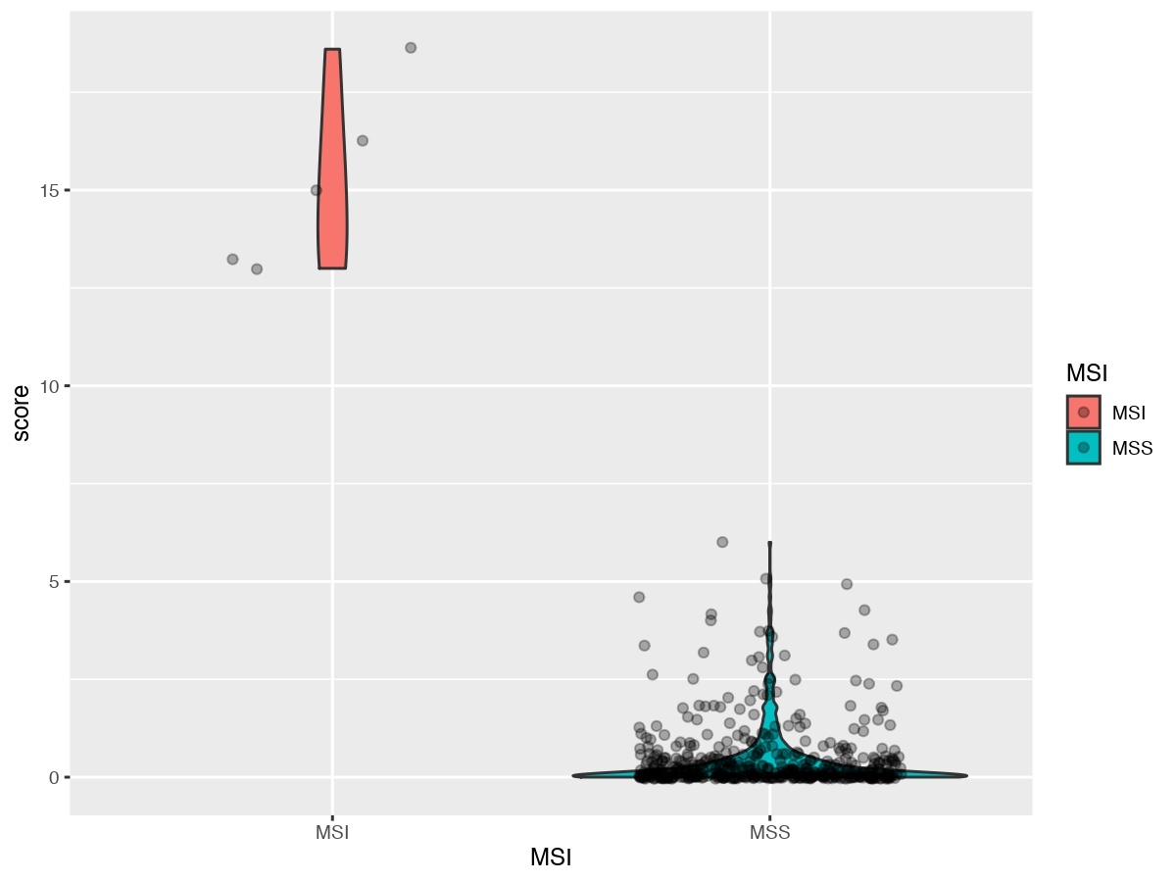
Supplementary Figure 1: Microsatellite instability (MSI) score violin.

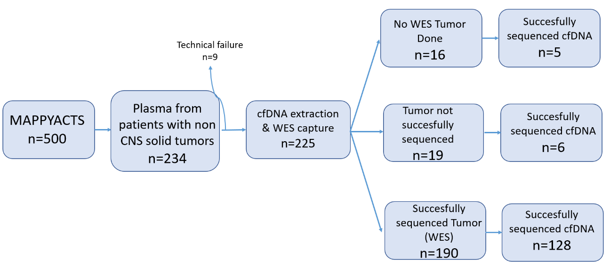
Supplementary Figure 2: cfDNA (circulating free DNA) ancillary study workflow. WES: whole exome sequencing.

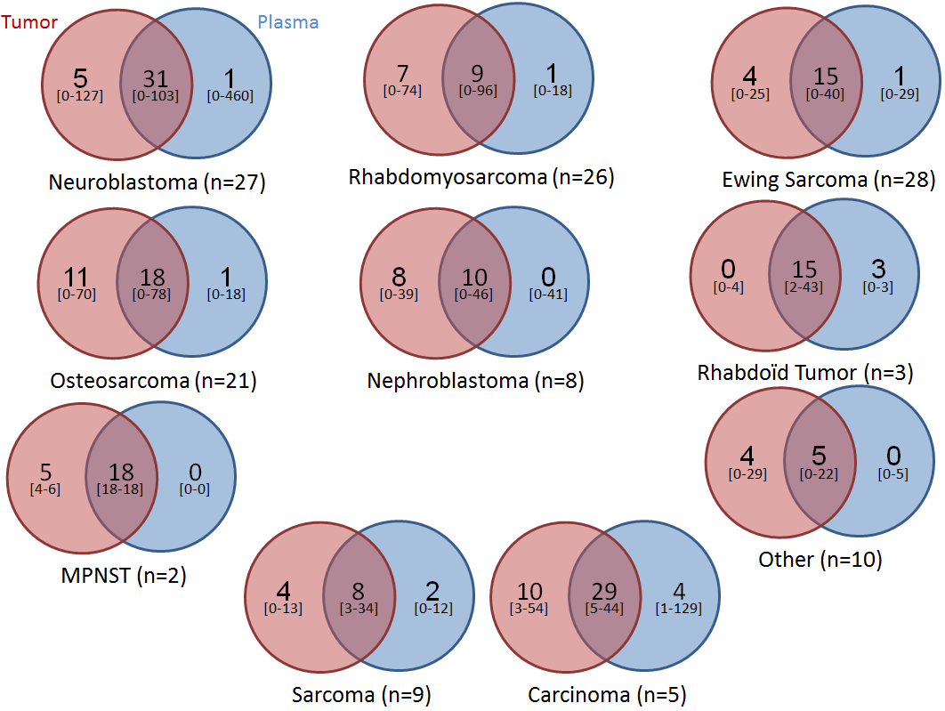
Supplementary Figure 3: Venn-Diagram of SNVs detected in each type of samples.

