SUPPLEMENTARY APPENDIX
Supplementary Methods . . . . . . . . . . . . . . . . . . . . . . . . . . . . . . . . . . . . . . . . . . . . . . . . . . . . . . . . . . . . . . . . . . 2
Supplementary References . . . . . . . . . . . . . . . . . . . . . . . . . . . . . . . . . . . . . . . . . . . . . . . . . . . . . . . . . . . . . . . .4
Supplementary Table 1: Association of ORR with F1(CDx) TMB cutoff . . . . . . . . . . . . . . . . . . . . . . . . . . . . . 5
Supplementary Table 2: Responses in patients with F1(CDx) TMB ≥16 mut/Mb tumors enrolled per MyPathway protocol version 4 and 5 . . . . . . . . . . . . . . . . . . . . . . . . . . . . . . . . . . . . . . . . . . . . . . . . . . . . . . . . 6
Supplementary Table 3: Locally assessed TMB assays at enrollment . . . . . . . . . . . . . . . . . . . . . . . . . . . . . . .7
Supplementary Table 4: Agreement in local CLIA versus central F1(CDx) TMB testing . . . . . . . . . . . . . . . . 8
Supplementary Table 5: Clinical outcomes by MSI status . . . . . . . . . . . . . . . . . . . . . . . . . . . . . . . . . . . . . . . .9
Supplementary Table 6: Mutations in differentially mutated genes by F1(CDx) TMB and MSI group . . . 10
Supplementary Table 7: Responses in patients with F1(CDx) TMB ≥16 mut/Mb tumors by PD-L1 and MSI status . . . . . . . . . . . . . . . . . . . . . . . . . . . . . . . . . . . . . . . . . . . . . . . . . . . . . . . . . . . . . . . . . . . . . . . . . . . . . . . . . 17
Supplementary Table 8: Real-world incidence of tumors by F1(CDx) TMB cutoff level and tumor type . 18
Supplementary Table 9: Clinical outcomes by tumor type in patients with F1(CDx) TMB ≥10 and <16 mut/Mb tumors . . . . . . . . . . . . . . . . . . . . . . . . . . . . . . . . . . . . . . . . . . . . . . . . . . . . . . . . . . . . . . . . . . . . . . . . .19
Supplementary Table 10: Clinical outcomes by tumor type in patients with TMB by any CLIA assay . . . .20
Supplementary Table 11: Most common treatment-related TEAEs . . . . . . . . . . . . . . . . . . . . . . . . . . . . . . .21
Supplementary Figure 1: MyPathway study design . . . . . . . . . . . . . . . . . . . . . . . . . . . . . . . . . . . . . . . . . . . .22
Supplementary Figure 2: Patient disposition . . . . . . . . . . . . . . . . . . . . . . . . . . . . . . . . . . . . . . . . . . . . . . . . . 23
Supplementary Figure 3: Correlation of ORR with F1(CDx) TMB cutoff . . . . . . . . . . . . . . . . . . . . . . . . . . . .24
Supplementary Figure 4: Local non-F1(CDx) CLIA TMB assay versus central F1(CDx) TMB testing . . . . . .25
Supplementary Figure 5: Time on treatment in patients with any CLIA TMB testing . . . . . . . . . . . . . . . . .27
Supplementary Figure 6: Progression-free and overall survival in efficacy-evaluable patients with any CLIA TMB testing . . . . . . . . . . . . . . . . . . . . . . . . . . . . . . . . . . . . . . . . . . . . . . . . . . . . . . . . . . . . . . . . . . . . . . . .29
Supplementary Figure 7: Progression-free and overall survival in efficacy-evaluable patients by F1(CDx) TMB and MSI status . . . . . . . . . . . . . . . . . . . . . . . . . . . . . . . . . . . . . . . . . . . . . . . . . . . . . . . . . . . . . . . . . . . . . 30
Supplementary Figure 8: MSI and PD-L1 status groups in F1(CDx) TMB ≥16 mut/Mb tumors . . . . . . . . . 32
Supplementary Figure 9: Progression-free and overall survival in efficacy-evaluable patients by F1(CDx) TMB and POLE/POLD1 mutation status . . . . . . . . . . . . . . . . . . . . . . . . . . . . . . . . . . . . . . . . . . . . . . . . . . . . . 33
Supplementary Figure 10: Tumor groups in efficacy-evaluable patients with any CLIA TMB testing . . . . 35
Supplementary Figure 11: Computed tomography scans of a patient with biliary cancer and TMB ≥16 mut/Mb . . . . . . . . . . . . . . . . . . . . . . . . . . . . . . . . . . . . . . . . . . . . . . . . . . . . . . . . . . . . . . . . . . . . . . . . . . . . . . . 36

Supplementary Methods
Estimated confirmed ORR adjusted by prior number of lines of therapy and gender
Some imbalances were observed in the prior number of lines of therapy and gender between patient cohorts with TMB ≥16 mut/Mb versus TMB ≥10 and <16 mut/Mb tumors at baseline. To adjust the estimate of confirmed ORR to account for these imbalances, we estimated the variable importance parameter (1), where the binary variable of interest was whether or not a patient had a TMB ≥16 mut/Mb tumor. We then estimated ORR for the population of patients with TMB ≥16 mut/Mb tumors assuming gender and number of prior lines of therapy were distributed as in the broader population of patients with TMB ≥10 mut/Mb tumors by applying a targeted maximum likelihood estimator (TMLE) (2) and choosing the best linear model, including those with interactions, via ten-fold cross-validation for the initial fits in the TMLE process.
Patients enrolled per MyPathway protocol versions 4 and 5
The MyPathway atezolizumab arm opened on February 6, 2017 (protocol version 4) as an early signal-seeking cohort for patients with tumors characterized by MSI-H, alterations of genes associated with DNA mismatch-repair genes, PD-L1 amplification, and/or TMB-H. Patients enrolled per protocol versions 4 and 5 were assessed using CTCAE 4.0 for safety and Immune-Modified Response Evaluation Criteria in Solid Tumors (imRECIST) for efficacy. On August 29, 2018 (protocol version 6), the MyPathway atezolizumab arm criteria were modified for registrational intent, with patients assessed using CTCAE 5.0 and RECIST v1.1. Furthermore, the collection of archival tissue for central TMB re-testing and radiographic scans for independent central review were required per protocol version 6, but not versions 4 or 5. Due to these differences in enrollment and assessment criteria, only patients enrolled per protocol versions 6 and beyond were included in the current report.
An ad hoc analysis of the early MyPathway atezolizumab cohort reaffirmed activity in a variety of tumor types with TMB ≥16 mut/Mb with both MSI-H and MSI-SL status, and limited activity in tumors with TMB <16 mut/Mb, similar to the results observed in the primary efficacy analysis population. However, comparisons of the protocol 4 and 5 versus protocol 6+ data sets are limited by the lack of archival tissue collected for central TMB re-testing, the lack of scans collected for independent central review, the use of CTCAE 4 versus 5 for safety, and differences between imRECIST and RECIST v1.1 criteria for tumor evaluations. Key changes in imRECIST criteria (compared with RECIST v1.1) for best overall response included allowance for an objective response or SD measurement after an initial assessment of PD, and modifications in the definitions of PD for new lesions and non-target lesions.
Real-world incidence of tumors by F1(CDx) TMB cutoff level and tumor type
Real-world incidence of tumors by F1(CDx) TMB cutoff level in the pan-tumor population was determined from the nationwide (US-based) de-identified Flatiron Health-Foundation Medicine Clinico-Genomic Database (FH-FMI CGDB) through June 2021, which includes longitudinal clinical data derived from electronic health records (EHR), curated via technology-enabled abstraction, from approximately 280 US cancer clinics (~800 sites of care), and linked to genomic data derived from FMI comprehensive genomic profiling tests by de-identified, deterministic matching (3,4). Patients with either a “TMB reported score” or “TMB RUO score” in CGDB were included in the analysis, prioritizing the RUO score if both existed. Tumor groups were determined from the disease-specific schema in the CGDB. MSI high or stable status was determined in patients with an “MSI reported score” or “MSI raw score” (if the patient did not have an MSI reported score).
Supplementary References
- van der Laan MJ. Statistical inference for variable importance. Int J Biostat 2006;2(1).
- van der Laan M, Gruber S. One-step targeted minimum loss-based estimation based on universal least favorable one-dimensional submodels. Int J Biostat 2016;12(1):351–78.
- Frampton GM, Fichtenholtz A, Otto GA, Wang K, Downing SR, He J, et al. Development and validation of a clinical cancer genomic profiling test based on massively parallel DNA sequencing. Nat Biotechnol 2013;31(11):1023–31.
- Singal G, Miller PG, Agarwala V, Li G, Kaushik G, Backenroth D, et al. Association of patient characteristics and tumor genomics with clinical outcomes among patients with non-small cell lung cancer using a clinicogenomic database. JAMA 2019;321(14):1391–9.

Supplementary Table 1: Association of ORR by F1(CDx) TMB cutoff

F1(CDx) TMB cutoff  mut/Mb | n/n | ORR, % (95% CI) | MSI status of respondersª | POLE/POLD1 status of responders^{b}
10 | 17/90 | 18.9 (11.4–28.5) | MSI-H, n=6  MSI-SL, n=9 | POLE/POLD1 mutated, n=2  POLE/POLD1 MND, n=15
13 | 16/56 | 28.6 (17.3–42.2) | MSI-H, n=6  MSI-SL, n=9 | POLE/POLD1 mutated, n=2  POLE/POLD1 MND, n=14
16 | 16/42 | 38.1 (23.6–54.4) | MSI-H, n=6  MSI-SL, n=9 | POLE/POLD1 mutated, n=2  POLE/POLD1 MND, n=14
19 | 15/34 | 44.1 (27.2–62.1) | MSI-H, n=6  MSI-SL, n=8 | POLE/POLD1 mutated, n=2  POLE/POLD1 MND, n=13
22 | 15/29 | 51.7 (32.5–70.6) | MSI-H, n=6  MSI-SL, n=8 | POLE/POLD1 mutated, n=2  POLE/POLD1 MND, n=13
25 | 15/25 | 60.0 (38.7–78.9) | MSI-H, n=6  MSI-SL, n=8 | POLE/POLD1 mutated, n=2  POLE/POLD1 MND, n=13
28 | 15/24 | 62.5 (40.6–81.2) | MSI-H, n=6  MSI-SL, n=8 | POLE/POLD1 mutated, n=2  POLE/POLD1 MND, n=13
31 | 12/20 | 60.0 (36.1–80.9) | MSI-H, n=6  MSI-SL, n=5 | POLE/POLD1 mutated, n=1  POLE/POLD1 MND, n=11
34 | 11/19 | 57.9 (33.5–79.7) | MSI-H, n=6  MSI-SL, n=4 | POLE/POLD1 mutated, n=1  POLE/POLD1 MND, n=10
37 | 10/16 | 62.5 (35.4–84.8) | MSI-H, n=6  MSI-SL, n=3 | POLE/POLD1 mutated, n=1  POLE/POLD1 MND, n=9
40 | 10/15 | 66.7 (38.4–88.2) | MSI-H, n=6  MSI-SL, n=3 | POLE/POLD1 mutated, n=1  POLE/POLD1 MND, n=9
ªMSI status was unknown in two responders.
^{b}POLE/POLD1 mutations refer to mutations in the exonuclease domains only.
CDx, Companion Diagnostic; CI, confidence interval; F1, FoundationOne; MND, mutation not detected; MSI, microsatellite instability; MSI-H, microsatellite instability high; MSI-SL, microsatellite instability stable or low; ORR, objective response rate; POLE, DNA polymerase epsilon; POLD1, DNA polymerase delta 1; TMB, tumor mutational burden.

Supplementary Table 2: Responses in patients with F1(CDx) TMB ≥16 mut/Mb tumors enrolled per MyPathway protocol version 4 and 5 (n=28)ª

Tumor location | Responders | Characteristics of responding tumors ^{a,b,c}
Breast (n=6) | 1 | MSI-SL, POLE/POLD1 MND
Uterine (n=4) | 0 | --
Gastroesophageal (n=3) | 3 | MSI-H (n=3), POLE/POLD1 MND (n=3)
Head and neck (n=3) | 1 | MSI-SL, POLE/POLD1 MND
Lung (n=3) | 0 | --
Prostate (n=3) | 0 | --
Skin (n=3) | 0 | --
Colorectal cancer (n=1) | 0 | --
Pancreatic (n=1) | 1 | MSI-SL, POLE/POLD1 MND
Small bowel (n=1) | 0 | --
ªAmong all 28 patients, nine had MSI-H tumors, one had an MSI-intermediate tumor, and 18 had MSI-SL tumors.
^{b}PD-L1 TPS and CPS scores were unknown for responders.
^{c}POLE/POLD1 mutations refer to mutations in the exonuclease domains only.
CDx, Companion Diagnostic; CPS, Combined Positive Score; F1, FoundationOne; MND, mutation not detected; MSI, microsatellite instability; MSI-H, microsatellite instability high; MSI-SL, microsatellite instability stable or low; PD-L1, programmed death-ligand 1; POLE, DNA polymerase epsilon; POLD1, DNA polymerase delta 1; TPS, Tumor Proportion Score; TMB, tumor mutational burden.

Supplementary Table 3: Locally assessed TMB assays at enrollment (N=121)

Vendor | NGS assay name | Number of patients
Foundation Medicine | FoundationOne® CDx | 53
 | FOUNDATIONONE® | 16
 | FoundationOne® Hemeª | 2
MSKCC | MSK-IMPACTTM | 25
Caris | MiProfileTM | 3
 | MiTumor SEEKTM | 1
 | Unspecified | 12
MDACC | Solid Tumor Genomic Assay 2018 - DNA | 2
NeoGenomics | NeoTYPE® Discovery Profile for Solid Tumors | 2
Paradigm | Paradigm Cancer Diagnostic (PCDxTM) | 1
Tempus | xT 648 Genes | 2
 | Onco-seq panel | 1
Quest Diagnostics | Solid Tumor Core Panel | 1
ªAssay is plasma-based.
CDx, companion diagnostic; CLIA, Clinical Laboratory Improvement Amendments; IMPACT, Integrated Mutation Profiling of Actionable Cancer Targets; MDACC, MD Anderson Cancer Center; MI, Molecular Intelligence; MSKCC, Memorial Sloan Kettering Cancer Center; NGS, next-generation sequencing; TMB, tumor mutational burden.

Supplementary Table 4: Agreement in local CLIA versus central F1(CDx) TMB testing in efficacy-evaluable patients (n=39ª)

 |  | Central TMB testing
 |  | ≥16 mut/Mb | ≥10 and <16 mut/Mb | <10 mut/Mb
Local TMB testing | Same tissue sample (n=25)
 | ≥16 mut/Mb | 7 | 3 | 1
 | ≥10 and <16 mut/Mb | 1 | 6 | 7
 | Different tissue samples (n=12)
 | ≥16 mut/Mb | 2 | 2 | 1
 | ≥10 and <16 mut/Mb | 0 | 1 | 6
Analysis in patients with local non-F1(CDx) TMB testing conducted in a CLIA-certified laboratory and central F1(CDx) TMB testing. Numbers of patients in each TMB cohort by testing method are shown.
ªTwo patients with unknown tissue sample collection date for central testing had local TMB ≥16 mut/Mb and central TMB <10 mut/Mb.
CDx, Companion Diagnostic; CLIA, Clinical Laboratory Improvement Amendments; F1, FoundationOne; TMB, tumor mutational burden.

Supplementary Table 5: Clinical outcomes by MSI status

 | F1(CDx) TMB  ≥16 mut/Mb |  | F1(CDx) TMB  ≥10 and <16 mut/Mb
Clinical outcome | MSI-H (n=11) | MSI-SL (n=29) | MSI-SL (n=45)
Confirmed ORR, n (%)  95% CI | 6 (54.5)  23.4–83.3  1 CRª, 5 PR | 9 (31.0)  15.3–50.8  2 CR^{b}, 7 PR | 0 (0)  0–7.9
DCR, n (%)  95% CI | 8 (72.7)  39.0–94.0 | 17 (58.6)  38.9–76.5 | 9 (20.0)  9.6–34.6
Confirmed DOR, median months  95% CI | NE | Not reached | NE
PFS, median months  95% CI | 8.3  1.3–NE | 5.6  2.7–8.5 | 1.8  1.4–2.6
OS, median months  95% CI | NE | 19.8  11.8–NE | 10.7  5.3–15.7
One patient with F1(CDx) TMB ≥10 and <16 mut/Mb + MSI-H (PD), two patients with TMB ≥16 mut/Mb and unknown MSI status (PR and PD), and two patients with TMB ≥10 and <16 mut/Mb and unknown MSI status (PR and SD) are not shown.
ªPatient with CR had colon cancer.
^{b}Patients with CR had biliary and head and neck cancer.
CDx, Companion Diagnostic; CI, confidence interval; CR, complete responses; DCR, disease control rate; DOR, duration of response; F1, FoundationOne; MSI-H, high microsatellite instability; MSI-SL, microsatellite instability stable or low; NE, not evaluable; ORR, objective response rate; OS, overall survival; PD, progressive disease; PFS, progression-free survival; PR, partial response; SD, stable disease; TMB, tumor mutational burden.

Supplementary Table 6: Mutations in differentially mutated genes by F1(CDx) TMB and MSI group

Gene | TMB ≥16 mut/Mb + MSI-H  N=11 | TMB ≥16 mut/Mb + MSI-SL  n=29 | TMB ≥10 and <16 mut/Mb + MSI-SL  n=45
ACVR1B | Q537* (PD, CUP)  V29fs*57 (PR, cervical)  T527M (CR, colorectal) | Rearrangement intron 1 (PD, breast)  H374R (SD, prostate)  F218S (PR, colorectal)  R485* (PR, colorectal) | --
ALK | E953K (PD, CUP)  R510Q (PR, pancreatic)  N1504S (PR, colorectal) | G667R (EENRª, sarcoma)  V1045M (PD, uterine)  H996D (PD, breast)  M1302_E1303>IK (SD, head and neck)  G616E, P1351S, P1412S, W883* (SD, sarcoma)  A1200T (SD, prostate)  G1121D, K423N, R88H (PR, colorectal) | I1179M (PD, breast)
ARID1A | D1850fs*4, Q601* (PD, uterine)  Q1365* (PD, uterine)  F214FS*59 (SD, colorectal)  A578V, D1850FS*33 (SD, gastroesophageal)  F2141fs*59, P1175fs*5, splice site 2420-1G>A (PR, cervical)  D1850fs*33 (PR, pancreatic)  P1175L (PR, prostate)  R1461* (PR, colorectal)  D1850FS*4 (PR, colorectal) | P1568S (PD, breast)  E1802Q, M2230I (PD, urothelial)  A978D (PD, colorectal)  P1643A (SD, prostate)  G925E, G925R, G939D, P484L, P773S, P913S (SD, sarcoma)  R1989* (PR, colorectal)  C1827F (PR, breast)  Q944*-subclonal (PR, CUP)  K101N (PR, colorectal)  Splice site 1138-2_114 (PR, CUP) | S552* (PD, breast)  A45_E46INSA (PD, colorectal)  E1780K, S334L (PD, breast)  R866W (SD, small bowel)  Splice site 5125-54_53 (SD, breast)  R1276* (SD, uterine)  LOSS, M274I (SD, breast)
ASXL1 | P937FS*8 (PD, uterine)  G645FS*58 (SD, colorectal)  G646FS*12 (PR, prostate)  G646FS*12 (PR, colorectal) | D969Y (PD, head and neck)  S689*-subclonal (EENRª, sarcoma)  S131Y (PD, breast)  Amplification (SD, urothelial)  E41K, G1339R, G200D, G869D, S526F, V1405I, W1037* (SD, sarcoma)  G646FS*12 (SD, prostate)  F354L, R321Q (PR, colorectal)  G643V (PR, breast) | Amplification (SD, colorectal)  V375M) (PD, breast)
AXIN1 | R415C (PD, uterine)  K641FS*64, T79FS*5 (SD, colorectal)  G425D (PR, colorectal)  V858A (PR, colorectal) | Q386* (PD, urothelial)  S64*, splice site 1116+1G>T (SD, prostate)  A180V (SD, head and neck)  G583D, R373C (SD, sarcoma)  S282C (PR, breast) | --
BAP1 | D399N (PD, CUP)  E405K (PR, pancreatic)  R56H, R728H (PR, cervical)  R657M (CR, colorectal) | T16_L18DEL (PR, CUP)  T254A (PR, colorectal) | G579R (PD, ovarian)
BRAF | N581S (PD, CUP)  V600E (SD, colorectal)  A762V (CR, colorectal) | Amplification, D594N (EENRª, sarcoma)  E26D (PD, breast)  E501G (PD, colorectal)  V600E (SD, colorectal)  G737D, P655S (SD, sarcoma)  L597Q (PR, adrenocortical)  E26D (PR, CUP)  S122C (PR, CUP) | S394P (PD, breast)
CTCF | P319S (PD, CUP)  R49H (PD, uterine)  T204FS*18, E363FS*5 (PD, uterine)  R277W) (PR, cervical)  T204FS*26 (PR, colorectal) | L183F, P185S, P68L (SD, sarcoma)  R239Q (PR, colorectal) | Y273S (SD, breast)
EPHA3 | Splice site 154-1G>T (PR, prostate)  A549V (CR, colorectal) | G158R AND Q434* (EENRª, sarcoma)  A797D (SD, lung)  D446N (SD, breast)  E936K (SD, skin)  M155_L157>IDF (SD, head and neck)  P48S (SD, sarcoma)  R750Q (SD, lung)  D129N (PR, adrenocortical)  E700*, F179L (PR, colorectal)  F179L, R639H, T925A (PR, colorectal) | N165S-subclonal* (PD, colorectal)
FBXW7 | K681T (PD, CUP)  R465H, T15_G16insP (PD, uterine)  D300fs*17 (PR, pancreatic)  R465C (PR, colorectal)  S668fs*39 (PR, cervical)  R465H (CR, colorectal) | SPLICE SITE 985+1G>A (PD, urothelial)  D527N (SD, sarcoma)  E328K (SD, urothelial)  K647Q, Q615P, R83I (PR, colorectal)  R658* (PR, colorectal) | S462Y, W566R (PD, uterine)  R465C (SD, uterine)
HNF1A | L377fs*7 (PD, uterine)  P291FS*51 (PD, uterine)  G292FS*25 (SD, colorectal)  P379L (PR, colorectal) | H505N (PD, colorectal)  Q444H (PD, breast)  A102T, T156M (SD, sarcoma) | A161T (PD, breast)
MERTK | A910T (PR, cervical) | I278M (PD, urothelial)  E770D (SD, head and neck)  E770K (SD, breast)  E859K, P326S (SD, sarcoma)  T378M (SD, prostate)  L593M (PR, colorectal)  P908S (PR, adrenocortical) | --
PDGFRB | R376W (PD, uterine)  V761I (PD, uterine)  D583G (PR, colorectal)  R251H (PR, pancreatic) | R502W (PD, breast)  R256W (SD, sarcoma) | I1022S (PD, breast)
PTCH1 | D776N (PD, CUP)  Q1253R, R1394Q (SD, gastroesophageal)  Q1285* (SD, colorectal)  N7S (PR, colorectal)  P1050L, S1203fs*52 (PR, pancreatic)  Y93C (PR, colorectal) | E48_N49INSE (PD, breast)  E967K, T143I (SD, sarcoma)  P1198S (SD, head and neck)  P25FS*54 (SD, biliary tract)  W1018* (SD, breast)  W387* (SD, skin)  E864D (PR, colorectal)  L745F (PR, colorectal) | A1037V (PD, breast)  Q274* (PD, colorectal)  E44G, R1303C, S827G (SD, breast)  G1340C, R1345L (SD, head and neck)
RPTOR | P906L (PD, uterine)  V1273I (PD, uterine)  G595S (PR, colorectal)  R83C, T1086M (PR, cervical)  V596M (PR, prostate) | S1326F (CR, head and neck)  G1136S, P253L, S1229N, T917I (SD, sarcoma)  K142E (PR, CUP)  Splice site 349-2A>G (PR, adrenocortical) | --
SETD2 | G1231E, P211Q (PD, CUP)  A2350T, P1085H (SD, gastroesophageal)  R445H (PR, prostate)  Y1017H (PR, colorectal)  R1089W (CR, colorectal) | D1616H (PD, urothelial)  P2057S, Q2362* (PD, breast)  W1780C (PD, head and neck)  Y1666FS*38 (PD, breast)  A1675T (SD, colorectal)  E1964K, G2343R, P617S, Q334* (SD, sarcoma)  P617S (SD, breast)  E670*, L1357I (PR, colorectal)  E986Q, Q269E (PR, CUP)  N1601H (PR, colorectal)  R1335C, S1531C (PR, breast) | H1774R (PD, head and neck)  S917fs*18 (PD, pancreatic nendocrine)  T1033A (PD, breast)  D699G (SD, pancreatic)  V1190M (SD, breast)
SMAD2 | -- | Loss of exons 7-8 (SD, lung)  P377S (SD, breast)  N154T (PR, colorectal)  R321Q (PR, colorectal)  T298FS*8 (PR, colorectal) | --
SMO | V157M (PD, uterine)  G24R (SD, colorectal)  P694FS*82 (PR, prostate) | Amplification (EENRª, sarcoma)  P663L (SD, sarcoma)  P747L (SD, head and neck)  F268C (PR, colorectal)  G383R (PR, CUP)
SPEN | I2915V (PD, CUP)  P2055FS*9, R1056G (PD, uterine)  S3207C (SD, gastroesophageal)  G3378S (PR, cervical)  R161W (PR, colorectal)  R987H (PR, pancreatic)  T1441A (PR, colorectal) | D466Y, R535Q (PD, head and neck)  A205T, D466N, D906N, E3157K, E953K, G2935E, G3427S, G3544E, G90R, P2285S, P2444S, P2987S, P3413S, S2628N, S910F, V2943I (SD, sarcoma)  I3507FS*12, G574FS*8 (SD, prostate)  L1868F (SD, lung)  R3411K (SD, breast)  E2012A, K1497Q, R505H (PR, colorectal)  E2365* (PR, breast)  P639A, Q1764E, Q921E, R678G, S1298C, S1314C, S1557F (PR, CUP) | I2469V, R1339G, Q531* (PD, breast)  Q1019* (PD, breast)  D629H, R1280W (SD, head and neck)  M2762L (SD, gastroesophageal)
TERT | Promoter-124C>T (PD, CUP) | Promoter-146C>T (PD, urothelial)  Promoter-124C>T (SD, lung)  Promoter-124C>T (SD, skin)  Promoter-124C>T, Promoter-101C>T (SD, head and neck)  Promoter-146C>T (SD, breast)  Promoter-146C>T (SD, biliary tract)  Promoter-124C>T (PR, adrenocortical)  Promoter-124C>T (PR, CUP)  Promoter-124C>T (CR, head and neck) | Promoter-124C>T (SD, biliary tract)
TNFAIP3 | R742M (PD, CUP)  G101S (PR, prostate)  G519R (PR, cervical)  T389M (PR, colorectal)  P457FS*20 (CR, colorectal) | A638T, E151K, S381F, T76I (SD, sarcoma) | A545V (PD, breast)  Q143E (PD, breast)  Q522E (SD, biliary tract)  R581G (SD, prostate)  V258I (SD, gastroesophageal)
TSC1 | G1035S, K587R (PD, CUP)  R284H (SD, colorectal)  S403L (PR, colorectal)  Splice site 364-2A>G (CR, colorectal) | L116V (SD, prostate)  R37S (SD, sarcoma)  E625Q, K587R (PR, CUP)  K587R (CR, biliary tract) | K587R (PD, pancreatic)
WHSC1 | E1344FS*91 (PD, CUP)  C834R, L461FS*12 (SD, gastroesophageal)  P1343FS*49 (SD, colorectal)  E1344FS*91 (PR , colorectal)  P989FS*8 (PR, colorectal) | S848F (EENRª, sarcoma)  D1009N (SD, breast)  G1049S, T1159I (SD, sarcoma)  I108F (SD, lung)  A333S (PR, breast)  R568I (PR, colorectal) | D560H (PD, breast)  H528N (PD, uterine)
XPO1 | R14H (PR, cervical)  Y279H (PR, colorectal) | H988D, S984L (PD, head and neck)  D471N, E737K, G40E, P95S (SD, sarcoma)  Q628E (SD, breast)  A817T, E571K, L831F (PR, colorectal)  L250F (PR, CUP) | --
Three-hundred and thirty six genes were assessed for differential rates of mutations in subgroups by F1(CDx) TMB ≥16 mut/Mb + MSI-H (n=11), TMB ≥16 mut/Mb + MSI-SL (n=29), and TMB ≥10 and <16 mut/Mb + MSI-SL (n=45). Of these genes, 72 had mutations enriched in a TMB/MSI subgroup, of which 24 genes had an adjusted p≤0.1. Genes mutated more frequently in the TMB ≥16 mut/Mb + MSI-SL group included TERT, EPHA3, BRAF, MERTK, and SMAD2. In patients with TMB ≥16 mut/Mb + MSI-H tumors, mutations in the hedgehog signaling-associated genes PTCH1 and SMO were enriched, among others. Differentially mutated genes are shown irrespective of potential clinical or biological significance, and are included as reported by participating sites in the eCRF based on the F1(CDx) report received or from central re-testing.
ªPatients discontinued treatment without a tumor assessment and were considered to be non-responders.
CDx, Companion Diagnostic; CR, complete response; CUP, carcinoma of unknown primary; eCRF, electronic case report form; EENR, efficacy-evaluable non-responder; F1, FoundationOne; MSI-H, high microsatellite instability; MSI-SL, microsatellite instability stable or low; PD, progressive disease; PR, partial response; SD, stable disease; TMB, tumor mutational burden.

Supplementary Table 7: Responses in patients with F1(CDx) TMB ≥16 mut/Mb tumors by PD-L1 and MSI status

 | PD-L1 TPS Score |  |  |  | PD-L1 CPS Score
 | <1 | ≥1 and <50 | ≥50 | Total | <1 | ≥1 and <50 | ≥50 | Total
All patients with PD-L1 TPS/CPS scoresª
n | 15 | 5 | 6 | 26 | 4 | 14 | 5 | 23
Confirmed ORR, n (%)  95% CI | 5 (33.3)  11.8–61.6  1 CR, 4 PR | 2 (40.0)  5.3–85.3  2 PR | 3 (50.0)  11.8–88.2  2 CR, 1 PR | 10 (38.5)  20.2–59.4 | 1 (25.0)  0.6–80.6  1 PR | 5 (35.7)  12.8–64.9  5 PR | 2 (40.0)  5.3–85.3  2 CR | 8 (34.8)  16.4–57.3
Tumor types with objective response | CRC (n=5 [1 CR]) | Prostate,  adrenocortical | Head and neck (CR), biliary tract (CR), cervical |  | CRC | CRC (n=3), prostate, adrenocortical | Head and neck, biliary tract
Patients with MSI-H^{b} and PD-L1 TPS/CPS scores
n | 5 | 2 | 1 | 8 | 0 | 6 | 0 | 6
Confirmed ORR, n (%)  95% CI | 2 (40.0)  5.3–85.3 | 1 (50.0)  1.3–98.7 | 1 (100)  2.5–100.0 | 4 (50.0)  15.7–84.3 | NA | 2 (33.3)  4.3–77.7 | NA | 2 (33.3)  4.3–77.7
Tumor types with objective response | CRC (n=2 [1 CR]) | Prostate | Cervical |  | NA | CRC, prostate | NA
Patients with MSI-SL^{b} and PD-L1 TPS/CPS scores
n | 8 | 3 | 5 | 16 | 3 | 7 | 5 | 15
Confirmed ORR, n (%)  95% CI | 2 (25.0)  3.2–65.1 | 1 (33.3)  0.8–90.6 | 2 (40.0)  5.3–85.3 | 5 (31.3)  11.0–58.7 | 0 | 3 (42.9)  9.9–81.6 | 2 (40.0)  5.3–85.3 | 5 (33.3)  11.8–61.6
Tumor types with objective response | CRC (n=2) | Adrenocortical | Head and neck (CR), biliary tract (CR) |  | NA | CRC (n=2), adrenocortical | Head and neck, biliary tract
ªThree patients had a TPS score, but did not have a CPS score.
^{b}Two patients with PD-L1 TPS/CPS scores had unknown MSI status.
CDx, Companion Diagnostic; CPS, Combined Positive Score; CR, complete response; CRC, colorectal cancer; F1, FoundationOne; MSI, microsatellite instability; MSI-H, microsatellite instability high; MSI-SL, microsatellite instability stable or low; NA, not applicable; ORR, objective response rate; PD-L1, programmed death-ligand 1; PR, partial response; TPS, Tumor Proportion Score; TMB, tumor mutational burden.
Supplementary Table 8: Real-world incidence of tumors by F1(CDx) TMB cutoff level and tumor type

TMB cutoff, mut/Mb | Overall  N=73693 | MSI-H  n=1241 | MSI-stable  n=61363 | CRC  n=8445 | NSCLC  n=11755 | SCLC  n=590 | Breast n=7842 | Ovarian n=3515 | Pancreatic n=3274 | Gastric n=2856 | Prostate n=2043 | Endometrial n=1384 | Bladder n=1368 | Head and neck n=760
4 | 40.3% | 99.3% | 40.9% | 41.5% | 65.5% | 81.4% | 33.9% | 26.6% | 13.0% | 47.4% | 18.6% | 42.1% | 67.7% | 48.0%
8 | 19.0% | 98.5% | 18.1% | 11.7% | 41.7% | 48.8% | 11.5% | 5.2% | 2.4% | 14.6% | 5.6% | 23.4% | 39.9% | 20.8%
12 | 12.2% | 95.8% | 11.0% | 6.5% | 26.7% | 26.1% | 5.9% | 1.6% | 1.2% | 7.0% | 3.7% | 19.1% | 24.7% | 10.0%
16 | 8.4% | 89.0% | 7.1% | 5.4% | 16.3% | 8.8% | 3.6% | 0.9% | 0.8% | 4.5% | 3.1% | 15.8% | 16.4% | 6.7%
20 | 6.5% | 80.5% | 5.3% | 5.1% | 11.1% | 5.1% | 2.7% | 0.7% | 0.6% | 3.6% | 2.8% | 12.8% | 11.5% | 4.2%
24 | 4.9% | 70.0% | 3.8% | 4.7% | 7.0% | 1.5% | 1.8% | 0.6% | 0.4% | 3.0% | 2.1% | 9.7% | 6.7% | 2.6%
28 | 4.0% | 60.5% | 3.0% | 4.3% | 4.9% | 1.2% | 1.4% | 0.5% | 0.4% | 2.5% | 1.8% | 7.2% | 4.8% | 1.7%
Data are derived from the Flatiron Health-Foundation Medicine Clinico-Genomic Database (FH-FMI CGDB) using F1(CDx) testing for TMB.
CDx, Companion Diagnostic; CRC, colorectal cancer; F1, FoundationOne; FH-FMI CGDB, Flatiron Health-Foundation Medicine Clinico-Genomic Database; MSI, microsatellite instability; MSI-H, high microsatellite instability; NSCLC, non-small cell lung cancer; SCLC, small cell lung cancer; TMB, tumor mutational burden.

Supplementary Table 9: Clinical outcomes by tumor type in patients with F1(CDx) TMB ≥10 and <16 mut/Mb tumors (n=48)

Tumor type | n | ORR, n (%)  95% CI | Responses by MSI and POLE/POLD1 statusª |  |  |  |  | PFS, median months  95% CI
 |  |  | MSI-H + POLE/POLD1 mutated, n/n | MSI-H + POLE/POLD1 MND, n/n | MSI-SL + POLE/POLD1 mutated, n/n | MSI-SL + POLE/POLD1 MND, n/n | MSI status unknown + POLE/POLD1 MND, n/n
Overall | 48 | 1 (2.1)  0.1–11.1 | -- | 0/1 | 0/4 | 0/41 | 1^{b}/2 | 1.8  1.4–2.6
Breast | 17 | 0 | -- | -- | 0/2 | 0/14 | 0/1 | 1.4  1.2–2.5
Colorectal | 11 | 0 | -- | -- | 0/1 | 0/10 | -- | 1.9  1.4–4.1
Gastroesophageal | 3 | 0 | -- | -- | -- | 0/3 | -- | 1.4  1.0–2.6
Biliary tract | 2 | 1^{b} (50.0)  1.3 – 98.7 | -- | -- | -- | 0/1 | 1^{b}/2 | NE  2.8–NE
Head and neck | 2 | 0 | -- | -- | -- | 0/2 | -- | 3.0  1.5–4.6
Ovarian | 2 | 0 | -- | -- | -- | 0/2 | -- | 1.6  1.3–1.9
Pancreatic | 2 | 0 | -- | -- | 0/1 | 0/1 | -- | 1.5  0.2–2.7
Small bowel | 2 | 0 | -- | -- | -- | 0/2 | -- | 3.0  1.4–4.6
Uterine | 2 | 0 | -- | -- | -- | 0/2 | -- | 3.6  1.5–5.7
Cervical | 1 | 0 | -- | -- | -- | 0/1 | -- | 11.1  NE–NE
Liver | 1 | 0 | -- | 0/1 | -- | -- | -- | 0.8  NE–NE
Pancreatic endocrine | 1 | 0 | -- | -- | -- | 0/1 | -- | 1.3  NE–NE
Prostate | 1 | 0 | -- | -- | -- | 0/1 | -- | 6.7  NE–NE
Urothelial | 1 | 0 | -- | -- | -- | 0/1 | -- | 3.7  NE–NE
ªPOLE/POLD1 mutations refer to mutations in the exonuclease domains only.
^{b}Responder had unknown MSI status, PD-L1 CPS score ≥1 and <50 and TPS score <1, and no detected POLE/POLD1 mutations.
CDx, Companion Diagnostic; CI, confidence interval; ORR, objective response rate; F1, FoundationOne; MND, mutation not detected; MSI-H, high microsatellite instability; MSI-SL, microsatellite stable or low; NA, not applicable; NE, not estimable; POLE, DNA polymerase epsilon; POLD1, DNA polymerase delta 1; PFS, progression-free survival.

Supplementary Table 10: Clinical outcomes by tumor type in patients with TMB by any CLIA assay (n=120)
 | TMB ≥16 mut/Mb  by any CLIA assay |  |  | TMB ≥10 and <16 mut/Mb  by any CLIA assay
Tumor type | n | ORR, n (%)  95% CI | PFS, median months  95% CI | n | ORR, n (%)  95% CI | PFS, median months  95% CI
Overall | 56 | 16 (28.6)  17.3–42.2 | 4.8  2.6–5.8 | 65 | 2 (3.1)  0.4–10.8 | 1.4  1.4–2.6
Breast | 12 | 1 (8.3)  0.2–38.5 | 1.4  1.2–4.1 | 17 | 0 | 1.4  1.3–2.8
Colorectal | 11 | 7 (63.6)  30.8–89.1 | 11.1  5.5–NE | 20 | 0 | 1.4  1.3–2.7
Uterine | 5 | 0 | 1.3  1.3–5.7 | 1 | 0 | 1.5  NE–NE
Biliary tract | 3 | 1 (33.3)  0.8–90.6 | 8.5  1.3–NE | 3 | 2 (66.7)  9.4–99.2 | NE  2.8–NE
Carcinoma of unknown primary | 3 | 2 (66.7)  9.4–99.2 | 4.8  1.3–5.7 | 0 | NA | NA
Cervical | 3 | 1 (33.3)  0.8–90.6 | 13.5  1.1–13.5 | 1 | 0 | 11.1  NE–NE
Head and neck | 3 | 1 (33.3)  0.8–90.6 | 5.7  1.2–NE | 2 | 0 | 3.0  1.5–4.6
Lung | 3 | 0 | 5.8  4.6–9.9 | 0 | NA | NA
Prostate | 3 | 1 (33.3)  0.8–90.6 | 8.3  2.6–8.5 | 2 | 0 | 6.7  NE–NE
Sarcoma | 2 | 0 | NE  NE–NE | 1 | 0 | 1.3  NE–NE
Urothelial | 2 | 0 | 3.2  0.9–5.5 | 1 | 0 | 3.7  NE–NE
Adrenocortical | 1 | 1 (100)  2.5–100.0 | NE  NE–NE | 0 | NA | NA
Central nervous system | 1 | 0 | 1.4  NE–NE | 0 | NA | NA
Gastroesophageal | 1 | 0 | 4.1  NE–NE | 4 | 0 | 2.0  1.0–2.8
Ovarian | 1 | 0 | 2.5  NE–NE | 4 | 0 | 1.3  1.3–1.9
Pancreatic | 1 | 1 (100)  2.5–100.0 | NE  NE–NE | 2 | 0 | 1.5  0.2–2.7
Skin | 1 | 0 | 2.7  NE–NE | 0 | NA | NA
Small bowel | 0 | NA | NA | 3 | 0 | 1.4  1.3–4.6
Pancreatic endocrine | 0 | NA | NA | 2 | 0 | 1.1  0.9–1.3
Liver | 0 | NA | NA | 1 | 0 | 0.8  NE–NE
CI, confidence interval; CLIA, Clinical Laboratory Improvement Amendments; ORR, objective response rate; NA, not applicable; NE, not estimable; PFS, progression-free survival, TMB, tumor mutational burden.
Supplementary Table 11: Most common treatment-related TEAEsª (N=121)

 | Any grade related TEAE, % | Grade 3–4 related TEAE, %
Fatigue | 15 (12.4) | 1 (0.8)
Pruritus | 13 (10.7) | 0
Nausea | 12 (9.9) | 1 (0.8)
Diarrhea | 9 (7.4) | 0
Hyponatremia | 9 (7.4) | 3 (2.5)
Infusion related reaction | 6 (5.0) | 1 (0.8)
Anemia | 6 (5.0) | 1 (0.8)
Decreased appetite | 6 (5.0) | 0
Lymphocyte count decreased | 4 (3.3) | 3 (2.5)
ªIncludes treatment-related TEAEs in ≥5% of the population (any grade) and ≥2% of the population (grade 3–4).
TEAE, treatment-emergent adverse event.

Supplementary Figure 1: MyPathway study design. MyPathway is a phase 2a study comprised of multiple treatment baskets. The atezolizumab basket was added per protocol version 4 amendments on February 6, 2017. As of protocol version 6 amendments on August 29, 2018, patients with PD-L1 copy number gain, dMMR, MSI-H, and alterations of DNA proofreading/repair genes (e.g., POLE/POLD1) without elevated TMB were no longer enrolled in the atezolizumab arm.

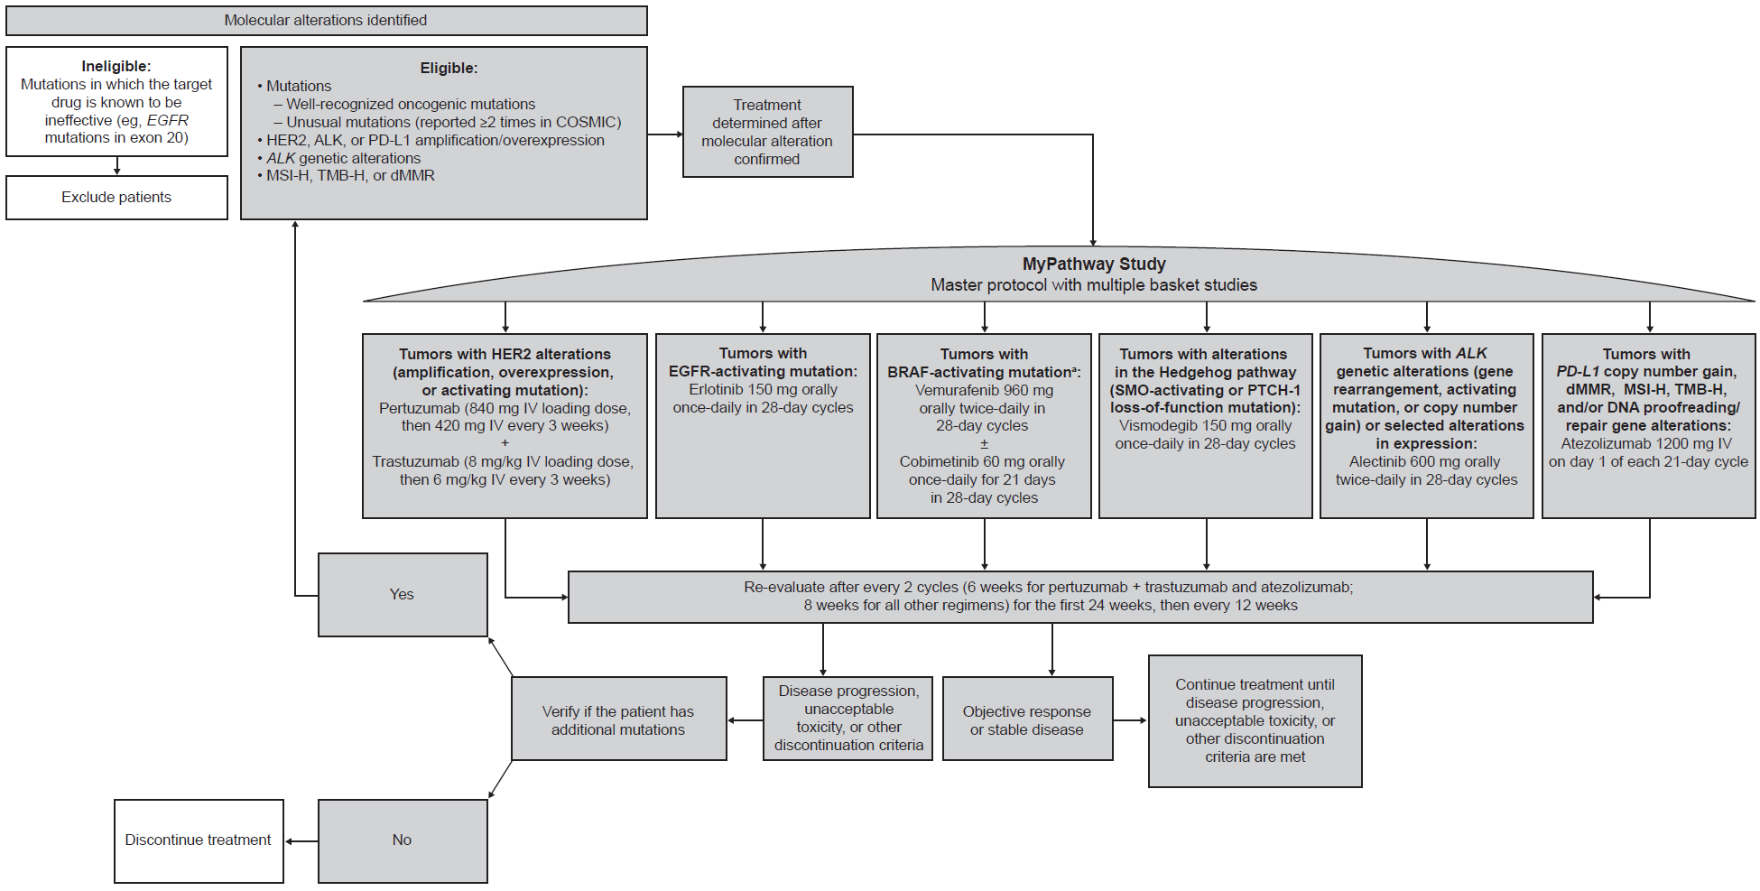

ALK, anaplastic lymphoma kinase; BRAF, v-Raf murine sarcoma viral oncogene homolog B; COSMIC, Catalogue of Somatic Mutations in Cancer; CTCAE, Common Terminology Criteria for Adverse Events; dMMR, deficient mismatch repair; EGFR, epidermal growth factor receptor; HER2, human epidermal growth factor receptor 2; IV, intravenous; MSI-H, microsatellite instability-high; NCI, National Cancer Institute; PD-L1, programmed death-1; PTCH-1, patched homolog-1; RECIST, Response Evaluation Criteria in Solid Tumours; SMO, smoothened; TMB-H, high tumor mutational burden.
Adapted with permission from Wolters Kluwer Health, Inc.: Hainsworth JD, Meric-Bernstam F, Swanton C, Hurwitz H, Spigel DR, Sweeney C, Burris H, Bose R, Yoo B, Stein A, Beattie M, Kurzrock R. Targeted Therapy for Advanced Solid Tumors on the Basis of Molecular Profiles: Results From MyPathway, an Open-Label, Phase IIa Multiple Basket Study. J Clin Oncol. 2018;36(6):536-42. https://ascopubs.org/doi/10.1200/JCO.2017.75.3780

Supplementary Figure 2: Patient disposition. MyPathway protocol version 4 (February 6, 2017) was the first to include atezolizumab as a treatment arm. Patients enrolled per protocol versions 4 and 5 were evaluated using immune-modified RECIST for tumor assessments and CTCAE v4.0 for safety. Protocol version 6 (August 29, 2018) modified the MyPathway atezolizumab arm for registrational intent, with patients assessed using RECIST v1.1 and CTCAE 5.0. Due to these differences in assessment criteria, only patients enrolled per protocol versions 6 and beyond are included in this analysis. One patient in the safety population had not been evaluated for efficacy as of the data cutoff and is not included in the efficacy population.

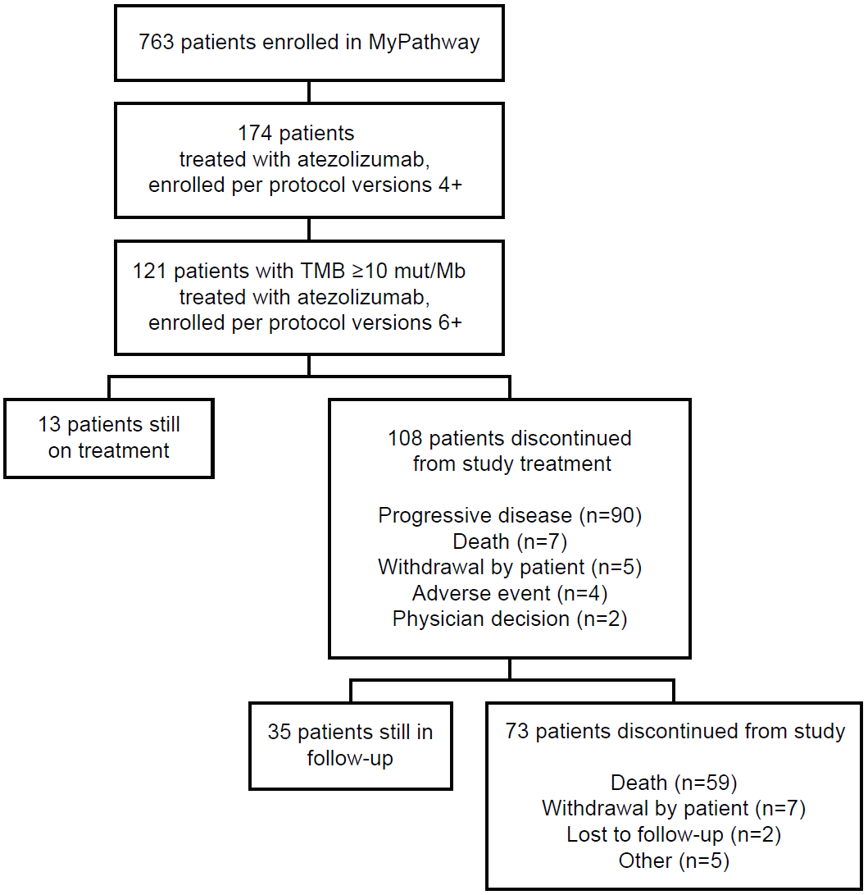

CTCAE, Common Terminology Criteria for Adverse Events; imRECIST, Immune-Modified Response Evaluation Criteria in Solid Tumors; RECIST, Response Evaluation Criteria in Solid Tumors; TMB, tumor mutational burden.

Supplementary Figure 3: Correlation of ORR with F1(CDx) TMB cutoff. Statistical analysis was based on a marginal structural model (MSM) estimate for ORR at various F1(CDx) TMB cut-offs. Red line represents the MSM estimate; ie, the estimated logistic linear trend. Grey boundaries represent 95% CI. Tables show the number of patients with the indicated tumor characteristic for each TMB cutoff level.

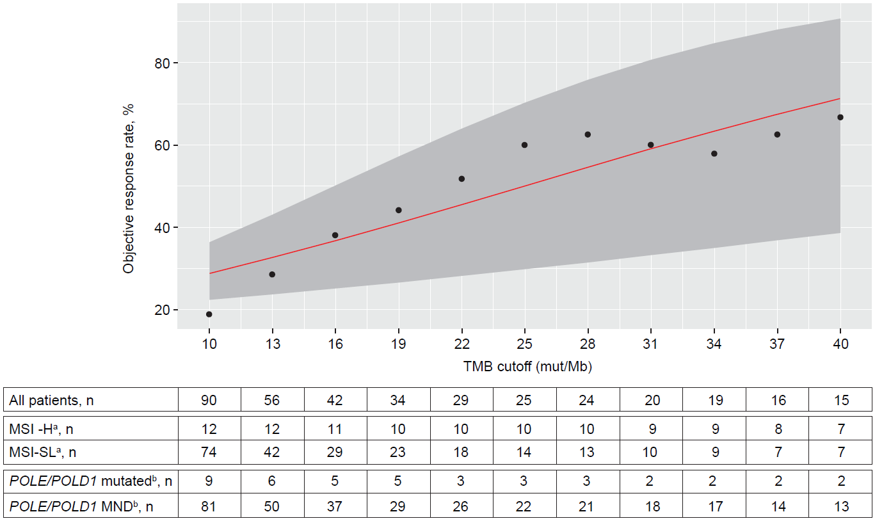

ªMSI status was unknown in four patients.
^{b}POLE/POLD1 mutations refer to mutations in the exonuclease domains only.
CDx, Companion Diagnostic; CI, confidence interval; F1, FoundationOne; MND, mutation not detected; MSI, microsatellite instability; MSI-H, microsatellite instability high; MSI-S/L, microsatellite instability stable or low; MSM, marginal structural model; ORR, objective response rate; POLE, DNA polymerase epsilon; POLD1, DNA polymerase delta 1; TMB, tumor mutational burden.

Supplementary Figure 4: Local non-F1(CDx) CLIA TMB assay versus central F1(CDx) TMB testing (n=24). (A) Local versus central testing in patients by type of local CLIA assay. (B) Local versus central testing in patients by tissue collection timepoint prior to treatment start. Patients with local and central testing results from the same tissue sample are shown. One patient with a local value of 889 mut/Mb and a central value of 964.54 mut/Mb was removed as an outlier.

A

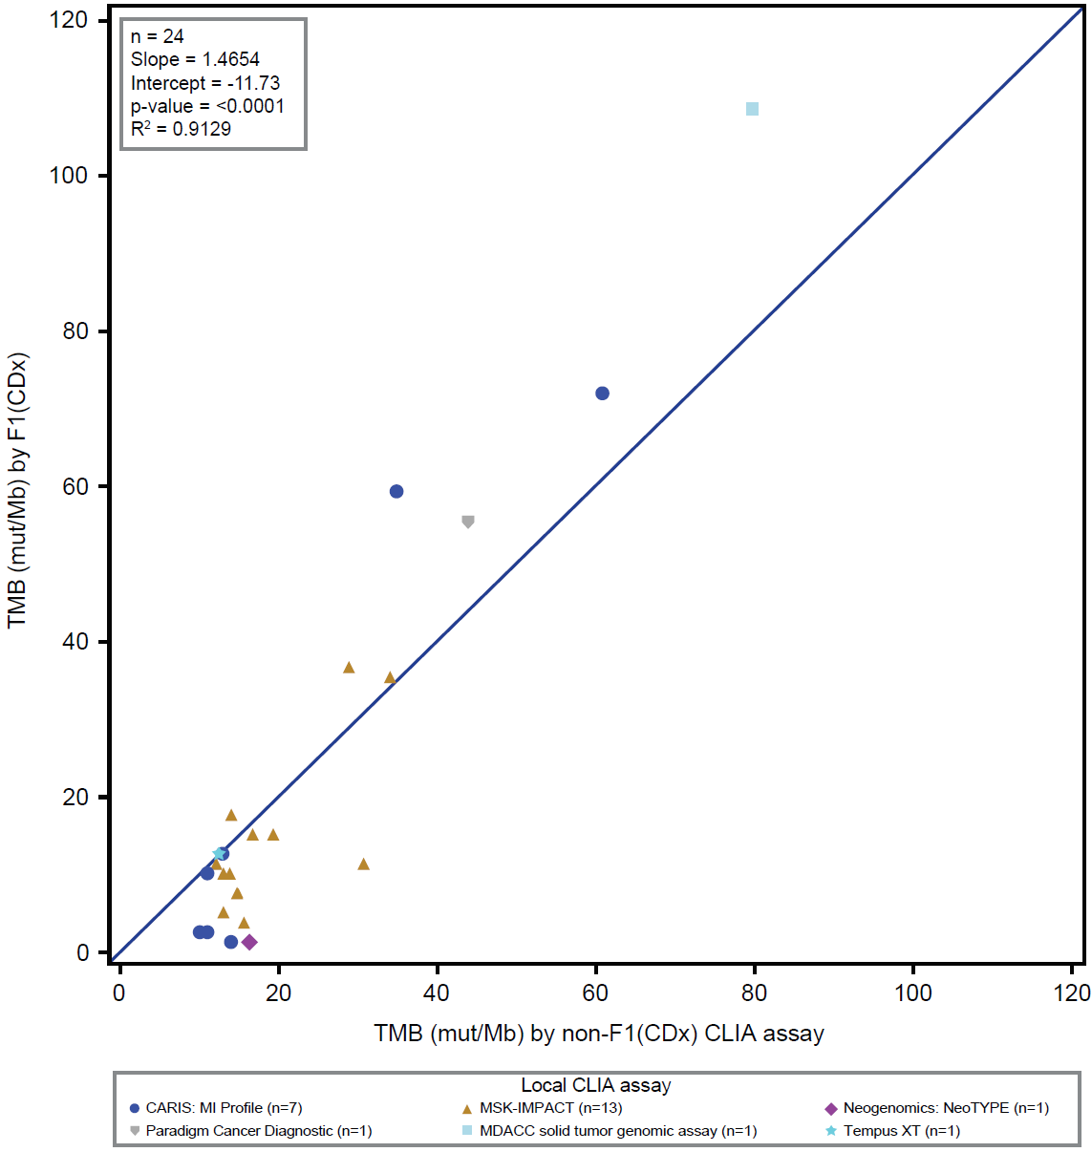

B

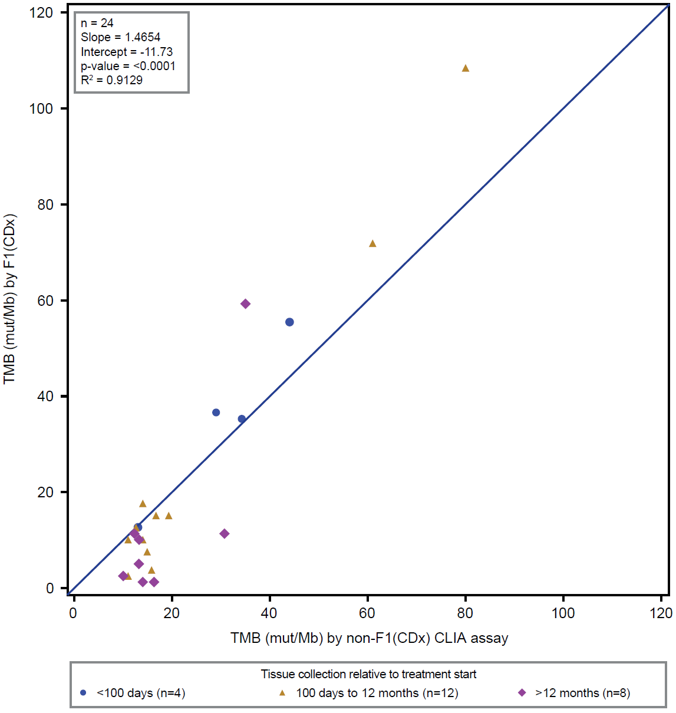

CDx, Companion Diagnostic; CLIA, Clinical Laboratory Improvement Amendments; CRF, case report form; F1, FoundationOne; IMPACT, Integrated Mutation Profiling of Actionable Cancer Targets; MDACC, MD Anderson Cancer Center; MI, Molecular Intelligence; MSK, Memorial Sloan Kettering; TMB, tumor mutational burden.

Supplementary Figure 5: Time on treatment in patients with any CLIA TMB testing. (A) Patients with TMB ≥16 mut/Mb tumors (n=56). (B) Patients with TMB ≥10 and <16 mut/Mb tumors (n=65). Patients with ongoing treatment at data cutoff and timepoints for first response, disease progression, and death are shown. Termination points of the treatment bars represent three weeks after the date of the last drug administration.

A
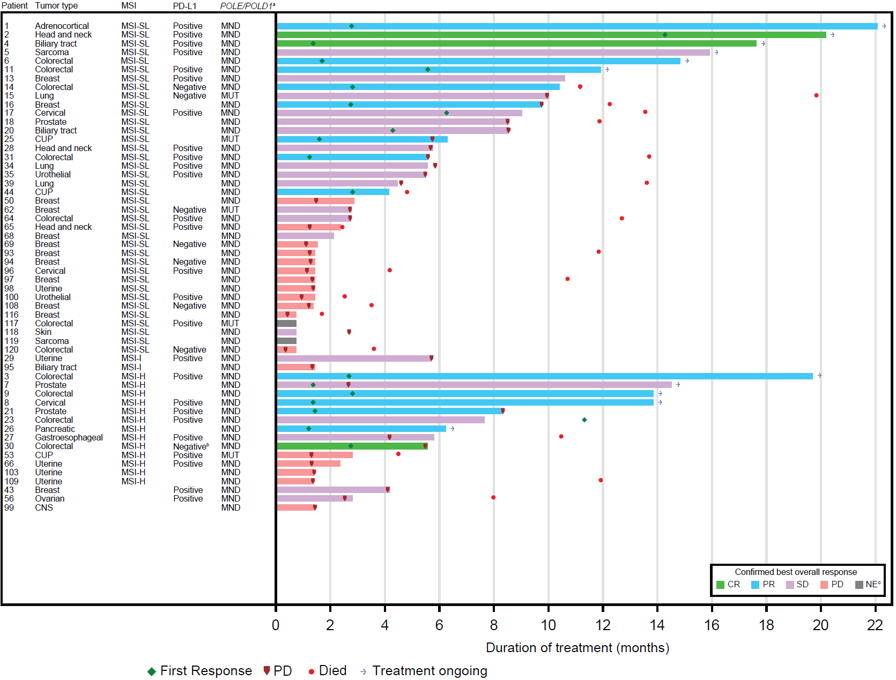

B
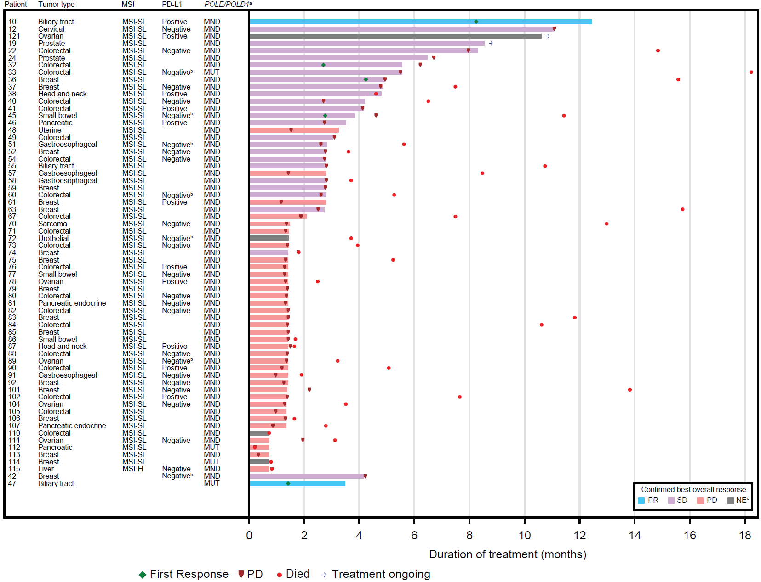

ªPOLE/POLD1 mutations refer to mutations in the exonuclease domains only.
^{b}Patient had a TPS score <1 and no CPS score.
^{c}Patients 72, 110, 114, 117, and 119 discontinued treatment without a tumor assessment and were considered to be non-responders. Patient 121 did not have an efficacy evaluation reported by the data cutoff date and was not included in the efficacy population.
CDx, Companion Diagnostic; CLIA, Clinical Laboratory Improvement Amendments; CNS, central nervous system; CPS, Combined Positive Score; CR, complete response; CUP, carcinoma of unknown primary; F1, FoundationOne; MND, mutation not detected; MSI-H, high microsatellite instability; MSI-SL, microsatellite instability stable or low; MUT, mutated; NE, not evaluable; PD, progressive disease, POLE, DNA polymerase epsilon; POLD1, DNA polymerase delta 1; PR, partial response; SD, stable disease; TMB, tumor mutational burden TMB, tumor mutational burden; TPS, Tumor Proportion Score.
Supplementary Figure 6: Progression-free and overall survival in efficacy-evaluable patients with any CLIA TMB testing (n=120). (A) Progression-free survival in patients with TMB ≥16 mut/Mb versus TMB ≥10 and <16 mut/Mb tumors. (B) Overall survival in patients with TMB ≥16 mut/Mb versus TMB ≥10 and <16 mut/Mb tumors.

A
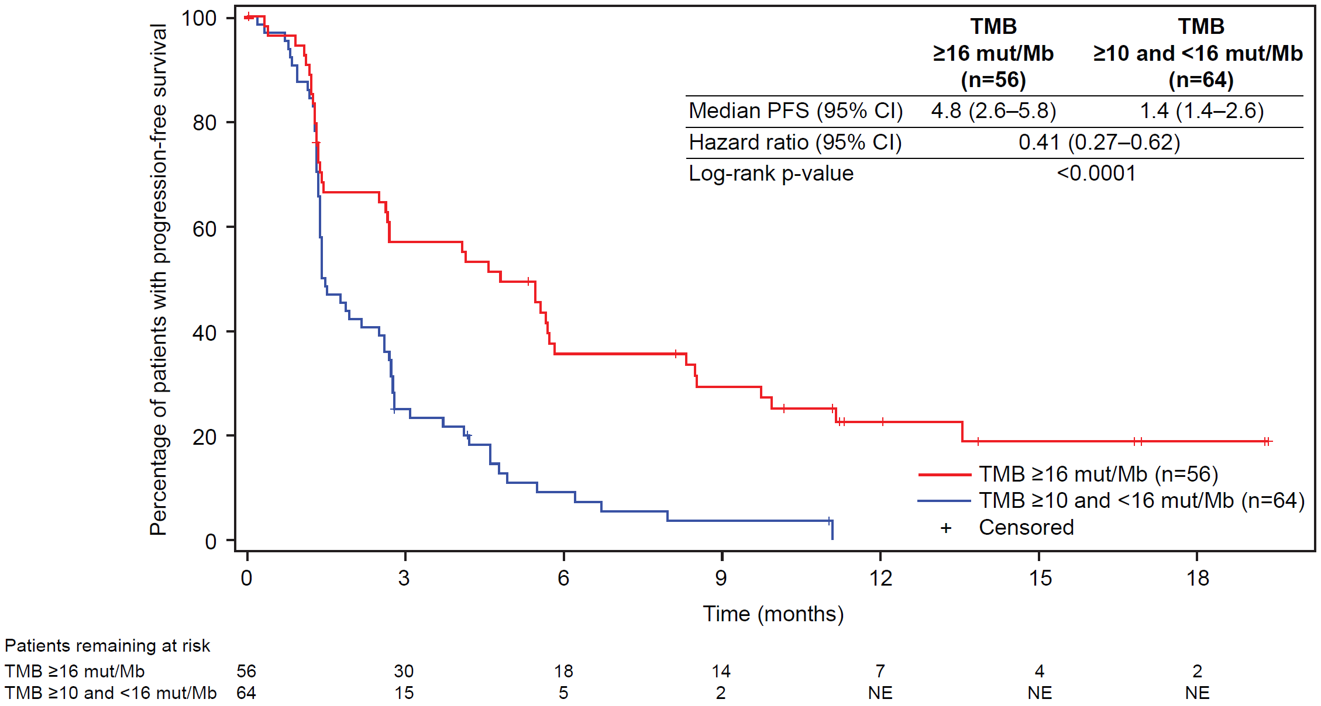

B
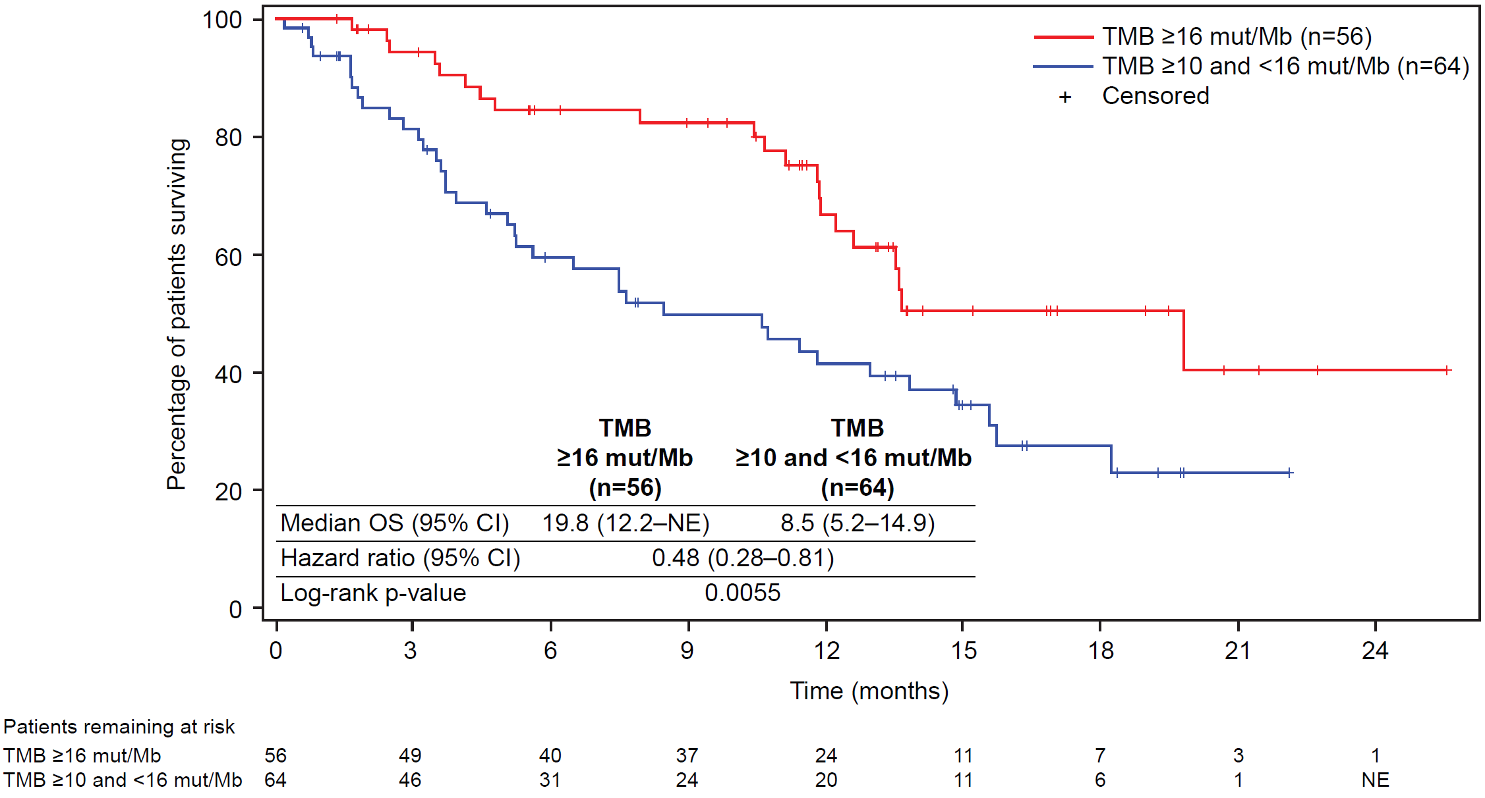

CLIA, Clinical Laboratory Improvement Amendments; NE, not evaluable; OS, overall survival; PFS, progression-free survival; TMB, tumor mutational burden.
Supplementary Figure 7: Progression-free and overall survival in efficacy-evaluable patients by F1(CDx) TMB and MSI status (n=86). (A) Progression-free survival by TMB cohort and MSI status. (B) Overall survival by TMB cohort and MSI status. Four patients with unknown MSI status (two with TMB ≥16 mut/Mb and two with TMB ≥10 and <16 mut/Mb) are not shown.

A

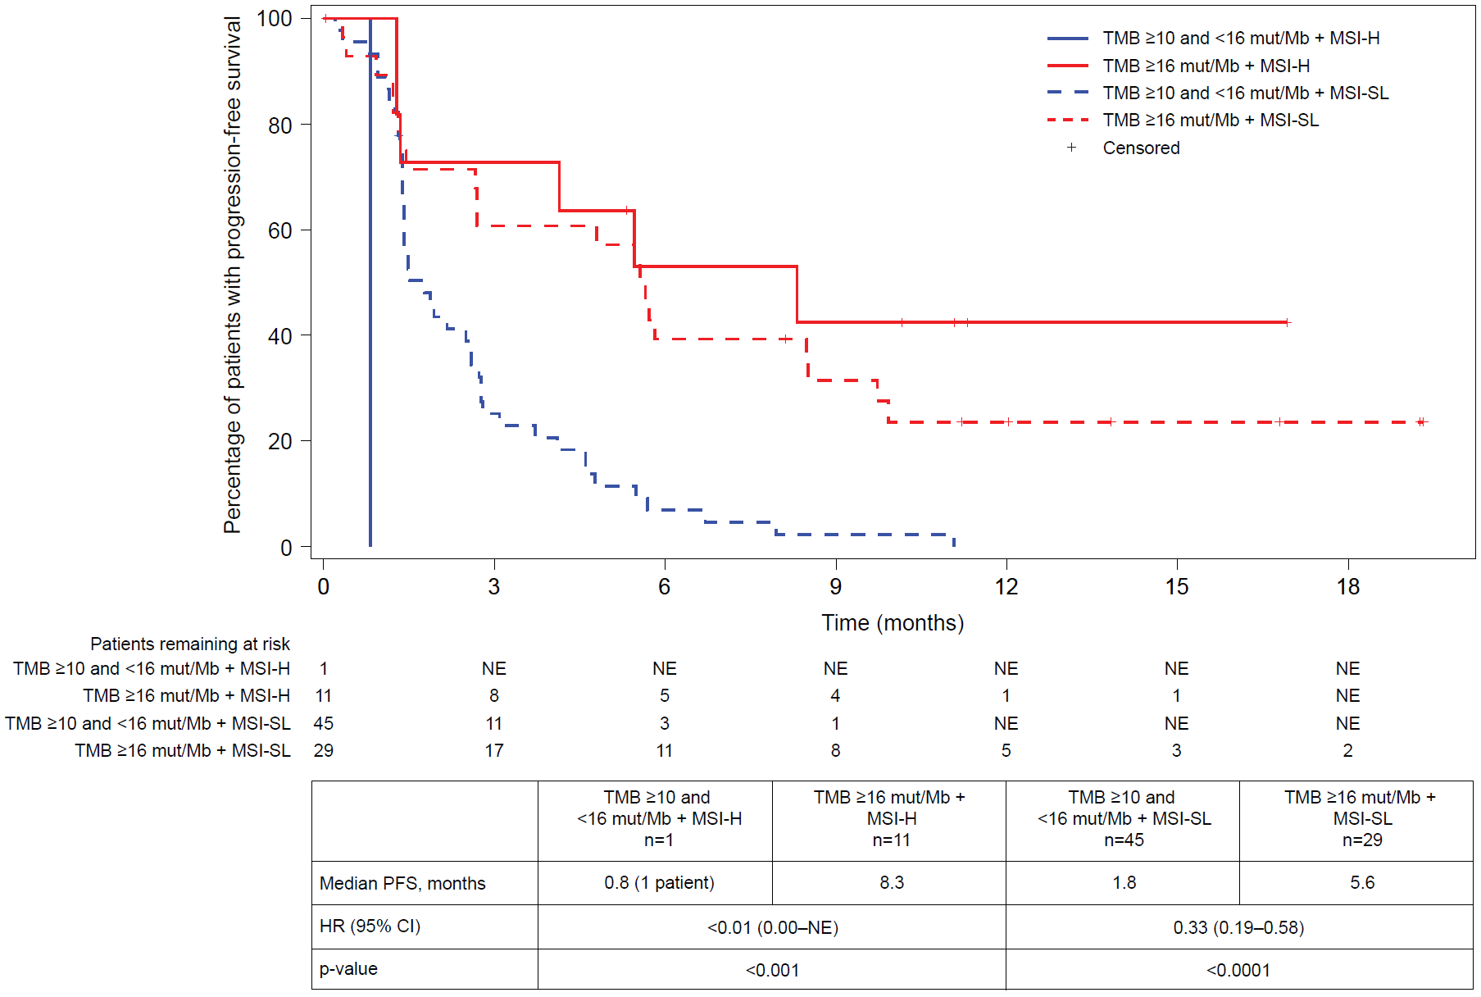

B

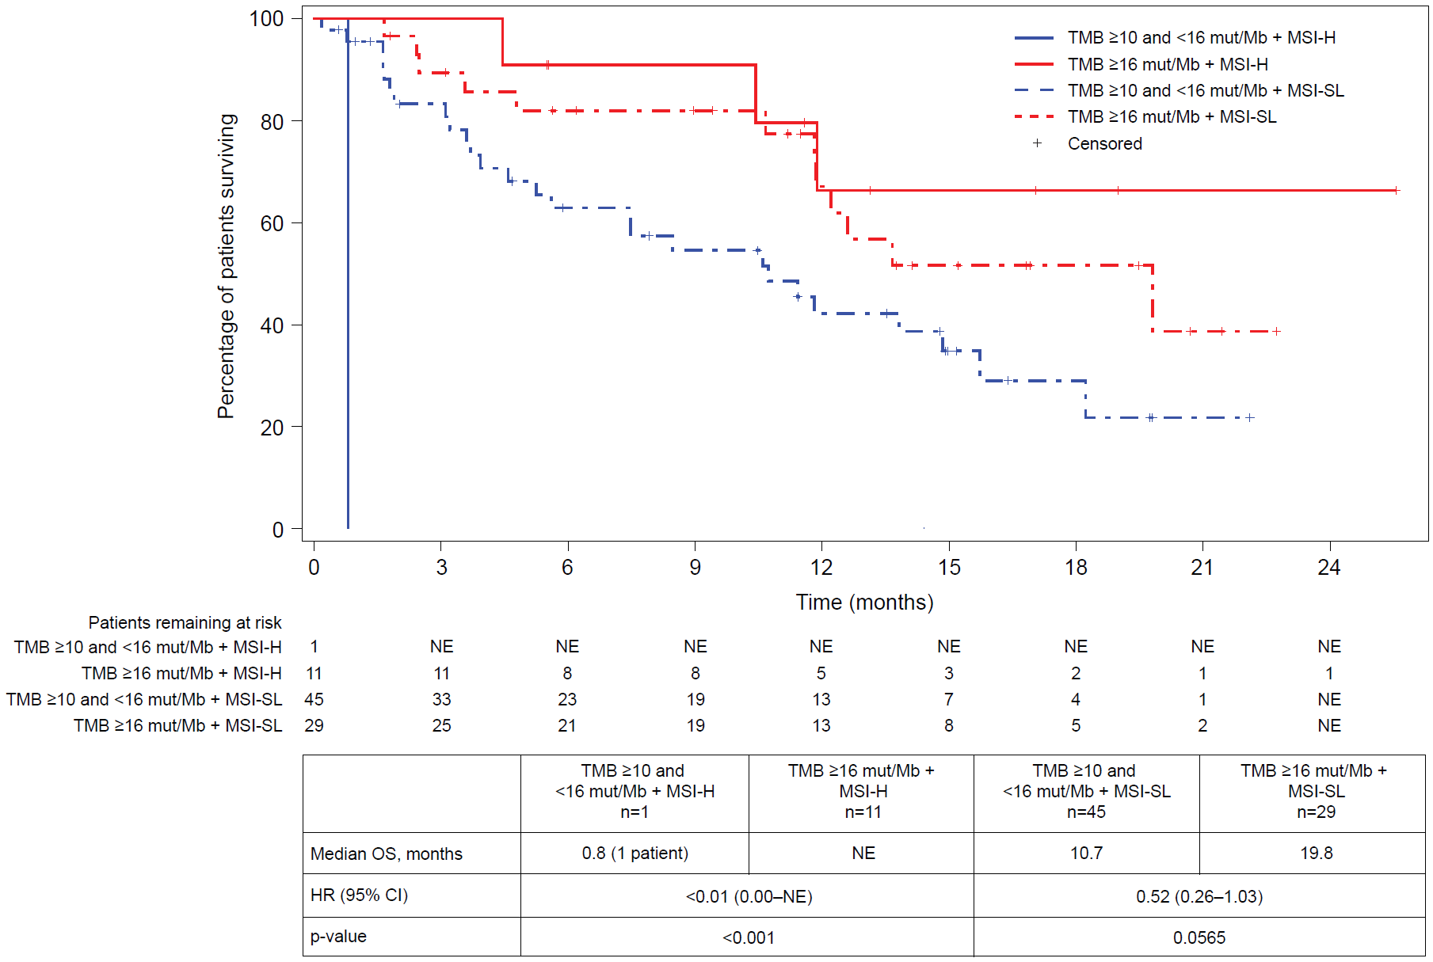

CDx, Companion Diagnostic; CI, confidence interval; F1, FoundationOne; HR, hazard ratio; MSI-H, NE, not evaluable; MSI-SL, microsatellite instability stable or low; OS, overall survival; PFS, progression-free survival; TMB, tumor mutational burden.
Supplementary Figure 8: MSI and PD-L1 status groups in patients with F1(CDx) TMB ≥16 mut/Mb tumors. (A) PD-L1 positive was defined as PD-L1 CPS and/or TPS score ≥1, and PD-L1 negative was defined as PD-L1 CPS (if available) and TPS score <1. (B) Patients with PD-L1 CPS and/or TPS score ≥50 versus PD-L1 TPS and CPS (if available) score <50 are indicated. Sixteen patients without CPS or TPS scores and two additional patients with unknown MSI status are not shown. POLE/POLD1 mutations refer to mutations in the exonuclease domains only.

A
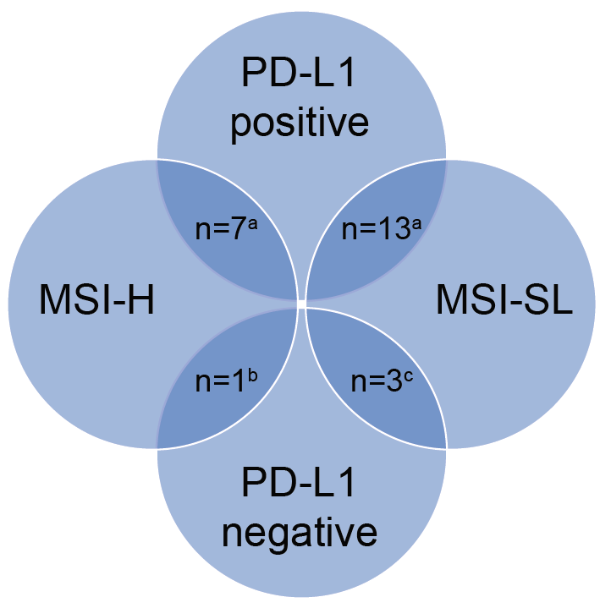

B
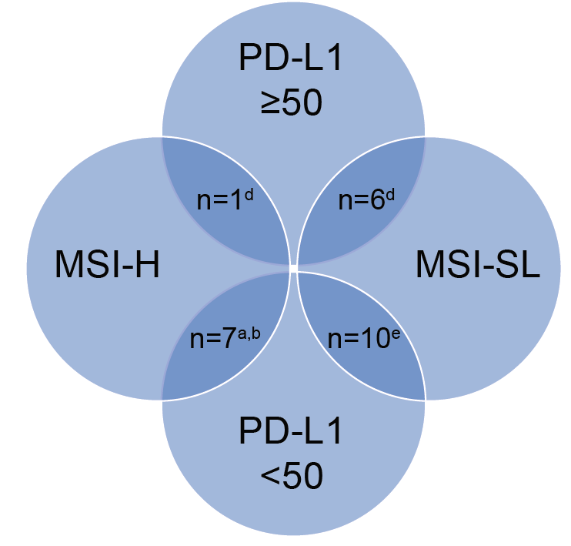

ªOne patient had a POLE/POLD1-mutated tumor.
^{b}One patient had a tumor with TPS score <1 and no CPS score.
^{c}Two patients had POLE/POLD1-mutated tumors.
^{d}One patient had a tumor with TPS score >50 and no CPS score.
^{e}Three patients had POLE/POLD1-mutated tumors.
CDx, Companion Diagnostic; CPS, Combined Positive Score; ED, exonuclease domain; F1, FoundationOne; MSI-H, high microsatellite instability; MSI-SL, microsatellite instability stable or low; PD-L1, programmed death-ligand 1; POLE, DNA polymerase epsilon; POLD1, DNA polymerase delta 1; TMB, tumor mutational burden; TPS, Tumor Proportion Score.
Supplementary Figure 9: Progression-free and overall survival in efficacy-evaluable patients by F1(CDx) TMB and POLE/POLD1 mutation status (n=90). (A) Progression-free survival by TMB cohort and POLE/POLD1 status. (B) Overall survival by TMB cohort and POLE/POLD1 status.

A
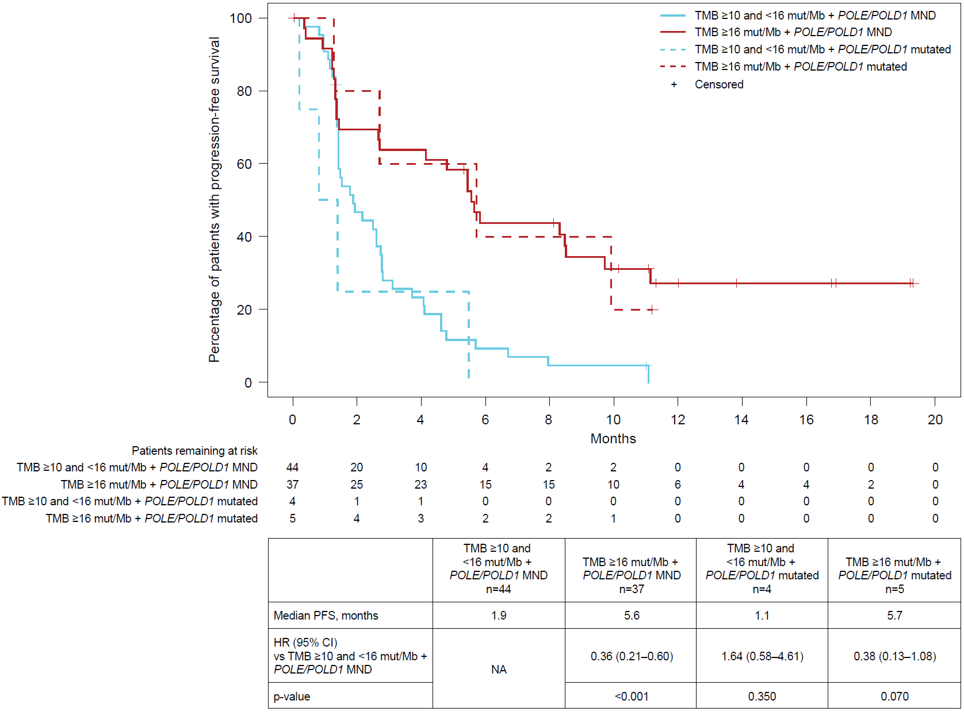

B
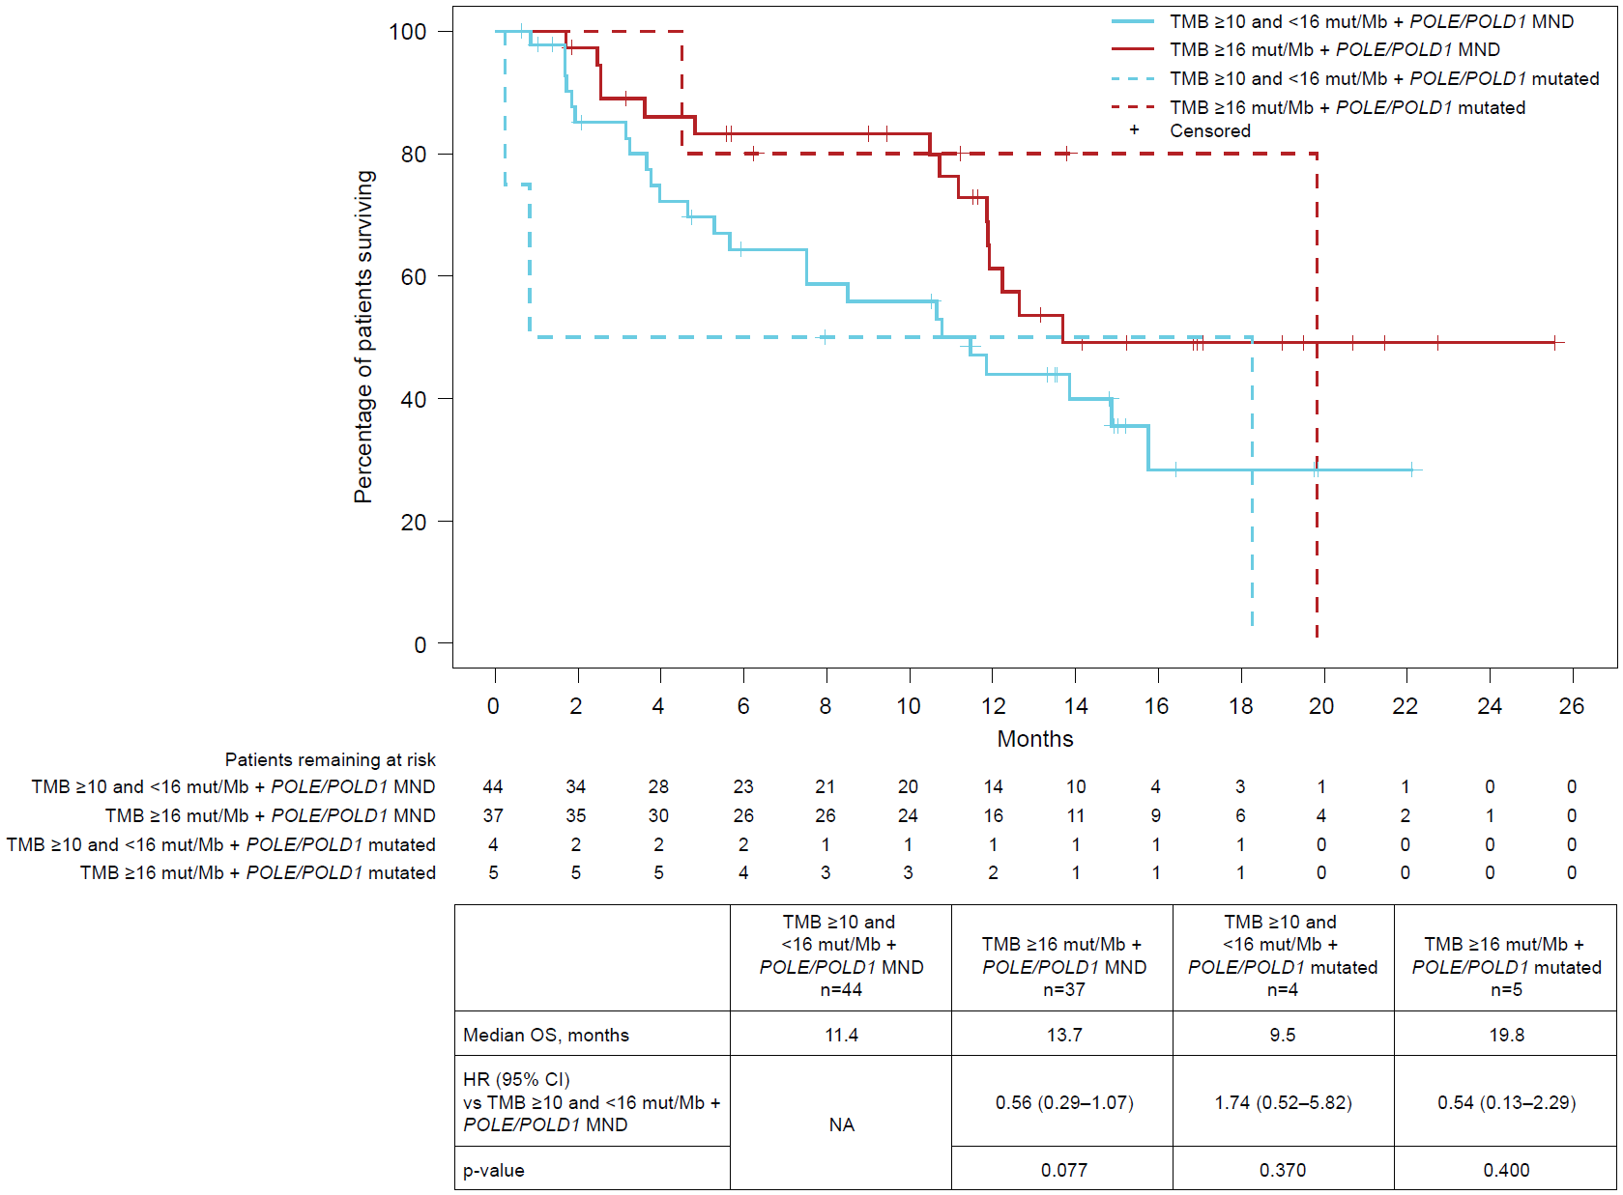

ªPOLE/POLD1 mutations refer to mutations in the exonuclease domains only.
CDx, Companion Diagnostic; F1, FoundationOne; MND, mutation not detected; OS, overall survival; POLE, DNA polymerase epsilon; POLD1, DNA polymerase delta 1; PFS, progression-free survival; TMB, tumor mutational burden.

Supplementary Figure 10: Tumor groups in efficacy-evaluable patients with any CLIA TMB testing (n=120). Twenty different tumor types were represented among efficacy-evaluable patients with any local CLIA TMB testing, with the largest cohorts comprised of patients with breast and colorectal cancers.

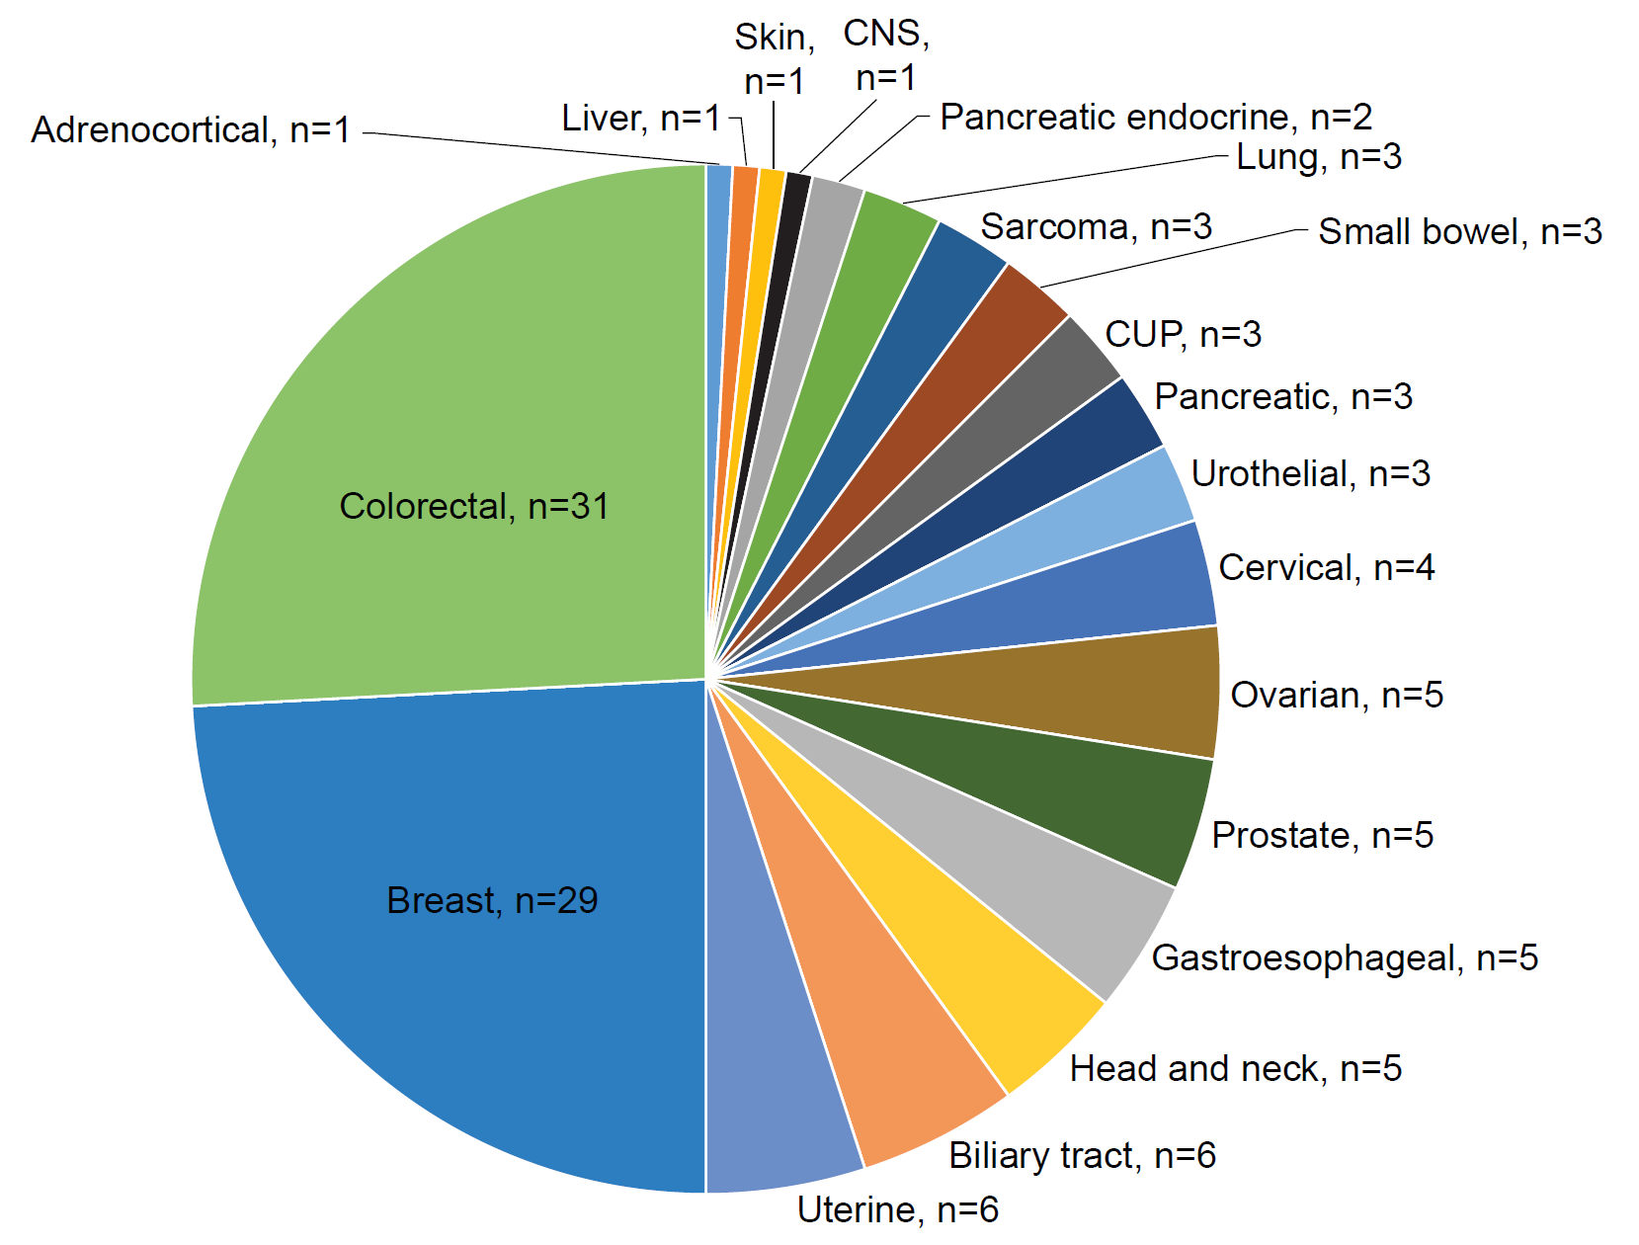

CLIA, Clinical Laboratory Improvement Amendments; CNS, central nervous system; CUP, carcinoma of unknown primary; TMB, tumor mutational burden.
Supplementary Figure 11: Computed tomography scans of a patient with biliary cancer and TMB ≥16 mut/Mb. A 74-year-old white male presented to medical attention in June 2018 with weight loss and abdominal pain. He underwent a right hemi-colectomy, partial hepatectomy, and cholecystectomy. Pathology was consistent with adenosquamous gallbladder cancer. He was treated with 6 months of adjuvant capecitabine. In April 2019, the patient underwent biopsy of a para-esophageal lymph node which confirmed recurrence. He was restarted on capecitabine, and tumor tissue was sent for MSK-IMPACT NGS. The NGS testing results were significant for a TMB of 29 mut/Mb, with hotspot mutations in BRCA1, CHEK2, APC, RB1, and TP53. He also had amplification of CD274 (PD-L1). The patient was enrolled in the atezolizumab arm of the MyPathway study based on elevated TMB, and initiated therapy on July 12, 2019. Central F1(CDx) testing of archival tumor tissue found a TMB of 36.56 mut/Mb. The patient had improvement in his tumor markers and achieved a confirmed complete response by RECIST. He remains on therapy as of the data cutoff. Scans are shown at (A) baseline, and (B) at the first tumor assessment after two cycles of treatment.

A
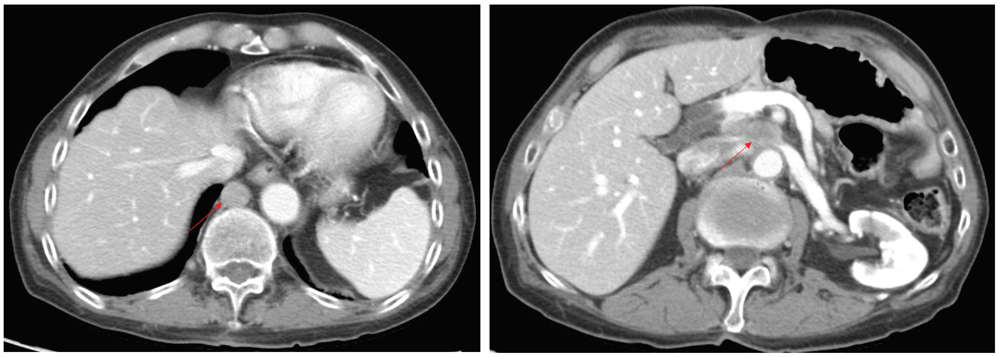

B
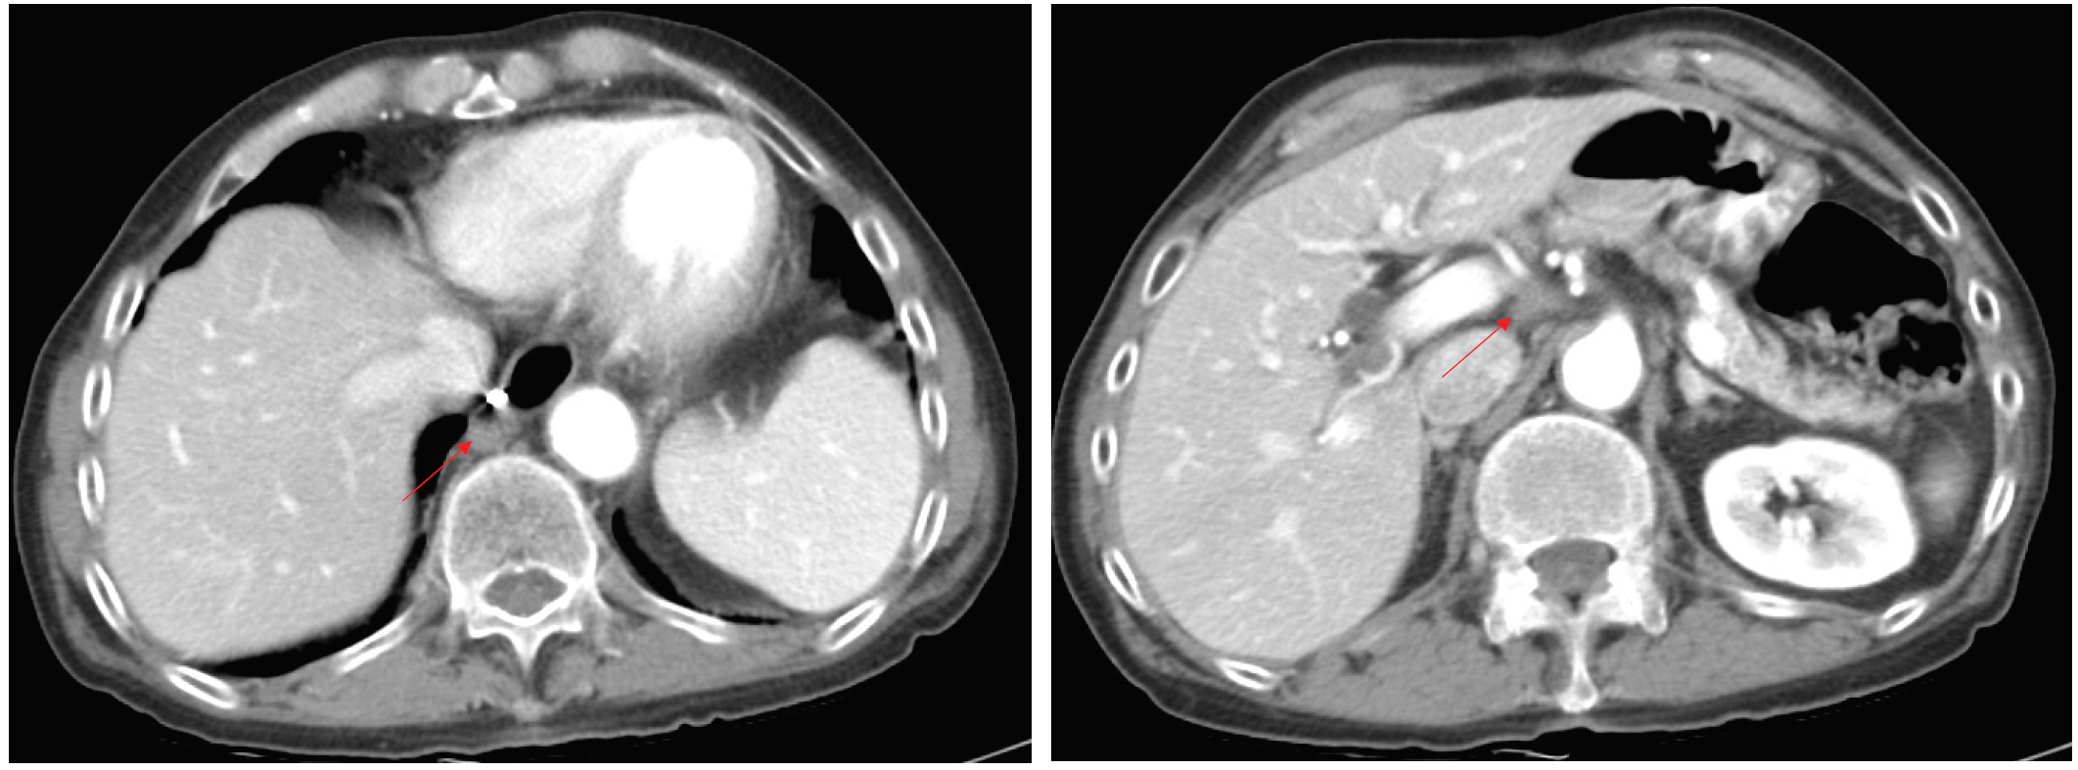

CDx, companion diagnostic; IMPACT, F1, FoundationOne; Integrated Mutation Profiling of Actionable Cancer Targets, MSK, Memorial Sloan Kettering; NGS, next-generation sequencing; RECIST, Response Evaluation Criteria in Solid Tumours; TMB, tumor mutational burden.

