Supplementary Material
Supplement to: Functional Precision Medicine Provides Clinical Benefit in Advanced Aggressive Hematological Cancers and Identifies Exceptional Responders. Kornauth, Pemovska, Vladimer et al.

Table of Contents
Statistical Analysis Plan 3
Background 3
Trial objective 3
Trial design 3
Analysis sets 3
Application 3
Trial centres 4
Analysis variables 4
Primary variable 4
Statistical analyses / methods 6
Primary analysis 6
Secondary analyses 6
Interim analysis 8
Deviations from the protocol 8
Software 8
References 8
Supplementary Figures 10
Supplementary Figure S1. 10
Supplementary Figure S2. 11
Supplementary Figure S3 13
Supplementary Figure S4 14
Supplementary Figure S5 16
Supplementary Figure S6 18
Supplementary Tables 20
Supplementary Table S1. Screening drug collection 20
Supplementary Table S2. Patient’s characteristics 35

Statistical Analysis Plan

Background

Trial objective
The project aims to assess the feasibility of scFPM in a clinical setting and to evaluate patient’s individual benefit from scFPM informed treatment.

Trial design
Single Center, single arm, open label, exploratory phase II trial.

Analysis sets

Definitions
The full analysis set includes all subjects who were tested by scFPM.
The per protocol set comprises all subjects who received treatment informed by scFPM and who had complete follow up and complete data accrual with regard to analysis variables. Patients which could not reach their PFS-ratio of 1.3 were excluded regardless of disease state.

Application
The target variable of primary analysis is the ratio of patients treated per protocol reaching a PFS-ratio (see 4.2.1) of ≥1.3. The H₀ is 15% of patients or less will reach a PFS of ≥1.3.

The secondary analysis will examine the ORR for patients with lymphoid and myeloid disease respectively

Trial centres
The trial center for testing is Division of Hematology and Haemostaseology, Department of Medicine I, Medical University of Vienna. Referred patients will be treated outside the trial center based on recommendations by the tumor board and in close contact with the primary trial center.

Analysis variables
Demography and baseline characteristics

Variable | Measurement Level | Time of Evaluation
Age (years) | continuous | Once, at study entry
Sex | Binary, categorial | Once, at study entry
Diagnosis | categorial | Once, at study entry
Disease subgroup (Lymphoma/Leukemia) | dichotomous | Once, at study entry
Response to last treatment  - Complete Remission (CR)  - Partial Remission (PR)  - Stable Disease (SD)  - Progressive Disease (PD) | ordinal | Once, at study entry, will be verified (and simplified) by investigators in analysis phase if necessary.
ECOG (0-4) | ordinal | Once, at study entry
Number of previous treatments | discrete, ratio | Once, at study entry
Progression free survival (PFS) on previous treatment (in days) | continuous | Once, at study entry

Primary variable

PFS ratio
This is the ratio between progression free survival (PFS) in days of scFPM guided treatment and previous treatment ($=\frac{PFS\left(scDDS treatment.\right)}{PFS(previous treatment)}$), based on considerations by Bailey et al. and Von Hoff et al (1,2). It is a continuous variable and results from PFS which in turn is based on response to treatment according to the individual disease marker.

PFS
PFS is the time in days from treatment start to first prove of progression or death from any cause (continuous variable, at censoring date). When a patient reaches CR by scFPM guided treatment and is then treated with consolidating treatment (e.g. HSCT), PFS of those treatments is to be added up. The mode of progression evaluation is dependent on the individual disease marker.

Individual disease marker
PFS depends on evaluation of response: The mode of response evaluation is specified by the patient’s individual disease marker which depends on the guidelines of the underlying disease and individual disease presentation. In our mixed patient population, it is therefore based on multiple modalities like imaging, laboratory, clinical and/or histopathological data. Response will be simplified to four categories: CR, PR, SD and PD (=ordinal, during analysis phase). Patients treated outside Division of Hematology and Hemostaseology will have their follow up reported using report sheets sent out to external investigators.

Secondary variables
Overall Response Rate (ORR), Disease Control Rate (DCR)
ORR is the proportion of patients reaching CR or PR as defined by disease-specific guidelines, DCR is ORR + rate of patient with SD. For response to scFPM guided treatment it is evaluated during the analysis phase.

Overall Survival
Overall survival is defined here as the time in days from start of treatment to death from any cause (continuous variable, evaluated during analysis phase at censoring date).

Handling of missing values
We choose a complete case analysis approach, so cases lacking variables will be excluded from analysis. A complete case for the primary endpoint is defined as having full data on last treatment (type, drugs used, PFS, best response), treatment received (type, drugs used, PFS, best response) and data from scFPM. For secondary analysis (see below) an available case approach will be used, with the necessity for all variables for as described for the primary endpoint and available data for other endpoints and subgroup analyses.

Statistical analyses / methods

Primary analysis
Primary analysis will examine the ratio of patients in the per protocol analysis set reaching a PFS-ratio (see 4.2) of ≥1.3. This is modelled by a binomial distribution. The H₀ is 15% of patients or less will reach a PFS of ≥1.3. To test this hypothesis, a one-sided binomial test will be applied with an alpha of 0.025. The null hypothesis can be rejected when at least 14 out of 50 patients show a PFS of ≥1.3.

Metric variables are described using median and range. Categorical variables are described using absolute counts and proportions.

Secondary analyses

ORR, DCR
ORR and DCR for scFPM treatment will be compared to ORR and DCR to last treatment for the entire as-treated set. The H0 is that ORR and DCR is the same for scFPM and last treatment (OR=1). This hypothesis will be tested using McNemars Test. If a sufficient number of patients is recruited for subgroup analysis, the ORR and DCR is calculated for each subgroup and compared to the ORR/DCR of last treatment. The H₀ is that ORR and DCR is the same for scFPM and last treatment (OR=1). This hypothesis will be tested using McNemars Test. The alpha will be 0.05.

PFS
We will compare the PFS on scFPM guided treatment with PFS of previous treatment by Kaplan Meier Estimates and Cox regression with clustered computation, as it is a repeated measurement setting(3). The alpha will be 0.05. PFS on scFPM guided versus non guided treatment and OS within subgroups compared using the Kaplan-Maier estimator and Cox-Proportional Hazard Models

Planned subgroup analyses
We will compare PFS ratio, ORR, DCR and PFS on scFPM guided treatment between subgroups of the per protocol set. These subgroups will be based on diagnostic group (leukemia vs. lymphoma, myeloid vs. lymphoid disease, B-NHL. vs. T-NHL), performance status (ECOG>1 vs. ≤1), age (<60 years vs. older), sex, genetic aberrations (given sufficient numbers), number of previous treatments, OR to last treatment and relative blast fraction.

Post hoc matching
We will perform a post hoc matching analysis to see how high the individual drugs given to the patients scored regardless if the treatment was scFPM informed or not. The scFPM scores were summed up (that is, the 1-AUC in the relative blast fraction as described before⁴.) across all the drugs that a patient received and that were tested by scFPM, and across all the markers used in the individual patient's assay. We call this score the integrated AUC by immunofluorescence (iAUC-IF). iAUC-IF >0 is a treatment supported by scFPM while iAUC-IF <=0 identifies treatments that were not supported.

Interim analysis
A planned interims report was published after one year (4). There were no predefined criteria influencing the conduct of the study. The findings of this report had no implication on the conduct of the study.

Deviations from the protocol
Patients who did not receive a full cycle of their individual treatment were excluded from analysis.

Software
For analysis, R, a language for statistical computation will be used inside the RStudio IDE. R core packages, survival (5), survminer (6), vcd (7), pwr (8), ggpubr (9), ggalluvial (10), and tidyverse (11) packages will be used for statistical computation, model building and data visualisation.

References

1. Bailey CH, Jameson G, Sima C, Fleck S, White E, Von Hoff DD, et al. Progression-free Survival Decreases with Each Subsequent Therapy in Patients Presenting for Phase I Clinical Trials. J Cancer [Internet]. 2011 [cited 2020 Nov 17];3:7–13. Available from: https://www.ncbi.nlm.nih.gov/pmc/articles/PMC3245603/
2. Von Hoff DD, Stephenson JJ, Rosen P, Loesch DM, Borad MJ, Anthony S, et al. Pilot Study Using Molecular Profiling of Patients’ Tumors to Find Potential Targets and Select Treatments for Their Refractory Cancers. JCO [Internet]. 2010 [cited 2018 Apr 13];28:4877–83. Available from: http://ascopubs.org/doi/abs/10.1200/JCO.2009.26.5983
3. Thenmozhi M, Jeyaseelan V, Jeyaseelan L, Isaac R, Vedantam R. Survival analysis in longitudinal studies for recurrent events: Applications and challenges. Clinical Epidemiology and Global Health [Internet]. 2019 [cited 2020 Jun 26];7:253–60. Available from: https://linkinghub.elsevier.com/retrieve/pii/S2213398418302185
4. Snijder B, Vladimer GI, Krall N, Miura K, Schmolke A-S, Kornauth C, et al. Image-based ex-vivo drug screening for patients with aggressive haematological malignancies: interim results from a single-arm, open-label, pilot study. The Lancet Haematology [Internet]. 2017 [cited 2018 Feb 17];4:e595–606. Available from: http://www.thelancet.com/journals/lanhae/article/PIIS2352-3026(17)30208-9/abstract
5. Terry M. Therneau, Patricia M. Grambsch. Modeling Survival Data: Extending the Cox Model. New York: Springer; 2000.
6. Kassambara A, Kosinski M, Biecek P. survminer: Drawing Survival Curves using “ggplot2” [Internet]. 2020. Available from: https://CRAN.R-project.org/package=survminer
7. Meyer D, Zeileis A, Hornik K. vcd: Visualizing Categorical Data. 2020.
8. Champely S. pwr: Basic Functions for Power Analysis [Internet]. 2020. Available from: https://CRAN.R-project.org/package=pwr
9. Kassambara A. ggpubr: “ggplot2” Based Publication Ready Plots [Internet]. 2020. Available from: https://CRAN.R-project.org/package=ggpubr
10. Brunson JC. ggalluvial: Layered Grammar for Alluvial Plots. Journal of Open Source Software. 2020;5:2017.
11. Wickham H, Averick M, Bryan J, Chang W, McGowan LD, François R, et al. Welcome to the tidyverse. Journal of Open Source Software. 2019;4:1686.

Supplementary Figures

Supplementary Figure S1.
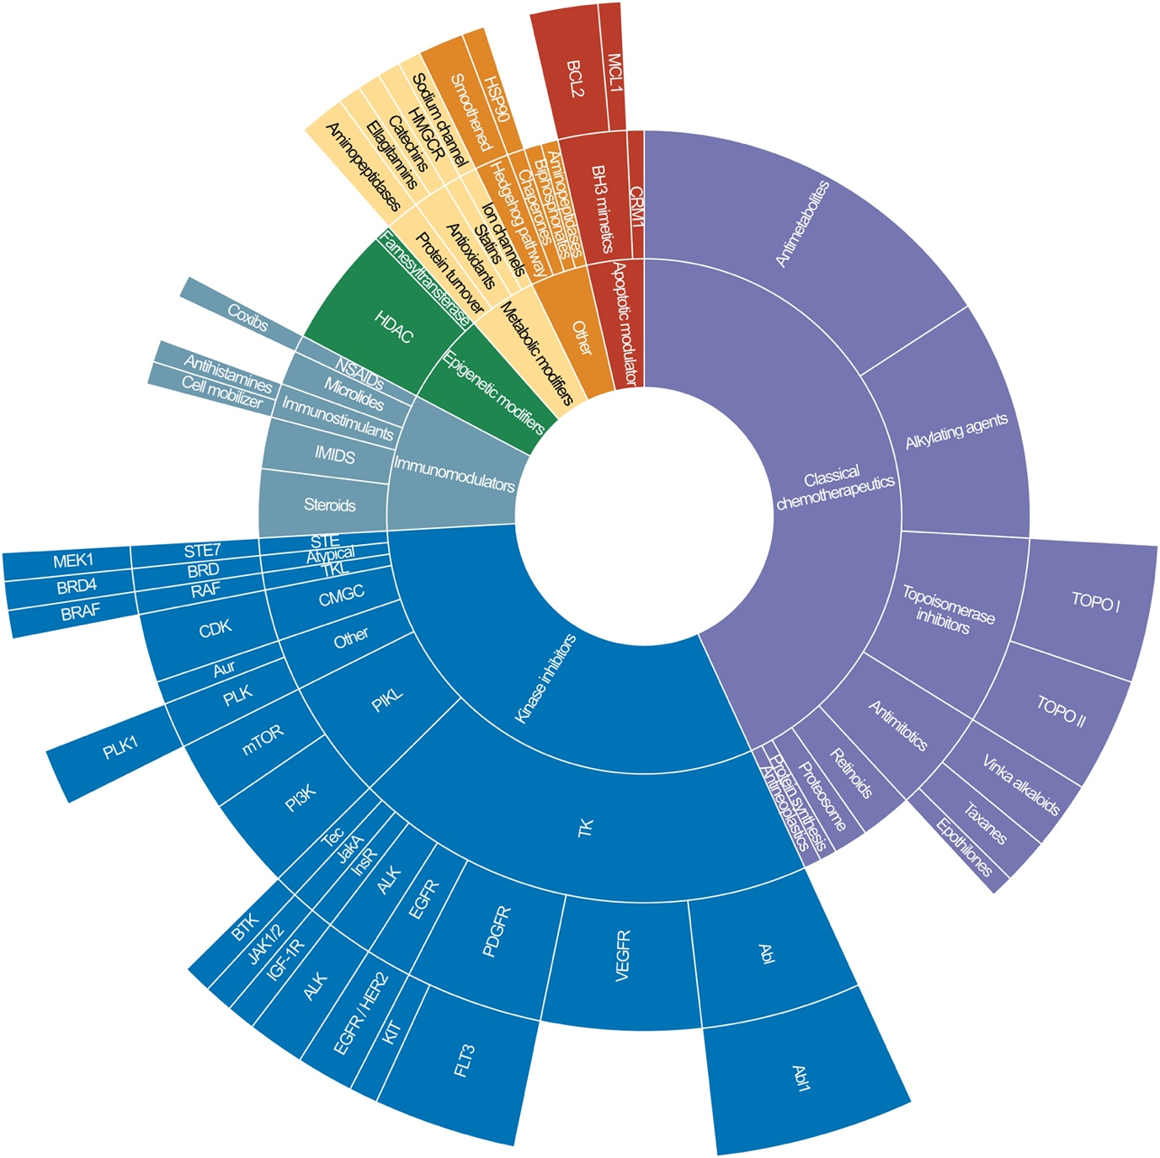

Supplementary Figure S1. Sunburst plot showing the classes of drugs tested by scFPM. Drugs can be broadly classified into kinase inhibitors, immunomodulatory drugs, epigenetic modifiers, metabolic modifiers, apoptotic modulators, classical chemotherapeutics and other drugs.

Supplementary Figure S2.

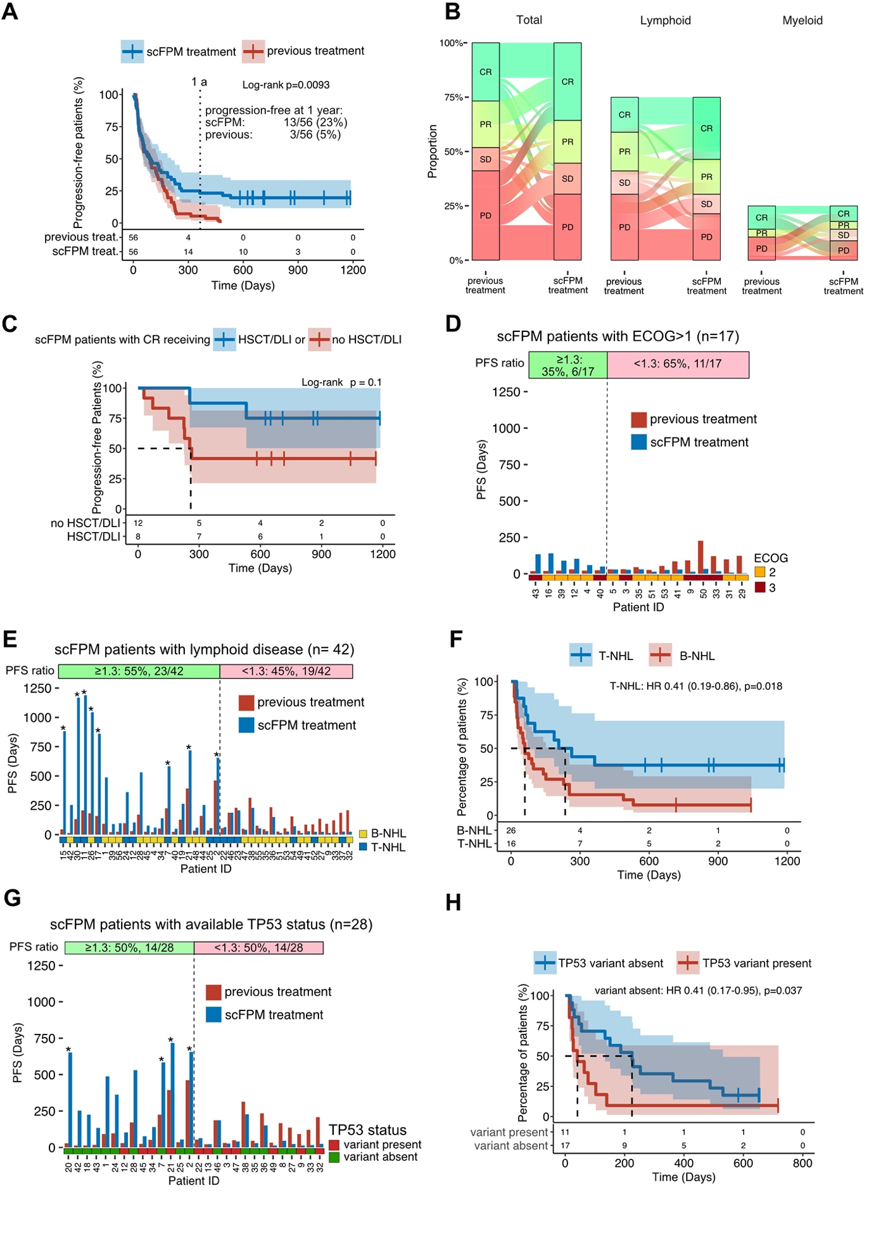
Supplementary Figure S2. Overall Response and Factors Influencing Outcome on scFPM Treatment. (A) Sankey diagram demonstrating the shift of best response between pervious treatment and scFPM guided treatment. The first pair of collums shows the shifts for all scFPM treated patients, the second and third pair is the facet according to lymphoid and myeloid disease. (B) Kaplan Meier plot comparing PFS on previous treatment with scFPM-guided treatment. The dotted line denotes one year follow up. (C) Kaplan Meier plot comparing PFS of patients reaching CR on scFPM-guided treatment with and without HSCT or donor lymphocyte infusion (DLI) as consolidating treatment. (D) Bar plot showing PFS for all patients with ECOG > 1 (n=17). (E) Bar plot showing PFS for all patients with lymphoid disease (n=42). Stars denote ongoing response for scFPM treatment at censoring date. (F) Kaplan Meier curve comparing PFS on scFPM guided treatment between patients with T-lymphoid disease and B-lymphoid disease. (G) Bar plot showing PFS for all patients with known TP53 status (n=28). Stars denote ongoing response for scFPM treatment at censoring date. (H) Kaplan Meier curve comparing PFS on scFPM guided treatment between patients with and without a TP53 variant.

Supplementary Figure S3

Supplementary Figure S3. Proportion of patients reaching PFS ratio ≥1.3 according to subgroups. (A) Violin plot showing PFS ratio stratified according to OR to previous treatment. (B) Violin plot showing PFS ratio stratified according to ECOG before scFPM treatment. (C) Violin plot showing PFS ratio stratified according lymphoid subgroup. (D) Violin plot showing PFS ratio stratified according to TP53 status.

Supplementary Figure S4

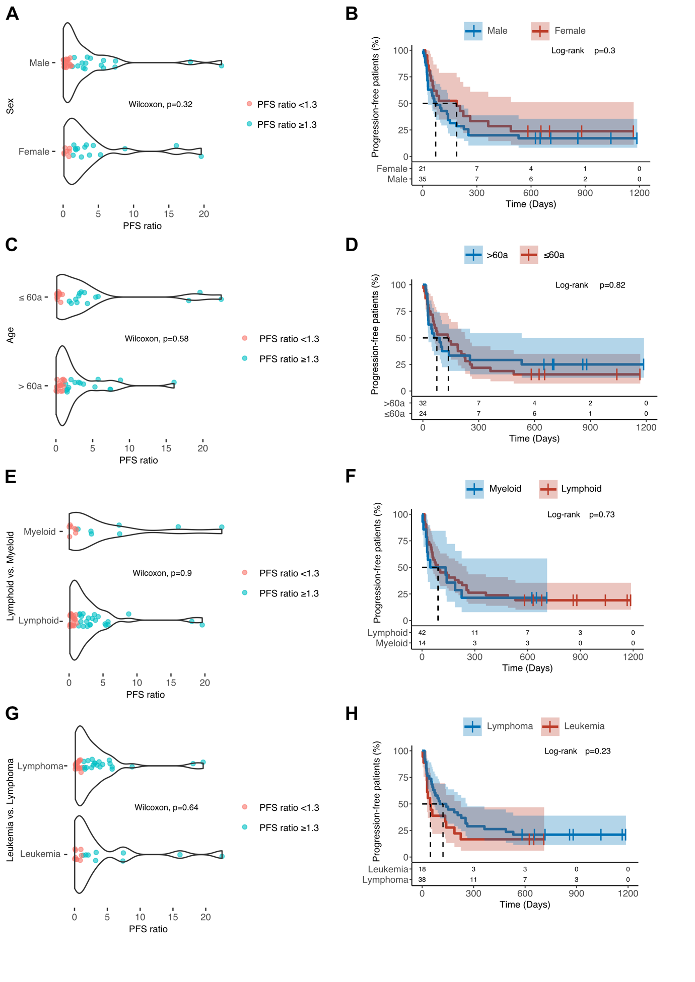

Supplementary Figure S4. Sex, age, lineage and disease subgroup do not influence PFS on scFPM treatment. (A) Violin plot showing PFS ratio stratified according to sex. (B) Kaplan Meier comparing PFS on scFPM treatment stratified according to sex. (C) Violin plot showing PFS ratio stratified according to age (up to 60 yrs. vs. above 60 years). (D) Kaplan Meier comparing PFS on scFPM treatment stratified according to age (up to 60 yrs. vs. above 60 years). (E) Violin plot showing PFS ratio stratified according to lineage (myeloid vs. lymphoid). (F) Kaplan Meier curve comparing PFS on scFPM guided treatment stratified according to lineage (myeloid vs. lymphoid). (G) Violin plot showing PFS ratio stratified according to disease subgroup (leukemia vs. lymphoma). (H) Kaplan Meier curve comparing PFS on scFPM guided treatment stratified according to disease subgroup (leukemia vs. lymphoma).

Supplementary Figure S5

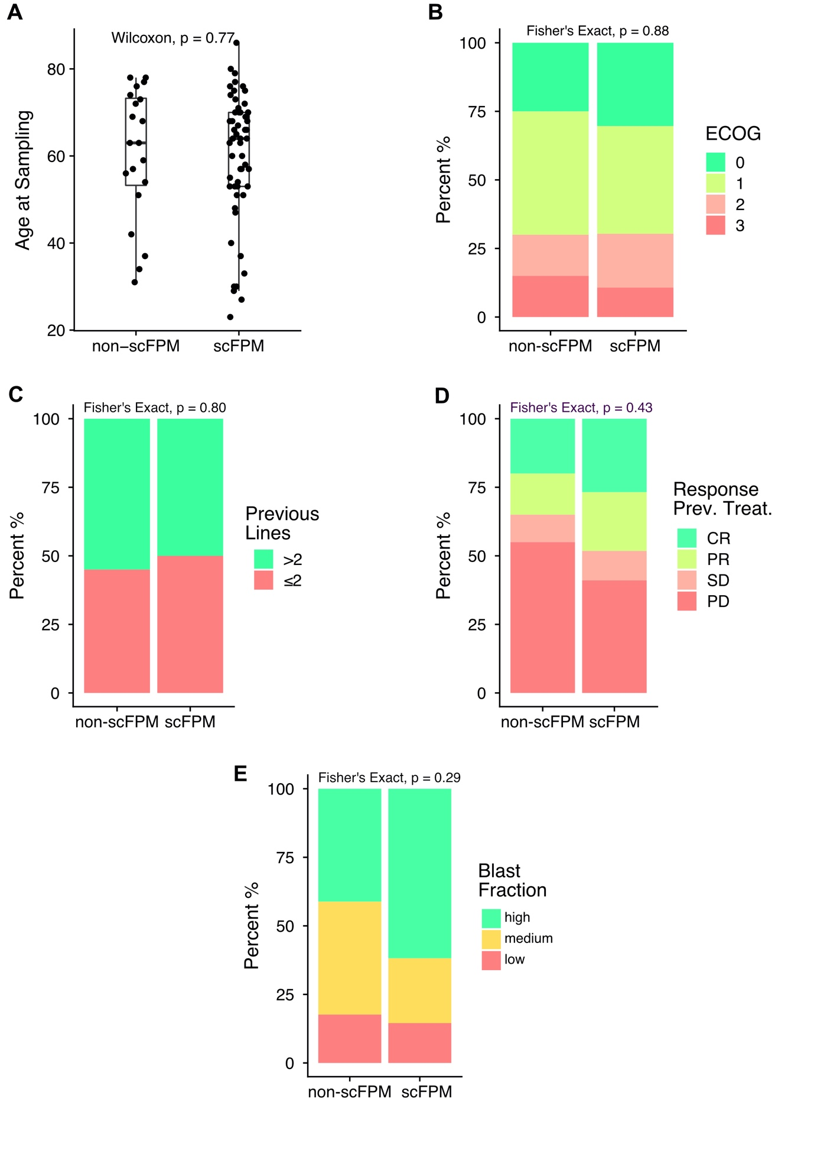
Supplementary Figure S5: Comparison of clinical characteristics between scFPM-guided patients and physician’s choice patients: (A) Age at sampling date compared with Wilcoxons test (B) ECOG at treatment start compared by Fisher’s exact test (C) Number of previous treatments dichotomized (≤2 versus >2) compared by Fisher’s exact test (D) Patient’s response to previous treatment compared by Fisher’s exact test (E) Sample Blast Fraction (≤10% = low, ≤50% = medium, >50% = high) compared by Fisher’s exact test.

Supplementary Figure S6

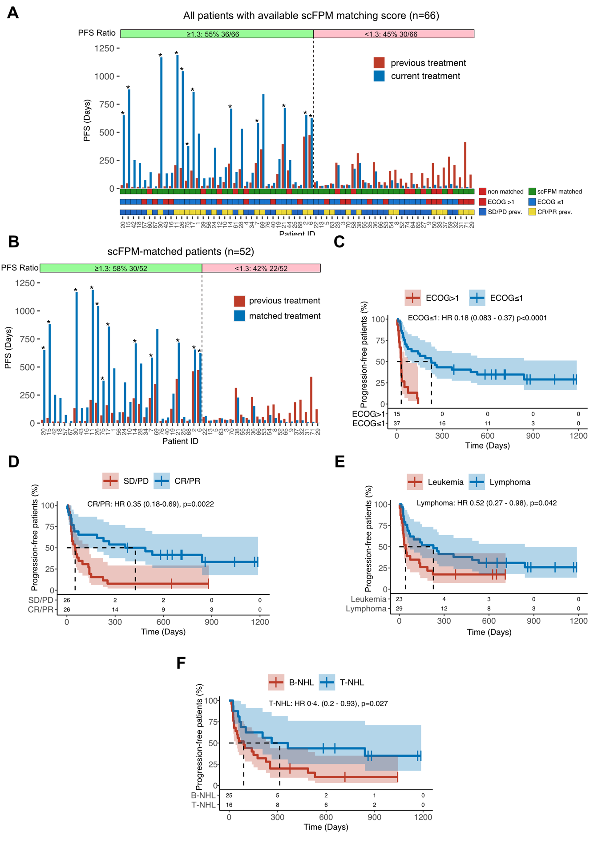

Supplementary Figure S6. PFS and influencing factors on scFPM matched treatment. (A) Bar plot showing the PFS for all evaluable patients with scFPM matching score (n=66): blue bars denote PFS in days for current treatment, red bars for previous treatment, stars denote ongoing response for current treatment at censoring date. Below, patient characteristics are color coded and stratified (scFPM matched vs. non-matched, ECOG>1 vs. ECOG≤1, OR to previous treatment). (B) Bar plot showing the PFS for scFPM matched patients. Stars denote ongoing response for scFPM treatment at censoring date (n=52), stars denote ongoing response for current treatment at censoring date. (C) Kaplan Meier Plot comparing PFS on scFPM matched between patients with ECOG ≤ 1 (n=37) versus ECOG > 1 (n=15). (D) Kaplan Meier comparing PFS on scFPM matched stratified according to OR on previous treatment (CR/PR: n=26, SD/PD: n=26). (E) Kaplan Meier comparing PFS on scFPM matched stratified according to disease presentation (leukemia (n=23) versus lymphoma patients (n=29)). (F) Kaplan Meier comparing PFS on scFPM matched stratified according to lymphoma lineage (T-NHL (n=16) versus B-NHL (n=25)).

Supplementary Tables

Supplementary Table S1. Screening drug collection
COMPOUND NAME | SIMPLIFIED DRUG CLASS | MODE OF ACTION | DRUG SUBCLASS | FDA APPROVAL STATUS | SUPPLIER | SUPPLIER REG_ID | MW
ABT-737 | Apoptosis modulator | BH3 mimetics | BCL2 inhibitor | Experimental | Adooq Bioscience | A10255 | 813.4
Navitoclax | Apoptosis modulator | BH3 mimetics | BCL2 inhibitor | Investigational Phase II/III | MedChem Express | HY-10087 | 974.6
Venetoclax | Apoptosis modulator | BH3 mimetics | BCL2 inhibitor | Approved | Adooq Bioscience | A12500 | 868.5
Obatoclax | Apoptosis modulator | BH3 mimetics | MCL1 inhibitor | Clinical development discontinued | Adooq Bioscience | A10665 | 413.5
Selinexor | Apoptosis modulator | CRM1 inhibitor |  | Approved | Adooq Bioscience | A12582 | 443.3
Aminopterin | Classical chemotherapeutic | Antimetabolites |  | Investigational Phase II (non-oncology) | Aldrich-CPR | MFCD00036692 | 440.4
AVN-944 | Classical chemotherapeutic | Antimetabolites | IMPDH inhibitor | Clinical development discontinued | MedChem Express | HY-13560 | 477.5
Azathioprine | Classical chemotherapeutic | Antimetabolites |  | Approved | Adooq Bioscience | A10107 | 277.3
Capecitabine | Classical chemotherapeutic | Antimetabolites |  | Approved | Aldrich-CPR | MFCD00930626 | 359.4
Cladribine | Classical chemotherapeutic | Antimetabolites |  | Approved | Cayman Chemical | 12085 | 285.7
Clofarabine | Classical chemotherapeutic | Antimetabolites |  | Approved | Adooq Bioscience | A10228 | 303.7
Cytarabine | Classical chemotherapeutic | Antimetabolites |  | Approved | Aldrich-CPR | MFCD00066487 | 243.2
Decitabine | Classical chemotherapeutic | Antimetabolites |  | Approved | Aldrich-CPR | MFCD00043011 | 228.2
Elacytarabine | Classical chemotherapeutic | Antimetabolites |  | Clinical development discontinued | Princeton BioMolecular Research, Inc. | OSSL_144797 | 279.7
Fludarabine | Classical chemotherapeutic | Antimetabolites |  | Approved | Adooq Bioscience | A10395 | 365.2
Fluorouracil | Classical chemotherapeutic | Antimetabolites |  | Approved | Aldrich-CPR | F0250000 | 130.1
Gemcitabine | Classical chemotherapeutic | Antimetabolites |  | Approved | MedChem Express | HY-17026 | 263.2
Mercaptopurine | Classical chemotherapeutic | Antimetabolites |  | Approved | Vitas-M Laboratory, Ltd. | STK727062 | 152.2
Methotrexate | Classical chemotherapeutic | Antimetabolites |  | Approved | Cayman Chemical | 13960 | 454.5
Nelarabine | Classical chemotherapeutic | Antimetabolites |  | Approved | Adooq Bioscience | A10632 | 297.3
Leflunomide | Classical chemotherapeutic | Antimetabolites |  | Approved | Aldrich-CPR | MFCD00867593 | 270.2
Pemetrexed | Classical chemotherapeutic | Antimetabolites |  | Approved | Aldrich-CPR | MFCD19105065 | 427.4
Pentostatin | Classical chemotherapeutic | Antimetabolites |  | Approved | Aldrich-CPR | SML0508 | 268.3
Pralatrexate | Classical chemotherapeutic | Antimetabolites |  | Approved | Adooq Bioscience | A11522 | 477.5
Raltitrexed | Classical chemotherapeutic | Antimetabolites |  | Approved | Adooq Bioscience | A10776 | 458.5
Thioguanine | Classical chemotherapeutics | Antimetabolites |  | Approved | Aldrich-CPR | MFCD00233553 | 167.2
Troxacitabine | Classical chemotherapeutics | Antimetabolites |  | Clinical development discontinued | Adooq Bioscience | A11232 | 213.2
Azacitidine | Classical chemotherapeutics | Alkylating agent |  | Approved | Cayman Chemical | 11164 | 244.2
Bendamustin | Classical chemotherapeutics | Alkylating agent |  | Approved | AvaChem Scientific | 2625B | 394.7
Busulfan | Classical chemotherapeutics | Alkylating agent |  | Approved | Aldrich-CPR | B2635 | 246.3
Carboplatin | Classical chemotherapeutics | Alkylating agent |  | Approved | Adooq Bioscience | A10182 | 373.3
Carmustine | Classical chemotherapeutics | Alkylating agent |  | Approved | Aldrich-CPR | MFCD00057706 | 214.1
Chlorambucil | Classical chemotherapeutics | Alkylating agent |  | Approved | Aldrich-CPR | Y0001298 | 304.2
Cisplatin | Classical chemotherapeutics | Alkylating agent |  | Approved | Adooq Bioscience | A10221 | 300.1
Cyclophosphamide | Classical chemotherapeutics | Alkylating agent |  | Approved | Adooq Bioscience | A10224 | 261.1
Ifosfamide | Classical chemotherapeutics | Alkylating agent |  | Approved | Aldrich-CPR | MFCD00057374 | 261.1
Lomustine | Classical chemotherapeutics | Alkylating agent |  | Approved | Aldrich-CPR | MFCD00012392 | 233.7
Melphalan | Classical chemotherapeutics | Alkylating agent |  | Approved | Aldrich-CPR | MFCD00057717 | 305.2
Mitomycin C | Classical chemotherapeutics | Alkylating agent |  | Approved | Cayman Chemical | 11435 | 334.3
Temozolomide | Classical chemotherapeutics | Alkylating agent |  | Approved | Aldrich-CPR | MFCD00866492 | 194.2
Thiotepa | Classical chemotherapeutics | Alkylating agent |  | Approved | Aldrich-CPR | MFCD00145452 | 189.2
Ixabepilone | Classical chemotherapeutics | Antimitotic | Epothilones | Approved | Adooq Bioscience | A11449 | 506.7
Docetaxel | Classical chemotherapeutics | Antimitotic | Taxanes | Approved | Aldrich-CPR | MFCD00800737 | 807.9
Paclitaxel | Classical chemotherapeutics | Antimitotic | Taxanes | Approved | Aldrich-CPR | MFCD00869953 | 853.9
Vinblastine | Classical chemotherapeutics | Antimitotic | Vinca alkaloid | Approved | Enamine | Z1634651125 | 811.0
Vincristine | Classical chemotherapeutics | Antimitotic | Vinca alkaloid | Approved | Adooq Bioscience | A11617 | 825.0
Vindesine | Classical chemotherapeutics | Antimitotic | Vinca alkaloid | Approved | AvaChem Scientific | 2181B | 850.0
Hydroxyurea | Classical chemotherapeutics | Antineoplastics |  | Approved | Aldrich-CPR | V900323 | 76.1
Omacetaxine | Classical chemotherapeutics | Protein translation inhibitor |  | Approved | Aldrich-CPR | SML1091 | 545.6
Bortezomib | Classical chemotherapeutics | Proteosome inhibitor |  | Approved | Adooq Bioscience | A10160 | 384.2
Carfilzomib | Classical chemotherapeutics | Proteosome inhibitor |  | Approved | MedChem Express | HY-10455 | 719.9
ATRA | Classical chemotherapeutics | Retinoid |  | Approved | Aldrich-CPR | T1850000 | 300.4
Bexarotene | Classical chemotherapeutics | Retinoid |  | Approved | Aldrich-CPR | MFCD00932428 | 348.5
Tamibarotene | Classical chemotherapeutics | Retinoid | Synthetic retinoid acid receptor (RAR) agonist | Investigational Phase II | Aldrich-CPR | MFCD00866188 | 351.5
Camptothecin | Classical chemotherapeutics | Topoisomerase I inhibitor |  | Experimental | Cayman Chemical | 11694 | 348.4
Etoposide | Classical chemotherapeutics | Topoisomerase I inhibitor |  | Approved | Cayman Chemical | 12092 | 588.6
Mitoxantrone | Classical chemotherapeutics | Topoisomerase I inhibitor |  | Approved | Princeton BioMolecular Research, Inc. | OSSL_856825 | 444.5
Teniposide | Classical chemotherapeutics | Topoisomerase I inhibitor |  | Approved | Aldrich-CPR | MFCD00866516 | 656.7
Topotecan | Classical chemotherapeutics | Topoisomerase I inhibitor |  | Approved | MedChem Express | HY-13768A | 457.9
Pixantrone | Classical chemotherapeutics | Topoisomerase I inhibitor |  | Approved | AvaChem Scientific | 2637B | 441.4
Daunorubicin | Classical chemotherapeutics | Topoisomerase II inhibitor |  | Approved | AvaChem Scientific | 2019B | 564.0
Doxorubicin | Classical chemotherapeutics | Topoisomerase II inhibitor |  | Approved | Adooq Bioscience | A14403 | 543.5
Amsacrine | Classical chemotherapeutics | Topoisomerase II inhibitor |  | Approved | Adooq Bioscience | A13093 | 393.5
Idarubicin | Classical chemotherapeutics | Topoisomerase II inhibitor |  | Approved | Aldrich-CPR | I1656 | 497.5
Valrubicin | Classical chemotherapeutics | Topoisomerase II inhibitor |  | Approved | MedChem Express | HY-13772 | 723.7
JQ1 | Epigenetic modifier | BRD4 inhibitor |  | Experimental | Adooq Bioscience | A12729 | 457.0
Belinostat | Epigenetic modifier | HDAC inhibitor |  | Approved | Combi-Blocks, Inc. | ST-7124 | 318.4
Mocetinostat | Epigenetic modifier | HDAC inhibitor |  | Investigational Phase II | MedChem Express | HY-12164 | 396.5
Panobinostat | Epigenetic modifier | HDAC inhibitor |  | Approved | Adooq Bioscience | A10518 | 349.4
Pivaloyloxymethyl butyrate | Epigenetic modifier | HDAC inhibitor |  | Clinical development discontinued | Aldrich-CPR | MFCD00209896 | 202.3
Romidepsin | Epigenetic modifier | HDAC inhibitor |  | Approved | Adooq Bioscience | A11920 | 540.7
Tacedinaline | Epigenetic modifier | HDAC inhibitor |  | Clinical development discontinued | Cayman Chemical | 12084 | 269.3
Vorinostat | Epigenetic modifier | HDAC inhibitor |  | Approved | Cayman Chemical | 10009929 | 264.3
Tipifarnib | Epigenetic modifier | Farnesyltransferase inhibitor |  | Investigational Phase III | Adooq Bioscience | A10935 | 489.4
Lenalidomide | Immunomodulators | IMIDS |  | Approved | Aldrich-CPR | MFCD07772307 | 259.3
Pomalidomide | Immunomodulators | IMIDS |  | Approved | Adooq Bioscience | A10743 | 273.3
Thalidomide | Immunomodulators | IMIDS |  | Approved | Aldrich-CPR | 1652500 | 258.2
Ceplene | Immunomodulators | Immunostimulants | Antihistamines | Approved | Key Organics / BIONET | BS-3141 | 184.1
Plerixafor | Immunomodulators | Immunostimulants | Cell mobilizer | Approved | Adooq Bioscience | A13074 | 502.8
Cyclosporine | Immunomodulators | Microlides |  | Approved | Adooq Bioscience | A10260 | 1202.6
Tacrolimus | Immunomodulators | Microlides |  | Approved | Adooq Bioscience | A10389 | 804.0
Celecoxib | Immunomodulators | NSAIDs | Coxibs | Approved | Aldrich-CPR | Y0001445 | 381.4
Dexamethasone | Immunomodulators | Steroids |  | Approved | Aldrich-CPR | D085 | 392.5
Methylprednisolone | Immunomodulators | Steroids |  | Approved | Aldrich-CPR | MFCD00010591 | 374.5
Prednisolone | Immunomodulators | Steroids |  | Approved | Aldrich-CPR | MFCD00003649 | 360.5
Prednisone | Immunomodulators | Steroids |  | Approved | Aldrich-CPR | P2900000 | 358.4
AT7519 | Kinase inhibitors | CMGS inhibitors | CDK inhibitor | Clinical development discontinued | Adooq Bioscience | A10093 | 382.3
Alvocidib | Kinase inhibitors | CMGS inhibitors | CDK inhibitor | Investigational Phase II | Adooq Bioscience | A10390 | 401.9
Palbociclib | Kinase inhibitors | CMGS inhibitors | CDK inhibitor | Approved | AstaTech, Inc. | 42034 | 447.5
AT9283 | Kinase inhibitors | Other | AURORA / JAK inhibitor | Clinical development discontinued | Adooq Bioscience | A10095 | 381.4
BI 2536 | Kinase inhibitors | Other | PLK inhibitor | Clinical development discontinued | Adooq Bioscience | A10134 | 521.7
Volasertib | Kinase inhibitors | Other | PLK inhibitor | Investigational Phase III | Adooq Bioscience | A10135 | 618.8
Buparlisib | Kinase inhibitors | PIKL inhibitor | pan-PI3K | Investigational Phase III | Adooq Bioscience | A11016 | 410.4
Dactolisib | Kinase inhibitors | PIKL inhibitor | mTOR / PI3K inhibitor | Clinical development discontinued oncology; Investigational Phase III (non-oncology) | Adooq Bioscience | A10133 | 469.6
Duvelisib | Kinase inhibitors | PIKL inhibitor | Dual PI3Kδ and PI3Kγ inhibitor | Approved | Adooq Bioscience | A12422 | 416.9
Idelalisib | Kinase inhibitors | PIKL inhibitor | PI3Kδ inhibitor | Approved | Adooq Bioscience | A10172 | 415.4
Everolimus | Kinase inhibitors | PIKL inhibitor | rapalog (mTOR) | Approved | MedChem Express | HY-10218 | 958.2
Sirolimus | Kinase inhibitors | PIKL inhibitor | rapalog (mTOR) | Approved | Adooq Bioscience | A10782 | 914.2
Temsirolimus | Kinase inhibitors | PIKL inhibitor | rapalog (mTOR) | Approved | Aldrich-CPR | MFCD00934421 | 1030.3
Trametinib | Kinase inhibitors | STE inhibitors | MEK inhibitor | Approved | Adooq Bioscience | A11029 | 615.4
Dabrafenib | Kinase inhibitors | TKL inhibitors | BRAF inhibitor | Approved | Cayman Chemical | 16989 | 519.6
Bafetinib | Kinase inhibitors | Tyrosine kinase inhibitors | BCR-ABL / LYN inhibitor | Clinical development discontinued | MedChem Express | HY-12039 | 576.6
Bosutinib | Kinase inhibitors | Tyrosine kinase inhibitors | BCR-ABL / SRC inhibitor | Approved | Adooq Bioscience | A10161 | 530.5
Dasatinib | Kinase inhibitors | Tyrosine kinase inhibitors | BCR-ABL / SRC inhibitor | Approved | Combi-Blocks, Inc. | ST-7591 | 488.0
Imatinib | Kinase inhibitors | Tyrosine kinase inhibitors | BCR-ABL / KIT / PDGFR inhibitor | Approved | Aldrich-CPR | MFCD05662257 | 493.6
Nilotinib | Kinase inhibitors | Tyrosine kinase inhibitors | BCR-ABL inhibitor | Approved | Cayman Chemical | 10010422 | 529.5
Ponatinib | Kinase inhibitors | Tyrosine kinase inhibitors | BCR-ABL / VEGFR / PDGFR inhibitor | Approved | Adooq Bioscience | A10080 | 532.6
Rebastinib | Kinase inhibitors | Tyrosine kinase inhibitors | BCR-ABL / SRC inhibitor | Investigational Phase I/II | Adooq Bioscience | A11200 | 553.6
Ceritinib | Kinase inhibitors | Tyrosine kinase inhibitors | ALK ihibitor | Approved | Adooq Bioscience | A13238 | 558.1
Crizotinib | Kinase inhibitors | Tyrosine kinase inhibitors | ALK ihibitor | Approved | Adooq Bioscience | A10712 | 450.3
Ibrutinib | Kinase inhibitors | Tyrosine kinase inhibitors | BTK inhibitor | Approved | MedChem Express | HY-10997 | 440.5
Erlotinib | Kinase inhibitors | Tyrosine kinase inhibitors | EGFR inhibitor | Approved | Cayman Chemical | 10483 | 393.44
Gefitinib | Kinase inhibitors | Tyrosine kinase inhibitors | EGFR inhibitor | Approved | Aldrich-CPR | MFCD04307832 | 446.9
XL228 | Kinase inhibitors | Tyrosine kinase inhibitors | IGF-1R / BCR-ABL / Aurora A / Src inhibitor | Clinical development discontinued | Adooq Bioscience | A13069 | 437.6
Ruxolitinib | Kinase inhibitors | Tyrosine kinase inhibitors | JAK1/2 inhibitor | Approved | Adooq Bioscience | A11041 | 306.4
Crenolanib | Kinase inhibitors | Tyrosine kinase inhibitors | PDGFR / FLT3 inhibitor | Approved | Adooq Bioscience | A11052 | 443.6
Lestaurtinib | Kinase inhibitors | Tyrosine kinase inhibitors | FLT3 / JAK2 / TrK inhibitor | Investigational Phase III | Cayman Chemical | 12094 | 439.5
Masitinib | Kinase inhibitors | Tyrosine kinase inhibitors | PDGFR / KIT inhibitor | Investigational Phase III | Adooq Bioscience | A10558 | 498.7
Midostaurin | Kinase inhibitors | Tyrosine kinase inhibitors | PDGFR / FLT3 / PKCα/β/γ inhibitor | Approved | MedChem Express | HY-10230 | 570.7
Quizartinib | Kinase inhibitors | Tyrosine kinase inhibitors | PDGFR / FLT3 | Investigational Phase III | Adooq Bioscience | A10027 | 560.7
Tandutinib | Kinase inhibitors | Tyrosine kinase inhibitors | PDGFR / FLT3 / KIT inhibitor | Clinical development discontinued | Key Organics / BIONET | ES-0051 | 562.7
Dovitinib | Kinase inhibitors | Tyrosine kinase inhibitors | VEGFR / FGFR inhibitor | Clinical development discontinued | Adooq Bioscience | A11411 | 392.4
Cabozantinib | Kinase inhibitors | Tyrosine kinase inhibitors | VEGFR inhibitor | Approved | Adooq Bioscience | A10996 | 501.5
Linifanib | Kinase inhibitors | Tyrosine kinase inhibitors | VEGFR inhibitor | Clinical development discontinued | Adooq Bioscience | A10025 | 375.4
Pazopanib | Kinase inhibitors | Tyrosine kinase inhibitors | VEGFR inhibitor | Approved | Aldrich-CPR | MFCD11616589 | 437.5
Sorafenib | Kinase inhibitors | Tyrosine kinase inhibitors | VEGFR inhibitor | Approved | Vitas-M Laboratory, Ltd. | STK627350 | 464.8
Sunitinib | Kinase inhibitors | Tyrosine kinase inhibitors | VEGFR inhibitor | Approved | Aldrich-CPR | MFCD09260778 | 398.5
Vandetanib | Kinase inhibitors | Tyrosine kinase inhibitors | VEGFR / EGFR / RET inhibitor | Approved | Combi-Blocks, Inc. | QA-0938 | 475.4
EGCG = Epigallocatechin gallate | Metabolic modifier | Antioxidant | Catechin | Investigational Phase II | Aldrich-CPR | MFCD00075940 | 458.4
Ellagic Acid | Metabolic modifier | Antioxidant | Ellagitannins | Investigational Phase II | Cayman Chemical | 10569 | 302.2
Ranolazine | Metabolic modifier | Ion channels inhibitors | Sodium-dependent calcium channel inhibitor | Approved | Adooq Bioscience | A10780 | 427.5
Bestatin | Metabolic modifier | Protein turnover | Aminopeptidase inhibitor | Clinical development discontinued | Enzo Lifesciences International, Inc. | ALX-260-012 | 308.4
Tosedostat | Metabolic modifier | Protein turnover | Aminopeptidase inhibitor | Clinical development discontinued | Tocris Bioscience | 3595 | 406.5
Atorvastatin | Metabolic modifier | Statins | HMG-CoA reductase inhibitor | Approved | Aldrich-CPR | MFCD00899261 | 558.7
Anagrelide | Other | Phosphodiesterase inhibitors |  | Approved | Enamine | EN300-187333 | 256.1
Erismodegib | Other | Hedgehog pathway | Smoothened inhibitor | Approved | Adooq Bioscience | A10520 | 485.5
Vismodegib | Other | Hedgehog pathway | Smoothened inhibitor | Approved | Aldrich-CPR | MFCD12407408 | 421.3
PU-H71 | Other | Chaperones | HSP90 inhibitor | Investigational Phase I | Adooq Bioscience | A11130 | 512.4
Zoledronate | Other | Biphosphonate |  | Approved | Princeton BioMolecular Research, Inc. | OSSL_857224 | 272.1

Supplementary Table S2. Patient’s characteristics
Pat ID | Diagnosis | Age | Sex | Number of previous treatments | Previous treatment | PFS on previous treatment | Sample type | Genetic data | scFPM treatment | Best response | PFS on scFPM treatment | Ongoing response | ECOG at treatment start | Exceptional Response | Markers used
1 | DLBCL, NOS | 70 | Female | 5 | Idelalisib | 92 | Lymph Node | negative | Lenalidomide Dexamethasone RT | PR | 488 | no | 1 | no | CD19 CD20
2 | PTCL, NOS | 67 | Female | 3 | autologous SCT + Brentuximab consolidation | 462 | Lymph Node | negative | Brentuximab Bendamustine Dasatinib | CR | 656 | yes | 0 | yes | CD3 CD5
3 | AML, NOS | 58 | Female | 2 | MIDAC | 31 | Peripheral Blood | KIT D816V, TP53 G244D | Azacytidine Thalidomide | PD | 27 | no | 3 | no | CD34 CD117/cKIT
4 | DLBCL, NOS | 53 | Male | 2 | G-ICE | 21 | Lymph Node |  | Rituximab Lenalidomide Atorvastatin | SD | 60 | no | 2 | no | CD19 CD20
5 | AML with inv16(p13.1q22) or t(16;16)(o13.1;q22);CBFB-MYH11 | 66 | Male | 4 | Azacytidine | 30 | Bone Marrow | CBFB-MYH11A pos. | Prednisolone Panobinostat | PD | 29 | no | 2 | no | CD34 CD117/cKIT
6 | AML with mutated NPM1 | 65 | Male | 3 | ICE ATRA Gemtuzumab_Ozogamicin + Azacytidine + allogenous SCT | 474 | Bone Marrow |  | Azacytidine followed by DLI | CR | 626 | yes | 0 | yes | CD34 CD117/cKIT
7 | AITL | 86 | Female | 3 | Bendamustin | 225 | Lymph Node | TET2 M1701fs*12 M496fs*1 | Cladribine Prednisolone | CR | 584 | yes | 1 | yes | CD3 CD5
8 | AML with MDS-related changes | 51 | Female | 3 | ClofCy + allo HSCT | 166 | Bone Marrow | negative | Decitabine | PD | 46 | no | 1 | no | CD14 CD19 CD33
9 | DLBCL, NOS | 68 | Male | 2 | R-ICE | 92 | Lymph Node | BRAF V471I, TP53 P278S | Pixantrone Prednisolone | PD | 14 | no | 3 | no | CD19 CD79a
10 | AML, NOS | 76 | Female | 3 | FLAG | 57 | Peripheral Blood | negative | AMSA Cytarabine + Azacytidine consolidation | SD | 188 | no | 1 | no | CD34 CD117/cKIT
11 | HSTCL | 29 | Male | 1 | SMILE | 207 | Peripheral Blood | TCR beta and gamma chain rearrangement | Cyclophosphamide Mitoxantrone Prednisolone Alemtuzumab + allogenous HSCT | CR | 1188 | yes | 0 | yes | CD34
12 | PTCL, NOS | 57 | Male | 5 | Romidepsin | 30 | Bone Marrow | TP53 P190L, TCR gamma chain rearrangement | Ixazomib Lenalidomide Dexamethasone | PR | 103 | no | 2 | no | CD3 CD4
13 | AML with MDS-related changes | 66 | Male | 4 | Cytarabine | 22 | Bone Marrow | TP53 R72P | Ponatinib Hydroxyurea | PR | 23 | no | 1 | no | CD34 CD117/cKIT
14 | AML with MDS-related changes | 57 | Male | 1 | Azacytidine | 221 | Bone Marrow | negative | Clofarabine Cyclophosphamide followed by allogenous HSCT FLAMSA + Cyclophosphamide + TBI | CR | 711 | yes | 0 | yes | CD34 CD117/cKIT
15 | PCGD-TCL | 37 | Female | 1 | SMILE | 45 | Skin | TCR beta chain rearrangement | Pemetrexed Vinablastine Dexamethasone Bexarotene followed by allo-HSCT w Cyclophosphamide ATG | CR | 882 | yes | 0 | yes | CD3 CD5
16 | Therapy-related myeloid neoplasms | 74 | Male | 2 | MIDAC light | 19 | Peripheral Blood | negative | Azacytidine Hydroxyurea | SD | 140 | no | 2 | no | CD34 CD117/cKIT
17 | ALCL, ALK-negative | 48 | Male | 1 | CHOP | 159 | Lymph Node |  | Brentuximab Etoposide followed by allogenous HSCT | CR | 861 | yes | 0 | yes | CD4 CD30 CD274/PDL1
18 | AML, NOS | 80 | Female | 1 | Azacytidine | 14 | Peripheral Blood | CALR Exon 9 Type I Mutation | Venetoclax Azacytidine | CR | 225 | no | 0 | no | CD34 CD117/cKIT
19 | AITL | 75 | Female | 1 | CHOP | 128 | Lymph Node | TCR beta and gamma chain rearrangement | Brentuximab Etoposide Cisplatin | CR | 263 | no | 0 | no | CD3 CD4 CD5
20 | AML, NOS | 55 | Male | 3 | Clofarabine Cytarabine | 29 | Peripheral Blood | negative | ClofCy followed by allogenous SCT Cyclophosphamide ATG TBI | CR | 652 | yes | 1 | yes | CD34 CD117/cKIT
21 | DLBCL, NOS | 53 | Female | 1 | R-CHOP + autologous SCT | 394 | Lymph Node | TP53 I195T | Idelalisib | CR | 718 | yes | 1 | yes | CD19 CD79a
22 | PTCL, NOS | 66 | Male | 1 | Ro-CHOP | 54 | Lymph Node | TP53 T220C | modified ICE wo Ifosfamide Selinexor | PR | 64 | no | 0 | no | CD5
23 | AITL | 64 | Female | 1 | Ro-CHOP | 229 | Bone Marrow | TCR beta and gamma chain rearrangement positive | Mitoxantrone Ifosfamide Brentuximab | PR | 207 | no | 1 | no | CD3 CD4
24 | AITL | 63 | Female | 1 | COEMP | 97 | Lymph Node | EGFR R776H | Romidepsin | PR | 363 | no | 0 | yes | CD3
25 | PTCL, NOS | 70 | Female | 1 | R-COMP | 36 | Lymph Node | KRAS A146V+G13D | Pixantrone | PD | 55 | no | 1 | no | CD30
26 | DLBCL, NOS | 69 | Male | 2 | R-DHAP | 182 | Lymph Node | negative | R-Gemox followed by Rituximab maintenance | CR | 1044 | yes | 1 | yes | CD19 CD79a
27 | DLBCL, NOS | 60 | Male | 4 | R-GEMOX + autologous HSCT | 136 | Lymph Node | MYD88 L256P | Imatinib Prednisolone | SD | 24 | no | 1 | no | CD19 CD20
28 | PMBL | 27 | Male | 6 | R-ICE + RT | 171 | Mediastinum | negative | Brentuximab Cladribine Bendamustine followed by allogenous HSCT | CR | 531 | no | 0 | no | CD20 CD30 CD79a
29 | AML, NOS | 70 | Male | 2 | Azacytidine Hydroxyurea | 123 | Peripheral Blood |  | Vindesine | PD | 3 | no | 2 | no | CD34 CD117/cKIT
30 | HSTCL | 71 | Female | 1 | Methylprednisolone | 133 | Spleen | TCR beta and gamma rearrangement | Gemcitabine | CR | 1168 | yes | 0 | yes | CD3
31 | AML, NOS | 69 | Male | 1 | Azacytidine | 99 | Peripheral Blood | negative | Venetoclax | PD | 8 | no | 2 | no | CD34 CD117/cKIT
32 | DLBCL, NOS | 33 | Female | 3 | R-ICE + auto HSCT | 208 | Gastrointestinal Tract | TP53 C176X + splicesite mutation, bcl2 amplified bcl6 amplified | Pembrolizumab Docetaxel | PD | 25 | no | 1 | no | CD19 CD20 CD79a
33 | MCL | 53 | Male | 4 | R-Bendamustine | 121 | Effusion | negative | Cyclophosphamide Prednisolone Carmustine | PR | 17 | no | 3 | no | CD20 CD79a
34 | HGBL-DH/TH | 54 | Male | 3 | R-DHAP | 52 | Lymph Node | TP53 Y234C, MYC amplified and translocated, bcl6 translocated | Pixantrone Idelalisib Prednisolone Obinutuzumab followed by CART with FC-lymphodepletion | SD | 140 | no | 0 | no | CD19 CD79a
35 | DLBCL, NOS | 57 | Male | 4 | R-PREBEN | 46 | Soft Tissue | EZH2 Y646H | Amsacrine | PD | 30 | no | 2 | no | CD20 CD79a
36 | DLBCL, NOS | 68 | Male | 7 | Ofatumumab Pixantrone + Ofatumumab maintenance | 234 | Lymph Node | EZH2 Y646F+K634T, BCL6 translocation, BCL2 translocation | Mitoxantrone Panobinostat Dexamethasone | CR | 151 | no | 0 | no | CD19
37 | T-LBL | 40 | Male | 1 | GMALL + allogenous HSCT | 186 | Bone Marrow | TCR beta rearrangement | Bortezomib Dexamethasone Mitoxantrone | PD | 26 | no | 1 | no | CD34
38 | MCL | 68 | Male | 2 | R2-COMP | 314 | Lymph Node | negative | Ibrutinib | CR | 228 | no | 1 | no | CD20
39 | B-LBL, NOS | 51 | Female | 3 | Blinatumumab | 21 | Effusion |  | Bortezomib Obinutuzumab Mercaptopurine Dexamethasone | PR | 90 | no | 2 | no | CD3 CD19 CD20
40 | B-LBL, NOS | 30 | Male | 2 | Blinatumomab | 24 | Peripheral Blood | FLT3 A680V KRAS G12D | Azacytidine Bortezomib | PR | 50 | no | 3 | no | CD3 CD20 CD34
41 | B-LBL, NOS | 23 | Male | 4 | Blinatumumab | 85 | Peripheral Blood | negative | Rituximab Ifosfamide Vincristine Methotrexate Bortezomib | CR | 29 | no | 2 | no | CD10 CD34
42 | THRLBCL | 30 | Male | 2 | Pixantrone | 14 | Lymph Node | CDKN2A A57V | Bortezomib Cladribine Dexamethasone followed by allogenous HCST with FC | CR | 253 | no | 1 | no | CD3 CD10 CD79a
43 | AML, NOS | 73 | Male | 2 | HAM | 18 | Peripheral Blood | NRAS G12D | Azacytidine | PR | 134 | no | 3 | no | CD34
44 | Monomorphic PTLD, B-cell | 70 | Male | 8 | RR-EPOCH | 160 | Skin | MYD88 L256P | Ibrutinib | CR | 253 | no | 1 | no | CD3 CD14 CD20
45 | FL, high grade | 63 | Female | 4 | O-GIFOX | 25 | Lymph Node | TP53 P278S, Fusion TBLXR1/PIK3CA | Panobinostat Bortezomib Dexamethasone | PD | 77 | no | 1 | no | CD19 CD20 CD79a
46 | PTCL, NOS | 75 | Male | 1 | CHOP | 187 | Lymph Node | ATM P2512* | Bendamustine | PR | 187 | no | 0 | no | CD5
47 | HGBL-DH/TH | 64 | Female | 3 | R-GIFOX | 50 | Lymph Node | EZH2 Y646F, TP53 F134L | Pixantrone | SD | 41 | no | 1 | no | CD19
48 | B-LBL, NOS | 72 | Female | 3 | Inotuzumab Ozogamycin | 34 | Bone Marrow | negative | Azacytidine Dasatinib | PD | 59 | no | 0 | no | CD19 CD34
49 | DLBCL, NOS | 79 | Male | 3 | RADOX | 33 | Lymph Node | CREBBP P1476A, TP53 Q331*, PTEN C71*, CDK12 L1027I, ATRX C235R | Methotrexate Dexamethasone | SD | 14 | no | 0 | no | CD19 CD20
50 | AML, NOS | 64 | Female | 2 | Azacytidine | 227 | Peripheral Blood |  | Dasatinib Thalidomide Hydroxyurea | SD | 33 | no | 3 | no | CD34 CD117/cKIT
51 | Monomorphic PTLD, B-cell | 53 | Female | 3 | MATRIX | 26 | Lymph Node |  | Lenalidomide Rituximab RT | PD | 14 | no | 2 | no | CD19
52 | PTCL, NOS | 76 | Male | 3 | ICE | 87 | Peripheral Blood |  | Cladribine | PD | 24 | no | 1 | no | CD3 CD34
53 | DLBCL, NOS | 47 | Male | 3 | R-ICE | 54 | Lymph Node | BCL2 translocation | Pixantrone | PD | 26 | no | 2 | no | CD19 CD20
54 | Nodal PTCL with TFH phenotype | 77 | Male | 1 | CHOEP | 156 | Lymph Node | negative | Cisplatin Dexamethasone Gemcitabine | CR | 72 | no | 1 | no | CD5
55 | DLBCL, NOS | 70 | Male | 2 | R-ICE | 76 | Lymph Node | negative | Venetoclax Pixantrone | PD | 53 | no | 1 | no | CD19
56 | FL, high grade | 60 | Male | 4 | R-GIFOX | 25 | Lymph Node |  | Idelalisib | PD | 97 | no | 1 | no | CD19 CD20 CD79a
Pat ID | Diagnosis | Age | Sex | Number of previous treatments | Previous treatment | PFS on previous treatment | Sample type | Genetic data | Physician's choice treatment | Best response | PFS on Physician's choice treatment | Ongoing response | ECOG at treatment start | Exceptional Response | Markers used
57 | MDS with excess blasts | 72 | Male | 3 | Hydroxyurea Azacytidine | 8 | Peripheral Blood | FLT3-ITD TP53 R72P | Venetoclax | SD | 73 | no | 2 | no | CD34 CD117/cKIT
58 | DLBCL, NOS | 42 | Male | 3 | R-ICE + autologous SCT | 219 | Lymph Node | CDH1 A408V | Selinexor | PR | 176 | no | 0 | no | CD19 CD20
59 | AML, NOS | 59 | Male | 4 | Azacytidine | 283 | Bone Marrow | negative | 3+7+ Mylotarg | SD | 38 | no | 1 | no | CD33 CD34 CD117/cKIT
60 | AML, NOS | 63 | Male | 2 | FLAG | 16 | Bone Marrow | negative | Azacytidine | CR | 144 | no | 1 | no | CD34 CD117/cKIT
61 | Systemic mastocytosis | 78 | Male | 1 | Hydroxycarbamid | 47 | Peripheral Blood | KIT D816V | CLAG | CR | 147 | no | 1 | no | CD25 CD33
62 | MPAL, B/myeloid, NOS | 31 | Male | 2 | Blinatumumab | 98 | Bone Marrow | IG light and heavy chain rearrangement | Inotuzumab Ozogamicin, afterwards allogenous SCT, TBI Cyclophosphamide ATG | CR | 1046 | yes | 0 | yes | CD19 CD20 CD34
63 | AML with MDS-related changes | 74 | Female | 2 | MIDAC light | 44 | Bone Marrow | TP53 P151R | Azacytidine | PR | 42 | no | 1 | no | CD34 CD117/cKIT
64 | t-MN | 76 | Female | 5 | Azacytidine | 137 | Peripheral Blood | negative | Hydroxyurea | PR | 37 | no | 1 | no | CD34
65 | AML, NOS | 54 | Male | 2 | MIDAC | 38 | Peripheral Blood |  | Azacytidine | PD | 8 | no | 1 | no | CD34
66 | t-MN | 69 | Female | 3 | FLAG | 58 | Peripheral Blood |  | Azacytidine | PD | 33 | no | 0 | no | CD34 CD117/cKIT
67 | B-LBL, NOS | 37 | Male | 4 | Inotuzumab | 2 | Peripheral Blood |  | ClofCy | PD | 18 | no | 2 | no | CD10 CD19
68 | AML with mutated NPM1 | 63 | Female | 3 | FLAG | 21 | Peripheral Blood |  | Clofarabine Cyclophosphamide | PD | 32 | no | 2 | no | CD34
69 | PTCL, NOS | 78 | Female | 1 | CHOP | 348 | Lymph Node |  | Lenalidomide Dexamethasone | SD | 840 | no | 0 | yes | CD3
70 | Monomorphic PTLD, B-cell | 56 | Male | 4 | Mini-BEAM | 35 | Lymph Node | BRAF G466E, PTEN A126T, TP53 R273H, ARID1A Y551fs, CDKN2A/B loss, DDXD3 splicesite mutation, MYC rearrangement, BCL6 rearrangement | Rituximab Idelalisib Prednisolone | PD | 29 | no | 3 | no | CD19 CD20
71 | AML with mutated NPM1 | 34 | Female | 1 | 3+7, HD-Cytarabine-consolidation allogenous SCT | 413 | Peripheral Blood |  | Azacytidine Hydroxyurea | PD | 12 | no | 3 | no | CD34 CD117/cKIT
72 | AML with MDS-related changes | 51 | Male | 5 | FLAG | 17 | Peripheral Blood |  | MIDAC | PD | 3 | no | 1 | no | CD34
73 | AITL | 77 | Female | 1 | CHOP | 210 | Lymph Node |  | Bendamustine Brentuximab | CR | 121 | no | 3 | no | CD3 CD5
74 | t-MN | 57 | Male | 3 | ClofCy | 51 | Bone Marrow |  | Azacytidine Venetoclax Hydroxyurea | PR | 14 | no | 1 | no | CD34
75 | PCL | 68 | Male | 5 | DTB-PACE | 69 | Bone Marrow |  | Daratumumab Bendamustine Dexamethasone | PR | 378 | yes | 1 | no | CD19
76 | DLBCL, NOS | 73 | Male | 2 | Obinutuzumab Venetoclax | 19 | Lymph Node |  | R-ICE | PD | 40 | no | 0 | no | CD19 CD79a
Table S2: Characteristics of scFPM-guided and physician's choice treated patients. Abbreviations: 3+7+ Mylotarg - Daunorubicin Cytarabine Gemtuzumab; AITL - Angioimmunoblastic T-cell lymphoma; AML - Acute myeloid leukemia; AMSA - amsacrine; ALCL - Anaplastic large cell lymphoma; ALK - Anaplastic lyphoma kinase; ATG - Anti-thymocyte globulin; ATRA - retinoic acid; B-LBL - B-Lymphoblastic lymphoma; CART - Chimeric antigen receptor T cell; CD - Cluster of differentiation; CHOP - cyclophosphamide, doxorubicin hydrochloride (hydroxydaunorubicin), vincristine sulfate (Oncovin), and prednisone; CHOEP - plus etoposide; CLAG - cladribine, cytarabine, G-CSF; ClofCy - clofarabine/cyclophosphamide; COEMP - cyclophosphamide, vincristine, etoposide, lysosomal doxorubicin, prednisone; COMP - cyclophosphamide, vincristine, lysosomal doxorubicin, prednisone; CR - Complete response; DHAP - dexamethasone, high-dose cytarabine, cisplatin; DLBCL - Diffuse large B-cell lymphoma; DLI - Donor lymphocyte infusion; DTB-PACE - bortezomib, cisplatin, adriblastin, cyclophosphamide, etoposide; EPOCH - etoposide, prednisolone, vincristine, cyclophosphamide, hydroxydaunorubicin; FC - fludarabine and cyclophosphamide; FL - Follicular lymphoma; FLAG - fludarabine, cytarabine and G-CSF; FLAMSA - fludarabine, amsacrine, and cytarabine; G - G-CSF (Granulocyte colony-stimulating factor), GEMOX - gemcitabine, oxaliplatin; GIFOX - gemcitabine, ifosfamide, oxaliplatin; GMALL - German Multi- center Study Group for Adult Acute Lymphoblastic Leukemia; HAM - high-dose cytosine arabinoside and mitoxantrone; HD - High dose; HSTCL - Hepatosplenic T-cell lymphoma; HGBL-DH/TH - High-grade B-cell lymphoma with MYC and BCL2 and/or BLC6 rearrangements ("double hit/triple hit lymphoma"); ICE - ifosfamide, carboplatin, etoposide; MATRIX - methotrexate, cytarabine, thiotepa and rituximab; MCL - Mantle cell lymphoma; Mini-BEAM - Carmustine Etoposide Cytarabine Melphalane; MDS - Myelodysplatic syndrome; MIDAC - mitoxantrone and cytarabine; NOS - not otherwised specified; O - obinutuzumab; PCGD-TCL - Primary cutaneous gamma-delta T-cell lymphoma; PCL - Plasma cell leukemia; PD - Progressive disease; PMBL - Primary mediastinal (thymic) large B-cell lymphoma; PR - Partial response; PREBEN - pixantrone, etoposide, bendamustine; PTCL - Peripheral T-cell lymphoma; PTLD - Post-transplant lymphoproliferative disorder; R - rituximab; RADOX - rituximab, cytarabine, dexamethasone and oxaliplatin; Ro - Romidepsin; RT - radiotherapy; SCT - Stem cell transplant; SD - Stable disease; SMILE - dexamethasone, methotrexate, ifosfamide, l-asparaginase, and etoposide; TBI - Total body irradiation; TCR - T-cell receptor; TFH - Follicular T-helper cells; THRLBCL - T-cell/histiocyte-rich large B-cell lymphoma; T-LBL - T-cell lymphoblastic lymphoma; t-MN - Therapy-related myeloid neoplasms.

