Supplementary Methods

Eligibility Criteria
Full inclusion criteria:
- Patient, parent, or guardian must voluntarily sign and date an informed consent prior to the initiation of any screening or study specific procedures
- Patient must have relapsed or refractory acute lymphoblastic leukemia (ALL) or relapsed or refractory lymphoblastic lymphoma (LL). Refractory is defined as persistent disease after at least 2 courses of chemotherapy
  - Patients with ALL with Philadelphia chromosome or with an ABL class targetable fusion are eligible
  - Patients with LL must have radiographic evidence of disease
- Must be aged ≥4 years
  - Patients aged <18 years who do not have a standard of care treatment option available
- Must weigh ≥20 kg
- Must be able to swallow pills
- Must have adequate hepatic function:
  - Alanine aminotransferase (ALT) and aspartate aminotransferase (AST) ≤3 × upper limit of normal (ULN); patients who received inotuzumab >30 days prior to day 1 must have ALT, AST, and bilirubin <ULN
  - Patients with documented Gilbert’s Syndrome must have total bilirubin up to 4 × ULN but must have a direct bilirubin of ≤1.5 × ULN
- Must have INR ≤1.5 × ULN and aPTT ≤1.5 × ULN
- Must have normal creatinine for age or have a calculated creatine clearance ≥60 mL/min/1.73 m²
- Must have adequate performance status: patients aged ≤16 years, Lansky ≥50; patients aged >16 years, Karnofsky ≥50 or ECOG <3
- Females of childbearing potential (i.e., those who are not postmenopausal for ≥1 year or surgically sterile) and their male partner must practice ≥1 method of birth control during the study and through ≥30 days after last doses of study drugs
- Female patients of childbearing potential must have negative results for serum or urine pregnancy test performed during screening
- Male patients who are sexually active with women of childbearing potential must agree to use condoms during the study and through ≥30 days after last doses of venetoclax and navitoclax and if on chemotherapy, the patients must follow instructions from the chemotherapy product label

Full exclusion criteria:
- Patients with central nervous system disease with cranial involvement that requires radiation
- Patients who are <100 days post-transplant, >100 days post-transplant with active graft versus host disease, and those still continuing post-transplant immunosuppressant therapy within 7 days prior to first dose of study drug
- Patients who received any of the following prior to the first dose of study drug:
  - Inotuzumab within 30 days
  - Biologic agent (ie, monoclonal antibodies) for antineoplastic intent within 30 days
  - Chimeric antigen receptor (CAR) T-cell infusion or other cellular therapy within 30 days; any anticancer therapy including blinatumomab, chemotherapy, radiation therapy, targeted small molecule agents, or investigational agents within 14 days or 5 half-lives (whichever is shorter); steroid therapy for antineoplastic intent within 5 days; or hydroxyurea that is ongoing (permitted up to the first dose)
  - Strong or moderate CYP3A inhibitors or inducers within 7 days
  - Aspirin within 7 days or 5 half-lives (whichever is longer)
  - Antiplatelet/anticoagulant drug or herbal supplement that affects platelet function within 7 days or 5 half-lives (whichever was longer).
- Consumed grapefruit, grapefruit products, Seville oranges, or star fruit within 3 days prior to the first dose of study drug
- Patients with active, uncontrolled infection
- Patients who have not recovered to less than Common Terminology Criteria for Adverse Events (CTCAE) grade 2 from clinically significant adverse effect(s)/toxicity(s) of the previous therapy
- Patients with malabsorption syndrome or any other condition that precludes enteral administration
- Patients who the investigator believes for any reason are not suitable candidates to receive venetoclax or navitoclax
- Females who are pregnant, breastfeeding, or planning to become pregnant during the study or within approximately 30 days after the last dose of venetoclax or navitoclax
- Males who are considering fathering a child within approximately 30 days or donating sperm during study within approximately 90 days after the last dose of venetoclax or navitoclax
Dose-Limiting Toxicities (DLTs)
Patients who enrolled on study from another venetoclax clinical trial were not DLT evaluable. Any grade ≥3 nonhematologic adverse event (AE) that concurs with administration of venetoclax, navitoclax, or chemotherapy was considered a DLT except:
- AEs that the investigator determines are due to an identifiable cause, such as disease progression, underlying illness, and concurrent illness
- AEs related to chemotherapy only (no causality to venetoclax or navitoclax), which are common, expected, and managed, as determined by the investigator
- Grade 3 nausea, vomiting, or diarrhea that is adequately managed with supportive care
- Infection
- Fever
- Electrolyte or laboratory abnormalities that resolve to grade ≤2 within 7 days without evidence of end organ damage, including those related to tumor lysis syndrome (TLS)
- Clinical TLS
Delayed count recovery was considered a DLT. Delayed count recovery was defined as absolute neutrophil count (ANC) <500/µL and platelets <25,000/µL that persists during the first 50 days, or at the week 8 visit, unless the delay in ANC or platelet recovery is due to another identifiable factor, such as leukemia, documented myelosuppressive infection, or concomitant medication other than study medication.
For patients with LL and adequate bone marrow function (ie, ANC >1000/μL and platelets >75,000/μL) at study entry, the following hematologic AEs were considered DLTs:
- Any grade 5 hematologic toxicity
- Grade 3 thrombocytopenia associated with a bleeding event that is grade >2
- Grade 4 febrile neutropenia
- Grade 4 anemia
DLTs required interruption and/or discontinuation of venetoclax and navitoclax. Chemotherapy doses were decreased prior to decreases in venetoclax or navitoclax. After study drug interruption, treatment could be reintroduced at a reduced dose given that the toxicity returned to grade 1 or less, or to baseline if grade 2 at study entry. Venetoclax and navitoclax doses could be increased thereafter, but not above the current dose level. All dose modifications were medically managed by the investigator.

Supplementary Table S1. Patient demographics and disease characteristics at baseline by dose level
Characteristic | Dose level 1ª  (n = 16) | Dose level 2^{b}  (n = 11) | Dose level 3^{c}  (n = 20)
Median age (range), y | 30 (14–45) | 20 (6–72) | 28 (6–72)
Male sex, n (%)ª | 12 (75.0) | 7 (63.6) | 10 (50.0)
Race, n (%)ª  White  Black or African American  Other  Missing | 11 (78.6)  2 (14.3)  1 (7.1)  2 (14.3) | 9 (81.8)  1 (9.1)  1 (9.1)  0 | 16 (88.9)  0  2 (11.1)  2 (11.1)
Type of primary cancer, n (%)ª  ALL  LL | 16 (100)  0 | 9 (81.8)  2 (18.2) | 19 (95.0)  1 (5.0)
ECOG performance status, n (%)^{d}  0  1  2  Missing | 4 (36.4)  6 (54.5)  1 (9.1)  5 (31.3) | 0  6 (100)  0  5 (45.5) | 0  9 (75.0)  3 (25.0)  8 (40.0)
Median prior lines of therapy (range) | 4 (1–8) | 3 (1–6) | 3 (1–10)
Key prior treatments, n (%)  Asparaginase or PEG-asparaginase  Blinatumomab  Inotuzumab ozogamicin  CAR T-cell therapy  Daratumumab  Venetoclax | 12 (75.0)  4 (25.0)  3 (18.8)  2 (12.5)  0  1 (6.3) | 7 (63.6)  3 (27.3)  0  2 (18.2)  1 (9.1)  1 (9.1) | 9 (45.0)  6 (30.0)  4 (20.0)  2 (10.0)  0  2 (10.0)
Prior transplant, n (%) | 7 (43.8) | 2 (18.2) | 4 (20.0)
Median time from diagnosis to first dose (range), mo | 26.2 (1.4–107.5) | 20.2 (5.7–99.1) | 25.6 (3.1–170.3)
Median time since last prior therapy (range), mo | 1.6 (0.3–21.2) | 1.5 (0.2–7.9) | 1.4 (0.1–9.2)
Bone marrow blasts  Median (range), %  Patients with <5%, n (%)^{e} | 90.0 (2.0–99.0)  2 (12.5) | 29.5 (0.0–96.0)  1 (9.1) | 62.1 (1.6–97.0)  4 (20.0)
ª Venetoclax with 25 mg navitoclax for patients ≥45 kg.
^{b} Venetoclax with 50 mg navitoclax for patients ≥45 kg and 25 mg navitoclax for patients <45 kg.
^{c} Venetoclax with 100 mg navitoclax for patients ≥45 kg and 50 mg navitoclax for patients <45 kg.
^{d} Percentages calculated based on total number of patients with available data.
^{e} Includes all patients (ALL and LL). Patients with relapsed/refractory ALL and LL with measurable disease, as defined as any measurable bone marrow blast percentage or detectable minimal residual disease, were allowed to enroll.
Abbreviations: ALL, acute lymphoblastic leukemia; CAR, chimeric antigen receptor; ECOG, Eastern Cooperative Oncology Group; LL, lymphoblastic lymphoma.

Supplementary Table S2. Median time on study treatment
Parameter | B-ALL  (n = 25) | T-ALL  (n = 19) | LL  (n = 3) | Dose level 1ª  (n = 16) | Dose level 2^{b}  (n = 11) | Dose level 3^{c}  (n = 20) | All patients  (N = 47)
Median time on venetoclax (range), mo | 1.7 (0.2–9.6) | 2.0 (0.0–17.5) | 1.5 (1.2–4.1) | 3.1 (0.8–17.5) | 1.7 (0.8–4.8) | 1.3 (0.0–7.3) | 1.9 (0.0–17.5)
Median time on navitoclax (range), mo | 1.6 (0.2–9.5) | 1.5 (0.2–17.4) | 1.4 (1.1ؘ–4.1) | 2.4 (0.7–17.4) | 1.6 (0.8–4.8) | 1.1 (0.2–7.2) | 1.5 (0.2–17.4)
ª Venetoclax with 25 mg navitoclax for patients ≥45 kg.
^{b} Venetoclax with 50 mg navitoclax for patients ≥45 kg and 25 mg navitoclax for patients <45 kg.
^{c} Venetoclax with 100 mg navitoclax for patients ≥45 kg and 50 mg navitoclax for patients <45 kg.
Abbreviations: ALL, acute lymphoblastic leukemia; B-ALL, B-cell acute lymphoblastic leukemia; LL, lymphoblastic lymphoma; T-ALL, T-cell acute lymphoblastic leukemia.
Supplementary Table S3. TEAEs of any grade occurring in ≥15% of all patients (N = 47)
 | n (%)
Any | 47 (100)
Hematologic
Febrile neutropenia | 22 (46.8)
Neutropeniaª | 19 (40.4)
Anemiaª | 12 (25.5)
Thrombocytopeniaª | 14 (29.8)
Nonhematologic
Diarrhea | 22 (46.8)
Nausea | 22 (46.8)
Hypokalemia | 21 (44.7)
Abdominal pain | 20 (42.6)
Vomiting | 18 (38.3)
ALT increased | 14 (29.8)
Fatigue | 13 (27.7)
Hyperbilirubinemiaª | 12 (25.5)
Insomnia | 12 (25.5)
Pyrexia | 12 (25.5)
Back pain | 11 (23.4)
Decreased appetite | 11 (23.4)
Edema peripheral | 11 (23.4)
AST increased | 10 (21.3)
Hypocalcemia | 10 (21.3)
Hyponatremia | 10 (21.3)
Sinus tachycardia | 10 (21.3)
Anxiety | 9 (19.1)
Constipation | 9 (19.1)
Headache | 9 (19.1)
Hyperglycemia | 9 (19.1)
Hypomagnesemia | 9 (19.1)
Sepsis | 9 (19.1)
Pneumonia | 8 (17.0)
Dyspnea | 8 (17.0)
Epistaxis | 8 (17.0)
ª Combined preferred terms are presented for neutropenia (neutropenia and neutrophil count decreased), anemia (anemia and hemoglobin decreased), thrombocytopenia (thrombocytopenia and platelet count decreased), and hyperbilirubinemia (hyperbilirubinemia and blood bilirubin increased).
Abbreviations: ALT, alanine aminotransferase; AST, aspartate aminotransferase; TEAE, treatment-emergent adverse event.

Supplementary Table S4. Safety by dose level
 | Dose level 1ª  (n = 16) | Dose level 2^{b}  (n = 11) | Dose level 3^{c}  (n = 20) | All patients  (N = 47)
DLT evaluable, n^{d} | 5 | 11 | 13 | 29
DLTs, n (%)^{e} | 1 (6.3) | 2 (18.2) | 4 (20.0) | 7 (14.9)
Delayed count recovery^{f} | 1 (6.3) | 1 (9.1) | 2 (10.0) | 4 (8.5)
Drug-induced liver injury | 0 | 1 (9.1) | 0 | 1 (2.1)
Intestinal ischemia | 0 | 0 | 1 (5.0) | 1 (2.1)
Hyperbilirubinemia | 0 | 0 | 1 (5.0) | 1 (2.1)
Sepsis | 0 | 0 | 1 (5.0)^{g} | 1 (2.1)^{g}
TEAEs leading to venetoclax or navitoclax discontinuation, n (%) | 5 (31.3) | 2 (18.1) | 5 (25.0) | 12 (25.5)
Sepsis | 1 (6.3) | 0 | 2 (10.0)^{h} | 3 (6.4)
Febrile neutropenia | 1 (6.3)^{i} | 1 (9.1)^{i} | 0 | 2 (4.3)
Septic shock | 1 (6.3) | 0 | 1 (5.0)^{h} | 2 (4.3)
Cardiac arrest | 1 (6.3) | 0 | 0 | 1 (2.1)
Death not otherwise specified | 0 | 0 | 1 (5.0) | 1 (2.1)
Drug-induced liver injury | 0 | 1 (9.1)^{i} | 0 | 1 (2.1)
Intestinal ischemia | 0 | 0 | 1 (5.0)^{i} | 1 (2.1)
Pancreatitis acute | 1 (6.3)^{j} | 0 | 0 | 1 (2.1)
Pulmonary embolism | 1 (6.3)^{j} | 0 | 0 | 1 (2.1)
Spinal cord compression | 0 | 0 | 1 (5.0) | 1 (2.1)
Grade 3/4 TEAEs reported in ≥10% of patients in any dose level, n (%)
Hematologic
Febrile neutropenia | 8 (50.0) | 6 (54.5) | 8 (40.0) | 22 (46.8)
Neutropenia^{k} | 8 (50.0) | 4 (36.4) | 6 (30.0) | 18 (38.3)
Thrombocytopenia^{k} | 3 (18.8) | 3 (27.3) | 6 (30.0) | 12 (25.5)
Anemia^{k} | 4 (25.0) | 1 (9.1) | 4 (20.0) | 9 (19.1)
Leukopenia^{k} | 3 (18.8) | 2 (18.2) | 3 (15.0) | 8 (17.0)
Nonhematologic
Hypokalemia | 5 (31.3) | 3 (27.3) | 3 (15.0) | 11 (23.4)
ALT increased | 4 (25.0) | 2 (18.2) | 3 (15.0) | 9 (19.1)
Hyperbilirubinemia^{k} | 3 (18.8) | 2 (18.2) | 4 (20.0) | 9 (19.1)
Sepsis | 4 (25.0) | 1 (9.1) | 4 (20.0) | 9 (19.1)
Pneumonia | 2 (12.5) | 2 (18.2) | 3 (15.0) | 7 (14.9)
AST increased | 4 (25.0) | 0 | 2 (10.0) | 6 (12.8)
Hyperglycemia | 3 (18.8) | 0 | 3 (15.0) | 6 (12.8)
Hyponatremia | 4 (25.0) | 1 (9.1) | 1 (5.0) | 6 (12.8)
Diarrhea | 2 (12.5) | 1 (9.1) | 2 (10.0) | 5 (10.6)
Back pain | 3 (18.8) | 1 (9.1) | 0 | 4 (8.5)
Hypotension | 1 (6.3) | 1 (9.1) | 2 (10.0) | 4 (8.5)
Sinus tachycardia | 2 (12.5) | 1 (9.1) | 1 (5.0) | 4 (8.5)
Vomiting | 1 (6.3) | 2 (18.2) | 1 (5.0) | 4 (8.5)
Abdominal pain | 2 (12.5) | 1 (9.1) | 0 | 3 (6.4)
Bacteremia | 0 | 2 (18.2) | 1 (5.0) | 3 (6.4)
Bone pain | 2 (12.5) | 0 | 1 (5.0) | 3 (6.4)
Hypocalcemia | 2 (12.5) | 0 | 1 (5.0) | 3 (6.4)
Respiratory failure | 3 (18.8) | 0 | 0 | 3 (6.4)
Dyspnea | 2 (12.5) | 0 | 0 | 2 (4.3)
Muscular weakness | 0 | 0 | 2 (10.0) | 2 (4.3)
Noncardiac chest pain | 2 (12.5) | 0 | 0 | 2 (4.3)
Pain | 2 (12.5) | 0 | 0 | 2 (4.3)
Pulmonary embolism | 2 (12.5) | 0 | 0 | 2 (4.3)
Respiratory distress | 0 | 0 | 2 (10.0) | 2 (4.3)
Vascular device infection | 0 | 0 | 2 (10.0) | 2 (4.3)
ª Venetoclax with 25 mg navitoclax for patients ≥45 kg.
^{b} Venetoclax with 50 mg navitoclax for patients ≥45 kg and 25 mg navitoclax for patients <45 kg.
^{c} Venetoclax with 100 mg navitoclax for patients ≥45 kg and 50 mg navitoclax for patients <45 kg.
^{d} At the time of dose escalation assessment.
^{e} All DLTs are listed. For dose escalation purposes, DLTs were assessed in DLT evaluable patients (ie, those who received ≥75% of study drug administration during the first 28 days) by weight group. Percentages are based on the total number of patients in each dose level.
^{f} Includes adverse events of neutropenia, neutrophil count decreased, and pancytopenia that persisted. One additional DLT of delayed count recovery was observed but was not collected as an AE (ie, grade 4 absolute neutrophil count persisting beyond day 50/week 8).
^{g} Event was considered a DLT due to prolonged cytopenia but was not captured as a DLT in the clinical database as of the data cutoff date.
^{h} Both events were considered related to venetoclax. One patient also reported the intestinal ischemia event leading to study drug discontinuation.
^{i} Considered related to venetoclax or navitoclax.
^{j} Reported in the same patient.
^{k} Combined preferred terms are presented for neutropenia (neutropenia and neutrophil count decreased), thrombocytopenia (thrombocytopenia and platelet count decreased), anemia (anemia and hemoglobin decreased), leukopenia (leukopenia and white blood cell count decreased), and hyperbilirubinemia (hyperbilirubinemia and blood bilirubin increased).
Abbreviations: ALT, alanine aminotransferase; AST, aspartate aminotransferase; DLT, dose-limiting toxicity; TEAE, treatment-emergent adverse event.

Supplementary Table S5. Summary of platelet and neutrophil counts by dose level
n (%) | Dose level 1ª  (n = 16) | Dose level 2^{b}  (n = 11) | Dose level 3^{c}  (n = 20) | All patients  (N = 47)
Platelets
Baseline
Grade 3/4 | 9 (56.3) | 3 (27.3) | 8 (40.0) | 20 (42.6)
On study
Grade 3/4 | 15 (93.8) | 7 (63.6) | 18 (90.0) | 40 (85.1)
Upward shift from grade ≤2 at baseline to grade 3/4 | 6/7 (85.7) | 4/8 (50.0) | 7/8 (87.5) | 17/23 (73.9)
Duration of grade 3/4 values, days
0–7 | 5 (31.3) | 3 (27.3) | 6 (30.0) | 14 (29.8)
8–14 | 2 (12.5) | 1 (9.1) | 7 (35.0) | 10 (21.3)
15–21 | 3 (18.8) | 1 (9.1) | 3 (15.0) | 7 (14.9)
22–28 | 4 (25.0) | 0 | 4 (20.0) | 8 (17.0)
29–35 | 5 (31.3) | 1 (9.1) | 2 (10.0) | 8 (17.0)
≥36 | 7 (43.8) | 3 (27.3) | 5 (25.0) | 15 (31.9)
Median time to platelet count recovery, days (min, max) | 24.5 (7.0, 45.0) | 2.2 (1.0, 9.0) | 26.0 (3.0, 37.0) | 21.7 (1.0, 45.0)
Neutrophils
Baseline
Grade 3/4 | 7 (14.9) | 6 (12.8) | 7 (35.0) | 20 (42.6)
On study
Grade 3/4 | 16 (100) | 10 (90.9) | 20 (100) | 46 (97.9)
Upward shift from grade ≤2 at baseline to grade 3/4 | 9/9 (100) | 4/5 (80.0) | 9/9 (100) | 22/23 (95.7)
Duration of grade 3/4 values, days
0–7 | 6 (37.5) | 5 (45.5) | 10 (50.0) | 21 (44.7)
8–14 | 7 (43.8) | 1 (9.1) | 6 (30.0) | 14 (29.8)
15–21 | 7 (43.8) | 1 (9.1) | 4 (20.0) | 12 (25.5)
22–28 | 4 (25.0) | 3 (27.3) | 4 (20.0) | 11 (23.4)
29–35 | 3 (18.8) | 2 (18.2) | 1 (5.0) | 6 (12.8)
≥36 | 6 (37.5) | 4 (36.4) | 4 (20.0) | 14 (29.8)
ª Venetoclax with 25 mg navitoclax for patients ≥45 kg.
^{b} Venetoclax with 50 mg navitoclax for patients ≥45 kg and 25 mg navitoclax for patients <45 kg.
^{c} Venetoclax with 100 mg navitoclax for patients ≥45 kg and 50 mg navitoclax for patients <45 kg.

Supplementary Table S6. Summary of efficacy parameters by dose level
 | Dose level 1^{a,b}  (n = 16) | Dose level 2^{a,c}  (n = 11) | Dose level 3^{a,d}  (n = 20)
Response, n (%)  CR rate (CR/CR_{i}/CR_{p})  PR  SD  PD | 12 (75.0)  1 (6.3)  3 (18.8)  0 | 8 (72.7)  1 (9.1)  2 (18.2)  0 | 8 (40.0)  1 (5.0)  3 (15.0)  8 (40.0)
DOR^{e} in all responders  n  Median (95% CI), mo | 13  9.5 (1.4–12.3) | 9  9.1 (0.7–9.1) | 9  3.8 (0.8–NA)
OS  Median (95% CI), mo  12-month, % (95% CI) | 9.7 (2.7–16.9)  41.7 (17.7–64.3) | NA (3.3–NA)  53.0 (20.9–77.3) | 4.3 (0.8–7.8)  NA
Bone marrow MRD, n (%)  MRD negative (<10⁻⁴)  MRD positive  Other^{f} | 8 (50.0)  6 (37.5)  2 (12.5) | 3 (27.3)  4 (36.4)  4 (36.4) | 5 (25.0)  4 (20.0)  11 (55.0)
Proceeded to CAR T-cell therapy or HCT, n (%) | 4 (25.0) | 6 (54.5) | 3 (15.0)
ª Includes patients with LL and those with morphologic CR at baseline.
^{b} Venetoclax with 25 mg navitoclax for patients ≥45 kg.
^{c} Venetoclax with 50 mg navitoclax for patients ≥45 kg and 25 mg navitoclax for patients <45 kg.
^{d} Venetoclax with 100 mg navitoclax for patients ≥45 kg and 50 mg navitoclax for patients <45 kg.
^{e} Patients who went to CAR T-cell therapy or transplant were censored at last tumor assessment date.
^{f} MRD assessment was missing or not evaluated (e.g., nonresponders).
Abbreviations: CAR T, chimeric antigen receptor T-cell; CR, complete remission; CR_{i}, complete remission with incomplete marrow recovery; CR_{p}, complete remission without platelet recovery; DOR, duration of response; HCT, hematopoietic cell transplantation; MRD, minimal residual disease; NA, not available; OS, overall survival; PD, progressive disease; PR, partial response; SD, stable disease.
Supplementary Table S7. Venetoclax dosing
 | Day 1  (200 mg equivalent)ª | Day 2 onwards  (400 mg equivalent)
Weight
20 to <30 kg | 70 mg | 170 mg
30 to <45 kg | 120 mg | 250 mg
≥45 kg | 200 mg | 400 mg
ª Patients who enrolled on study who were already on ≥400 mg venetoclax once-daily were allowed to start venetoclax at the 400 mg weight-adjusted dose on day 1.

Supplementary Table S8. Navitoclax dose level on day 3 and onwards
 | Dose level 1  (25 mg equivalent) | Dose level 2  (50 mg equivalent) | Dose level 3  (100 mg equivalent)
Weight
20 to <45 kg | NA | 25 mg | 50 mg
≥45 kg | 25 mg | 50 mg | 100 mg
Abbreviation: NA, not applicable

Supplementary Figure S1. Patient disposition for dose escalation portion of study. The 47 patients who were enrolled and received treatment comprised the intent-to-treat population.
ª Six patients did not meet study criteria: did not meet weight requirement (n = 1); had active, uncontrolled infection (n = 1); received prior antineoplastic agents within the exclusion window (n = 1); received prohibited medications within the exclusion window (n = 1); and did not have measurable, relapsed/refractory disease (n = 2).
^{b} Patients ≥45 kg received 400 mg venetoclax. Patients <45 kg received 400 mg weight-equivalent venetoclax as follows: 170 mg for patients 20 to <30 kg and 250 mg for patients 30 to <45 kg.
^{c} At time of data cutoff.
^{d} One patient discontinued study per physician decision but proceeded to CAR T.
^{e} One patient discontinued study to proceed to transplant but subsequently experienced infection complications after stopping study drug and the patient did not receive transplant. Abbreviations: CAR T, chimeric antigen receptor T-cell therapy; Nav, navitoclax; PD, progressive disease; W/D, withdrawal.
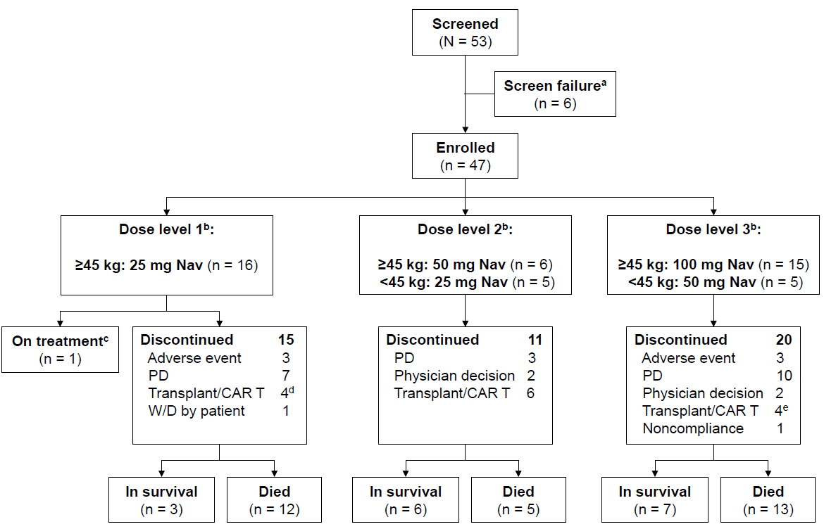

Supplementary Figure S2. Study design. ª In the original protocol, chemotherapy could be started on Day 9; following protocol amendment, chemotherapy could begin on Day 1. Chemotherapy (any of the three drugs) could be omitted, reduced, or delayed at the investigator’s discretion. Abbreviations: ALL, acute lymphoblastic leukemia; LL, lymphoblastic lymphoma; S, screening.
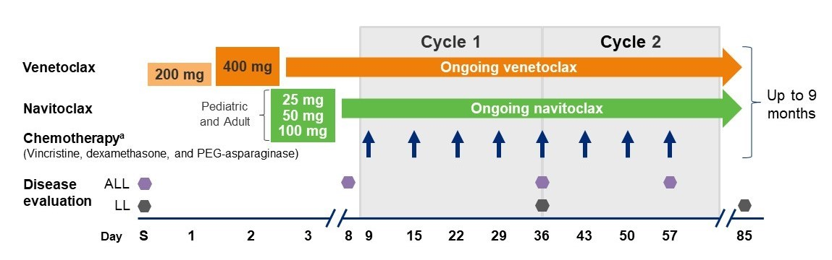

Supplementary Figure S3. Cumulative incidence probability of platelet count recovery stratified by dosing groups. Abbreviations: DL1, dose level 1; DL2, dose level 2; DL3, dose level 3.
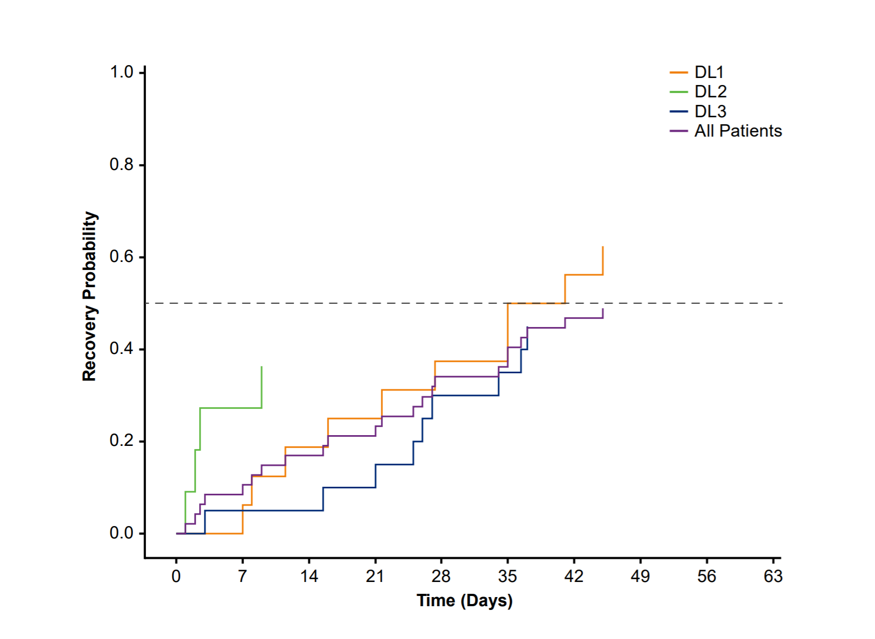

Supplementary Figure S4. (A) Venetoclax mean plasma concentration time profiles by day. (B) Venetoclax exposures by weight. Abbreviations: AUC_{0–8}, area under the plasma concentration-time curve from day 0–8.
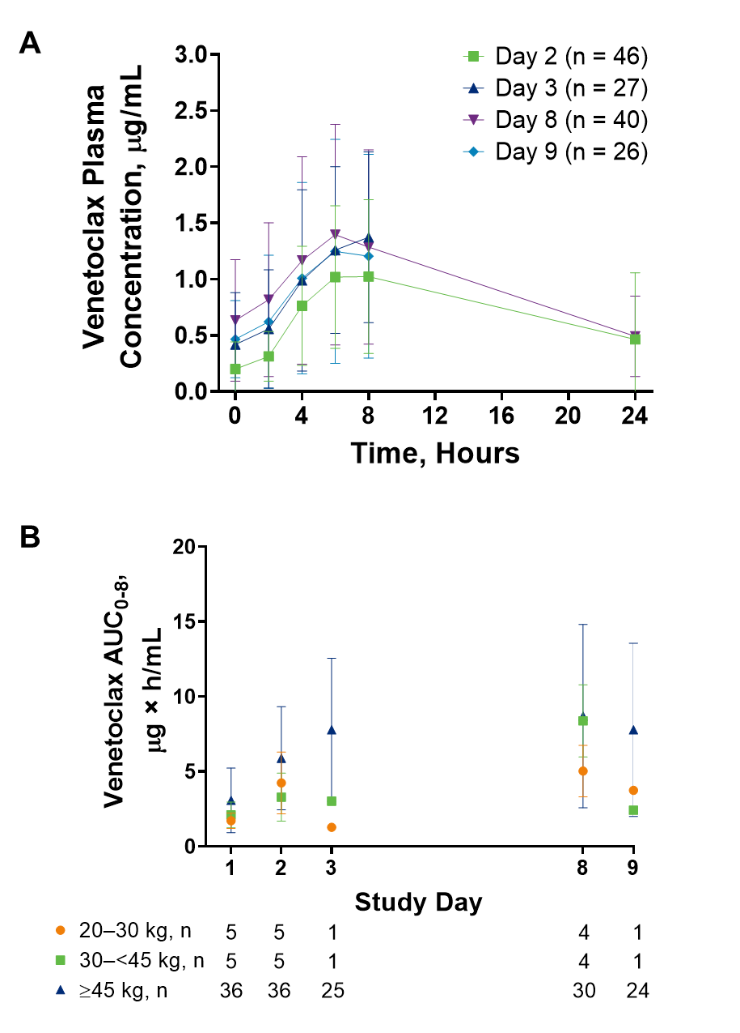

Supplementary Figure S5. (A) Navitoclax mean plasma concentration time profiles by dose level on day 8. (B) Navitoclax dose-normalized exposures by weight. Abbreviations: AUC_{0–8}, area under the plasma concentration-time curve from day 0–8.
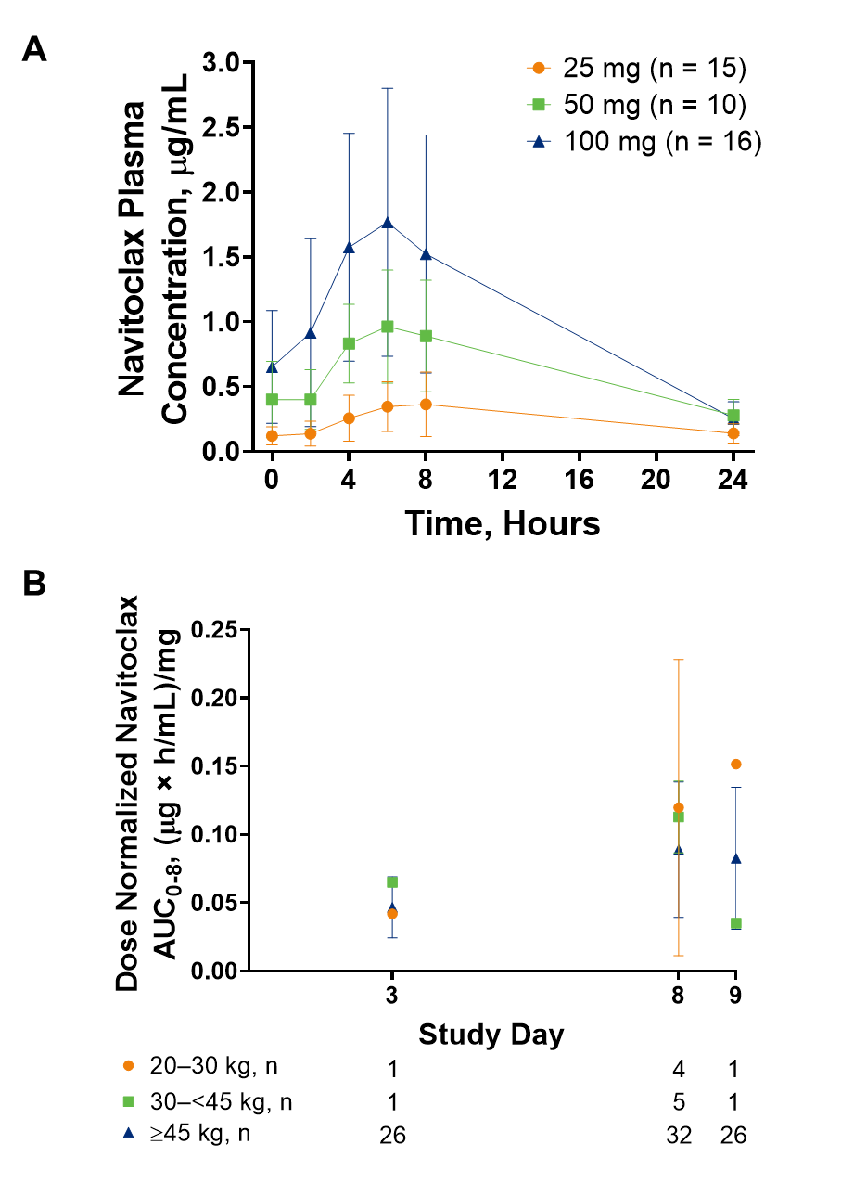

Supplementary Figure S6. Forest plot of investigator-assessed CR/CRi/CRp rates by patient subgroups. ª Venetoclax with 25 mg navitoclax for patients ≥45 kg. ^{b} Venetoclax with 50 mg navitoclax for patients ≥45 kg and 25 mg navitoclax for patients <45 kg. ^{c} Venetoclax with 100 mg navitoclax for patients ≥45 kg and 50 mg navitoclax for patients <45 kg.
Abbreviations: B-ALL, B-cell acute lymphoblastic leukemia; CAR, chimeric antigen receptor; CR, complete remission; CR_{i}, complete remission with incomplete marrow recovery; CR_{p}, complete remission without platelet recovery; HCT, hematopoietic cell transplantation; LL, lymphoblastic lymphoma; T-ALL, T-cell acute lymphoblastic leukemia.
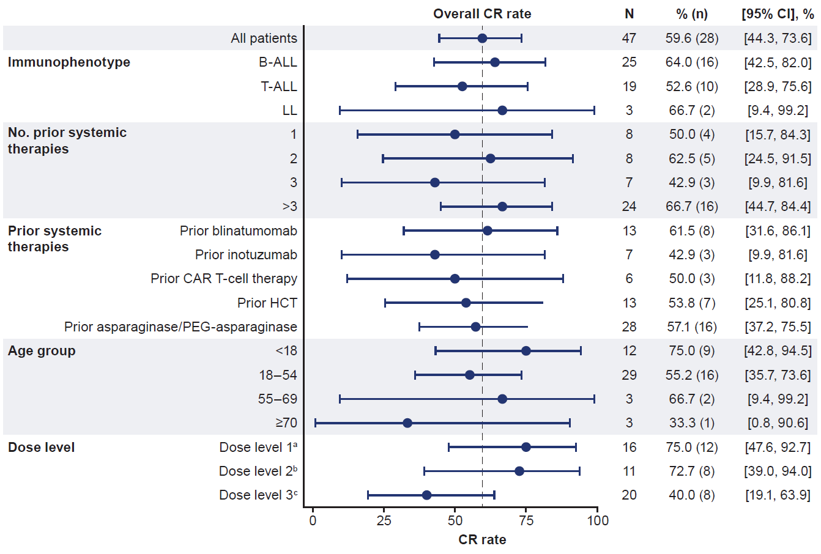

Supplementary Figure S7. Patient status and responses over time. Median time on study (95% CI) was calculated using reverse Kaplan-Meier curve of overall survival. ª Patient discontinued study to proceed to transplant but subsequently experienced infection complications after stopping study drug that delayed transplant; the patient did not receive transplant. ^{b} As of data cutoff. Abbreviations: CR, complete remission; CR_{i}/CR_{p}, complete remission with incomplete marrow recovery/complete remission without platelet recovery; PD/RE, progressive disease/relapse; PR, partial response; SD, stable disease; W, week.
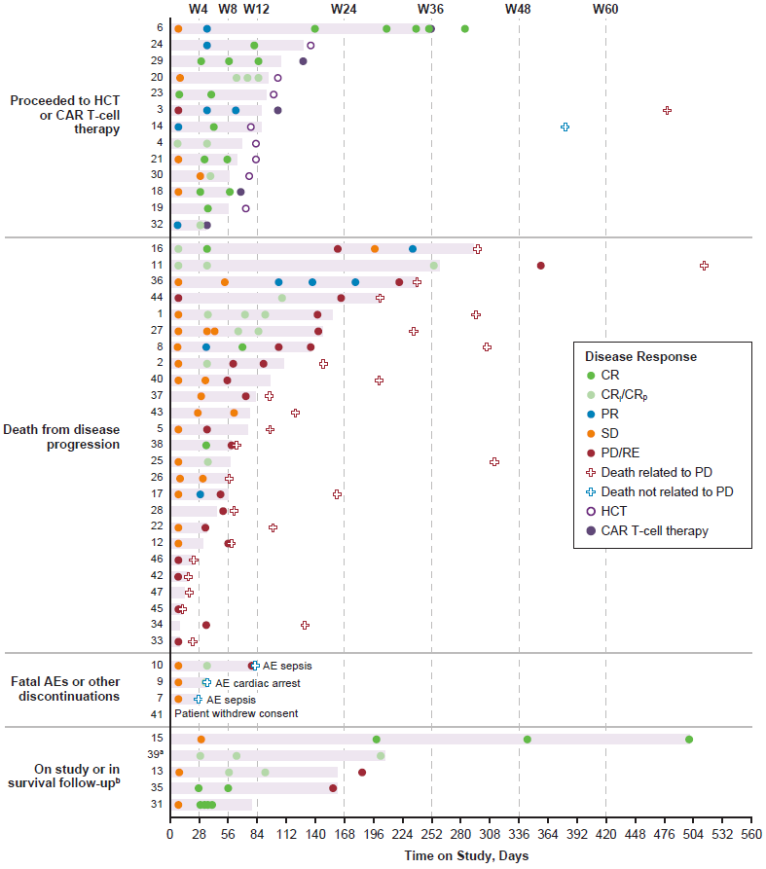

Supplementary Figure S8. BCL2, BCL2L1, and MCL1 gene expression in identified genomic subtypes of B-ALL (A, C) and immunophenotypes of non-ETP-ALL and ETP-ALL (B, C). Abbreviations: ALL, acute lymphoblastic leukemia; BCL-2, B-cell lymphoma 2; BCL2L1, BCL2 like 1; ETP-ALL, early T-cell precursor acute lymphoblastic leukemia; MCL-1, myeloid cell leukemia 1.
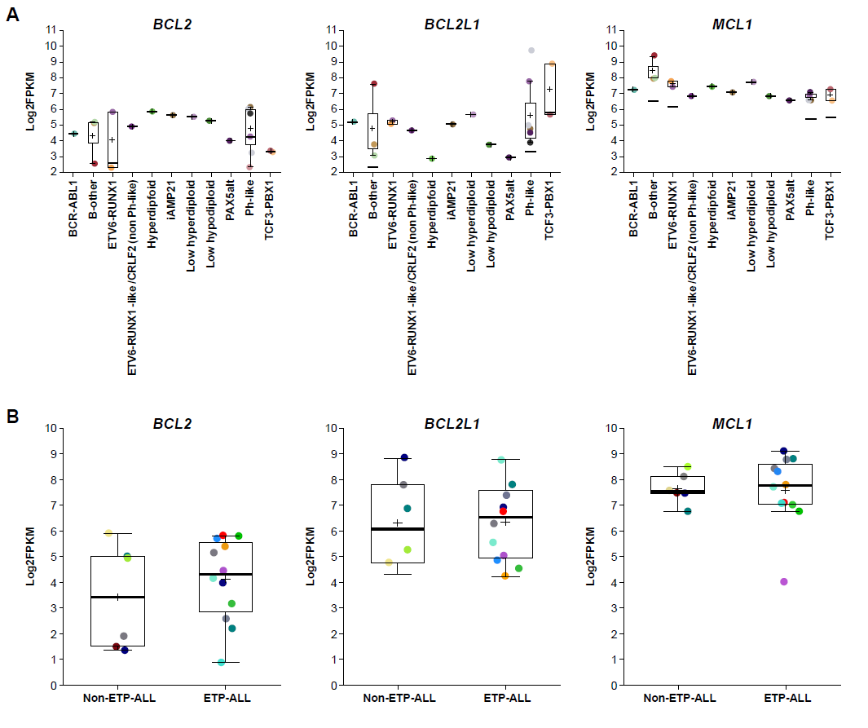
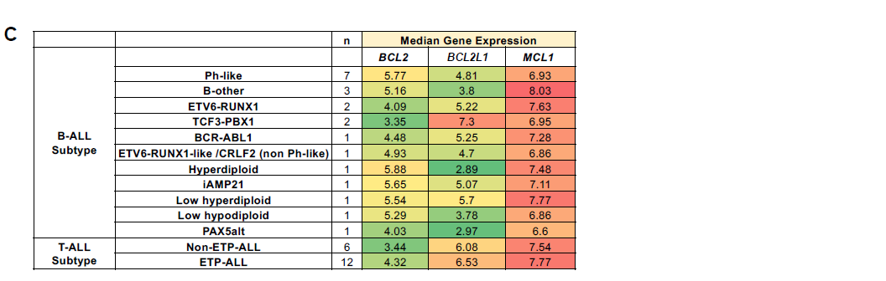

Supplementary Figure S9. BCL2, BCL2L1, and MCL1 gene expression by BH3 functional profile dependencies (BCL-2 dependency: BCL-2 or BCL-2 > BCL-X_{L}; BCL-X_{L} dependency: BCL-X_{L}, BCL-X_{L} > MCL-1, or BCL-X_{L}, MCL-1, BCL-2). Abbreviations: ALL, acute lymphoblastic leukemia; BCL-2, B-cell lymphoma 2; BCL2L1, BCL2 like 1; ETP-ALL, early T-cell precursor acute lymphoblastic leukemia; MCL-1, myeloid cell leukemia 1.
