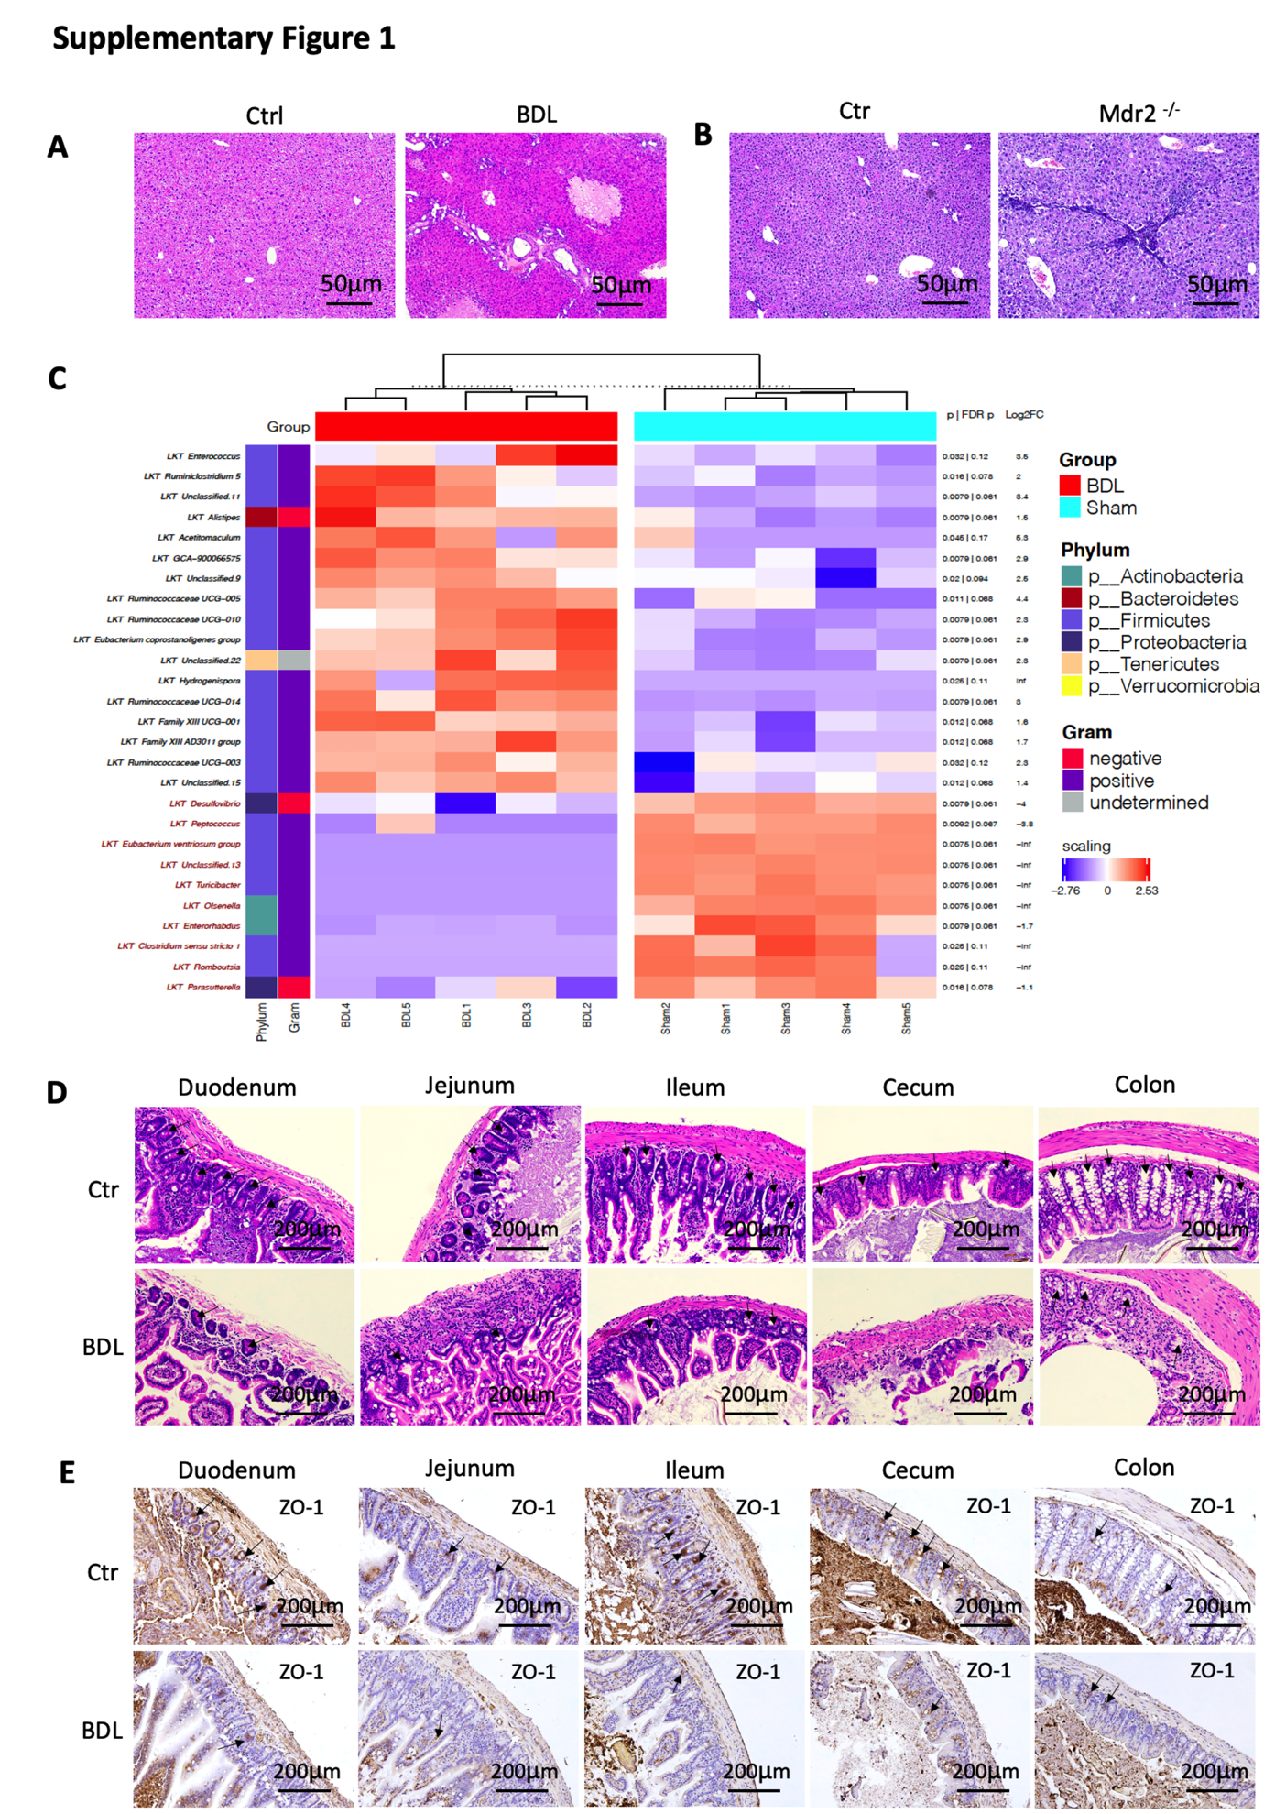
Figure S1. PSC causes decreased tight junction protein expression and increased inflammation in gut.
(A) Representative H&E staining of liver sections from mice after BDL and controls.
(B) Representative H&E staining of liver sections from Mdr2^{-/-} or control mice.
(C) OTU (Operational taxonomic unit) counts were normalized to relative abundance and compared between groups using the Mann-Whitney-Wilcoxon test. Shown are only features whose p-values for difference between the Control and BDL groups were smaller than 0.05. Heatmap rows are scaled.
(D) BDL was performed in C57BL/6 mice. Two weeks later duodenum, jejunum, ileum, cecum and colon samples were collected for H&E staining.
(E) Bile duct ligation (BDL) was performed in C57BL/6 mice. Two weeks later, different parts of gastrointestinal tract (Duodenum, Jejunum, Ileum, Cecum and Colon) were collected for Immunochemistry (IHC). The IHC of ZO-1 was presented.

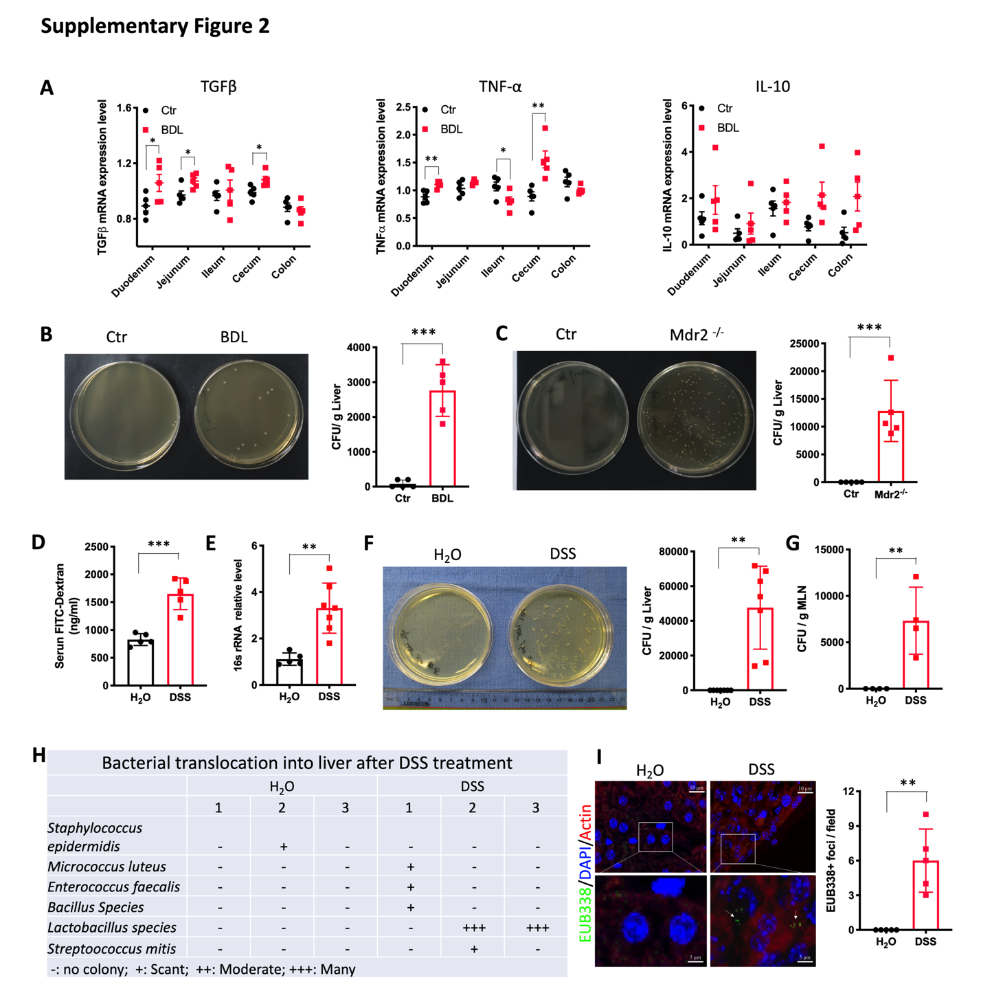
Figure S2. PSC and colitis cause leaky gut and bacterial translocation.
(A) Bile duct ligation (BDL) was performed in C57BL/6 mice. Two weeks later, different parts of gastrointestinal tract (Duodenum, Jejunum, Ileum, Cecum and Colon) were collected for RT-PCR. The relative mRNA expression levels of TGFβ, TNF-α and IL-10 in Duodenum, Jejunum, Ileum, Cecum and Colon of BDL and control mice were detected. n=5 for Ctr and BDL. Data represent mean ± SEM. *p<0.05, **p<0.01, two-way ANOVA.
(B) Liver tissues from Ctr and BDL mice were homogenized and cultured on LB medium without antibiotics. The clone formation units (CFU) were calculated. Data represent mean ± SEM. n=5 for Ctr and BDL, **p<0.01, Student’s t test.
(C) Liver tissues from Ctr and Mdr2^{-/-} mice were homogenized and cultured on LB medium without antibiotics. The clone formation units (CFU) were calculated. Data represent mean ± SEM. n=5 for Ctr and Mdr2^{-/-}, ***p<0.001, Student’s t test.
(D) C57BL/6 mice were treated with H₂O or 2.5% DSS for 7days. Then, mice received 440mg/kg body weight FITC-Dextran by oral gavage. 4 hours later blood was collected, and the concentration of FITC-Dextran was measured. n=5 for H₂O and DSS. Data represent mean ± SEM. ***p<0.001, Student’s t test.
(E) C57BL/6 mice were treated with H₂O or 2.5% DSS for 7days. Quantitative real time PCR for relative 16s rRNA levels in portal vein blood. n=5 for H₂O, 7 for DSS. Data represent mean ± SEM. **p<0.01, Student’s t test.
(F) C57BL/6 mice were treated with H₂O or 2.5% DSS for 7days. Liver tissues were homogenized and cultured on LB medium without antibiotics. The colon formation units (CFU) were calculated. Data represent mean ± SEM. n=5 for H₂O, 7 for DSS, **p<0.01, Student’s t test.
(G) C57BL/6 mice were treated with H₂O or 2.5% DSS for 7days. Mesenteric lymph nodes MLN were homogenized and cultured on LB medium without antibiotics. The colon formation units (CFU) were calculated. Data represent mean ± SEM. n=4 for H₂O and DSS, **p<0.01, Student’s t test.
(H) C57BL/6 mice were treated with H₂O or 2.5% DSS for 7days. Bacterial strain in liver tissues were detected using selective culture plates. n=3 for H₂O and DSS.
(I) C57BL/6 mice were treated with H₂O or 2.5% DSS for 7days. Liver tissues were fixed for FISH. Representative FISH sections are shown, **p<0.01, Student’s t test.

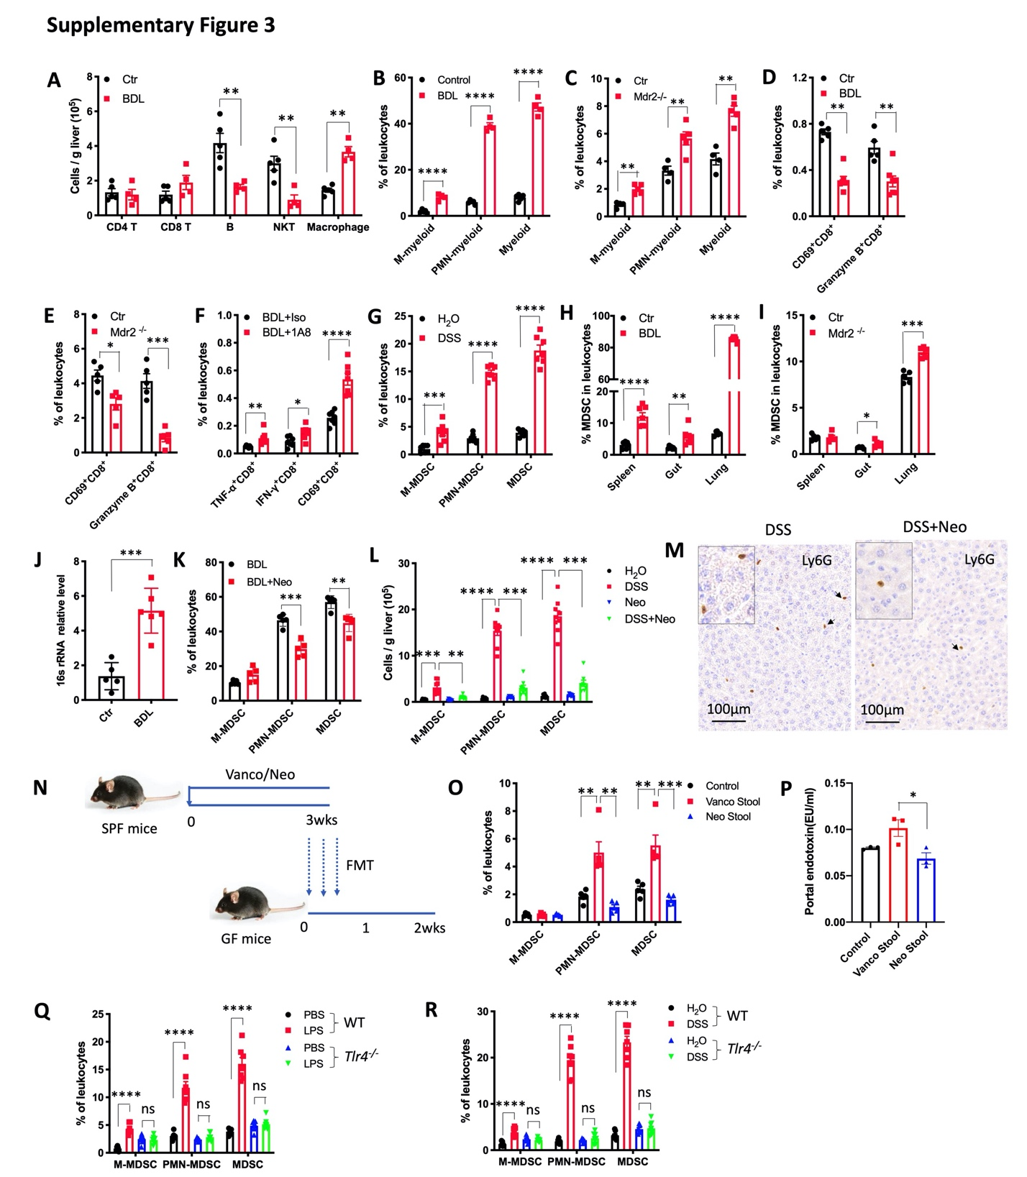

Figure S3. LPS/TLR4 induces MDSC accumulation in liver.
(A) Two weeks after BDL in C57BL/6 mice, the absolute number of hepatic CD4⁺ T, CD8⁺ T, B cell, NKT cell and macrophage were determined. n=4 for each group. Data represent mean ± SEM. ** p<0.01, two-way ANOVA.
(B) Two weeks after BDL in C57BL/6 mice, the percentage of hepatic M-myeloid, PMN-myeloid and total myeloid in leukocytes were determined. n=4 for each group. Data represent mean ± SEM. **** p<0.0001, two-way ANOVA.
(C) The percentage of hepatic M-myeloid, PMN-myeloid and total myeloid cells in leukocytes were determined in FVBN/J control (Ctr) and Mdr2^{-/-} mice at the age of 10 week. n=4 for Ctr, 5 for Mdr2^{-/-}. Data represent mean ± SEM. ** p<0.01, two-way ANOVA.
(D) Two weeks after BDL, the percentage of hepatic CD69⁺CD8⁺ T, Granzyme B⁺CD8⁺ T in leukocytes were determined. n=5 for each group. Data shown mean ± SEM. ** p<0.01, two-way ANOVA.
(E) Percentage of hepatic CD69⁺CD8⁺ T, Granzyme B⁺CD8⁺ T in leukocytes were determined in FVBN (Ctr) or Mdr2 ^{-/-} mice. n=5 for each group. Data represent mean ± SEM. * p<0.05, ***p<0.001, two-way ANOVA.
(F) BDL was performed and mice were treated with anti-Ly6G antibody (BDL+1A8) (200 μg, i.p. every other day) or isoptype control. Two weeks later, the percentage of hepatic TNF-α ⁺CD8⁺ T, IFN-γ⁺CD8⁺ T and CD69⁺CD8⁺ T in leukocytes was determined. n=5 for each group. Data represent mean ± SEM. * p<0.05, ***p<0.001, two-way ANOVA.
(G) The percentage of hepatic M-MDSC, PMN-MDSC and total MDSC in leukocytes were determined in C57BL/6 mice after 1 cycle DSS treatment (2.5% DSS in drinking water for 1 week, followed by regular water for 2 weeks). n=6 for H₂O, 7 for DSS. Data represent mean ± SEM. **** p<0.0001, two-way ANOVA.
(H) Two weeks after BDL in C57BL/6 mice, the percentage of MDSC in leukocytes of spleen, gut and lung were determined. n=7 for Ctr and BDL. Data represent mean ± SEM. ** p<0.01, **** p<0.0001, two-way ANOVA.
(I) In 7 weeks old FVBN (Ctr) or Mdr2 ^{-/-}, the percentage of MDSC in leukocytes of spleen, gut and lung were determined. n=5 for Ctr and Mdr2 ^{-/-}. Data represent mean ± SEM. ** p<0.01, **** p<0.0001, two-way ANOVA.
(J) Quantitative real time PCR for relative 16s rRNA in lung of Ctr and BDL mice. n=5 for Ctr, 6 for BDL. Data represent mean ± SEM. ***p<0.001, Student’s t test.
(K) C57BL/6 mice were treated with Neomycin for 2 weeks prior to BDL (BDL+Neo). Two weeks after BDL, the percentage of hepatic M-MDSC, PMN-MDSC and MDSC were determined. n=5 for each group. Data represent mean ± SEM. ** p<0.001, *** p<0.001, two-way ANOVA.
(L) C57BL/6 mice were treated with H₂O, DSS, neomycin (Neo) or DSS+ neomycin (DSS+Neo) for 1 cycle. The absolute numbers of hepatic M-MDSC, PMN-MDSC and total MDSC were detected. n=8 for H₂O, n= 9 for DSS, n=8 for Neo, n=8 for DSS+Neo. Data represent mean ± SEM. **p<0.01, ***p<0.001, ****p<0.0001, two-way ANOVA.
(M) Liver tissues from DSS, or DSS+ neomycin (DSS+Neo) treated mice were detected by immunochemistry of Ly6G. The representative IHC of Ly6G was shown.
(N and O) Oral gavage was performed on C57BL/6 germ free mice using stool from mice treated for 3 weeks with Vancomycin (Vanco Stool) or Neomycin (Neo Stool) (N). Two weeks later, the percentage of M-MDSC, PMN-MDSC and MDSC in liver leukocytes were detected (O). n=5 for each group. Data represent mean ± SEM. **p<0.01, ***p<0.001, two-way ANOVA.
(P) Oral gavage was performed on C57BL/6 germ free mice using stool from mice treated for 3 weeks with Vancomycin (Vanco Stool) or Neomycin (Neo Stool). The concentration of endotoxin in portal vein was detected. n=3 for each group. Data represent mean ± SEM. *p<0.05, Student’s t test.
(Q) WT or Tlr4^{-/-} C57BL/6 mice were i.p. injected with PBS or 2.5mg/kg LPS. Three days later, the percentage of M-MDSC, PMN-MDSC and total MDSC in leukocytes were determined. Data represent mean ± SEM. n=6 for PBS and 7 for LPS in WT mice, n=7 for PBS and LPS in Tlr4^{-/-} mice. ns, no significant. ****p<0.0001, two-way ANOVA.
(R) WT or Tlr4^{-/-} C57BL/6 mice were treated with H₂O or DSS for 1 cycle. The percentage of M-MDSC, PMN-MDSC and total MDSC in leukocytes were determined. Data represent mean ± SEM. n=7 for H₂O and DSS in WT mice, n= 7 for H₂O and 8 for DSS in Tlr4^{-/-} mice. ns, no significant. ****p<0.0001, two-way ANOVA.

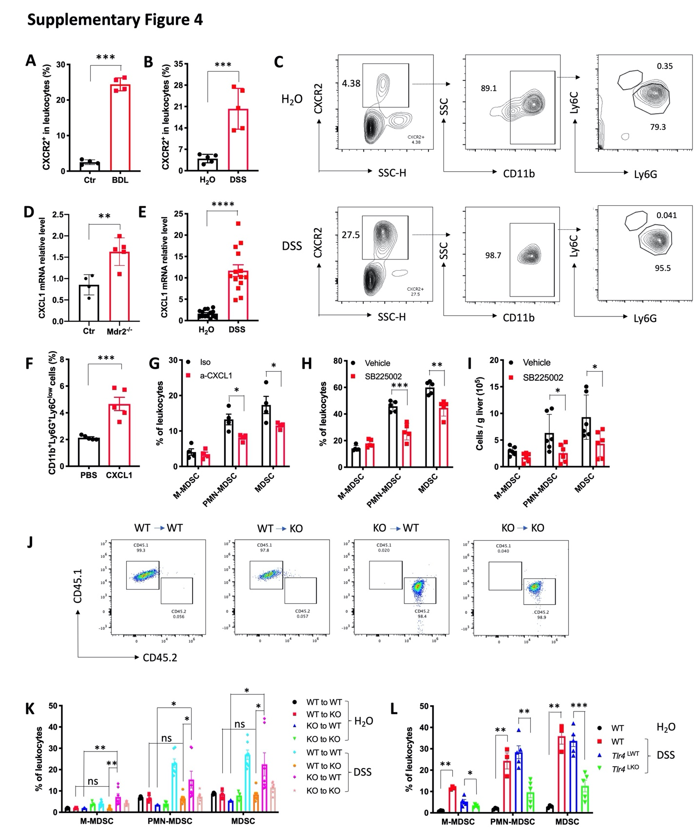

Figure S4. Hepatocytes mediate MDSC accumulation via LPS/TLR4/CXCL1.
(A and B) The percentage of CXCR2⁺ cells in leukocytes of C57BL/6 mice of Ctr and 2 weeks after BDL(A) or C57BL/6 mice treated with H₂O or 1 cycle DSS (B). Data represent mean ± SEM. n=4 for Ctr and BDL, 5 for H₂O and DSS. ***p<0.001, Student’s t test.
(C) Representative M-MDSC and PMN- MDSC staining in hepatic CXCR2⁺ cells after 1 cycle H₂O or DSS treatment in C57BL/6 mice.
(D and E) CXCL1 mRNA expression levels were detected in liver tissues of 10 weeks old FVBN/J (Ctr) and Mdr2^{-/-} (D), or C57BL/6 mice treated with H₂O or 1 cycle DSS (E). n=4 for Ctr, 5 for Mdr2 ^{-/-}, 14 for H₂O and DSS. Data represent mean ± SEM. **p<0.01, ****p<0.0001, Student’s t test.
(F) Hydrodynamic injection of PBS or CXCL1 overexpression plasmid (Cat no: MG50150-UT, Sino Biological) was performed on C57BL/6 mice. The percentage of PMN-MDSC in leukocytes was detected 7 days later. n=5 for PBS and CXCL1. Data represent mean ± SEM. **p<0.01, Student’s t test.
(G) C57BL/6 mice were treated with 2.5% DSS for 7days. CXCL1 neutralization antibody or isotype control at 4 mg/kg was i.v. injected at day 5,7,9. The mice were sacrificed at day 11. The percentages of M-MDSC, PMN-MDSC and total MDSC in leukocytes were detected. Data represent mean ± SEM. n=4 for Iso and a-CXCL1. *p<0.05, two-way ANOVA.
(H) BDL was performed on C57BL/6 mice and mice were treated with vehicle or SB225002 (10mg/kg, i.p. every other day). The percentages of hepatic M-MDSC, PMN-MDSC and total MDSC in leukocytes were determined. n=5 for Vehicle and SB225002. Data represent mean ± SEM. ** p<0.01, ***p<0.001, two-way ANOVA.
(I) C57BL/6 mice were treated with DSS for 1 cycle, and the mice were treated with vehicle or SB225002 (10mg/kg, i.p. every other day). The absolute number of hepatic M-MDSC, PMN-MDSC and total were determined. n=6 for Vehicle and SB225002. Data represent mean ± SEM. *p<0.05, two-way ANOVA.
(J and K) C57BL/6 mice (WT) or Tlr4^{-/-} mice (KO) was lethally irradiated with 900 rad, followed by i.v. injection with 2x10⁷ bone marrow cells from WT or KO mice. Six weeks later, peripheral blood was collected for CD45.1 (PercpCy5.5) and CD45.2 (PE) staining (J). Then, the mice were treated with H₂O or 2.5% DSS for 1cycle. The percentage of M-MDSC, PMN-MDSC and total MDSC in leukocytes were detected (K). n=3 for WT to WT+ H₂O, WT to KO+ H₂O, KO to WT+ H₂O, KO to KO+ H₂O, n=7 for WT to WT+ DSS, WT to KO+ DSS, KO to WT+ DSS, KO to KO+ DSS. Data represent mean ± SEM. ns, no significant. *p<0.05, **p<0.01, two-way ANOVA.
(L) C57BL/6 mice (WT) were treated with H₂O or 2.5% DSS for 1cycle, Alb-Cre-; Tlr4 ^{f/f} (Tlr4^{LWT}) and Alb-Cre+;Tlr4^{f/f} (Tlr4^{LKO}) mice were treated with 2.5% DSS for 1cycle. Then, the percentage of hepatic M-MDSC, PMN-MDSC and total MDSC in leukocytes were detected. n=3 for WT+ H₂O and WT+ DSS, n=5 for Tlr4^{LWT} + DSS and Tlr4^{LKO} + DSS. Data represent mean ± SEM. *p<0.05, **p<0.01, two-way ANOVA.

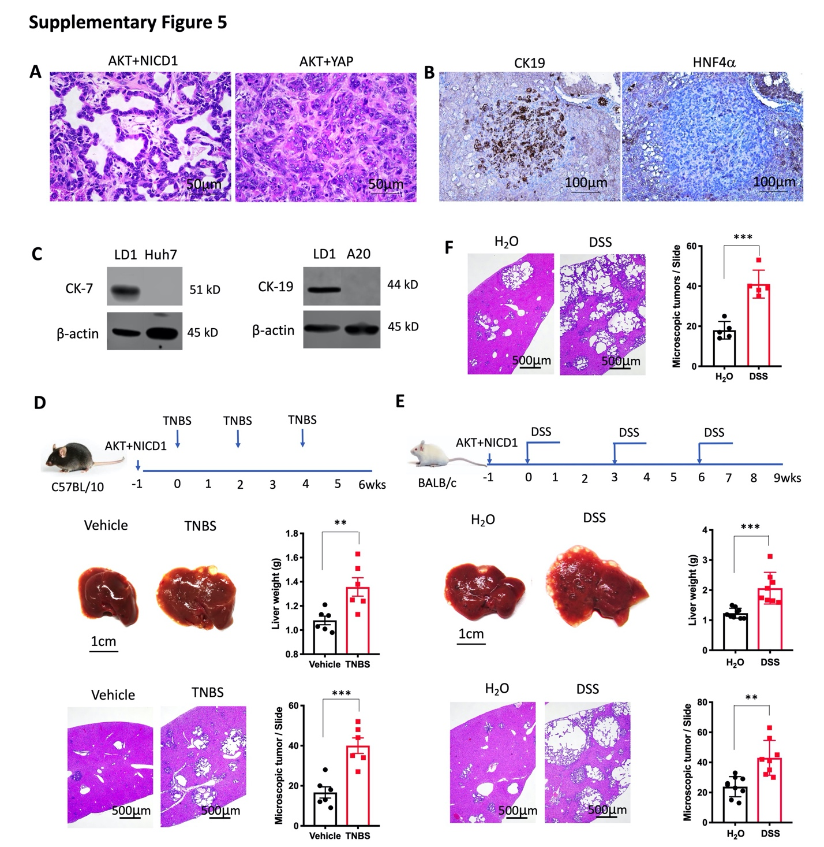

Figure S5. PSC and colitis promote cholangiocarcinoma.
(A) Representative H&E staining of liver section from AKT+NICD1 and AKT+YAP cholangiocarcinoma mice.
(B) Representative immunochemistry of CK19 and HNF4α in AKT+YAP cholangiocarcinoma liver sections.
(C) Western blotting of CK-7 and CK-19 expression in different cell lines (LD1, Huh7 and A20). β-actin was used as control.
(D) Cholangiocarcinoma was induced in C57BL/10J mice by hydrodynamic injection of AKT+NICD1. On weeks 0,2,4, the mice were injected intrarectally with 100ul 5%TNBS or Vehicle. After 7 weeks, the mice were sacrificed, and the liver weight and microscopic tumors were measured. n=6 for Vehicle and TNBS, Data represent mean ± SEM. **p<0.01, ***p<0.001, Student’s t test.
(E) Cholangiocarcinoma was induced in female BALB/c mice by hydrodynamic injection of AKT+NICD1 and treated with 3 cycles of DSS. After 10 weeks, the mice were sacrificed, and the liver weight and microscopic tumors were detected. n=9 for H₂O, 8 for DSS, Data represent mean ± SEM. **p<0.01, ***p<0.001, Student’s t test.
(F) Cholangiocarcinoma was induced in C57BL/6 mice by hydrodynamic injection of AKT and NICD1. After 2 cycles of DSS treatment, the mice were sacrificed, and the liver weight was measured. n=5 for H₂O and DSS, Data represent mean ± SEM. **p<0.01, ***p<0.001, Student's t test.

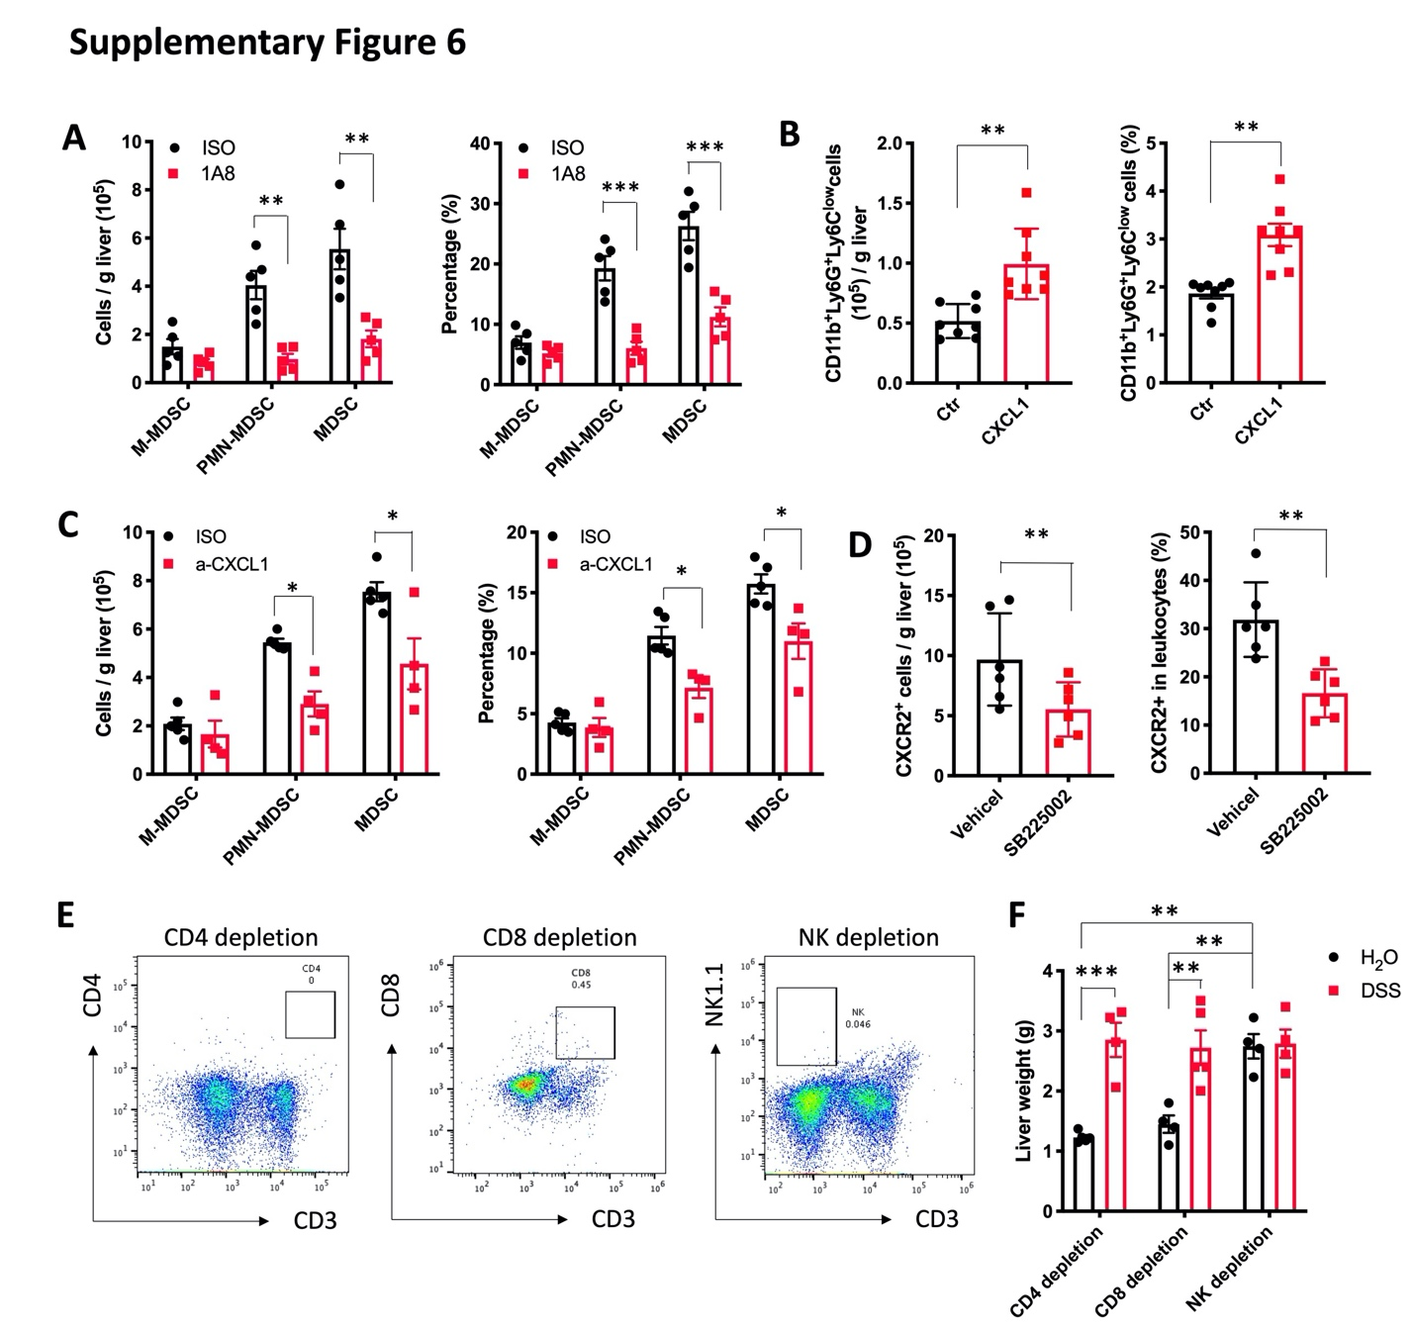
Figure S6. Targeting PMN-MDSC reduces cholangiocarcinoma.
(A) AKT+ NICD1 tumor bearing C57BL/6 mice with DSS-colitis were treated with isotype control (ISO) or anti-Ly6G antibody (1A8) (200 μg, i.p. every other day). The absolute number and percentage of M-MDSC, PMN-MDSC and total MDSC were determined after 2 cycles of DSS treatment. Data represent mean ± SEM. n=5 for each group. * p<0.05, Student’s t test.
(B) C57BL/6 mice were used to induce cholangiocarcinoma via hydrodynamic injection of AKT+NICD1 (Ctr), or AKT+NICD1+CXCL1 (CXCL1). Seven weeks later, the absolute number and the percentage of hepatic M-MDSC, PMN-MDSC and total MDSC were detected. Data represent mean ± SEM. n=8 for Ctr and CXCL1. **p<0.01, Student’s t test.
(C) C57BL/6 mice were induced cholangiocarcinoma via hydrodynamic injection of AKT+YAP. Mice were treated with CXCL1 neutralization antibody or isotype control (4 mg/kg, i.v.) and sacrificed after 2 cycles DSS treatment. The absolute number and percentage of hepatic M-MDSC, PMN-MDSC and total MDSC were detected. Data represent mean ± SEM. n=5 for Iso, 4 for a-CXCL1. *p<0.05, Student’s t test.
(D) C57BL/6 mice were induced cholangiocarcinoma via hydrodynamic injection of AKT+ NICD1, followed by 2 cycles DSS treatment. The mice were treated with vehicle or SB225002 (10mg/kg, i.p. every other day). The absolute number and percentage of hepatic CXCR2⁺ cells were detected. Data represent mean ± SEM. n=6 for Vehicle and SB225002. ** p<0.01, Student’s t test.
(E and F) C57BL/6 mice were used to induce cholangiocarcinoma via hydrodynamic injection of AKT+ NICD1. Mice were treated with CD4, CD8 or NK depleting antibodies and euthanized after 2 cycles of DSS treatment. The efficacy of CD4, CD8 or NK depletion were confirmed using flow cytometry (E). Liver weight was measured (F). n=5 for CD8 depletion in DSS-treated mice, 4 for some other groups. Data represent mean ± SEM. **p<0.01, ***p<0.001, two-way ANOVA.

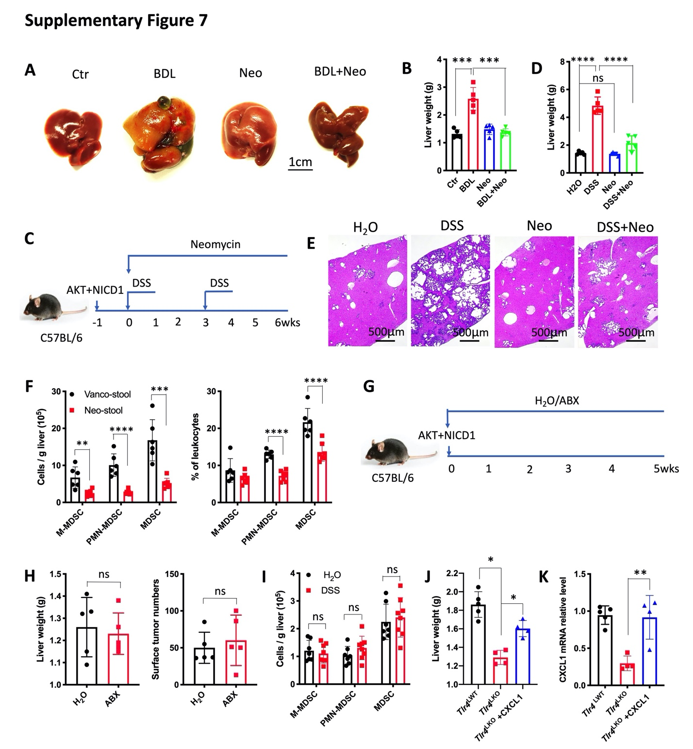
Figure S7. Gram negative bacteria direct hepatocytes to control cholangiocarcinoma development.
(A and B) C57BL/6 mice were used to induce cholangiocarcinoma via hydrodynamic injection of AKT+YAP and treated with Neomycin. One week later, BDL was performed on the mice. Control (Ctr), BDL, neomycin (Neo) and BDL+ neomycin (BDL+Neo) mice were sacrificed 3 weeks after BDL. Liver weight in each group was detected. n=5 for each group. Data represent mean ± SEM. ***p<0.001, one-way ANOVA.
(C, D and E) Cholangiocarcinoma was induced in C57BL/6 via hydrodynamic injection of AKT+NICD1. Mice were sacrificed after 2 cycles of H₂O, DSS, neomycin (Neo) or DSS+neomycin (DSS+Neo) treatment (C). Liver weights were measured (D). The representative H&E staining of liver sections in each group was shown (E). n=5 for each group. Data represent mean ± SEM. ns, no significance. ***p<0.001, one-way ANOVA.
(F) C57BL/6 mice were treated with antibiotics cocktail for 3 weeks, followed by oral garaged with 3 weeks Vancomycin (Vanco Stool) or Neomycin (Neo Stool) treated-cecum stool. Two weeks later (Week 5), intrahepatic injection with 3x10⁵ RIL175 cell line was performed on the mice. At week 8, the mice were sacrificed. The absolute number and percentage of hepatic M-MDSC, PMN-MDSC and total MDSC were detected. n=6 for Vanco stool, 7 for Neo stool. Data represent mean ± SEM. **p<0.01, ***p<0.001, two-way ANOVA.
(G and H) C57BL/6 mice were used to induce cholangiocarcinoma via hydrodynamic injection of AKT+ NICD1 and mice were treated with H₂O or ABX. Five weeks later, the mice were sacrificed (G). The liver weight and the surface tumor numbers were examined (H). n=5 for each group. Data represent mean ± SEM. ns, no significance. Student’s t test.
(I) Tlr4^{-/-} mice were used to induce AKT+YAP cholangiocarcinoma. Mice were treated with H₂O or DSS for 2 cycles. The absolute number of hepatic M-MDSC, PMN-MDSC and total MDSC was detected. Data represent mean ± SEM. n=9 for H₂O, 8 for DSS. ns, no significant, Student’s t test.
(J and K) Alb-Cre-;Tlr4 ^{f/f} (Tlr4^{LWT}) was used to induce cholangiocarcinoma via hydrodynamic injection of AKT+YAP. Alb-Cre+;Tlr4^{f/f} (Tlr4^{LKO}) mice were used to induce cholangiocarcinoma via hydrodynamic injection of AKT+YAP, or AKT+YAP+CXCL1. Mice were sacrificed after 2 cycles DSS treatment. Liver weight in each group was detected (J). CXCL1 mRNA expression levels in liver tissues from each group were determined (K). n=5 for Tlr4^{LWT}, 4 for Tlr4^{LKO} and Tlr4^{LKO}+CXCL1. Data represent mean ± SEM. **p<0.01, two-way ANOVA.

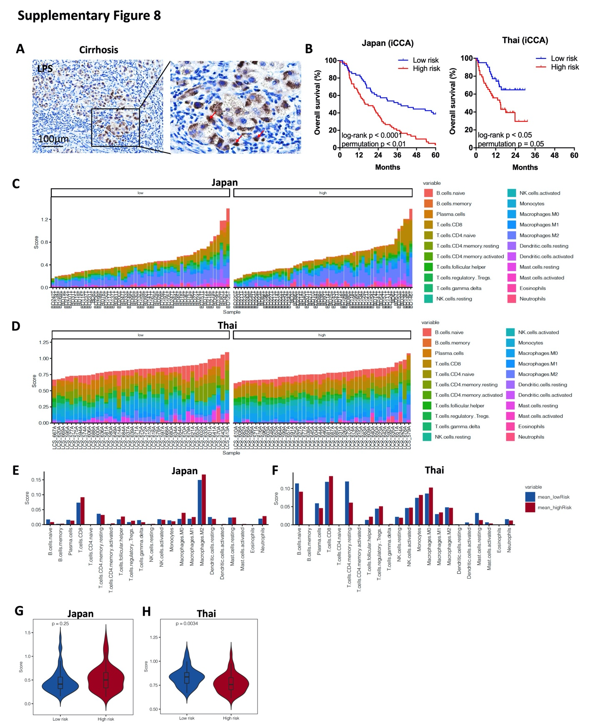

Figure S8. TLR4 signature genes expression is associated with the outcome of cholangiocarcinoma patients.
(A) Immunochemistry of LPS in human cirrhosis sample. Human cirrhosis sample was collected and fixed for IHC of LPS. The representative IHC of LPS in cirrhosis sample.
(B) 114 intrahepatic cholangiocarcinoma (iCCA) cases in Japan cohort, 85 iCCA cases in Thai cohort were divided into two groups (low-risk and high-risk) according to the expression of Tlr4 activation-associated genes. Log-rank (Mantel-Cox) test was performed to detect overall survival of the two groups. Log-rank p value and permutation p value are provided.
(C, D, E, F, G and H) CIBERSORT application was applied to estimate the abundance of different immune cells based on TLR4 gene expression level. The abundance of different immune cell in each iCCA patient is shown in Japan cohort (C) and Thai cohort (D). The abundance of different immune cell in low-risk and high-risk iCCA patient is shown in Japan cohort (E) and Thai cohort (F). The overall abundance of immune cells in low-risk and high-risk groups was analyzed in Japan cohort (G) and Thai cohort (H).

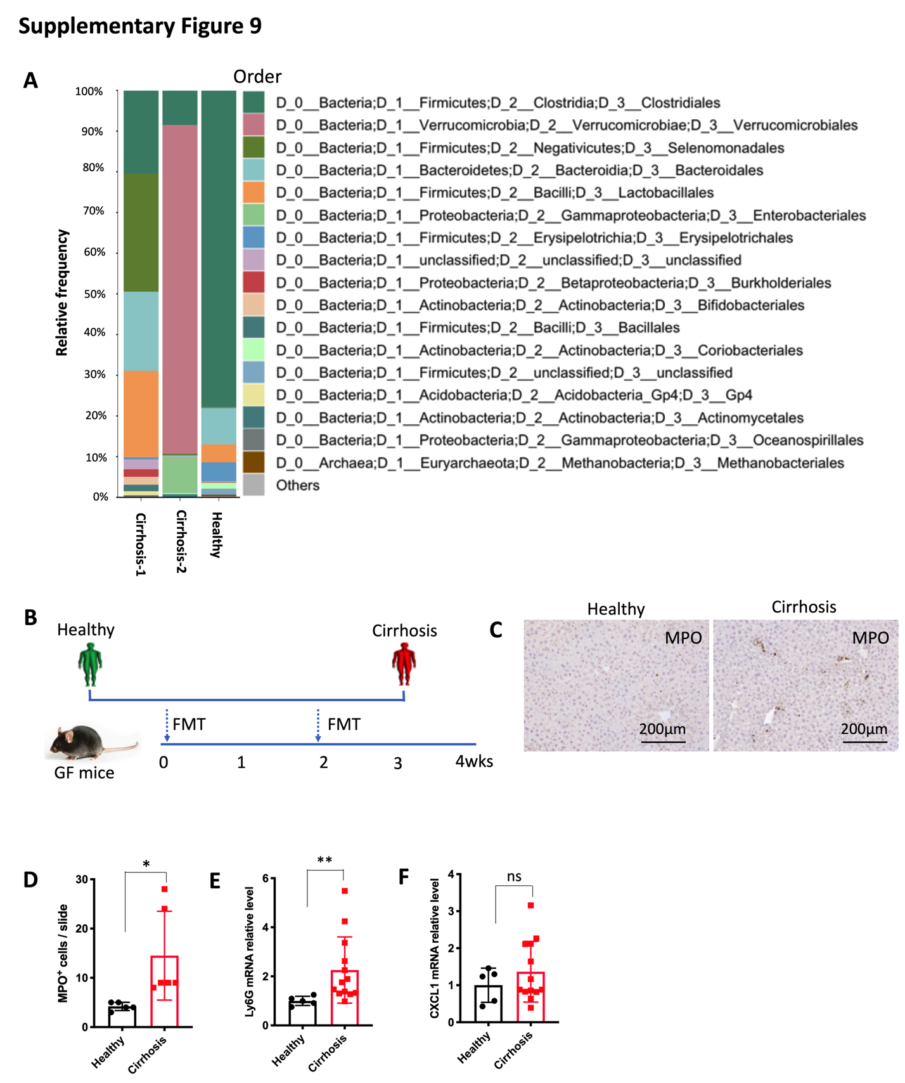
Figure S9. The gut microbiome from patients with cirrhosis affects myeloid cells in the liver.
(A) The stools from 2 cirrhosis patients and 1 healthy donor were collected for 16s rRNA sequencing. Bar plots of the order levels in cirrhosis patients and healthy donor are shown. Relative abundance is plotted for each sample.
(B) Fecal microbiota transplant (FMT) from cirrhosis patients or healthy control was performed on germ free (GF) mice through oral gavage at week 0 and weeks 2. At week 4, the mice were sacrificed for further analysis
(C and D) IHC of MPO in liver tissues of mice from experiment (B) was performed. The MPO+ cells in each slide were counted (D). n=5 for healthy control, 6 for cirrhosis patients. *p<0.05, Student’s t test.
(E and F) The mRNA expression levels of Ly6G (E) and CXCL1 (F) were detected in liver. n=5 for healthy control, 13 for cirrhosis patients. Data represent mean ± SEM. **p<0.01, ns, no significant. Student’s t test.

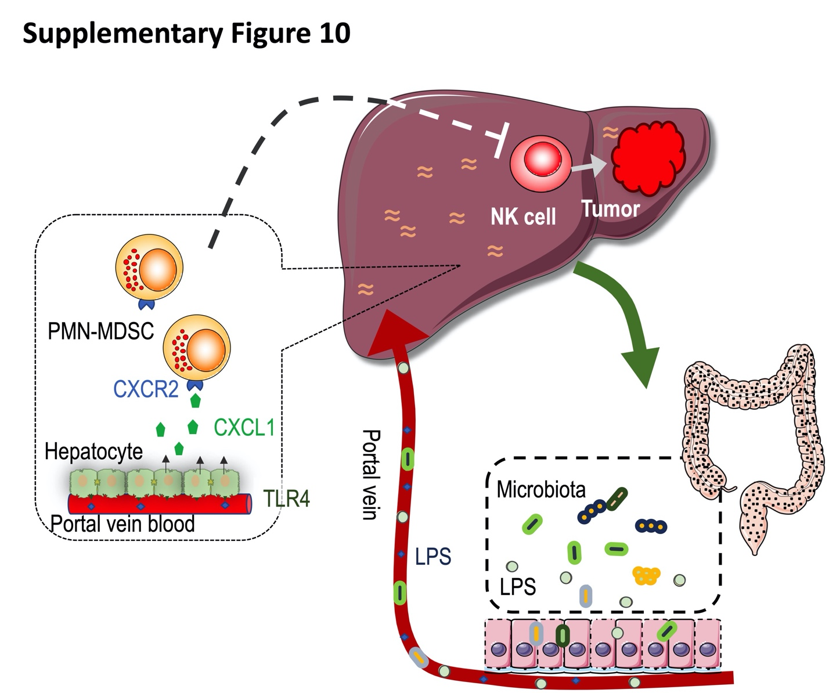
Figure S10. Graphical abstract.
In leaky gut caused by PSC or colitis, microbiota or products of microbiota, such as LPS, enter portal vein due to increased gut permeability. The increased portal LPS stimulates hepatocytes to secrete CXCL1 via TLR4. CXCL1 recruits CXCR2⁺ PMN-MDSC in the liver, which promotes cholangiocarcinoma via inhibiting NK cell function.

