SUPPLEMENTARY DATA

Participating institutions

The following Cancer and Leukemia Group B (CALGB)/Alliance for Clinical Trials in Oncology (Alliance) institutions participated in this study and contributed at least five patients. For each of these institutions, the current or last principal investigator are listed as follows:

The Ohio State University Medical Center, Columbus, OH: Claire F. Verschraegen; Wake Forest University School of Medicine, Winston-Salem, NC: Heidi D. Klepin; North Shore University Hospital, Manhasset, NY: Jonathan E. Kolitz; Roswell Park Cancer Institute, Buffalo, NY: Ellis G. Levine; Dana Farber Cancer Institute, Boston, MA: Harold J. Burstein; Washington University School of Medicine, St. Louis, MO: Nancy L. Bartlett; University of Iowa Hospitals, Iowa City, IA: Umar Farooq; University of North Carolina, Chapel Hill, NC: Matthew I. Milowsky; University of Chicago Medical Center, Chicago, IL: Hedy L. Kindler; Duke University Medical Center, Durham, NC: Jeffrey Crawford; Dartmouth Medical School, Lebanon, NH: Konstantin H. Dragnev; University of Maryland Greenebaum Cancer Center, Baltimore, MD: Heather D. Mannuel; Ft. Wayne Medical Oncology/Hematology, Ft. Wayne, IN: Sreenivasa Nattam; Christiana Care Health Services, Inc., Newark, DE: Gregory A. Masters; Rhode Island Hospital, Providence, RI: Howard P. Safran; Western Pennsylvania Hospital, Pittsburgh, PA: Gene G. Finley; SUNY Upstate Medical University, Syracuse, NY: Stephen L. Graziano; University of Vermont Cancer Center, Burlington, VT: Peter A. Kaufman; University of Massachusetts Medical Center, Worcester, MA: William V. Walsh; Weill Medical College of Cornell University, New York, NY: Scott Tagawa; Eastern Maine Medical Center, Bangor, ME: Sarah J. Sinclair; Massachusetts General Hospital, Boston, MA: David Ryan, Justin Gainor; Mount Sinai School of Medicine, New York, NY: Michael A. Schwartz; University of California San Diego Moores Cancer Center, San Diego, CA: Lyudmila A. Bazhenova; University of Tennessee Cancer Center, Memphis, TN: Harvey B. Niell; University of Missouri/Ellis Fischel Cancer Center, Columbia, MO: Clint Kingsley; Long Island Jewish Medical Center, Lake Success, NY: Daniel R. Budman; Walter Reed National Military Medical Center, Bethesda, MD: Mary Kwok; University of Illinois, Chicago, IL: Arkadiusz Z. Dudek; Virginia Commonwealth University, Richmond, VA: Steven Grossman; University of Nebraska Medical Center, Omaha, NE: Apar Ganti; University of Alabama at Birmingham, Birmingham, AL: Robert Diasio; University of Minnesota, Minneapolis, MN: Anne H. Blaes; University of California at San Francisco, San Francisco, CA: Charalambos Andreadis.

Patients and treatment
Surveillance, Epidemiology, and End Results (SEER) patients
SEER is a collection of high quality population-based cancer registries with very high estimated completeness of reporting. These nine registries capture data covering approximately 9.4% of the U.S. population. Data reflecting sociodemographic, clinical and survival/vital statistics factors included in these registries were obtained from case listing sessions using SEER*Stat software (version 8.3.6). We used the SEER Program of the National Cancer Institute to identify 25,523 adults aged ≥18 years diagnosed with AML (excluding acute promyelocytic leukemia) between 1986 and 2015 and included in one of nine SEER registries (1). Metropolitan/non-metropolitan county residence based on Rural-Urban Continuum Codes (RUCC) developed by the United States Department of Agriculture (USDA). RUCC codes distinguish metropolitan (RUCC codes 1-3) from non-metropolitan (RUCC codes 4-9) counties by degree of urbanization and adjacency to a metropolitan area or areas. In addition, area-based socioeconomic status was examined using the county-level variable ‘percent of families below poverty level’ and indicated the percentage of families with income below the poverty based on the Census American Community Survey 2013–2017– a median cut was used for analyses.

Alliance patients
A total of 1,339 patients with untreated acute myeloid leukemia (AML) enrolled on CALGB/Alliance study protocols detailed below, were included. CALGB is now part of the Alliance for Clinical Trials in Oncology. All patients provided written informed consent for participation in the studies, and all study protocols were in accordance with the Declaration of Helsinki and approved by Institutional Review Boards at each treatment center.
For definition of race, the CALGB/Alliance Registration forms follow guidelines from the National Cancer Institute: 1) White: A person having origins in any of the original peoples of Europe, the Middle East, or North Africa. 2) Black or African American: A person having origins in any of the black racial groups of Africa.

Patients were treated on CALGB/Alliance studies 19808 (n=297), 10503 (n=252), 9720 (n=213), 10201 (n=142), 9621 (n=134), 8525 (n=67), 9222 (n=62), 10603 (n=51), 10502 (n=28), 8923 (n=26), 11002 (n=23), 9420 (n=21), 8821 (n=7), 11001 (n=6), 9022 (n=5), 8721 (n=2), 9120 (n=1), and 10801 (n=1). Patients enrolled on CALGB 19808 were randomly assigned to receive induction chemotherapy with cytarabine, daunorubicin, and etoposide with or without PSC-833 (valspodar), a multidrug resistance protein inhibitor (2). On achievement of complete remission (CR), patients were assigned to intensification with high-dose cytarabine and etoposide for stem-cell mobilization followed by myeloablative treatment with busulfan and etoposide supported by autologous peripheral blood SCT. Patients enrolled on CALGB 10503 were assigned to receive induction chemotherapy consisting of cytarabine, daunorubicin, and etoposide. Upon achievement of CR, patients received high-dose cytarabine (HiDAC) and etoposide for stem-cell mobilization followed by myeloablative treatment with busulfan and etoposide supported by autologous peripheral blood SCT. Patients not eligible for SCT received HiDAC. After intensification, patients received the DNA methyltransferase inhibitor decitabine for maintenance (3). Patients on CALGB 9720 received a single cytarabine/daunorubicin consolidation course and were randomly assigned to low-dose recombinant interleukin-2 maintenance therapy or none (4). Patients on CALGB 10201 received induction chemotherapy consisting of cytarabine and daunorubicin, with or without the BCL2 antisense oblimersen sodium. The consolidation included two cycles of cytarabine (2g/m²/d) with or without oblimersen (5). Patients enrolled on CALGB 9621 were treated similarly to those on CALGB 19808, as previously reported (6). The patients on CALGB 8525 were treated with induction chemotherapy consisting of cytarabine and daunorubicin, and were randomly assigned to consolidation with or without 3g/m² cytarabine followed by maintenance treatment (7). Patients on protocol CALGB 9222 received induction chemotherapy consisting of cytarabine in combination with daunorubicin followed by consolidation with one cycle of HiDAC. Different doses of mitoxantrone were explored as well, and the consolidation treatment was randomized to three cycles of monotherapy with HiDAC or consolidation with one cycle of HiDAC, a cycle of cyclophosphamide and etoposide, and one cycle of mitoxantrone and diaziquone (8). In CALGB 10603, cytarabine and daunorubicin followed by consolidation with HiDAC was applied with or without PKC-412 (9). On CALGB 10502, bortezomib was added to induction consisting of daunorubicin and cytarabine and consolidation with high-dose cytarabine (10). CALGB 8923 double-blind trial in which patients with de novo AML less than 60 years of age were randomized to receive either granulocyte-macrophage colony-stimulating factor (GM-CSF) or a placebo infusion (11). Patients on CALGB 11002 received decitabine with or without addition of the proteasome inhibitor bortezomib, for both induction and postremission therapy (12). Patients on CALGB 9420 received induction chemotherapy consisting of cytarabine in combination with daunorubicin and etoposide, with PSC-833 or without PSC-833 (13).
Patients enrolled on CALGB 8821 received cytarabine combined with daunorubicin as induction and mitoxantrone/diaziquone, and etoposide/cyclophosphamide were then successively administered in two intensification courses (14). For patients treated on CALGB 11001, sorafenib was added to the induction and consolidation treatment consisting of daunorubicin and cytarabine and consolidation with high-dose cytarabine, followed by sorafenib maintenance (15). Patients enrolled onto CALGB 9022 received induction chemotherapy consisting of cytarabine in combination with daunorubicin followed by consolidation with one cycle of HiDAC, a cycle of cyclophosphamide and etoposide, and one cycle of mitoxantrone and diaziquone (16). Patients enrolled on CALGB 8721 were randomly assigned to one of two remission induction regimens. Regimen I consisted of HiDAC plus asparaginase on days 1 and 8 and regimen II consisted of HiDAC alone. Patients enrolled on CALGB 9120 received standard induction chemotherapy. After CR had been achieved, idarubicin (two days) and cytarabine (five days) were administered. Patients with histocompatible siblings were offered allogeneic stem-cell transplantation (SCT), whereas the remaining patients were randomly assigned to receive a single course of high-dose cytarabine or transplantation of autologous marrow treated with perfosfamide (4-hydroperoxycyclophosphamide, ref. 17). Patients on CALGB 10801 received cytarabine/daunorubicin induction on days 1 to 7 and oral dasatinib 100 mg/d on days 8 to 21. Upon achieving complete remission, patients received consolidation with high-dose cytarabine followed by dasatinib 100 mg/d on days 6 to 26 for 4 courses, followed by dasatinib 100 mg/d for 12 months (18).

Cytogenetic analyses
For all CALGB/Alliance patients, pretreatment cytogenetic analyses of bone marrow (BM) and/or blood samples were performed by institutional cytogenetics laboratories using unstimulated short-term (24- and/or 48-hour) cultures, and the results were confirmed by central karyotype review as previously reported (19). In each patient with cytogenetically normal AML, at least 20 BM metaphase cells were analyzed and the karyotype found to be normal.

Mutational profiling
The mutational status of 80 protein coding genes (AKT1, ARAF, ASXL1, ATM, AXL, BCL2, BCOR, BCORL1, BRAF, BRD4, BRINP3, BTK, CBL, CCND1, CCND2, CSNK1A1, CTNNB1, DNMT3A, ETV6, EZH2, FBXW7, FLT3, GATA1, GATA2, GSK3B, HIST1H1E, HNRNPK, IDH1, IDH2, IKZF1, IKZF3, ILR7, JAK1, JAK2, JAK3, KIT, KLHL6, KMT2A, KRAS, MAPK1, MAPK3, MED12, MYD88, NF1, NOTCH1, NPM1, NRAS, PHF6, PIK3CD, PIK3CG, PLCG2, PLEKHG5, PRKCB, PRKD3, PTEN, PTPN11, RAD21, RAF1, RUNX1, SAMHD1, SETBP1, SF1, SF3A1, SF3B1, SMARCA2, SMC1A, SMC3, SRSF2, STAG2, SYK, TET2, TGM7, TP53, TYK2, U2AF1, U2AF2, WT1, XPO1, ZMYM3, ZRSR2) was determined by targeted amplicon sequencing using the MiSeq platform (Illumina, San Diego, CA, ref. 20). DNA library preparations were performed according to the manufacturer’s instructions. Briefly, samples were pooled and run on the MiSeq machine using the Illumina MiSeq Reagent Kit v3. Sequenced reads were aligned to the hg19 genome build using the Illumina Isis Banded Smith-Waterman aligner. Single nucleotide variant and indel calling were performed using MuTect and VarScan, respectively (21,22). The MuCor algorithm was used as the baseline for integrative mutation assessment (23). We only considered non-synonymous variants not listed in either the 1000 Genome database or dbSNP142-common variants. All called variants underwent visual inspection of the aligned reads using the Integrative Genomics Viewer (Broad Institute, ref. 24). All variants that occurred with VAFs of <.10 or were sequenced to a depth of <15 reads were excluded from the analysis. In addition, variants were excluded when they occurred only in one read direction if sequenced in both directions, if the region contained many variants with low quality scores, or if they occurred in all analyzed samples including run controls. In addition, samples with high background noise were entirely excluded from analysis. Samples were considered non-evaluable for a specific gene if ≥85% of the amplicons covering the target regions within the coding sequence of the gene were sequenced to a depth of <15 reads. If <15 reads were present, the gene mutation status was considered as not evaluable. The presence or absence of FLT3 internal tandem duplications (FLT3-ITD), as well as quantification of the FLT3-ITD to FLT3 wild-type allelic ratio (low/no vs high defined as ratio ≥.50), were determined as previously described (25). Furthermore, testing for CEBPA mutations was performed with Sanger sequencing methods (26), thus adding up to a total of 81 genes analyzed in our study. In accordance with the current World Health Organization classification, only patients with biallelic CEBPA mutations were considered as CEBPA mutated (27).
For variant curation, 2 separate filters were used. In filtering step 1, we only considered non-synonymous variants not listed in either the 1000 Genome database or dbSNP142-common variants. In filtering step 2, we used Gnomad to account for race-associated polymorphisms and removed all variants that were present in Black (African) or White patients with a minor allele fraction <0.001.

Definition of clinical endpoints
For Alliance data, CR required an absolute neutrophil count ≥1.5 x 10⁹/l, a platelet count >100 x 10⁹/l, no leukemic blasts in the blood or BM, cellularity greater than 20% with maturation of all cell lines, no Auer rods, less than 5% BM blast cells, and no evidence of extramedullary leukemia, all of which had persisted for at least one month. Relapse was defined by ≥5% BM blasts, circulating leukemic blasts, or the development of extramedullary leukemia (28). Disease-free survival (DFS) was measured from the date of CR until the date of relapse or death; patients alive and relapse-free at last follow-up were censored. Overall survival (OS) was measured from the date on study until the date of death, and patients alive at last follow-up were censored.

Outcome analyses
In our outcome analyses, we used P-values adjusted to control for per family error rate (probability of a Type I error) for all variables considered in univariable analyses (UVA). The families were all variables considered in each outcome analysis and only the variables whose likelihood ratio test adjusted P-value was <0.20 from the univariable models were considered in the multivariable analysis (MVA).

SEER
In the SEER patients, to identify variables associated with OS in both younger and older SEER black AML patients the following parameters were included in the UVA and MVA: race, age, sex, metropolitan area residential status, county-level variable ‘percent of families below poverty level’ and decade of diagnosis.

Alliance
To identify variables associated with CR, DFS and OS in all younger AML patients the following parameters were included in the UVA: race, hemoglobin, platelets, white blood cell count, age, sex, extramedullary involvement, mutation status of DNMT3A, FLT3-ITD, IDH2, NPM1, and NRAS mutations and normal karyotype, and atypical complex karyotype status.
To identify variables associated with achievement of CR in younger AML patients the following parameters were included in the MVA: race, hemoglobin, white blood cell count, age DNMT3A, FLT3-ITD, NPM1 and NRAS mutations and normal and atypical complex karyotype status. To identify variables associated with achievement of DFS in younger AML patients the following parameters were included in the MVA: race, white blood cell count, age, extramedullary involvement, DNMT3A, and FLT3-ITD mutations and atypical complex karyotype status. To identify variables associated with achievement of OS in younger AML patients the following parameters were included in the MVA: race, white blood cell count, age, extramedullary involvement, DNMT3A, FLT3-ITD and NPM1 mutations and normal and atypical complex karyotype status.

To identify variables associated with achievement of CR, DFS and OS for younger (aged <60 years) Black AML patients the following parameters were included in the UVA: race, hemoglobin, platelets, white blood cell count, age, sex, extramedullary involvement, mutation status of the DNMT3A, FLT3-ITD, IDH2, NPM1, and NRAS genes, and normal and atypical complex karyotype status.

To identify variables associated with achievement of CR in younger Black AML patients the following parameters were included in the MVA: hemoglobin and platelet count. To identify variables associated with DFS in younger Black AML patients the following parameters were included in the MVA: hemoglobin and white blood cell count. To identify variables associated with OS in younger Black AML patients, the following parameters were included in the MVA: hemoglobin, DNMT3A, FLT3-ITD, IDH2 and NPM1 mutations, and atypical complex karyotype status.

Supplementary references

1. Surveillance, Epidemiology, and End Results (SEER) Program (www.seer.cancer.gov) SEER*Stat Database: Incidence - SEER Research Data, 9 Registries, Nov 2019 Sub (1975-2017) - Linked To County Attributes - Time Dependent (1990-2017) Income/Rurality, 1969-2018 Counties, National Cancer Institute, DCCPS, Surveillance Research Program, released April 2020, based on the November 2019 submission.
2. Kolitz JE, George SL, Marcucci G, Vij R, Powell BL, Allen SL, et al. P-glycoprotein inhibition using valspodar (PSC-833) does not improve outcomes for patients under age 60 years with newly diagnosed acute myeloid leukemia: Cancer and Leukemia Group B study 19808. Blood 2010;116:1413-21.
3. Blum W, Sanford BL, Klisovic R, DeAngelo DJ, Uy G, Powell BL, et al. Maintenance therapy with decitabine in younger adults with acute myeloid leukemia in first remission: A phase 2 Cancer and Leukemia Group B study (CALGB 10503). Leukemia 2017;31:34-9.
4. Baer MR, George SL, Sanford BL, Mrózek K, Kolitz JE, Moore JO, et al. Escalation of daunorubicin and addition of etoposide in the ADE regimen in acute myeloid leukemia patients aged 60 years and older: Cancer and Leukemia Group B study 9720. Leukemia 2011;25:800-7.
5. Marcucci G, Moser B, Blum W, Stock W, Wetzler M, Koltiz JE, et al. A phase III randomized trial of intensive induction and consolidation chemotherapy ± oblimersen, a pro-apoptotic Bcl-2 antisense oligonucleotide in untreated acute myeloid leukemia patients >60 years old. J Clin Oncol 2007;25(suppl):360s, (abstract 7012).
6. Kolitz JE, George SL, Dodge RK, Hurd DD, Powell BL, Allen SL, et al. Dose escalation studies of cytarabine, daunorubicin, and etoposide with and without multidrug resistance modulation with PSC-833 in untreated adults with acute myeloid leukemia younger than 60 years: final induction results of Cancer and Leukemia Group B study 9621. J Clin Oncol 2004;22:4290-301.
7. Mayer RJ, Davis RB, Schiffer CA, Berg DT, Powell BL, Schulman P, et al. Intensive postremission chemotherapy in adults with acute myeloid leukemia. N Engl J Med 1994;331:896-903.
8. Moore JO, George SL, Dodge RK, Amrein PC, Powell BL, Kolitz JE, et al. Sequential multiagent chemotherapy is not superior to high-dose cytarabine alone as postremission intensification therapy for acute myeloid leukemia in adults under 60 years of age: Cancer and Leukemia Group B study 9222. Blood 2005;105:3420-7.
9. Stone RM, Mandrekar SJ, Sanford BL, Laumann K, Geyer S, Bloomfield CD, et al. Midostaurin plus chemotherapy for acute myeloid leukemia with a FLT3 mutation. N Engl J Med 2017;377:454-64.
10. Attar EC, Johnson JL, Amrein PC, Lozanski G, Wadleigh M, DeAngelo DJ, et al. Bortezomib added to daunorubicin and cytarabine during induction therapy and to intermediate-dose cytarabine for consolidation in patients with previously untreated acute myeloid leukemia age 60 to 75 years: CALGB (Alliance) study 10502. J Clin Oncol 2012;31:923-9.
11. Stone RM, Berg DT, George SL, Dodge RK, Paciucci PA, Schulman P, et al. Granulocyte-macrophage colony-stimulating factor after initial chemotherapy for elderly patients with primary acute myelogenous leukemia. N Engl J Med 1995;332:1671-7.
12. Roboz GJ, Mandrekar SJ, Desai P, Laumann K, Walker AR, Wang ES, et al. Randomized trial of 10 days of decitabine ± bortezomib in untreated older patients with AML: CALGB 11002 (Alliance). Blood Adv 2018;2:3608-17.
13. Lee EJ, George SL, Caligiuri M, Szatrowski TP, Powell BL, Lemke S, et al. Parallel phase I studies of daunorubicin given with cytarabine and etoposide with or without the multidrug resistance modulator PSC-833 in previously untreated patients 60 years of age or older with acute myeloid leukemia: Results of Cancer and Leukemia Group B study 9420. J Clin Oncol 1999;17:2831-9.
14. Schiffer CA, Davis RB, Schulman P, Cooper B, Coyle T, Lee E, et al. Intensive post remission therapy of acute myeloid leukemia (AML) with cytoxan/etoposide (CY/VP16) and diazaquone/mitoxantrone (AZQ/MITO). Blood 1991;78(suppl):460 (abstract 1829).
15. Uy GL, Mandrekar SJ, Laumann K, Marcucci G, Zhao W, Levis MJ, et al. A phase 2 study incorporating sorafenib into the chemotherapy for older adults with FLT3-mutated acute myeloid leukemia: CALGB 11001. Blood Adv 2017;1:331-40.
16. Moore JO, Dodge RK, Amrein PC, Kolitz J, Lee EJ, Powell B, et al. Granulocyte-colony stimulating factor (filgrastim) accelerates granulocyte recovery after intensive postremission chemotherapy for acute myeloid leukemia with aziridinyl benzoquinone and mitoxantrone: Cancer and Leukemia Group B study 9022. Blood 1997;89:780-8.
17. Cassileth PA, Harrington DP, Appelbaum FR, Lazarus HM, Rowe JM, Paietta E, et al. Chemotherapy compared with autologous or allogeneic bone marrow transplantation in the management of acute myeloid leukemia in first remission. New Engl J Med 1998; 23: 1649-56.
18. Marcucci G, Geyer S, Laumann K, Zhao W, Bucci D, Uy GL, et al. Combination of dasatinib with chemotherapy in previously untreated core binding factor acute myeloid leukemia: CALGB 10801. Blood Adv 2020;4:696-705.
19. Mrózek K, Carroll AJ, Maharry K, Rao KW, Patil SR, Pettenati MJ, et al. Central review of cytogenetics is necessary for cooperative group correlative and clinical studies of adult acute leukemia: the Cancer and Leukemia Group B experience. Int J Oncol 2008;33:239-44.
20. Eisfeld AK, Mrózek K, Kohlschmidt J, Nicolet D, Orwick S, Walker CJ, et al. The mutational oncoprint of recurrent cytogenetic abnormalities in adult patients with de novo acute myeloid leukemia. Leukemia 2017;31:2211-8.
21. Cibulskis K, Lawrence MS, Carter SL, Sivachenko A, Jaffe D, Sougnez C, et al. Sensitive detection of somatic point mutations in impure and heterogeneous cancer samples. Nat Biotechnol 2013;31:213-9.
22. DePristo MA, Banks E, Poplin R, Garimella KV, Maguire JR, Hartl C, et al. A framework for variation discovery and genotyping using next-generation DNA sequencing data. Nat Genet 2011;43:491-8.
23. Kroll KW, Eisfeld A-K, Lozanski G, Bloomfield CD, Byrd JC, Blachly JS. MuCor: Mutation aggregation and correlation. Bioinformatics 2016;32:1557-8.
24. Robinson JT, Thorvaldsdóttir H, Winckler W, Guttman M, Lander ES, Getz G, et al. Integrative genomics viewer. Nat Biotechnol 2011;29:24-6.
25. Whitman SP, Archer KJ, Feng L, Baldus C, Becknell B, Carlson BD, et al. Absence of the wild-type allele predicts poor prognosis in adult de novo acute myeloid leukemia with normal cytogenetics and the internal tandem duplication of FLT3: a Cancer and Leukemia Group B study. Cancer Res 2001;61:7233-9.
26. Marcucci G, Maharry K, Radmacher MD, Mrózek K, Vukosavljevic T, Paschka P, et al. Prognostic significance of, and gene and microRNA expression signatures associated with, CEBPA mutations in cytogenetically normal acute myeloid leukemia with high-risk molecular features: A Cancer and Leukemia Group B study. J Clin Oncol 2008;26:5078-87.
27. Arber DA, Orazi A, Hasserjian R, Thiele J, Borowitz MJ, Le Beau MM, et al. The 2016 revision to the World Health Organization classification of myeloid neoplasms and acute leukemia. Blood 2016;127:2391-405.
28. Cheson BD, Cassileth PA, Head DR, Schiffer CA, Bennett JM, Bloomfield CD, et al. Report of the National Cancer Institute-sponsored workshop on definitions of diagnosis and response in acute myeloid leukemia. J Clin Oncol 1990;8:813-9.

Supplementary Table S1. Outcome of younger (aged <60 years) and older (aged ≥60 years) non-Hispanic Black and White acute myeloid leukemia patients included in the SEER database

Outcome | Younger patients |  |  | Older patients
 | Black  n=1,356 | White  n=8,074 | Pª | Black  n=1,258 | White  n=14,835 | Pª
Overall survival  Median, years  Alive at 3 years, % (95% CI) | 1.4  34 (31-36) | 1.8  43 (42-44) | <0.001 | 0.4  9 (8-11) | 0.5  11 (11-12) | 0.02

ª P-values are from the log-rank test and compare the two groups: Black and White AML patients.

Supplementary Table S2. Multivariable modeling of associations between patient characteristics and risk of death among 9,430 younger (aged <60 years) SEER acute myeloid leukemia patients

Variables in final model | Outcome
 | Overall Survival
 | P-value | Hazard Ratio (95% CI)
Race, Black vs. White | <0.001 | 1.27 (1.19, 1.37)
Age, continuous, 10-year increase | <0.001 | 1.29 (1.26, 1.32)
Sex, female vs. male | <0.001 | 0.89 (0.85, 0.93)
Metro, yes vs. no | 0.03 | 0.92 (0.85, 0.99)
Poverty, less poverty vs more poverty (using median cut) | <0.001 | 0.91 (0.87, 0.96)
Decade of diagnosis  1996-2005 vs. 1986-1995  2006-2015 vs. 1986-1995 | <0.001 | 0.78 (0.73, 0.84)  0.62 (0.58, 0.66)

Abbreviations: CI, confidence interval
P-values are from the Cox proportional hazard regression model. A hazard ratio>1 (<1) corresponds to a higher (lower) risk for higher values of continuous variables and the first level listed of a dichotomous variable.

Supplementary Table S3. Multivariable modeling of associations between patient characteristics and risk of death among 16,093 older (aged ≥60 years) SEER acute myeloid leukemia patients

Variables in final model | Outcome
 | Overall Survival
 | P-value | Hazard Ratio (95% CI)
Race, Black vs. White | <0.001 | 1.11 (1.05, 1.67)
Age, continuous, 10-year increase | <0.001 | 1.65 (1.61, 1.68)
Sex, female vs. male | <0.001 | 0.95 (0.92, 0.98)
Poverty, less poverty vs more poverty (using median cut) | 0.01 | 0.96 (0.93, 0.99)
Decade of diagnosis  1996-2005 vs. 1986-1995  2006-2015 vs. 1986-1995 | <0.001 | 0.86 (0.82, 0.90)  0.73 (0.69, 0.76)

Abbreviations: CI, confidence interval.

P-values are from the Cox proportional hazard regression model. A hazard ratio>1 (<1) corresponds to a higher (lower) risk for higher values of continuous variables and the first level listed of a dichotomous variable.

Supplementary Table S4. Gene mutations detected in Black and White younger (aged <60 years) and older (aged ≥60 years) patients diagnosed with acute myeloid leukemia and treated on the CALGB/Alliance study protocols

Geneª | Younger patients |  |  | Older patients
 | Black patients n=72 | White patients n=777 | P^{b} | Black patients  n=23 | White patients  n=467 | P^{b}
ASXL1, n (%) |  |  | 0.23 |  |  | 0.75
Mutated | 5 (7) | 32 (4) |  | 3 (13) | 55 (12)
Wild-type | 67 (93) | 745 (96) |  | 20 (87) | 412 (88)
BCOR, n (%) |  |  | 0.76 |  |  | 0.40
Mutated | 2 (3) | 33 (4) |  | 3 (13) | 34 (7)
Wild-type | 70 (97) | 744 (96) |  | 20 (87) | 433 (93)
BCORL1, n (%) |  |  | 0.70 |  |  | 1.00
Mutated | 2 (3) | 19 (2) |  | 0 (0) | 15 (3)
Wild-type | 70 (97) | 758 (98) |  | 23 (100) | 452 (97)
BRINP3, n (%) |  |  | 0.37 |  |  | 1.00
Mutated | 2 (3) | 13 (2) |  | 0 (0) | 10 (2)
Wild-type | 70 (97) | 764 (98) |  | 23 (100) | 457 (98)
BTK, n (%) |  |  | 0.23 |  |  | 0.09
Mutated | 1 (1) | 2 (0) |  | 1 (4) | 1 (0)
Wild-type | 71 (99) | 775 (100) |  | 22 (96) | 466 (100)
CEBPA, n (%) |  |  | 1.00 |  |  | 0.43
Mutated | 5 (9) | 66 (11) |  | 1 (5) | 11 (3)
Wild-type | 48 (91) | 533 (89) |  | 19 (95) | 417 (97)
DNMT3A, n (%) |  |  | 1.00 |  |  | 0.81
Mutated  R882  Non-R882 | 17 (24)  10  4 | 186 (24)  135  52 |  | 5 (22)  1  4 | 125 (27)  76  50
Wild-type | 55 (76) | 591 (76) |  | 18 (78) | 342 (73)
ETV6, n (%) |  |  | 0.37 |  |  | 0.54
Mutated | 2 (3) | 13 (2) |  | 1 (4) | 15 (3)
Wild-type | 70 (97) | 764 (98) |  | 22 (96) | 452 (97)
FLT3-ITD, n (%) |  |  | 0.77 |  |  | 0.80
Present | 17 (25) | 177 (24) |  | 6 (27) | 111 (24)
Absent | 51 (75) | 573 (76) |  | 16 (73) | 344 (76)
FLT3-TKD, n (%) |  |  | 0.50 |  |  | 1.00
Present | 4 (6) | 66 (9) |  | 1 (5) | 30 (6)
Absent | 68 (94) | 706 (91) |  | 21 (95) | 434 (94)
GATA2, n (%) |  |  | 1.00 |  |  | 0.35
Mutated | 4 (6) | 43 (6) |  | 1 (4) | 8 (2)
Wild-type | 68 (94) | 734 (94) |  | 22 (96) | 459 (98)
HIST1H1E, n (%) |  |  | 1.00 |  |  | 0.08
Mutated | 0 (0) | 5 (1) |  | 2 (9) | 8 (2)
Wild-type | 72 (100) | 772 (99) |  | 21 (91) | 459 (98)
IDH1, n (%) |  |  | 0.65 |  |  | 0.74
Mutated | 4 (6) | 64 (8) |  | 3 (13) | 53 (11)
Wild-type | 68 (94) | 713 (92) |  | 20 (87) | 414 (89)
IDH2, n (%) |  |  | 0.03 |  |  | 1.00
Mutated  R140  R172 | 12 (17)  10  2 | 63 (8)^{c}  45  15 |  | 4 (17)  3  1 | 84 (18)  70  14
Wild-type | 60 (83) | 714 (92) |  | 19 (83) | 383 (82)
IKZF1, n (%) |  |  | 0.30 |  |  | 1.00
Mutated | 2 (3) | 11 (1) |  | 0 (0) | 5 (1)
Wild-type | 70 (97) | 766 (99) |  | 23 (100) | 462 (99)
IKZF3, n (%) |  |  | 0.007 |  |  | 1.00
Mutated | 2 (3) | 0 (0) |  | 0 (0) | 1 (0)
Wild-type | 70 (97) | 777 (100) |  | 23 (100) | 466 (100)
KIT, n (%) |  |  | 0.57 |  |  | 1.00
Mutated | 2 (3) | 40 (5) |  | 0 (0) | 7 (2)
Wild-type | 68 (97) | 719 (95) |  | 23 (100) | 454 (98)
KRAS, n (%) |  |  | 0.78 |  |  | 0.44
Mutated | 4 (6) | 40 (5) |  | 1 (4) | 11 (2)
Wild-type | 68 (94) | 737 (95) |  | 22 (96) | 456 (98)
NOTCH1, n (%) |  |  | 0.07 |  |  | 1.00
Mutated | 3 (5) | 9 (1) |  | 0 (0) | 9 (2)
Wild-type | 62 (95) | 722 (99) |  | 18 (100) | 356 (98)
NPM1, n (%) |  |  | 0.04 |  |  | 0.38
Mutated^{d} | 18 (25) | 291 (38) |  | 6 (26) | 173 (37)
Wild-type | 54 (75) | 484 (62) |  | 17 (74) | 292 (63)
NRAS, n (%) |  |  | 1.00 |  |  | 0.74
Mutated | 11 (15) | 119 (15) |  | 3 (13) | 54 (12)
Wild-type | 61 (85) | 658 (85) |  | 20 (87) | 413 (88)
PIK3CD, n (%) |  |  | 0.04 |  |  | 1.00
Mutated | 3 (4) | 7 (1) |  | 0 (0) | 2 (0)
Wild-type | 66 (96) | 751 (99) |  | 21 (100) | 431 (100)
PTPN11, n (%) |  |  | 0.36 |  |  | 0.64
Mutated | 3 (4) | 64 (8) |  | 2 (9) | 28 (6)
Wild-type | 69 (96) | 713 (92) |  | 21 (91) | 439 (94)
RUNX1, n (%) |  |  | 0.64 |  |  | 1.00
Mutated | 4 (6) | 60 (8) |  | 3 (13) | 76 (16)
Wild-type | 68 (94) | 717 (92) |  | 20 (87) | 391 (84)
SETBP1, n (%) |  |  | 0.08 |  |  | 0.29
Mutated | 4 (6) | 16 (2) |  | 1 (4) | 6 (1)
Wild-type | 68 (94) | 761 (98) |  | 22 (96) | 461 (99)
SF1, n (%) |  |  | 1.00 |  |  | 0.08
Mutated | 0 (0) | 5 (1) |  | 2 (9) | 8 (2)
Wild-type | 72 (100) | 772 (99) |  | 21 (91) | 459 (98)
SF3A1, n (%) |  |  | 0.06 |  |  | 1.00
Mutated | 2 (3) | 3 (0) |  | 0 (0) | 6 (1)
Wild-type | 70 (97) | 774 (100) |  | 23 (100) | 461 (99)
SF3B1, n (%) |  |  | 1.00 |  |  | 1.00
Mutated | 2 (3) | 24 (3) |  | 0 (0) | 17 (4)
Wild-type | 70 (97) | 753 (97) |  | 23 (100) | 450 (96)
SMARCA2, n (%) |  |  | 0.29 |  |  | 1.00
Mutated | 4 (6) | 24 (3) |  | 0 (0) | 9 (2)
Wild-type | 68 (94) | 753 (97) |  | 23 (100) | 458 (98)
SMC1A, n (%) |  |  | 1.00 |  |  | 1.00
Mutated | 2 (3) | 30 (4) |  | 0 (0) | 17 (4)
Wild-type | 70 (97) | 747 (96) |  | 23 (100) | 450 (96)
SMC3, n (%) |  |  | 0.75 |  |  | 0.35
Mutated | 3 (4) | 29 (4) |  | 1 (4) | 8 (2)
Wild-type | 69 (96) | 748 (96) |  | 22 (96) | 459 (98)
SRSF2, n (%) |  |  | 1.00 |  |  | 1.00
Mutated | 2 (3) | 27 (3) |  | 5 (22) | 96 (21)
Wild-type | 70 (97) | 747 (97) |  | 18 (78) | 368 (79)
STAG2, n (%) |  |  | 1.00 |  |  | 1.00
Mutated | 1 (1) | 16 (2) |  | 1 (4) | 23 (5)
Wild-type | 71 (99) | 761 (98) |  | 22 (96) | 444 (95)
TET2, n (%) |  |  | 0.39 |  |  | 0.33
Mutated | 4 (6) | 75 (10) |  | 8 (35) | 119 (25)
Wild-type | 68 (94) | 702 (90) |  | 15 (65) | 348 (75)
TP53, n (%) |  |  | 0.59 |  |  | 0.22
Mutated | 5 (7) | 42 (5) |  | 5 (22) | 62 (13)
Wild-type | 67 (93) | 735 (95) |  | 18 (78) | 405 (87)
TYK2, n (%) |  |  | 1.00 |  |  | 0.29
Mutated | 1 (1) | 14 (2) |  | 1 (4) | 6 (1)
Wild-type | 71 (99) | 763 (98) |  | 22 (96) | 461 (99)
U2AF1, n (%) |  |  | 0.66 |  |  | 1.00
Mutated | 2 (3) | 16 (2) |  | 1 (4) | 34 (7)
Wild-type | 70 (97) | 761 (98) |  | 22 (96) | 433 (93)
WT1, n (%) |  |  | 0.05 |  |  | 0.54
Mutated | 2 (3) | 75 (10) |  | 1 (4) | 15 (3)
Wild-type | 70 (97) | 702 (90) |  | 22 (96) | 452 (97)
ZRSR2, n (%) |  |  | 0.003 |  |  | 1.00
Mutated | 5 (7) | 8 (1) |  | 0 (0) | 11 (2)
Wild-type | 67 (93) | 769 (99) |  | 23 (100) | 456 (98)
Total number of mutations |  |  | 0.33 |  |  | 0.62
Median  Range | 3  0-9 | 3  0-9 |  | 3  1-7 | 3  0-8

Abbreviations: n, number; y, years.

ª Only gene mutations found in ≥3% of Black patients with AML in either older or younger age group are listed. The following genes were mutated in none or less than 3% of Black AML patients: AKT1, ARAF, ATM, AXL, BCL2, BRAF, BRD4, CBL, CCND1, CCND2, CSNKN1A, CTNNB1, EZH2, FBXW7, GATA1, GSK3B, HNRNPK, IKZF1, IL7R, JAK1, JAK3, KLHL6, KMT2A, MAPK1, MAPK3, MED12, MYD88, PHF6, PIK3CG, PLCG2, PLEKHG5, PRKCB, PRKD3, PTEN, RAD21, RAF1, SAMHD1, SYK, TGM7, U2AF2, XPO1, ZMYM3.
^{b} P-values for categorical variables are from Fisher’s exact test. The P-value for total number of mutations is from the Wilcoxon rank sum test and P-values are comparing the two groups: black and white AML patients.
^{c} Three IDH2 mutated patients had a mutation not listed in this table.
^{d} The NPM1 mutations detected in Black AML patients comprise only the gene’s known hotspot mutations, L287fs and W288fs.

Supplementary Table S5. Multivariable analyses for overall survival among 809 younger patients (aged <60 years) with acute myeloid leukemia treated on the CALGB/Alliance study protocols

Variable | Categories | P-value | Hazard Ratio (95% CI)
Race | Black vs. White | 0.02 | 1.40 (1.06, 1.87)
Age | continuous, 10-year increase | <0.001 | 1.30 (1.20, 1.40)
WBC count | continuous, 50-unit increase | <0.001 | 1.14 (1.07, 1.22)
FLT3-ITD | present vs. absent | <0.001 | 1.78 (1.46, 2.16)
NPM1 | mutated vs. wild-type | <0.001 | 0.66 (0.54, 0.79)

Abbreviations: CI, confidence interval; FLT3-ITD, internal tandem duplication of the FLT3 gene; WBC, white blood cell.
P-values are from the Cox proportional hazard regression model. A hazard ratio>1 (<1) corresponds to a higher (lower) risk for higher values of continuous variables and the first level listed of a dichotomous variable.
Markers included into the multivariable analyses are listed in the outcome analyses section of the Supplemental material.

Supplementary Table S6. Multivariable analyses for overall survival among 67 younger Black patients (aged <60 years) with acute myeloid leukemia treated on the CALGB/Alliance study protocols
Variable | Categories | P-value | Hazard Ratio (95% CI)
Hemoglobin | continuous | 0.01 | 0.85 (0.75, 0.97)
FLT3-ITD | present vs. absent | 0.03 | 1.95 (1.06, 3.57)
IDH2 | mutated vs. wild-type | 0.008 | 2.17 (1.27, 4.81)

Abbreviations: CI, confidence interval; FLT3-ITD, internal tandem duplication of the FLT3 gene.
A hazard ratio >1 (<1) corresponds to a higher (lower) risk for higher values of continuous variables and the first level listed of a dichotomous variable.
Markers included into the multivariable analyses are listed in the outcome analyses section of the Supplemental Appendix.

Supplementary Figure S1. Overall survival of younger (aged <60 years) SEER patients with acute myeloid leukemia (AML) based on time of diagnosis across decades. A, overall survival of combined non-Hispanic Black and White AML patients by decades. B, overall survival of Black and White patients during 1986-1995. C, overall survival of Black and White patients during 1996-2005. D, overall survival of Black and White patients during 2006-2015.
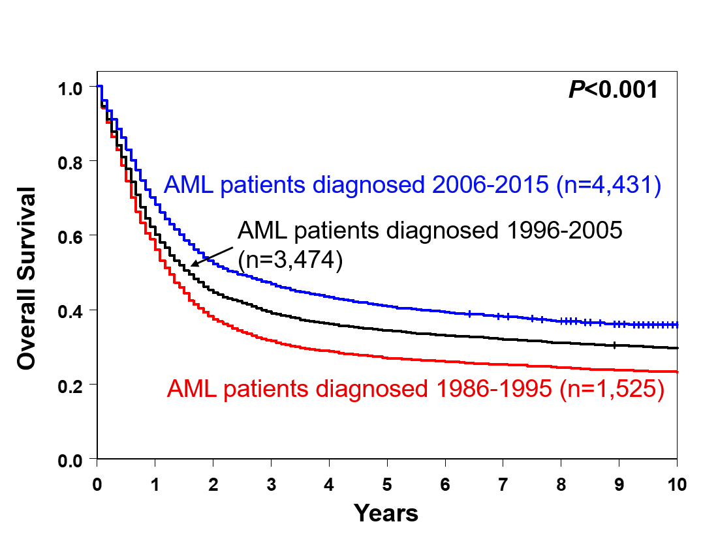
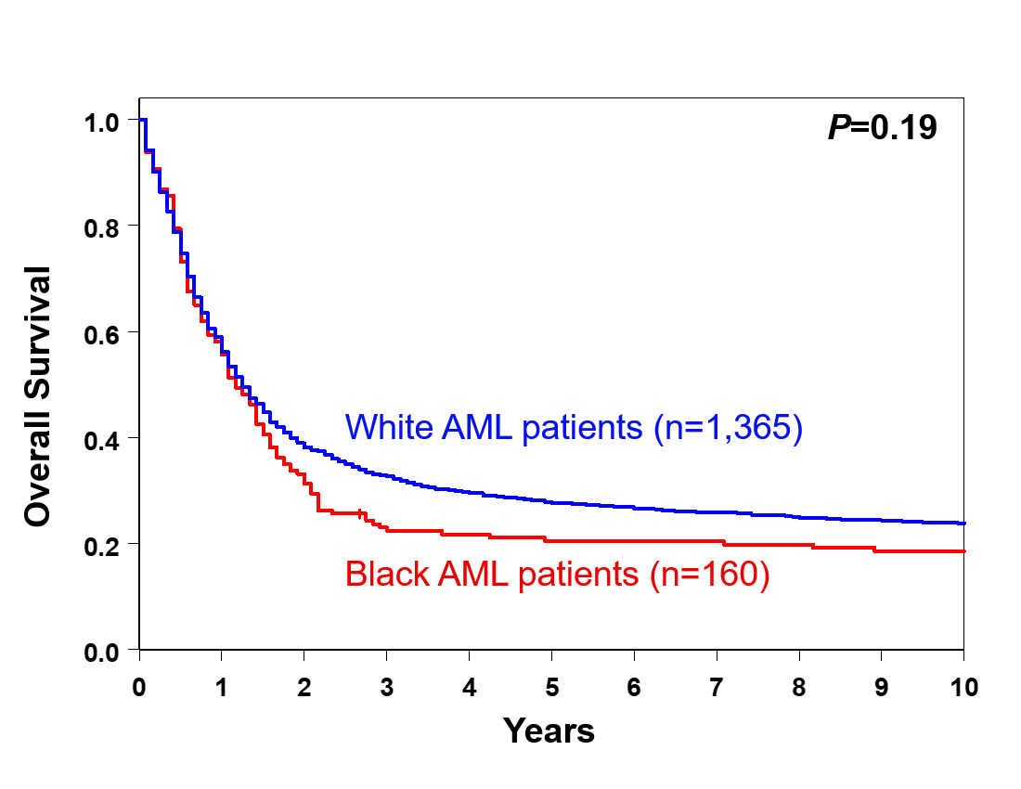
A B

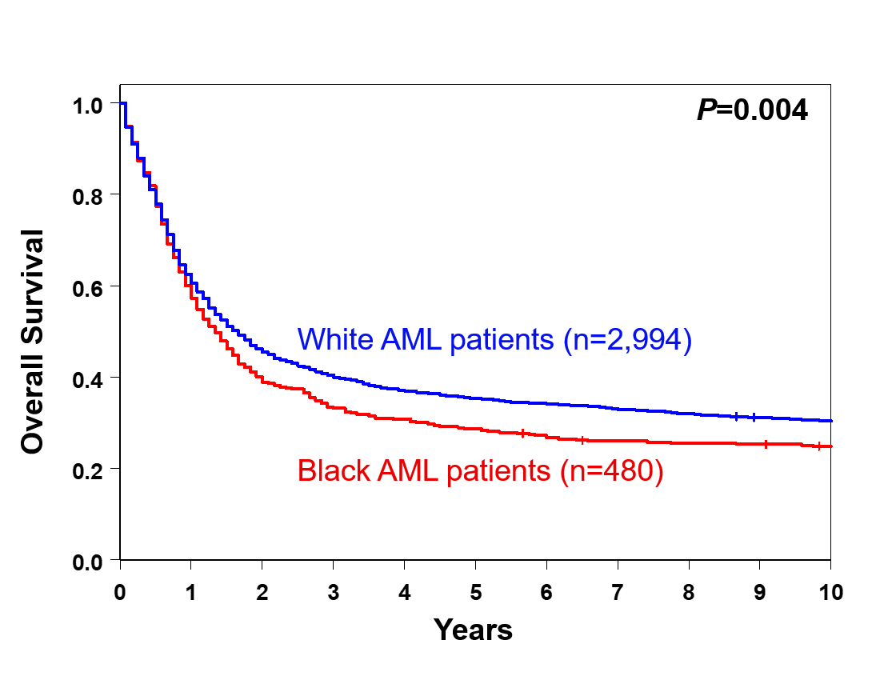
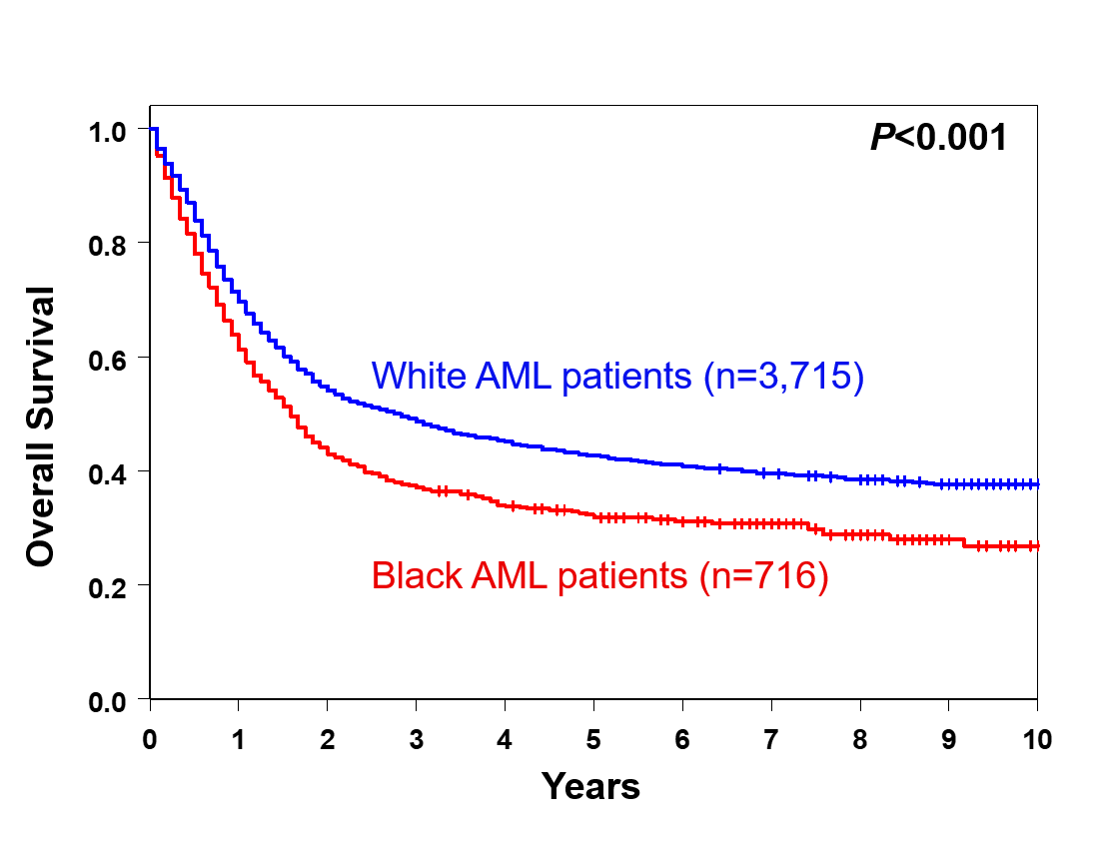
C D

Supplementary Figure S2. Overall survival of older (aged ≥60 years) SEER patients with acute myeloid leukemia (AML) based on time of diagnosis across decades. A, overall survival of combined non-Hispanic Black and White AML patients by decades. B, overall survival of Black and White patients during 1986-1995. C, overall survival of Black and White patients during 1996-2005. D, overall survival of Black and White patients during 2006-2015.
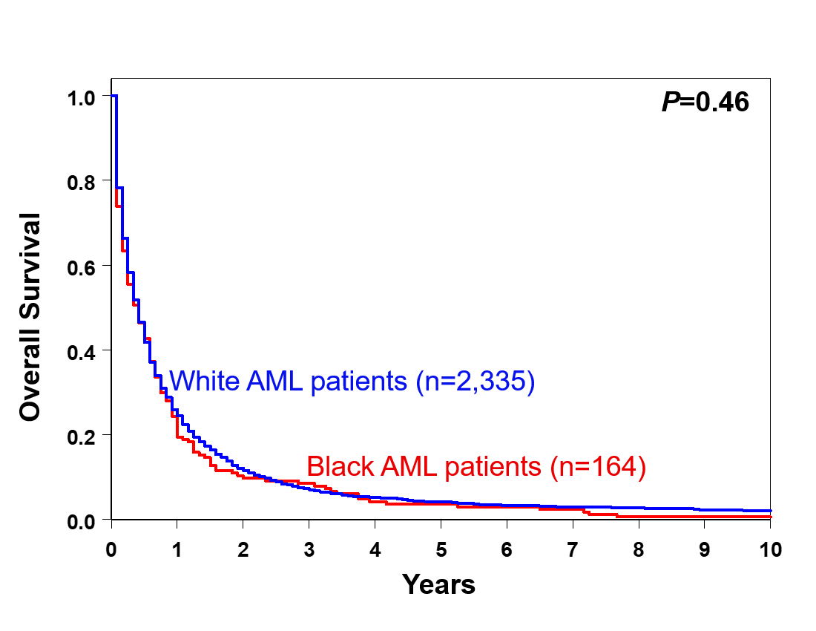
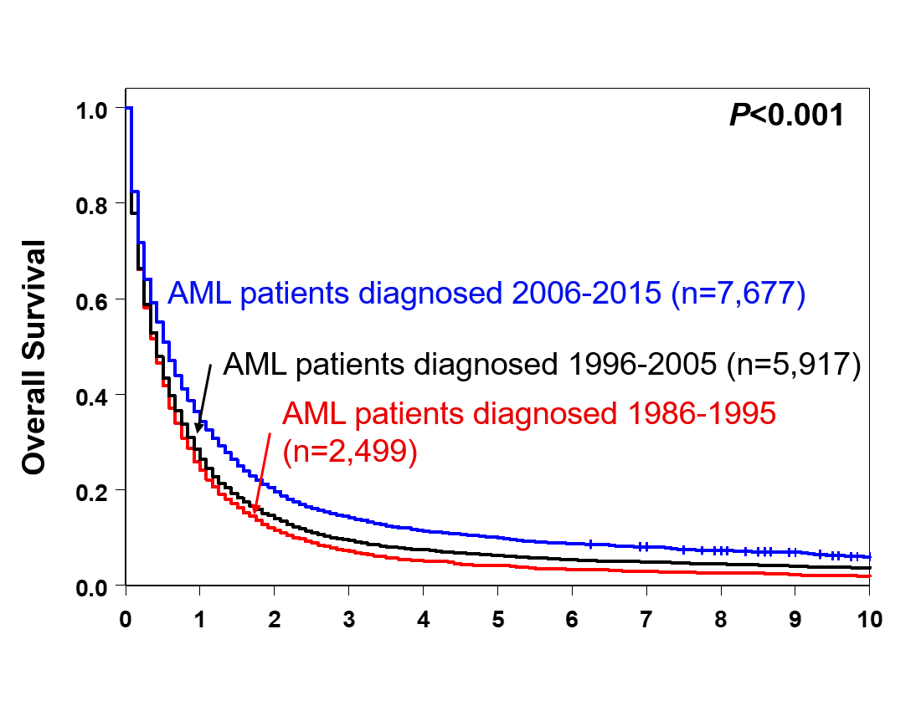
A B

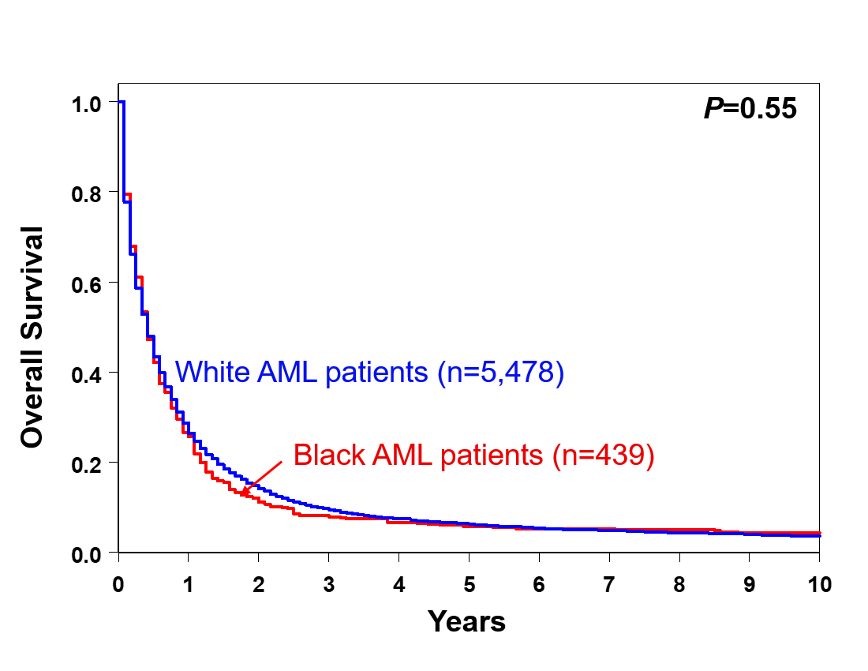
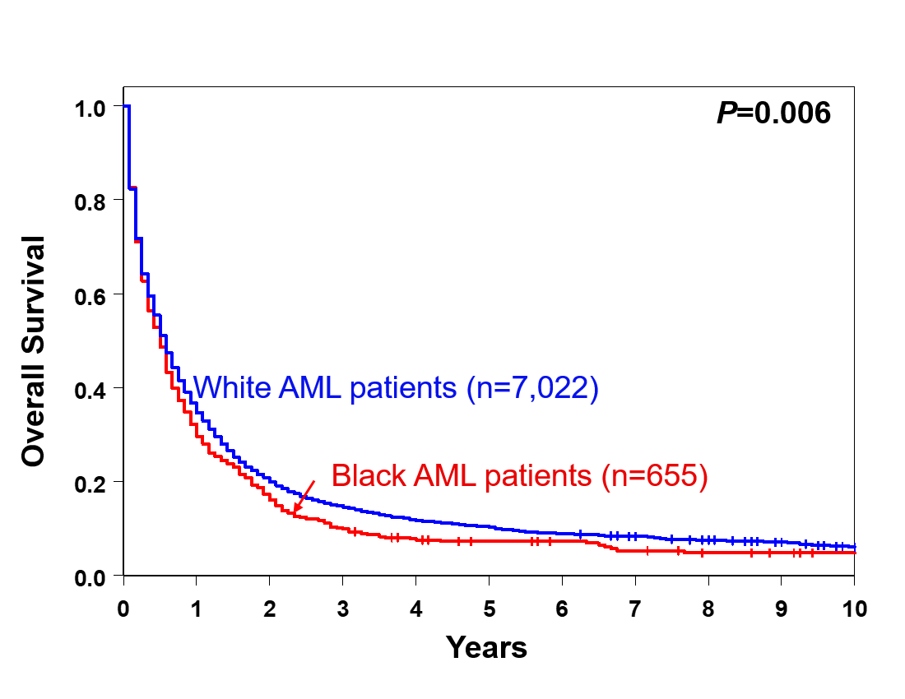
C D

Supplementary Figure S3. Survival of Black and White AML patients ≤60 years who were treated on Alliance protocols, classified into 2017 European LeukemiaNet (ELN) genetic-risk groups. A, disease-free and B, overall survival of patients in the 2017 ELN intermediate-risk group. C, disease-free and D, overall survival of patients in the 2017 ELN adverse-risk group.
A B
C D

Supplementary Figure S4. Survival of younger (aged <60 years) Black Alliance patients with acute myeloid leukemia. A, disease-free survival and B, overall survival of NPM1-mutated vs NPM1 wild-type patients.
A B
