Supplementary material for

Phenotypic mapping of pathological crosstalk between glioblastoma and innate immune cells by synthetic genetic tracing

Matthias Jürgen Schmitt^{1,6}, Carlos Company^{1,6}, Yuliia Dramaretska^{1,6}, Iros Barozzi², Andreas Göhrig¹, Sonia Kertalli¹, Melanie Großmann¹, Heike Naumann¹, Maria Pilar Sanchez-Bailon¹, Danielle Hulsman³, Rainer Glass⁴, Massimo Squatrito⁵, Michela Serresi¹ and Gaetano Gargiulo^{1,} *

¹ Max-Delbrück-Center for Molecular Medicine (MDC), Robert-Rössle-Str. 10, 13092 Berlin, Germany
² Department of Surgery and Cancer, Imperial College London, London, UK
³ Division of Molecular Genetics, The Netherlands Cancer Institute, Plesmanlaan 121, Amsterdam 1066 CX, The Netherlands.
⁴ Neurosurgical Research, Department of Neurosurgery, University Hospital, LMU Munich, 81377 Munich, Germany
⁵ Seve Ballesteros Foundation Brain Tumor Group, Molecular Oncology Programme, Spanish National Cancer Research Center, CNIO, 28029 Madrid, Spain.
⁶ co-first authors
* email: gaetano.gargiulo@mdc-berlin.de; Tel: +49 (0)30-9406-3861

Supplementary Figures with Legends
Supplementary Figure S1. Extended characterization of selected reporters and reporter lines.
Supplementary Figure S2. Extended analysis of in vivo mesenchymal trans-differentiation.
Supplementary Figure S3. Extended analysis of mesenchymal sLCR activation by external signaling.
Supplementary Figure S4. Extended analysis of mesenchymal sLCR activation by environmental triggers.
Supplementary Figure S5. Phenotypic CRISPR/Cas9 forward genetic screens using sLCRs.
Supplementary Figure S6. Extended characterization of microglia-driven mesenchymal transition in glioma-initiating cells.
Supplementary Figure S7. hMG cells induce mesenchymal glioblastoma with similar features as patients’ derived signatures.

Supplementary Tables
Supplementary Table S1. GBM-sLCR features
Supplementary Table S2. Phenotypic CRISPR-screen data analysis
Supplementary Table S3. List of reagents, software and deposited data

Supplementary References

Figures with Figure Legends

Supplementary Figure S1

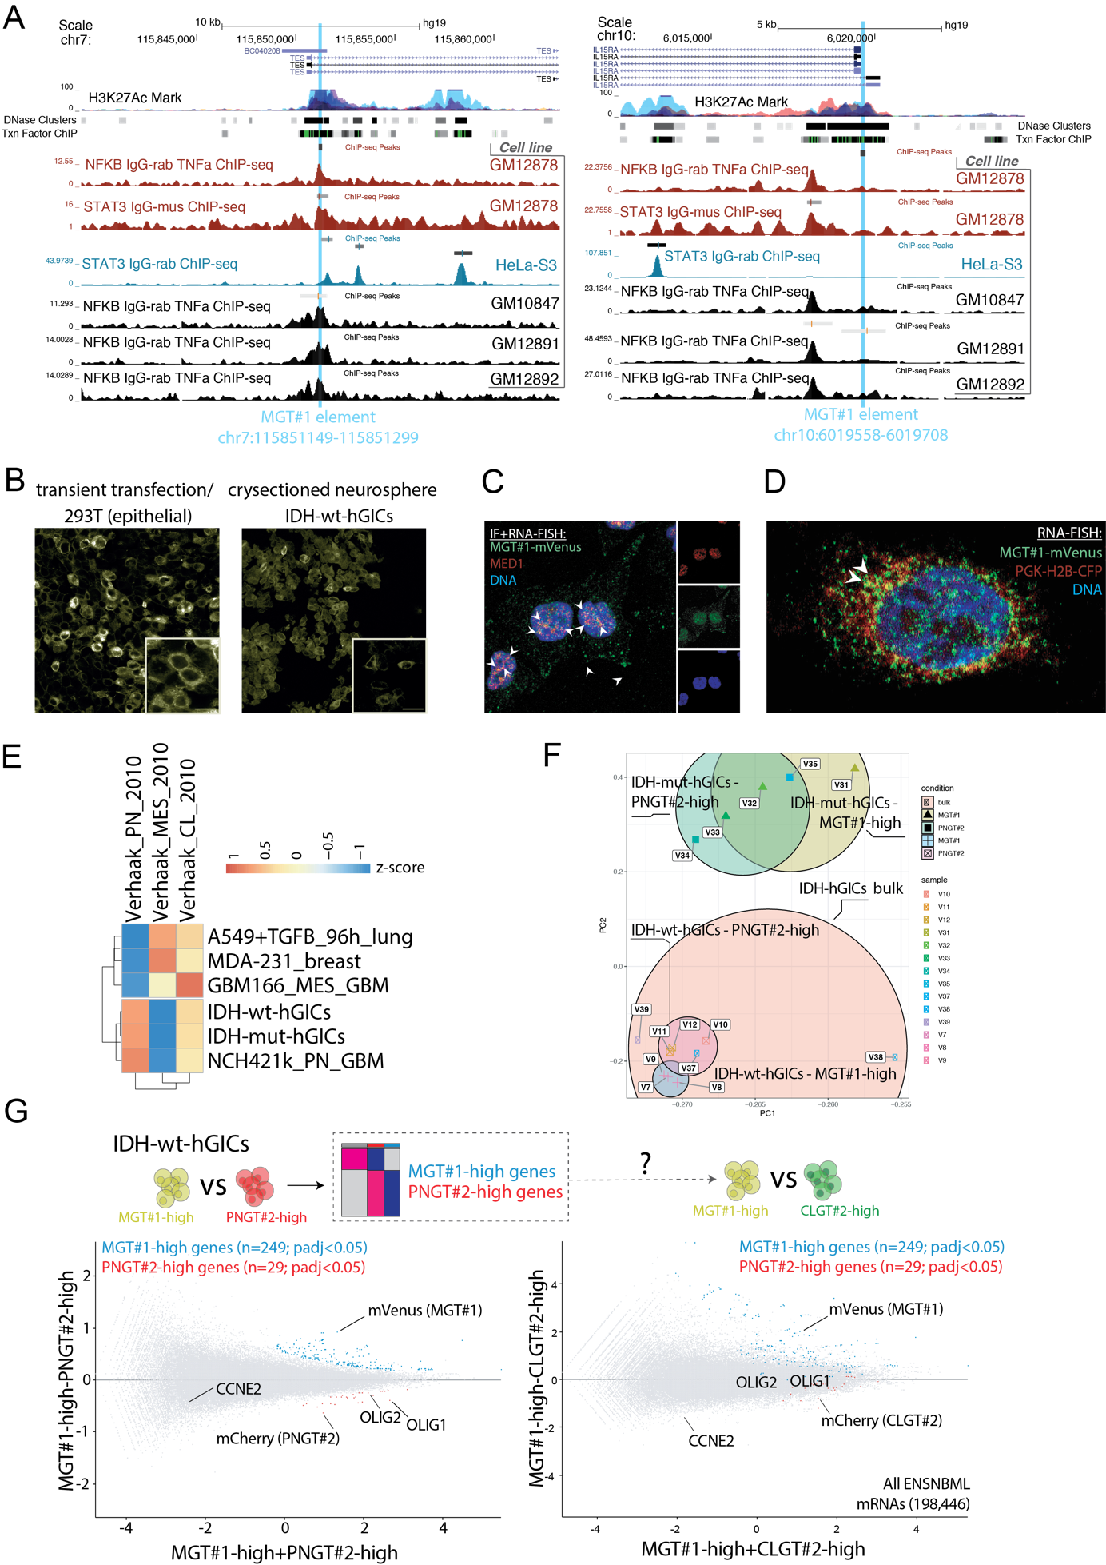
Supplementary Figure S1. Extended characterization of selected reporters and reporter lines.
(A) UCSC Genome Browser view of ENCODE ChIP-seq for NFKB and STAT3 binding at two independent regions used as cis-regulators elements in MGT#1 (light blue column). (B) Left; confocal imaging of transiently MGT#1-transfected 293T; right, cryosectioned IDH-wt-hGICs tumorspheres upon lentiviral transduction. Scale=10μm. (C) Dual IF and smRNA-FISH. Images of the merged (left) and separate channels (right) are shown. Overlapping signal in yellow and arrowheads denote co-localization between MED1 and MGT#1-driven mVenus in TNFα-stimulated A549 cells. (D) single-molecule RNA FISH quantification of MGT#1- and PGK-driven gene expression in TNFα-stimulated A549 cells. Arrowheads/yellow denote cytoplasmic colocalization. (E) GSEA normalized scores for TCGA subtypes (3) of indicated cell lines from Fig.1D. (F) Principal component analysis of the indicated RNA-seq profiles. Bulk RNA-seq are generated by FACS sorting live and single hGICs. Note that bulk cells are more variable than reporter-expressing cells. (G) MA plot for the indicated FACS sorted RNA-seq profiles. Blue dots represent significant MGT#1 specific markers in the comparison MGT#1 vs PNGT#2 (padj<0.05). Reporter and selected genes are highlighted. Note that MGT#1 selected markers remain enriched in MGT#1 fraction, whereas PNGT#2 selected markers change when CLGT#2 is used in the comparison (schematic above).

Supplementary Figure S2

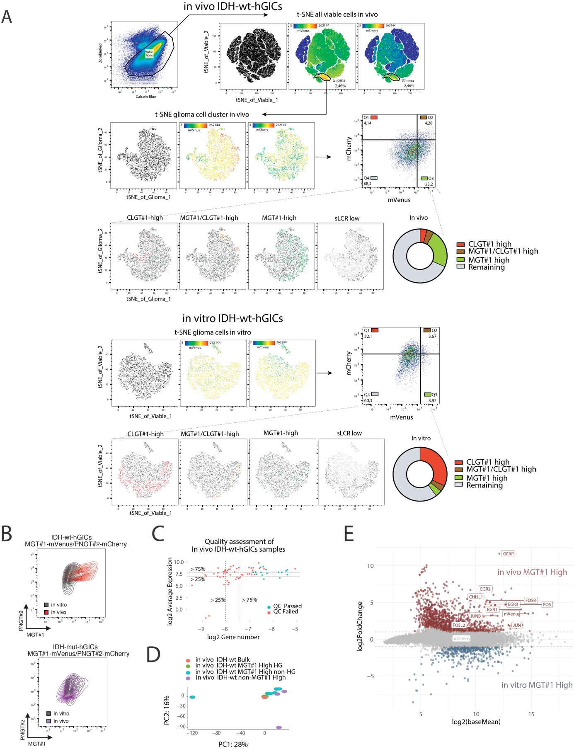

Supplementary Figure S2. Extended analysis of in vivo mesenchymal trans-differentiation.
(A) Example of gating strategy for FACS analysis of viable- and single-IDH-wt-hGICs-MGT#1-CLGT#1 in vitro and in vivo. (see Methods). (B) In vivo/in vitro FACS profile comparison of representative MGT#1/PNGT#2 dual-sLCR IDH-wt-hGICs and IDH-mut-hGICs. (C) Representation of the average expression (Y-Axis) and the number of expressed genes (X-axis) per in vivo expression profile profiles. Selected files (QC Passed) are shown in blue (see Methods). (D) PCA of retained in vivo transcriptome profiles. Conditions for each sample are indicated in the legend. (E) MA plot of the comparison between in vitro MGT#1-high and in vivo MGT#1-high. Selected genes are highlighted.

Supplementary Figure S3

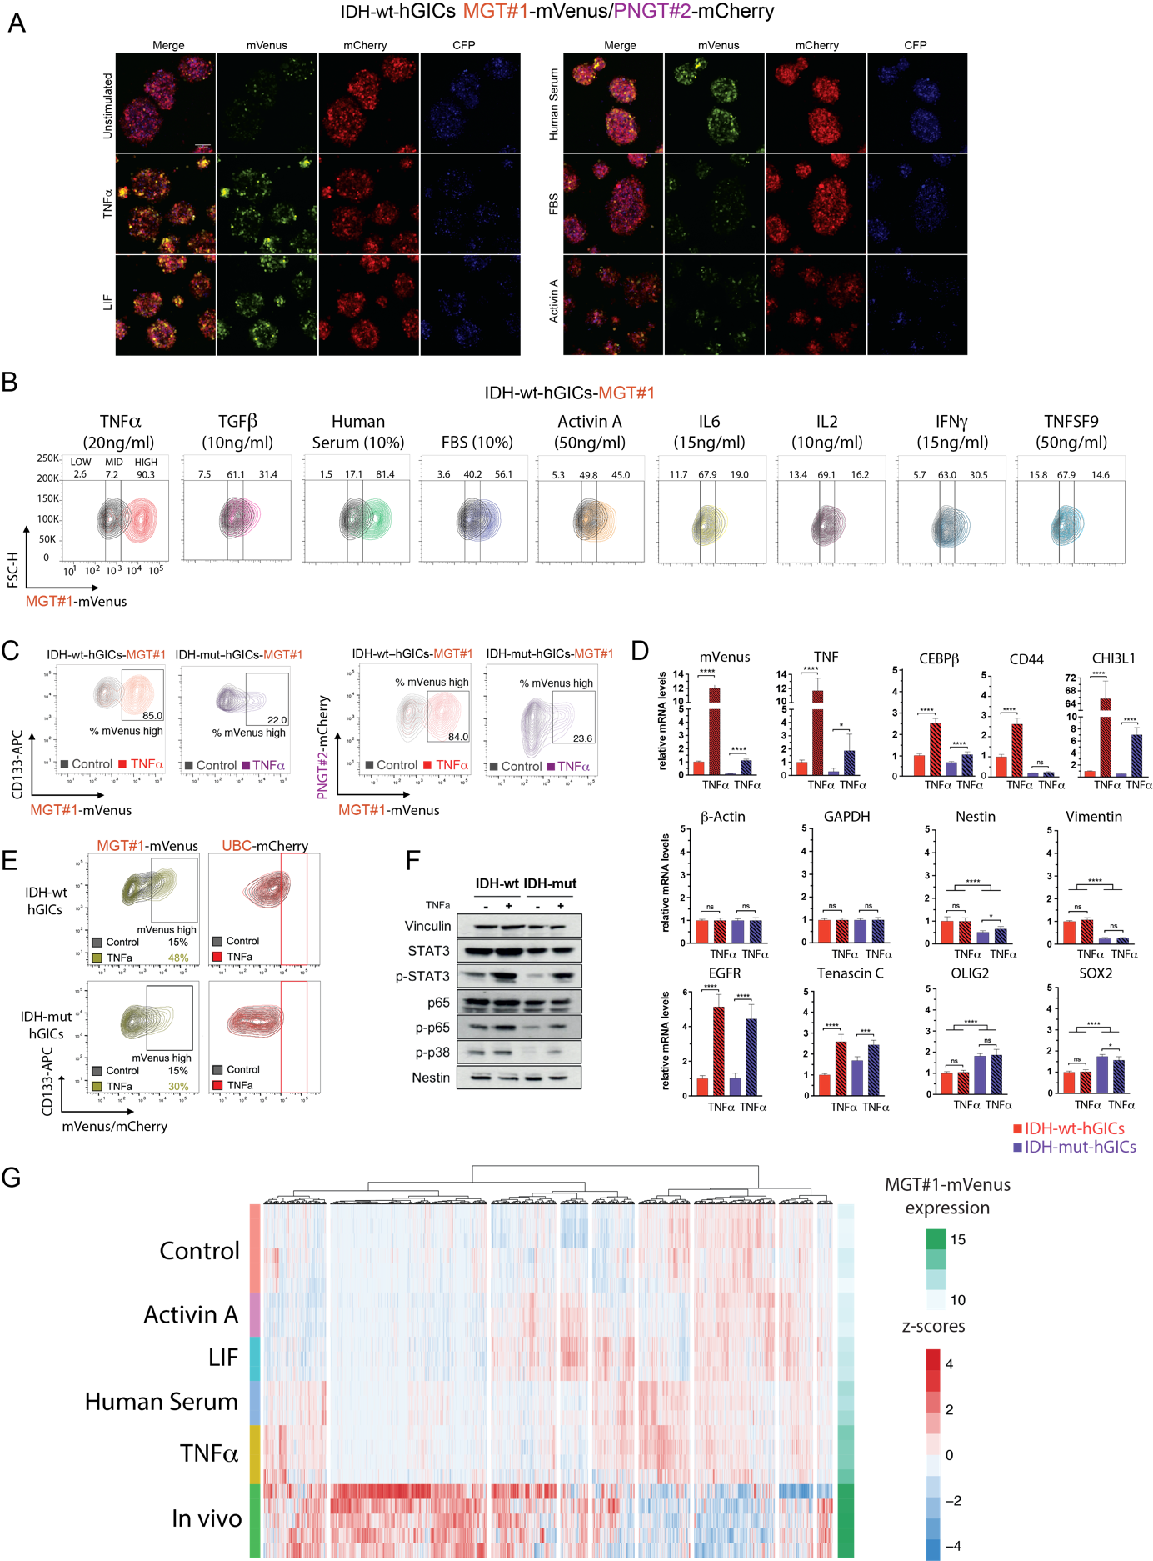
Supplementary Figure S3. Extended analysis of mesenchymal sLCR activation by external signaling.
(A) Representative confocal live cell imaging of MGT#1/PNGT#2 dual-sLCR IDH-wt-hGICs exposed to indicated stimuli after 48h as in (B). (B) Representative MGT#1 activation in IDH-wt-hGICs by FACS upon the indicated stimuli. (C) Representative FACS profile of selected markers expression in the indicated conditions. (D) RT-qPCR validation of the indicated genes in response to Tumor Necrosis Factor alpha (TNFα) treatment in the indicated GICs. n=3 biologically independent samples, ANOVA followed by Dunnet’s post hoc test; ****=P<0.0001; mRNAs are normalized to β−Actin and IDH-wt-hGICs control cells. (E) Representative FACS profile of selected markers expression in the indicated conditions. UBC-mCherry is a control reporter generated by using a broadly expressed promoter (UBC). (F) Immunoblotting of the indicated conditions and antibodies. (G) Heatmap of combined up-regulated gene expression normalizes values for the indicated comparisons. MGT#1-mVenus expression is individually indicated for all the samples grouped by condition (green).

Supplementary Figure S4

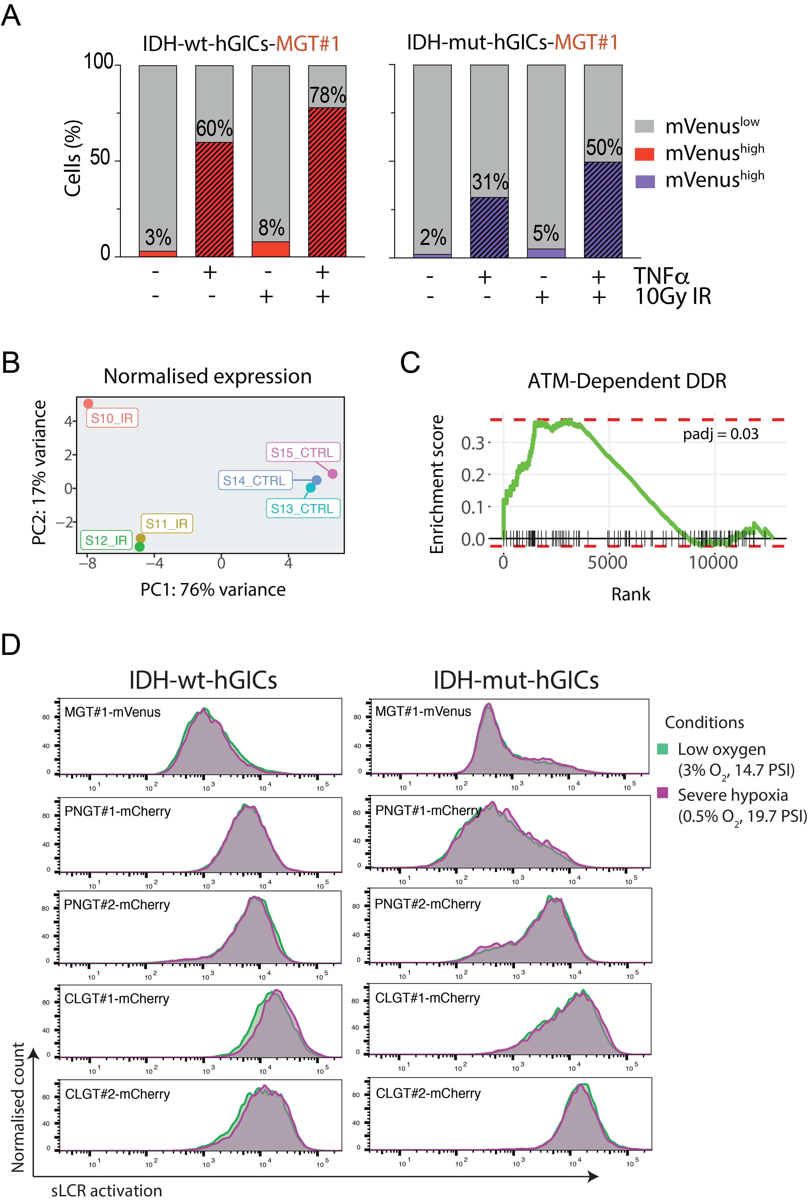
Supplementary Figure S4. Extended analysis of mesenchymal sLCR activation by environmental triggers.
(A) Representative FACS quantification of MGT#1 activation at 48h in response to the indicated stimuli. (B) PCA of normalized transcriptome profiles of the irradiated and control samples. (C) Differential GSEA of the irradiated (n=2) versus control (n=3) samples for the indicated gene set. (D) Representative FACS profiles of sLCR expression in hGICs after 3d under severe hypoxia (magenta) compared to low oxygen (green).
Supplementary Figure S5

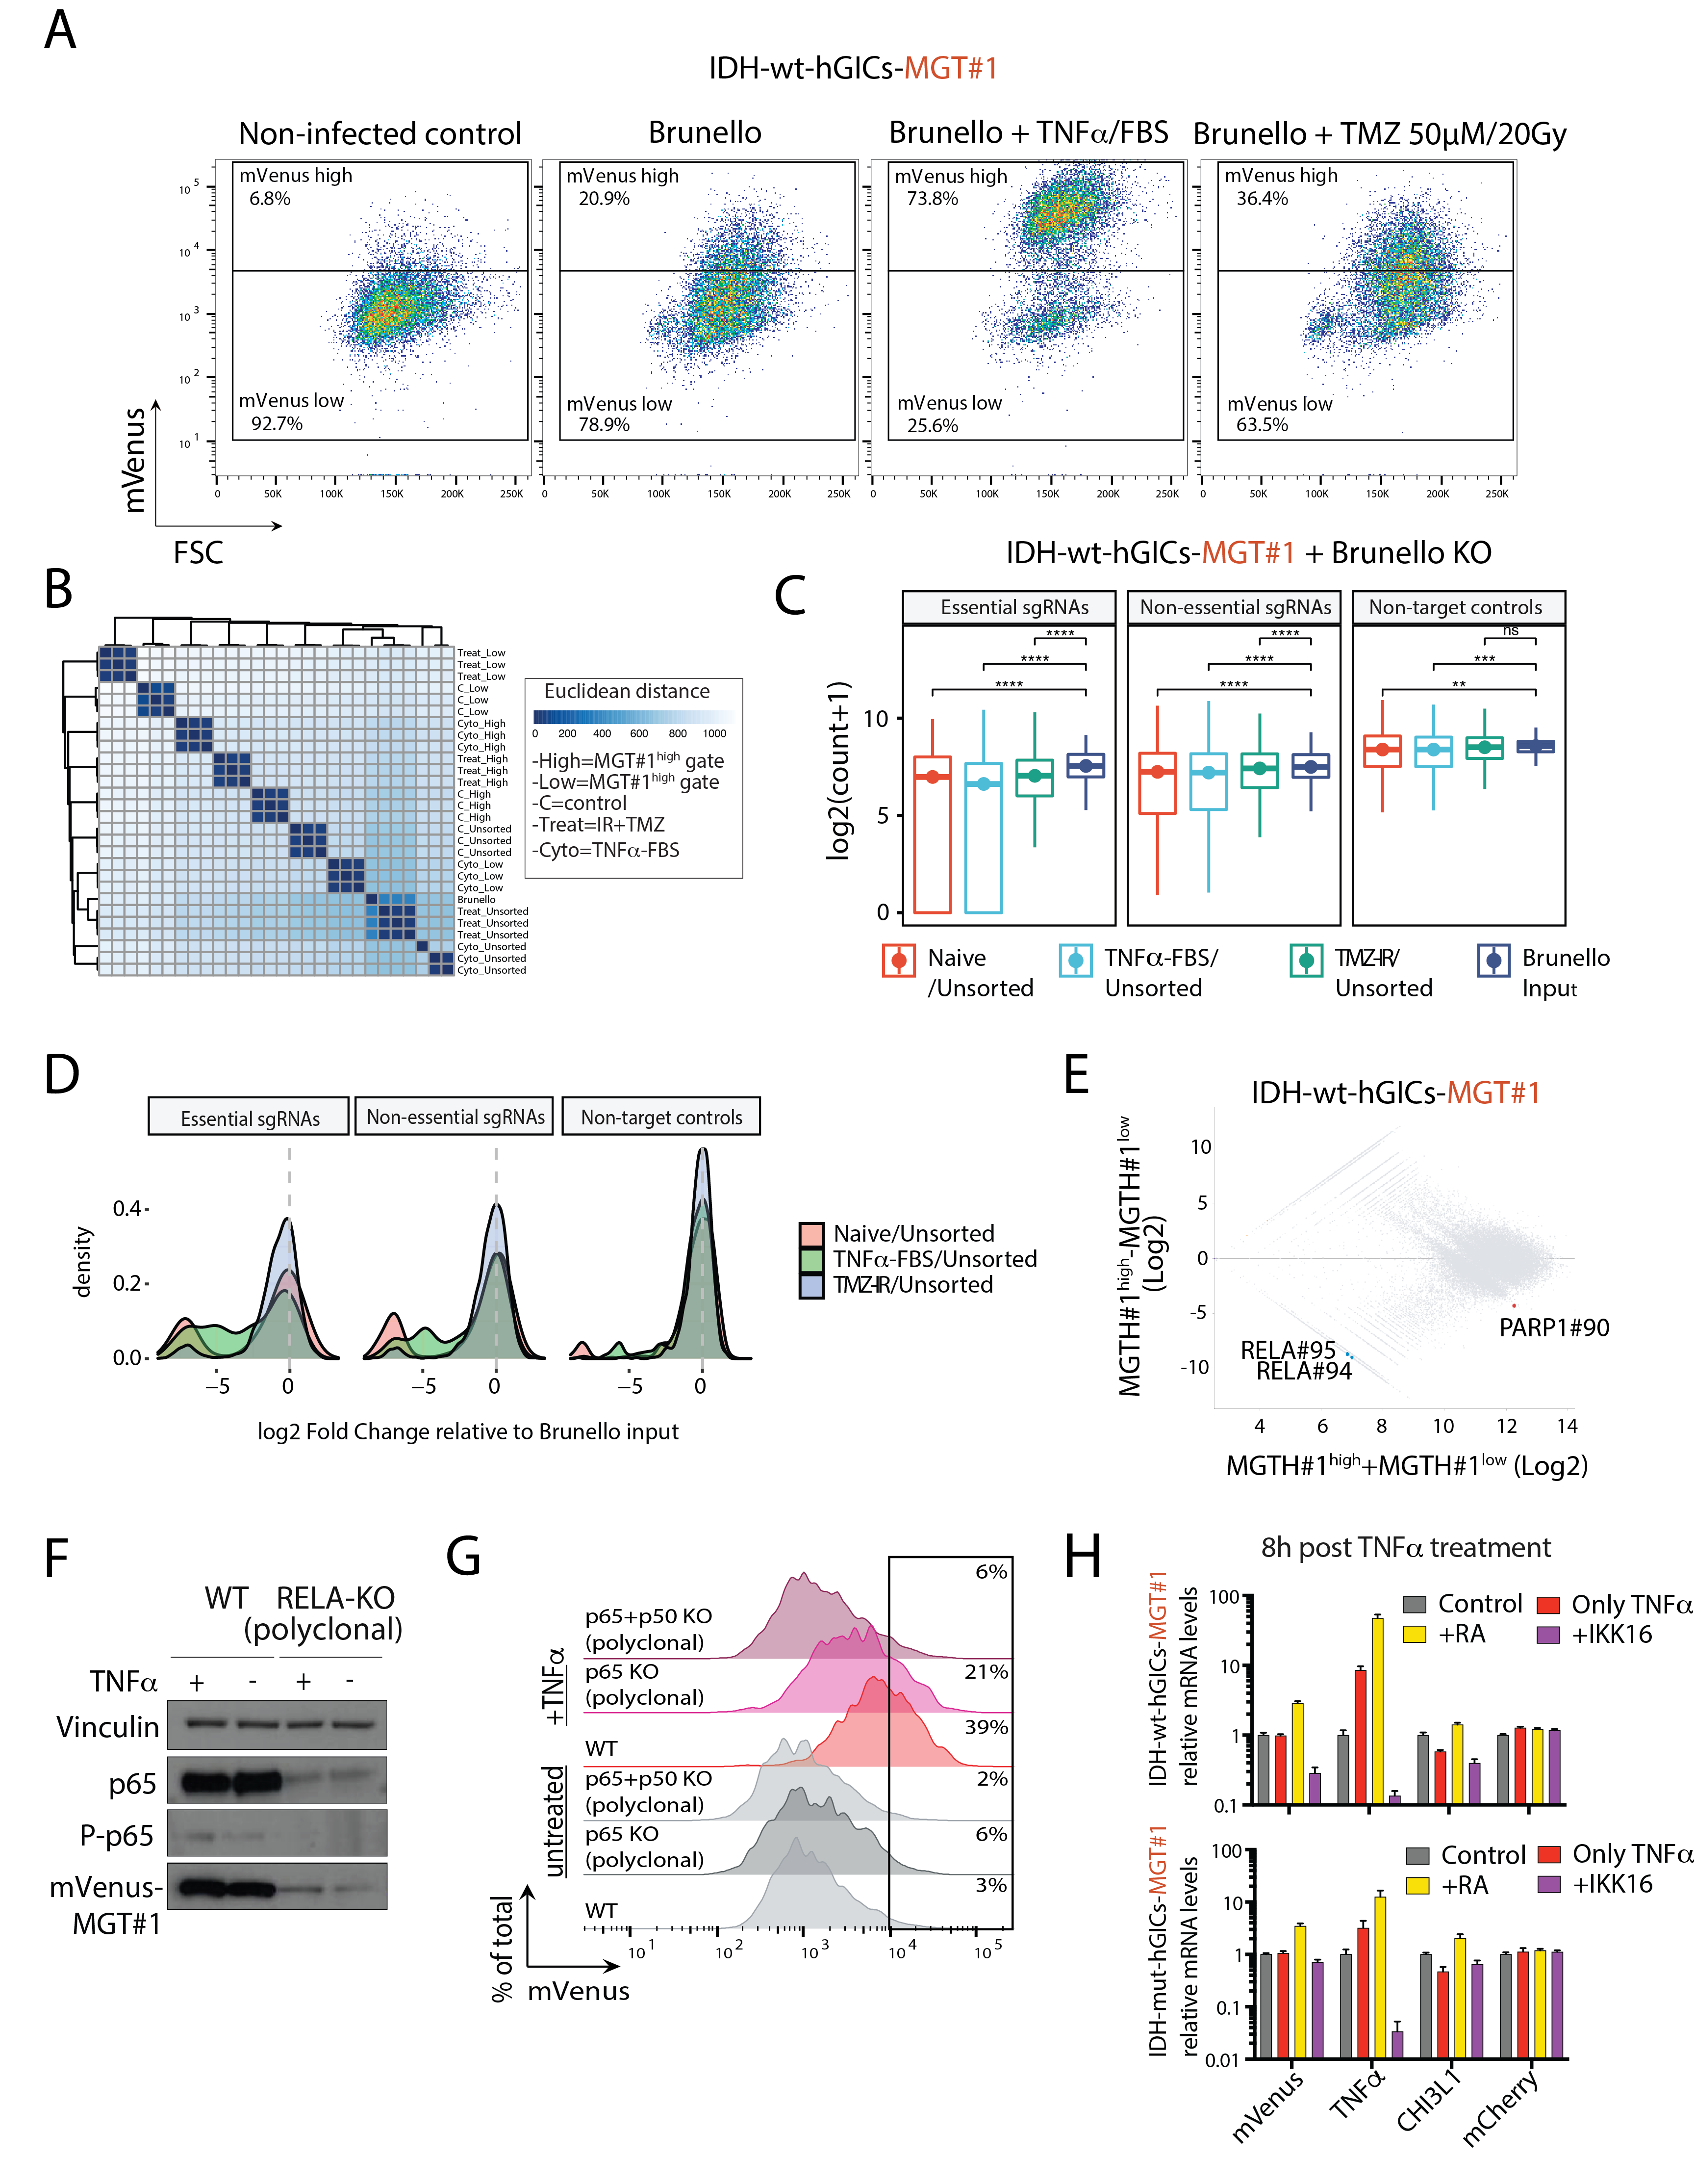
Supplementary Figure S5. Phenotypic CRISPR/Cas9 forward genetic screens using sLCRs.
(A) FACS plots prior sorting of the MGT#1-high and MGT#1-low fractions and subsequent sgRNA amplification for indicated conditions. (B) Correlation heatmap showing Euclidian distance between the indicated samples post regularized log2 normalization of the sgRNAs abundance. (C) Box plot showing data quality assessment for the indicated conditions at the time-point chosen to perform the phenotypic screen by comparing the distribution of validated essential sgRNAs to all non-essential or non-targeting sgRNAs (P-value = Wilcoxon rank-sum test). (D) Distribution of log2-fold changes for sgRNAs targeting the indicated gene sets in the averaged unsorted IDH-wt-hGICs conditions (n=3) relative to the Brunello input. (E) MA plot of sgRNA abundance (x-axis) and fold-change (y-axis) for FACS sorted MGT#1-high and MGT#1-low fraction in naïve IDH-wt-hGICs carrying the Brunello library. The gRNAs were normalized to the largest dataset and log2-transformed. The highlighted sgRNAs are depleted compared to MGT#1-high fraction. (F) Immunoblotting of the indicated conditions and antibodies. (G) Representative FACS quantification of MGT#1 activation by the indicated treatments at 48h and 72h, respectively. (H) RT-qPCR of the indicated genes upon sequential treatment with the indicated treatments and challenging with TNFα.

Supplementary Figure S6

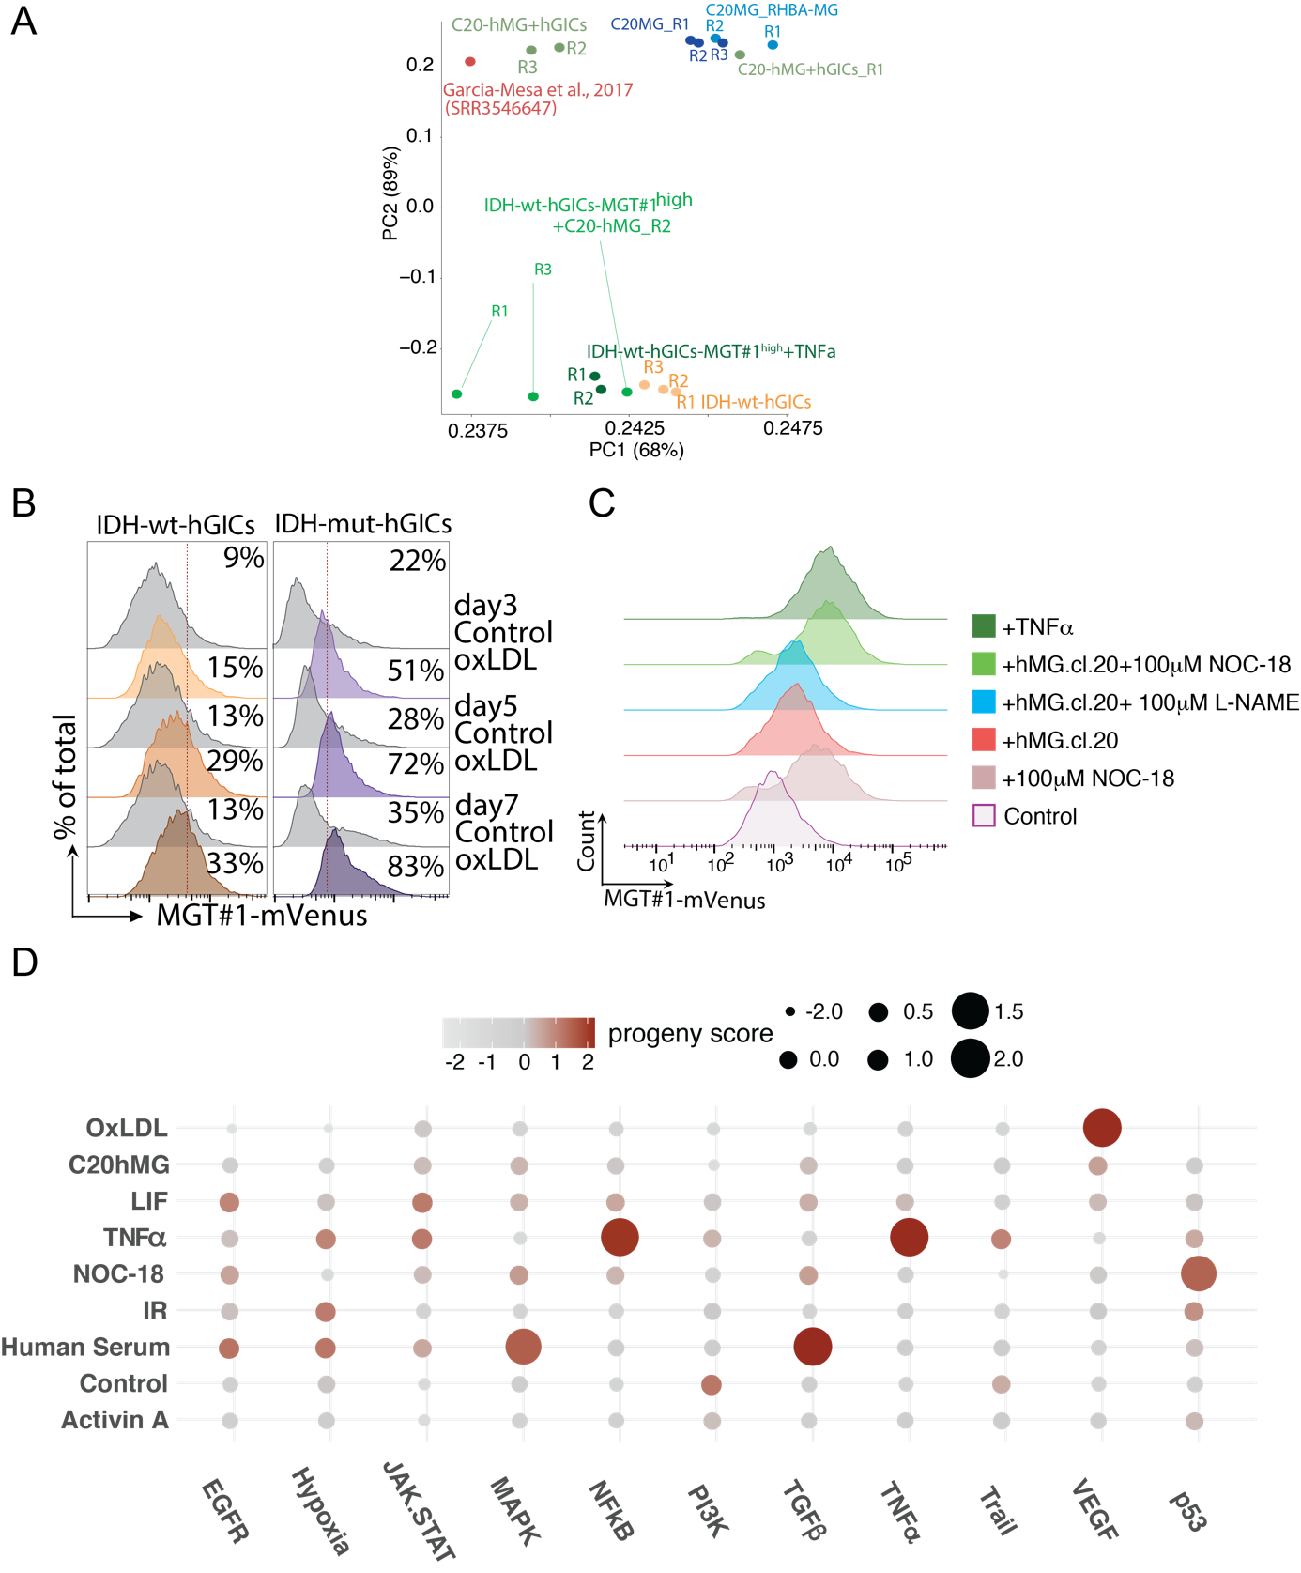

Supplementary Figure S6. Extended characterization of microglia-driven mesenchymal transition in glioma-initiating cells.
(A) Principal component analysis of the indicated RNA-seq profiles. Distances were calculated based on the average expression level of selected human MG markers obtained from (60). (B) Representative FACS profiles of IDH-wt and IDH-mut-hGICs-MGT#1 treated with 15µg/ml oxLDL or control for the indicated time. (C) Representative FACS profiles of IDH-wt-hGICs-MGT#1 treated as indicated for 48h. In co-culture experiments, hMG cells were pre-treated for 24h with the indicated drug concentrations before IDH-wt-hGICs-MGT#1 were seeded. Drugs were refreshed at the time of seeding IDH-wt-hGICs for co-culture. (D) Pathway analysis of condition-specific genes for each MGT#1 activator using PROGENy.

Supplementary Figure S7

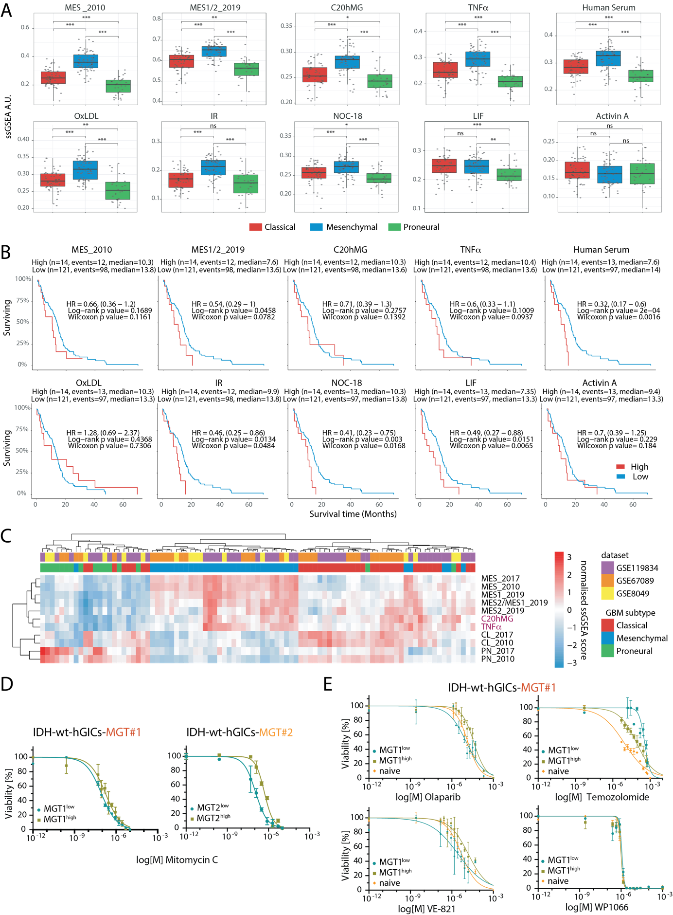
Supplementary Figure S7. hMG cells induce mesenchymal glioblastoma with similar features as patients’ derived signatures.
(A) Box-plot representation of single-sample GSEA normalised scores for the indicated gene sets for each TCGA GBM patients’ expression profile, grouped by TCGA-assigned GBM subtype. P-values are calculated by t-test followed by Benjamini-Hochberg post hoc test. (ns=not significant; ***=P<0.001; see Methods). (B) Kaplan-Meier survival plots of TCGA-GBM patients grouped by high and low expression of indicated gene sets(see Methods). (C) Heatmap of the relative single-sample GSEA score for the indicated gene sets in patient-derived GSCs from the indicated profiles. The corresponding GBM subtypes are also indicated. (D) Dose-response curve of FACS-sorted IDH-wt-hGICs subjected to increasing concentrations of Mitomycin C for IDH-wt-hGICs fractions FACS sorted using either MGT#1- or MGT#2-high. (E) Dose-response curve of MGT#1-high, MGT#1-low and naïve IDH-wt-hGICs cells subjected to increasing concentrations of the indicated compounds.

Supplementary References

60. Gosselin D, Skola D, Coufal NG, Holtman IR, Schlachetzki JCM, Sajti E, Jaeger BN, et al. An environment-dependent transcriptional network specifies human microglia identity. Science. 2017 Jun 23;356(6344):eaal3222.

61. Gilbert LA, Horlbeck MA, Adamson B, Villalta JE, Chen Y, Whitehead EH, et al. Genome-Scale CRISPR-Mediated Control of Gene Repression and Activation. Cell. 2014 Oct 23;159(3):647-61.

