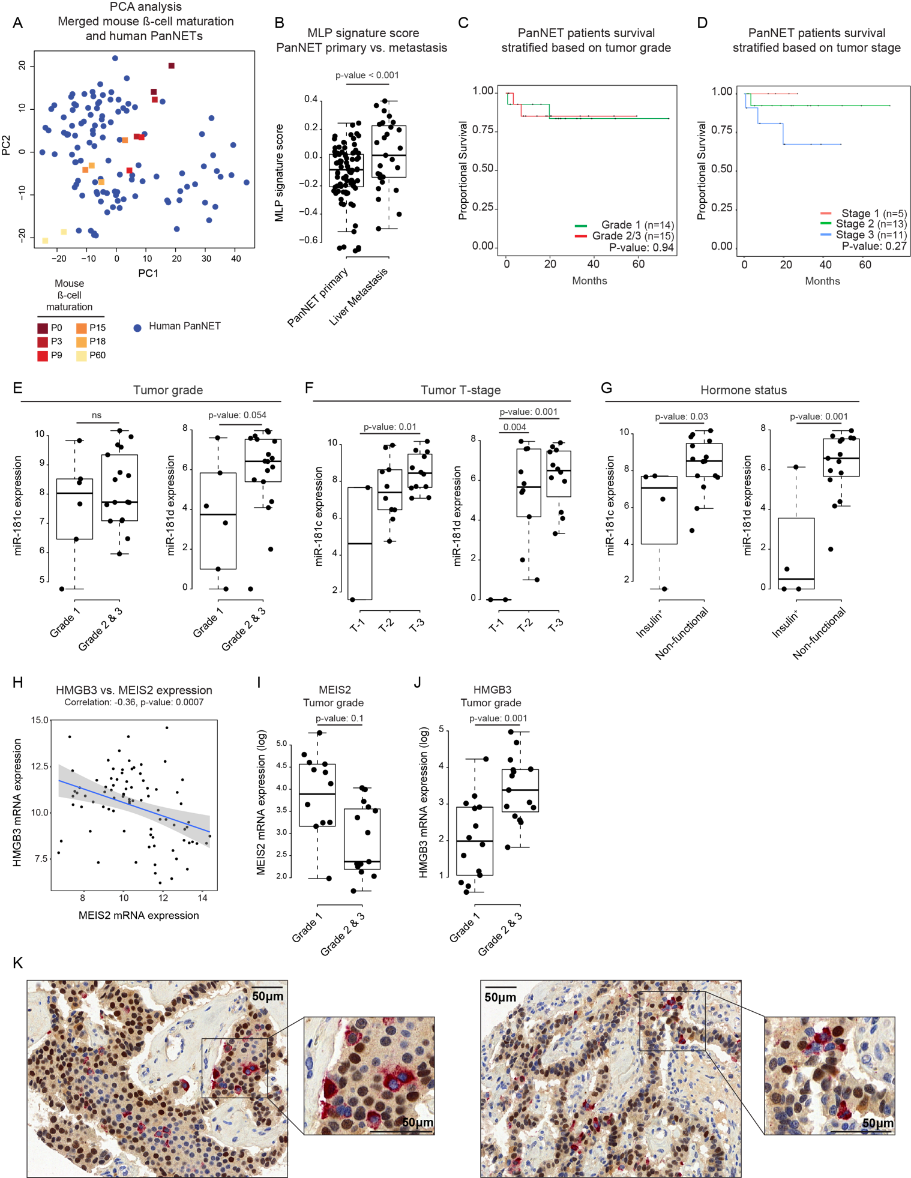

Supplementary Fig. S7
A. PCA representation of β-cell postnatal maturation samples (in squares) and human PanNETs (in blue circles).
B. The MLP mRNA signature score in primary human PanNETs and liver metastasis.
C, D. Lack of association of overall survival of PanNET patients with tumor grade (C), and tumor stage (D).
E-G. miR-181c (left graph) and miR-181d (right graph) expression in low- vs. high-grade (E), tumor stages (F), and functional (Insulin⁺) vs. non-functional (Insulin⁻) (G) of human PanNETs.
H. Inverse-correlation between MEIS2 and HMGB3 mRNA expression in primary human PanNETs.
I, J. MEIS2 (I) and HMGB3 (J) mRNA expression in low- vs. high-grade human PanNETs.
K. Representative images of Insulin (red; cytoplasmic) and HMGB3 (brown; nuclear) immunostaining of human PanNETs biopsies, revealing IT and MLP cells, respectively.

