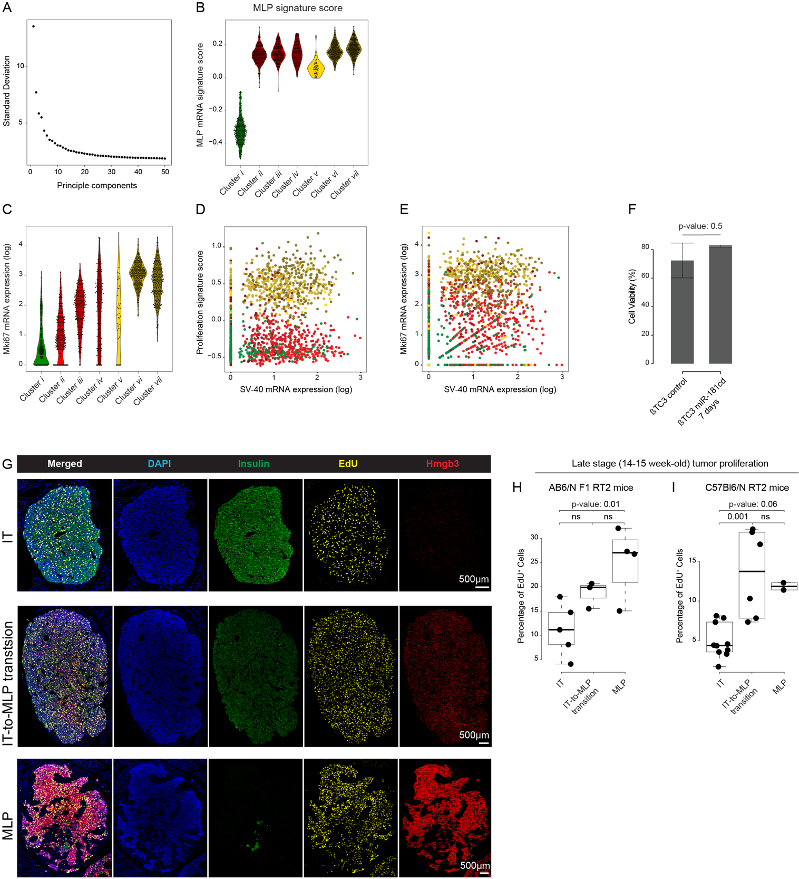

Supplementary Fig. S6
A. Variation (standard deviation) of top 50 principal components of PCA analysis of cancer cell single cell transcriptome.
B. Violin plot showing the MLP mRNA-signature score for each cancer cell sub-cluster.
C. Violin plot showing the Mki67 mRNA expression for each cancer cell sub-cluster shown in panel A, and Supplementary Fig. S2E.
D, E. Scatter-plots showing no correlation between cancer cell proliferation and SV-40 (D) or Mki67 (E) expression.
F. Cell viability for βTC3 cells before (control) and 7 days after DOX-induction of miR-181cd expression.
G. Representative images of Insulin, Hmgb3, and EdU immunostaining, IT, MLP, and proliferation markers, respectively, along with DAPI, of early lesions, from 7-8 weeks old RT2;AB/6J-F1 mice.
H, I. Quantification of EdU immunostaining to reveal proliferation of cancer cells in IT and MLP tumor lesions isolated from late stage tumors from RT2;AB/6J-F1 (H) and RT2;C57Bl6/N (I) mice.

