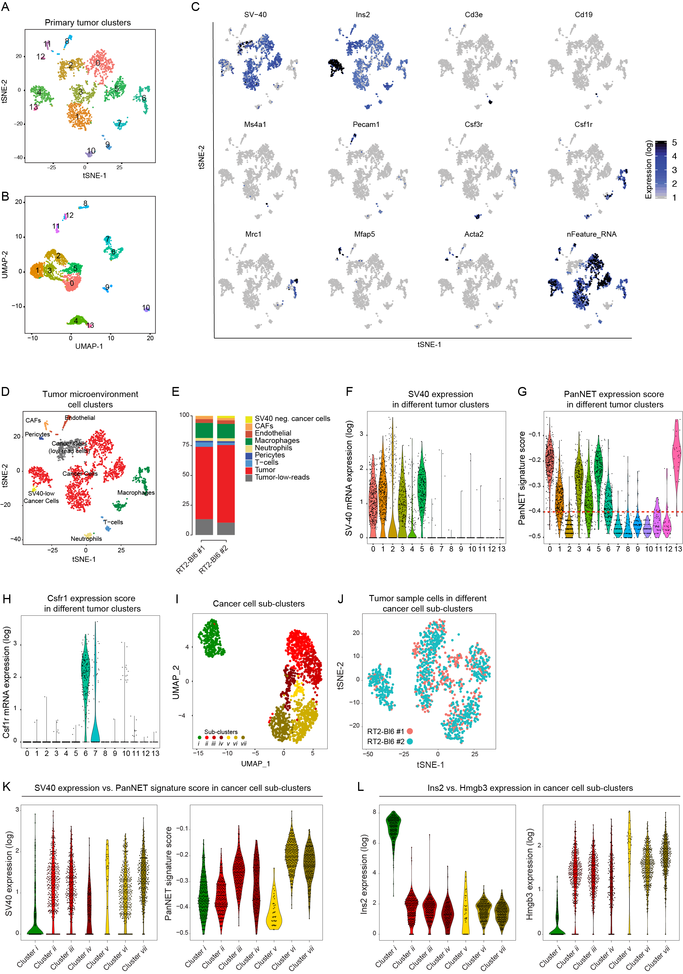

Supplementary Fig. S5
A,B. t-distributed stochastic neighbor embedding (t-SNE, A), Uniform Manifold Approximation and Projection (UMAP, B) map of single cells isolated from primary tumor samples from two 14-week old RT2;C57Bl6/N mice, labeled and color-coded according to the tumor cell clusters.
C. Gene expression levels of different markers used to identify cell-type populations in tumor microenvironment. SV-40 = cancer cells; Ins2 = ß-cells and cancer cells; Cd3e = T-lymphocytes; Cd19 & Ms4a1 = B-lymphocytes; Pecam1 = endothelial cells; Csf3r = neutrophils, Csf1r = macrophages, Mrc1= M2 macrophages; Mfap5 = CAFs; Acta2 = Pericytes.
D. t-SNE map of single cells isolated from primary tumor samples 14-week old RT2;C57Bl6/N mice, labeled and color-coded according to the different cell-type populations.
E. Abundance of distinctive cell types within the tumor microenvironment of two individual primary tumors isolated from two 14-week old RT2;C57Bl6/N mice.
F-H: Violin plots showing the SV40 mRNA expression (F), PanNET signature score (G), and Csf1r mRNA expression (H) in different cell clusters. Dashed line in panel G shows the cutoff that was used to select cancer cell clusters (-0.4).
I. UMAP analysis for all cancer cells based on scRNA-sequencing analysis, color coded according the seven distinct cancer cell sub-clusters.
J. t-SNE analysis for all cancer cells showing the distribution of the two analyzed tumor sample cells within the cancer cell sub-clusters.
K. Violin plots showing the SV40 mRNA expression of (left) and PanNET signature score (right) in different cancer cells sub-clusters.
L. Violin plots showing the Ins2 (left) and Hmgb3 (right) mRNA expression in different cancer cells sub-clusters.

